LAB-2 REPORT

RC Circuits

**K Nithin Raj and Kayyuru Prakash**

31.08.2018

# AC Signal to RC Circuit :

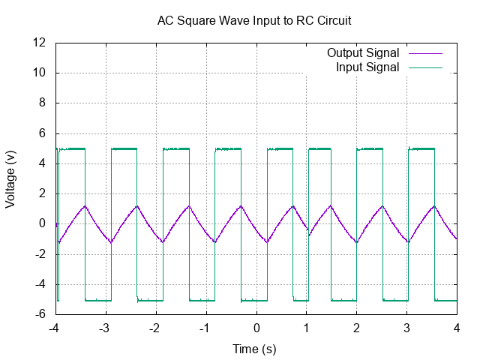

* 1 cycle : Theoretical RC = (10*10-6)*(100*103)

= 1s

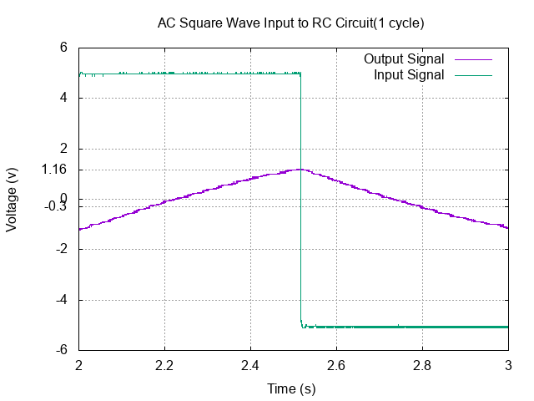

# Differentiator :

* Input and Output Signal

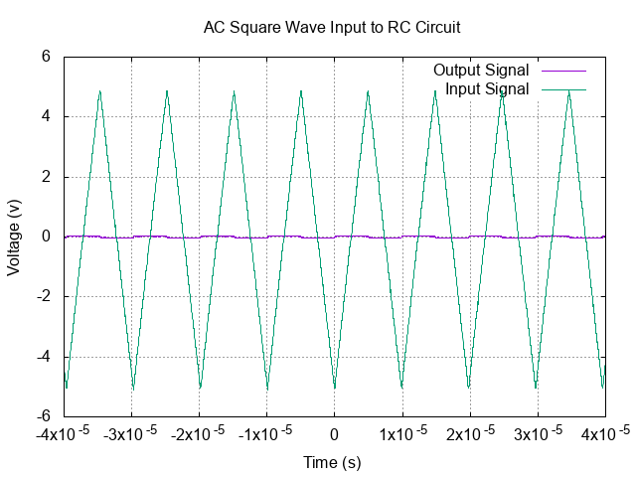

* Input Signal :
* Output Signal :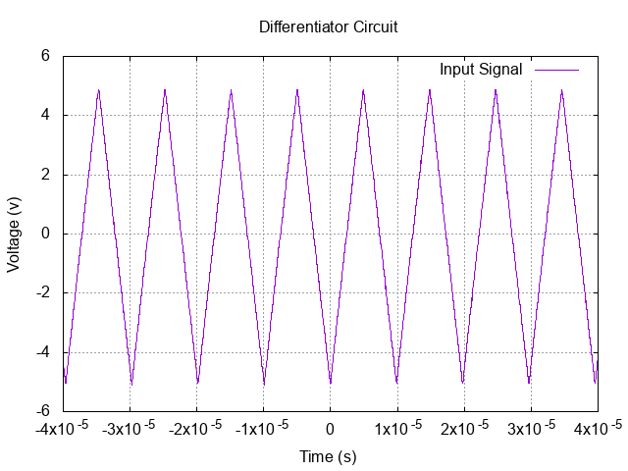

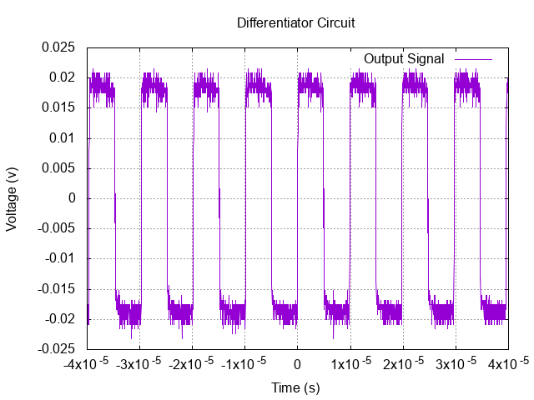

# Integrator :

* Input and Output Signal :

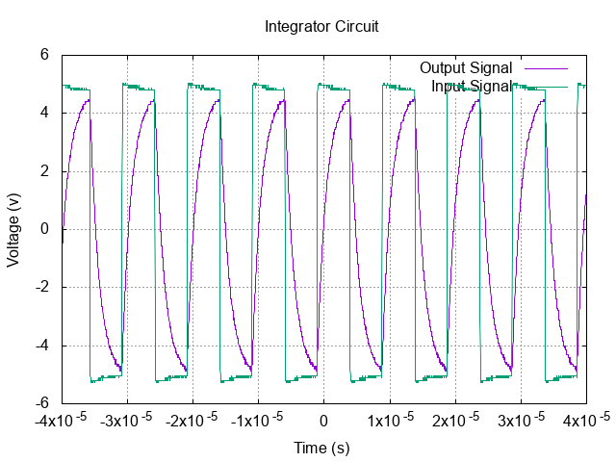

* Input Signal :

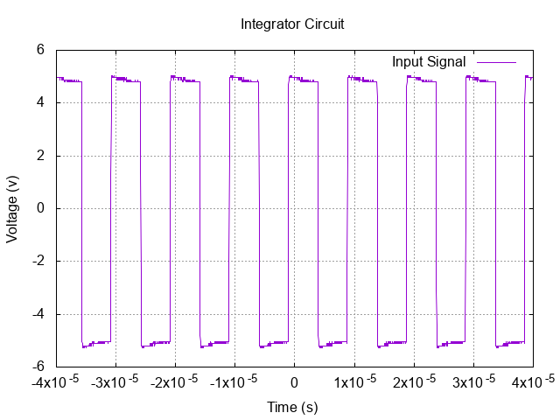

* Output Signal :

