LAB-2 REPORT

RC Circuits

**K Nithin Raj and Kayyuru Prakash**

31.08.2018

# AC Signal to RC Circuit :

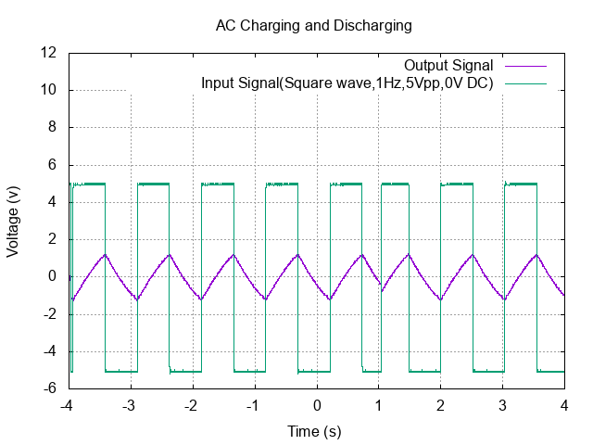

* 1 cycle : Theoretical RC = (10*10-6)*(100*103)

= 1s

Experimental RC = 0.3s

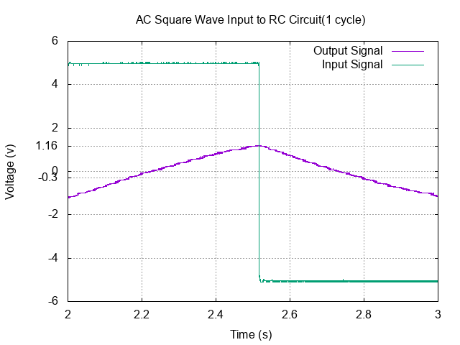

# Differentiator :

* Input and Output Signal

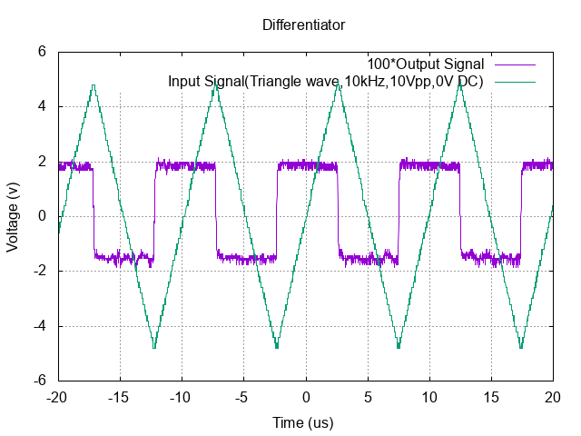

* Input Signal :

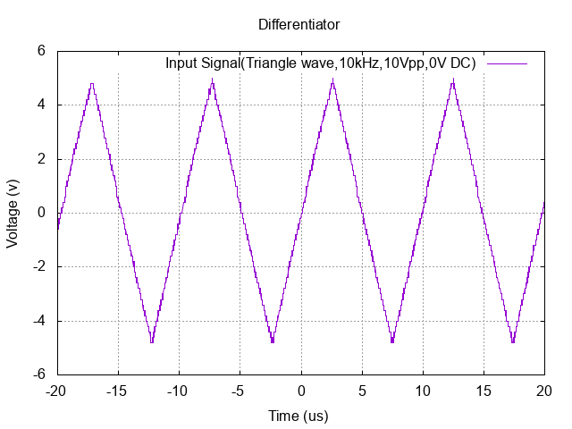

* Output Signal :

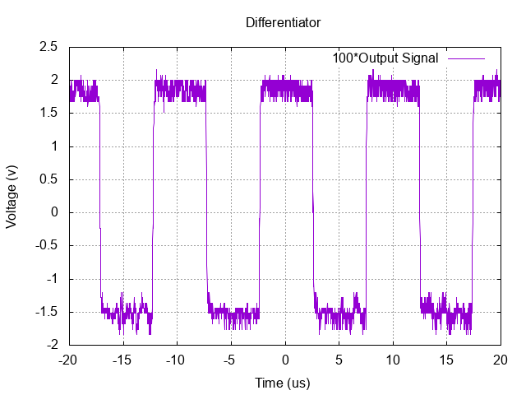

# Integrator :

* Input and Output Signal :

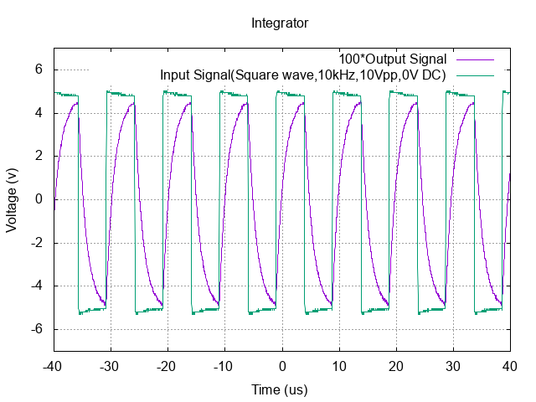

* Input Signal :

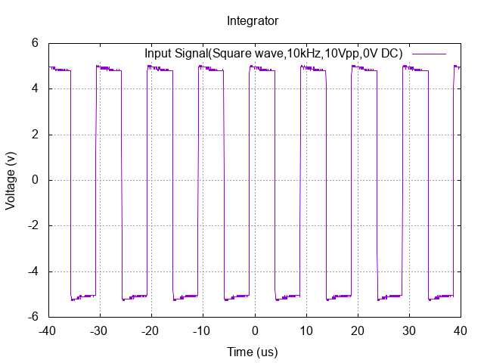

* Output Signal :

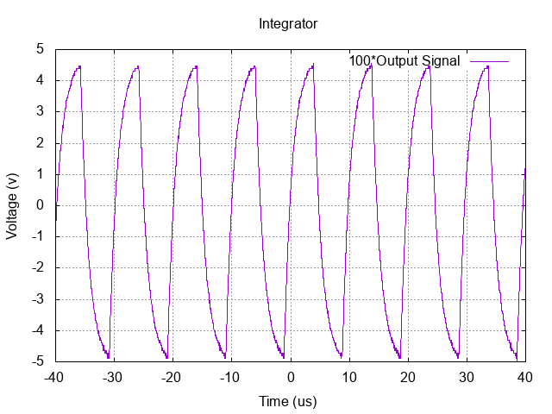

### Multisim

# I-V Characteristics :

* **Resistors : 10k ohm and 20k ohm**
* Circuits :

# 

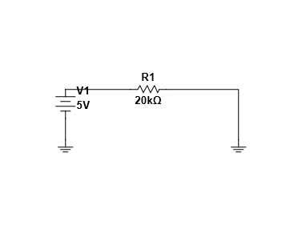

`

` ` `

# 

* Graph :

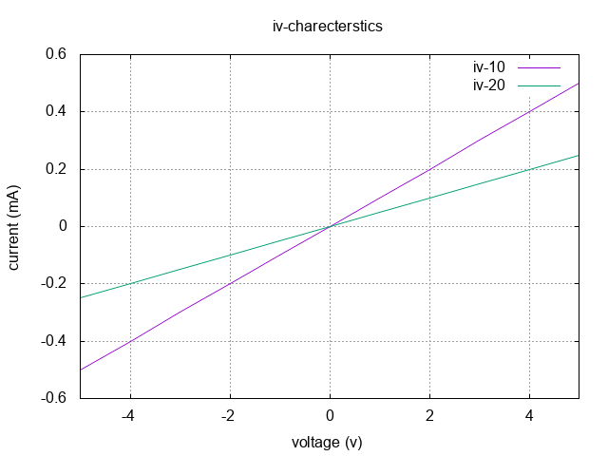

# 

# 

# 

# 

# Voltage Divider :

* Circuit :

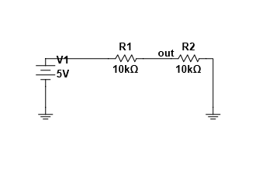

* Graph :

# 