Momentum Electrical Contractors
Application Audit and Operations Review
Prepared for review as one immutable publication.
Report date | 2026-08-01
Classification | Internal
Table of Contents
Media and Layout Acceptance

Media and Layout Acceptance
This acceptance-only member checks raster images, SVG import, code, a wide table, and a landscape section.

PNG figure


JPEG figure
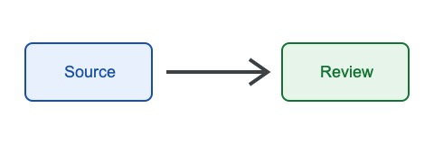

SVG figure


Code sample
func stableTarget(publicationID string) string {
return "publication:" + publicationID
}

Wide table
Control | DOCX | Google | Owner | Evidence | Result
Cover | Required | Required | Release reviewer | Rendered first page | Pass
Sections | Required | Verify | Release reviewer | Portrait and landscape pages | Pass
Tables | Required | Verify | Release reviewer | Repeated header and wrapping | Pass
Figures | Required | Verify | Release reviewer | PNG, JPEG, and SVG | Pass
Links | Required | Verify | Release reviewer | Static TOC and heading links | Pass

