**Path Planning Project**

**Udacity.com Self-Driving Car Engineer Nanodegree Program – Term 3**

**Panchakshari Gollaratti – v1.0 Dated: 22- Aug-2017**

* The project is developed with with base code as provided in the class.
* The surround car information is extracted from the sensor fusion data and stored in *other_cars* structure. The nearest cars from my car on each lane on front and back are extracted and stored as defined in line #297 to #302:

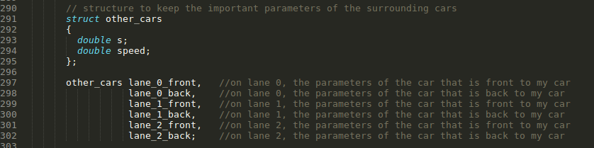

* The car driving status is managed via finite state machine with states:
  + KEEP_LANE : car will follow the lane in this state while looking for overtaking as needed
  + CHANGE_TO_LEFT : car will follow change lane to left in this state
  + CHANGE_TO_RIGHT: car will follow change lane to right in this state
  + PREP_CHANGE_TO_LEFT: car will prepare for changing the lane to left; lane variable is changed in this state.
  + PREP_CHANGE_TO_RIGHT: car will prepare for changing the lane to left; lane variable is changed in this state.

This state machine is implemented in the code line #443 to #634.

* Conditions for overtaking are implemented in KEEP_LANE state with following tunable #defines:

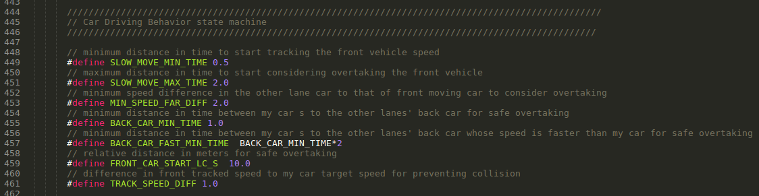

* The above parameters are tuned based on the driving behavior and reasonable calculated values from physics of motion.
* The basic path planning is based on the calculating the current path appended with previously calculated path.
* The safe and required conditions for changing lane are checked as shown in the code snippet below:

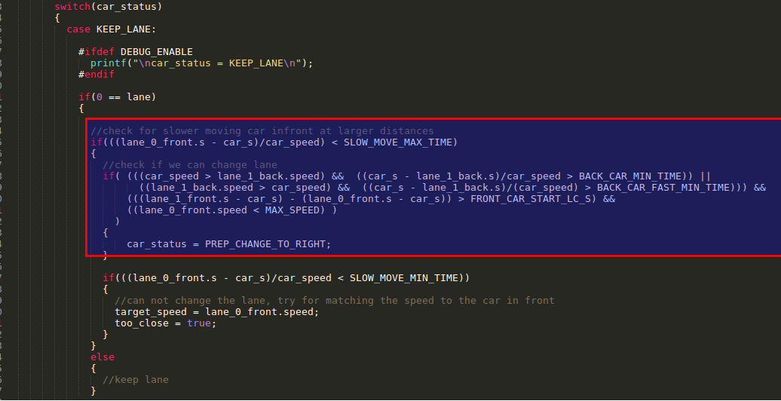

* The following *#define DEBUG_ENABLE 1*can be used to enable debugging that will show the sensor fusion data, the extracted surrounding cars and the status of my car along with status variables at the instance. Below is a typical screen-shot of the status:
* 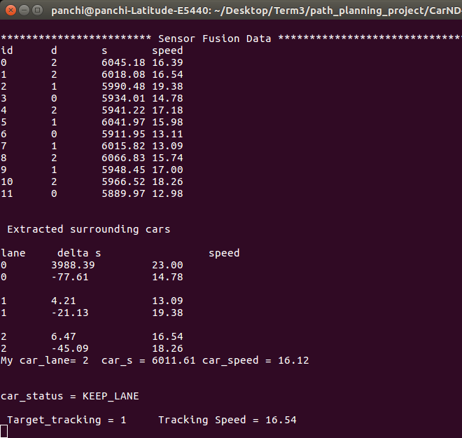The speed shown in the debug window is in m/s unit. The “delta s” is s value difference between my car and the surrounding cars of interest. When target tracking is active, the car is following the speed of the front vehicle since the car is unable to overtake.
* Screen of the car driving successfully for round the complete track without incidents:

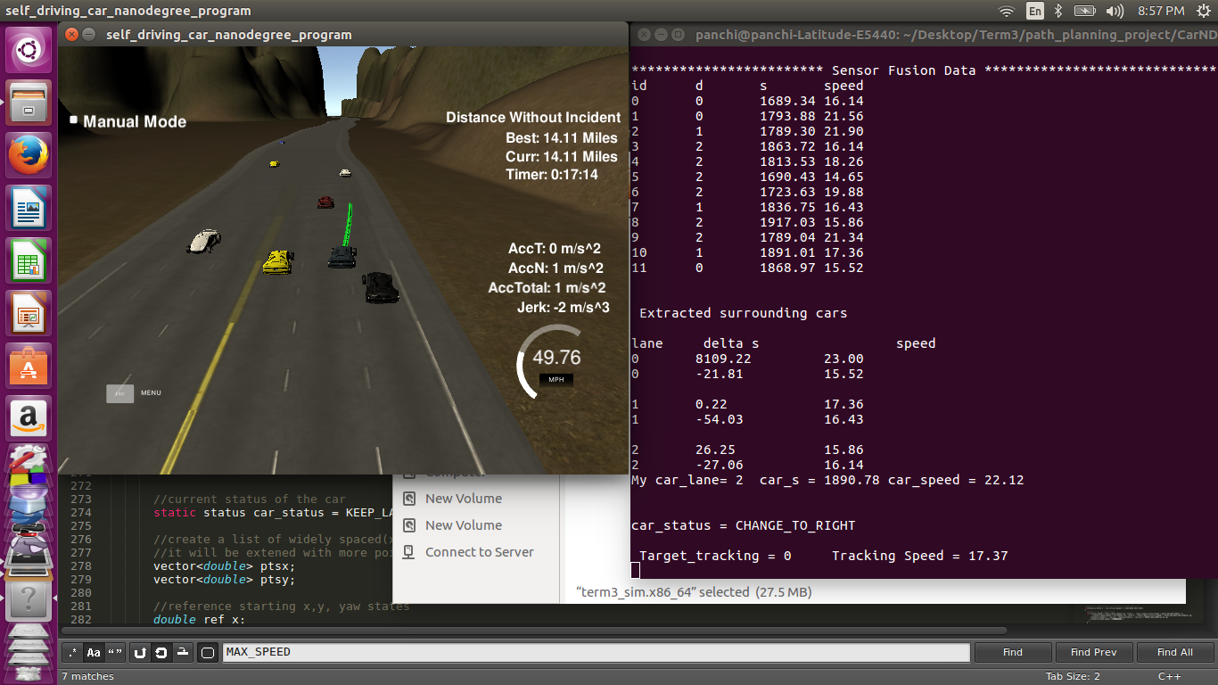

* Scope of the future improvements possible:
  + The path extrapolated from the cars of interest from sensor fusion data can be used to better predict and plan the path for my car.
  + Safe overtaking is enforced through the choice of parameters choosen, however parameters can be further optimized.
  + The efficiency of behavior of my car can be further enhanced by considering additional car states than the currently chosen simple 5 states.
  + For evaluating lane change or keep lane decisions, more quantitative cost functions can be used instead of simple logical conditions.