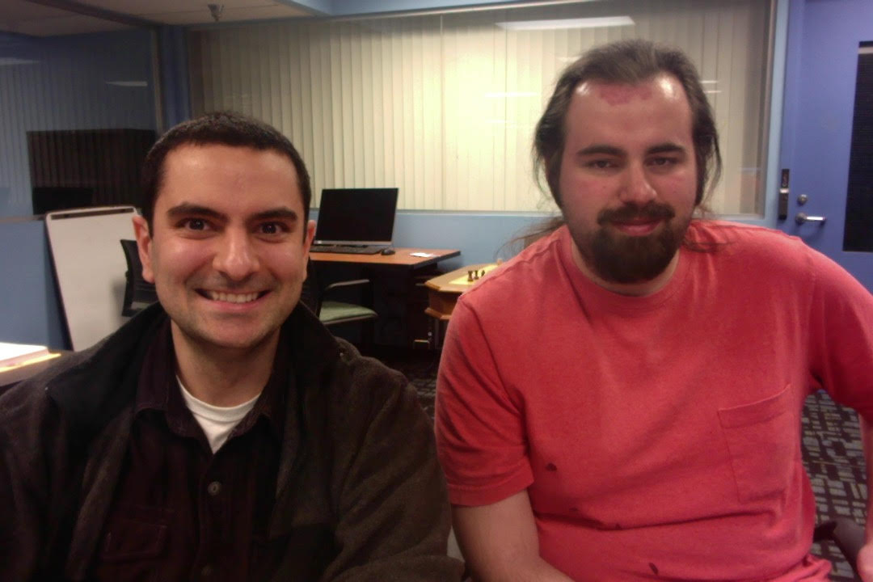

Assignment: Project#03
Name: Christen Ford/Daniel Izadnegahdar
Csu Id#: 2741896/2420596
Turnin Id#: 2741896(chford)
Turnin Date: 04/07/20

- Summary:
  - The purpose of this project is to design a client-server network system that can query a database. It will exercise C functions like TCP/UDP sockets, lseek, and lockf. The program is broken down into 3 files, the servicemap.c, server.c, and client.c files. Each of them are described in more detail in this report.

- Flow:
  - Description:
    - A TCP client-server connection model was used for this project. TCP is designed for applications that require high reliability at the cost of transmission speed. It allows data to arrive in the same order it was sent, handles congestion, and provides error checking.
    - A main part of the client-server model is socket programming. Socket programming is a way of connecting two nodes in a network by having one node listen to a port at an ip# address, while the other socket reaches out to the other to form a connection.
    - The key elements of the TCP network process is described below, as described during the 02/02/20 lecture. Their sequence is described under the diagram section.
  - Socket:
    - Prototype:
      - int socket(int domain, int type, int protocol);
    - Description:
      - Creates a socket, to initialize an endpoint referenced by the file descriptor returned.
  - Connect:
    - Prototype:
      - int connect(int sockfd, const struct sockaddr *addr, socklen_t addrlen);
    - Description:
      - Initiates a connection with the socket that is referenced by the file descriptor to the addr address.
  - Bind:
    - Prototype:
      - int bind(int sockfd, const struct sockaddr *addr, socklen_t addrlen);
    - Description:
      - Assigns the address from addr to the socket referenced by the file descriptor.
  - Listen:
    - Prototype:
      - int listen(int sockfd, int backlog);
    - Description:
      - sets the sockfd socket as passive, so it can accept incoming connection requests using the accept() function.
  - Accept:
    - Prototype:
      - int accept(int sockfd, struct sockaddr *addr, socklen_t *addrlen);
    - Description:
      - It accepts and processes the 1st request from the queue of connections. It returns a file descriptor of the newly connected socket.
  - Read:
    - Prototype:
      - ssize_t read(int fd, void *buf, size_t count);
    - Description:
      - Reads a message from the file descriptor, up to the count byte size.
  - Write:
    - Prototype:
      - ssize_t write(int fd, const void *buf, size_t count);
    - Description:
      - Writes a message to the buffer, starting at the buf pointer, and up to the count byte size.
  - Close:
    - Prototype:
      - int close(int fd);
    - Description:
      - Used to close a file descriptor.
  - Diagram:
Server:
Client:

socket()

socket()

bind()

connect()

listen()

handshake

accept()

Blocks from client
data request

read()
read()

data reply

write()

close()

read()

close()

- File servicemap.c:
  - Summary:
    - This file is used for initializing the server-client database program. After the server requests a local TCP port, and broadcast a registration message in UDP, this program will accept this message, determine the command, and return socket addresses to the client.
  - Code Description:
    - The program begins with a series of networking and socket libraries for connectivity reasons. This includes <sys/socket.h>, <netinet/ip.h>, and <arpa/inet.h>.
    - Next, the main() function starts by creating a socket() and binding(). The program will exception handle if either of those functions return less than 0. To convert the port#, the htons() function was used, because the unsigned short integer from the host needs to be converted to network byte order.
    - Next, the program listens for the incoming string from the UDP socket, and parses it into tokens. The 1st token is the command i.e. ‘PUT’ or ‘GET’, the 2nd token is the service name, and the 3rd token is the ip#/port# string. Once the command is received, a “received” confirmation is printed.
    - If the mapper receives a ‘PUT’, it will insert the service name, ip# address, and port# into an address table, and confirm success to the server.
    - If the mapper receives a ‘GET’, it will fetch the ip# and port# from the address table(provided a service name argument) and return this to the client.

- File server.c:
  - Summary:
    - This file is used to take client commands and run it against a database. To achieve this, it needs to make a connection with the client and fork a child process to handle the request. The child process will use lseek() to locate the position to rewrite, and lockf() to protect a critical region from updating simultaneously. The parent process will use a signal-catching routine to clean up child processes that have terminated.
    - A standard TCP server will follow the sequence of events described on the flow diagram of this report i.e. socket() → bind() → listen() → accept() → read() → write() → read() → close() and is structured similarly to the class Server_TCP.c example.
  - Code Description:
    - The program begins with a series of networking and socket libraries for network connectivity reasons.
    - Next, a series of structs are defined for the command messages and socket.
    - Next, it broadcasts the service to the mapper using a broadcast_service() function. In this function, it first creates a socket using socket() and enables broadcasting on it using setsockopt(). The port# is converted between host and network byte order using htons(), for the same reason described in the mapper section. Next, the socket is bound to the address using the bind() function, as described by the sequence in the flow diagram. The program will then run through a series of internet address mainpulation routines such as inet_addr() and inet_ntoa() because different address types have different formats. For example, linux lab broadcast address is 137.148.254.255, local in-home address is 192.168.0/1.255, and generic broadcast address is 255.255.255.255. It then sends the message to the socket using sendto(), and waits to receive the message using recvfrom(). Finally, the socket is closed.
    - Once the broadcast is done, the server is ready to read messages from the client, through a process of binding, listening, and accepting. The program will run through an infinite while loop, to continuously listen for signals from the client. If a message is accepted, it creates a new process using fork(). If the process is a child, it will read the message, process the command with the database, return the results to the client using the send() command, and exit with a success mode of 0. If the process is the parent, the remote_tcp_sk socket will close. If the process is anything else, an error is handled and the program exits with a failure mode of 1.
    - When the program is running the commands from the client, it will either run the query_db() or the update_db() function.
      - The query_db() function is similar to SELECT in SQL. It begins by calling open(), to bind the db20 binary database to a file descriptor. The descriptor is then read through, one byte at a time, to search for a match with the account# provided in the acctnum argument. If no match is found, query_db() returns -1.
      - The update_db() function is a data manipulation command similar to UPDATE in SQL. It begins by calling open(), to bind the db20 binary database to a file descriptor. If the account# is found, it will use lseek() to update the location of the pointer in the database data, and update the proper record. The lockf() function is used to protect the critical region from being updated by another concurrent query.
    - The print_db() function is used for printing the database results clearly to the user. It opens and reads the proper records, and uses the printf() command to display properties of the account.
    - Finally, there are a series of other helper functions for string manipulation, token extraction, and byte format conversion using quotient and remainder properties of division. The reason they are not included in their own helper file is to maintain the syntax of the provided turnin command. In an industrial application, these functions would live inside their own file to avoid code redundancy.

- File client.c:
  - Summary:
    - This file serves as user interface that communicates with the server to execute database commands, in this case, the ‘query’ and ‘update’ commands. The ‘query’ command will return the record for the person and has the following message structure: 1001(4-byte int)+acct num(4-byte int) in big-endian order. The ‘update’ command will change a person’s record in the database and has the following message structure: 1002(4-byte int)+a ct num(4-byte int)+amount(4-byte float) in big-endian order.
    - A standard TCP client will follow the sequence of events described on the flow diagram of this report i.e. socket() → connect() → write() → read() → close() and is structured similarly to the class Client_TCP.c example.
  - Code Description:
    - The program begins with a series of networking and socket libraries for network connectivity reasons.
    - in progress...

- File db20 description:
  - Summary:
    - this file is the provided database which contains data in binary format.
  - Code Description:
    - The data contains a series of the following struct record{int acctnum; char name[20]; float value; int age;};

- File makefile description:
  - Summary:
    - This file is used to make it easy to run complex commands by using a single term.
  - Code Description:
    - The file starts with a series of header macros and $() variables to maintain one source of truth.
    - The file then includes a series of commands for cleaning files, linking, compiling, and submitting. It contains 3 main commands: (1)make, (2)clean, (3)submit. The ‘make’ command will build the object and executable files. Running ‘clean’ will remove those files. Running ‘submit’ will run the turnin command to compress and send the project to the cis620 grading archive.

- Results:
  - Run instructions:
    - To run the program, open 3 terminals and ssh connect to 3 linux computers i.e. spirit, strauss, and rodin.
    - Browse to the location of the program and type ‘make’.
    - On the 1st terminal, type: ./servicemap.
    - On the 2nd terminal, type: ./server.
    - On the 3rd terminal, type ./client.
    - Still on the 3rd terminal, type the database command.

  - Run output:
    - run servicemap on spirit:
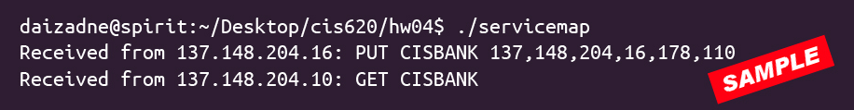
    - run server on strauss:

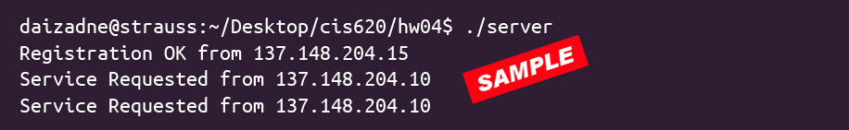
    - run client on rodin:

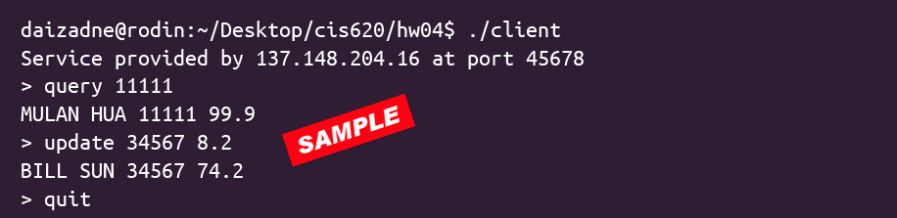
- Experiences in testing/debugging:
  - Error#01:
    - File:
      - server.c
    - Description:
      - host addresses in struct h_addr_list is not accepting provided input.
    - Solution:
      - The h_addr_list struct requires in_addr pointers instead, per the IBM documentation.
  - Error#02:
    - File:
      - in progress...
    - Description:
      - in progress...
    - Solution:
      - in progress...
  - Error#03:
    - File:
      - in progress...
    - Description:
      - in progress...
    - Solution:
      - in progress...

