Homework ACL Johan Martinson TIDAL-3

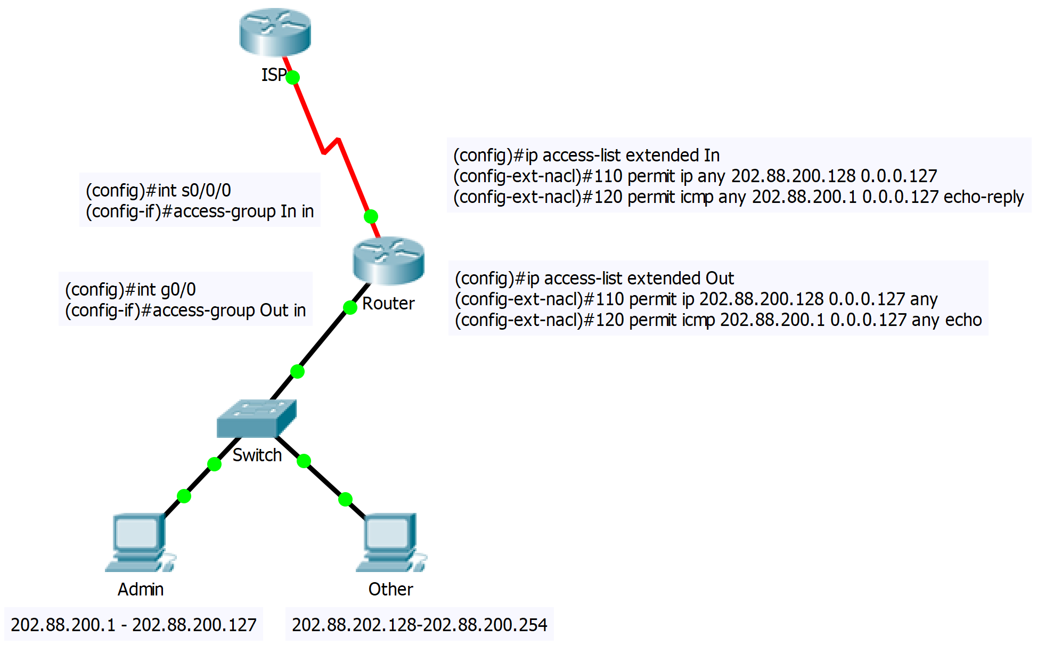All commands are done on router.

Comments:

I have called the ACLs in and out depending on which traffic they will permit i.e. in permits inbound traffic and out permits outbound traffic.

They are both configured inbound on the router because it would be unnecessary for the traffic went through the routing table just to be dropped after, it is better that it’s dropped immediately that will decrease the routers workload.