XRMC (X-ray Monte Carlo) version 6.4.3

TUTORIAL

Bruno Golosio, Tom Schoonjans, Antonio Brunetti, Giovanni Luca Masala, Piernicola Oliva
Università degli Studi di Sassari

Copyright & Disclaimer
© 2013 Bruno Golosio. This tutorial is part of the XRMC software package. XRMC is free software: you can redistribute it and/or modify it under the terms of the GNU General Public License as published by the Free Software Foundation, either version 3 of the License, or (at your option) any later version. This program is distributed in the hope that it will be useful, but WITHOUT ANY WARRANTY; without even the implied warranty of MERCHANTABILITY or FITNESS FOR A PARTICULAR PURPOSE. See the GNU General Public License for more details. You should have received a copy of the GNU General Public License along with this program. If not, see <http://www.gnu.org/licenses/>.

Table of Contents
XRMC (X-ray Monte Carlo) version 6.4.3 1
TUTORIAL 1
1 Installation 3

1.1 Requirements 3

1.2 Extracting the source 3

1.3 Building and installing the program 3

1.4 Platforms known to compile and run XRMC 5
2 Support 5
3 Bugs 5
4 Getting started 5
5 Using the program 6

5.1 The main input file 6

5.2 The device files 7

5.3 The spectrum file 7

5.4 The source file 10

5.5 The detector file 12

5.6 The composition file 15

5.7 The quadric array file 15

5.8 The three-dimensional object geometric description file 17

5.9 The sample file 18

5.10 The output file 19
6 Direction-dependent beam intensity and energy spectrum 20

6.1 The anisotropicsource and the intensityscreen devices 20

6.2 The beamsource and the beamscreen devices 21
7 Simulation of a realistic imaging detector response 23
8 Free-space propagation phase contrast imaging 25
9 Examples 26

9.1 Cylindrical shell 27

9.2 Star shape 1 28

9.3 Star shape 2 28

9.4 Different type of quadrics 28

9.5 A wheel shape 29

9.6 Objects with different compositions 29

9.7 X-ray fluorescence spectroscopy example 30

9.8 anisotropicsource/intensityscreen example 32

9.9 beamsource/beamscreen example 32

9.10 Free-propagation phase contrast imaging example 33
10 Bibliography 34

Installation

Requirements
The following requirements exist for building XRMC:
ANSI-C Compiler and Build System
Make sure you have an ANSI-C compiler installed. The GNU C compiler (GCC) from the Free Software Foundation (FSF) is recommended. If you don't have GCC then at least make sure your vendor's compiler is ANSI compliant. In addition, your PATH must contain basic build tools such as make.
xraylib (version >= 2.15.0)
To compile XRMC you need the xraylib shared library version >= 2.15.0 .
xraylib is a library of x-ray interaction parameters, freely available for several platforms at the following URL:

http://github.com/tschoonj/xraylib

Note that only the xraylib shared library is needed for XRMC installation. The command line tool and the bindings are not necessary, although they can be valuable tools for researchers working with x-rays.
This version of XRMC was tested with xraylib v2.16.0

Extracting the source
Extract the source using any program able to extract/uncompress tar.gz archives.
For instance, in Linux, Unix and Unix-like systems you can extract the source using the gzip utility, by typing the command:

gunzip -xvzf xrmc-x.x.x.tar.gz

where x.x.x refers to the version of the program that you are installing. This will create a new directory xrmc-x.x.x under the current directory containing the source code for the distribution.

Building and installing the program
There are two main methods of installing XRMC from source: system wide installation and personal installation. The former requires root privileges on most systems. Both ways are described below.

System wide installation
After unpacking the distribution, go to the directory "xrmc-x.x.x" (where x.x.x refers to the version of the program that you are installing) and type the command:

./configure

You can then build the program by typing,

make

To verify that the build went ok, use,

make check

The installation can be performed with the command

make install

The default installation directory prefix is /usr/local.
The installation directory can be changed with the --prefix option to configure. Consult the "Further information" section below for instructions on installing the library in another location or changing other default compilation options.
On some systems you might need to update the ldconfig cache by doing:

ldconfig

Try running XRMC:

xrmc

Personal installation
After unpacking the distribution, go to the directory "xrmc-x.x.x" (where x.x.x refers to the version of the program that you are installing) and type the command:

./configure --prefix=DIRNAME

where DIRNAME is the name of the directory where you want to install the binary executable and the libraries.
You can then build the program by typing,

make

To verify that the build went ok, use,

make check

The installation can be performed with the command

make install

This command will install the executable in the subdirectory bin/ of the installation directory, and the libraries in the subdirectory lib/
You should add the subdirectories bin/ and /lib to the PATH and to the LD_LIBRARY_PATH environmental variables, respectively.
For instance, if you use the bash shell you can add the following lines to the file .bashrc (or bashrc_private if you use it) in your home directory:

export PATH=${PATH}:DIRNAME/bin:
export LD_LIBRARY_PATH=${LD_LIBRARY_PATH}:DIRNAME/lib:

If you use the tcsh shell you can add the following lines to the file .cshrc
(or cshrc_private if you use it) in your home directory:
setenv PATH ${PATH}:DIRNAME/bin:
setenv LD_LIBRARY_PATH ${LD_LIBRARY_PATH}:DIRNAME/lib:

Try running XRMC:

xrmc

Platforms known to compile and run XRMC
Linux (32-bit/64-bit)
Mac OS X (32-bit/64-bit)
Windows (native and Cygwin)

In principle, it should be possible to compile and run XRMC in any platform that supports the xraylib library. See the section "Platforms known to compile and run xraylib" in the INSTALL documentation file of xraylib for further information.

Support
Sorry, we don't give any kind of support to XRMC users besides this tutorial, mainly because we lack human resources for doing it. You can use the program freely if you find it useful, however please don't write us emails asking for help with your simulations, or asking for explanations if they do not give the results that you expect.

Bugs
For sure there are bugs in XRMC. In every new version of the code we try fix bugs from previous versions. If you find a bug, your feedback will be greatly appreciated. However, bugs should be reported in a proper way. If you believe that there is a bug in the program, please try to insulate it, reducing your setup to the minimum one that presents such problem, and send your bug report together with the configuration files to golosio@uniss.it .

Getting started
This section contains some basic advises for new XRMC users.
- It can be useful to start working with existing examples, which are described in section 6. You can choose the example that is more similar to the experimental conditions that you want to simulate. First, run the example as it is and display the results of the simulation. Then you can try to modify the example to make it closer to the setup that you want to simulate. It is better that you modify one device file at a time, so that in case something does not work as you want you know where is the problem.
- The current version of XRMC does not include tools to visualize the experimental setup. However, you can use the program itself to visualize radiographic projections of the sample. Even if you want to run a simulation with a single element detector (for instance if you are simulating a spectroscopy measurement) it can be useful to define also a second source and an array detector, as those used in the imaging examples, loaded by a second input file, used only for visualization purpose. In this way you can check if the sample geometry looks correct.
- If the sample geometry does not look as you expect, try to visualize only one three-dimensional object at a time. You can do this easily by commenting all the lines corresponding to the other objects in the geom3d file, as described in section 5.8.
- When defining the geometric description of the sample, pay particular attention to XRMC limitations in three-dimensional objects definition, as outlined in section 5.8.
- At the beginning, run your simulations with a very small number of events, just to check that everything is working fine. Increase the number of events gradually to check that the output is reasonable before running very long simulations.

Using the program
Before running XRMC, you must prepare the input files that describe the experimental setup that you want to simulate. Those files include a main input file, a parameter file and some device files. The term device refers to a C++ object that is created to be used by the simulation and whose parameters are loaded from the corresponding file. It is not necessarily a physical device. For instance, the phase (material) array and the sample are considered to be devices. Each device file consists of a header that specifies the type and name of the device, a list of commands or variable names, and finally the “End” command. The order of commands/variable names is generally not important, unless they are part of the same group (for instance, the atomic number and weight percent of the elements in a material), as described in the following paragraphs. Each command/variable name can be followed by one or more arguments (real values, integer values or strings, depending on the command). Command/variable names need not to be in the same line. Comments can be inserted in all input files by preceding them by any of the following characters: ';', '!' or '#'. XRMC is case sensitive. Most commands and variable names in the input files follow the CamelCase convention, i.e. the first letter of each concatenated word is capitalized. The following paragraphs describe the commands that can be used in all device files used by the program. Although all variables have a default value, and therefore most commands are not mandatory, it is strongly recommended to explicitly assign a value to all variables in the input files.

The main input file
The main input file specifies the commands for loading all device files, the command for running the simulation and the command for saving the output in a file.
A device is created, and its parameters are loaded from a file, through the command:
Load filename
where filename is the name of the device file.
The typical setup for x-ray imaging/spectroscopy simulations include the following devices:
- a source (source device);
- a spectrum (spectrum device);
- a detector (detectorarray device);
- a sample (sample device);
- a phase (material) composition array (composition device);
- a quadric array (quadricarray device);
- a three-dimensional object geometric description (geom3d device).
The associated input files are described in the following sections.
The order of the “Load” commands is not relevant.
After such commands, the simulation can be started by the command
Run devicename
where devicename is the name of the device that controls the acquisition of the simulation results, i.e. in x-ray imaging/spectroscopy simulations the name of the detectorarray device, as specified in the header of the corresponding file.
Finally, the result of the simulation is saved by the command
Save devicename dataname filename
where devicename has the same meaning as described for the previous command, dataname is a name associated to the data that should be saved, and filename is the name of the file used to save the results. The allowed entries for dataname depend on the device; for the detectorarray device the only allowed entry for dataname is Image.

The device files
Every file for defining a new device has the following structure:

Newdevice device-type device-name ; New device file header
command/variable-name arguments
…
End

It is also possible to change the setup for an already-defined device, using the command

Device device-name

in place of the Newdevice command. The following sections describe the commands for the devices available in the current version of the program.

The spectrum file
The source spectrum is modeled as the sum of two components: a set of discrete lines and a continuous component. The radiation can be unpolarized, partially polarized or totally polarized. The lines can have a Gaussian or a Dirac δ distribution (the latter one being simply a particular case of Gaussian distribution with σ = 0). Each line is specified by its mean energy E_{l}, by its intensity I_{l} and by σ_{l}.
In case of (partially or totally) polarized radiation, the intensity of the two components polarized along the local x and y directions are specified separately for each line.
The continuous component is defined by N samples at arbitrary energies E₁, …., E_{N}, by specifying for each sample the corresponding height of the spectral distribution I₁, …., I_{N}. The height of the distribution in the interval between two consecutive energies of the sample E_{i}, E_{i+1} is approximated by a linear function of E that goes from I_{i} to I_{i+1}, therefore the spectrum in each interval between two consecutive samples has a trapezoidal shape. The area of the trapezium (E_{i+1} – E_{i})·(I_{i} + I_{i+1})/2 represents the intensity of the interval. In case of (partially or totally) polarized radiation, the height of the x and y components are specified separately for each sample of the continuous component.
There are two possible ways of extracting the initial energy of x-ray photons produced by the source:
- extract random energies on the whole spectrum: the photon initial energy is extracted using the whole spectrum itself as a probability distribution;
- loop on all lines and on all intervals of the spectrum: a loop is made on all lines and on all intervals of the spectrum; the initial energy of the photon is extracted according to the probability distribution limited to the single line or to the single interval; the event is assigned a weight proportional to the line/interval intensity.
The first is the traditional Monte Carlo approach. Lines or regions of the spectrum with lower intensity
are less represented in the generated statistic, no matter how important is the contribution that they give to the detected signal. There can be some drawback in this approach. For instance, if the spectrum has a relative low intensity at higher energies and if the sample is a strongly absorbing object, the statistic of events with higher energies will be low even though they give the most important contribution to the detected signal.
The second approach is closer to deterministic integration methods and should normally be preferred to the first one. All lines and all interval are equally represented in the generated statistic, and their relative probability is corrected by using the method of weighting the event.
If the second method is chosen, than for each interval of the continuous component there are two possible ways of extracting the photon energy:
- extract the energy randomly according to the probability distribution inside the interval itself (which is modeled by a linear function, as discussed previously);
- force the photon energy to be equal to the central energy of the interval.
The second method is the pure deterministic approach, and normally it should not be used.
The program offers the opportunity to resample the continuous component after its definition. In this case, the user must specify the starting energy, the energy step and the number of points used for the resampling. The intensities I_{i} are then recalculated for the new values of E_{i}. Normally this option will not be used, however it may be useful for variance reduction if the space between sampling energies in the continuous component definition is too large and a finer separation is desired or, in the opposite case, if the energy step in the initial definition of the spectrum is unnecessarily too small.

spectrum device file header:

Newdevice spectrum ; Device type
name (string) ; Device name

Commands:

PolarizedFlag val
specifies if the beam is polarized:
val = 0: unpolarized beam;
val = 1: polarized beam;

LoopFlag val
energy extraction method:
val = 0: extract random energies on the whole spectrum;
val = 1: loop on all lines and sampling points;

ContinuousPhotonNum val
val (integer): multiplicity of events for each interval in spectrum;

LinePhotonNum val
val (integer): multiplicity of events for each line in spectrum;

RandomEneFlag val
enable/disable random energy in each interval of the continuous spectrum;
val = 0: random energy disabled;
val = 1: random energy enabled (recommended);

Lines
specifies the discrete energy lines of the spectrum;
energies and σ are expressed in keV:
N_{l} (integer): Number of lines in the spectrum
E_{l} σ_{l} I_{l} (real values): energy, width (rms) and intensity of the 1st line
…..
E_{Nl} σ_{Nl} I_{Nl} (real values): energy, width (rms) and intensity of the N^{th} line
for polarized beam, or
E_{l} σ_{l} I_{x1} I_{y1} (real values):
energy, width (rms) and intensities of the two polarization components of the 1st line
…..
E_{Nl} σ_{Nl} I_{xNl} I_{yNl} (real values):
energy, width (rms) and intensities of the two polarization components of the N^{th} line

ContinuousSpectrumFile
continuous component of the spectrum;
N_{I} (integer): Number sampling points in the continuous spectrum
filename : name of the file containing the continuous spectrum;
in the case of unpolarized beam, the file has the following format:
E_{l} I_{l} (real values): energy and intensity of the 1st sampling point
…..
E_{NI} I_{NI} (real values): energy and intensity of the N^{th} sampling point;
while for polarized beam it has the following format:
E_{l} I_{x1} I_{y1} (real values):
energy and intensities of the two polarization components of the 1st sampling point
…..
E_{NI} I_{xNI} I_{yNI} (real values):
energy and intensityies of the two polarization components of the N^{th} sampling point;

ContinuousSpectrum
same as ContinuousSpectrumFile, but the spectrum is loaded inline rather than from an external file. Clearly, the filename parameter is not used in this case

Resample val
val = 0: do not resample continuous spectrum;
val = 1: resample continuous component of the spectrum;
If val = 1, the following arguments must also be provided:
N_{R} (integer): number of resampling points;
E_{min} (real): minimum resampling energy (keV);
E_{max} (real): maximum resampling energy (keV);

End
End of file.

The total number of generated events is given by the product of the multiplicities in the spectrum, in the interactions with the sample and in the detector pixels.

j_{d}
j_{s}
i_{d}

k_{d}
r_{s}
r_{d}
k_{s}
Sample
Source
photon
i_{s}

Detector

Figure 1. The standard experimental setup simulated by XRMC consists of a x-ray source, a sample and a detector (two-dimensional array or single element). A local coordinate system is attached to the source and to the detector. r_{s} and r_{d} are the position vector of the source and of the detector geometric center, respectively. i_{s}, j_{s} and k_{s} are the directions of the source local x, y, and z axis, respectively. i_{d}, j_{d} and k_{d} are the directions of the detector local x, y, and z axis, respectively. The detector local z axis is perpendicular to the detector surface, while the local x and y axes are parallel to the detector rows and columns, respectively.

The source file
The current version of the code assumes that the x-ray beam is produced by a point source or by an extended source with a three-dimensional Gaussian distribution. A local coordinate system is associated to the source, specified by the vector position of the origin r_{s} and by the orthonormal unit vectors i_{s}, j_{s} and k_{s} (see Fig. 1), which are the directions of the local x, y, and z axis, respectively. The local z axis represents the main source direction, while the local x and y axes are used to define the beam polarization and angular aperture. Let θ_{s} and φ_{s} be the polar and azimuthal angle, respectively, relative to the source coordinate system. The user can specify the angular apertures θ_{x} and θ_{y} in the x and in the y direction, respectively. In general, the angular aperture of the source is elliptical and it is defined by the inequality:

θ² ≤ θ_{x}²cos²φ_{s} + θ_{y}²sin²φ_{s}

The source intensity distribution is assumed to be uniform within the solid angle limited by this angular aperture.

source device file header:

Newdevice source ; Device type
name (string) ; Device name

Commands:

SpectrumName name
name (string): spectrum input device name;

X val1 val2 val3
val1, val2, val3 (real values) source x, y, z coordinates

uk val1 val2 val3
source orientation: k_{s} components (local z axis direction, i.e. main source direction);
val1 val2 val3 (real values): k_{sx}, k_{sy}, k_{sz}

ui val1 val2 val3
source orientation: i_{s} components (local x axis direction);
val1 val2 val3 (real values): i_{sx}, i_{sy}, i_{sz}

Divergence val1 val2
beam divergence:
val1 val2 (real values): θ_{x} , θ_{y}

Size val1 val2 val3
Source size; the source is modeled as a three-dimensional Gaussian distribution:
val1 val2 val3 (real values) σ_{x}, σ_{y}, σ_{z} ;

Rotate val1 val2 val3 val4 val5 val6 val7
rotation of the source around the axis passing through x₀ and with direction u :
val1 val2 val3 (real values): x₀, y₀, z₀ ;
val4 val5 val6 (real values): u_{x}, u_{y}, u_{z} ;
val7 (real) rotation angle θ (degrees);

End
End of file.

If i_{s} is not perpendicular to k_{s} , then the program replace it by a vector on the same common plane, but perpendicular to k_{s}. If k_{s} or i_{s} are not unit vectors then they are normalized by the program. The vector j_{s} is computed by the program, so that i_{s} , j_{s} , k_{s} are orthonormal unit vectors.

The detector file
In general, the program can simulate two-dimensional array detectors with energy binning for each pixel. A single element detector can be simulated as a special case of array detector with only one pixel. The pixel shape can be defined as rectangular or elliptical. The latter possibility is particularly useful when a round, single element detector has to be simulated.
A local coordinate system is associated to the detector, specified by the vector position of its geometric center r_{d} and by the orthonormal unit vectors i_{d}, j_{d} and k_{d} (see Fig. 1), which are the directions of the local x, y, and z axis, respectively. The local z axis is perpendicular to the detector surface, while the local x and y axes are parallel to the detector rows and columns, respectively.
According to a variance reduction technique used in the code, each event is forced to end with a photon that reaches a pixel of the detector (and its weight is multiplied by a proper probability factor). The intersection between the last photon trajectory and the pixel can be a random position on the pixel surface, or it can be forced to be the midpoint of the pixel. The latter method is a pure deterministic approach, and normally it should not be used.
The user has the possibility to simulate a statistical uncertainty on pixel counts based on Poisson statistic. In the traditional Monte Carlo approach the number of photons detected by each channel of each pixel is always an integer number. Using variance reduction techniques the events are weighted, therefore the estimated number of detected photons is a real number. However it is possible to round it to the closest integer number.
The weight associated to the probability that the last photon of an event reaches a detector pixel is proportional to a geometric efficiency factor ε_{geom}, which is related to the solid angle from the interaction point to the pixel surface. If the last interaction occurs at a distance from the pixel that is comparable or smaller than the pixel size, ε_{Ω} can become very large. In order to avoid spikes in the signal on single pixels, it is useful to set a cut on ε_{Ω} . By default, this cut is set to 2π.
Two acquisition modalities are possible:
- fluence: each channel simply counts the number of photons that it detects;
- energy fluence: each channel sums up the energy of the photons that it detects
The energy response of the detector can eventually be taken into account by using the first modality with a sufficient number of energy bins and by a proper postprocessing of the acquisition.

detectorarray device file header:

Newdevice detectorarray ; Device type
name (string) ; Device name

Commands:

SourceName name
name (string): source input device name;

NPixels val1 val2
pixel number (N_{x} × N_{y});
val1, val2 (integer values): number of columns (N_{x}) and rows (N_{y});

PixelSize val1 val2
pixel size (L_{x} × L_{y} , cm);
val1, val2 (real values): rectangle sides (L_{x} , L_{y});

Shape val
pixel shape:
val = 0 : rectangular;
val = 1 : elliptical;

dOmegaLim val
cut on ε_{Ω} (if this entry is 0, then ε_{Ω} is set to the default value 2π);
val (real) ε_{Ω};

X val1 val2 val3
val1, val2, val3 (real values) detector geometric center coordinates x, y, z;

uk val1 val2 val3
orientation: k_{d} components (local z axis direction, i.e. normal to the detector surface);
val1 val2 val3 (real values): k_{dx}, k_{dy}, k_{dz}

ui val1 val2 val3
detector orientation: i_{d} components (local x axis direction);
val1 val2 val3 (real values): i_{dx}, i_{dy}, i_{dz}

ExpTime val
val (real value): exposure time (seconds)

PhotonNum val
val (integer): multiplicity of simulated events per pixel;

RandomPixelFlag val
val (integer): enable random point on pixels (0/1)

PoissonFlag val
val (integer): enable Poisson statistic on pixel counts (0/1)

RoundFlag val
val (integer): round pixel counts to integer (0/1)

HeaderFlag val
val (integer): use header in output file (0/1)

AsciiFlag val
val (integer): use binary or ascii output file format (0/1)

Rotate val1 val2 val3 val4 val5 val6 val7
rotation of the detector around the axis passing through x₀ and with direction u :
val1 val2 val3 (real values): x₀, y₀, z₀ ;
val4 val5 val6 (real values): u_{x}, u_{y}, u_{z} ;
val7 (real) rotation angle θ (degrees);

PixelType val
Pixel content type:
val (integer): 0, 1, 2 or 3;
0: fluence;
1: energy fluence;
2: fluence with energy binning;
3: energy fluence with energy binning;

Only if energy binning is used, i.e. if pixel content type is 2 or 3:

Emin val
val (real): minimum binning energy;

Emax val
val (real): maximum binning energy;

NBins val
val (integer): number of energy bins;

SaturateEmin val
val (integer): saturate energies lower than Emin (0/1)

SaturateEmax val
val (integer): saturate energies greater than Emax (0/1)

End
End of file.

If i_{d} is not perpendicular to k_{d} , then the program replace it by a vector on the same common plane perpendicular to k_{d} ; if k_{d} or i_{d} are not unit vectors then they are normalized by the program; the vector j_{d} is computed by the program, so that i_{d} , j_{d} , k_{d} are orthonormal unit vectors;

The composition file
The materials that compose the sample are called phases. A composition file is used to list all the phases and to characterize them by their mass density and by their elemental composition, i.e. the atomic numbers and weight fractions of the atomic species that compose them. Each phase is assumed to be homogeneous. Phases are referred to by their user-defined names. There is a predefined phase named “Vacuum” with mass density equal to zero and no elements. This is the phase that fill the “universe”. If the user wants to simulate an experiment in a different medium (e.g. in air) he should first define it. However, only a finite region of space can be filled by a phase different from vacuum.

composition file header:

Newdevice composition ; Device type
name (string) ; Device name

Commands:

Phase name
name (string): material name; define a new material;
NElem val
val (integer): number of atomic species N_{e} in the phase;
Z₁ w₁ (integer, real): atomic number and weight percent of 1st element;
…..
Z_{Ne} w_{Ne} (integer, real): atomic number and weight percent of N^{th} element;

Rho val
val (real): mass density of the phase (g/cm³);

End
End of file.

The quadric array file
The sample geometry is described through a set of quadrics, which are used to define the surfaces of solid objects. A quadric is a surface in the three-dimensional space defined as the locus of zeros of a quadratic polynomial. The general quadric is defined by the algebraic equation:

.

If we define, then the general quadric may be compactly written in vector and matrix notation as

where is a row vector, is the transpose of (a column vector) and A is a 4×4 matrix with for , and .
The matrix A must be symmetric, thus .
A quadric divides the space in two regions, one with , the other with .
We will call those two regions space outside the quadric (or external space) and space inside the quadric (or internal space), respectively, no matter whether the quadric is closed or not.
Whenever a unit vector normal to the quadric surface has to be defined, by default we will assume that is is oriented toward the external space. Examples of quadrics are planes, ellipsoids, cylinders.

quadricarray file header:

Newdevice quadricarray ; Device type
name (string) ; Device name

Commands:

- Quadric A₀₀ A₀₁ A₀₂ A₀₃ A₁₁ A₁₂ A₁₃ A₂₂ A₂₃ A₃₃
Generic quadric defined by its elements' contents. Since the matrix has to be symmetric, only 10 elements are used.

- Plane x₀ y₀ z₀ u_{x} u_{y} u_{z}
Plane containing the point (x₀ , y₀ , z₀ ) with normal vector (u_{x} , u_{y} , u_{z}).

- Ellipsoid x₀ y₀ z₀ R_{x} R_{y} R_{z}
Ellipsoid with principal axis parallel to the main axis, centered in (x₀ , y₀ , z₀ ) and with semi-axes R_{x}, R_{y}, R_{z} .

- CylinderX y z R_{y} R_{z}
Cylinder having the main axis parallel to the x axis with coordinates y, z on the yz plane, and having elliptical section with semi-axes R_{y}, R_{z} .

- CylinderY x z R_{x} R_{z}
Cylinder having the main axis parallel to the y axis with coordinates x, z on the xz plane, and having elliptical section with semi-axes R_{x}, R_{z} .

- CylinderZ x y R_{x} R_{y}
Cylinder with the main axis parallel to the z axis with coordinates x, y on the xy plane, and having elliptical section with semi-axes R_{x}, R_{z} .

- Translate Δx Δy Δz
Translate the position of the last defined quadric by (Δx, Δy, Δz).

- Rotate x₀ y₀ z₀ u_{x} u_{y} u_{z} θ
Rotate the last defined quadric around the axis passing through the point (x₀ , y₀ , z₀ ) and directed as (u_{x} , u_{y} , u_{z}) by an angle θ (expressed in degrees).

- TranslateAll Δx Δy Δz
Translate the position of all previously defined quadrics by (Δx, Δy, Δz).

- RotateAll x₀ y₀ z₀ u_{x} u_{y} u_{z} θ
Rotate all previously defined quadrics around the axis passing through the point (x₀ , y₀ , z₀ ) and directed as (u_{x} , u_{y} , u_{z}) by an angle θ (expressed in degrees).

- End
End of file.

The three-dimensional object geometric description file
A solid object is defined as a solid shape delimited by a set of quadric surfaces that separates the space inside from the space outside it. The quadrics delimiting an object must be properly oriented, in such a way that their normal vectors are directed outward with respect to the object itself.
- Only convex objects are allowed in XRMC. Non-convex shapes can be built by combining convex objects. The demo files show some examples of how to build non-convex shapes.
- The surfaces delimiting different objects can not be in contact with each other. The users have to pay particular attention to this point, because the code does not make any check on it. If the user wants two objects to be in contact with each other (for instance when building non-convex shapes by joining convex objects) a workaround is to separate them using two different quadrics, very close to each other but separated by a small gap, in such a way that the effect of the intermediate space on the radiation is negligible. The demo files show some examples of this trick.
- An object may contain other objects, or it may be contained in another object, as far as their delimiting surfaces are not in contact.
All objects must be contained in a finite region of space, called sample region.

geom3d device file header:

Newdevice geom3d ; Device type
name (string) ; Device name

Commands:

QArrName name
name (string): quadricarray input device name;

CompName name
name (string): composition input device name;

Object name
name (string): 3d object name; defines a new object;
phase-in-name
name of the phase (material) inside the object;
phase-out-name
name of the phase (material) surrounding the object;
N_{q}
number of quadrics that define the object surface;
quadric-name-1 quadric-name-2 ….. quadric-name-N_{q}
names of the quadrics that define the object surface;

End
End of file.

The sample file
When a photon exits from the source or when it is produced by a scattering/fluorescence emission process, its trajectory is characterized by its position vector r_{ph} and by its direction vector u_{ph}. The program evaluates the intersection of this trajectory with the quadric surfaces delimiting the objects, and divide it in N_{s} steps with uniform phases. Each step is a segment of the trajectory delimited by its intersection with different objects. There are two possible modalities of extracting the next interaction position:
- extract the interaction position according to the interaction probability distribution along the trajectory, which is evaluated from the linear absorption coefficient of the phases and from the steplengths of the paths;
- extract a step at random using a random integer number 0≤m<N_{s} , Extract a random position on step m using a uniform probability distribution, and multiply the weight associated to the event by a proper factor;
The first modality is that of the traditional Monte Carlo approach. The second one is sometimes used for variance reduction. It can be useful, for instance, when an object that emits a relevant fluorescence signal is surrounded by a strongly absorbing material, so that the probability that the incident radiation reaches such object is relatively low.

sample device file header:

Newdevice sample ; Device type
name (string) ; Device name

Commands:

SourceName name
name (string): source input device name;

Geom3DName name
name (string): geom3d input device name;

CompName name
name (string): composition input device name;

WeightedStepLength val
modality that will be used for the extraction of the next interaction position:
val = 0: method 1) described above;
val = 1: method 2) described above;

FluorFlag val
activate Fluorescence (0/1); it can be useful to deactivate it in imaging experiments where fluorescent emission is not relevant, to save computational time;

ScattOrderNum N_{I}
N_{I} (integer): maximum scattering order (0: transmission, 1: first order scattering or fluorescence emission, 2: second order scattering or fluorescence emission, …)
M₁
multiplicity of simulated events for order 0;
…..
M_{NI}
multiplicity of simulated events for order N_{I} ;

End
End of file.

As discussed previously, the total number of generated events is given by the product of the multiplicities in the spectrum, in the interactions with the sample and in the detector pixels.

The output file
By default, the output file is saved in raw binary format. The detector bin contents are written in C double format (64 bit real). If you prefer to save the data in ascii format, you can use the AsciiFlag command, which is described in the detectorarray file section.
The total number of entries is:
N. of scattering orders × N. of energy bins × N. of columns × N. of rows
with the rows running faster.
If the header flag is set to 1 in the detector file, then the bin contents are preceded by a 60-bytes-long header, also in binary format, containing the following information:
- N. of scattering orders (C int format, 32 bit integer)
- N. of columns (C int format, 32 bit integer)
- N. of rows (C int format, 32 bit integer)
- Pixel size Sx (C double format, 64 bit real)
- Pixel size Sy (C double format, 64 bit real)
- Exposure time in sec. (C double format, 64 bit real)
- Pixel content type (C int format, 32 bit integer)
- N. of energy bins (C int format, 32 bit integer)
- Minimum bin energy (C double format, 64 bit real)
- Maximum bin energy (C double format, 64 bit real)

Direction-dependent beam intensity and energy spectrum
This paragraphs describes special devices used to define a beam with direction-dependent intensity and/or spectrum.

The anisotropicsource and the intensityscreen devices
The anisotropicsource and the intensityscreen devices are used to describe a source with intensity that depends on the emission direction. Note that for those devices the energy spectrum does not depend on the direction: if the user wants that not only the intensity, but also the spectrum depends on the direction, he should rather use the beamsource-beamscreen devices, described in the following section.
The anisotropicsource input file has exactly the same format as the source file, the only differences being the device type, specified after the Newdevice command, and an additional input device, of type intensityscreen.

anisotropicsource device file header:
Newdevice anisotropicsource ; Device type
name (string) ; Device name

Additional command:
IntensityScreenName name
name (string): intensityscreen input device name;

The intensityscreen device represents the beam intensity distribution on an ideal screen, located in an arbitrary position and with arbitrary orientation. The ideal screen is divided in pixels. The intensity distribution is defined by specifying the number of x-ray photons per seconds impinging on each pixel.

intensityscreen device file header:

Newdevice intensityscreen ; Device type
name (string) ; Device name

Commands:

NPixels val1 val2
pixel number (N_{x} × N_{y});
val1, val2 (integer values): number of columns (N_{x}) and rows (N_{y});

PixelSize val1 val2
pixel size (L_{x} × L_{y} , cm);
val1, val2 (real values): rectangle sides (L_{x} , L_{y});

X val1 val2 val3
val1, val2, val3 (real values) screen geometric center coordinates x, y, z;

uk val1 val2 val3
orientation: k_{d} components (local z axis direction, i.e. normal to the screen surface);
val1 val2 val3 (real values): k_{dx}, k_{dy}, k_{dz}

ui val1 val2 val3
screen orientation: i_{d} components (local x axis direction);
val1 val2 val3 (real values): i_{dx}, i_{dy}, i_{dz}

InterpolFlag val
val (integer): use interpolation inside pixels (0/1)

ImageFile filename
filename (string) name of the file containing the intensity distribution on the screen pixels. The file should contain N_{x} × N_{y} entries (one for each pixel) stored in C double format (64 bit real) with the x-running-faster ordering scheme.

Rotate val1 val2 val3 val4 val5 val6 val7
rotation of the screen around the axis passing through x₀ and with direction u :
val1 val2 val3 (real values): x₀, y₀, z₀ ;
val4 val5 val6 (real values): u_{x}, u_{y}, u_{z} ;
val7 (real) rotation angle θ (degrees);

The beamsource and the beamscreen devices
The beamsource and the beamscreen devices are used to describe a source with both the intensity and the energy spectrum that depends on the emission direction.
The beamsource input file has exactly the same format as the source file, the only differences being the device type, specified after the Newdevice command, and the input device, which is of type beamscreen instead of spectrum.

beamsource device file header:
Newdevice beamsource ; Device type
name (string) ; Device name

Input device command (replaces the SpectrumName command used in the source device):
BeamScreenName name
name (string): beamscreen input device name;

The beamscreen device represents the direction-dependent beam intensity and energy spectrum on an ideal screen, located in an arbitrary position and with arbitrary orientation. The ideal screen is divided in pixels and energy bins. The intensity distribution and the spectrum are defined by specifying, for each pixel and energy bin, the number of x-ray photons per seconds impinging on that pixel with energy inside that bin.

beamscreen device file header:

Newdevice beamscreen ; Device type
name (string) ; Device name

Commands:

NPixels val1 val2
pixel number (N_{x} × N_{y});
val1, val2 (integer values): number of columns (N_{x}) and rows (N_{y});

PixelSize val1 val2
pixel size (L_{x} × L_{y} , cm);
val1, val2 (real values): rectangle sides (L_{x} , L_{y});

X val1 val2 val3
val1, val2, val3 (real values) screen geometric center coordinates x, y, z;

uk val1 val2 val3
orientation: k_{d} components (local z axis direction, i.e. normal to the screen surface);
val1 val2 val3 (real values): k_{dx}, k_{dy}, k_{dz}

ui val1 val2 val3
screen orientation: i_{d} components (local x axis direction);
val1 val2 val3 (real values): i_{dx}, i_{dy}, i_{dz}

InterpolFlag val
val (integer): use interpolation inside pixels (0/1)

PolarizedFlag val
val (integer): unpolarized/polarized beam flag (0/1)

LoopFlag val
energy extraction method:
val = 0: extract random energies on the whole spectrum;
val = 1: loop on all energi bins;

PhotonNum val
val (integer): multiplicity of events for each energy bin;

Emin val
val (real): minimum binning energy;

Emax val
val (real): maximum binning energy;

NBins val
val (integer): number of energy bins;
ImageFile filename
filename (string) name of the file containing the intensity/energy spectrum distribution on the screen pixels/bins. For unpolarized beam, the file should contain N_{bins} × N_{y} × N_{x} entries (one for each pixel) stored in C double format (64 bit real) with the x-running-faster ordering scheme. For polarized beam, the file should contain 2 × N_{bins} × N_{y} × N_{x} entries, with the x-polarized component in the first half and the y-polarized component in the second half of the file.

Rotate val1 val2 val3 val4 val5 val6 val7
rotation of the screen around the axis passing through x₀ and with direction u :
val1 val2 val3 (real values): x₀, y₀, z₀ ;
val4 val5 val6 (real values): u_{x}, u_{y}, u_{z} ;
val7 (real) rotation angle θ (degrees);

Simulation of a realistic imaging detector response
A realistic imaging detector response can be simulated by issuing additional commands in the detectorarray input file. Such commands are used to define the detector point spread function (PSF), the source size and the detector efficiency versus energy.
The x/y projections of the detector PSF and of the source size are modeled by the superposition of one or more Gaussian functions. Those function can be fixed (not dependent on energy) or energy dependent. In the latter case, the parameters of all Gaussians (height, mean, sigma) for each energy bin are loaded from a separate file.

Additional commands:

ConvolveFlag val
val (integer): Generates convoluted image (0/1);

Z12 val
val (double): Distance between object plane and detector, used to take into account source size in detector image convolution;

EfficiencyFlag val
val (integer): flag for using efficiency versus energy before convolution (0/1);
to use it, ConvolveFlag MUST also be activated.

EfficiencyFile filename: name of the input file holding the efficiency;
file format (ascii):
ε₁ ; efficiency for the first energy bin
….
ε_{Nbins} ; efficiency for the last energy bin

GaussPSFx N
Gaussian model of detector PSF (x component):
superposition of N Gaussian functions (N = 0 : disabled);
h₁ x₁ σ₁ : height, mean and standard deviation of the first Gaussian function;
….
h_{N} x_{N} σ_{Ν} : height, mean and standard deviation of the N-th Gaussian function;

GaussPSFy N
Gaussian model of detector PSF (y component):
superposition of N Gaussian functions (N = 0 : disabled);
h₁ x₁ σ₁ : height, mean and standard deviation of the first Gaussian function;
….
h_{N} x_{N} σ_{Ν} : height, mean and standard deviation of the N-th Gaussian function;

GaussPSFxBinFile N filename
Energy dependent Gaussian model of detector PSF (x component):
superposition of N Gaussian functions (N = 0 : disabled);
filename (string): name of the input file holding Gaussian function parameters;
input file format (ascii): 3N columns with height, mean and sigma of the N
Gaussian functions for each energy bin:
h₁ x₁ σ₁ h₂ x₂ σ₂ …. h_{N} x_{N} σ_{N} ; first energy bin
….
h₁ x₁ σ₁ h₂ x₂ σ₂ …. h_{N} x_{N} σ_{N} ; last energy bin

GaussPSFyBinFile N filename
Energy dependent Gaussian model of detector PSF (y component):
superposition of N Gaussian functions (N = 0 : disabled);
filename (string): name of the input file holding Gaussian function parameters;
input file format (ascii): 3N columns with height, mean and sigma of the N
Gaussian functions for each energy bin:
h₁ x₁ σ₁ h₂ x₂ σ₂ …. h_{N} x_{N} σ_{N} ; first energy bin
….
h₁ x₁ σ₁ h₂ x₂ σ₂ …. h_{N} x_{N} σ_{N} ; last energy bin

GaussSourceX N
Gaussian model of source x size:
superposition of N Gaussian functions (N = 0 : disabled);
h₁ x₁ σ₁ : height, mean and standard deviation of the first Gaussian function;
….
h_{N} x_{N} σ_{Ν} : height, mean and standard deviation of the N-th Gaussian function;

GaussSourceY N
Gaussian model of source y size:
superposition of N Gaussian functions (N = 0 : disabled);
h₁ x₁ σ₁ : height, mean and standard deviation of the first Gaussian function;
….
h_{N} x_{N} σ_{Ν} : height, mean and standard deviation of the N-th Gaussian function;

GaussSourceXBinFile N filename
Energy dependent Gaussian model of source x size:
superposition of N Gaussian functions (N = 0 : disabled);
filename (string): name of the input file holding Gaussian function parameters;
input file format (ascii): 3N columns with height, mean and sigma of the N
Gaussian functions for each energy bin:
h₁ x₁ σ₁ h₂ x₂ σ₂ …. h_{N} x_{N} σ_{N} ; first energy bin
….
h₁ x₁ σ₁ h₂ x₂ σ₂ …. h_{N} x_{N} σ_{N} ; last energy bin

GaussSourceYBinFile N filename
Energy dependent Gaussian model of source y size:
superposition of N Gaussian functions (N = 0 : disabled);
filename (string): name of the input file holding Gaussian function parameters;
input file format (ascii): 3N columns with height, mean and sigma of the N
Gaussian functions for each energy bin:
h₁ x₁ σ₁ h₂ x₂ σ₂ …. h_{N} x_{N} σ_{N} ; first energy bin
….
h₁ x₁ σ₁ h₂ x₂ σ₂ …. h_{N} x_{N} σ_{N} ; last energy bin

Free-space propagation phase contrast imaging
The x-ray phase contrast imaging techniques are based on the observation of interference patterns produced when an x-ray beam partially or totally coherent crosses an object characterized by variation in the real part of the refractive index with position. In a typical setup for this type of experiment, the radiation produced by a relatively small x-ray source acquires partial coherence during propagation in free space, crosses an object placed at relatively large distance from the source, and produces an image on an observation plane (screen).
The method used by XRMC for phase contrast imaging simulation is described in ref. [4]. Such method can be used for monochromatic as well as for polychromatic sources. Furthermore, while other methods are valid only in the approximation of relatively large source-object distance, the method used by XRMC is suitable also in the case of small source-object distance. On the other hand, the thin-sample approximation is used: assuming that the object is thin along the radiation propagation direction, the deviation of the x-ray paths inside the object from straight lines can be neglected.
Phase contrast imaging experiments can be simulated in XRMC by using the special device phcdetector, which inherits all the variable names and commands of the detectorarray device, but has additional commands specific for phase contrast imaging. All the devices that can be used for imaging experiments can also be used for phase contrast imaging, except for the detectorarray device, which is replaced by the phcdetector device.
Note: the detector pixel size L_{x} × L_{y} must satisfy the inequality:

L_{x} × L_{y} ≪ Z₁₂ × λ

where Z₁₂ is the object detector distance and λ is the radiation wavelength;

phcdetector device file header:

Newdevice phcdetector ; Device type
name (string) ; Device name

Additional commands:

Z12 val
val (double): Distance between object plane and detector;

NScreenBorder val1 val2
additional rows and columns at the top, bottom, left and right sides of the detector (NB_{x} × NB_{y});
val1, val2 (integer values): number of additional columns (NB_{x}) at the left and right sides, and additional rows (NB_{y}) at the top and bottom of the detector; the simulation is extended to those additional pixels in order to avoid discontinuities at the border in the simulated phase contrast image. If you are not sure of which values you should use, simply do not use this command, so that the default values will be used.

NInterpBorder val1 val2
additional rows and columns at the top, bottom, left and right sides of the detector, used for interpolation (NIB_{x} × NIB_{y});
val1, val2 (integer values): number of additional columns (NIB_{x}) at the left and right sides, and additional rows (NIB_{y}) at the top and bottom of the detector; those additional pixels are not included in the simulation, but they are used to interpolate the complex values of the transmission function from the border of the simulated image to the flat field values, to avoid discontinuities at the border in the simulated phase contrast image. If you are not sure of which values you should use, simply do not use this command, so that the default values will be used.

Examples
The examples can be found in the subdirectories of xrmc/examples. The examples are described by comments in the corresponding input files. To run an example, go to the corresponding subdirectory and type the command:
xrmc input.dat
At the end of the simulation, the output will be stored in the file image.dat (or output.dat for the fluor_layers example). The output of the examples are either images in raw binary format or measured spectra in ascii format. The raw binary images can be opened with any image visualization program able to import such format. For instance, the figures in this document have been produced using ImageJ, which is a public domain image processing program, freely available for several platforms. In case you want to open the output images of the examples using this program, select from the menu:
file → import → raw...
chose the image and use the following settings in the import form:
- Image type: 64-bit real;
- Width: N. of columns;
- Height: N. of rows;
- Offset to first image: 60 if the image contains the header, 0 otherwise;
- Number of images: N. of scattering orders (1 if only transmission was simulated);
- Little endian byte order: depends on the architecture of your system;
Example 7 represents the simulation of a x-ray fluorescence spectroscopy experiment. A simple program is provided with this example, in the same directory, to simulate a Silicon Drift detector response.

Cylindrical shell
Example 1: simulating a cylindrical shell using convex objects, directory cylind_shell.
To simulate a cylindrical shell using only convex objects, two objects have been used:
- An external full cylinder, delimited by two planes;
- An internal empty cylinder (the phase inside it is vacuum, phase index=0), delimited by other two planes very close to those of the external cylinder but separated from them by a small gap
Figure 2 shows the output image. Image size: 400 × 400

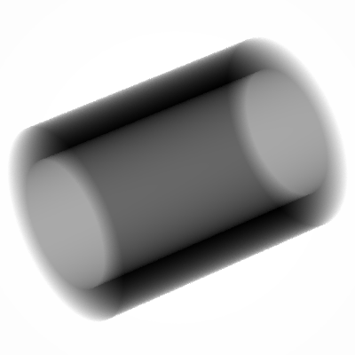
Figure 2 Example of simulation of radiographic images of a cylindrical shell This example is described by comments in the corresponding input files.

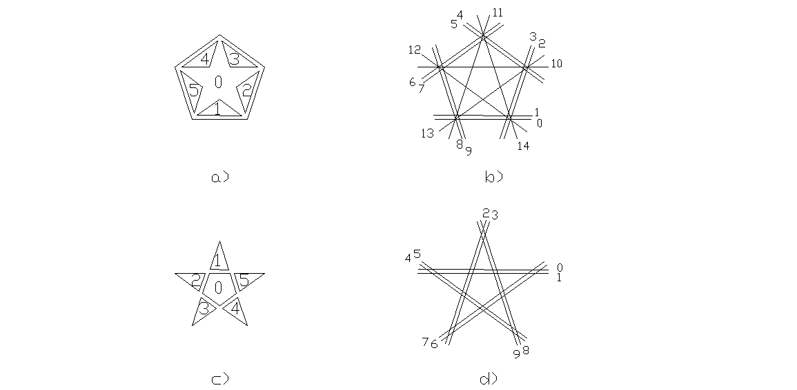
Figure 3 Schematic representations of two ways of building a star shape by combining convex objects. In the quadric definition files, the planes between adjacent objects are separated by a very small gap, however in this figure their separation is increased for clarity. (a) Geometrical objects used to compose the star shape described in example 2. (b) Planes used to define the geometrical object surfaces described in example 2. (c) Geometrical objects used to compose the star shape described in example 3. (d) Planes used to define the geometrical object surfaces described in example 3. All objects are delimited by two planes parallel to the figure plane. Those examples are described by comments in the corresponding input files.

Star shape 1
Example 2: one way of building a star shape by combining convex objects, directory star1.
Figure 3(a) shows the geometrical objects used to compose the star shape. The five triangles are separated from the inner pentagon by small gaps. The phase inside the triangles and that inside pentagon are the same. Figure 3(b) shows the planes used to define the geometrical object surfaces. All objects are delimited by two planes parallel to the figure plane.
Figure 4(a) shows the output image. Image size: 400 × 400

Star shape 2
Example 3: another way of building a star shape by combining convex objects, directory star2.
Figure 3(c) shows the geometrical objects used to compose the star shape. The five triangles are empty (i.e. the phase inside them is vacuum, phase index=0), and they are separated from the external pentagon by small gaps. Figure 3(d) shows the planes used to define the geometrical object surfaces. All objects are delimited by two planes parallel to the figure plane.

Different type of quadrics
Example 4: an image with different types of quadrics, directory quadrics.
Figure 4(b) shows the output image. Image size: 400 × 400

A wheel shape
Example 5: a wheel, directory wheel.
A wheel is built by combining different cylinders and using the rotation commands.
Figure 4(c) shows the output image. Image size: 400 × 400

Objects with different compositions
Example 6: cylinders with different compositions, directory materials.
Four cylinders having different compositions (polymethyl methacrylate, adipose tissue, water, bone-equivalent plastic) and placed inside a polymethyl-methacrylate frame are simulated.
Figure 4(d) shows the output image. Image size: 400 × 400

(a) (b)
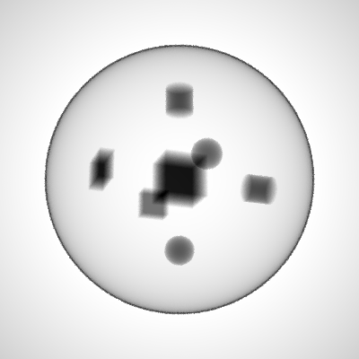

(c) (d)
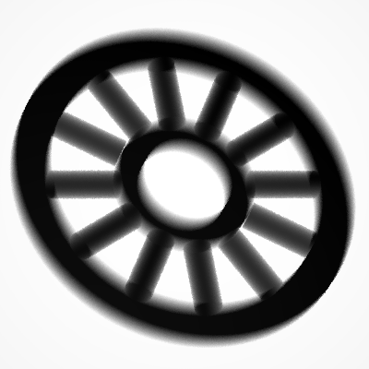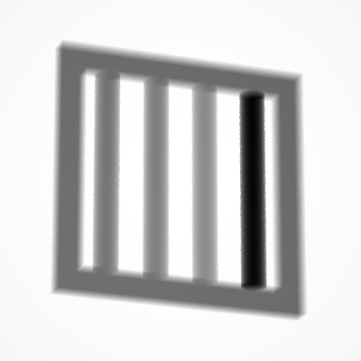

Figure 4 Example of simulation of radiographic images of different shapes: a star shape (a), a thin spherical shell containing different types of quadrics (b), a wheel (c) and four cylinders having different compositions and placed inside a frame (d). All the examples are described by comments in the corresponding input files.

X-ray fluorescence spectroscopy example
Example 7: x-ray fluorescence spectroscopy example, directory fluor_layers. Fig. 5 represents schematically the experimental setup. The source is an Ag-anode x-ray tube set to 40 kVp and 10 μA current. The source spectrum is polychromatic and it was measured experimentally. The beam was collimated through a 1 mm wide cylindrical collimator. The detector is a 25 mm² diameter Silicon drift detector (X-123SDD by Amptek) 500 mm thick. The sample is a parallelepiped made of the following three layers (ordered starting from the one closest to the source):
- a 200 μm thick mixture layer incrustation simulation;
- a 300 μm thick copper layer;
- a 2.5 mm thick mixture layer, similar to the first one.
The current version of XRMC does not include the simulation of the response of real detectors. The users must take care of this point by post-processing of the simulation output. For the example just described, a separate program is provided to simulate the response of a Silicon drift detector. This program can be found in the directory example/fluor_layers/src, A README file explains how to compile and run it. Figure 6 shows a comparison between the measured signal and the simulated one.

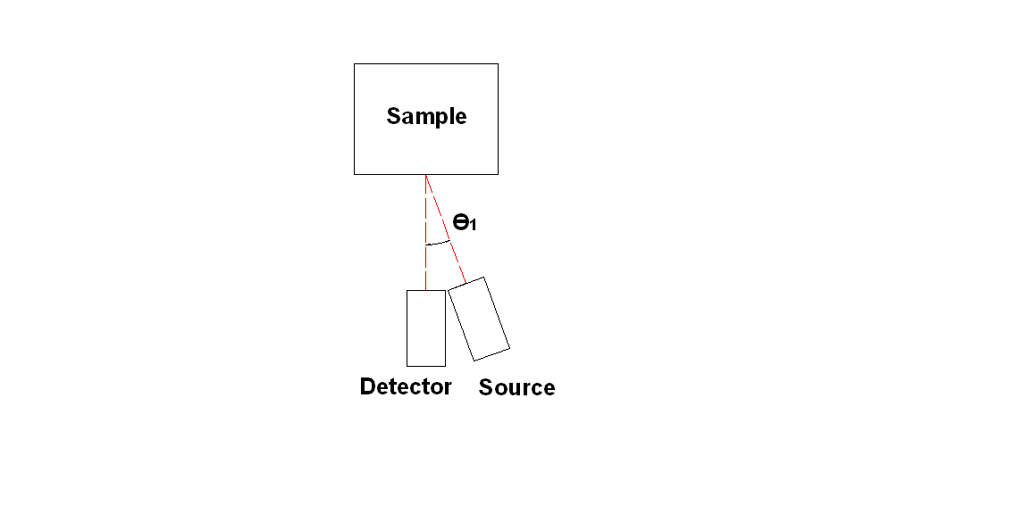
Figure 5 Schematic representation of the experimental setup for the fluorescence spectroscopy example.

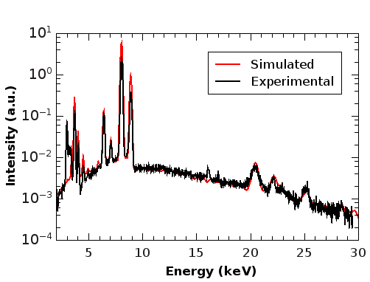

Figure 6 Comparison between simulated and measured signal for the fluorescence example.

anisotropicsource/intensityscreen example
Example 8: example of source with direction-dependent intensity, directory anisotropicsource. The simulated sample is the same as in the example 1. The program intensityscreen_image.c produces the file with the intensity distribution on an ideal screen placed at 115 cm distance from the source and divided in 100×100 pixels. The intensity on this ideal screen is distributed according to a two-dimensional Gaussian function,
with σ_{x} = 4 cm and σ_{y} = 2 cm. A README file in the same directory explains how to compile and run the program intensityscreen_image.c . Figure 7 shows the output image. Image size: 400 × 400

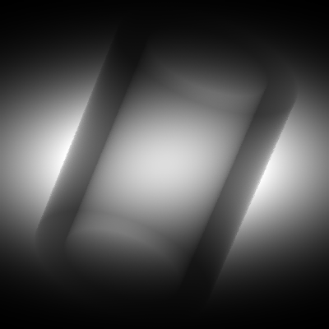

Figure 7 Example of image produced using the anisotropicsource/intensityscreen devices. This example is described by comments in the corresponding input files.

beamsource/beamscreen example
Example 9: example of source with direction-dependent intensity and energy spectrum, directory beamsource. The simulated sample is the same as in the example 1. The program beamscreen_image.c produces the file with the intensity and energy distribution on an ideal screen placed at 115 cm distance from the source and divided in 100×100 pixels. The intensity on this ideal screen is distributed according to a two-dimensional Gaussian function,
with σ_{x} = 4 cm and σ_{y} = 2 cm. The energy spectrum depends on the radial distance r from the screen center, and it is a gaussian function with σ = 4 keV and centered in
E_{c} = E_{c0} + (E_{c1} - E_{c0}) × r / L
where E_{c0} = 50 keV, E_{c1}=100 keV and L is the half-side of the screen. A README file in the same directory explains how to compile and run the program beamscreen_image.c .
The simulation can be run by typing the command:

xrmc input.dat

The output image is stored in the file image.dat.
The file spectrum_detector.dat defines an energy sensitive detector with 25 energy bins, which can be used to visualize the intensity as a function of the energy. The simulation can be run by typing the command

xrmc input_spectrum.dat

The results are stored in the file "image_spectrum.dat", which contains a stak of 25 images, one for each energy bin. Figure 8 shows the output image for the central bin (energy between 74 and 76 keV). Image size: 400 × 400

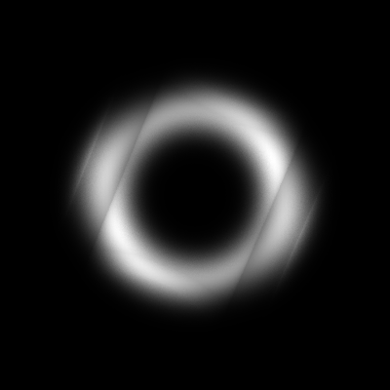

Figure 8 Example of image produced using the beamsource/beamscreen devices. This image represents the central energy bin (energy between 74 and 76 keV). This example is described by comments in the corresponding input files.

Free-propagation phase contrast imaging example
Example 10: example of simulation of a phase contrast imaging experiment. The sample is a 100 μm diameter PMMA (Polymethyl methacrylate) wire. The source-object distance z₁ and the object-detector distance z₁₂ are 23 m and 3.5 m, respectively. The source size is 100 μm FWHM (42.5 μm standard deviation). The detector pixel size is 0.5 μm. The source is monochromatic, with E = 17 keV. The unconvoluted image is stored in the file image.dat . The image convoluted to take into account the source size is stored in the file convoluted_image.dat . Fig. 9 shows the unconvoluted and the convoluted images.. Image size: 800 × 800

(a) (b)
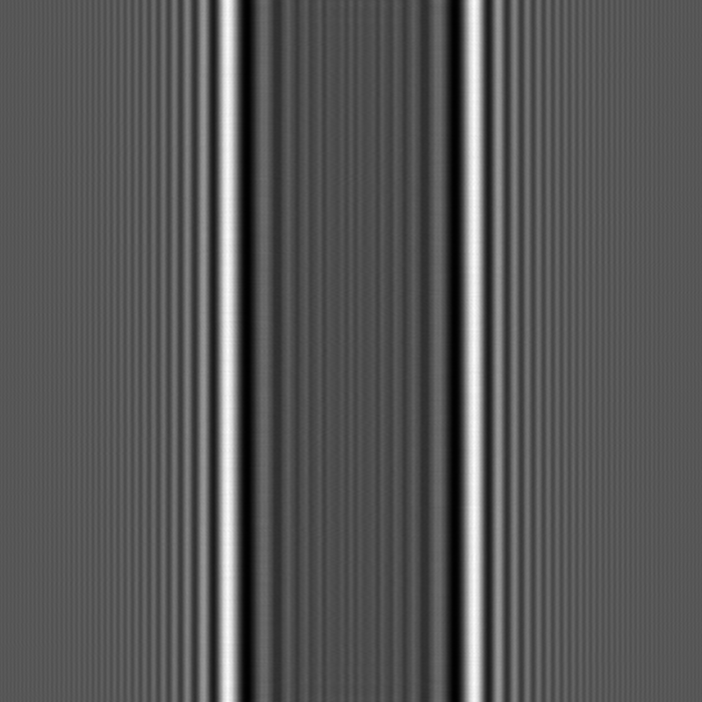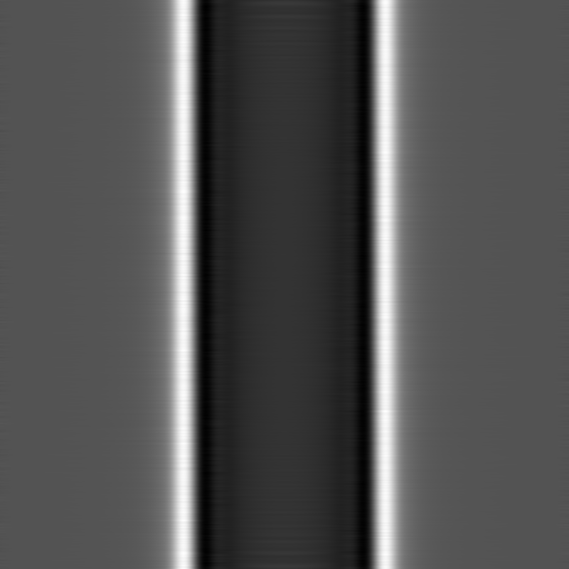
(c) (d)
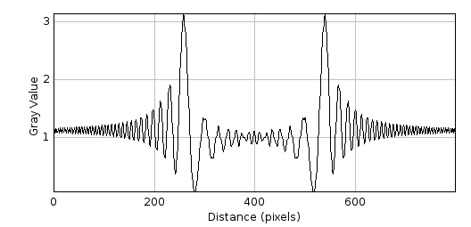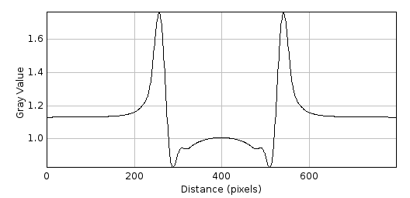

Figure 9 Example of phase-contrast imaging experiment simulation. The sample is a 100 μm diameter PMMA (Polymethyl methacrylate) wire. The source-object distance z₁ and the object-detector distance z₁₂ are 23 m and 3.5 m, respectively. The source size is 100 μm FWHM (42.5 μm standard deviation). The detector pixel size is 0.5 μm. The source is monochromatic, with E = 17 keV. Figure (a) represents the unconvoluted image, while figure (b) represents the image convoluted to take into account the source size. Image size: 800 × 800. Figures (c) and (d) represent the intensity profile for the unconvoluted and for the convoluted images, respectively.

Bibliography
[1] U. Bottigli, A. Brunetti, B. Golosio, P. Oliva, S. Stumbo, L. Vincze, P. Randaccio, P. Bleuet, A. Simionovici, A. Somogyi, Voxel-based Monte Carlo simulation of X-ray imaging and spectroscopy experiments, Spectrochim. Acta Part B 59 (2004) 1747–1754.
[2] A. Brunetti, M. Sanchez del Rio, B. Golosio, A. Simionovici, A. Somogyi, A library for X-ray-matter interaction cross sections for X-ray fluorescence applications, Spectrochim. Acta Part B 59 (2004) 1725–1731.
[3] T. Schoonjans, A. Brunetti, B. Golosio, M. Sanchez del Rio, V.A. Solé, C. Ferrero, L. Vincze, The xraylib library for X-ray–matter interactions. Recent developments, Spectrochim. Acta Part B 66 (2011) 776–784.
[4] B. Golosio, P. Delogu, I. Zanette, M. Carpinelli, G. L. Masala, P. Oliva, A. Stefanini, S. Stumbo, Phase contrast imaging simulation and measurements using polychromatic sources with small source-object distances, Journal of Applied Physics 104, 093102 (2008)

