Halal Basket
Stakeholder System Workflow
How the system works today · Pilot-ready overview · Glossary included
Based on the live apps and features built so far

1. What Halal Basket is
Halal Basket is a grocery ordering and delivery platform. Customers shop one branded catalogue. Partner shops prepare the goods. Drivers deliver. Operations staff support orders, catalogue, and customer care — including WhatsApp when enabled.

2. Who uses the system
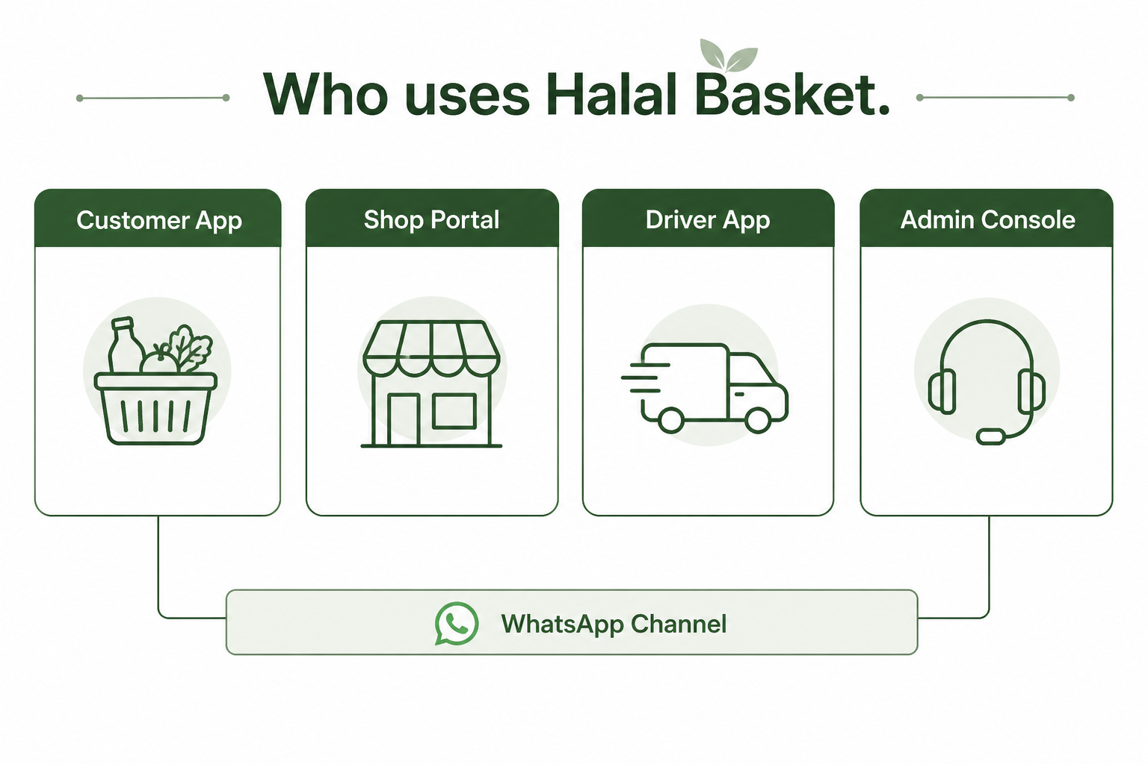
Four apps work together. WhatsApp is a messaging channel that connects customers and support — it is not a separate login role.
Who | App they use | Main job
Customer | Customer App | Browse, order, pay, track
Shop staff | Shop Portal | Prepare orders, stock, assign driver
Driver | Driver App | Deliver assigned orders
Ops / Admin | Admin Console | Support, catalogue, settings, WhatsApp inbox
Platform owner | Admin Console (elevated) | Roles, legal, branding, languages

3. How an order flows (happy path)
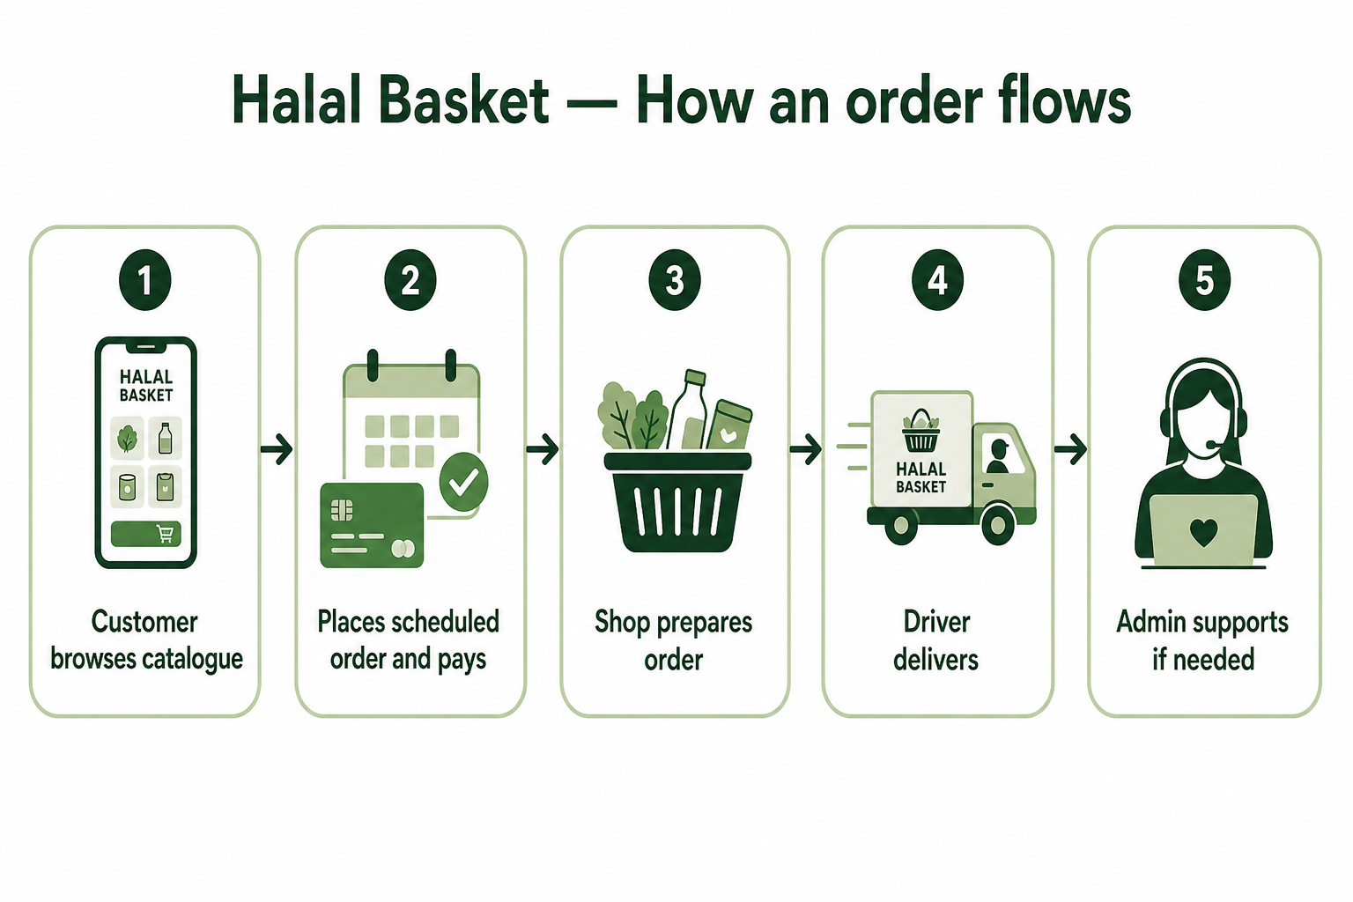
The standard journey stakeholders should remember:
- Customer browses the catalogue for their delivery area and builds a basket.
- Customer checks out for scheduled delivery and places the order (stock is held briefly).
- Customer pays on the confirmation screen.
- Shop prepares the fulfillment and assigns a driver.
- Driver delivers and updates status.
- Admin can look up the order, help with issues, refunds, or WhatsApp care if needed.

4. Who does what on one order
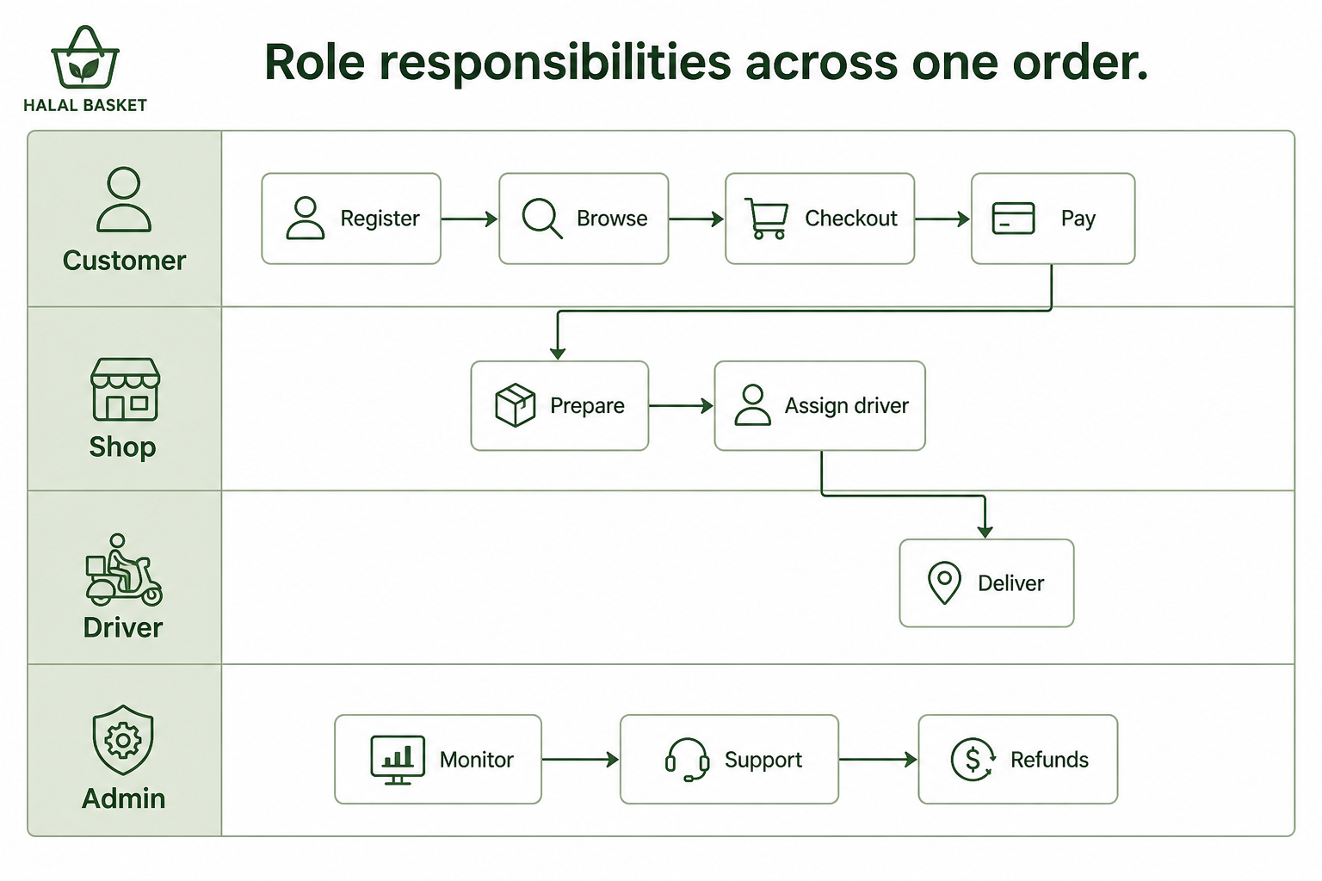
Think of one order as a relay: Customer starts it, Shop prepares it, Driver finishes delivery, Admin only steps in when support or configuration is needed.

5. Role workflows (step by step)

Customer
- Register or sign in on the Customer App.
- Choose a delivery area and browse the catalogue.
- Add items to the basket (favourites optional).
- Checkout: confirm basket → delivery details → place order.
- Pay on the confirmation screen.
- Track the order under My orders; manage profile, addresses, and favourites.

Shop (partner)
- Open the Shop Portal and review new fulfillments.
- Update status: preparing → ready → out for delivery.
- Assign a driver when ready for delivery.
- Maintain product price and stock quantity.
- Use the prep view to plan by delivery date.

Driver
- Open the Driver App and review today’s assigned jobs.
- Open an order, complete the delivery steps, and mark progress.
- Submit feedback / ratings where prompted.
- Review history of completed work.

Admin / Operations
- Look up orders, totals, coupons, and fees.
- Handle refunds, complaints, and customer risk/block actions when needed.
- Manage shops, drivers, staff users, and permissions.
- Maintain catalogue, featured categories, delivery fees, promotions, branding.
- Publish legal pages; use GDPR tools when required.
- Monitor WhatsApp care inbox and catalogue sync (when WhatsApp is enabled).

WhatsApp (optional channel)
- Customer can opt in at checkout for order notifications.
- Keywords and inbox support help (status, pay link, order help).
- Support can send assist or shop links from the admin inbox.
- Customers can shop the WhatsApp catalogue; cart can create a Halal Basket order plus pay link.

6. Simple end-to-end picture
Register → Catalogue (choose area) → Basket → Checkout (scheduled delivery) → Place order → Pay → Shop prepares & assigns driver → Driver delivers → Ops available for support
Optional side path: customer opts into WhatsApp for updates; or shops via WhatsApp catalogue, which can create the same unpaid order plus a pay link.

7. What is live for pilot vs not yet

Live / ready to demonstrate
- Customer browse → scheduled delivery order → pay → shop prepare → driver deliver → ops support
- Four portals: Customer, Shop, Driver, Admin
- Delivery areas & calendar (e.g. Lucan, Swords, Tallaght)
- Coupons / promotions, favourites, multi-language string packs (when languages are published)
- WhatsApp care + catalogue commerce in Meta sandbox / test setup

Not yet for stakeholders to treat as production-live
- Production / public staging website cutover (still local pilot-ready)
- Pickup and realtime delivery in the customer checkout screen (API exists; UI is scheduled-only today)
- Warehouse-led fulfillment published to customers
- Multi-shop split orders in production (feature exists, default off)
- WhatsApp on a live production business number (sandbox/test today)

Part 2 — Glossary of terms
Every important term used in this document is defined below. Use this section when someone asks “what does that mean?” during the meeting.
Term | Meaning in Halal Basket
Halal Basket | The platform brand customers see. One catalogue experience, not separate shop storefronts.
Customer App | Where shoppers browse, add items, check out, pay, and track orders.
Shop Portal | Where a partner shop prepares orders, updates stock/prices, and assigns drivers.
Driver App | Where drivers see assigned deliveries and mark progress through to delivered.
Admin Console | Where operations and platform teams manage orders, users, catalogue, fees, legal, and WhatsApp.
Catalogue | The shared product listing customers browse. Availability depends on the selected delivery area.
Basket / Cart | The list of items the customer intends to buy, before the order is placed.
Delivery area | A named place we deliver to (for example Lucan, Swords, Tallaght). Affects stock and delivery day.
Delivery calendar | Rules that map each delivery area to the weekday(s) when deliveries run.
Scheduled delivery | The live checkout option today: customer orders ahead for a planned delivery day.
Order | The customer’s purchase record (items, totals, payment, delivery details).
Fulfillment | The shop’s part of an order — prepare, ready, out for delivery, delivered.
Stock hold | A short reservation of stock while checkout completes, so items are not double-sold.
Payment | Customer pays after placing the order (mock pay in pilot, or Stripe Checkout when configured).
Coupon / Promo | Discount codes or cart promotions applied at checkout (for example HALAL10, WELCOME5).
Partner shop | A store that stocks and prepares items for Halal Basket orders.
Warehouse | A central stock location type in the system; not published for customer fulfillment in the current pilot.
WhatsApp channel | Optional messaging path: order updates, customer care inbox, and catalogue cart → Halal Basket order.
Care inbox | Admin view of WhatsApp conversations so support can reply and help customers.
Assist link | A secure short-lived link that helps a customer continue checkout with support guidance.
Opt-in | Customer agrees to receive WhatsApp order updates and share a phone number.
RBAC / Permissions | Staff access controls — who can see ops, catalogue, GDPR, WhatsApp, and so on.
Platform vs Work | Admin navigation: Platform = settings/governance; Work = day-to-day operations.
GDPR tools | Admin privacy tools to search, export, or erase customer data under policy constraints.
Legal documents | Published policies (privacy, terms, cookies, refunds) shown to customers.
Favourites | Products a signed-in customer has hearted for quick re-find.
Live order status | Customer order tracking updates while the order moves through shop and driver steps.

Meeting tip
For a live walkthrough, open the visual companion HTML in a browser (Halal-Basket-Stakeholder-System-Workflow.html) and share your screen. Use this Word/PDF file as the leave-behind handout.

