Customer Shopping Behavior Analysis

1. What This Project Is About
This project looks at how customers shop. We studied 3,900 purchases across different product categories to understand how much people spend, who our customers are, which products they like, and how subscriptions affect their buying. The goal is simple: use the data to help the business make better decisions.

2. About the Data
The dataset has 3,900 rows (one per purchase) and 18 columns. The columns fall into three groups:
- Who the customer is: age, gender, location and whether they have a subscription.
- What they bought: the item, its category, the amount paid, the season, size and color.
- How they shop: whether a discount or promo code was used, how many times they have bought before, how often they buy, their review rating and the shipping type.
Only one column had missing data: 37 customers had not left a review rating. Customers are aged 18 to 70 (average about 44), and a typical purchase is around $60, ranging from $20 to $100.

3. Cleaning and Preparing the Data (Python)
Before any analysis, the data was cleaned and organised in Python:
- Loading: the dataset was loaded using the pandas library.
- First look: we checked the structure and basic statistics (averages, minimums, maximums) to understand what we had. The summary is shown below, split in two parts because it is wide.
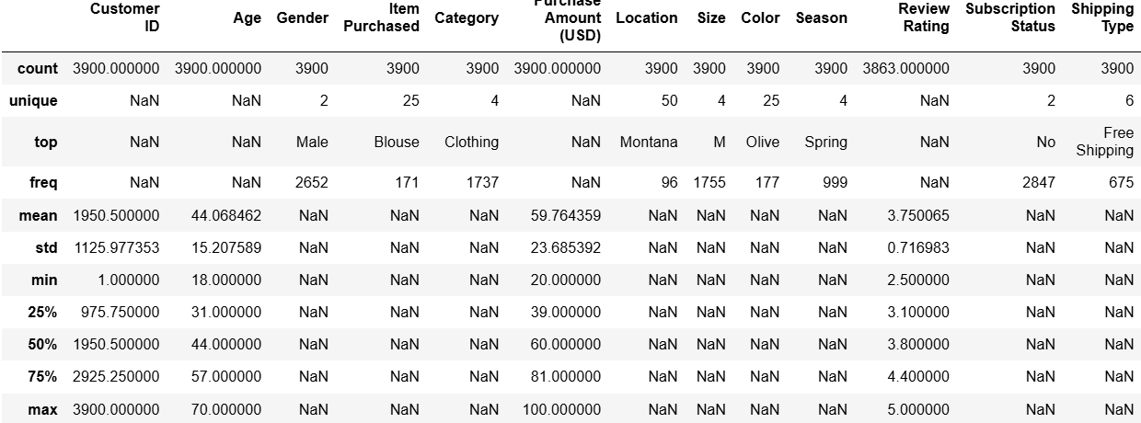
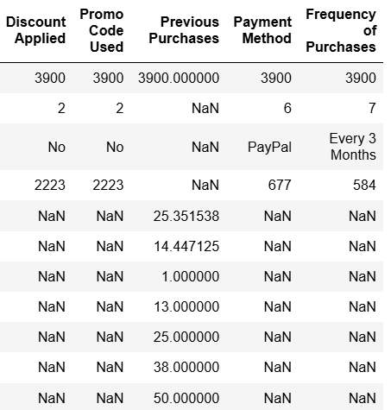
- Filling the gaps: the 37 missing review ratings were filled in using the middle (median) rating of the product's category, so we did not have to throw those rows away.
- Tidy column names: all column names were changed to a consistent lowercase style with underscores (for example, review_rating) so they are easy to read and use.
- New columns: we created age_group by sorting customers into age bands, and purchase_frequency_days by turning "how often they buy" into a number of days.
- Removing duplicates of information: we checked whether discount_applied and promo_code_used told us the same thing. They did, so promo_code_used was dropped.
- Moving to a database: the cleaned data was loaded into a PostgreSQL database so we could ask it questions using SQL.

4. Answering Business Questions (SQL)
Using PostgreSQL, we answered ten practical questions about the business. Here is what each one found.

Q1. Who brings in more money, men or women?
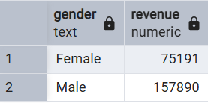
Men generated about two-thirds of all revenue, which is more than double what women generated.

Q2. Which customers used a discount and still spent more than average?
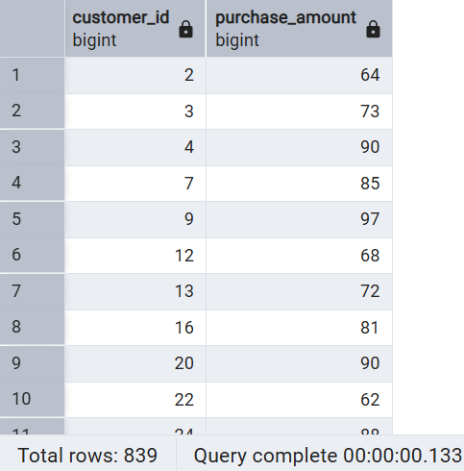
A total of 839 customers used a discount but still spent more than the average purchase amount. These are valuable shoppers: they like a deal, but they also spend well.

Q3. Which five products have the best reviews?
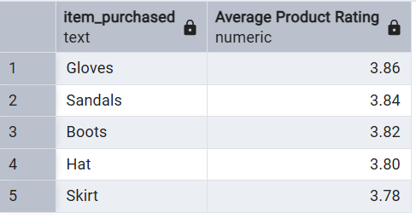
Gloves, Sandals, Boots, Hat and Skirt are the best rated. The ratings are very close to each other, so there is no single standout product.

Q4. Do people spend more with Standard or Express shipping?
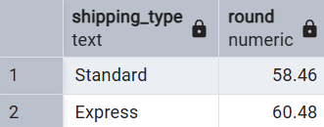
Express shipping customers spend slightly more, about $60.48 per purchase compared with $58.46 for Standard.

Q5. Do subscribers spend more than non-subscribers?
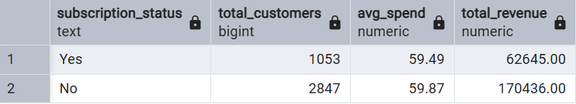
Subscribers do not spend any more per purchase than non-subscribers. In fact, they spend slightly less. Non-subscribers bring in most of the revenue simply because there are more of them.

Q6. Which products rely most on discounts?
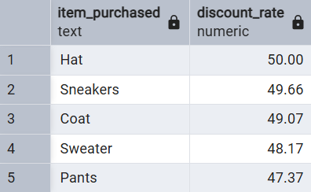
For Hat, Sneakers, Coat, Sweater and Pants, about half of all sales happened with a discount applied.

Q7. How many customers are New, Returning or Loyal?
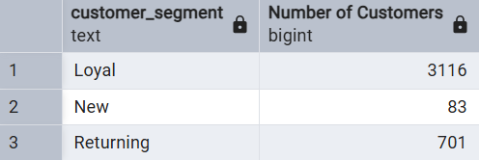
Most customers (about 80%) fall into the Loyal group, and only a small number are brand new.

Q8. What are the three most purchased products in each category?
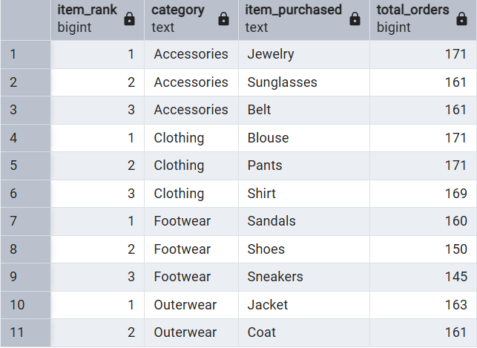
The table shows each product's rank within its category and how many times it was bought. Jewelry, Blouse, Sandals and Jacket lead their categories.

Q9. Are frequent buyers more likely to subscribe?
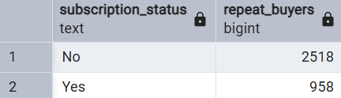
Most frequent buyers (more than 5 purchases) are not subscribers. Buying often does not automatically lead to subscribing, so the business needs to actively encourage it.

Q10. Which age group brings in the most revenue?
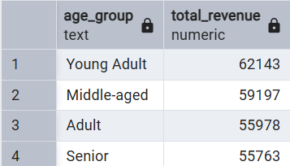
Young Adults lead, but all four age groups are fairly close, so no group can be ignored.

5. The Power BI Dashboard
To make the findings easy to explore, we built an interactive Customer Behavior Dashboard in Power BI. It shows these headline numbers:
- Number of customers: about 3,900.
- Average purchase amount: $59.76.
- Average review rating: 3.75 out of 5.
It also includes charts for the subscription split (27% subscribed, 73% not), revenue and sales by category, and revenue and sales by age group. You can filter everything by subscription status, gender, category and shipping type.
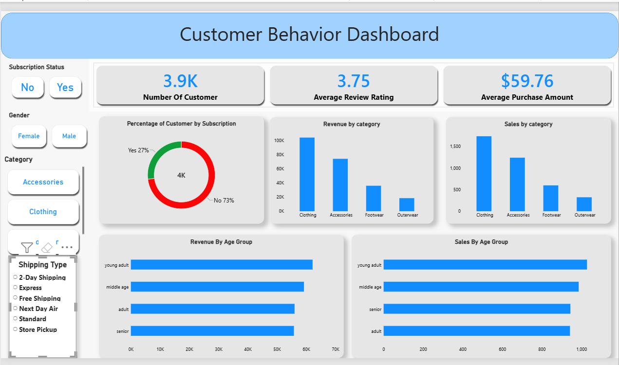

6. What We Recommend
- Encourage more subscriptions. Only 27% of customers subscribe, and subscribers do not currently spend more. Offer real perks, such as exclusive deals or free shipping, to make subscribing worthwhile.
- Reward loyal customers. Set up a loyalty program that thanks repeat buyers and encourages Returning customers to become Loyal ones.
- Review the discount policy. Discounts help sales, but products like Hat, Sneakers and Coat are discounted on about half of their sales. Check that this is not cutting too far into profit.
- Promote the right products. Feature top-rated items (Gloves, Sandals, Boots) and best sellers (Jewelry, Blouse, Pants, Sandals, Jacket) in campaigns.
- Target the right people. Focus marketing on the age groups that bring in the most revenue, and on Express shipping customers, who spend a little more per order. Also look for ways to attract more female customers, since they currently bring in much less revenue.

