|  |  |
| --- | --- |
| **Soal Project**  *Project Case* |  |
| T0053  Web Programming |
| **Teknik Informatika**  *Computer Science* | **C2-T0053-SE01** |
| **Periode Berlaku** Semester Pendek 2015/2016  ***Valid on*** *Compact SemesterYear 2015/2016* | **Revisi 00**  *Revision 00* |

1. Seluruh kelompok tidak diperkenankan untuk :

*The whole group is not allowed to:*

* + - Melihat sebagian atau seluruh proyek kelompok lain,

*Seeing a part or the whole project from other groups*

* + - Menyadur sebagian maupun seluruh proyek dari buku,

*Adapted a part or the whole project from the book*

* + - Mendownload sebagian maupun seluruh proyek dari internet,

*Downloading a part or the whole project from the internet,*

* + - Mengerjakan soal yang tidak sesuai dengan tema yang ada di soal proyek,

*Working with another theme which is not in accordance with the existing theme in the matter of the project,*

* + - Melakukan tindakan kecurangan lainnya,

*Committing other dishonest actions,*

* + - Secara sengaja maupun tidak sengaja melakukan segala tindakan kelalaian yang menyebabkan hasil karyanya berhasil dicontek oleh orang lain / kelompok lain.

*Accidentally or intentionally conduct any failure action that cause the results of the project was copied by someone else / other groups.*

1. Jika kelompok terbukti melakukan tindakan seperti yang dijelaskan butir 1 di atas, maka **nilai kelompok** yang melakukan kecurangan (menyontek maupun dicontek) akan di – **NOL** – kan.

*If the group is proved to the actions described in point 1 above, the score of the group which committed dishonest acts (cheating or being cheated) will be “Zero”*

1. Perhatikan jadwal pengumpulan proyek, segala jenis pengumpulan proyek di luar jadwal tidak dilayani.

*Pay attention to the submission schedule for the project, all kinds of submission outside the project schedule will not be accepted*

1. Jangan lupa untuk melihat kriteria penilaian proyek yang ditempel di papan pengumuman, atau tanya asisten anda.

*Don’t forget to look at the project assessment criteria that posted on the announcement board, or ask your teaching assistant.*

1. Persentase penilaiaan untuk matakuliah ini adalah sebagai berikut:

*Marking percentage for this subject is described as follows:*

|  |  |  |
| --- | --- | --- |
| **Tugas Mandiri**  *Assignment* | **Proyek**  *Project* | **UAP**  *Final Exam* |
| - | 100% | **-** |

1. Software yang digunakan pada matakuliah ini adalah sebagai berikut:

*Software will be used in this subject are described as follows:*

|  |
| --- |
| **Software**  *Software* |
| Adobe Dreamweaver CS3  XAMPP 1.8.0 (MySQL)  Tomcat 7  Java 6  MySQL Java Connection Library  IE / Firefox |

## Ekstensi file yang harus disertakan dalam pengumpulan tugas mandiri dan proyek untuk matakuliah ini adalah sebagai berikut:

*File extensions should be included in assignment and project collection for this subject are described as follows:*

|  |  |
| --- | --- |
| **Tugas Mandiri**  *Assignment* | **Proyek**  *Project* |
| - | JSP, SQL, image files (JPG/PNG/GIF), CSS |

## Soal

*Case*

General Provisions:

* Use **MySQL** asdatabase.
* **Regular Expression (Regex)** will not be marked, **except validate email**.
* You are free to design your own database table **based on given requirements**.
* Print screen given below is only an example. You are free to create your own user interfaces.

**Bluejack Store**

**Bluejack Store** is a largest online shop in Indonesia which allows individuals and business owners in Indonesia to open and manage their online stores easily and free of charge. To expand its business, **Bluejack Store** wants to create a website for their shop. In that website, people can find information about the product and buy it. This website also allows admin to manage product, member, and all transaction made by users.

As a web developer, you are asked to create a website using JSP for this online shop. There are three types of user’s role in this website: **Admin**, **Member**, and **Guest** (**non-logged-in user**).

Minimum pages you need to create for each role are:

* + - **Admin**
* Home
* Product
* Member
* Transaction
* Profile
* Logout
  + - **Member**
* Home
* Product
* Member
* Transaction
* Cart
* Profile
* Logout
  + - **Guest**
* Home
* Login
* Register

Each page shows **greeting to user, total online user, and current** **date** **time**. The descriptions for each page are:

* + - 1. **Home**

This page tells about **Bluejack Store** in general.

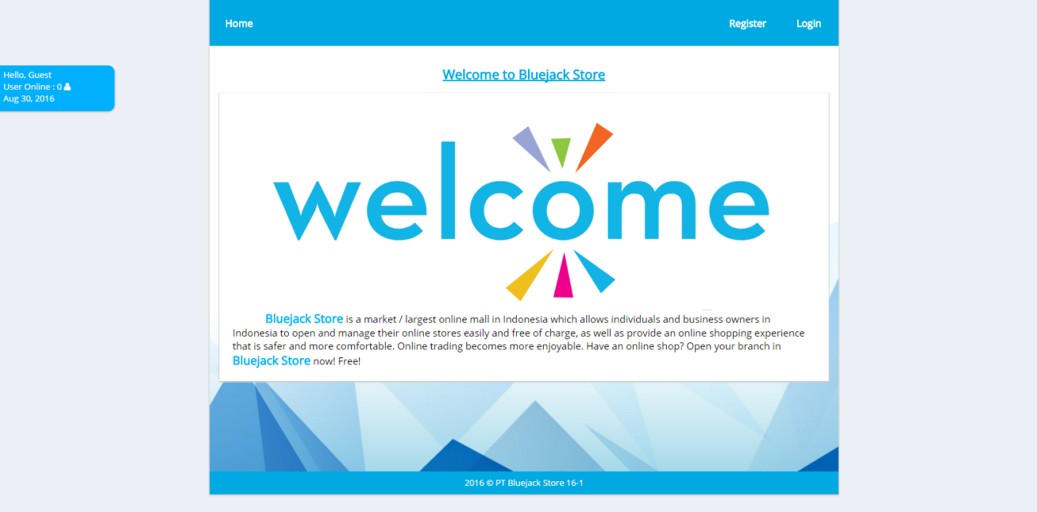

***Home Page (for Guest)***

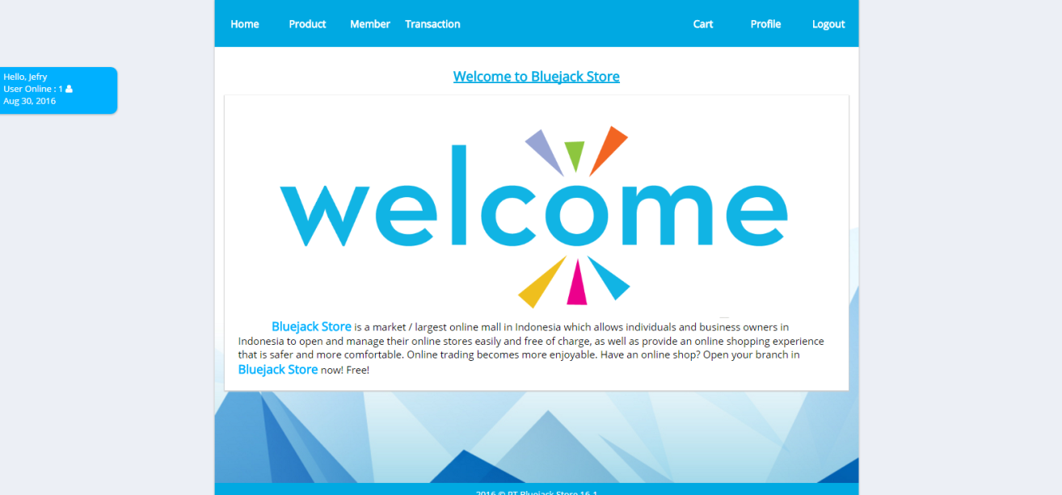

***Home Page (for Member)***

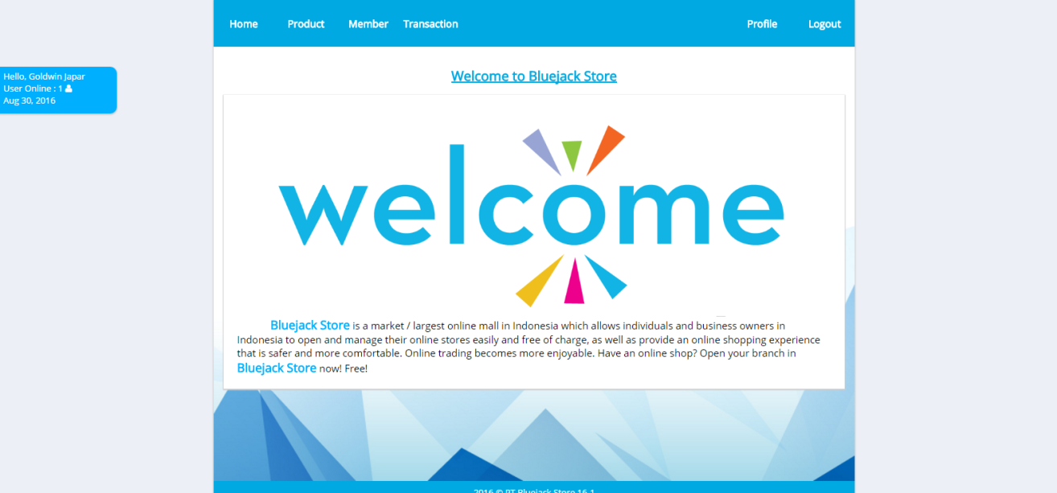

***Home Page (for Admin)***

1. **Login**

This page allows user to log in to the website. Validate this page is accessible only to **guest**. Display an **error message** on the login page if user enters wrong combination of **Username** and **Password**. The following table shows the existing fields in this page and validations for each field:

|  |  |
| --- | --- |
| **Field** | **Information** |
| **Username** | * + - Must be filled and appropriate with the data in the database |
| **Password** | * + - Must be filled and appropriate with the data in the database |

If user has entered correct **Username** and **Password**, the page will be redirected to the **Home Page** **for member** or **admin** based on the user role menu and if user checks the “**Remember Me**” checkbox, the website will save the **Username** and **Password** using cookies for **1 hour**.

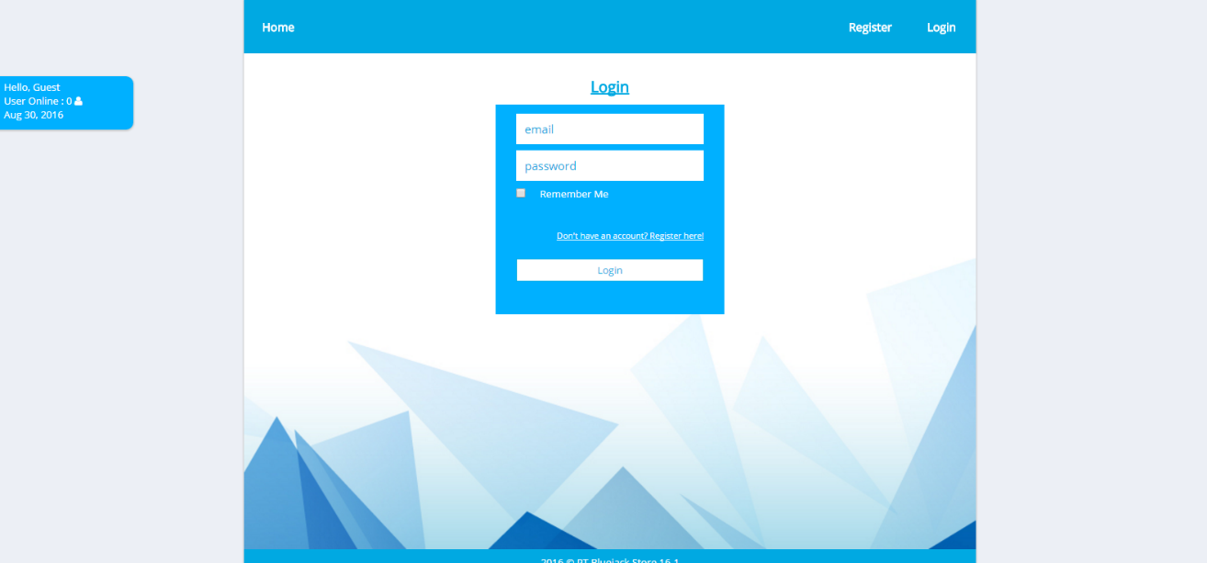

***Login Page***

1. **Register**

This page allows guests to **register** themselves as **Bluejack Store** member. Validate this page is accessible to **guest** only. Display an **error message** if user input incorrect personal data. The following table shows the existing fields on this page and the validation for each field:

|  |  |
| --- | --- |
| **Field** | **Information** |
| **Fullname** | * + - Must be filled with **alphabet** and **space** |
| **Phone** | * + - Must be **numeric** and **length** between **10** and **13** characters |
| **Email** | * + - Must be filled     - Email must match with the format below (**allowed regex**): * Email must contain at sign (@) and dot (.) character * At sign (@) and dot (.) character cannot be placed besides each other and must ended with “.com” * At sign (@) cannot be more than one |
| **Password** | * + - Must be filled and **alphanumeric** |
| **Confirm Password** | * + - Must be filled and **same with password** |
| **Gender** | * + - Must be selected |
| **Date of Birth** | * + - Must be filled in **yyyy-MM-dd** format     - Age must be more than 17th |
| **Address** | * + - Must be filled and **ends with ‘ Street’** |
| **Phone** | * + - Must be selected and **extension** must be **.jpg** or .**png** |

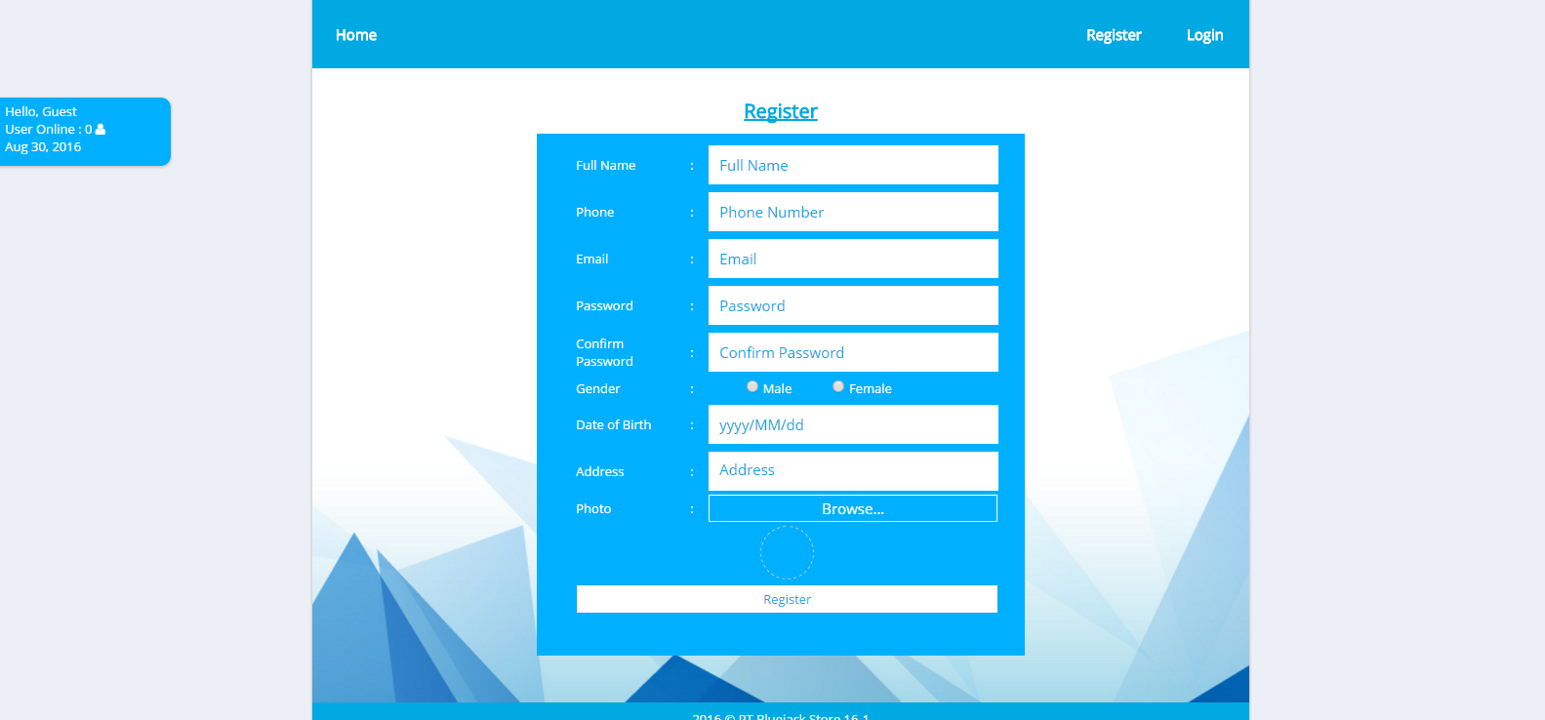

***Register Page***

1. **Product**

This page allows user to see all **Bluejack Store’s** **product information** and **search** the product by **name**. This page is accessible for **member** and **admin** only. Product information is displayed using **paging** with **5** products for each page.

For **member**, **Add to Cart** button will be visible and **Add Product, Update Product, Delete Product** buttons will be invisible. **Member** can click **Add to Cart** button, then validate:

* Display **error message** if the quantity **lass than or equal to zero (0)** or **less than selected product’s stock**
* If the selected product is already exist in **carts** table, the quantity will be accumulated
* After all inputs are appropriate, update the available stock of the selected product and insert the selected product into the cart’s table

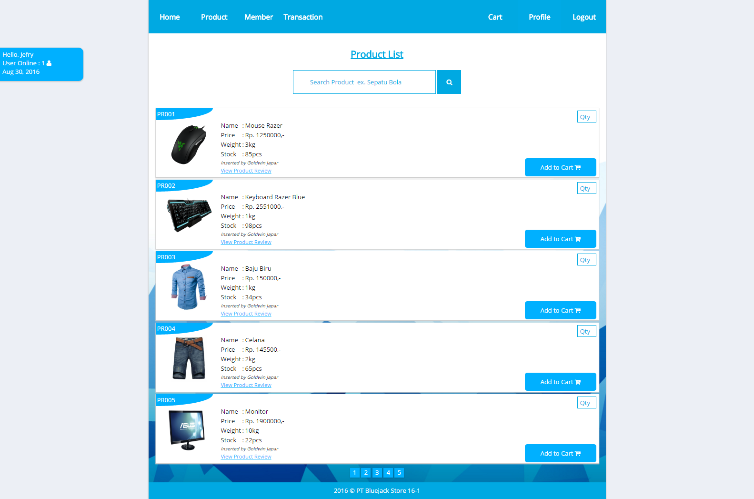

***Product Page (for Member)***

For **admin**, **Add Product**, **Update Product**, **Delete Product** buttons will be visible, and **Add to Cart** button will be invisible:

* To add new product, **admin** can click **Add Product** button
* To update information of selected product, **admin** can click **Update Product** button
* To delete the selected product, **admin** can click **Delete Product** button

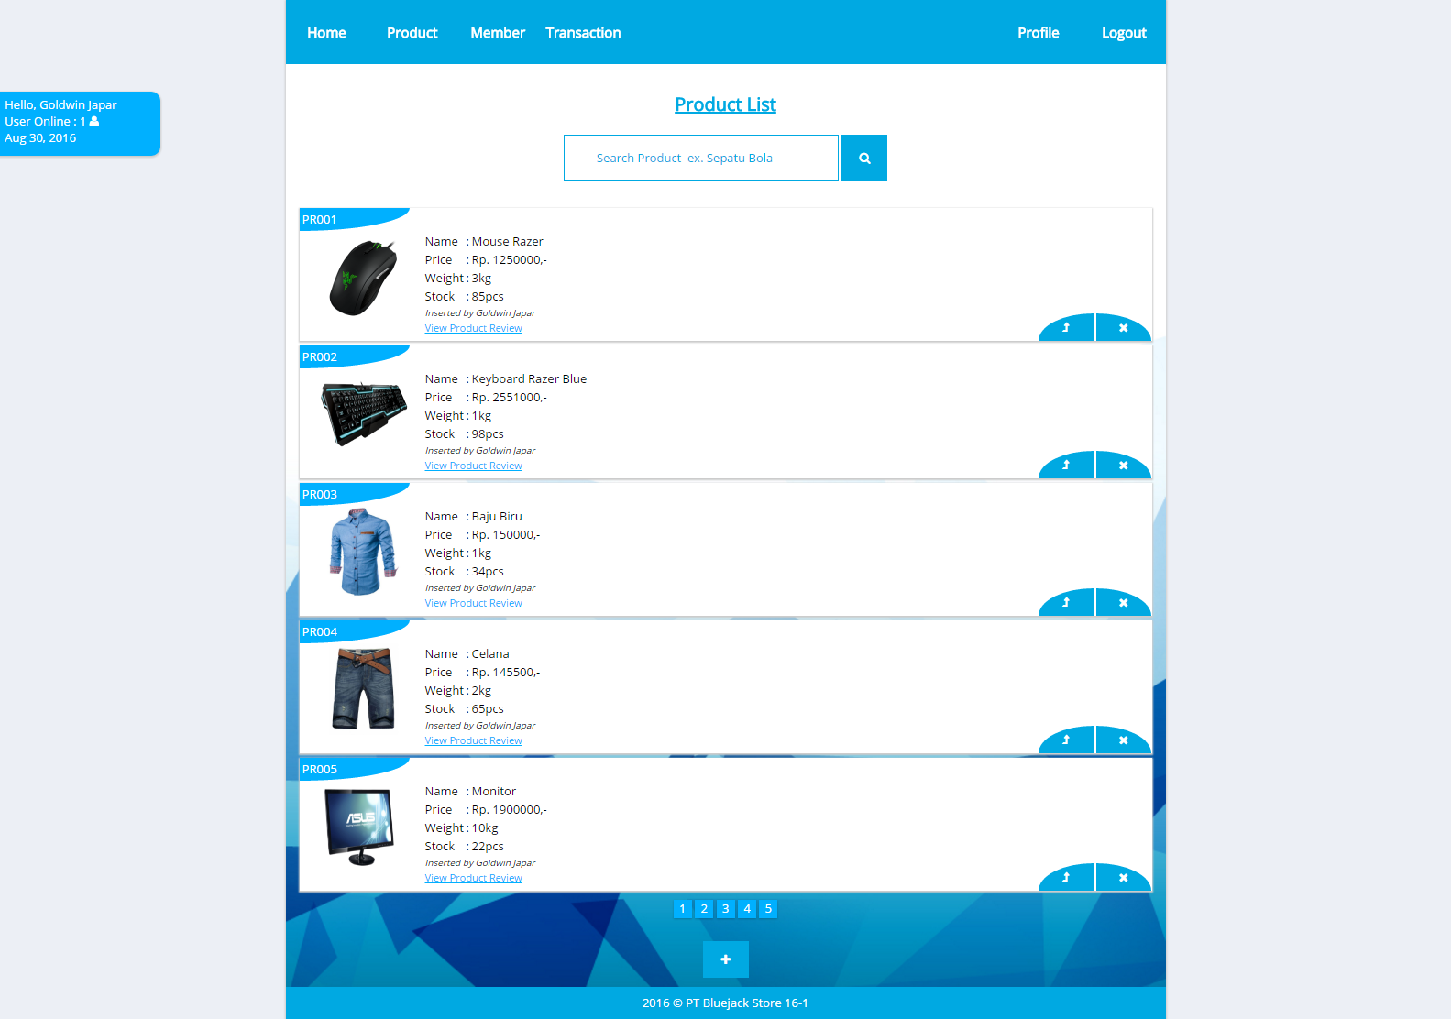

***Product Page (for Admin)***

1. **Add Product**

This section allows **admin** to insert new product. This section will be shown if **admin** clicks **Add Product** button in **Product** page. Display **error message** if **admin** input incorrect product data. The following table shows existing fields in this page and the validation for each field:

|  |  |
| --- | --- |
| **Field** | **Information** |
| **Product ID** | * + - The program automatically **generate** new product ID based on last product ID in **product’s** table   Example : If the last data in database is **PR004**, the program automatically generate **PR005** as a new product ID |
| **Name** | * + - Must be filled |
| **Price** | * + - Must be filled with numbers |
| **Weight** | * + - Must be filled with numbers |
| **Stock** | * + - Must be filled with numbers and **greater** than **0** |
| **Image** | * + - Must be selected and image **extension** must be .**jpg** or .**png** |
| **InsertedBy** | * + - Automatically filled by logged user’s ID |

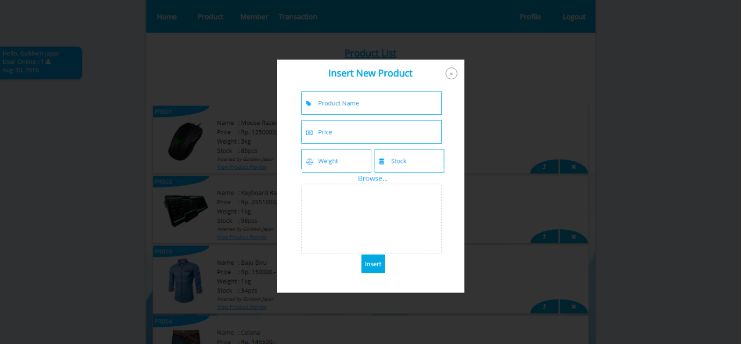

***Add Product page***

1. **Update Product**

This section allows **admin** to update existing product. This section will be shown if **admin** clicks **Update Product** button in **Product** page. Display **error message** if **admin** input incorrect product data. The following table shows existing fields in the page and the validation for each field:

|  |  |
| --- | --- |
| **Field** | **Information** |
| **Name** | * + - Must be filled |
| **Price** | * + - Must be filled with numbers |
| **Weight** | * + - Must be filled with numbers |
| **Stock** | * + - Must be filled with numbers and **greater** than **0** |
| **Image** | * + - Must be selected and image **extension** must be .**jpg** or .**png** |

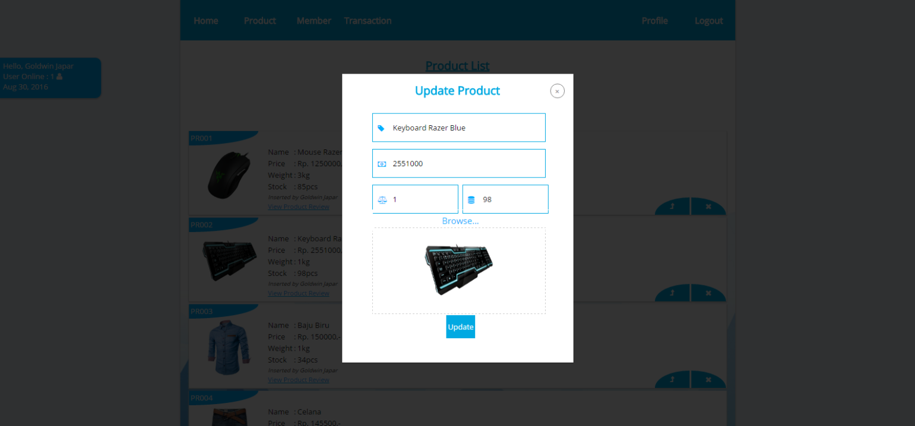

***Update Product page***

1. **Profile**

This page allows **admin** or **member** to view their personal data. This page will be shown if **admin** or **member** clicks **greeting to user link** in header section and also provide **Update profile** button to update their personal data. This page is accessible only for **admin** and **member**.

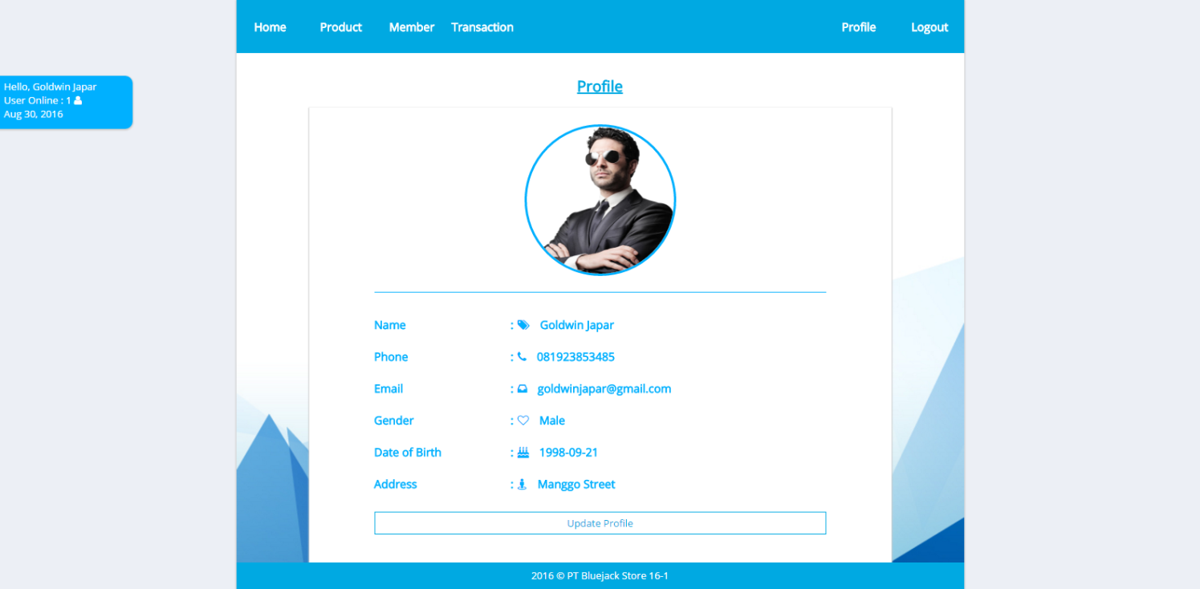

***Profile page***

1. **Update Profile**

This page allows **admin** or **member** to update their personal data. This page will be shown if **admin** or **members** clicks **Update Profile** button from **Profile** page. Display **error message** if **admin** or **member** input incorrect personal data. The following table shows existing fields in this page and the validation for each field:

|  |  |
| --- | --- |
| **Field** | **Information** |
| **Old Password** | * + - Must be filled     - Match with **user’s** table in DB |
| **New Password** | * + - Must be filled with **alphanumeric** |
| **Confirm Password** | * + - Must be filled and **exactly same** with New Password |
| **Phone** | * + - Must be filled with **numbers** |
| **Email** | * + - Must be filled     - Email must match with the format below (**allowed to use regex**): * Email must contain at sign (@) and dot (.) character * At sign (@) and dot (.) character cannot be placed besides each other and must ended with “.com” * At sign (@) cannot be more than one |
| **Address** | * + - Must be filled and **ends with ‘ Street’** |
| **Photo** | * + - Must be selected and **extension** must be **.jpg** or **.png** |

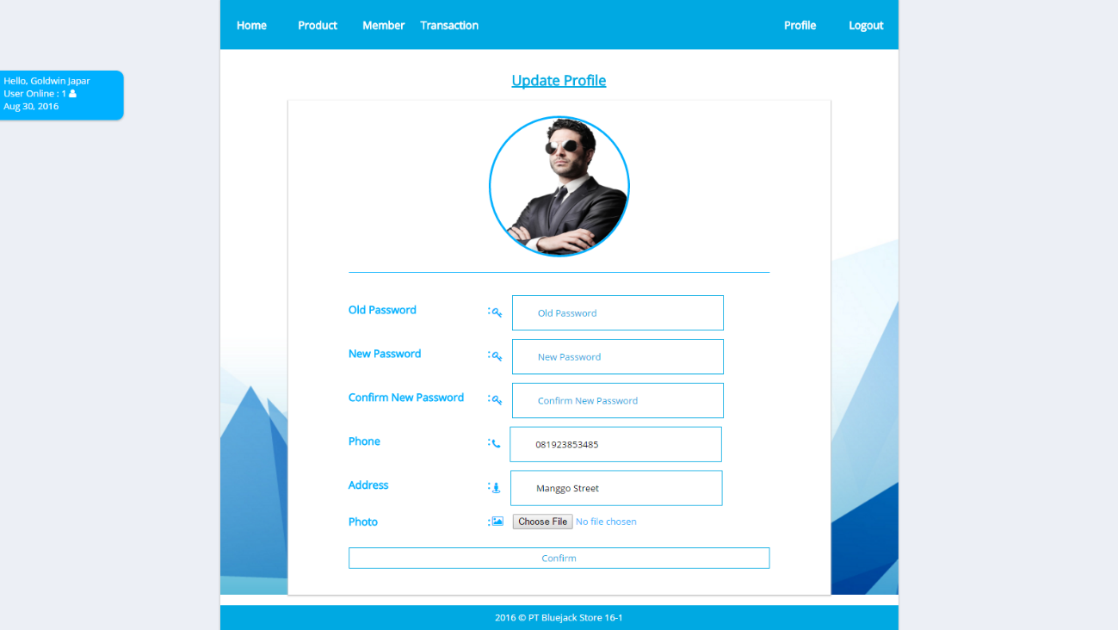

1. **Member**

This page is accessible for **admin** and **member**. This page allows **admin** and **member** to see all members registered in **Bluejack Store** and **search** member **by** **name**.

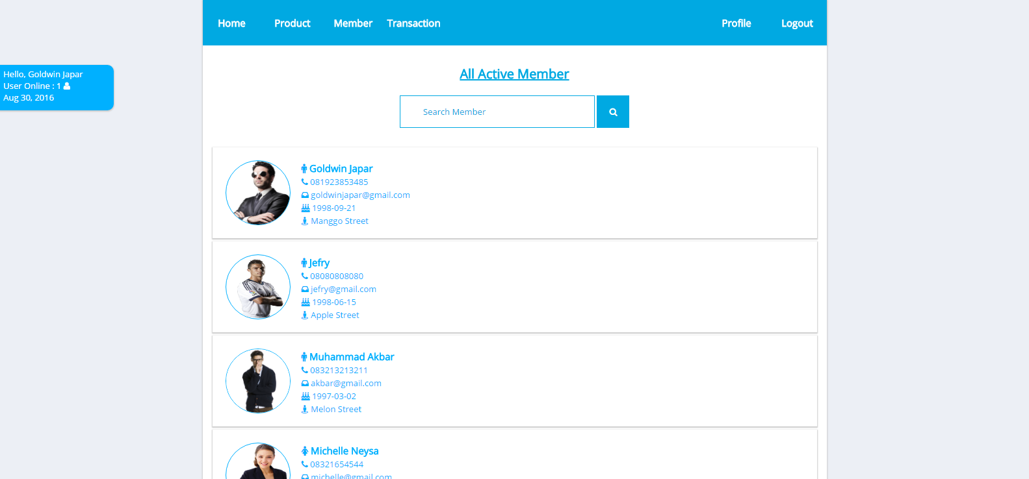

***Member Page***

1. **Cart**

This page is accessible only for **member**. This page displays all products that have been added into user’s shopping cart. Display cart information such as **Product ID, Name**, **Quantity**, **Subtotal Price**, and **Grand Total**.

There are two buttons in this page, **Delete Product** button for each product on cart and **Complete the Payment** button.

* If **member** clicks **Complete the Payment** button, then **member** will be redirected to product page and the shopping cart data will be **inserted** to **Transaction** with “**Waiting for Approval**” status, then all shopping cart data will be **deleted** from database.
* Otherwise, if **member** clicks **Delete Product** button, data will be removed from the current active cart and return product quantity from cart to available stock in **product’s table** 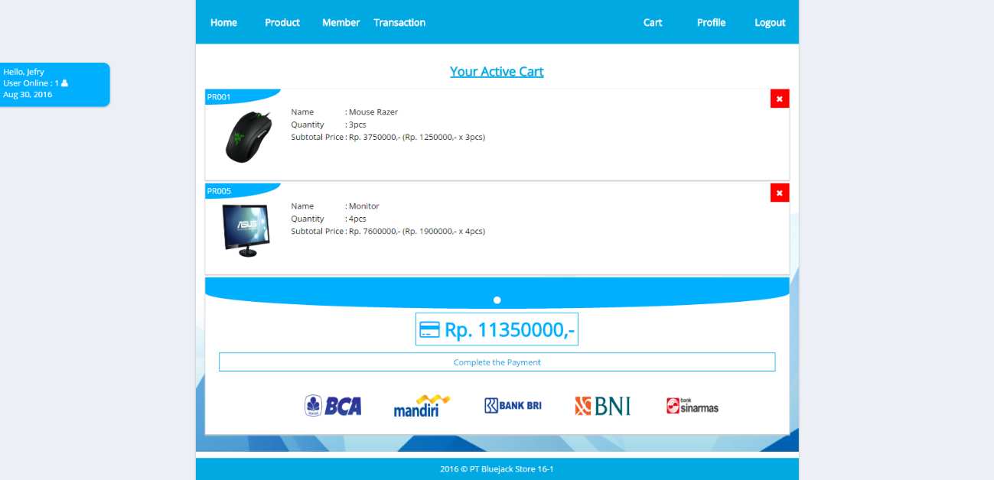

***Cart page***

1. **Transaction**

This page is accessible for **admin** and **member**. The information of transaction that must be shown are **Transaction ID**, **Customer Name**, **Approved Date**, **Status,** **Product Name**, **Price**, **Quantity**, **Sub Total**, and **Grand Total**. Transaction list is displayed using **paging** with **5** transactions for each page.

If **member** clicks transaction, they can see are their own transaction.

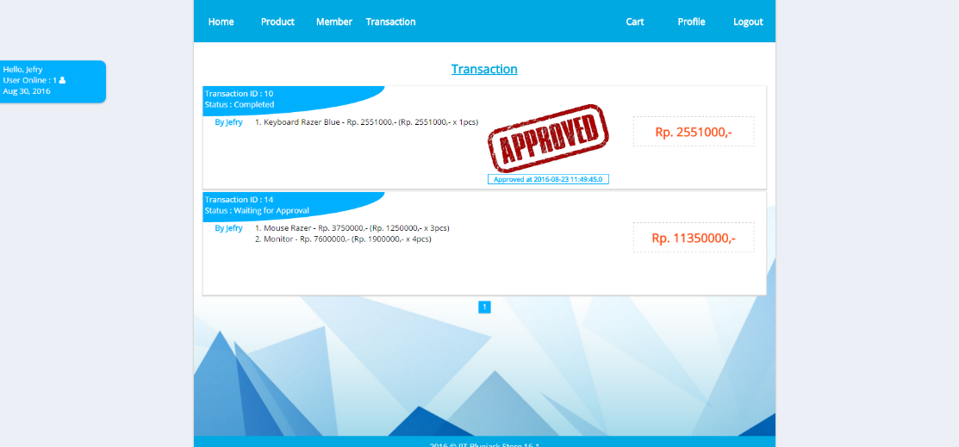

***Transaction page (for Member)***

If **admin** clicks transaction, this page displays all transactions that have been made by **member**. If the transaction’s status is “**Waiting for Approval**”, the **Approve** button will be shown:

* If the **Approve** button is clicked, then the transaction’s status will be updated from “**Waiting for Approval**”to “**Completed**”.

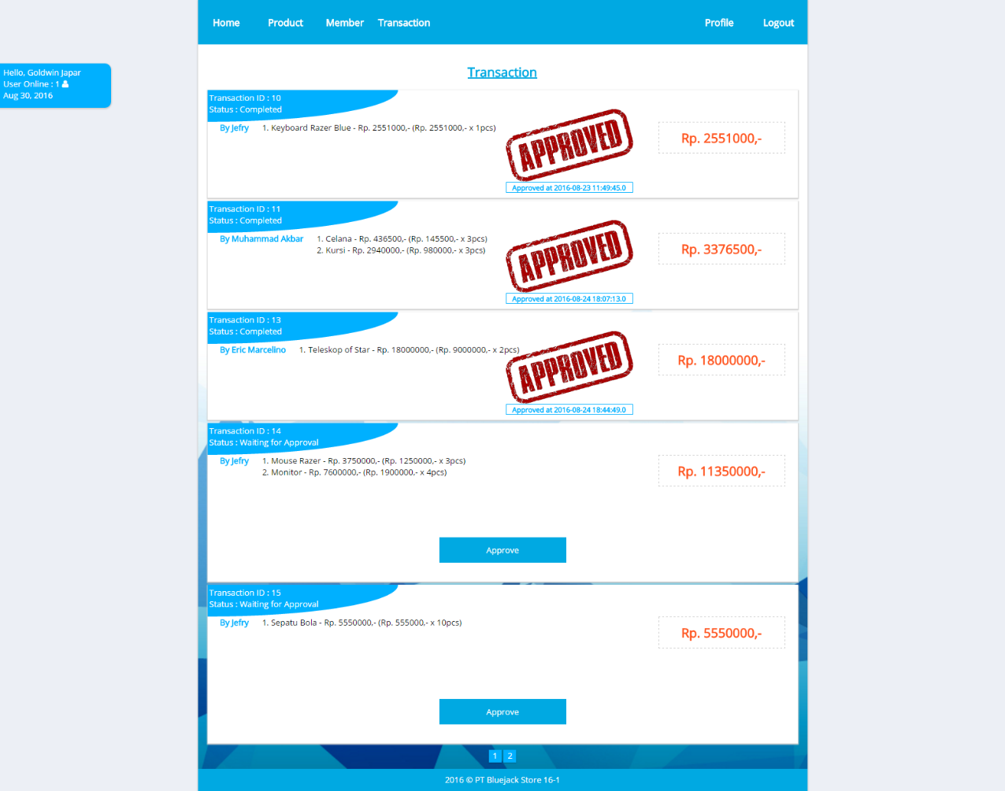

***Transaction Page (for Admin)***

1. **Comments**

This page allow user to see all comments that have been made by **member**. This page is accessible for **admin** and **member**.

This page provides **Add Comment**, then **Delete** and **Update** button will be shown if that’s their own comments:

* To add comment, theycan click **Add Comment** button
* To update information of selected comment, theycan click **Update Comment** button
* To delete the selected comment, theycan click **Delete Comment** button

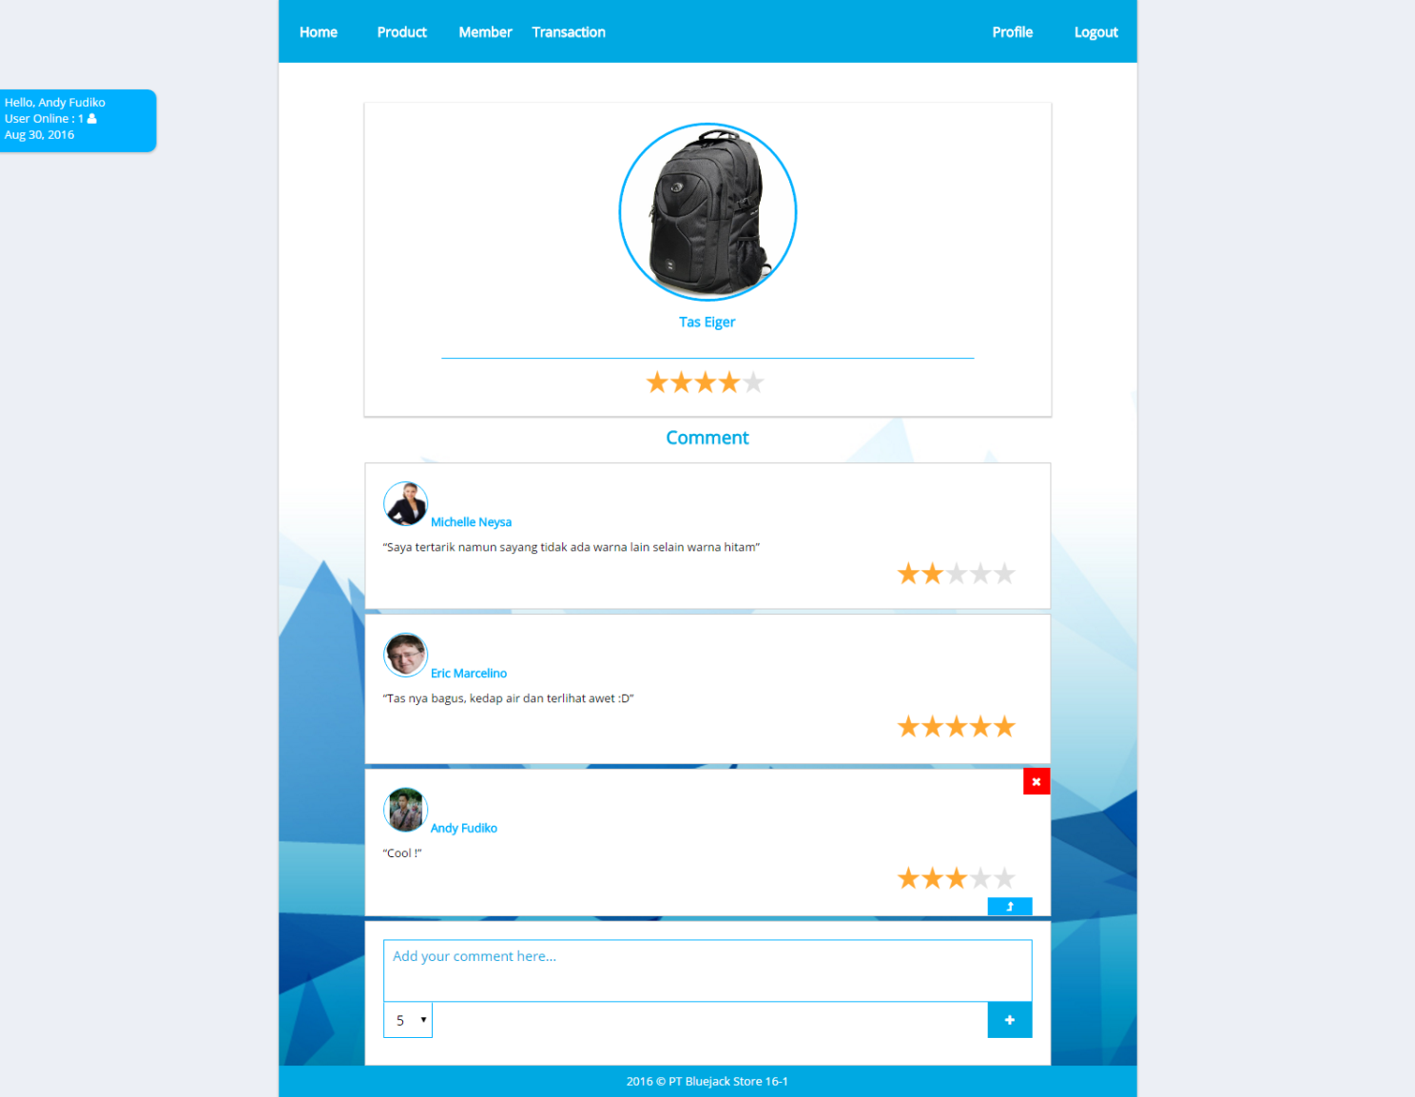

***Comment Page***

1. **Update Comment**

This section will allow member to **update their own comment**. This section will be shown if **members** clicks **Update Comment** button from **Comments** page. Display an error message on this page if user enters incorrect data. The following table shows the existing fields in this section and the validation for each field:

|  |  |
| --- | --- |
| **Field** | **Information** |
| **Content** | * + - Must be filled and **max length** is **255 characters** |
| **Star** | * + - Must be selected in **range between 1** and **5** |

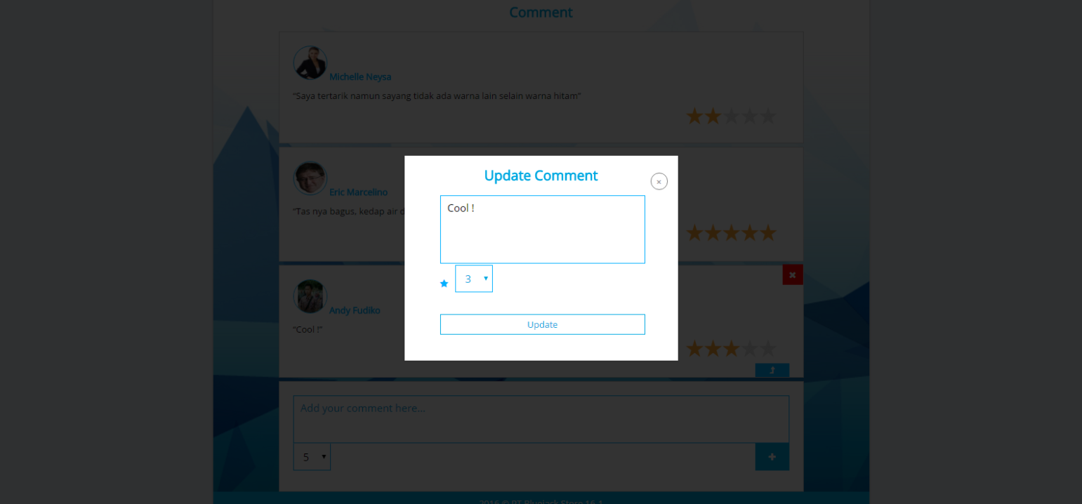

***Update Comment Page***

1. **Insert Comment**

This section is only accessible for **admin** and **member**. This section will be shown if **admin** or **member** clicks **Insert Comment** button from **Comments** page. Display an error message on this page if user enters incorrect data. The following table shows the existing fields in this page and the validation for each field:

|  |  |
| --- | --- |
| **Field** | **Information** |
| **Content** | * + - Must be filled and **max length** is **255 characters** |
| **Star** | * + - Must be selected in **range between 1** and **5** |

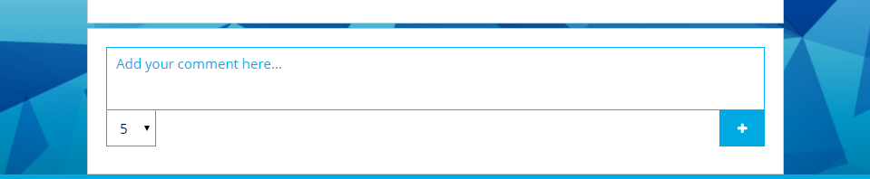

***Insert Comment***

Here are the rules that you must follow to create your project:

1. Use appropriate software for this subject based on **Sistem Praktikum** that can be downloaded from Binusmaya.
2. Collect appropriate files for this subject based on **Sistem Praktikum** that can be downloaded from Binusmaya.
3. Include the other files that can support your project, such as:
   * All files in your project
   * Other files (image, audio, video, etc.) used in your project
   * *.DOC file (documentation of your project) that contains all pages in your project, reference links of additional files (image, audio, video, etc.) used in your project, the description about how to use your application, etc

**References Link:**

Welcome - http://huntersville.discoveryplacekids.org/assets/images/_visit/overview/welcome.HKjAzA&ust=1471676386389291

Mousepad - http://img.technofare.com/2015/07/steel-series.jpg

Mouse - http://assets.razerzone.com/eeimages/products/293/razer-taipan-gallery-5-black.png

Keyboard - http://assets.razerzone.com/eeimages/products/76/razer-tron-keyboard-gallery-2.png

Baju - http://gloimg.rosewholesale.com/ROSE/2015/201507/source-img/1436466658259-P-2819655.jpg?01

Kursi - https://s4.bukalapak.com/img/485280951/large/1.jpg

Teleskop - http://www.rmolsumsel.com/images/berita/normal/515902_04314818022016_teleskop.jpg

Headset - http://www.144hzmonitors.com/wp-content/uploads/2015/11/Sentey-GS-4730-814x1024.jpg?d2b74a

Sofa - http://content.blueport.com/ProductImages/0/95434.jpg

Dasi - https://2.bp.blogspot.com/-htzvx0wjM-U/UXl93Rl1nCI/AAAAAAAAAkQ/mtzqQWxYgvQ/s1600/dasi+cara+mengikat.jpg

Kacamata - http://4.bp.blogspot.com/-y_mxHFmQ1T8/VO8XcK7gjOI/AAAAAAAACE0/nEbH4o7zBWw/s1600/Harga%2BKacamata%2BMinus.PNG

Celana - http://store.pakaianfashionpria.com/736-thickbox_default/celana-pendek-jeans-pria-cp058.jpg

Ikat pinggang - http://ganlob.com/wp-content/uploads/2013/06/burberry-630x350.jpg

jaket - http://static1.squarespace.com/static/560a1c09e4b0b632352d71dd/t/56283edfe4b052cf19157c66/1445478114125/?format=500w

Tas - http://3.bp.blogspot.com/-R84sf6RyPGc/Uv9Ia4FKo3I/AAAAAAAAA6Q/uiCacdHvc64/s1600/Tas+eiger+2154.jpg

Sarung tangan - http://www.peralatangunung.com/sarungtangan/polar2001-800x800.jpg

Topi - http://sarangsepatu.com/upload/M67896_topi_adidas_20150621002507.jpg

Boneka - https://encrypted-tbn0.gstatic.com/images?

Monitor - https://images-na.ssl-images-amazon.com/images/I/81jZu8IN%2BYL._SL1500_.jpg

Sepatu - http://sepatucibaduyut.web.id/toko/537-658-thickbox/sepatu-sekolah-e-054.jpg

Nametag - https://cdn.vectorstock.com/i/composite/01,18/name-tag-vector-1090118.jpg

Powerbank - http://global.mifile.cn/webfile/globalimg/my/2014/main/dianyuan/home-body-product.jpg?20131217

USB Cable - http://i.telegraph.co.uk/multimedia/archive/02755/microUSB858_2755791b.jpg

Flashdisk - http://1.bp.blogspot.com/-63jIzPxXaYI/UkGDfE7kwzI/AAAAAAAABn0/Q1ibCq639YE/s1600/flash-disk1.png

Harddisk : http://i602.photobucket.com/albums/tt106/noozle369/seagate-freeagent-goflex-external-hard-drive.jpg

Ronaldo : http://rs32.pbsrc.com/albums/d29/Dixelcut/CristianoRonaldo_zps44c704bb.png~c200

Business Man : http://pngimg.com/upload/businessman_PNG6557.png

Blue Polygonal : https://www.google.com/url?sa=i&rct=j&q=&esrc=s&source=images&cd=&cad=rja&uact=8&ved=0ahUKEwi9oOKU6NnOAhXBp48KHcbaAzoQjRwIBw&url=http%3A%2F%2Fwww.freepik.com%2Ffree-vector%2Fpolygonal-blue-background_805095.htm&bvm=bv.130731782,d.c2I&psig=AFQjCNGTwc8N5N-yNW7mgXV1x_ZG5iSh7Q&ust=1472119648002374

Business Girl : http://www.garciayanta.es/wp-content/uploads/revslider/home1/busineswoman.png

Business Woman : http://vignette1.wikia.nocookie.net/camphalfbloodroleplay/images/2/2a/Business-Woman.gif/revision/latest?cb=20131106232030

Justine Bieber : http://www.pngall.com/wp-content/uploads/2016/06/Justin-Bieber-PNG-Image.png

Riki : http://www.dota2.cz/files/images/gallery/riki-model.png