**Name: Golnaz Zolfaghari**

**Phone:647-830-7309**

**Email:** [**golnaz.zolfaghari@gmail.com**](mailto:golnaz.zolfaghari@gmail.com)

**Q1. Build and Develop a CloudFormation Template to deploy following AWS Resources**

**Github:**

[**https://github.com/golzolfa/Golnaz-FinalExam-29May2024.git**](https://github.com/golzolfa/Golnaz-FinalExam-29May2024.git)

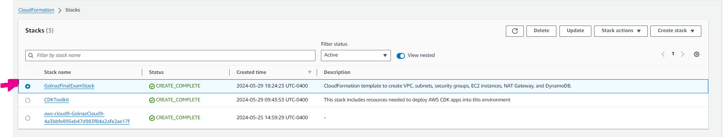

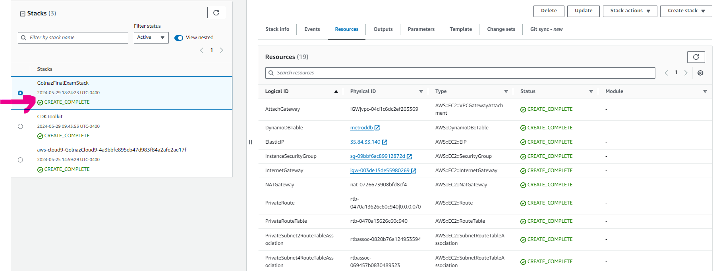

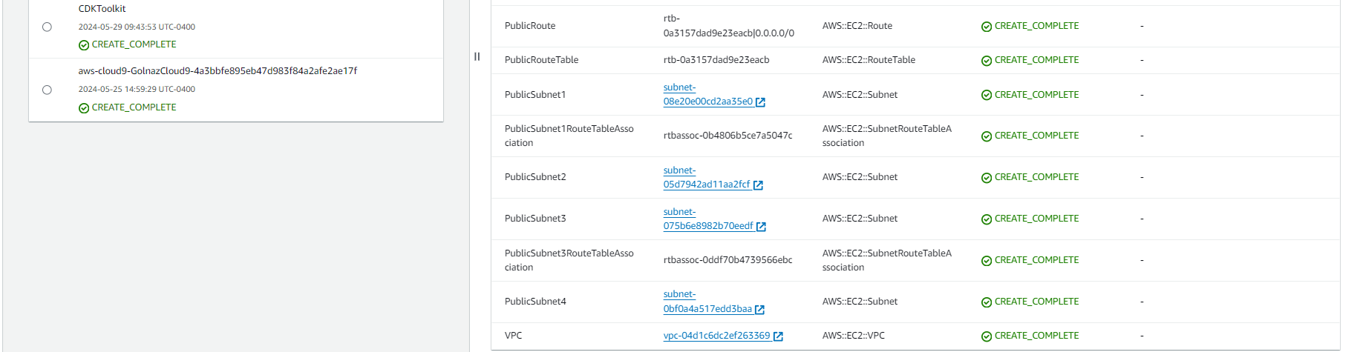

**Q2. Build and Develop a Terraform Template to deploy following AWS Resources**

**Github:**

[**https://github.com/golzolfa/Golnaz-FinalExam-29May2024.git**](https://github.com/golzolfa/Golnaz-FinalExam-29May2024.git)

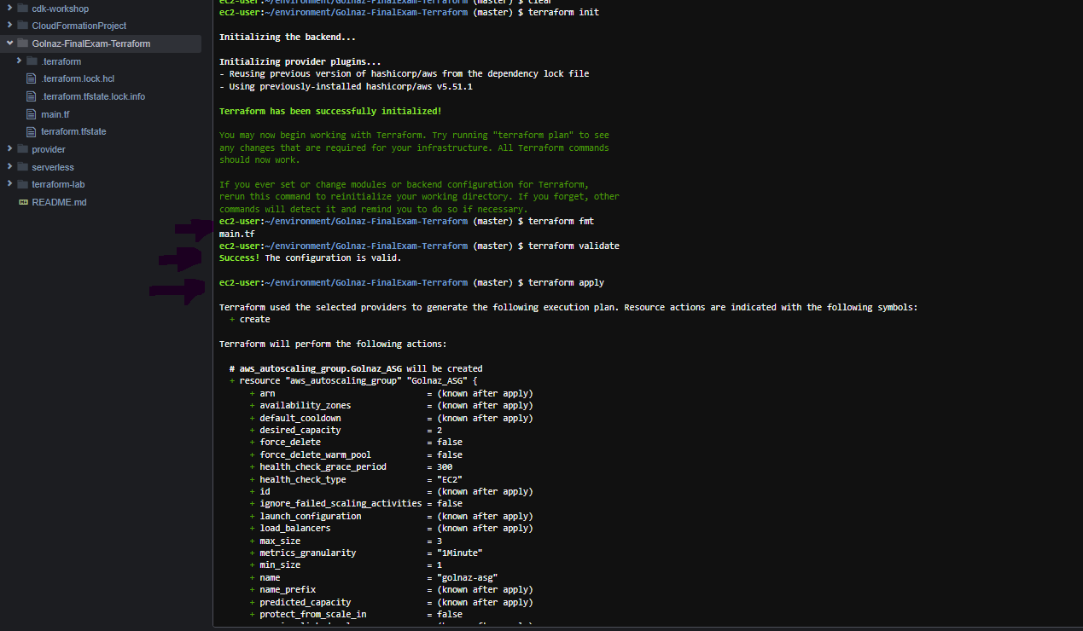

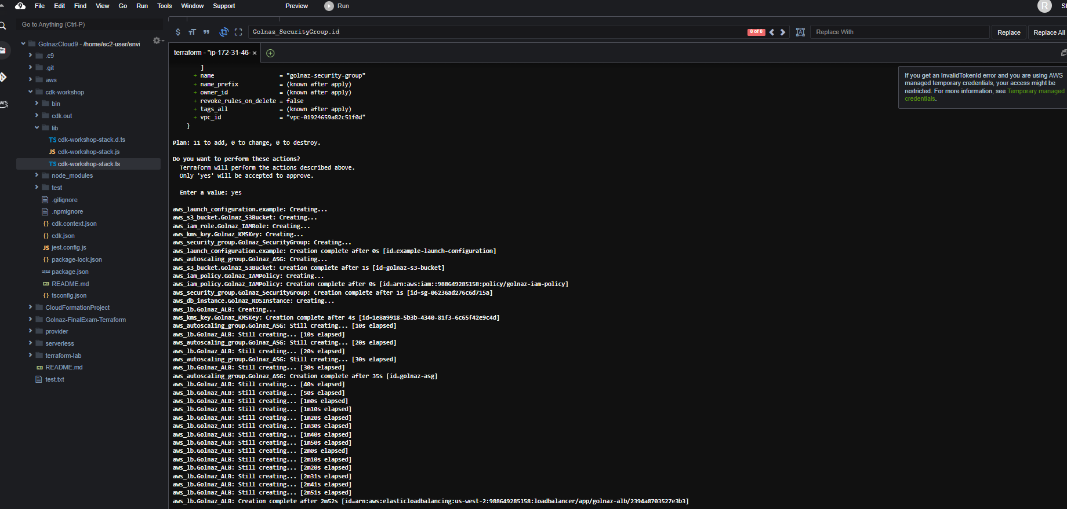

**Q3: Build and Develop a CDK Template to deploy following AWS Resources**

**Github:** [**https://github.com/golzolfa/Golnaz-FinalExam-29May2024.git**](https://github.com/golzolfa/Golnaz-FinalExam-29May2024.git)

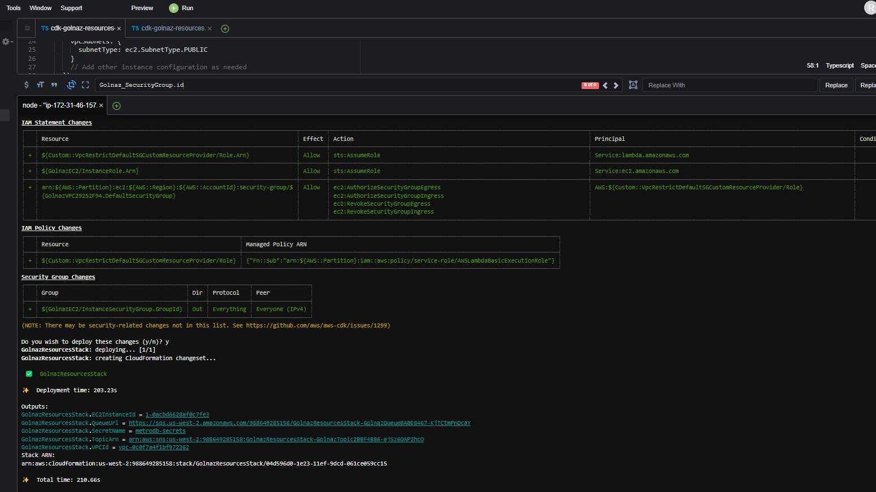

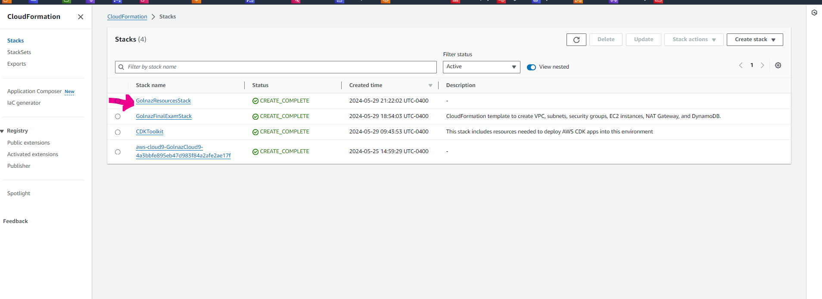

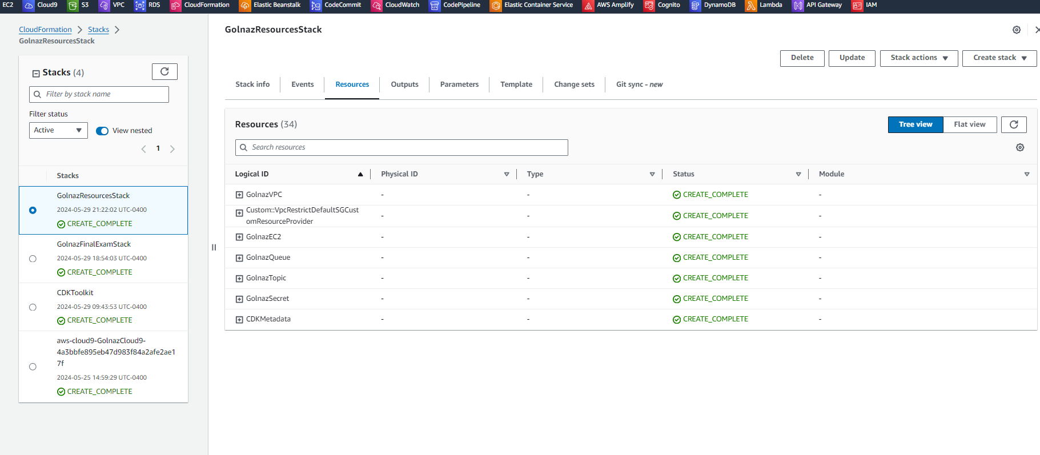

**Q4. Screenshot**

I am trying to solve this question, but this question is very old, and in the new version of AWS, we don't have the VPC Wizard.  
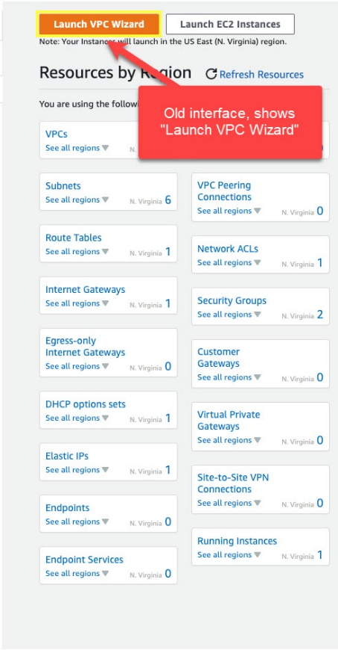 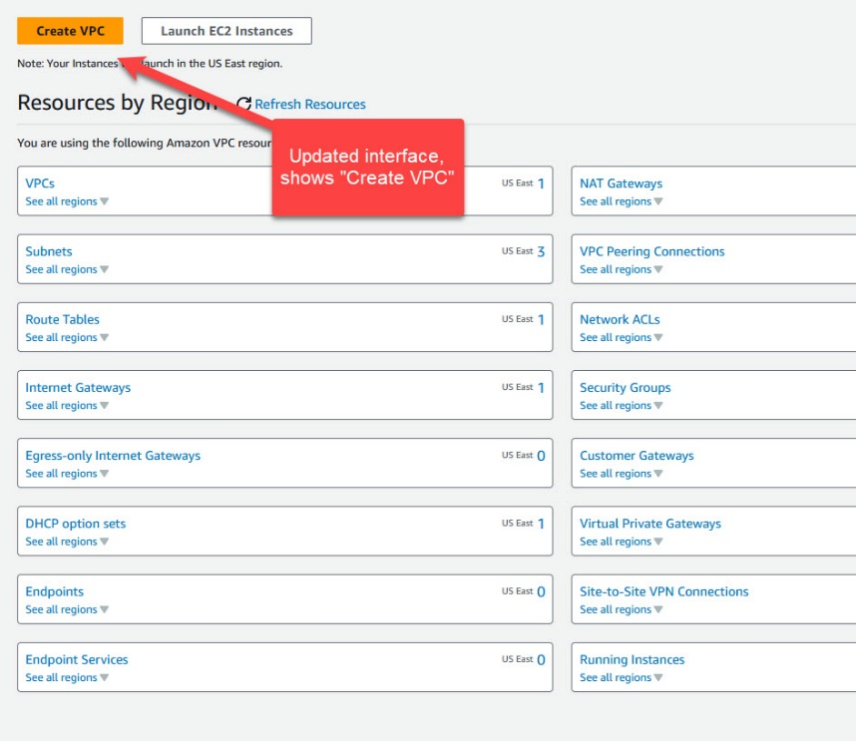

I also tried to do it this way, but I didn't find any place to replace the Elastic IP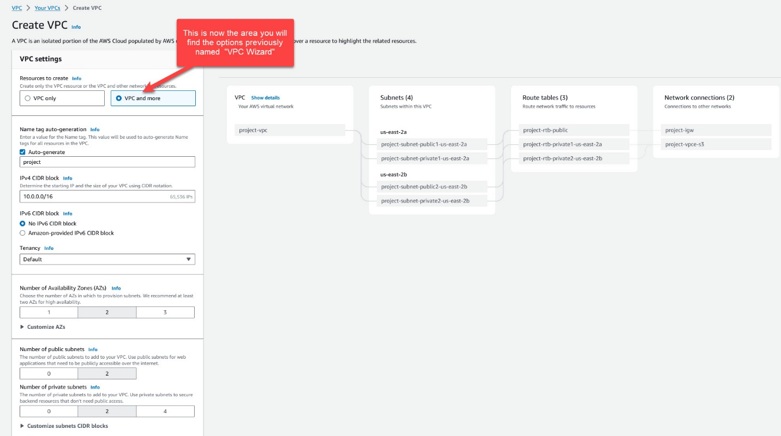

**Q5. Screenshot**

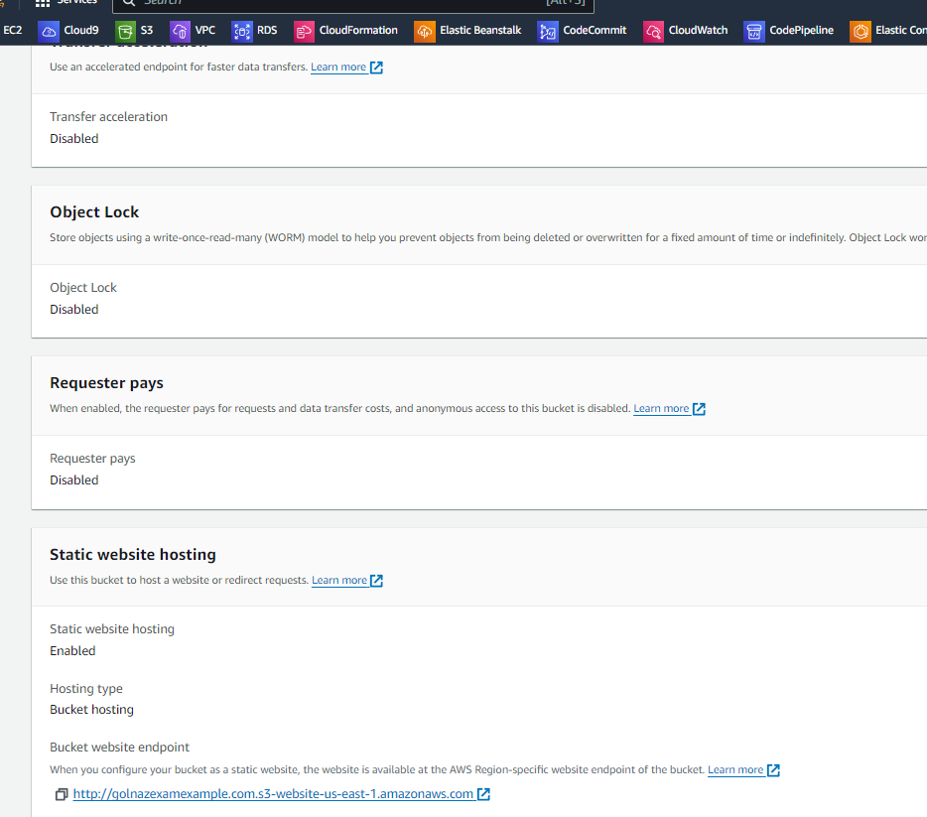

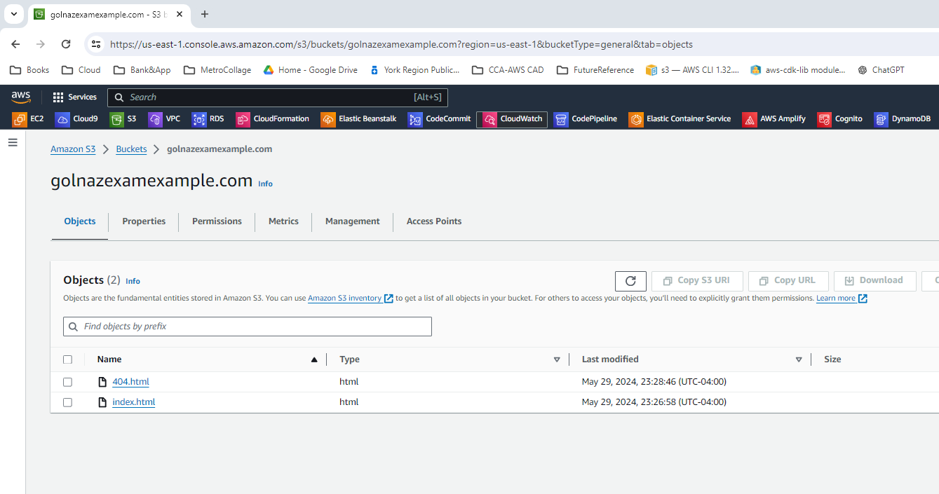

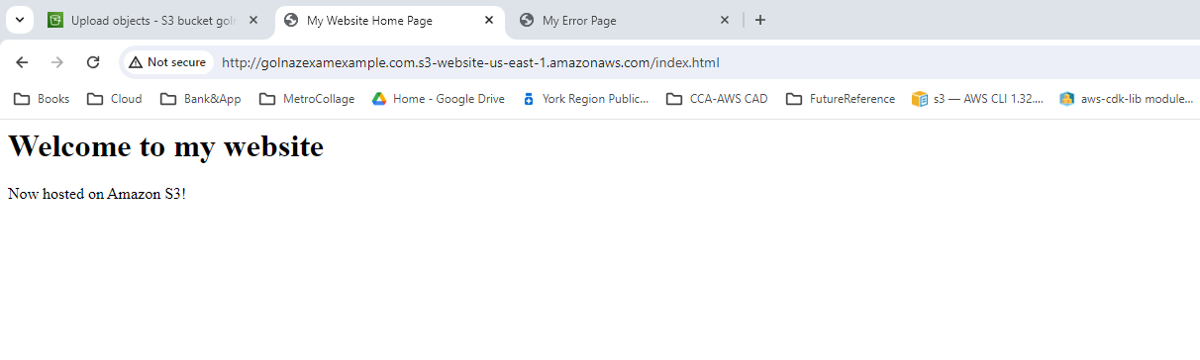

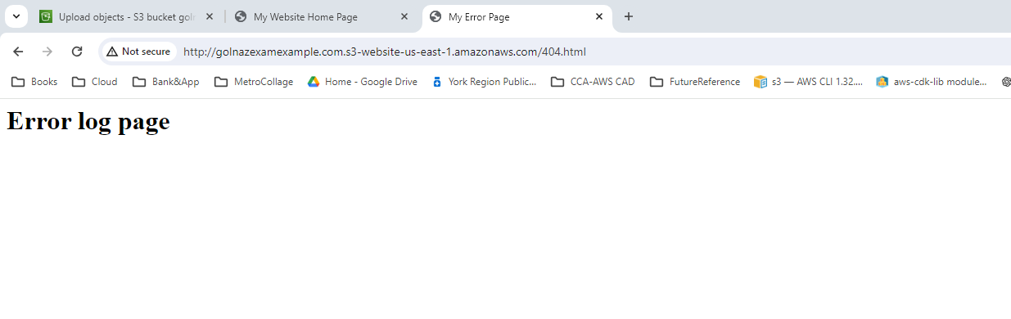

**Q6. Screenshot**

