AI Student Support Assistant
Agentic AI Project Report

1. Project Overview

Problem Statement
College students and staff routinely ask the same repetitive questions — about academic regulations, syllabus content, examination rules, attendance policies, fee deadlines, and campus notices — that are already documented but scattered across handbooks, circulars, and department notice boards. Locating the right information takes time, and administrative staff and faculty are frequently interrupted with queries that a well-grounded assistant could answer directly, delaying responses to more complex student needs.

Brief Description of the Project
The AI Student Support Assistant is a conversational agent that answers college-related questions by grounding its responses in the institution's own regulations, syllabus documents, FAQs, and notices. Rather than giving generic or hallucinated answers, the agent retrieves the relevant official document, reasons over it, and responds with an accurate, cited answer — while remembering context across a conversation so students don't have to repeat themselves.

2. Objectives & Proposed Solution

Project Objectives
- Build a conversational agent that accurately answers college-related questions
- Ground responses in real institutional documents using Retrieval-Augmented Generation (RAG)
- Use tools to fetch live information such as notices, deadlines, or timetable updates
- Retain conversational context so follow-up questions are understood correctly
- Provide a clean, working demo of the end-to-end system

How the Agentic AI Solution Works
The system combines three core capabilities into a single agentic workflow:
RAG (Retrieval-Augmented Generation): Retrieves the relevant sections of regulations, syllabus PDFs, FAQs, and notices from a vector-indexed knowledge base to ground every answer in the college's actual documentation.
Tools: Callable functions such as looking up the current notice board, checking exam or fee-deadline dates, fetching timetable entries, and searching specific syllabus units.
Memory: Retains context within and across sessions so the assistant remembers what a student already asked — for example, their department or semester — and doesn't require it to be repeated.

Key Features
- Accurate, document-grounded answers instead of generic responses
- Handles regulation, syllabus, FAQ, and notice queries in one place
- Remembers student context (department, semester) across the conversation
- Cites the source document/section for transparency
- Simple chat interface accessible to any student

3. Implementation & Results

Technologies / Tools Used
Category | Tools / Technologies
LLM / Reasoning | Claude (Anthropic API) — powers the agent's reasoning and conversation
Retrieval (RAG) | Vector database (Chroma / FAISS / Pinecone) for embedding and retrieving college documents
Tools / Actions | Custom Python/Node functions for notice lookup, deadline checks, and timetable/syllabus search
Interface | Web-based chat UI (React or Streamlit)
Data | College regulations, syllabus PDFs, FAQs, and notice archive

Working Process
Design: Defined scope and identified the top recurring student queries (regulations, syllabus, exam rules, fee deadlines, notices).
Knowledge Base + RAG: Collected college regulations, syllabus documents, and FAQs; chunked and embedded them; built and tested a retrieval pipeline for accuracy.
Tools Integration: Implemented callable tools for notice lookup, deadline checks, and timetable/syllabus search.
Integration & Testing: Connected RAG, tools, and memory into a single pipeline with a chat interface; ran end-to-end test scenarios across departments and semesters.
Polish & Evaluation: Refined the interface and evaluated the system against defined success metrics.

Output
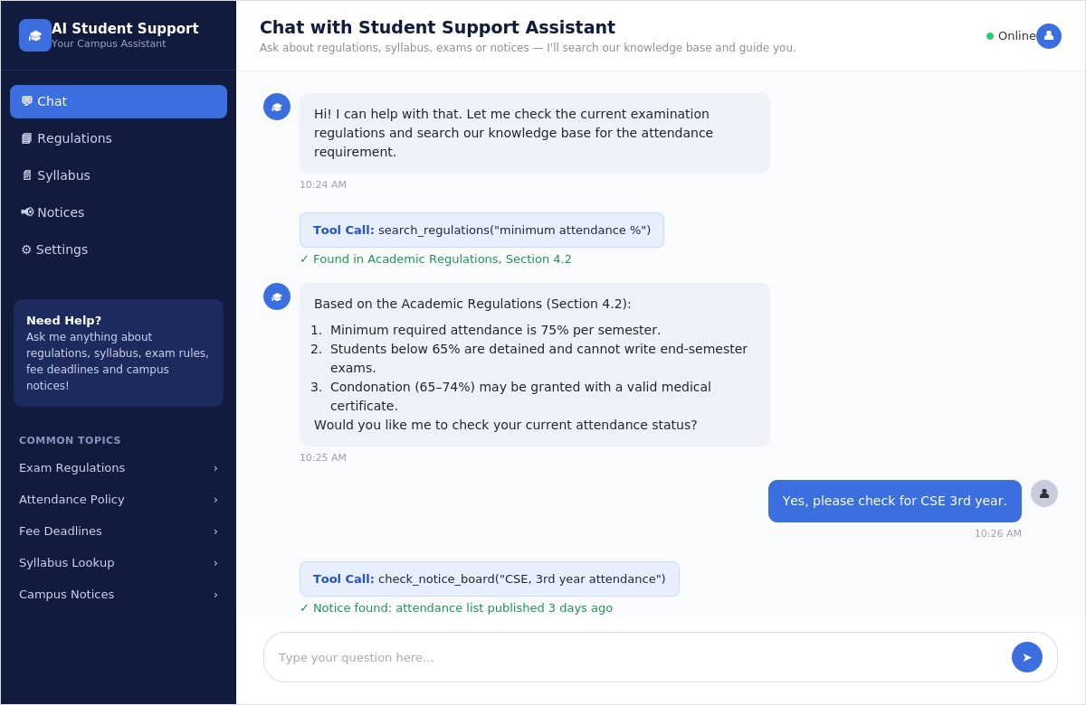
AI Student Support Assistant — chat interface demo

Results Achieved
The system was evaluated against the following targets:
Metric | Target / Expected Result
Answer accuracy | Correctly answers ≥ 85% of test questions grounded in college documents
Retrieval accuracy | Relevant document/section retrieved in top-3 results for ≥ 85% of test queries
Context retention | Correctly recalls student-provided context (e.g., semester) across ≥ 90% of follow-ups
Response quality | Clear, well-cited answers rated helpful by evaluators
Coverage | Handles queries across regulations, syllabus, FAQs, and notices without gaps

4. Conclusion & Future Scope

Project Conclusion
The AI Student Support Assistant demonstrates how combining RAG, tool calling, and memory can automate a meaningful share of routine student queries. By grounding responses in the college's own regulations, syllabus, and notices, the system gives students faster, self-service answers while reducing repetitive interruptions for faculty and administrative staff.

Challenges Faced
- Keeping the knowledge base current as regulations and notices are updated
- Ensuring answers cite the correct document version when policies change across years
- Handling ambiguous queries that span multiple departments or semesters

Future Enhancements
- Auto-sync the knowledge base with the college's official notice board and website
- Add multi-language support for a broader student base
- Integrate with the student portal for personalized, login-based answers
- Expand memory to persist across sessions for returning students
- Add an analytics dashboard to track common query trends over time

References
- Anthropic Claude API Documentation
- Internal college regulations, syllabus, and FAQ documentation (sample/curated dataset)
- Vector database documentation (Chroma / FAISS / Pinecone)

