# Cloud Computing Lab

# List of Experiments

1. Working with Google Drive to make spreadsheet and notes.

2. Launch a Linux Virtual Machine.

3. To host a static website.

4. Exploring Google cloud for the following a) Storage b) Sharing of data c) manage your calendar, to-do lists, d) a document editing tool.

5. Working and installation of Google App Engine.

6. Working and installation of Microsoft Azure.

7. To Connect Amazon Redshift with S3 bucket.

8. To Create and Query a NoSQL Table.

**Working with Google Drive to make spreadsheet and notes.**

Experiment No. 1

Objective: Working of Google Drive to make spreadsheet and notes.

Requirement: Google account, Internet Connection.

**Google Drive**

Google Drive is a file storage and synchronization service developed by Google. Launched on April 24, 2012, Google Drive allows users to store files in the cloud, synchronize files across devices, and share files.

Google Docs is a free cloud-based suite of tools for creating documents, spreadsheets, presentations, and more. This tutorial will cover the Spreadsheets application in Google Docs, in addition to showing you how to access and store your Docs from Google Drive.

Google Docs, Sheets, and Slides are productivity apps that let you create different kinds of online documents, work on them in real time with other people, and store them in your Google Drive online — all for free. You can access the documents, spreadsheets, and presentations you create from any computer, anywhere in the world. (There's even some work you can do without an Internet connection!) This guide will give you a quick overview of the many things that you can do with Google Docs, Sheets, and Slides.

**Google Docs**

Google Docs is an online word processor that lets you create and format text documents and collaborate with other people in real time. Here's what you can do with Google Docs:

• Upload a Word document and convert it to a Google document

• Add flair and formatting to your documents by adjusting margins, spacing, fonts, and colors — all that fun stuff

• Invite other people to collaborate on a document with you, giving them edit, comment or view access

• Collaborate online in real time and chat with other collaborators — right from inside the document

• View your document's revision history and roll back to any previous version

• Download a Google document to your desktop as a Word, OpenOffice, RTF, PDF, HTML or zip file

• Translate a document to a different language

• Email your documents to other people as attachments

**Google Sheets**

Google Sheets is an online spreadsheet app that lets you create and format spreadsheets and simultaneously work with other people. Here's what you can do with Google Sheets:

• Import and convert Excel, .csv, .txt and .ods formatted data to a Google spreadsheet

• Export Excel, .csv, .txt and .ods formatted data, as well as PDF and HTML files

• Use formula editing to perform calculations on your data, and use formatting make it look the way you'd like

• Chat in real time with others who are editing your spreadsheet

• Create charts with your data

• Embed a spreadsheet — or individual sheets of your spreadsheet — on your blog or website

**Google Slides**

Google Slides is an online presentations app that allows you to show off your work in a visual way. Here's what you can do with Google Slides:

• Create and edit presentations

• Edit a presentation with friends or coworkers, and share it with others effortlessly

• Import .pptx and .pps files and convert them to Google presentations

• Download your presentations as a PDF, a PPT, or a .txt file

• Insert images and videos into your presentation

• Publish and embed your presentations in a website

**Create, name or delete a Google document**

**Create a Google document**

To create a new document, go to your Drive, click the Create button, and select Document.

A window with a new Google document will open, and you'll be able to edit the document, share it with other people, and collaborate on it in real-time. Google Docs saves your document automatically, and you can always access it from your Drive.

**Name a document**

When you create a new document, Google Docs will name it Untitled by default.

To choose a name other than Untitled, click the File menu, and select Rename. From here you can choose and confirm your document's title. You can also edit the name by clicking the title displayed at the top of the page, and making your changes in the dialog that appears.

Titles can be up to 255 characters long.

**Delete a document**

Delete an item that you own from your Drive

1. From your Drive, select the item(s) you want to delete.

2. From the More menu, choose Move to trash.

3. If you're deleting a shared document that you own, you'll see an option to change the ownership of the document.

4. The item will be moved to the Trash.

5. To purge individual items from Trash, select them and choose Delete forever. To purge all your items click Empty Trash in the upper left.

**Create and save a document**

There are different ways of getting started using Google documents: you can create a new online document, you can upload an existing one, or you can use a template from our templates gallery.

To create a new document, go to your Drive, click the red Create button, and select Document from the drop-down menu.

As soon as you name the document or start typing, Google Docs will automatically save your work every few seconds. At the top of the document, you'll see text that indicates when your document was last saved. You can access your document at any time by opening your Drive at http://drive.google.com.

To save a copy of a document to your computer, you can download it. In your document, go to the File menu and point your mouse to the Download as option. Select one of the following file types: HTML (zipped), RTF, Word, Open Office, PDF, and plain text. Your document will download to your computer.

**Upload a document**

You can upload existing documents to Google documents at any time. When you're uploading, you can either keep your document in its original file type or convert it to Google Docs format. Converting your document to Google Docs format allows you to edit and collaborate online from any computer.

Note: When uploaded, images within a document are left as images (rather than being converted to text by Optical Character Recognition technology).

You can upload the following file types:

• .html

• .txt

• .odt

• .rtf

• .doc and .docx

• .pdf

Follow these steps to upload a document:

1. Click the Upload icon in the top left of your Documents List.

2. Click Files..., and select the document you'd like to upload.

3. Click Open.

4. Check the box next to 'Convert documents, presentations, spreadsheets, and drawings to the corresponding Google Docs format' if you'd like to be able to edit and collaborate on the document online. Uploaded document files that are converted to Google documents format can't be larger than 1 MB.

5. Click Start upload. The uploaded file will appear in your Documents List.

1. How to share spreadsheet to the team members
2. Sharing spreadsheets through social media
3. Sharing spreadsheets through Gmail
4. Adding sheets
5. Removing sheets
6. Entering data
7. Inserting links
8. Using functions for google sheets
9. Accessing all functions of google sheets
10. Changing font and font size
11. Merge cells
12. Protecting sheets
13. Downloading

**1. Create a Spreadsheet and Fill It With Data**

There are 3 ways to create a new spreadsheet in Google Sheets:

1. Click the red "NEW" button on [Google Drive dashboard](https://drive.google.com/) and select "Google Sheets"
2. Open the menu from within a spreadsheet and select "File > New Spreadsheet"
3. Click "Blank" or select a template on the [Google Sheets](https://sheets.google.com/) homepage

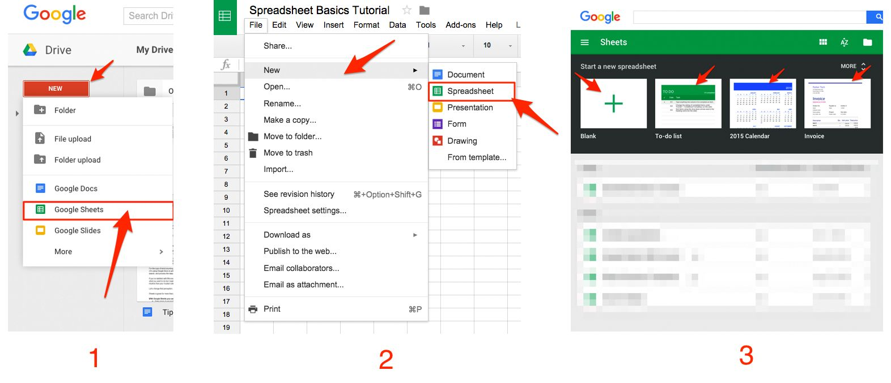

This will create a new blank spreadsheet (or a pre-populated template if you choose one of those, start with a blank spreadsheet.

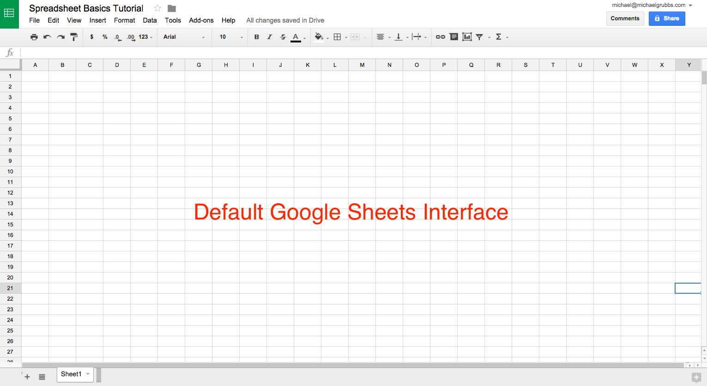

**2. Adding Data to Your Spreadsheet**

1. Press **ENTER** to save the data and move to the **beginning** of the next row
2. Press **TAB** to save the data and move **to the right** in the same row
3. Use the **ARROW KEYS** on your keyboard (up, down, left, and right) to **move 1 cell in that direction**
4. **Click any cell** to jump **directly to that cell**
5. Copy and paste a list of text or numbers into your spreadsheet
6. Copy and paste an HTML table from a website
7. Import an existing spreadsheet in csv, xls, xlsx and [other formats](https://support.google.com/docs/answer/40608?hl=en)
8. Copy any value in a cell across a range of cells via a *click and drag*

To import a file from outside of your Google Drive, go to the **FILE > IMPORT > UPLOAD** menu.

**Format Data for Easy Viewing**

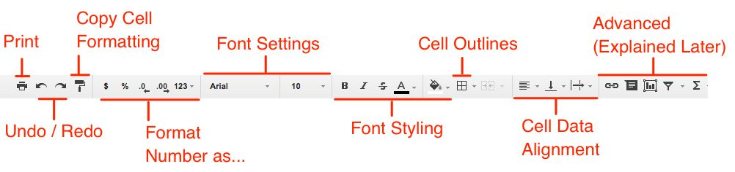

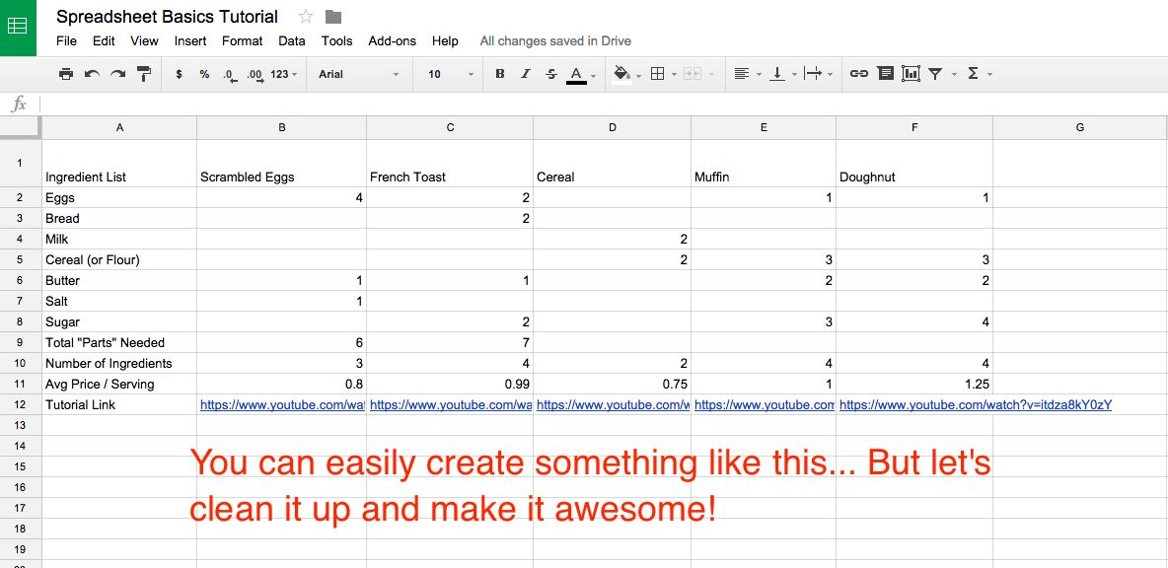

Freeze

**"Freeze" the first row** in place. That means if we scroll down the spreadsheet, the first row will still be visible, no matter how much data lies below it. This allows you to have a long list and helps to keep tabs on what you’re actually looking at.

here are two ways to freeze rows:

1. Click **VIEW > FREEZE > 1 ROW** in the navigation bar to lock the first row in place
2. Hover the dark grey bar in the top left of the spreadsheet (until it becomes a hand) and drag between rows 1 and 2

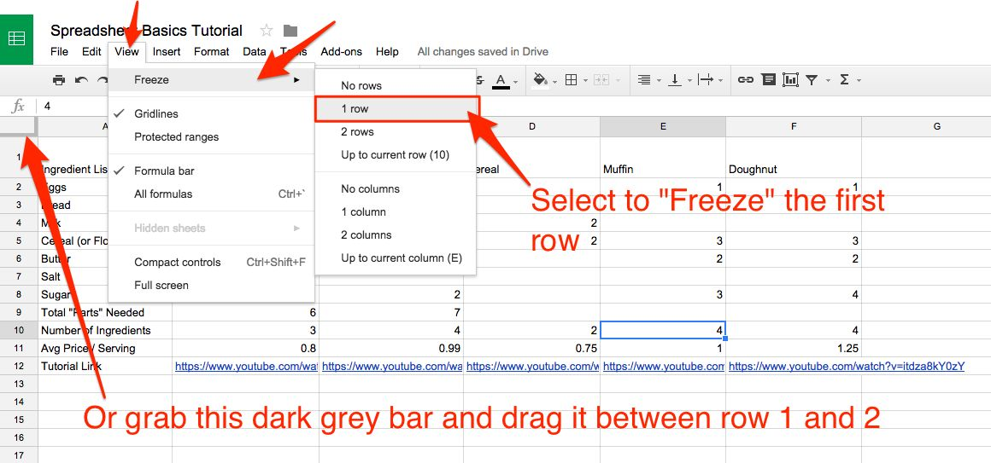

simple text formatting

1. Drag to select the cells you want to format
2. Bold the text
3. Increase font size to 12pt
4. Center-align the whole row
5. Give give your cells a grey fill

**Add, Average, and Filter Data with Formulas**

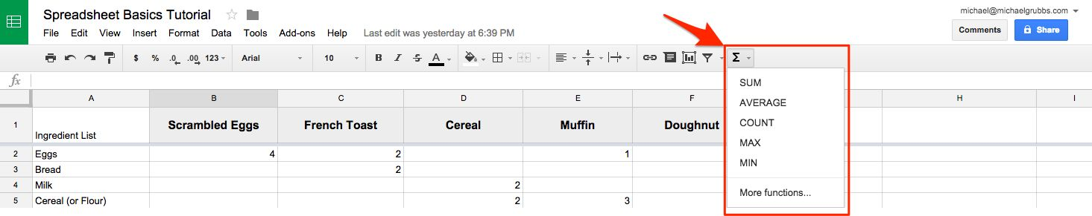

There are three ways to use the basic formulas accessible via the top navigation:

1. **Select a range** then **click the formula** (this will put the result either below or to the side of the range).
2. **Select the result cell** (i.e. the cell where you want the result to appear), then **click on the formula** you want to use from the toolbar. Finally, select the range of cells to perform your operation on.
3. **Type the formula** into the result cell (don't forget the = sign) then either manually type a range or select the range