AIPC
Automatic Intelligent Phase Changeover
Keeps Your Loads Running From a Healthy Phase — Automatically, and With Balanced Loading

What AIPC Does
AIPC watches all three incoming phases all the time. If one phase becomes bad — the voltage goes too high or drops too low — AIPC moves the loads on that phase over to a phase that is still good. Your equipment keeps running. Nobody has to touch anything.
What makes AIPC intelligent is how it picks the replacement phase. It looks at how much load each good phase is already carrying and shifts the work to the one carrying less. So the changeover does not simply move the problem onto a phase that is already heavily loaded.
When the bad phase becomes normal again, AIPC gives its loads straight back to it. And if two phases fail at the same time, the one remaining good phase is used to feed all three outputs, so the whole installation stays alive instead of two thirds of it going dark.
AIPC is also a complete three-phase energy meter and a connected device. It measures Voltage (V), Current (I), Active Power (P) and Energy (E) on every phase, shows everything on its own built-in web page and on the EVIQtech IoT mobile app, keeps a permanent event log inside the unit, sends data to the EVIQtech Cloud, and can be updated remotely — all without a site visit.
Key Highlights
Automatic phase changeover | A bad phase is transferred to a good phase on its own — no operator, no downtime
Intelligent source choice | The good phase carrying less load is chosen, so loading stays balanced
Runs on one phase if needed | A single good phase can feed all three outputs
Fast decision | Voltage of all three phases is re-checked every mains cycle
Automatic restoration | Loads go back to their own phase as soon as it is normal again
Adjustable thresholds | Factory settings of 170 V – 270 V can be changed by the user at any time
Safe switching | Contactor feedback is confirmed before any operation; contactors are also electrically interlocked
3-phase energy metering | Voltage, Current, Active Power and Energy measured on each phase separately
Web page + mobile app | Built-in web dashboard, plus the EVIQtech IoT app on your phone
Cloud connected | Live data, graphs and history on the EVIQtech Cloud — set up with just an e-mail
Remote firmware update | Both processors inside the unit can be updated over the internet
Works without internet | Everything except cloud reporting keeps working when the internet is down

Where AIPC is used: homes, shops, offices and apartment sub-boards; commercial and industrial distribution panels; areas with weak or unreliable supply; telecom and CCTV cabinets; lifts, pumps, cold rooms and any place where losing one phase must not stop the work.

HOW AIPC WORKS

Step 1 — AIPC Checks Whether Each Phase Is Good or Bad
Every incoming line (R, Y and B) has its own voltage measurement. AIPC calculates the true RMS voltage of each phase every mains cycle, then averages it over a few cycles. This is why AIPC reacts quickly to a real supply problem, but a single spike or a noisy reading can never cause an unnecessary changeover.
Condition | What AIPC Does
Good (healthy) phase | Voltage between 170 V and 270 V. The phase keeps feeding its own loads normally.
Voltage too high | Above 270 V — a surge or a neutral problem. The phase is treated as bad and its loads are moved away.
Voltage too low | Below 170 V — a brown-out or a missing phase. The phase is treated as bad and its loads are moved away.
Phase recovers | As soon as the voltage comes back inside the good range, the phase is treated as good again and gets its own loads back.

170 V and 270 V are the factory (default) settings — they are not fixed. The user can raise or lower both limits at any time from the Protection page of the built-in web dashboard or the mobile app, and the new values are stored inside the unit.
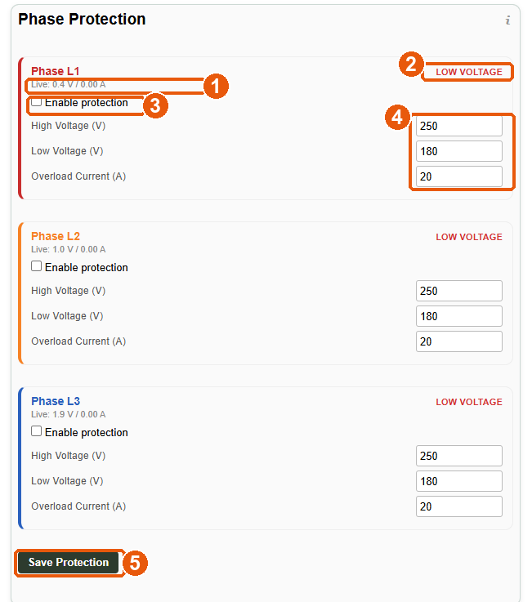
Figure 1 — Protection page, showing the default limits for Phase L1, L2 and L3
1 live voltage and current of the phase 2 present status of the phase 3 enable protection on this phase 4 your own High Voltage, Low Voltage and Overload Current limits 5 save
Step 2 — AIPC Chooses the Best Replacement Phase
This is the difference between AIPC and an ordinary changeover relay. When a phase goes bad, AIPC does not simply grab the first good phase it finds. It measures how much current the good phases are actually drawing and transfers the loads to the phase that is carrying less. What you get from that:
- Balanced loading — the remaining phases share the extra load instead of one being pushed to its limit while the other stays almost idle.
- Better voltage at the load — a lightly loaded phase holds its voltage better, so the transferred equipment gets a healthier supply.
- Longer life for your wiring — even loading means less heating in the cables and the contactors, and fewer nuisance trips.

SAFE, RELIABLE CHANGEOVER

Step 3 — Even One Good Phase Keeps Everything Running
If two of the three phases fail together, AIPC does not shut the installation down. The one phase that is still good is connected across to support the other two outputs as well, so all three sections of the board stay energised from that single healthy source. The moment either failed phase comes back to normal, its own supply is handed back to it and the temporary support is released — again, automatically.
Note for the installer: when one phase is supporting all three outputs, the total load is carried by that phase alone. Size the incoming cable and the phase rating accordingly, or arrange for non-essential loads to be switched off during this condition.
Step 4 — Switching Is Confirmed, Not Assumed
AIPC never fires a contactor blindly. Before it operates any contactor, it reads back the feedback from that contactor to confirm its real position. Only when the feedback agrees does the next step happen. There is no fixed waiting time built into the sequence — the controller moves as soon as the contactor has genuinely changed state, which makes the changeover both faster and safer than a timer-based design.
- Break before make — the bad phase's own contactor and all its cross-connections are opened first, and their feedback is confirmed open, before any new source is connected.
- Failed contactor detected — a contactor that is stuck, welded or has lost its coil supply does not go unnoticed, because the commanded state and the feedback state will not agree.
- Software interlock — the control logic allows only one source onto an output at a time, so two phases can never be connected together.
Electrical Interlock — Protection Built Into the Wiring
Software alone is not enough for something as serious as paralleling two phases, so AIPC is electrically interlocked as well. The contactors are wired so that the coil circuit of one contactor is broken by the auxiliary contact of the contactor it must never close with. In other words, the hardware itself physically prevents two different phases from being connected to the same output — even in the unlikely event of a controller fault, a wrong command, a software problem or a mistake during maintenance.
- Two independent layers — two sources onto one output is prevented in two independent ways: by the control logic and by the wiring.
- No dependency on firmware — the interlock is made from the contactors' own auxiliary contacts, so it works with no power to the controller at all.
- Protects the installation — phase-to-phase short circuits through the panel are ruled out by design, which protects the incoming supply, the panel and everything connected to it.
You Can Always See What It Is Doing
Every changeover is visible, both live and after the event. The Home page shows the present state of each phase and which source is feeding each output, and the Event Log inside the unit records each action with its date, time, voltage and current — for example 'Y Phase Low', 'Y Switched to B', 'Y Phase Normal Resume' and 'Y to B switching reverted'. The same information is also available in the mobile app and on the cloud dashboard.

PROTECTION FEATURES

Protection You Can Set Yourself
Along with the changeover function, each phase has its own protection limits that the user can set from the web dashboard or the mobile app. The values are saved inside the unit, so they survive power failures and firmware updates. Protection can be enabled phase by phase — you may protect all three, or only the ones that matter to you.
Setting | What It Does
High Voltage (V) | Upper voltage limit for the phase. Protects your equipment from supply surges and neutral faults.
Low Voltage (V) | Lower voltage limit for the phase. Protects motors, compressors, pumps and electronics from brown-out damage.
Overload Current (A) | Current limit for the phase. If the current on that phase crosses the limit, AIPC switches that phase OFF through its contactor, so the fault is isolated instead of being allowed to develop.
Enable protection | A simple tick box per phase. Untick it and that phase is monitored but not acted upon.
Live value shown | Each phase shows its present voltage and current right next to the limits, so you can set sensible values while looking at real numbers.
Values are checked | An out-of-range entry is refused, so protection can never be silently disabled by a typing mistake.
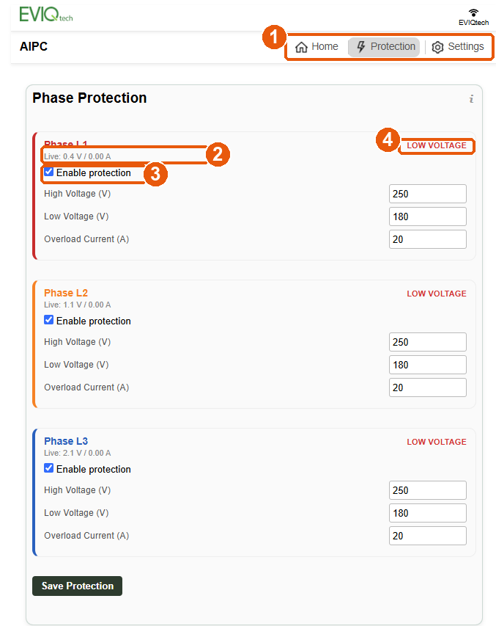
Figure 2 — Protection switched on for all three phases
1 Home, Protection and Settings pages 2 live voltage and current 3 protection enabled — the same tick box on every phase 4 present status of the phase
Where You See the Status
Each phase continuously reports its own condition — OK, HIGH VOLTAGE, LOW VOLTAGE, OVERLOAD or disabled — shown next to its present measured value. This status appears in two places: on the Home page for the live picture, and in the Event Log for the history, so you can see not only what is happening now but also what happened last night or last week.

MEASUREMENT & ENERGY

How AIPC Measures
AIPC uses a dedicated power-monitoring IC to obtain Voltage (V), Current (I), Active Power (P) and Energy (E). Because the measurement is done by a purpose-built metering IC rather than by the processor, the readings are accurate and consistent, and measurement is never disturbed by what the communication side of the device is doing.
- Voltage (V) — true RMS value of each phase. This is also what the changeover decision is based on.
- Current (I) — the actual current drawn on each phase. A small dead-band makes an idle line read a clean 0.00 A instead of showing sensor noise. This is also what AIPC uses to find the lightly loaded phase.
- Active Power (P) — the real power being consumed on each phase, so you can see loading at a glance.
- Energy (E) — consumption on each phase — explained below.
- Changeover position — which contactors are closed, so the present changeover position is always visible.
Energy: Per-Phase and Cumulative
AIPC keeps energy in two forms, and both are shown for every phase:
Reading | Meaning
Energy (E) | The energy counted for the phase in the present running period. If the power supply is interrupted, this value starts again from zero — so it tells you the consumption since the unit last powered up.
Cumulative energy (cE) | The lifetime total for that phase. This value is retained and keeps counting across power failures, so it is the figure to use for billing and for month-on-month comparison.
Total cumulative | The combined cumulative energy of all three phases together — the consumption of the whole installation in one number.
Because each phase is measured on its own, an unbalanced load, a weak phase or one overloaded line is visible individually — not hidden inside an average of the three.
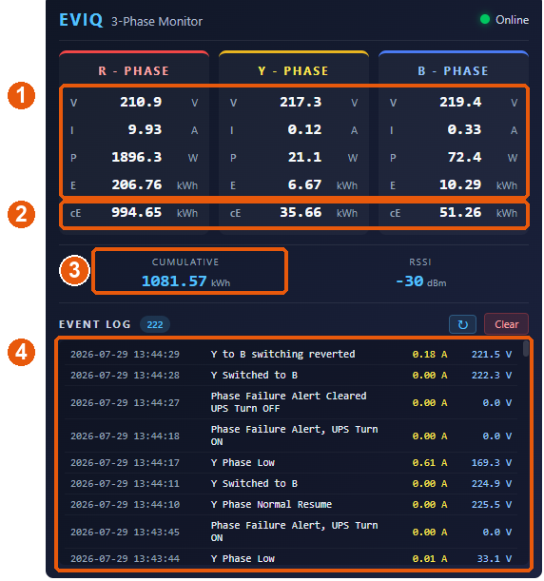
Figure 3 — Home page of the built-in dashboard, with all three phases live
1 Voltage, Current, Active Power and Energy of each phase 2 cumulative energy per phase (cE) 3 total for the whole installation 4 event log — every changeover with date, time, current and voltage

LOCAL ACCESS & BUILT-IN DASHBOARD

Reach the Unit From Your Own Phone or Laptop
AIPC creates its own Wi-Fi hotspot and joins your site Wi-Fi at the same time. This matters on site: the settings screen never disappears the moment the device goes online. You can always connect straight to the unit — even if the site router is switched off, the Wi-Fi password has been changed, or the network has not been installed yet.
- Its own Wi-Fi hotspot — named after the device, so several AIPC units in one building are easy to tell apart.
- Hotspot password — leave the hotspot open for quick commissioning, or set a password so only your team can reach it.
- Easy to open — once the unit is on your network, open it by name — for example http://AIPC.local — instead of hunting for an IP address. The page also shows the IP address and the device MAC address for your records.
- Reconnects on its own — the Wi-Fi details are stored inside the unit, and it reconnects by itself after a power cut or a router restart.
- Change it any time — Wi-Fi details can be changed or cleared completely from the Settings page, which returns the unit to a clean state for reuse elsewhere.
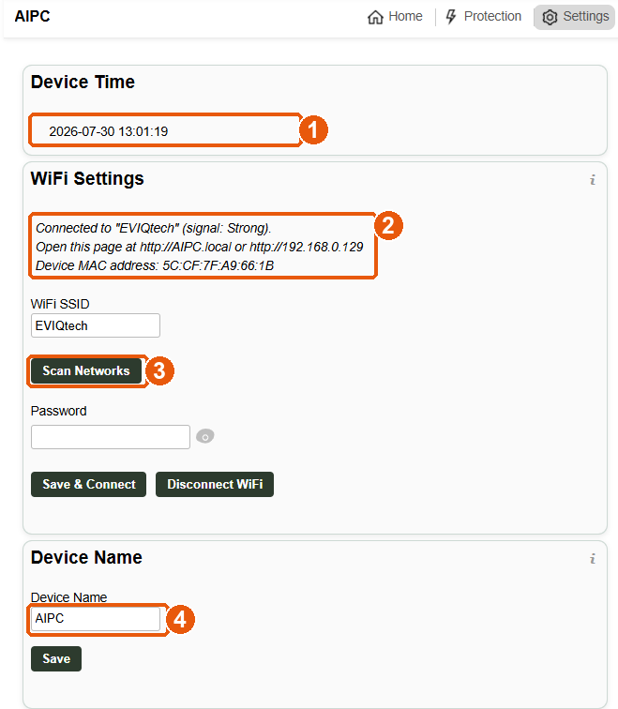
Figure 4 — Settings page — Wi-Fi and device identity
1 the unit keeps its own date and time 2 connection status and signal, the address to open the page, and the MAC address 3 scan for networks nearby 4 give the unit its own name
What You Can Do From the Dashboard
The whole dashboard is stored inside the device itself, so it opens instantly even on a network with no internet, and it cannot break because something on the internet changed.
Screen | What You Can Do
Home page | Live Voltage, Current, Power, Energy and cumulative Energy for all three phases, the installation total, which phase is feeding which output, and the live event log.
Protection page | Enable protection per phase and set High Voltage, Low Voltage and Overload Current limits.
Event log | Full history with date and time, refreshed on demand, with a Clear button.
Wi-Fi and name | Scan, connect, change or disconnect Wi-Fi; give the unit its own name; read the device time.
Firmware update | Update either processor inside the unit from a file, with live progress.
Security | Device PIN and hotspot password, with login and logout.

MOBILE APP & EVIQTECH CLOUD

EVIQtech IoT Mobile App
AIPC is supported by the EVIQtech IoT mobile app, so you do not have to stand in front of the panel with a laptop. From the app you can see the live readings of all three phases, check which phase is feeding which output, read the event history and follow energy consumption — from anywhere. One app handles all your AIPC units, each under the name you gave it.
Connecting to the Cloud Takes One E-Mail Address
There is nothing complicated to set up. Type your e-mail address into the EVIQtech Cloud box on the Settings page and press Connect to Cloud. The unit registers itself on the EVIQtech IoT platform over a secure connection, gets its own private credential and starts sending data. There are no keys to copy, no files to install and no steps for the installer to remember.
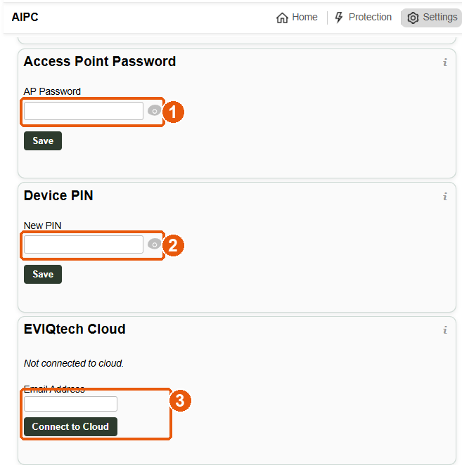
Figure 5 — Settings page — security and cloud connection
1 password for the unit's own Wi-Fi hotspot 2 device PIN that locks the settings 3 connect to the cloud with one e-mail address
What the Cloud Gives You
- Live data, automatically — Voltage, Current, Power and Energy of all three phases are sent regularly with the correct date and time, so nothing has to be read manually.
- Trend graphs and history — voltage and load are plotted over hours, days and months, so you can prove how bad your incoming supply really is, and see the effect of your loads.
- Alerts and event history — changeover actions, phase failures and restarts are reported to the cloud, and are held safely inside the unit while the internet is down and sent as soon as it returns — nothing is lost.
- One view of every unit — all your units in one place, each with its name, type and the firmware version it is running.
- You stay in control — the cloud link can be paused or disconnected at any time from the unit itself, and changeover, protection and metering carry on exactly as before.
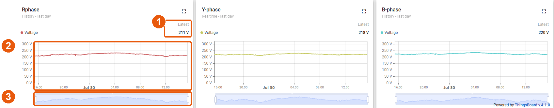
Figure 6 — EVIQtech Cloud dashboard — voltage history of the R, Y and B phases over a full day
1 latest voltage of the phase 2 how the supply voltage behaved through the day and night 3 any time window can be selected for reporting

ELECTRICAL DESIGN & CONSTRUCTION

AIPC is not only a clever controller — it is built as a complete, industrial-quality panel. The points below describe what is inside the product and why each choice matters to you.
Contactors and Switching
Item | Specification and Benefit
Contactors | 7 × L&T MNX-18 industrial contactors: 3 for the phase mains, 3 for the cross-connections between phases, and 1 for the UPS / standby source. These are standard, widely available industrial parts — not custom items.
Relay drive outputs | 11 relay outputs from the controller: 9 for the contactor circuits (3 mains and 6 cross-connection combinations, giving every phase a path to every output) and 2 for the UPS arrangement.
Electrical interlock | The contactors are interlocked through their own auxiliary contacts, so two phases can never be connected together even if the controller were to command it.
Easy replacement | Contactors are mounted so that a unit can be swapped out quickly with ordinary tools, using a standard part from any electrical supplier — no return to the factory.
Bypass arrangement | A bypass is provided so the supply can be maintained directly while service work is carried out on the controller or a contactor. Your loads do not have to be switched off for maintenance.
Ratings and Terminations
Item | Specification and Benefit
Current ratings | Available in 16 A, 32 A, 40 A and 63 A versions — choose the rating that matches your incoming supply and load.
Control supply | The 230 V AC input is converted internally to 12 V DC, and the whole controller side runs on that 12 V DC — a low, safe voltage.
Terminal blocks | High-quality ELMEX 16 sq mm DIN-rail terminal blocks — proper terminations for full-load cabling, easy to tighten and inspect.
Isolation and safety | The controller side is properly isolated from the power side and shock-proofed, so service staff can work on the low-voltage electronics safely.
Surge protection | A surge protector is fitted for lightning and switching-surge protection, guarding both AIPC and the loads behind it.
Enclosure | Rust-free, powder-coated panel — suitable for long service in Indian conditions, including humid and dusty locations.
Maintenance | Maintenance free in normal service. There is nothing to lubricate, calibrate or replace periodically.

ELECTRONICS, INDICATION & EXPANSION

Processing and Measurement Hardware
Item | Specification and Benefit
Two powerful processors | An STM32G4 handles all measurement, phase-health decisions and contactor control, while an ESP8266 handles Wi-Fi, the web dashboard, the app and the cloud. Because the two jobs are separated, network activity can never delay a changeover.
Dual-channel current monitoring | Each phase is monitored by two current channels, giving a cross-check on the load reading and a more dependable basis for the overload and least-loaded-phase decisions.
Noise filtering | An external filter circuit is fitted to suppress electrical noise, so measurements stay clean in a real panel environment full of switching loads.
Reliable internal link | Twisted-pair cabling is used for the internal communication between boards, so data transfer between the control and communication sides stays seamless and error-free.
Indication and Controls
Item | Specification and Benefit
Input status indicators | Indicators show the state of each incoming phase, so an electrician can see at a glance which supply is present.
Output status indicators | Indicators show the state of each output, confirming which sections of the board are energised.
Relay state indicators | Every relay / contactor position is indicated, so the present changeover arrangement can be read directly from the panel — no meter and no laptop needed.
Phase reversal indication | Incorrect phase sequence is indicated, which protects motors, pumps and compressors from running in the wrong direction after a supply change or a rewiring job.
Tactile switch | A press switch on the unit provides combination functions such as factory reset and Wi-Fi reset, with further functions to be added in future firmware — so recovery never needs a laptop.
Power Backup and Expansion
Item | Specification and Benefit
External UPS with battery | An external uninterrupted power supply with up to 8 hours of battery backup keeps the controller, its monitoring, its logging and its communication alive through a supply failure. You still get the alert and the record even when the mains is gone.
UPS / standby source | A dedicated UPS contactor arrangement allows a backup source to support the outputs when required.
Modbus extension | A Modbus interface is provided for integration with building management systems, PLCs, SCADA and existing energy-monitoring installations — AIPC fits into what you already have.
No internet, no problem | Changeover, protection, metering, indication, the event log, the built-in web dashboard and the local hotspot all work with no internet connection at all. The internet only adds remote viewing, cloud history and remote updates — it is never required for the product to protect your loads.

UPDATES & SECURITY

Remote Firmware Update — Both Processors
AIPC is designed to keep improving after it is installed. New firmware is assigned to a unit or a group of units in the cloud; the unit notices that the assigned version is newer than the one it is running, and updates itself. No site visit and no button press. Both the control processor and the communication processor can be updated this way, and at sites with no internet the same update can be done from a file through the local web page.
- Every update is checked — the size and checksum of the new firmware are verified before it is accepted, so a partly downloaded or corrupted file is rejected instead of being installed.
- You can see it happening — progress and the final result are shown on the dashboard and reported to the cloud, so you know the update actually completed.
- Your unit gets better over time — improvements to measurement, protection and changeover behaviour reach installed units without changing any hardware.
Access Control
- Device PIN — the settings screens are locked behind a PIN that you can change, with a proper logout — a shared laptop does not leave your device open.
- Hotspot password — the unit's own Wi-Fi hotspot can be given a password so nobody nearby can reach the dashboard.
- Secure connections — cloud registration and firmware downloads use secure, verified connections, and every unit has its own private cloud credential.
- Your settings are safe — thresholds, protection limits, Wi-Fi details, device name and PIN are all stored inside the unit and survive power failures and firmware updates.
Reliability by Design
- Protection is never blocked — measurement, phase-health decisions and contactor control run on their own processor, so a busy network, a cloud outage or a firmware download can never delay a changeover.
- Safety does not depend on software — the contactor interlock is made from the contactors' own auxiliary contacts, so the most critical safety function does not depend on software at all.
- History survives power loss — the event log is written to memory inside the unit, so the history of what happened is still there after a total power failure.
Why Choose AIPC
- No downtime from one bad phase — your loads ride through a single-phase failure or a bad supply voltage instead of stopping.
- Intelligent, not just automatic — it picks the lightly loaded phase, so the surviving supply is used evenly rather than one phase being overloaded.
- Four products in one — changeover controller, three-phase energy meter, protection and IoT gateway in a single industrial panel.
- Commissioned in minutes — open the hotspot, enter your Wi-Fi and an e-mail address, and the unit is live locally, on the app and in the cloud.
- Industrial-quality build — standard L&T contactors, ELMEX terminals, bypass arrangement and a powder-coated panel — built to last and easy to service.
- Lower cost of ownership — remote updates for both processors keep installed units improving for years without a site visit.

SPECIFICATION SUMMARY

Parameter | Specification
Product | AIPC — Automatic Intelligent Phase Changeover, with three-phase energy metering, protection and IoT connectivity
Phases | 3 (R, Y, B) — voltage and current measured independently on each phase
Healthy voltage range | 170 V – 270 V per phase by default; both limits adjustable by the user from the web dashboard or app and stored in the unit
Health check | True RMS voltage per phase, recalculated every mains cycle and averaged over several cycles
Changeover logic | Loads of a bad phase are transferred to the good phase carrying less load; a single good phase can support all three outputs; loads return automatically when the phase recovers
Switching | 7 × L&T MNX-18 contactors (3 mains, 3 cross-connection, 1 UPS) driven by 11 relay outputs; break-before-make with contactor feedback confirmation; electrical interlock through auxiliary contacts
Measurement | Dedicated power-monitoring IC — Voltage, Current, Active Power and Energy per phase; dual-channel current monitoring per phase
Energy | Per-phase energy for the present running period, per-phase cumulative energy retained across power failures, and the combined total of all three phases
Protection | High Voltage, Low Voltage and Overload Current limits per phase, individually enabled; an overloaded phase is switched off by its contactor
Current ratings | 16 A / 32 A / 40 A / 63 A versions
Control supply | 230 V AC input converted to 12 V DC; controller side operates on 12 V DC
Backup | External UPS with up to 8 hours of battery backup; dedicated UPS / standby contactor arrangement
Indication | Input status, output status, relay/contactor state and phase-reversal indication on the panel
Controls | Tactile switch for combination functions — factory reset, Wi-Fi reset and future functions
Processors | STM32G4 control processor and ESP8266 communication processor
Communication | 2.4 GHz Wi-Fi (802.11 b/g/n) with hotspot and network operation at the same time; Modbus extension for BMS / PLC / SCADA integration
Local interface | Web dashboard served from inside the device, plus the EVIQtech IoT mobile app
Cloud | EVIQtech IoT Cloud — automatic registration with an e-mail address, live telemetry, trend graphs, alerts and remote diagnostics
Event log | Date-and-time stamped history stored inside the unit; viewable and clearable from the dashboard, app and cloud
Firmware update | Remote (cloud) and local file update for both processors, with checksum verification
Construction | Rust-free powder-coated panel, ELMEX 16 sq mm DIN-rail terminal blocks, surge / lightning protection, external noise filter, twisted-pair internal wiring, isolated and shock-proof controller side, bypass arrangement, easily replaceable contactors, maintenance free
Offline operation | All protection, changeover, metering, indication, logging and local access work with no internet connection

EVIQtech
info@eviqtech.com | EVIQtech IoT Cloud: iot.eviqtech.com | EVIQtech IoT mobile app
Specifications are subject to change without notice as the product is developed.

