OPEN CART DOCUMENTATION

1. ADDING CATEGORY:

In Admin page, go to categories click "Add New" button.
In general tab, Add Category name and meta tag name.
In data tab, Add parent for the category, If the category is root element, then select none, otherwise select category name.
In data tab, check the top option.
And give the sort order number.
Change the status disable to enable.
Then click "save" button.

1. Choosing Category for menu:

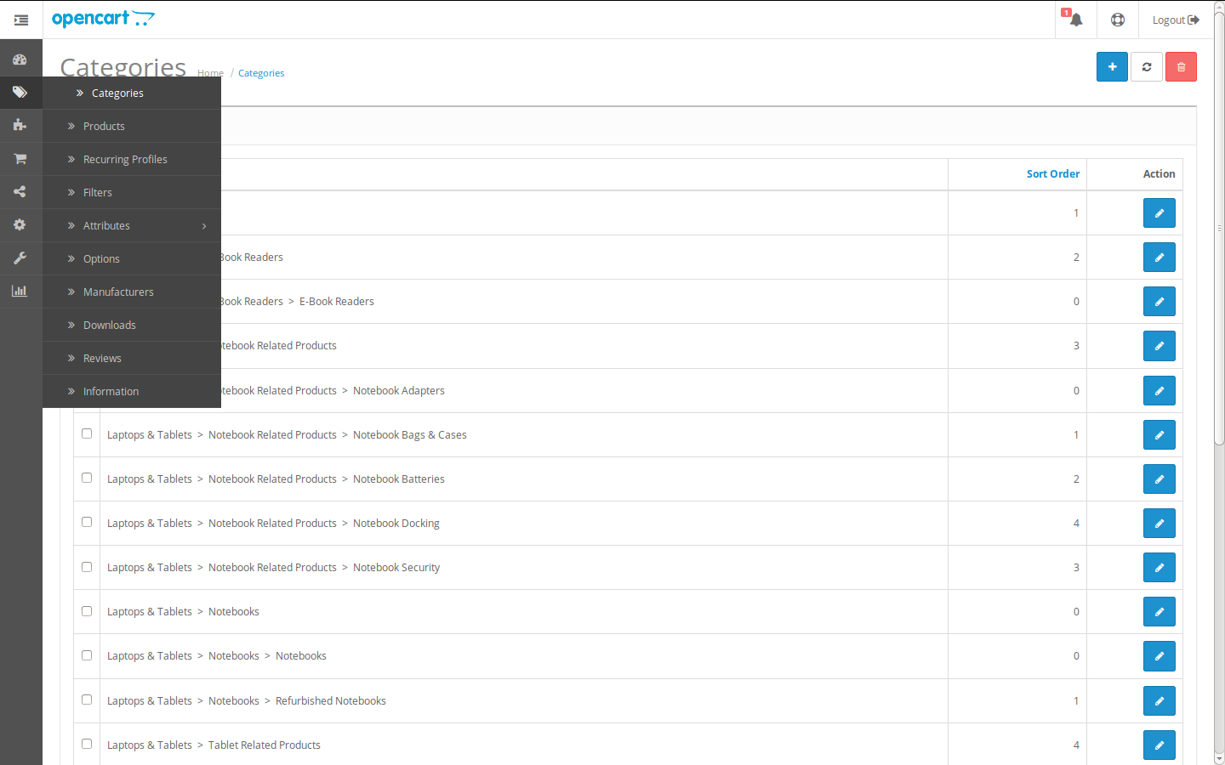

2. Adding General details for category:

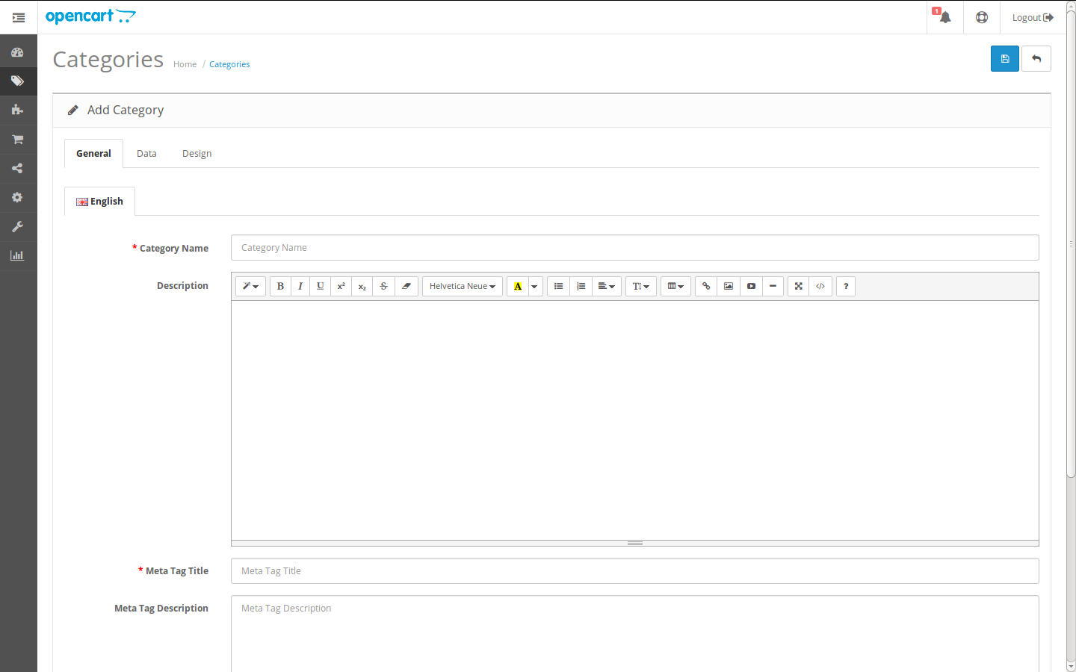
3. Adding Data tab values:

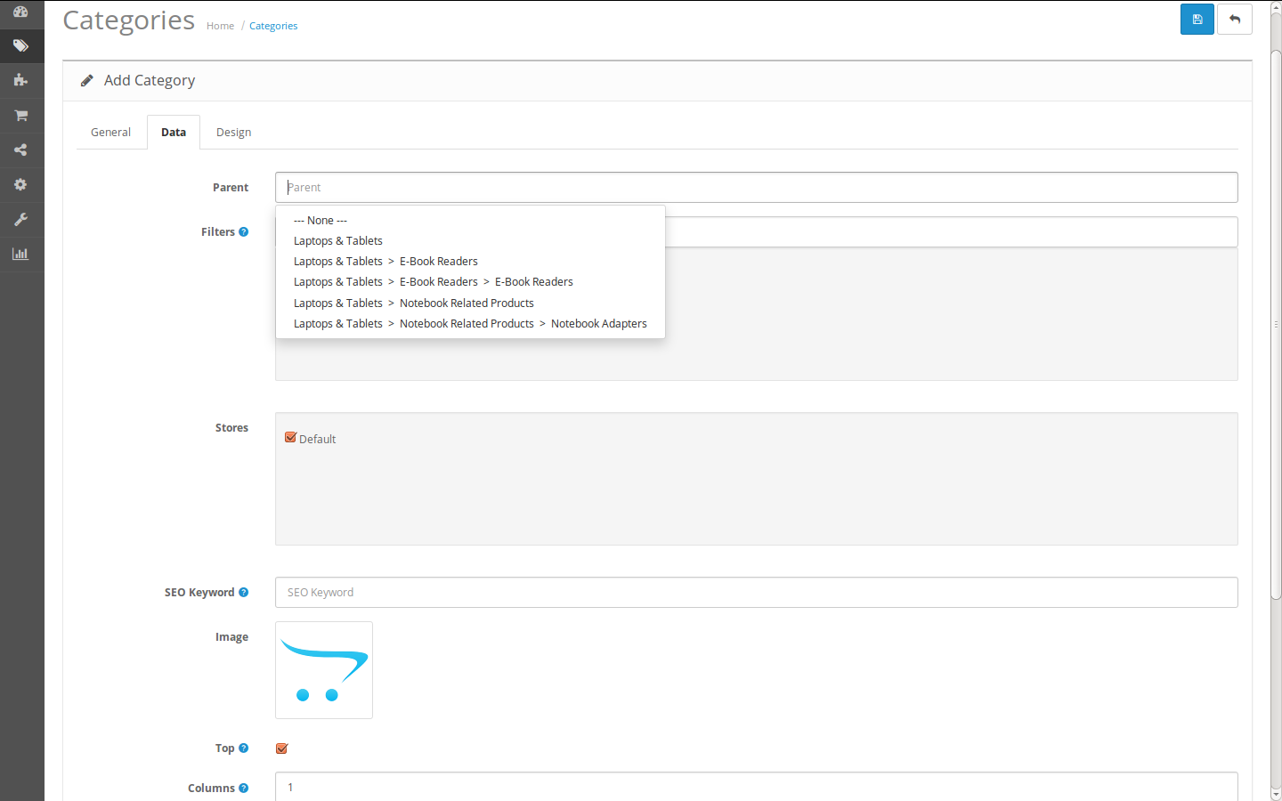
4. Edit Category Details:

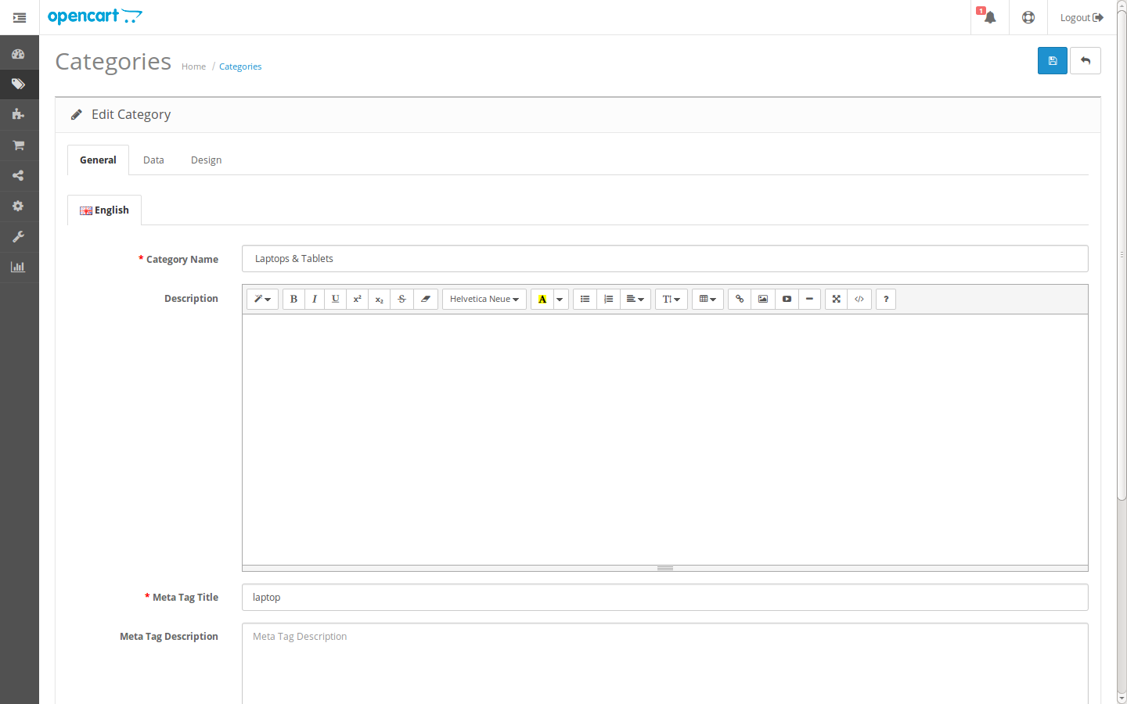

2. ADDING PRODUCTS:
In general tab, Add Products name and description of that Products, and give meta tag tittle.
In data tab, Add the image of the product, Model, Price, Quantity, Location, weight, Sort order, and status.
In links, Add Manufacturer, product related, Categories.
In Special tab, we can add that product as Special.
In Image tab, we can add images of that products as different views.
Then click "save" button.

1. Adding Product and listing:

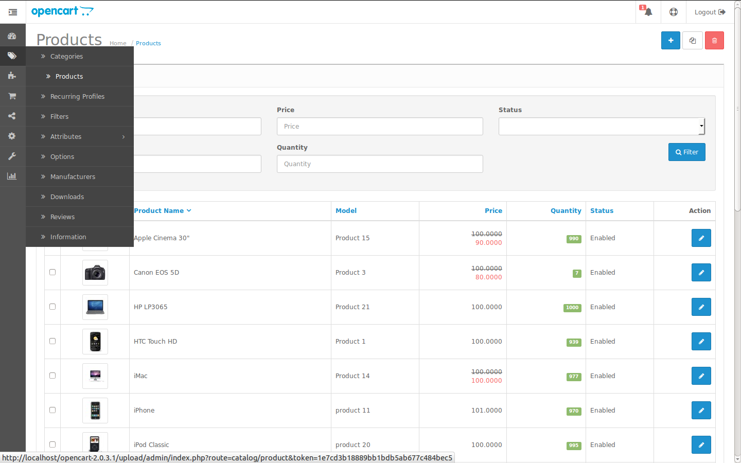

2. Adding Products:

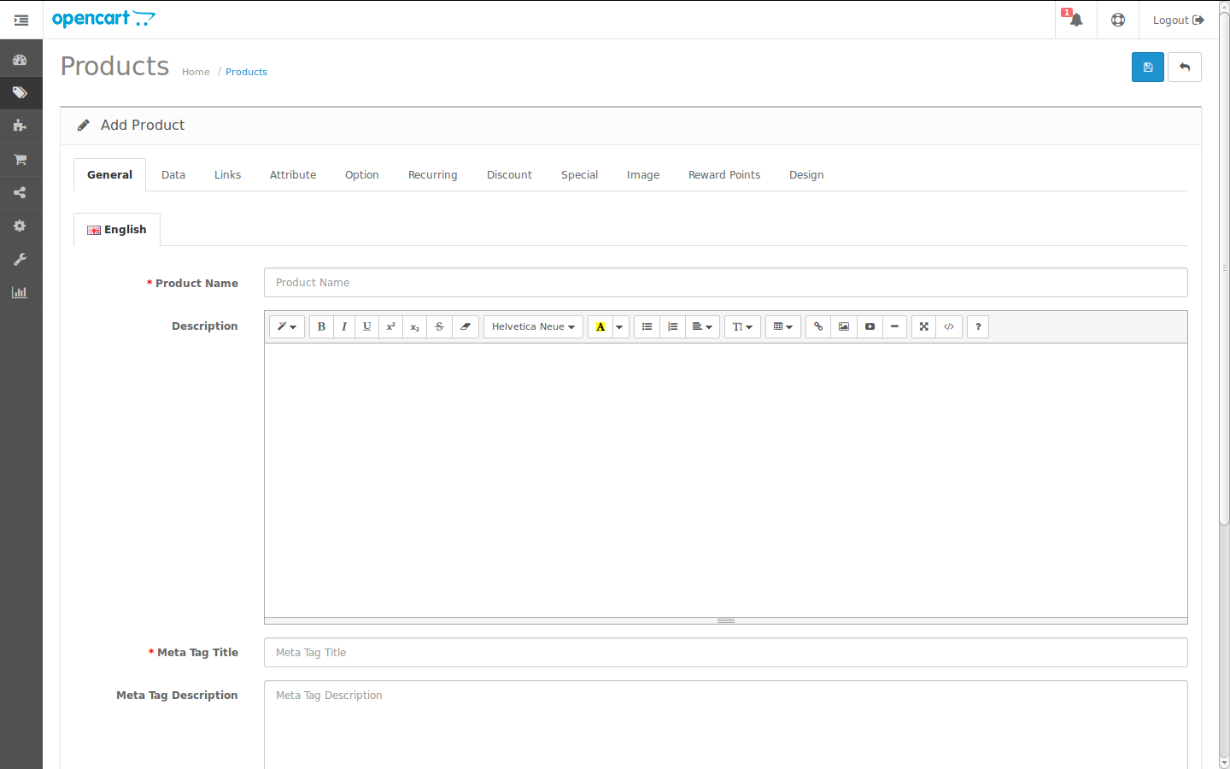

3. Edit Products:

3. ADDING MANUFACTURERS:
Add Manufacturer name, image and sort order in Add manufacturer form.
Then click "save" button.

4. ADD/UPDATE CONTENT IN ABOUT US PAGE:
In admin, Information > About us > Edit
In general, add/change name, description, and meta tag tittle.
In data, add sort order, status as enable and check the bottom option.

5. ADDING INFORMATION PAGE:
To add new Information page

Carousel Banners

For adding Carousel banners go to System > Design > Banners.
Click on “Add New” button to add new banner.
Give Banner Name : Manufacture
From status select Enabled,
and click on “Add Banner” button.
Give title of your banner and click on image to upload your banner.
Now click on “Save” button.
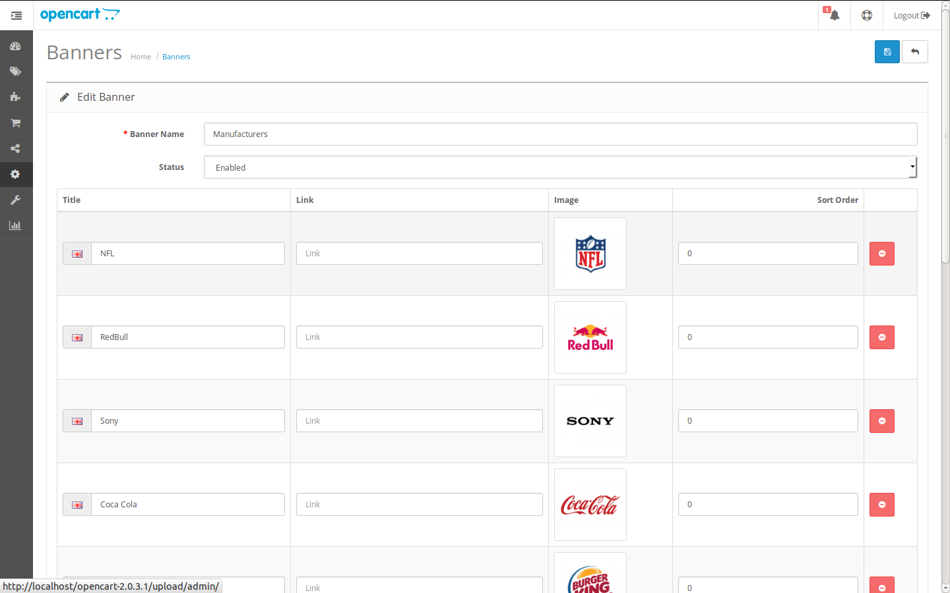
Now to activate your banner go to Extensions > Modules > Carousel click on Add Module button.
Give Module name: Carousel-HomePage,
From banner select Manufacturers,
Give Width & Height (200 X 110) (your banner Width and height),
From status select Enabled,
Now click on “Save” button.

Add Tax Rate:
Go to Setting >Localization > Taxes > Taxe Rate > edit

Add Language:
Go to Setting >Localization > Language > edit

Add Shipping rate:
Go to Extension > Shipping > Flat Rate > edit

View Return List:
Go to cart menu > Return

