INVENTION OF WIRELESS TECHNOLOGY
The background and the need:
Wireless technology has revolutionized the way we communicate, work, and live. The history of wireless technology dates to the 19th century with the pioneering work of scientists like James Clerk Maxwell and Heinrich Hertz, who theorized and demonstrated the existence of electromagnetic waves. However, the practical application of wireless technology began to take shape in the early 20th century.
One of the key developments was Guglielmo Marconi's successful transmission of the first wireless signal across the Atlantic Ocean in 1901, demonstrating the feasibility of wireless communication over long distances. his achievement marked the beginning of the wireless communication era.
The need for wireless technology arose from the limitations of wired communication systems. Wired systems were not only cumbersome and expensive to install but also had limited mobility. Wireless technology offered the promise of overcoming these limitations by enabling communication without the need for physical connections.
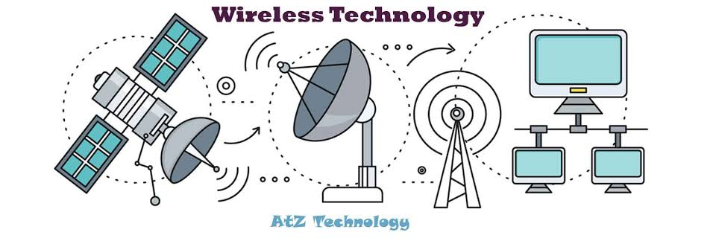
Description of the Invention:
The invention of wireless technology is a story that spans several centuries, with contributions from many scientists, engineers, and inventors. Here's a brief overview of some key milestones:
1.Theoretical Foundations: The groundwork for wireless technology was laid in the 19th century by physicists such as James Clerk Maxwell, who formulated the theory of electromagnetism. Maxwell's equations predicted the existence of electromagnetic waves, which are essential for wireless communication.
2.Experimental Verification: Building on Maxwell's work, Heinrich Hertz conducted experiments in the late 19th century that confirmed the existence of electromagnetic waves. Hertz's experiments demonstrated that these waves could be generated and detected, laying the foundation for wireless communication.
3.Wireless Telegraphy: One of the first practical applications of wireless technology was in wireless telegraphy, pioneered by inventors such as Guglielmo Marconi. In 1895, Marconi successfully transmitted radio signals over several kilometres, leading to the development of wireless telegraph systems.
4. Transatlantic Communication: Marconi's most famous achievement came in 1901 when he successfully transmitted the first wireless signal across the Atlantic Ocean, demonstrating the feasibility of long-distance wireless communication.
5.Voice Communication: Building on the success of wireless telegraphy, inventors like Reginald Fessenden and Lee de Forest made significant advances in wireless voice communication. Fessenden conducted the first voice broadcast in 1906, while de Forest's invention of the vacuum tube helped improve the quality and range of wireless transmissions.
6.Commercialization and Expansion: The early 20th century saw the commercialization and rapid expansion of wireless technology. Companies like Marconi Wireless Telegraph Company began offering wireless communication services, leading to the establishment of radio broadcasting and the development of technologies like radar and radio navigation.
7.Modern Wireless Technology: The invention of the transistor in the mid-20th century revolutionized wireless technology, leading to the development of modern devices like mobile phones, Wi-Fi networks, and Bluetooth technology. Today, wireless communication is an integral part of everyday life, connecting people and devices around the world.
Conclusion:
In conclusion, the invention of wireless technology has had a profound impact on society, revolutionizing the way we communicate, work, and live. From its theoretical beginnings in the 19th century to its practical applications in the 20th and 21st centuries, wireless technology has evolved rapidly, driven by the need for greater mobility, convenience, and efficiency in communication.
The pioneering work of scientists like James Clerk Maxwell and Heinrich Hertz laid the theoretical groundwork for wireless communication, while inventors like Guglielmo Marconi, Reginald Fessenden, and Lee de Forest transformed these theories into practical applications. Their contributions paved the way for the development of modern wireless devices and technologies that have become indispensable in today's interconnected world.
Looking ahead, wireless technology continues to evolve, with ongoing advancements in areas such as 5G networks, Internet of Things (IoT) devices, and wireless power transfer. These advancements promise to further expand the capabilities of wireless technology and continue to shape the way we communicate and interact with the world around us.
References:
1)www.wikipedia.com
2)www.encyclopedia.com
3)www.researchgate.com
4)www.acedmia.edu
Name: Disha Gomes
Registration Number: 230953010

