Desenvolvimento de Aplicações para TVDI para Pessoas Idosas no Contexto das Três Ondas de IHC
Luiz Alberto Ferreira Gomes
UNICAMP
Instituto de Computação
gomes.luiz@gmail.com

ABSTRACT
Updated 7/30/2014. In this sample paper, Sheridan Printing Co., Inc. describes the formatting requirements for SIGCHI Conference Proceedings, and this sample file offers recommendations on writing for the worldwide SIGCHI readership. Please review this document even if you have submitted to SIGCHI conferences before, some format details have changed relative to previous years.

Author Keywords
Guides; instructions; author’s kit; conference publication; keywords should be separated by a semi-colon.
Optional section to be included in your final version, but strongly encouraged.

introdução
A interação com computadores nos dias atuais pode ser realizada por meio de uma gama diversificada de tecnologias[Baranauskas, 2015]: Sistemas Ubíquos(em inglês: Ubiquitous Systems(US)); Interação com Sistemas Multi-dispositivos(em inglês: Simultaneos Multi-device(SMDI)); Interfaces Tangíveis(em inglês: Tangible User Interface(TUI)); Interfaces Baseadas em Gestos (em inglês: Gesture-based Interfaces(GBI)); e Interfaces Baseadas em Pensamento (em inglês: Brain Computer Interface(BCI)). Tais tecnologias são empacotadas e oferecidas em uma variedade de aparelhos eletrônicos que vêm se tornando populares como smartphones, smartwatches, louças interativas e Televisões Digitais Interativas (TVDi).
Embora os consumidores brasileiros, mesmo com a disponibilidade de outras opções, ainda consumam excessivamente mídias consideradas mais tradicionais como TVs e rádios, cada vez mais pessoas têm experimentado as comodidades oferecidas por estas novas tecnologias como as TVDI e redes sociais.
Neste contexto, emergem grandes desafios que impactam fortemente na qualidade na experiência de utilização destas tecnologias[Baranauskas, 2015]:
- Quais modelos teóricos podem ajudar a definir o contexto de interação a partir de aspectos individuais (por exemplo, a cognição);
- Como auxiliar a tomada de decisão em modelos de interação a partir de modelos teóricos ou formulações matemáticas que poderiam fornecer explicações, previsões e otimizações para estruturar fenômenos de interação entre usuários e sistemas computacionais;
- Como melhor explorar os estímulos visuais em soluções de BCI quando o projeto de tais sistemas não foram desenvolvidos por especialistas em IHC.
- Como definir novos métodos e técnicas que ajudam a elaborar o projeto de interação homem-computador para aplicações baseadas em US, SMDI, TUI e BCI, cujas entradas proveem de diversas fontes, considerando o contexto da realidade brasileira.
Este artigo posiciona os desafios precedentes -- circunscritos nas questões relacionadas ao desenvolvimento de aplicações para TVDI para pessoas idosas -- no contexto das três ondas da Interação Humano Computador(IHC) [3, 4].

AS três ondas de ihc
Em seus artigos, Bødker[3,4] subdivide a área de conhecimento IHC em três compartimentos, cada um guardando características próprias, denominados por ela de ondas.
A primeira onda (Figura 1), considerada uma ciência cognitiva relacionada à fatores humanos (como, por exemplo, ergonomia), é caracterizada pela orientação a modelos que colocavam o ser humano como objeto de estudo; pela utilização de guidelines rígidos, pelo emprego métodos formais e testes sistemáticos baseados em regras.
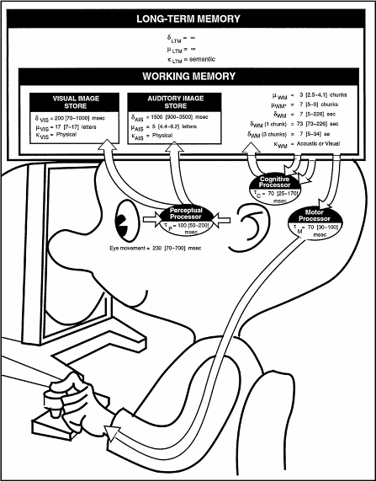
Figura 1: Metáfora da primeira onda de IHC.

Na segunda onda ocorre a mudança de “fatores humanos” para “atores humanos”. Nela, o foco é colocado em grupos de pessoas trabalhando em um coleção de aplicações de software. Empregam-se abordagens qualitativas(?) e não mais quantitativas, prototipação e design contextual. O conceito de contexto entrou em foco na análise e na interação homem-computador.
Figura 2
Na terceira onda, aspectos culturais e estéticos são observados. Expansão do cognitivo ao emocional. Fatores pragmáticos sociais da experiência. Tecnologias ubíquas, móveis e pequenas. A tecnologia espalha-se do local de trabalho para residências, o dia-a-dia e na cultura.
Figura 3

Televisão digital e interativa
A adoção da televisão digital e interativa (TVDi), se apropriadamente projetada, deve ser particularmente atrativa para pessoas mais velhas que tendem ser esquecidos quando novos serviços e novas aplicações são introduzidas e continuam marginalizados no segmento (the television broadcasting population).
Avanços técnicos e a convergência da tecnologia da informação e diversos produtos eletrônicos presentas nas residências abriram uma ampla gama de possibilidades para a televisão digital como uma porta de entrada de serviços novos e emergentes[2]. Novos oportunidades existem para tecnologias domésticas para suportar atividades orientadas socialmente para uma ampla faixa de pessoas. Para pessoas mais velhas, variações conhecidas das mudanças relacionadas à idade para visão, cognição e destreza manual e o cultural e geracional diferenças tecnológicas., sugere que o design de aplicações e serviços para televisão digital para suportar esse importante segmento da população é um grande desafio de pesquisa.
O uso da televisão é conhecido por proporcionar uma sensação de companheirismo para espectadores mais velhos. Apesar disto, existem evidências que sugerem que pessoas mais velhas são relutantes na adoção da televisão digital.
As a result of the constraints of conventional text-based captioning, a new form of graphical representation, called “emotive captions” have been developed specifically to support hearing impaired viewers [Lee et al. 2007].
According to Neale and Carroll [1997], a diversity of metaphors (e.g., real world, spatial, and concrete) offer huge potential for contemporary interface design and new multimedia formats. However, TV-based applications remain influenced by metaphorical features which are not traditionally associated with leisure and entertainment activities of the home. This limitation has led to calls for alterative paradigms of interaction that can more easily provide access to domestic technologies [Chorianopoulos et al. 2003].
In testing, the researchers reported that older volunteers generally experienced more difficulties in using the system than their younger visually impaired counterparts [Carmichael et al. 2003]. In particular, they found that the older participants had disproportionately more difficulties understanding and responding to implicit screen prompts.

Notably, a large amount of human factors research for older people and DTV is available from Carmichael’s ‘Style Guide’ [1999]. This guide offers detailed information on the design of digital services appropriate to this user group, in relation to their sensory and cognitive abilities and the demands the system may place on them. For example, the
importance of clear visual/spatial navigational support, such as suitable highlighting and lowlighting, to relieve working memory load, minimize errors, and help guide attention through operations on screen. However, while DTV studies have, for example, investigated effective means of navigating and manipulating video content (e.g.,Chorianopoulos and Spinellis [2004] and Kim et al. [2006]), they have been evaluated with relatively young subjects. Given the variety of characteristics and functionality of older users, research that can be applied to the wider population is necessary.

When working with older users, conventional methods for eliciting requirements for the design of systems in a user-centred context have been found to be problematic [Eisma et al. 2004]. Although this is not true of all older adults, HCI researchers found that due to lack of experience many older people do not understand and thus criticise design concepts [Eisma et al. 2003]. Studies show that older people, owing to a limited understanding of computer systems, can be more reluctant to complain about aspects of technology and its usage [Hawthorn 2007].

In the context of DTV, reevaluating methods that go beyond traditional forms of usability evaluation such as efficiency and task completion have also been established as important factors in the development of entertainment systems [Chorianopoulos 2005; Eronen 2005]. However, while this does not entail abandoning usability engineering techniques, it does require DTV practitioners to consider suitable methods for involving users in conceptualizing new leisure-orientated applications [Chorianopoulos 2005].
Em face a estas questões e desafios, têm-se tentado explorar novos métodos para coletar informações de pessoas mais velhas que possuem pouca ou nenhuma experiência com sistemas de computadores: Teatro Interativo; ; ;

Teatro Interativo
Influenciado pelas práticas do design participativo que encoraja empoderamento dos usuários finais no processo de design centrado no usuário[2]. Baseia-se na performance teatral para apresentar ideias de uma forma tangível de forma a levantar questões e elicitar soluções no desenvolvimento de uma aplicação para exibição de uma novela na TV. (FALAR SOBRE AS ONDAS)
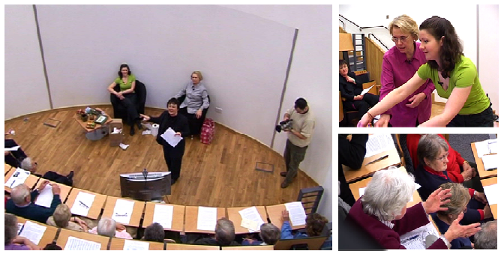
Figura 2: Cenas de uma sessão de teatro interativo[2].
User-Generated Dialogue and Paper Prototyping
For the first part, participants were asked to generate a wide range of ideas on how they envisaged setting up the communication system. To aid the discussion, a small set of colored prompting cards were presented to users (see Figure 2), illustrating the possible interactive steps necessary for a two-way conversation between a TV caller and the recipient. Within this process, participants were encouraged not only to verbally describe, but also sketch, any
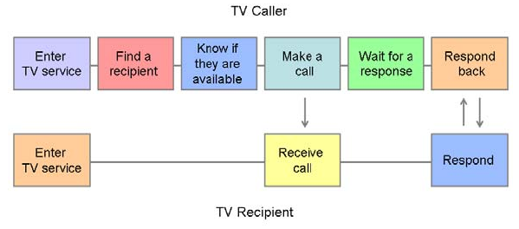
For the second part of the study, participants were given more concrete representations of what the communication system might look like via paper prototypesbased on conventional design metaphors for DTV. However, rather than simply present screen shots or hand drawings, participants undertook the physical task of assembling the interfaces themselves. In the participatory design approach, the ability to change the physical artefact is an important way to engage with and explore different points of view
[Muller 2003].

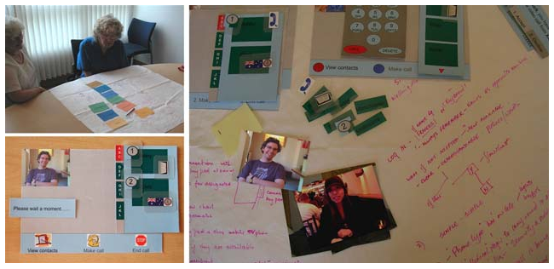
Figura 3: Protótipo de baixa finalidade em papel [2].

Abstract and Keywords
Every submission should begin with an abstract of about 150 words, followed by a set of keywords. The abstract and keywords should be placed in the left column of the first page under the left half of the title. The abstract should be a concise statement of the problem, approach and conclusions of the work described. It should clearly state the paper's contribution to the field of HCI.
The first set of keywords will be used to index the paper in the proceedings. The second set are used to catalogue the paper in the ACM Digital Library. The latter are entries from the ACM Classification System [3].

Normal or Body Text
Please use a 10-point Times Roman font or, if this is unavailable, another proportional font with serifs, as close as possible in appearance to Times Roman 10-point. The Press 10-point font available to users of Script is a good substitute for Times Roman. On a Macintosh, use the font named Times and not Times New Roman. Please use sans-serif or non-proportional fonts only for special purposes, such as headings or source code text.

First Page Copyright Notice
This sample word document has the correct ACM SIGCHI copyright notice in place (see page 1, bottom of column 1) Copyright will be held by ACM. Accepted extended abstracts and papers will be distributed in the Conference Publications. They will also be placed in the ACM Digital Library, where they will remain accessible to thousands
of researchers and practitioners worldwide. To view
ACM’s copyright and permissions policy, click this link: http://www.acm.org/publications/policies/copyright_policy

Subsequent Pages
On pages beyond the first, start at the top of the page and continue in double-column format. The two columns on the last page should be of equal length.

Figure 1. With Caption Below, be sure to have a good resolution image (see item D within the preparation instructions).

References and Citations
Use a numbered list of references at the end of the article, ordered alphabetically by first author, and referenced by numbers in brackets [2, 4, 5, 7]. Kindly make the text of this section ragged-right, so that the increasing number of references/citations with web addresses/urls do not have large word and letter spacing. For papers from conference proceedings, include the title of the paper and an abbreviated name of the conference (e.g., for Interact 2003 proceedings, use Proc. Interact 2003). Do not include the location of the conference or the exact date; do include the page numbers if available. See the examples of citations at the end of this document.
Objects | Caption – pre-2002 | Caption – 2003 and afterwards
Tables | Above | Below
Figures | Below | Below
Table 1. Table captions should be placed below the table.
 | Anyone | SN | Specific | No one
Flight | 45% | 34% | 18% | 3%
City | 47% | 35% | 14% | 3%
Table 2: Sharing travel plans
Your references should be published materials accessible to the public. Internal technical reports may be cited only if they are easily accessible (i.e., you provide the address for obtaining the report within your citation) and may be obtained by any reader for a nominal fee. Proprietary information may not be cited. Private communications should be acknowledged in the main text, not referenced (e.g., “[Robertson, personal communication]”).

SECTIONS
The heading of a section should be in Helvetica 9-point bold, all in capitals (Heading 1 Style in this template file). Conclusion

is important that you write for the SIGCHI audience. Please read previous years’ Proceedings to understand the writing style and conventions that successful authors have used. It is particularly important that you state clearly what you have done, not merely what you plan to do, and explain how your work is different from previously published work, i.e., what is the unique contribution that your work makes to the field? Please consider what the reader will learn from your submission, and how they will find your work useful. If you write with these questions in mind, your work is more likely to be successful, both in being accepted into the Conference, and in influencing the work of our field.

ACKNOWLEDGMENTS
Sample Text: We thank all the volunteers, and all publications support and staff, who wrote and provided helpful comments on previous versions of this document. As well authors 1, 2, & 3 gratefully acknowledge the grant fron NSF (#1234-2012-ABC). This whole paragraph is just for example … Some of the references cited in this paper are included for illustrative purposes only.

References format
References must be the same font size as other body text.

REFERENCES
- Adobe Acrobat Reader 7, Be sure that the references sections text is Ragged Right, Not Justified. http://www.adobe.com/products/acrobat/.
- Rice, M., and Alm, N. 2008. Designing new interfaces for digital interactive television usable by older adults. ACM Comput. Entertain. 6, 1, Article 6 (May 2008), 20 pages.
- Susanne Bødker. 2006. When second wave HCI meets third wave challenges. In Proceedings of the 4th Nordic conference on Human-computer interaction: changing roles (NordiCHI '06). ACM, New York, NY, USA, 1-8.
- Susanne Bødker. 2015. Third-wave HCI, 10 years later---participation and sharing. interactions 22, 5 (August 2015), 24-31.
- Zellweger, P.T., Bouvin, N.O., Jehøj, H., and Mackinlay, J.D. Fluid Annotations in an Open World. Proc. Hypertext 2001, ACM Press (2001), 9-18.

The columns on the last page should be of approximately equal length.
Remove these two lines from your final version.

