ECLIPSE

Instalado el jdk
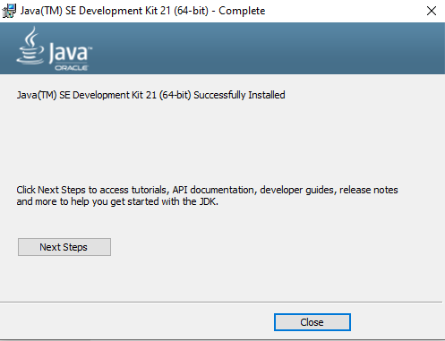

Eclipse descargado
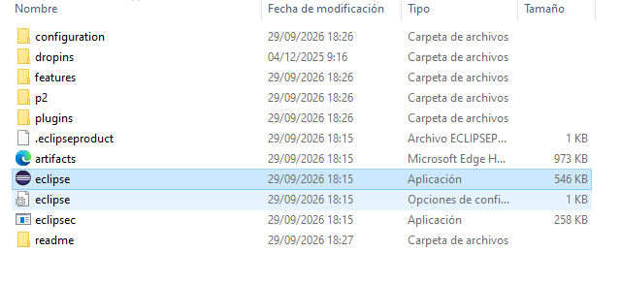

Arrancamos el tomcat
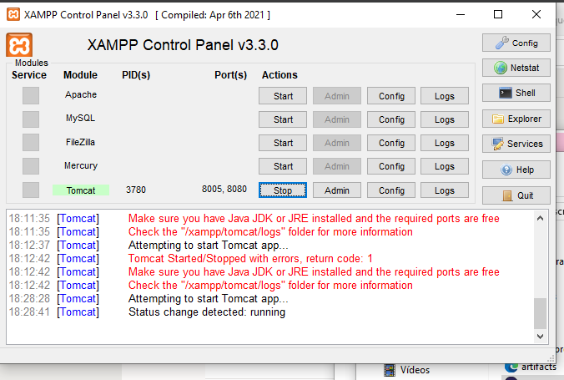

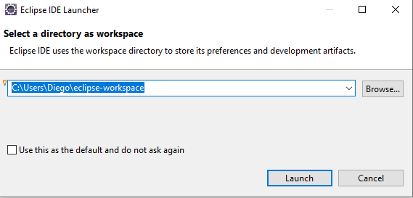
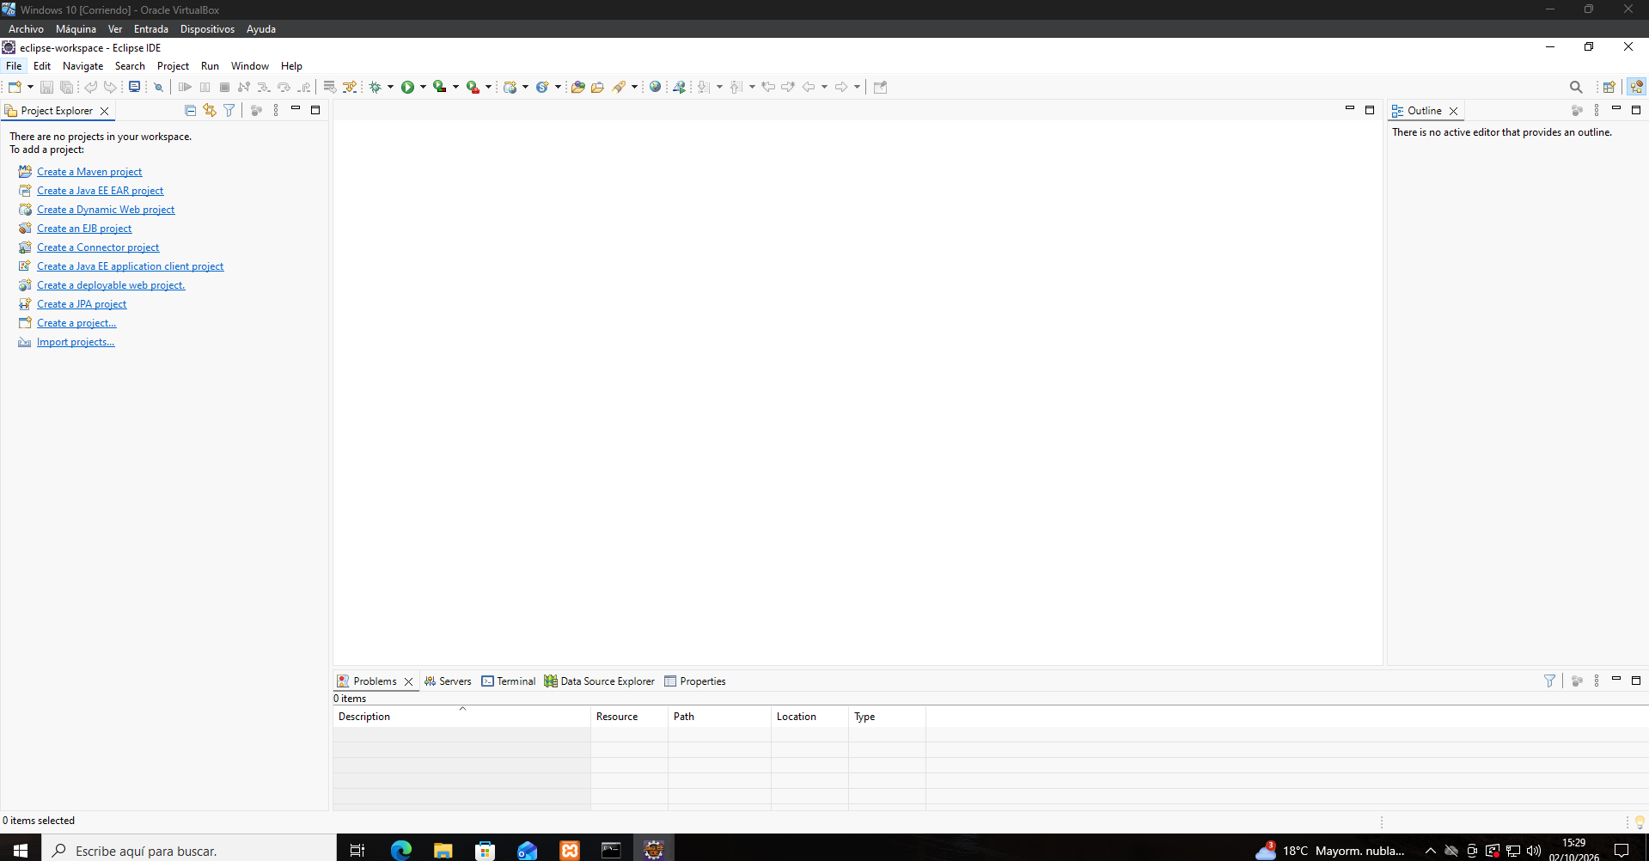
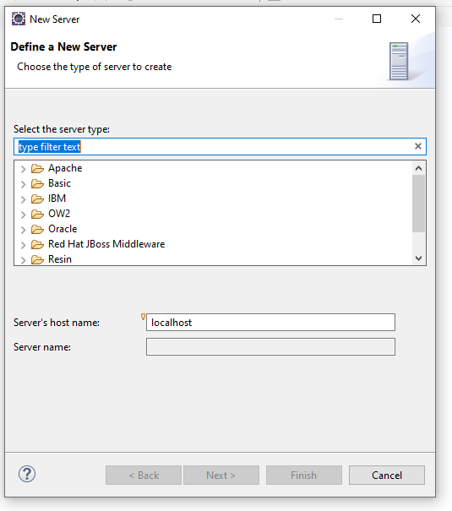
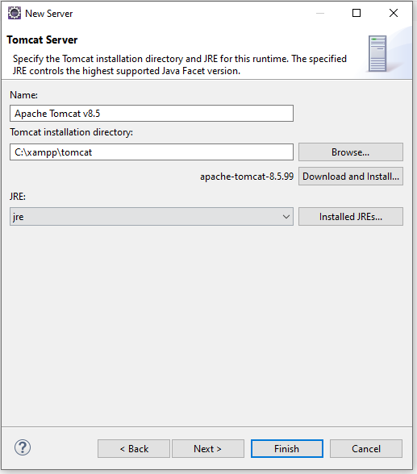
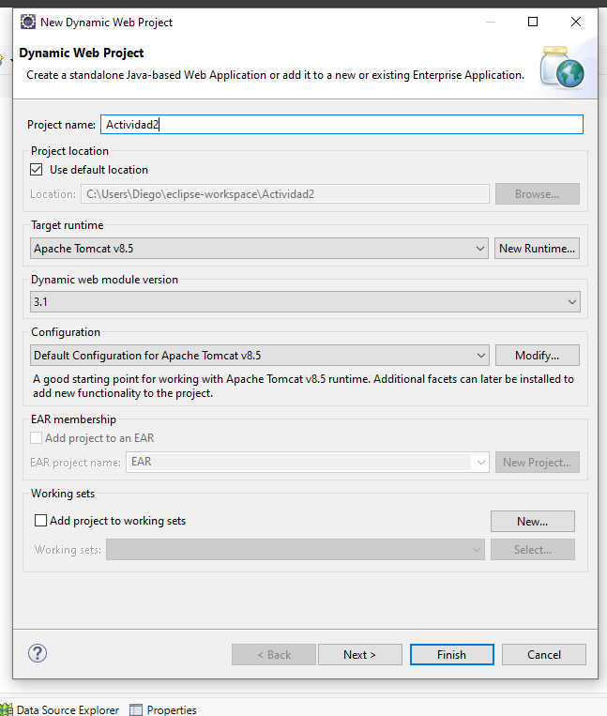
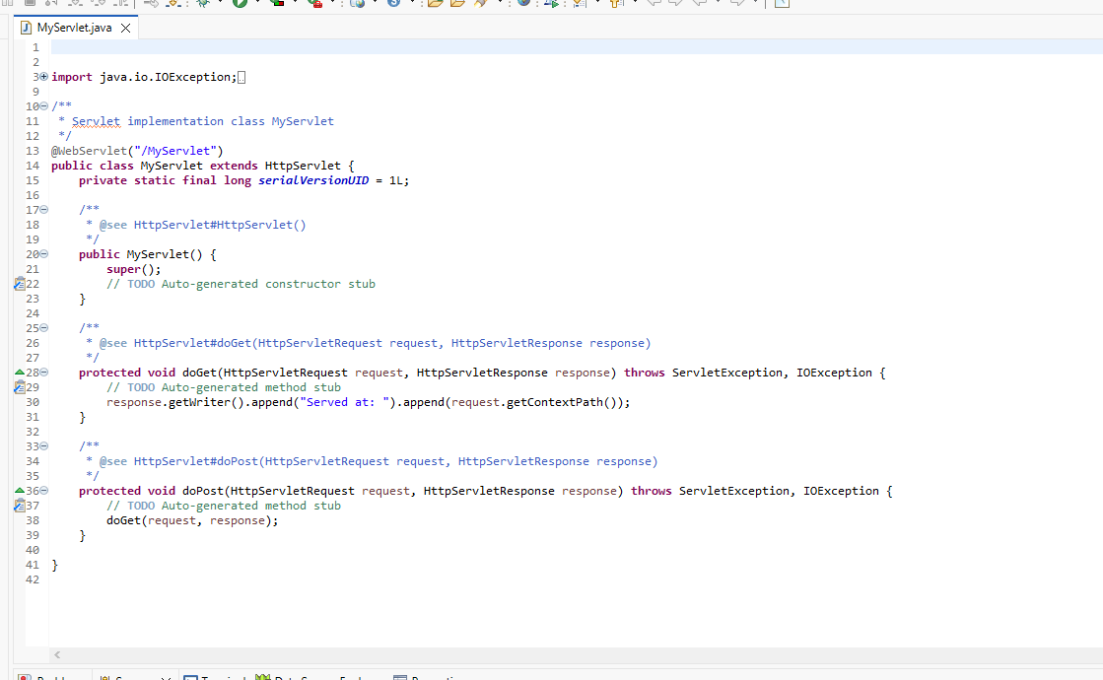
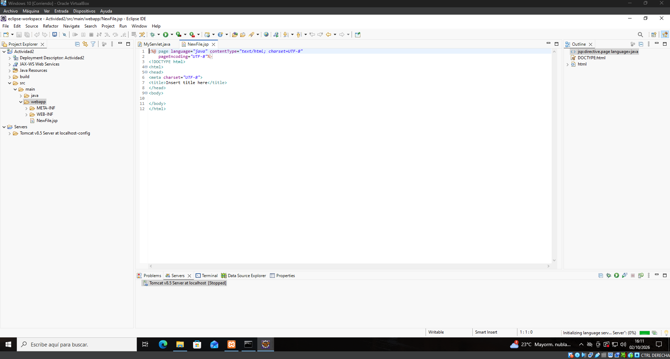
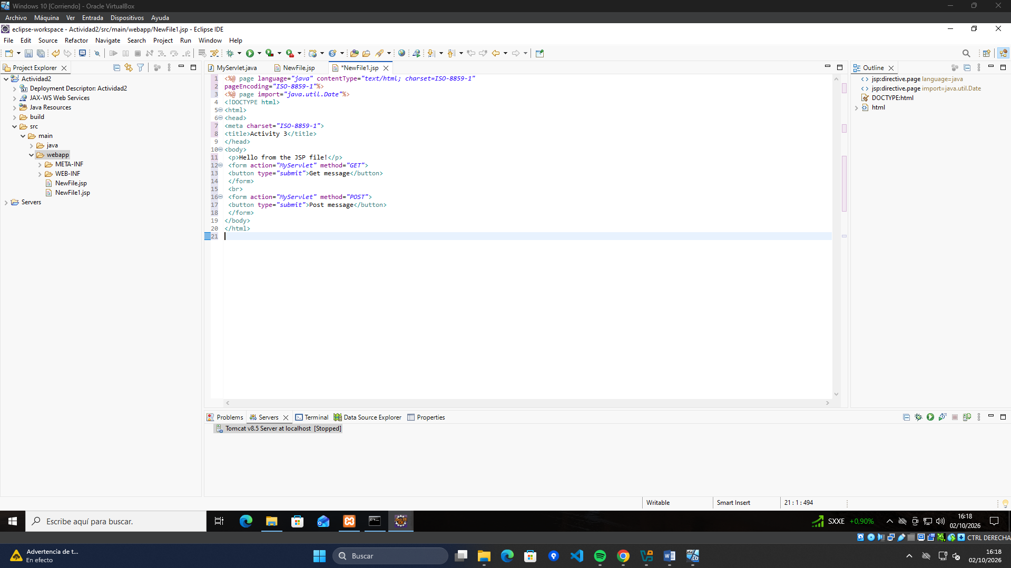
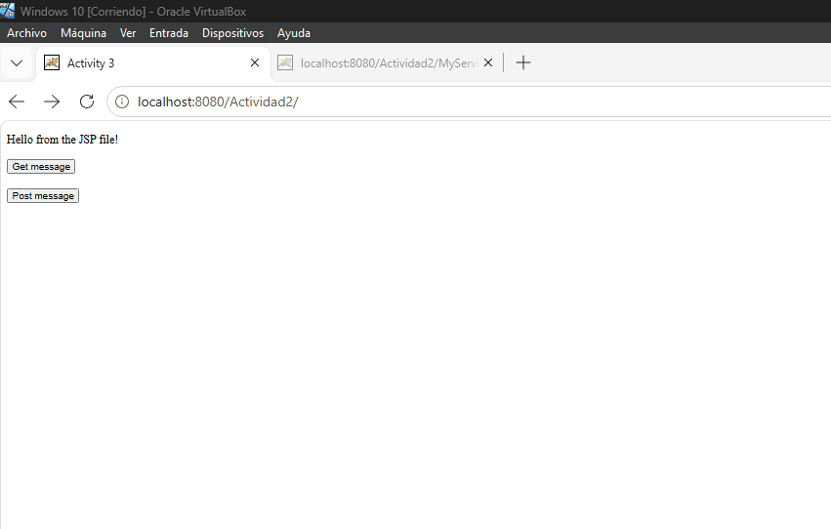

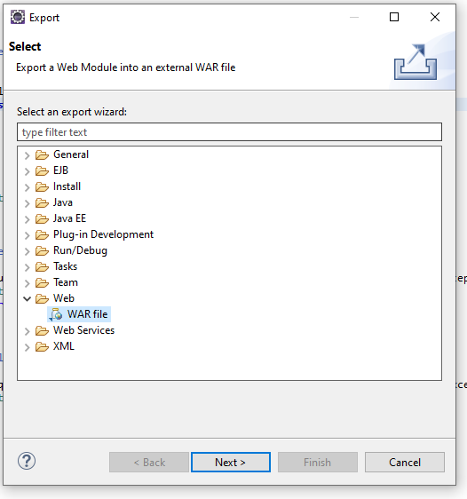
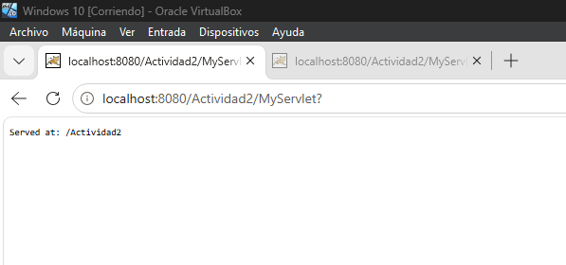

package servlets;

import java.io.IOException;
import java.io.PrintWriter;

import jakarta.servlet.ServletException;
import jakarta.servlet.annotation.WebServlet;
import jakarta.servlet.http.HttpServlet;
import jakarta.servlet.http.HttpServletRequest;
import jakarta.servlet.http.HttpServletResponse;

@WebServlet("/LetraDNIServlet")
public class LetraDNIServlet extends HttpServlet {

private static final long serialVersionUID = 1L;
private static final String LETRAS = "TRWAGMYFPDXBNJZSQVHLCKE";

@Override
protected void doGet(HttpServletRequest request, HttpServletResponse response)
throws ServletException, IOException {
mostrarPagina(response, null, null);
}

@Override
protected void doPost(HttpServletRequest request, HttpServletResponse response)
throws ServletException, IOException {

request.setCharacterEncoding("UTF-8");
String entrada = request.getParameter("dni");
String resultado;
String error = null;

try {
int dni = Integer.parseInt(entrada.trim());

if (dni < 0 || dni > 99999999) {
error = "El DNI debe ser positivo y tener como máximo 8 dígitos.";
resultado = null;
} else {
char letra = LETRAS.charAt(dni % 23);
resultado = String.format("%08d-%c", dni, letra);
}
} catch (NumberFormatException | NullPointerException e) {
error = "Introduce solo números.";
resultado = null;
}

mostrarPagina(response, resultado, error);
}

private void mostrarPagina(HttpServletResponse response, String resultado, String error)
throws IOException {

response.setContentType("text/html;charset=UTF-8");
PrintWriter out = response.getWriter();

out.println("<!DOCTYPE html>");
out.println("<html lang='es'>");
out.println("<head>");
out.println("<meta charset='UTF-8'>");
out.println("<title>Calculadora de letra del DNI</title>");
out.println("<style>");
out.println("body{font-family:Arial,sans-serif;max-width:400px;margin:60px auto;text-align:center}");
out.println("input{padding:8px;font-size:16px}");
out.println("button{padding:8px 16px;font-size:16px;cursor:pointer}");
out.println(".ok{color:#1b7f3b;font-size:22px;margin-top:20px}");
out.println(".error{color:#c0392b;margin-top:20px}");
out.println("</style>");
out.println("</head>");
out.println("<body>");
out.println("<h1>Letra del DNI</h1>");
out.println("<form method='post' action='LetraDNIServlet'>");
out.println("<input type='text' name='dni' maxlength='8' placeholder='8 números' required>");
out.println("<button type='submit'>Calcular</button>");
out.println("</form>");

if (resultado != null) {
out.println("<p class='ok'>Tu DNI completo es: <strong>" + resultado + "</strong></p>");
}
if (error != null) {
out.println("<p class='error'>" + error + "</p>");
}

out.println("</body>");
out.println("</html>");
}

<%@ page language="java" contentType="text/html; charset=UTF-8" pageEncoding="UTF-8"%>
<!DOCTYPE html>
<html lang="es">
<head>
<meta charset="UTF-8">
<title>Calculadora de letra del DNI</title>
<style>
body { font-family: Arial, sans-serif; max-width: 400px; margin: 60px auto; text-align: center; }
input { padding: 8px; font-size: 16px; }
button { padding: 8px 16px; font-size: 16px; cursor: pointer; }
</style>
</head>
<body>
<h1>Letra del DNI</h1>
<form method="post" action="<%= request.getContextPath() %>/LetraDNIServlet">
<input type="text" name="dni" maxlength="8" pattern="[0-9]{1,8}" placeholder="8 números" required>
<button type="submit">Calcular</button>
</form>
</body>
</html>



