**Julian Gomez Jr**

**Module 1.2**

**1. Local directory setup**

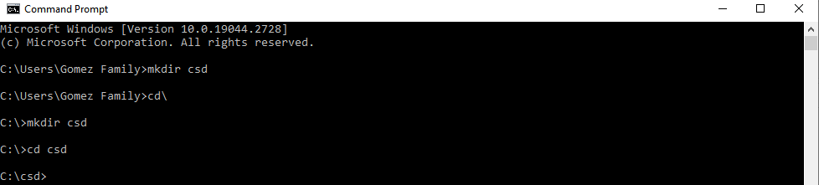



**2. Repository Setup**

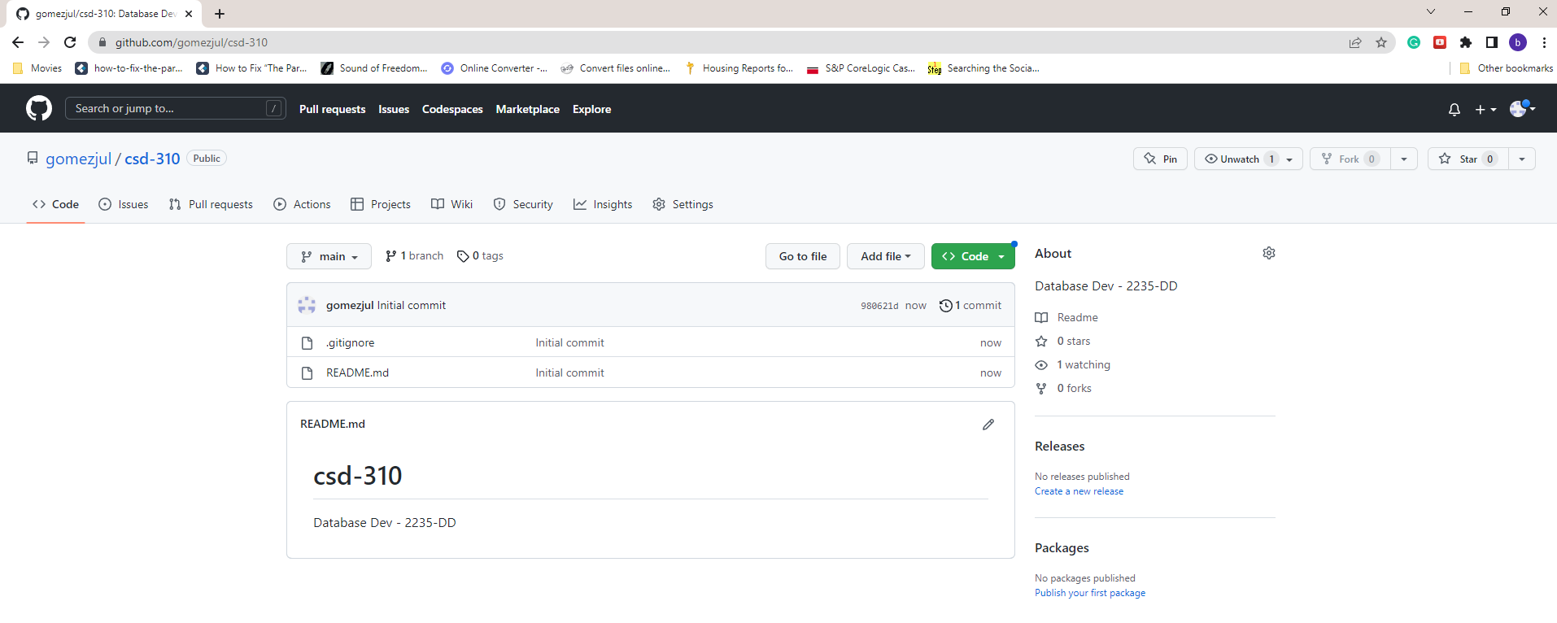

**3. Clone**

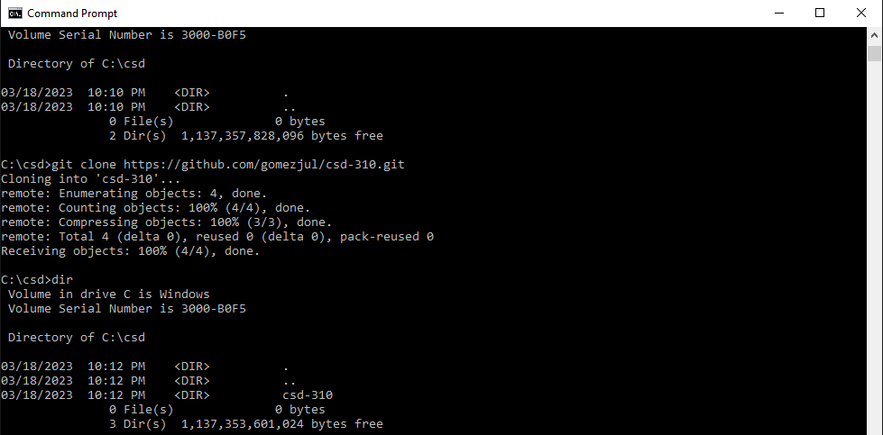

**4. Git State, Commit, Push**

