**Computer vision-based analysis of tumor cell invasion and adhesion**

**James E. Bear, Ph.D.** *Principal investigator*

**Shawn Gomez, Eng.Sci.D** *Co-principal investigator*

**Abstract:**

**Innovation and Impact Statement:**

This is a new collaborative project between the Bear and Gomez groups that brings together expertise in the cell biology of tumor cell behavior and computer vision-based analysis of massive image data sets. With the advent of multicolor live-cell imaging and gene manipulation, there is an increasing need to find new methods to extract quantitative information from images and movies. The cellular structures that are the focus of this project, invadopodia and focal adhesions, are critical for tumor cell metastasis. Yet the standard in the field for analyzing these structures is to hand select a small number (<10) and perform limited measurements of area and some dynamic properties. The method under development here will allow unbiased analysis of *all* the invadopodia and/or focal adhesions (~50-1000 per cell) over 12-16 hours. This level of data analysis is required to identify subtle or combinatorial effects of genetic and/or pharmacological manipulation. Beyond method development, this approach will allow us to understand the effects of genes known to be involved in tumor metastasis such as PTEN and LKB1 that have never been studied at this level. Furthermore, we will evaluate the effects of B-Raf inhibition on these structures using the new Plexicon compound in a B-Raf mutant melanoma cell line. Thus, this project will have a significant impact on the field of cancer metastasis by allowing the inter-related dynamics of extracellular matrix degradation and cellular adhesion to be studied at an unprecedented level.

**Specific Aims:**

In this proposal, we seek to develop methods to analyze tumor cell behavior using computer vision-based techniques. We will use these methods to understand the role of known pro-invasive genes and test the role of metastasis-implicated genes such as PTEN and LKB1 whose role in matrix degradation and adhesion control is unknown. To accomplish this, we propose two specific aims:

**Aim 1. Computer vision-based analysis of invadopodia:** In this aim, we will develop an automated, computer vision-based assay to quantify invadopodia population statistics and dynamics from live-cell movies. Using this assay, we will evaluate gene knockdowns of candidate metastasis genes such as PTEN and LKB1. In addition, we will evaluate the use of this tool with pharmacological inhibitors such as the B-Raf inhibitor.

**Aim 2. Multiplex analysis of invadopodia and focal adhesions:** In this aim, we will combine or multiplex the established method for quantification of focal adhesion dynamics with the new method of invadopodia quantification from Aim 1 using 3-color live-cell imaging. By simultaneously and quantitatively examining these structures, we can begin to ask questions about how cells manage to dynamically balance adhesion and matrix degradation to achieve invasive motility.

**Background:**

Advanced melanoma is one of the most feared human cancers {Sharpless, 2003 #5122; Chin, 1998 #5123}. Although curable through surgery when diagnosed at early stage, melanoma is characterized by its therapeutic resistance, aggressive clinical behavior, and proclivity for early metastasis. Early metastasis is a key clinical feature of melanoma, and in perhaps no other malignancy is the ability to metastasize more closely correlated with clinical outcome {Cochran, 1997 #5243; Ahmed, 1997 #5244}. Metastasis is the process by which tumor cells leave the primary lesion and move to other parts of the body, thereby initiating tumor formation at multiple sites. During this process, cells detach from their adhesive contacts, degrade barriers such as the basement membrane, migrate to other locations within the body, invade new organs, and regain adherence to re-initiate growth {Kopfstein, 2006 #6767}. It is therefore not surprising that metastatic tumor cells have high *in vitro* cell motility and invasive capabilities.

Through the combined work of many labs, a conceptual framework for understanding cell migration has emerged {Lauffenburger, 1996 #304}. Motile cells display a characteristic cycle of steps leading to translocation. First, cells must become polarized, thereby defining a front-to-rear axis for directed movement. Second, once a cell is polarized, it protrudes a structure such as lamellipodia at the leading edge. Third, after the lamellipodia has extended forward, it must become stabilized by attachment to the underlying substratum. These attachment points are known as focal contacts or focal adhesions and contain clustered integrin receptors that create a bridge between the extracellular matrix and the actin cytoskeleton. Fourth, the cell body is then squeezed forward from the rear in an actomyosin-based contraction event. Finally, cells must lose substratum attachment at the rear or trailing edge. In the case of tumor cells, these general steps of migration must be preceded by the local degradation of extracellular matrix using spot-like structures called invadopodia that are heavily enriched with matrix metaloproteases (MMPs). The coordination of matrix degradation by invadopodia and adhesion to matrix required for movement is poorly understood.

Computer vision approaches have been applied in cellular biology settings to analyze large collections of both still and time lapse microscopy to quantitatively assess cellular phenotypes (Peng 2008, Bioinformatics). The applications of computer vision approaches to analyzing microscopy images have ranged from large siRNA-based screens designed to discover proteins involved in mitosis (Neumann 2010 Nature) to tracking the effect of camptothecin on protein localization in individual cells (Cohen 2008 Nature). In the field of cellular motility, studies have demonstrated, using computer vision techniques, the subtle connection between cell edge movement and the Rho GTPases (Machacek 2009 Nature). These applications of computer vision techniques demonstrate the power of combining computational image processing techniques to determine the connection between perturbations cells and phenotype. By applying computer vision methods to examine Invadopodia and the interplay between Invadopodia and focal adhesions, this proposal seeks to determine the effects of several candidate genes on metastasis and develop sets of image processing tools that can be widely applied.

**Preliminary Studies:**

In collaboration with the Hahn lab at UNC, the Gomez lab has developed a software suite which automates the analysis of time-lapse movies of fluorescently tagged focal adhesion. This work has been submitted to PLOS Biology and is currently in revision. The publication describes a set of programs that automatically finds the focal adhesions in each frame of a provided movie, tracks those focal adhesions through time and then collects various sets of properties that describe the focal adhesions (Figure 1). The properties collected fall into three categories: static, dynamic and spacial. The static properties of the adhesions include area, intensity and eccentricity. The dynamic properties, such as the assembly and disassembly rates, are determined by automatically analyzing the properties of the adhesions through time (Figure 2). These automated methods are comparable in technique to the prior methods used to assess focal adhesion properties (Webb 2004), but the computer vision approaches allow all the detectable adhesions to be analyzed. Thus, while manual methods are able to quantify small number of adhesions (10-25) per experimental condition, the automated methods we have developed can scale to collect hundreds of data points (Figure 2). Finally, the software also tracks the position of each focal adhesion through time in comparison to the nearest cell edge, providing a normalized spacial measurement (data not shown). The software suite was designed as a series of modules to make expansion of capabilities easier. We expect that several of the key software components developed to analyze focal adhesions will be able to be reused with little or no modification in the development of the Invadopodia analysis system.

|  |  |
| --- | --- |
| graphic_workflow.png  Figure 1: Summary of Focal Adhesion Analysis Methods showing a small region of a migrating fibroblast, the puncta identified in this region and how a single puncta is tracked. | kinetics.png  Figure 2: (A) Sample tracking of single adhesion (green), surrounding adhesions (blue) and the cell edge (red) (B) The intensity of the adhesion in A over time with the assembly phase (green), the stability phase (yellow) and the disassmbly phase (red) indicated. (C) Summaries of the assembly and disassembly rates. |

**Research Plan:**

**Aim 1. Quantitative analysis of invadopodial dynamics:**

Rationale: Invadopodia are highly dynamic structures, which form and disassemble as cancer cells degrade the extracellular matrix. Their role in cancer cell metastasis has been known for many years, but the methods used to quantify their appearance has been limited to relatively qualitative measurements. We propose to develop computer vision software designed to quantitatively assess the properties currently collected by hand and develop new quantitative measures of Invadopodia effect on matrix degradation.

Experimental plan: This aim focuses on using the well-characterized cell line melanoma cell line WM-2664 to assess the properties of Invadopodia. We have extensive expertise maintaining, transfecting and imaging this cell type. The experiment procedure has been adapted from a prior study (Invado Gel Method Ref) and involves creating a thin layer of fluorescently labeled gelatin, onto which the 2664 cells are then plated. As the cells attach to the gel, many of the 2664 cells start to form Invadopodia, resulting in regions where the gelatin structure is degraded. As the gel degrades, the fluorescent marker diffuses away, reducing the amount of fluorescence in the region affected by the Invadopodia. In addition to the fluorescent gelatin, a fluorescent tag for actin (Lifeact) is also transfected. During the imaging stage, two sets of movies are collected, one of the gelatin and the other of the actin tag. To determine the role of various proteins in influencing the properties of Invadopodia, a set of candidate genes have been selected. These genes have either been implicated in Invadopodia functions or have known effects on the cytoskeleton (Table 1?).

The first stage of the image processing pipeline is to identify the regions of high actin concentration (actin puncta or just puncta) in each frame of the movie. This is accomplished using a thresholding algorithm based on the focal adhesion identification methods. With each of the puncta identified, they are then tracked through the entire movie and various properties, such as size and longevity are extracted from the raw image data. With the puncta identified and tracked, the next stage of the analysis involves determining which of the long lived puncta are Invadopodia. We are pursuing a method based on using the intensity of the gelatin in the region near the puncta as a filter for identifying Invadopodia (Figure 3). Specifically, our current method uses the difference in average value of the region immediately beneath the actin puncta and the region in a five pixel border around the puncta as a filtering method. If this local difference value is consistently below zero, then we know that the region of gel immediately underneath the puncta has lost fluorescence relative to the surrounding region, indicating degradation of the gelatin. We also look to the frame immediately before the actin puncta was born to determine if the gelatin appeared degraded, perhaps due to another Invadopodia or an uneven gel coating, before the puncta was born. If there are significant differences in the degradation before and during the puncta’s life, we can classify the puncta as an Invadopodia (Figure 4). We are continuously developing new extensions/improvements to this filtering methodology and adding metastasis relevant measurements. Also, to complement the high-content analysis of single Invadopodia, we are developing a set of complementary methods that can be used scan an entire field of cells to identify the number of cells that form Invadopodia.

Potential pitfalls:

|  |  |
| --- | --- |
| local_diff_filtering.png  Figure 3: Overall filtering strategy for identifying Invadopodia is based around the mean values of the gelatin intensity underneath and adjacent to the actin puncta extent. The punta overlay rows indicate the puncta extent in green and the adjacent region in purple. | sm_data_plot.png  Figure 4: (A) Sample Invadopodia (green), the surrounding region (purple), other puncta (blue), frames immediately before birth and after death are included (B) the full set of difference measurements from Invadopodia in A, the error bars are 95% confidence intervals on the mean |

**Aim 2. Combined imaging of invadopodia and focal adhesions:**

Rationale:

Experimental Plan: We propose to develop an imaging methodology that allows us to watch the development of Invadopodia and Focal Adhesions simultaneously. With simultaneous image sets collected, we will then coordinate the results of the Invadopodia and Focal Adhesion analysis methods. More writing about the wet-lab methods behind the dual imaging setup

With sets of movies that show the position of Invadopodia, Focal Adhesions and gelatin degradation, we will apply both of the software suites to independently determine the properties of Invadopodia and Focal Adhesions in single cells. From these data sets, additional software will be written that combines these data sets. While difficult to predict the types of relationships we will observe in this combined data, we expect several areas to be of particular interest. Comparisons between the rate of focal adhesion turnover and the formation of successful Invadopodia will indicate the relative timing between these events crucial for a successful metastasis event. For example, we may observe that adhesion turn over rates increase, a necessary condition for rapid cell motility, following several Invadopodia formation events. We will also be developing tools needed to compare the spacial characteristics of the Invadopodia and Focal Adhesion populations. These tools will make it possible to quantify how formation of Focal Adhesion and Invadopodia affect one another in local regions of the cell, suggesting how these two structures interact and negotiate sharing similar components. The combination of a novel imaging setup and sophisticated computer vision algorithms will provide the first analysis of how Focal Adhesions and Invadopodia interact in cancer cells.

Potential pitfalls:

Alternative Figures

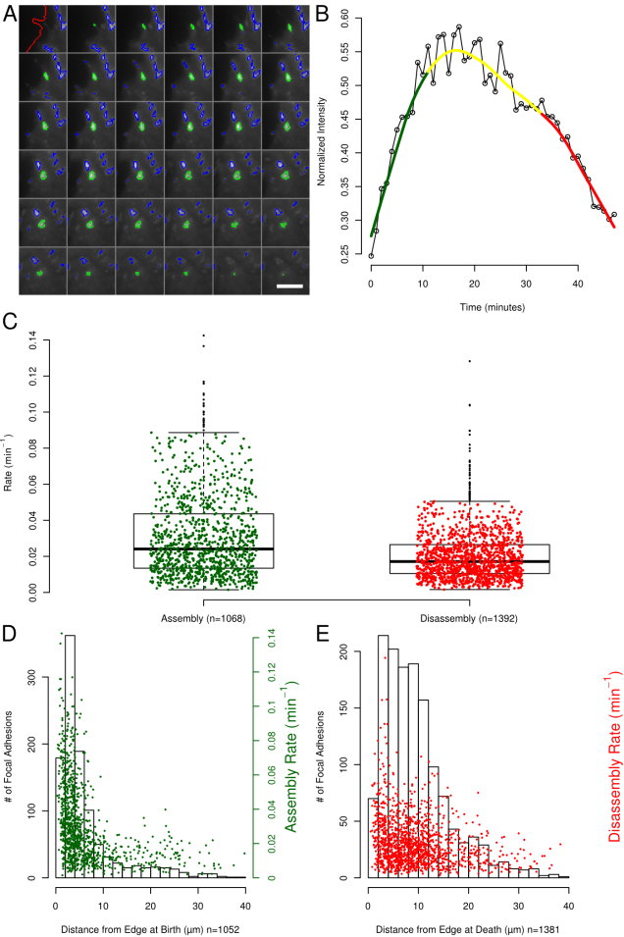

A more complicated version of Figure 2, I think the simpler figure works though.