

Intelligent Systems
- Milestone 3 -

Juan Garrido Arcos

Pedro-Manuel Gómez-Portillo López
Abstract

In this milestone we had been asked for developing a basic versions of a search algorithm following 3 different strategies; breath-first search, depth-first search (depth-limited search and iterative deeping search) and uniform cost.

We are programming in python 2.7, using emacs24 as IDE and bitbucket as code control version. The result of the comparative between the studied data structures have been obtained under an Intel CoreDuo Ubuntu 14.04 with 3,8 GB of RAM.

Comparative between data structures

We were asked to choose an appropriate data structure for storing the fringe of our problem. For so, we studied two different alternatives,

· basic pythonic list managed by bisect, a library named so because it uses a basic bisection algorithm for orderly inserting elements into a list
API - https://docs.python.org/2/library/bisect.html

· heapq, a library which implements a priority queue by means of a binary tree API - https://docs.python.org/2/library/heapq.html

By using bisect for managing our fringe, we obtained the following results after one minute of execution,

Number of nodes in the fringe | Time to accomplish so
50,000 | 3.218
100,000 | 9.379
150,000 | 19.672
200,000 | 35.112
250,000 | 63.254

By using the GNU/Linux tool System Monitor we were able to compute how many MB of RAM the program did generate, and it was not even a 15% of our PC capacity, just around 400MB.

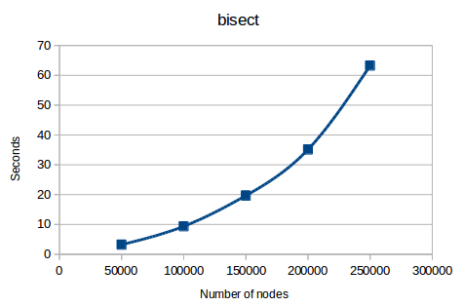
It can be seen that the plot of this function is following an exponential growth.

After studying heapq we collected results shown bellow,

Number of nodes in the fringe | Time to accomplish so
100,000 | 2.808
250,000 | 7.561
500,000 | 14.723
750,000 | 22.696
1,000,000 | 29.949

Passed 30 seconds we had to kill the process as the computer in which we were testing it ran out of RAM; a total of 70% of 3,8 GB of RAM were occupied just before killing the process.

Several times it was needed hard-reseting the PC in order to stop it.
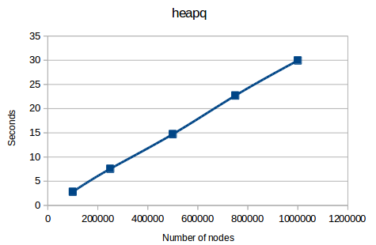
As we can observe, the function follows a linear growth.
Conclusions

The comparative among the experimental result of both data structure is displayed bellow.
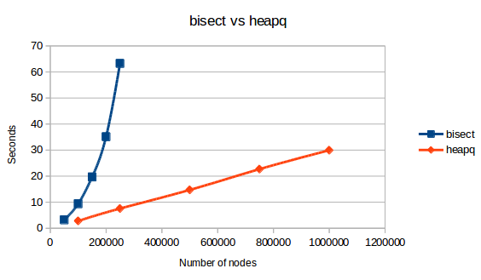
Bisect behaves considerably worse; doubling the execution time of heapq, it has hardly managed to insert not even a quarter of the number of nodes heaqp has been able to, and by the graph we can deduce that gap will heighten very quickly as time goes on.

In conclusion, it is clear that we will be implementing our fringe by means of the heapq library, as it is faster in terms of magnitude than the bisect library.

Interesting parts of code

Aqui comentamos trozos de código to interesantes, como el getSuccessors

Bibliography

Todos los enlaces a stackoverflow que existen

