

Laboratory project improvements
- Intelligent Systems -

Juan Garrido Arcos
juan.garrido3@alu.uclm.es

Pedro-Manuel Gómez-Portillo López
pedromanuel.gomezportillo@alu.uclm.es

Introduction

This GUI is a mere interface for executing the program which has been developed throughout the course. It will gather up the input data from the user avoiding they to remind and use the terminal's complex syntax.

Interface

It has several input boxes devoted to the different kinds of data expected from the user to define. Buttons and labels are aimed to be self-explicative and user-friendly.

After having completed all the input data and pressed the “Generate GPX file” button the interface will collect the information and execute the laboratory program.

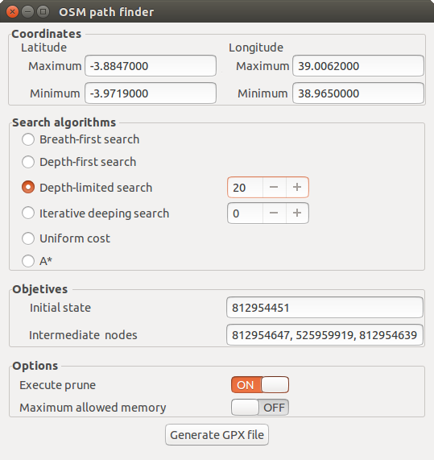
Glade 3.18 has been used for this task. This open-source program allows to create graphical user interfaces and to link to its events by means of its API.

Bibliography

https://glade.gnome.org/

http://www.pygtk.org/articles/pygtk-glade-gui/

http://www.micahcarrick.com/gtk-glade-tutorial-part-1.html

