**Royal Docks Enterprise Zone Governance Arrangements**

February 2016

1. **Executive Summary**
   1. This document sets out the proposed governance arrangements between the London Enterprise Panel (LEP) and other key stakeholders in relation to the Royal Docks Enterprise Zone (EZ).
   2. There is a need to establish an appropriate governance structure for oversight and programme delivery in the Royal Docks EZ for which the LEP has overall responsibility. This will give greater accountability with regards to the collection and use of EZ-related income streams and form a coordinated approach to the delivery and monitoring of regeneration and development projects. This needs to be set within the context of the wider Royal Docks Opportunity Area (OA) for which the GLA and the London Borough of Newham (LBN) are joint leads.
   3. It is proposed that the LEP establish a Royal Docks Enterprise Zone Programme Board for these purposes. Separately, a Royal Docks Board will be established as a joint public/private partnership advisory board for the wider Royal Docks Opportunity Area.
   4. These Boards will both be supported by the existing Royal Docks Delivery Officers Group which currently comprises GLA, LBN and TfL programme and project leads.
   5. The Enterprise Zone Programme Board will make recommendations relating to EZ programmes, projects and their associated spend and will have specific responsibility for programme delivery in the EZ.
   6. These arrangements will only apply to the investment that is agreed for the Royal Docks EZ Delivery Plan; they will not apply to any decisions relating to any surplus income generated once the Delivery Plan is complete.
2. **Background**
   1. The Royal Docks EZ, as established by the Secretary of State, is located in the London Borough of Newham (LBN). EZs are single or multiple sites designated for business development which may offer business rate discounts or enhanced capital allowance for new businesses locating on the sites.
   2. The Royal Docks EZ became operational on 1 April 2012 and has the potential to deliver up to 40,000 jobs and 4,000 homes. It covers 125ha of the Royal Docks Opportunity Area, focussed on the major sites in the area that are due to come forward for commercial development.
   3. Under Department for Communities & Local Government (DCLG) guidance on EZs, the local authority on which an EZ is situated is entitled to use any increase in business rates they collect to support the further development of the EZ in agreement with the LEP.
   4. DCLG guidance for EZs sets out that ‘local arrangements’ are needed to permit LB Newham (as local billing authority for the EZ) to engage with the LEP to establish agreed investment priorities, mechanisms for delivery against these priorities, and such resources as may be required to monitor and programme manage the Royal Docks EZ.
   5. Progress reports on EZ delivery should be a standing item at LEP board meetings, and the LEP is to be represented on any management board or steering group established to take forward delivery of the EZ.
   6. The GLA and LBN have been working in partnership to accelerate development in the Royal Docks, and there is now a need to extend this vehicle of joint working to incorporate the LEP as well as other stakeholders operating in the area.
   7. Within Government, the implementation of all EZs will be overseen by the cross-Whitehall Enterprise Zones Programme Advisory Group, chaired jointly by Peter Schofield (Director-General for Housing and Planning, DCLG) and Philip Rutnam (Director General, Business and Skills, Department for Business, Innovation & Skills), which will monitor progress and escalate any issues as necessary. This Board has membership from a number of Government Departments including HM Treasury and the Departments for Transport, Work & Pensions, Culture, Media & Sports and Energy & Climate Change. It meets approximately every 6 weeks with the DCLG EZ Programme Management Office providing the secretariat.
   8. The main role of the Advisory Group is to foster commitment, consensus and collaboration across Whitehall and relevant statutory consultees, and to enable Departments to identify and prioritise their contribution to EZ delivery.
   9. The Group operates as a forum to update OGD representatives on progress and to monitor progress on delivery on EZ-related actions.
3. **The Royal Docks EZ Delivery Plan**
   1. To maximise the potential income and regeneration in the Royal Docks, significant investment in infrastructure and regeneration activity is required.
   2. A team of consultants have produced robust evidence making the case for this early investment, including a prioritised, costed and phased infrastructure and regeneration investment plan, identifying what investment is required and when. This work takes the form of the following documents:

* Royal Docks: Unlocked, 2037 Economic Vision
* Royal Docks Investment Priority Projects
* Royal Docks Strategic Outline Business Case
  1. These reports form the basis of the Royal Docks EZ Delivery Plan, a requirement under DCLG guidance for EZs.
  2. They are targeted at unlocking major growth and development opportunities, and at supporting the prosperity of residents, visitors and businesses in the Royal Docks. The plan tackles long standing challenges to ensure that they can achieve the ambition of a “place of many places”: a vibrant, thriving, prosperous destination with opportunities for the many, and a first class location in which to work, live and play.
  3. The Royal Docks Strategic Outline Business Case element of the Delivery Plan has established that additional resources within all partner bodies are needed to facilitate the Delivery Plan being realised.
  4. Dedicated officers (or officer time) will be required within LBN and the GLA family if the Delivery Plan is to be made real. This will range from extra capacity to deal with the actual collection of business rates, through to officers tasked with delivering projects and interventions within the EZ.

1. **Governance Structure**
   1. It is proposed that the LEP retains strategic oversight and governance of the EZ including approval of the Delivery Plan and delegates programme delivery to the EZ Programme Board.
   2. Under these proposals, the structure will be organised as follows:

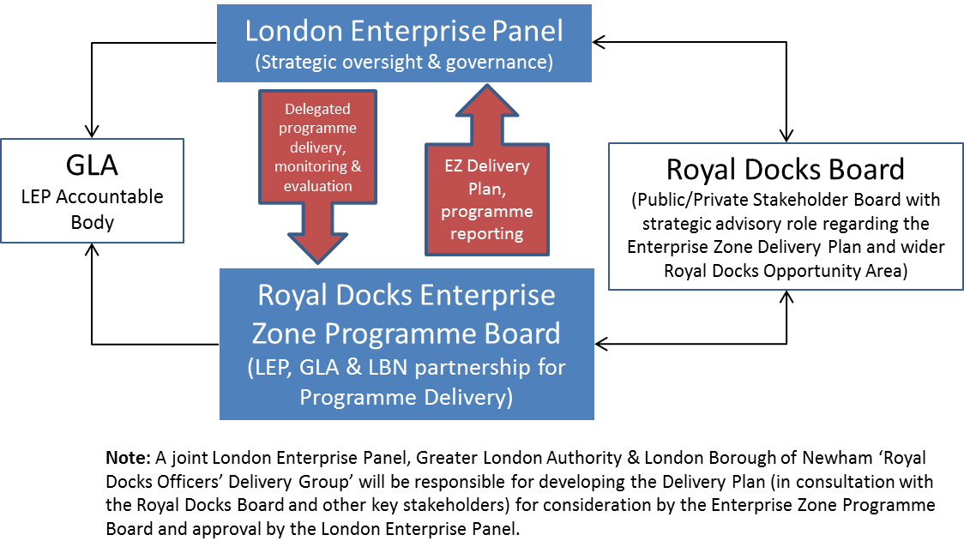

1. **Royal Docks Enterprise Zone Programme Board**

Purpose

The Royal Docks Enterprise Zone Programme Board acts as a senior level forum to drive forward regeneration and economic growth opportunities within the Royal Docks Enterprise Zone (EZ).

It is responsible for establishing the EZ Delivery Plan for approval by the LEP and monitoring its implementation as well as the allocation of funding generated by the uplift in business rates receipts through HM Government’s EZ business rates retention scheme.

Constitution and Membership

The Royal Docks EZ Programme Board will be established as a subordinate body of the LEP.

The Board will be Co-Chaired by a LEP Member and an elected representative from the LBN (as nominated by the borough). Members will be appointed by the LEP in consultation with LBN and the GLA.

Accountability

The Programme Board will be responsible for reporting to the London Enterprise Panel and the London Borough of Newham as appropriate.

Terms of Reference

The Board will:

* ensure alignment of programme objectives and senior level support for the regeneration of the Royal Docks EZ;
* develop the Royal Docks EZ Delivery Plan for submission to the London Enterprise Panel;
* monitor the effective implementation of the EZ Delivery Plan by the Royal Docks Officers Delivery Group;
* receive and approve progress and budget reports from the Royal Docks Officers Delivery Group;
* resolve, mitigate or escalate high level risks and conflicts that cannot be addressed by the Royal Docks Officers Delivery Group;
* work closely with the LEP subgroups to ensure the delivery of LEP priorities;
* report delivery progress and business rate income to the London Enterprise Panel and Royal Docks Board on a quarterly basis;
* receive and approve briefing reports where required; and
* ensure all decisions relating to spending and funding is subject to all GLA internal approval processes, as accountable body to the LEP.

Meetings

The Board will meet on a bi-monthly cycle or at such other intervals as the Board may agree. The Chair (or Co-Chairs) of the Board may decide to cancel meetings or call additional meetings as required.

Reports for consideration by the Board, which will be sponsored by a named Board Member, will normally be issued to Members by the Secretariat a minimum of 5 working days before the meeting.

1. **Royal Docks Board**

Purpose

The Royal Docks Board will include all key public and private sector stakeholders acting as a partnership and advisory board for the wider Royal Docks Opportunity Area. They will be responsible for ensuring that regeneration and economic growth opportunities within the Royal Docks Opportunity Area, including the Enterprise Zone (EZ), are maximised.

Constitution and Membership

Members who are appointed by the GLA in consultation with LBN. Membership must include representatives from the following bodies:

* The London Borough of Newham (LBN)
* The Greater London Authority (GLA)
* The London Enterprise Panel (LEP)

The Board will usually be Co-Chaired by a representative from the GLA and the London Borough of Newham.

Other Members should include other relevant public and private bodies involved in the delivery of the Royal Docks development and regeneration programmes.

Board Members will be appointed for a 1 year term and membership will be reviewed annually.

Accountability

The Board is responsible for reporting to the GLA and LBN. With regards to relevant Enterprise Zone matters, the Board can report to the London Enterprise Panel (as the body with strategic oversight of the EZ Delivery Plan) directly and via the Royal Docks Enterprise Zone Programme Board.

Terms of Reference

The Board will:

* set strategic direction for the Royal Docks Opportunity Area;
* champion the regeneration of the Royal Docks and promote the interests of the Royal Docks in relation to regeneration and economic growth;
* review and advise the London Enterprise Panel and Enterprise Zone (EZ) Programme Board on delivering the Royal Docks EZ Delivery Plan;
* receive and consider progress and budget reports from the Royal Docks EZ Programme Board; and
* resolve or mitigate high level risks and conflicts that cannot be addressed by the Royal Docks EZ Programme Board.

Meetings

The Board will meet on a quarterly cycle or at such other intervals as the Board may agree. The Chair (or Co-Chairs) of the Board may decide to cancel meetings or call additional meetings as required.

Reports for consideration by the Board, which will be sponsored by a named Board Member, will normally be issued to Members by the GLA Secretariat a minimum of 5 working days before the meeting.

Conduct of Business

When discussing issues that affect the whole Royal Docks, each member of the Board has a responsibility to act in the best interests of the Royal Docks as a whole.

Board Members will be expected to take a Royal Docks wide view of issues ahead of their individual organisations interests, insofar as this is not inconsistent with their professional responsibilities, to rigorously examine and challenge issues before the Board and to do so in a constructive way.

Board Members are responsible for advising the GLA secretariat of any external interests which may conflict with duties and responsibilities and these are recorded in a formal register of interests.

The Board will conduct a tri-annual evaluation of its performance and every three years it will formally consider its remit, constitution and operating procedures unless an earlier review is considered necessary.

Declarations of Interest

Should a Board Member become aware they have a pecuniary interest, direct or indirect, in any matter to be considered at a meeting then they shall disclose such interest to the meeting. They shall not take part in any consideration or discussion of the matter.

In line with the constitution and membership requirements above, initial membership will comprise the following stakeholders:

|  |  |
| --- | --- |
| **ROYAL DOCKS BOARD** | |
| **Name** | **Organisation** |
| Mayor of Newham | LBN |
| Portfolio Holder for Regeneration | LBN |
| Chief Executive | LBN |
| Deputy Mayor for Housing | GLA |
| Deputy Mayor for Culture and Education | GLA |
| Executive Director Housing and Land | GLA |
| Executive Director Development Enterprise and Environment | GLA (LEP representative) |
| Managing Director | TfL |
| Senior Representative | LEP |
| Senior Representative | ExCeL |
| Senior Representative | Royal Docks Management Authority Ltd. |
| Senior Representative | Siemens PLC |
| Senior Representative | City Airport |
| Senior Representative | University of East London |
| Senior Representative | Royal Albert Dock - ABP |
| Senior Representative | Silvertown Quays -The Silvertown Partnership |
| Senior Representative | Royal Albert Basin - Notting Hill Housing |
| Senior Representative | Carillion Igloo |
| Senior Representative | Ballymore |
| Senior Representative | Canning Town – Bouygues UK |
| **Total Board Members – 20** | |

|  |  |
| --- | --- |
| **ROYAL DOCKS BOARD DELIVERY OFFICERS** | |
| **Name** | **Organisation** |
| Assistant Director Housing and Land | GLA |
| Assistant Director Regeneration | GLA |
| Principal Development Manager | GLA |
| Head of Planning and Regeneration | LBN |
| Senior Manager, Regeneration | LBN |

1. **Royal Docks Officers Delivery Group**

The Delivery Group is an existing officers’ forum responsible for delivering the programmes and projects associated with the regeneration and development of the Royal Docks Opportunity Area including the Enterprise Zone. It is proposed that this Group continues in its current form with an additional responsibility for reporting to the new EZ Programme Board.

Purpose

To co-ordinate the delivery of development, regeneration and estate management in the Royal Docks, focusing largely on operational matters.

Constitution and Membership

The Delivery Group will comprise key officers responsible for delivering the programmes and projects associated with the regeneration and development of the Royal Docks Opportunity Area including the Enterprise Zone including project managers from the various GLA, TfL and LBN projects across the Royal Docks as well as representatives from HM Government.

Terms of Reference

The Delivery Group will:

* develop the EZ Delivery Plan on behalf of the London Enterprise Panel and the Enterprise Zone Programme Board;
* ensure the EZ Delivery Plan is carried out efficiently and sustainably;
* ensure successful management and delivery of the remaining development sites;
* make sure to connect the Royal Docks to the surrounding communities;
* agree the approach to managing the identity and communications of activity taking place in the Royal Docks;
* ensure high quality estate management and maximise potential for use for events and meanwhile use;
* maximise the benefits of the EZ and secure any additional funding sources; and
* prepare update and briefing documents for the Royal Docks EZ Programme Board and Royal Docks Board as and when required.

Meetings

The Delivery Group will meet on a monthly basis for 2 hours, alternating between City Hall and Newham Dockside. The Chair (or Co-Chairs) of the Board may decide to cancel meetings or call additional meetings as required.

In line with the constitution and membership requirements above, membership comprises the following officers:

|  |  |  |
| --- | --- | --- |
| **ROYAL DOCKS OFFICERS DELIVERY GROUP** | | |
| **Title** | **Name** | **Organisation / Department** |
| Mr | Colm Rasdale | LB Newham |
| Mr | Murray Woodburn | LB Newham |
| Ms | Nuala Gallagher | LB Newham |
| Mr | Saeed Janjua | LB Newham |
| Mr | Shelim Shakir | LB Newham |
| Ms | Ellen Nicholson | LB Newham |
| Ms | Yvonne Shaw | LB Newham |
| Mr | Damian Atkinson | LB Newham |
| Ms | Monica Thomas | LB Newham |
| Mr | Jack Stevens | BIS |
| Mr | Tim Neale | TfL |
| Mr | Rajesh Gami | TfL |
| Mr | Daniel Bridge | GLA |
| Mr | Paul Clarke | GLA |
| Mr | Jamie Dean | GLA |
| Mr | Alex Marsh | GLA |
| Ms | Bethan James | GLA |
| Mr | Paul Guest | GLA |
| Ms | Caroline Cameron | GLA |
| Ms | Lauren Noble | GLA |
| Ms | Chenine Bathena | GLA |
| Ms | Natalie Gentry | GLA |
| Mr | Mike Luddy | RoDMA |
| **Total Attendees – 23** | | |

The Group will be Co-Chaired by Daniel Bridge (GLA) and Nuala Gallagher (LBN). Membership will be reviewed annually. A series of working groups are established underneath this Group and operate on a project-by-project basis.