**Tips for supporting children with autism practically and emotionally around Corona Virus**

**(from The Bristol Autism Team)**

***Introduction:***

We have put together this resource in response to requests from families we know in Bristol about supporting children at home over this time of uncertainty.

There is already lots of information available from other areas and internationally about how to manage anxiety about Corona and the practical side of being at home. We have included some of the most helpful information and links in this document and also some fuller references at the end for those who would like to search more for themselves. Mainly, we have tried to summarise the advice that is coming through and combine it here with our experience of children on the spectrum.

Of course, as always, take those bits that are helpful for you and your family and remember that at times of change trying to do too much that is new can be quite overwhelming for children with autism as well as their parents. Just choosing one or two things to introduce could be the best way forward initially along with planning and pacing for yourself as well.

***Practical advice to help with keeping clean:***

* We have been told a lot recently that it is important to help our children learn about the guidelines for hand washing and keeping clean. For many children this has been difficult especially for those who may not have developed these habits yet.
* Providing and increasing visual reminders to target hand washing is helpful. Visuals like this one (put together by the Speech and Language therapists at Sheilings school) can help especially when they are stuck up around eating areas and where children use the toilet:



* Many parents are finding that their children are needing lots of extra prompting and practice at the handwashing – this is not an easy change for them. Some are finding that washing hands for the length of a favourite song or rhyme is helping with washing for a longer time. Another favourite around is the elephant visual below:

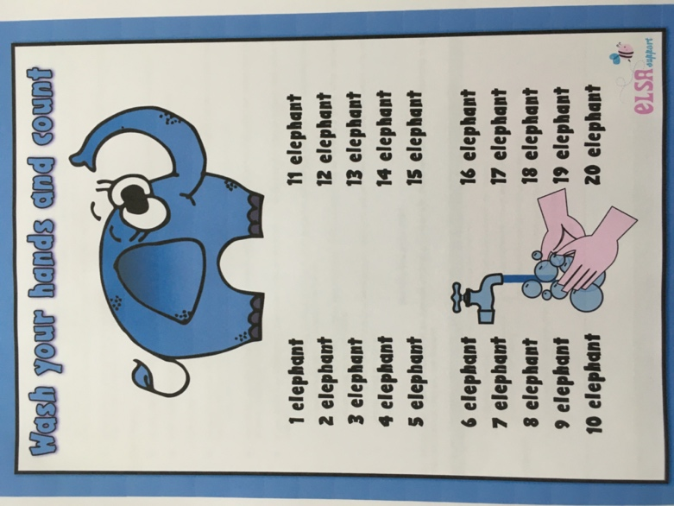

***Providing information about the virus and measures in place:***

* Try to keep explanations about the virus very simple and to your child’s level of understanding. Have a think about the worries and questions that they may have and try to give them opportunities to ask questions and have discussions.
* For many children this may just be brief verbal explanations and we don’t want them to get too sucked into worry about this if they are not showing it.
* Remember that children’s biggest worries can be quite different to those of adults and may just relate to their world or routines (for example, when they will be able to go back to their favourite club or see their teacher/LSA again).
* If children do seem to have lots of questions then you could encourage them to write these down (particularly where they are showing anxiety about what might happen). You can then have a think about the questions and how to respond to them at their level:

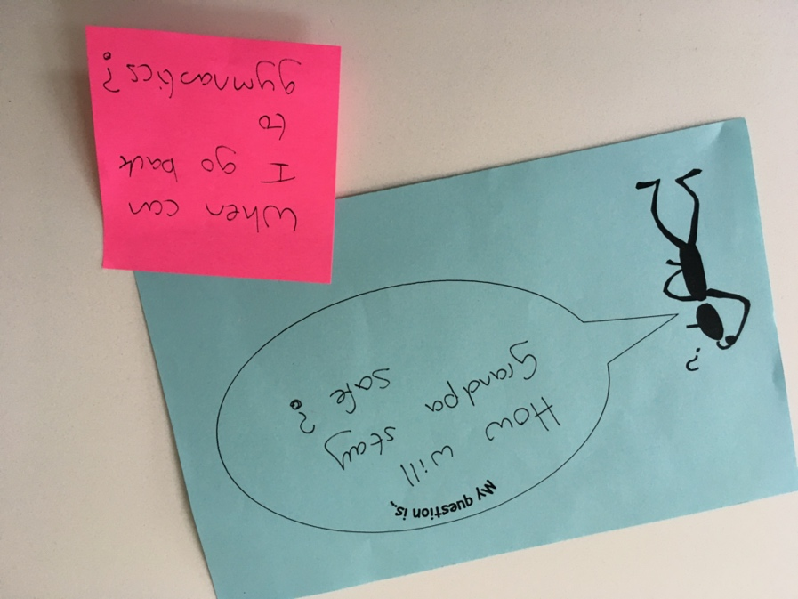

Very anxious children may need responses to be written to avoid patterns of repetitive questions and answers establishing.

* Keep information in perspective to your child and family. For most children this will be reassurance that the virus is not known to be dangerous in children also that it also does not harm the majority of adults in the long-term (especially for healthy adults that this is very unlikely). Explain to them simply what the symptoms are so that they know what to expect (e.g. “it can consist of a cough and feeling hot/sweaty which might last for a few days”).
* If you or your child or another family member has a more complex health situation then it is important to address this in a simple, honest way and with an appropriate level of reassurance about the support and care that is available.

Here are some links to help further with explaining Corona Virus to your children. Two locally produced resources are also attached to this email (information on Coronavirus and a Coronavirus visual):

* **ChildMind: Talking to Children**  
  <https://childmind.org/article/talking-to-kids-about-the-coronavirus/>
* **ELSA: Coronavirus Story for Children**  
  <https://www.elsa-support.co.uk/coronavirus-story-for-children/>
* **This lovely story is available in many different languages and has already been used to support many children from around the world:**  
  https://www.mindheart.co/descargables

***Be media aware:***

* Be aware of having the news on. This will inflate anxiety because children will not understand some of the adult themes and words and may take things very literally or get confused (this is especially important for literal thinkers or those who take language literally). Children do not have the same filters as adults in terms of responding to alarming news. It is important that you filter any important news down to them.
* In addition, the use of a lot of red colour on the news programmes and pictures of the virus is likely to be especially alarming to children (especially those with visual stress and/or an eye for detail). Red is usually implicitly picked up as alarming or dangerous. This is not a conscious process but it may raise anxiety generally as well as when programmes are on.
* Much of the guidance around for adults on Corona anxiety is advising that we all limit our input of news/media consumption each day so that we too can prevent anxiety rising to an unhelpful level and keep a balance going in our lives.

***Be aware of your own anxiety:***

* Parents’ anxiety and adult conversations which children pick up on can inflate their own feelings and lead to misinterpretations. Some of the advice (especially coming from the States) is talking about ‘Modelling a calm response’. This relates really to responding to our own internal anxiety rather than reacting and showing stress around our children. It is natural that parents will be feeling stressed at this time and trying to organise things. Having adult chats out of earshot and monitoring thoughts and feelings will help to minimise the impact on children.
* If there are differences in your own behaviour (like buying a few extra bits) try to explain this is a way that will not be alarming for them so that it makes sense.
* It is important to also think about your own needs and coping strategies and start to make plans about how these might fit in as well. For example, if you have your own need for exercise, planning for this and putting it into the daily plan with your family is helpful for you and for them.

***Here are some further links relating to Corona Virus advice:***

**American Psychological Association: Information on Pandemics (a wide range of resources)**  
<https://www.apa.org/practice/programs/dmhi/research-information/pandemics?utm_source=linkedin&utm_medium=social&utm_campaign=apa-pandemics&utm_content=pandemics-resources>

**Anna Freud: Self-Care and Coping Strategies**  
<https://www.annafreud.org/selfcare/>

**BBC: How to protect your mental health**  
<https://www.bbc.co.uk/news/health-51873799>      
   
**CBBC: Video and Questions**  
<https://www.bbc.co.uk/newsround/51861089>   
   
**ChildMind: Talking to Children**  
<https://childmind.org/article/talking-to-kids-about-the-coronavirus/>   
   
**ELSA: Coronavirus Story for Children**  
<https://www.elsa-support.co.uk/coronavirus-story-for-children/>     
   
**National Association of School Psychologists: Parent Resources**  
<https://www.nasponline.org/resources-and-publications/resources-and-podcasts/school-climate-safety-and-crisis/health-crisis-resources/talking-to-children-about-covid-19-(coronavirus)-a-parent-resource>    
   
**Young Minds: Feeling Anxious about Coronavirus**  
<https://youngminds.org.uk/blog/what-to-do-if-you-re-anxious-about-coronavirus>

**This website provides a further helpful overview of advice and resources:**<https://edpsy.org.uk/blog/2020/coronavirus-covid-19-information-for-children-families-and-professionals/>

***Here are some books which may be helpful in explaining things and/or to help with talking about feelings:***

**Something Bad Happened: A Kid’s Guide to Coping with events in the News**  
Dawn Huebner. How to process different world events (ages 6-12).  
   
**The Day the Sea Went Out and Never Came Back**  
Margot Sunderland. A story for children who have lost someone they love (ages 4-12).

**Draw on Your Emotions**Margot Sunderland. A resource to help people express and communication their emotions.   
  
**What To Do When You’re Scared & Worried: A Guide for Kids**  
James Crist. A help guide to processing fears and worries (ages 9-13).  
   
**Have You Filled A Bucket Today? A Guide to Daily Happiness for Kids**  
Carol McCloud. Encourages positive behaviour and expressing kindness and appreciation.  
   
**How are you Peeling: Foods with Moods**  
Saxton Freymann & Joost Elffers. Explores how emotions look through pictures of Foods. A good way to talk about emotions with young children.  
   
**The Way I Feel**  
Janan Cain. Explores feelings and a helpful way to talk about emotions with young children.

**This document has been researched and developed by Tanya Rawlinson (Clinical Psychologist and NAS licenced EarlyBird Trainer)**