Delegations will find attached document SWD(2016) 200 final.

Encl.: SWD(2016) 200 final

COMMISSION STAFF WORKING DOCUMENT
Accompanying the document
Report from the Commission to the European Parliament and the Council
on the review of the wholesale roaming market
Table of Contents

Table of Figures 5
Table of Tables 7
List of Acronyms 8
1. Introduction 11
2. The Commission's approach to the review of national wholesale markets and its legislative proposal 13
2.1. Information and data gathering on wholesale and retail roaming markets 13
2.2. Analysis of the data 14
2.3. External study to estimate the costs of providing wholesale roaming services 14
2.4. Public consultation 15
2.5. BEREC input 15
2.6. Commission's inter-service group 16
2.7. The report on national wholesale roaming markets (this report) 16
2.8. Impact assessment for the Commission's legislative proposal 16
3. Overview of the EU Roaming Regulations and market developments (2007-2015) 16
3.1. Evolution of the EU Roaming Regulations (2007-2015) 16
3.2. Evolution of wholesale and retail roaming prices (2007-2015) 20
3.2.1. Retail roaming prices 20
3.2.2. Wholesale roaming prices 22
3.3. Evolution of roaming traffic in Europe 24
4. Competition developments in retail roaming markets 26
4.1. Description of the Commission's approach 26
4.1.1. Literature review 26
4.1.2. Questionnaires to operators and analysis of the data 26
4.2. Market failures in retail roaming markets 27
4.2.1. Imperfect substitutes at the retail level 27
4.2.2. Lack of tariff transparency and bill shock 29
4.2.3. Inelastic demand for roaming services for a significant proportion of the customer base 29
4.3. Domestic price level and consumption pattern 31
4.4. A comparison of retail roaming and domestic traffic 31
4.5. Retail roaming offers 35
4.6. Current technological developments as potential substitutes to roaming 36
4.7. Conclusion 39
5. Assessment of the cost of providing wholesale roaming services in the EEA 40
5.1. Introduction 40
5.2. Description of the Commission's approach 40
5.2.1. Questionnaires to NRAs and operators 41
5.2.2. External study to estimate wholesale roaming costs 41
5.2.2.1. The call for tenders 41
5.2.2.2. The objectives of the study 41
5.2.2.3. Consultation with NRAs and mobile operators 41
5.3. Previous estimates of wholesale roaming costs 42
5.4. The TERA Consultants cost model 42
5.4.1. The approach followed by TERA Consultants 43
5.4.2. High level assumptions in TERA's cost model 44
5.4.2.1. The choice of cost standard 44
5.4.2.2. The approach to cost modelling 46
5.4.2.3. Estimation of network costs 47
5.4.2.4. Roaming-specific costs 54
5.4.2.5. Impact of seasonality 57
5.4.2.6. Total estimated wholesale roaming costs 59
5.5. Termination rates 60
5.6. Transit costs 62
5.7. Comparison of the voice cost estimates derived from TERA's study against an alternative approach based on national mobile termination rates 63
5.8. Cost estimates for SMS services 66
5.9. Conclusion on the costs of wholesale roaming services 67
6. Degree of competition in wholesale roaming markets 68
6.1. Description of the Commission's approach 69
6.1.1. Literature review and previous studies 69
6.1.2. Questionnaire to operators and analysis of the data 69
6.1.3. Public consultation 70
6.2. Market failures in wholesale roaming markets 70
6.2.1. Natural oligopoly structure, which fosters low intensity of competition 70
6.2.2. Imperfect wholesale roaming substitutes 71
6.2.3. Double marginalisation and difficulties in coordination 71
6.2.4. Bilateral nature of wholesale roaming agreements 72
6.2.5. Exclusion of MVNOs from wholesale roaming markets 72
6.3. Overview of wholesale roaming agreements 73
6.3.1. Standard Roaming Agreements and roaming discount agreements 73
6.3.2. Bilateral and unilateral roaming agreements 73
6.3.3. Number of roaming agreements in each destination country 74
6.3.4. Pricing models 74
6.3.5. Permanent roaming 75
6.3.6. Machine-to-Machine communications (M2M) 76
6.4. Description of the wholesale roaming market in the EU 77
6.4.1. Wholesale roaming traffic flows between Member States 77
6.4.2. Wholesale roaming traffic compared to retail domestic traffic 79
6.4.3. Wholesale roaming payments and revenues balance 82
6.4.4. Wholesale roaming prices in the EU 84
6.5. Degree of competition in national wholesale roaming markets 87
6.5.1. Operators' views of the functioning of the national wholesale roaming markets 87
6.5.2. Operators' views about the ability of the current functioning of national wholesale roaming markets to enable RLAH in the EU 90
6.5.3. MVNOs' views of the functioning of the national wholesale roaming markets 90
6.5.4. Wholesale roaming prices vs wholesale and retail domestic prices and underlying costs 91
6.5.5. Presence of pan-European mobile operators 93
6.5.6. Inside vs outside group roaming 95
6.5.6.1. Steering roaming traffic inside the group 95
6.5.6.2. Inside vs outside group wholesale roaming prices 96
6.5.7. Competitive situation of operators with limited geographic scope 99
6.6. Conclusions 103
7. RLAH in 2017 104
8. Conclusions 105
BIBLIOGRAPHY 108
ANNEX 1: Existing 'Roam-Like-At-Home' (RLAH) offers 110
ANNEX 2: Wholesale roaming price paid and received 111
ANNEX 3: Roaming traffic flows between countries 112

Table of Figures
Figure 1 - EEA average retail price per minute for intra-EEA roaming voice calls made 20
Figure 2 - EEA average retail price for intra-EEA outgoing SMS 21
Figure 3 - EEA average retail price per MB 21
Figure 4 - EEA average price per minute for wholesale non-group roaming voice calls 22
Figure 5 - Average wholesale price per intra-EEA roaming SMS: charges to non-group companies 23
Figure 6 - Average wholesale data price per MB (prepaid+postpaid), EEA average 23
Figure 7 - Roaming traffic index: intra-EEA outgoing calls (Q3 2008=100) 24
Figure 8 - Retail SMS sent traffic index (Q3 2008=100) 25
Figure 9 - Retail roaming data traffic index: (Q3 2008 = 100) 25
Figure 10 - Intra-EEA retail roaming revenues as % of total retail revenues (x-axis) 32
Figure 11 - Intra-EEA retail roaming traffic as % of total retail traffic (outgoing minutes) 33
Figure 12 - Intra-EEA retail roaming consumption as % of total retail consumption (outgoing SMS) 33
Figure 13 - Intra-EEA retail roaming consumption as % of total retail consumption (data) 34
Figure 14 - Intra-EEA retail roaming revenues and volumes as % of total retail revenues and volumes (y-axis) by country, 2014 35
Figure 15. Steps in the estimation of costs in the TERA cost model 47
Figure 16: Re-allocation of costs not recovered through voice and SMS termination 48
Figure 17: Example of re-balancing of costs with effective mobile termination rates 49
Figure 18: TERA's cost estimates for voice origination after re-balancing for national MTRs under Scenario B (€c/min) 50
Figure 19: TERA's cost estimates for data services (€c/MB) 50
Figure 20: Comparison of TERA's voice origination costs against retail unit voice prices (€c/min) 53
Figure 21: Comparison of TERA's data costs against retail unit data prices (€c/MB) 54
Figure 22: Mark-ups on voice services for roaming-specific costs (€c/min) 56
Figure 23: Mark-ups on data services for roaming-specific costs (€c/MB) 56
Figure 24: Mark-ups on voice services for seasonality (€c/min) 59
Figure 25: Total estimated wholesale roaming unit costs for voice origination (€c/min) 60
Figure 26: Total estimated wholesale roaming unit costs for data services (€c/MB) 60
Figure 27: Fixed termination rates applicable in MS (S2 2015) – BU-LRIC rates in blue (€c/min) 61
Figure 28: Mobile termination rates applicable in MS (S2 2015) – BU-LRIC rates in blue (€c/min) 61
Figure 29: Total estimated costs of wholesale roaming voice origination including the termination rate and transit costs (€c/min) 64
Figure 30: Total estimated costs of wholesale roaming data services including transit costs (€c/MB) 64
Figure 31: Comparison between the TERA-based estimated cost for wholesale roaming voice,an alternative approach to estimating costs for wholesale roaming voice, average wholesale roaming market price for unbalanced traffic (€c/min) 65
Figure 32: Current wholesale roaming prices for SMS in MS (€c/SMS) 67
Figure 33 – Intra-EEA wholesale roaming (inbound) revenue as % of retail domestic revenue all services (x-axis) 79
Figure 34 – Intra-EEA wholesale roaming (inbound) traffic as % of retail domestic traffic (x-axis) (outgoing voice) 80
Figure 35 – Intra-EEA wholesale roaming (inbound) traffic as % of retail domestic traffic (outgoing SMS) 80
Figure 36 – Intra-EEA wholesale roaming (inbound) traffic as % of retail domestic traffic (x-axis) (data) 81
Figure 37 – Intra-EEA wholesale roaming (inbound) revenues and traffic as % of retail domestic revenues and traffic (y-axis), 2014 82
Figure 38 - Total intra-EEA wholesale roaming balance (revenues minus payments) as a % of total retail domestic revenues (x-axis), all services included 83
Figure 39 - Total intra-EEA wholesale roaming balance (revenues minus payments) as a % of total retail domestic revenues (y-axis), all services included, per country 84
Figure 40 - Average wholesale roaming prices for balanced and unbalanced traffic (inbound and outbound): voice services (2015) 85
Figure 41 - Average wholesale roaming prices for balanced and unbalanced traffic (inbound and outbound): SMS services (2015) 86
Figure 42 - Average wholesale roaming prices for balanced and unbalanced traffic (inbound and outbound): data services (2015) 86
Figure 43 – Ratio inside group over outside group roaming volumes per operator and destination country (voice - outbound roaming traffic) 95
Figure 44 - Ratio inside group over outside group roaming volumes per operator and destination country (SMS - outbound roaming traffic) 96
Figure 45 - Ratio inside group over outside group roaming volumes per operator and destination country (data - outbound roaming traffic) 96
Figure 46 – Ratio between inside group and outside group wholesale roaming unit prices per operator and destination country (voice - outbound roaming traffic) 97
Figure 47 - Ratio between inside group and outside group wholesale roaming unit prices per operator and destination country (SMS - outbound roaming traffic) 98
Figure 48 Ratio between inside group and outside group wholesale roaming unit prices per operator and destination country (data - outbound roaming traffic) 98
Figure 49 – Average wholesale roaming price for unbalanced traffic vs operator size (voice - outbound traffic) 100
Figure 50 – Average wholesale roaming price for unbalanced traffic vs operator size (SMS - outbound traffic) 101
Figure 51 – Average wholesale roaming price for unbalanced traffic vs operator size (data - outbound traffic) 101
Figure 52 - Difference between effective unit prices (payments/volumes) paid and received (data - outside group traffic) 102
Figure 53 - Difference between effective unit prices paid and received (voice - outside group traffic) 111
Figure 54 - Difference between effective unit prices paid and received (SMS - outside group traffic) 111

Table of Tables
Table 1 - Regulatory measures introduced by the Roaming Regulations (2007-2016) 18
Table 2: When travelling to another EU country, you generally... 28
Table 3 - BEREC's estimations for upper bound, average and lower bound of wholesale costs for wholesale roaming services (2010) 42
Table 4 - BEREC's estimations wholesale costs for wholesale roaming services (2012) 42
Table 5: Allowances included in the baskets of the study considered to estimate retail prices 51
Table 6: Country VAT rates used to derive domestic retail prices excluding VAT 51
Table 7: Country retail prices using the relative prices of wholesale roaming prices 52
Table 8: Roaming-specific costs estimated by TERA 55
Table 9: Termination rate to be considered within the cost of originating a mobile roaming call (€c/min) 62
Table 10: Wholesale roaming services' cost estimates in each of the 29 countries considered in TERA Consultants' cost model 68
Table 11 - Inbound/Outbound ratio for roaming services: voice, data and SMS (in green values above 150%, in blue values below 75%) 78
Table 12 - Presence of pan-European mobile operators 94
Table 13 - RLAH offers per country (add-ons are excluded), September 2015 110
Table 14 - Roaming voice traffic flow between countries in the second semester of 2014 112

List of Acronyms
ARPM - Average Revenue Per Minute
ARRPU - Average Retail Revenue Per User
BEREC - Body of European Regulators in Electronic Communications
DG CNECT - Directorate General for Communications Networks, Content & Technology
EEA - European Economic Area
EU - European Union
EUR - Euro
EUR/PPP - EUR/Purchasing Power Parity
FUP - Fair Use Policy
GB - Gigabyte
GSM - Global System for Mobile communications
GSMA - GSM Association
HD - High Definition
IA - Impact Assessment
IMSI - International Mobile Subscriber Identity
IOT - Internet of Things
JRC - Joint Research Centre
LBO - Local Break Out
LTE - Long-Term Evolution
MB - Megabyte
MS - Member State
MNO - Mobile Network Operator
MTR - Mobile Termination Rate
MVNO - Mobile Virtual Network Operator
MWC - Mobile World Congress
M2M - Machine to Machine
NRA - National Regulatory Authority
OECD - Organisation for Economic Co-operation and Development
OTT - Over-the-top
VoIP - Voice over Internet Protocol
Q1 - Quarter 1
Q2 – Quarter 2
Q3 - Quarter 3
Q4 - Quarter 4
RLAH - Roaming Like At Home
SIM - Subscriber Identity Module
SME - Small and medium-sized enterprises
SMS - Short Message Service
STIRA - Standard Terms for International Roaming Agreements
US - United States
VAT - Value-added tax
VoIP - Voice over Internet Protocol
VoLTE - Voice over Long-Term Evolution
Wi-Fi - Wireless Fidelity
3G - 3rd Generation
4G - 4th Generation
€c - euro cent

Countries
BE - Kingdom of Belgium
BG - Republic of Bulgaria
CY- Cyprus
CZ - Czech Republic
DK - Kingdom of Denmark
DE - Federal Republic of Germany
EE - Republic of Estonia
IE - Ireland
EL - Hellenic Republic
ES - Kingdom of Spain
FR - French Republic
HR - Republic of Croatia
IS - Republic of Iceland
IT - Italian Republic
LI - Principality of Liechtenstein
LV - Republic of Latvia
LT - Republic of Lithuania
LU - Grand Duchy of Luxembourg
HU - Hungary
MT - Republic of Malta
NL - Kingdom of the Netherlands
NO - Kingdom of Norway
AT - Republic of Austria
PL - Republic of Poland
PT - Portuguese Republic
RO - Romania
SI - Republic of Slovenia
SK - Slovak Republic
FI - Republic of Finland
SE - Kingdom of Sweden
UK - United Kingdom of Great Britain and Northern Ireland
- Introduction
In October 2015 the European Parliament and the Council adopted Regulation 2015/2120, which, inter alia, amended Regulation 531/2012 (hereinafter Roaming III Regulation) and entered into force on 29 November 2015. In this report, the Roaming III Regulation as amended by Regulation 531/2012 is called the Roaming Regulation or simply the Regulation.
The Regulation mandates the abolition of retail roaming surcharges in the EU from 15 June 2017 (the Roam Like At Home – RLAH – regime), subject to fair usage of roaming services and a sustainability clause. With the establishment of the obligation to charge retail roaming services at domestic prices (no more retail roaming surcharges) subject to a fair use of these services, Regulation EU 2015/2120 has substantially defined a new retail regulatory regime for regulated roaming services: the roam-like-at-home (RLAH) regime.
However, while retail pricing of roaming and domestic services are aligned by regulation, the provision of retail roaming services does not use the same wholesale inputs as retail domestic services, in view of the fact that the provision of retail roaming service requires, by definition, the use of a different (visited) network.
These wholesale roaming inputs are therefore to be bought in the market by the visiting operator. Wholesale roaming inputs include a number of costs specific to roaming (i.e. not incurred in providing domestic services), such as roaming operation and management costs, roaming financial and data clearing costs, roaming negotiation and contract management costs. In order to ensure that the retail roaming services can be provided at domestic retail prices, therefore, it is necessary that wholesale roaming inputs are available at a price that makes generally possible for the visiting (home) operators the provision of RLAH, eventually subject to fair use and without prejudice to the possibility to ask for a sustainability derogation in exceptional circumstances, while at the same time ensuring that visited operators can recover the costs of provision of these services.
The Regulation therefore mandates the Commission to review the wholesale roaming market by 15 June 2016, with a view to assessing measures necessary to enable abolition of retail roaming surcharges by 15 June 2017.
On the one hand, with regard to retail roaming regulation, the choice to establish a RLAH regime has been already taken by the co-legislators with Regulation 2120/2015; on the other hand the correct working of wholesale roaming market is a precondition for the achievement of the RLAH regime. Therefore the Commission has been entrusted with the specific task to review the wholesale roaming markets, rather than the evaluation of the functioning of the entire Roaming III Regulation. The review of roaming wholesale market was carried out with a view to analyse the degree of competition in national roaming markets, any observable risk of distortion of competition and investment incentives in domestic and visited markets in order to assess the measures necessary to enable the achievement of the objective established by the co-legislators, i.e. the abolition of retail roaming surcharges by 15 June 2017. This was done taking into account the need to ensure that the visited network operators are able to recover all costs of providing regulated wholesale roaming costs and the need to prevent permanent roaming or anomalous or abusive use of wholesale roaming (Article 19 of the Roaming Regulation).
In line with this mandate, therefore, the aim of this report, together with its associated impact assessment, is not to review the entire functioning of the original Roaming III Regulation nor the RLAH obligation for which the wholesale review is actually a pre-condition, but is rather focused on the review of the wholesale roaming markets in the EU and to propose the most appropriate legislation at the wholesale level to ensure the success of the RLAH regime. In line with the mandate of the European Parliament and the Council set out in Article 19 of the Regulation, the focus of the Commission's assessment in this report is on:
- the developments in competition in the retail roaming markets (section 4);
- the costs of providing wholesale roaming services in the EU (section 5); and
- the degree of competition in national wholesale markets, including an assessment of the wholesale charges applied, the competitive situation of operators with limited geographic scope, the effects of commercial agreements on competition, as well as the ability of operators to take advantage of economies of scale (section 6).
In addition, the Regulation mandates the Commission to have regard to specific criteria when assessing the most appropriate measures at the wholesale level to enable the abolition of retail roaming surcharges. The Commission has carefully considered the criteria set out by the European Parliament and Council in the Regulation in its impact assessment and legislative proposal accompanying this report, namely:
- the risks of distortion of competition and investment incentives in domestic and visited markets of any measure proposed for wholesale roaming markets;
- the need to ensure that visited network operators are able to recover all costs of providing regulated wholesale roaming services, including joint and common costs; and,
- the need to prevent permanent roaming or anomalous or abusive use of wholesale roaming access for purposes other than the provision of regulated roaming services to roaming providers' customers while the latter are periodically travelling within the Union.
The remainder of this report is structured as follows:
- section 2 describes the overall methodology followed by the Commission in the review of national wholesale roaming markets;
- section 3 provides an overview of the EU Roaming Regulations to date and their impact on market developments;
- section 4 describes the competition developments in retail roaming markets across the EU to date;
- section 5 sets out the Commission's approach to assessing the costs of providing wholesale roaming services and a summary of the outcome of the Commission's assessment (more detail on this analysis can be found in the Final report of the study);
- section 6 assesses the degree of competition in national wholesale roaming markets;
- section 7 assesses the possible impact of the future retail RLAH obligation on competition on the wholesale roaming markets;
- section 8 summarises the main conclusions of this report.
- The Commission's approach to the review of national wholesale markets and its legislative proposal
In this section the Commission's approach in reviewing national wholesale markets and its legislative proposal is described, in particular, as regards:
- Information and data gathering on wholesale and retail roaming markets
- Analysis of the data
- The external study commissioned by the Commission to assess the costs of providing wholesale roaming services
- Public consultation
- Body of European Regulators in Electronic Communications (BEREC) input
- Commission's inter-service group
- Report on national wholesale roaming markets (this report)
- Impact assessment of the Commission's legislative proposal
  - Information and data gathering on wholesale and retail roaming markets
The first phase of the review process consisted in gathering quantitative and qualitative information about wholesale and retail markets in the EU. On 28 July 2015, the Commission sent an information request to BEREC specifying the data and information necessary to conduct the review of national wholesale roaming markets in accordance with the Regulation requirements.
Following that request, BEREC, in collaboration with the Commission, sent two questionnaires to, respectively, mobile (virtual) network operators M(V)NOs and national regulatory authorities (NRAs) on 11 September 2015. These questionnaires aimed at collecting detailed data, facts and figures about the degree of competition in national wholesale markets, the level of wholesale roaming costs incurred by a visited operator, including relevant joint and common costs, any observable risks of distortions of competition and investment incentives in home and visited market, and the competition developments in the retail roaming markets. The questionnaire to NRAs also aimed at gathering information on the cost models and input data used by NRAs to estimate mobile network costs. Replies from operators and NRAs to these questionnaires were received in the course of September and October 2015. Some operators provided updated replies in November-December 2015 and early January 2016.
Through this information gathering exercise, the Commission received quantitative and qualitative information from 135 operators and from the 28 EU NRAs plus the Norwegian NRA. In the remainder of this report to the information gathered from operators and NRAs is referred as the 'autumn 2015 data collection'.
In the course of December 2015 and January 2016, the Commission complemented this data collection exercise with additional requests on the characteristics and inputs of NRAs' mobile termination rates cost models, for the purpose of developing a cost model to assess the costs of providing wholesale roaming services (a more detailed description of the external study commissioned by the Commission to TERA Consultants for this purpose is included in section 5.4 below).
In addition to these formal information requests, the Commission has held informal meetings with NRAs and stakeholders since the start of the review in July 2015. The Commission's approach has been to consult openly with NRAs and BEREC on the analysis contained in this report and the conclusions of its legislative proposal (as further described in section 2.5 below).
  - Analysis of the data
The analysis of the qualitative and quantitative data received on wholesale and retail roaming markets in the autumn 2015 data collection was conducted by DG CNECT and the Competence Centre on Microeconomic Evaluation (CC-ME) of the Joint Research Centre (JRC) from November 2015 to February 2016. DG CNECT has also relied on BEREC's analysis of this data carried out in parallel to the Commission's analysis (see section 2.5).
  - External study to estimate the costs of providing wholesale roaming services
The assessment of the level of costs incurred by visited network operators to offer wholesale roaming services provides, among other things, input for the analysis of the degree of market competition. To this end, the Commission ordered an external study to TERA Consultants. The study was conducted between October 2015 and March 2016. Building upon cost models used by NRAs for mobile networks, the contractor has developed a cost model to estimate the costs of providing wholesale roaming services by a generic European mobile network operator. The cost model was developed in close collaboration with the BEREC International Roaming Expert Working Group and NRAs. Anonymised data on wholesale roaming specific costs collected from operators in the autumn 2015 data collection described in section 2.1 above were used in the study to develop the cost model. In addition, BEREC updated its wholesale roaming costing methodology in December 2015 and the Commission used this assessment as an input to its external study to estimate the costs of providing wholesale roaming services.
In addition, the Commission invited NRAs, operators and trade associations, as well as other interested stakeholders, to a workshop organised together with TERA Consultants on 28 January 2016 in Brussels to present the interim results of the TERA study and to obtain feedback on the study's cost model for wholesale roaming services. The feedback from stakeholders has been incorporated into the cost model developed by TERA Consultants.
Finally, a reality check exercise was conducted in March 2016. During two weeks, NRAs were invited to run and test the cost model on their input data. 20 NRAs provided comments and further information, in particular input data, where they deemed relevant to improve the model. The model and the country input data used were then revised by TERA Consultants to take into account the feedback received from NRAs.
The final version of the cost model developed by the contractor is described in more detail in Final report of the study.
  - Public consultation
On 26 November 2015 the Commission launched a wide-ranging 12-week public consultation to gather views on the functioning of, and level of competition on, the wholesale roaming markets in the EU, on the need to regulate them in view of the abolition of retail roaming surcharges by 15 June 2017, on possible options for doing so, and on the possible risks associated with permanent roaming and the ways to address them. The public consultation was closed on 18 February 2016. The Commission received 92 responses to the online consultation from individual consumers, consumers' associations, mobile network operators (MNOs), mobile virtual network operators (MVNOs), NRAs and governments, as well as a couple of responses from other businesses from all over the EU and Norway.
Among the 32 MNOs that replied to the public consultation, the 9 group operators which operate mobile networks in at least three Member States have responded to the public consultation at the group level (i.e. 1 reply per group).
The responses to the public consultation are summarised in the relevant sections of the present report on wholesale roaming markets (sections 5.4.1, 6.5.1, 6.5.2 and 7) and of the Commission's impact assessment (section 7.1) accompanying the legislative proposal. The full analysis of the replies is available in Annex 2 of the Commission's impact assessment.
  - BEREC input
The Commission has worked closely with BEREC in its review of the wholesale roaming market. BEREC provided information collected in autumn 2015 from operators and NRAs (as described in section 2.1 above) and contributed to the Commission's assessment of the costs of providing wholesale roaming services.
On 29 February 2016, BEREC published its report on the wholesale roaming market which analysed the data and information collected from operators in autumn 2015. The Commission has relied on BEREC's report in the analysis contained in the present report. The present report also draws on data from the 16th International Roaming BEREC Benchmark Data Report published on 29 February 2016.
  - Commission's inter-service group
In order to support the preparation and drafting of this report and the impact assessment, a Commission inter-service group was established. The following Commission services were invited to participate: Secretariat General, Legal Service, Competition, Internal Market, Industry, Entrepreneurship and SMEs, Justice and Consumers. The group met on a regular basis throughout the wholesale roaming review process.
  - The report on national wholesale roaming markets (this report)
Based on the inputs received via the questionnaires, the external study and the public consultation, this report analyses the functioning of the wholesale and retail roaming markets and assesses whether these markets are working well for consumers. To this aim, the report has also relied on previous work on roaming markets done by the Commission and more generally. The overarching objective of this analysis is to determine whether it is necessary to further intervene in wholesale roaming markets in order to enable the provision of roaming services at domestic prices in the EU, within fair use limits, from 15 June 2017.
  - Impact assessment for the Commission's legislative proposal
Following the conclusion in this report that further regulatory measures are needed in wholesale roaming markets to enable a sustainable provision of RLAH, the Commission's impact assessment accompanying the legislative proposal assesses which is the best regulatory option to intervene in wholesale roaming markets.
- Overview of the EU Roaming Regulations and market developments (2007-2015)
In this section the evolution of the EU Roaming Regulations and the associated market developments at the wholesale and retail level over the period 2007-2015 are briefly described.
  - Evolution of the EU Roaming Regulations (2007-2015)
Since the introduction of mobile phone services, European consumers have faced high roaming charges (compared to the charges paid for equivalent domestic services) when using their mobile phones while travelling abroad in other EU Member States. The 2003 EC Recommendation on relevant markets included the "wholesale national market for international roaming on public mobile networks" as one of the markets to be reviewed by NRAs. However, competition problems in international roaming markets were difficult to address using the regulatory tools provided by the 2002 EU Regulatory Framework, and none of the NRAs found any individual or joint-dominance justifying the regulation of this wholesale market.

Unable to tackle the problem nationally, national telecoms regulators requested the EU to intervene to address the problem of excessive roaming prices within the EU. In order to tackle the problems in EU roaming markets, the Commission proposed three regulations that were adopted by the European Parliament and the Council in 2007, 2009 and 2012. The main regulatory measures introduced by the Commission's Roaming Regulations are summarised in Table 1 below.

Table 1 - Regulatory measures introduced by the Roaming Regulations (2007-2016)
Roaming Regulation | Period | Voice (outgoing calls) |  | SMS (outgoing SMS) |  | Data |  | Other
Roaming Regulation | Period | Wholesale | Retail | Wholesale | Retail | Wholesale | Retail | Other
2007 | August 2007- June 2010 | Price cap | Price cap | Not regulated | Not regulated | Not regulated | Not regulated | Free of charge SMS on retail roaming prices
2009 | July 2010 – June 2012 | Lower cap | Lower cap | Price cap | Price cap | Price cap | Maximum bill threshold (€50 by default) | Free of charge SMS on retail roaming prices
2012 | July 2012 – April 2016 | Lower cap | Lower cap | Lower cap | Lower cap | Lower cap | Price cap | Structural measures to increase competition in the roaming market
2016 | April 2016-June 2017 | Unchanged | Domestic price + wholesale cap (RLAH+) | Unchanged | Domestic price + wholesale cap (RLAH+) | Unchanged | Domestic price + wholesale cap (RLAH+)

The first EU Roaming Regulation was introduced in 2007, it included the following regulatory measures:
- Voice services: wholesale and retail price caps; and
- Transparency measures: SMS informing about retail roaming prices when entering a visited country free of charge.

The retail cap forced operators to respect the price caps by default (the so-called Eurotariff), but allowed them to offer alternative retail tariffs for those customers that voluntarily opted out of the Eurotariff. The aim was to protect consumers from excessive retail charges while at the same time allowing competition to develop in the form of alternative tariffs. This first regulation also included transparency measures to alert consumers of retail roaming charges and avoid bill shock.

The first EU Roaming Regulation was reviewed in 2009. The second EU Roaming Regulation included the following regulatory measures:
- Voice services: lower wholesale and retail price caps;
- SMS services: wholesale and retail price caps introduced for the first time;
- Data services: wholesale price cap and maximum bill threshold introduced for the first time; and
- Continuation of transparency measures.
The second EU Roaming Regulation lowered the wholesale and retail price caps on voice services to account for the reduction in the underlying costs of provision. In addition, it introduced for the first time wholesale and retail price caps for SMS services. Finally, it imposed a "safeguard cap" on data services at the wholesale level and a maximum bill threshold for data services. The latter was designed to protect consumers from "bill shock" by setting a maximum bill of €50 by default (that could be adjusted by the consumer).

The third EU Roaming Regulation was adopted in June 2012, it included:
- Voice services: lower wholesale and retail price caps;
- SMS services: lower wholesale and retail price caps;
- Data services: lower wholesale price cap and introduction of retail price caps;
- Continuation of transparency measures;
- Extension of maximum bill threshold to extra-EEA roaming; and
- Obligation to publish a wholesale access reference offer and meet all reasonable requests for wholesale roaming access;
- Introduction of structural measures to foster competition in the roaming market.

Lastly, the fourth Regulation of 25 November 2015 includes the following measures:
- From 30 April 2016 to 14 June 2017: the surcharges on roaming services applicable in addition to domestic prices are capped by the last wholesale price caps set in the third Roaming Regulation; the charge on incoming calls while roaming is capped at the level of the weighted average of maximum MTRs across the EU;
- From 15 June 2017: RLAH, i.e. retail roaming services to be provided at domestic prices, subject to fair use policy and to a sustainability clause, both to be detailed in an implementing act to be adopted by the Commission before 15 December 2016;
- Adaptation of transparency measures to the RLAH regime;
- Commission mandated to conduct a wholesale roaming review and make appropriate proposals by 15 June 2016 to enable a sustainable RLAH regime in the EU.

  - Evolution of wholesale and retail roaming prices (2007-2015)
The evidence on wholesale and retail roaming prices presented below shows that since the introduction of the roaming regulations in 2007, wholesale and retail roaming prices have steadily declined in line with the price caps introduced by these regulations. Below the impact of the roaming regulations on the evolution of wholesale and retail roaming prices since 2007 is described.

    - Retail roaming prices
In the third quarter of 2015, the EEA average retail prices for intra-EEA roaming voice, SMS and data services were 13.1 €c/min, 5.2 €c/SMS and 5.9 €c/MB respectively (VAT excluded) below the regulated caps of 19 €c/min, 6 €c/SMS and 20 €c/MB.

Figure 1 to Figure 3 show the evolution of EEA average retail prices for intra-EEA roaming voice, SMS and data services over the period 2007-2015.

Figure 1 - EEA average retail price per minute for intra-EEA roaming voice calls made
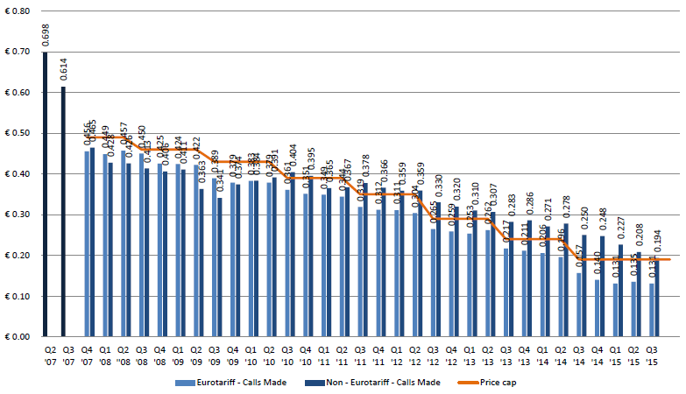
Source: International roaming BEREC Benchmark Data Report April – September 2015, BoR(16)28, February 2016

Figure 2 - EEA average retail price for intra-EEA outgoing SMS
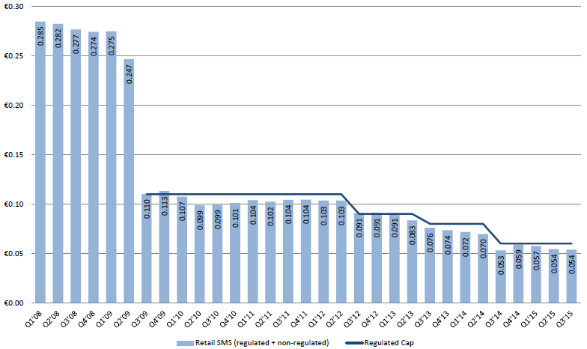
Source: International roaming BEREC Benchmark Data Report April – September 2015, BoR(16)28, February 2016

Figure 3 - EEA average retail price per MB
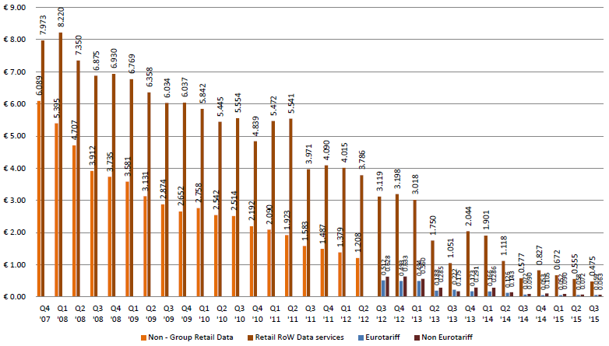
Source: International roaming BEREC Benchmark Data Report April – September 2015, BoR(16)28, February 2016

The evidence presented above suggests that the evolution of retail prices for voice and SMS roaming services has been very closely aligned to the retail price caps set by the EU Roaming Regulations since 2007. In the case of data services, the difference between retail price caps and effective market prices has been significantly larger than for voice and SMS services. However, the evidence presented in Figure 3 shows that the three successive reductions observed in retail data roaming prices since 2007 were triggered by the introduction of retail wholesale data roaming caps in 2012 and its successive reductions in 2013 and 2014. Section 4 below assesses in more detail the reasons why effective retail roaming prices for data services are lower than retail caps to a greater extent than in the case of voice and SMS services.
    - Wholesale roaming prices
In the third quarter of 2015, the EEA average wholesale prices for intra-EEA roaming voice, SMS and data services were 3.6 €c/min, 1.2 €c/SMS and 1.7 €c/MB respectively (VAT excluded), below the regulated caps of 5 €c/min, 2 €c/SMS and 5 €c/MB.

Figure 4 to Figure 6 show the evolution of EEA average wholesale prices for intra-EEA roaming voice, SMS and data services over the period 2007-2015.

Figure 4 - EEA average price per minute for wholesale non-group roaming voice calls
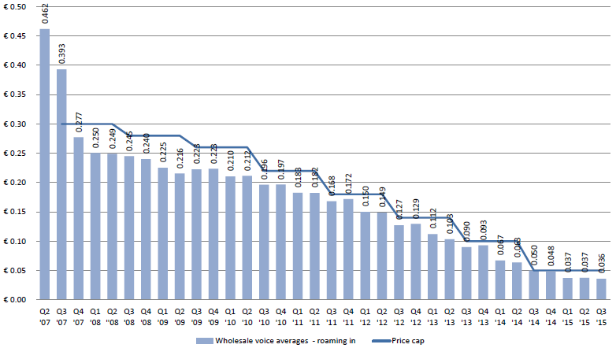
Source: International roaming BEREC Benchmark Data Report April – September 2015, BoR(16)28, February 2016

Figure 5 - Average wholesale price per intra-EEA roaming SMS: charges to non-group companies
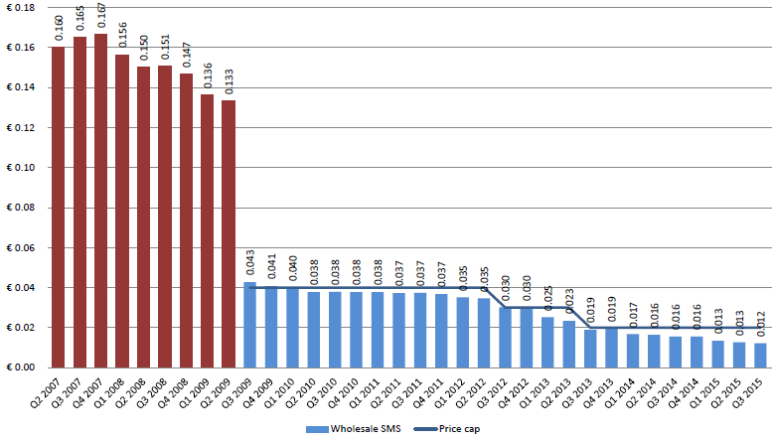
Source: International roaming BEREC Benchmark Data Report April – September 2015, BoR(16)28, February 2016

Figure 6 - Average wholesale data price per MB (prepaid+postpaid), EEA average
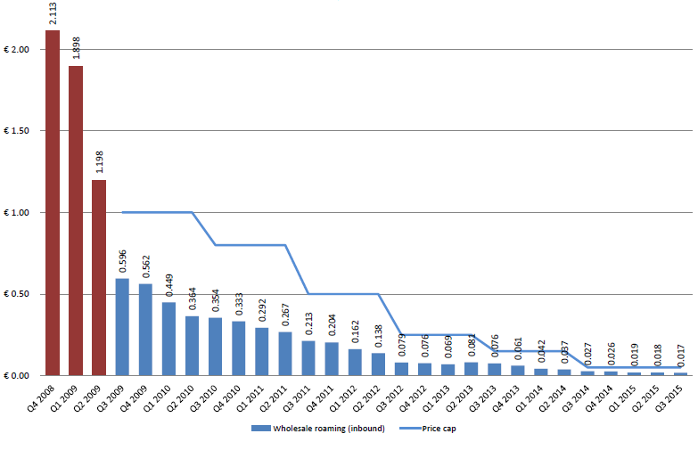
Source: International roaming BEREC Benchmark Data Report April – September 2015, BoR(16)28, February 2016

Similarly to the case of retail prices, the evidence presented above suggests that the evolution of wholesale prices for voice and SMS roaming services has been very closely aligned with the wholesale price caps set by the EU Roaming Regulations since 2007. In the case of wholesale prices for data, the market prices have been significantly lower than wholesale price caps over the period 2009-2014. While retail prices for data decreased in correspondence with entry into force of the reduction of caps, the decrease in wholesale prices for data also continued over each time period between two successive changes in cap level. However, the gap between market prices and wholesale caps has substantially decreased over time as wholesale price caps have been reduced.

  - Evolution of roaming traffic in Europe
The evidence on roaming traffic described below shows that the decline in wholesale and retail roaming prices triggered by the roaming regulations since their introduction in 2007 have been accompanied by a steady increase in roaming traffic. The evolution of retail roaming traffic since 2008 is described below.
Figure 7 to Figure 9 show the evolution of roaming traffic for voice, SMS and data since the first quarter of 2008.

Figure 7 - Roaming traffic index: intra-EEA outgoing calls (Q3 2008=100)
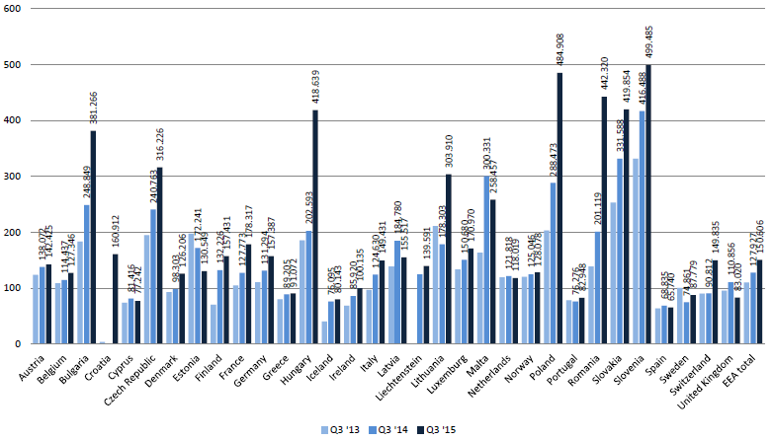
Source: International roaming BEREC Benchmark Data Report April – September 2015, BoR(16)28, February 2016
Figure 8 - Retail SMS sent traffic index (Q3 2008=100)
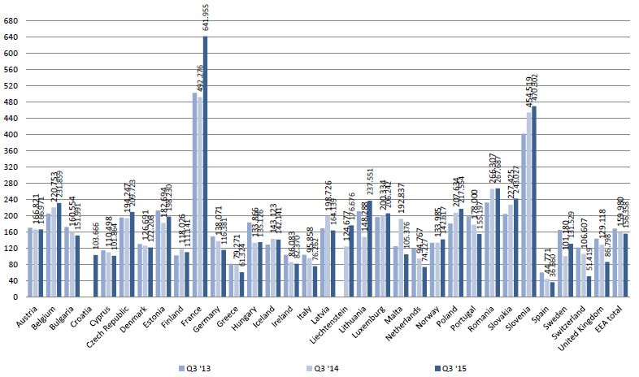
Source: International roaming BEREC Benchmark Data Report April – September 2015, BoR(16)28, February 2016
Figure 9 - Retail roaming data traffic index: (Q3 2008 = 100)
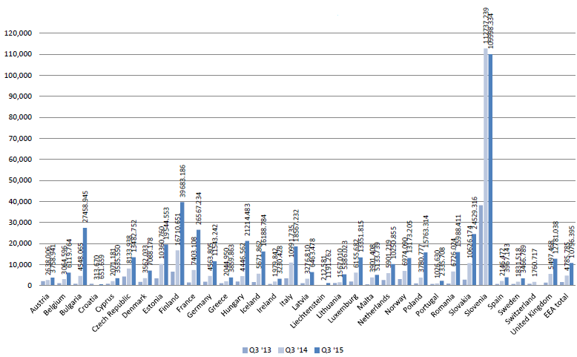
Source: International roaming BEREC Benchmark Data Report April – September 2015, BoR(16)28, February 2016

There has been a significant increase in voice and SMS roaming traffic since 2008: on average traffic in the EEA has increased by 51% in the case of voice and 56% in the case of SMS sent between the third quarter of 2008 and the third quarter of 2015. This contrasts with the relatively lower growth observed in the EU for domestic traffic for these services. This shows that the decrease in retail roaming prices triggered by the successive roaming regulations has enabled an increase in consumers' use of roaming voice and SMS services in the EEA since 2008.
The increase in roaming data traffic since 2008 has been even greater. Data roaming traffic in the EEA has increased by 796% between the third quarter of 2008 and the third quarter of 2015. While a significant share of this increase reflects the structural increase in mobile data usage also observed in domestic markets, the increase in roaming data traffic has been facilitated by the sharp reduction in retail roaming prices for data triggered by the roaming regulations over the last years.

- Competition developments in retail roaming markets
In this section the Commission reviews the developments in retail roaming markets observed in the last years. The remainder of the section is structured as follows:
- First, the Commission's approach to analysing developments in retail roaming markets is provided;
- Second, the market failures that have been traditionally associated with retail roaming markets are reviewed;
- Third, a comparison of retail roaming and domestic markets is presented;
- Fourth, the retail roaming offers that exist in EU telecoms markets, with a special focus on RLAH-type of offers, are described;
- Fifth, the technological developments and potential substitutes to roaming that have appeared in the last years are reported;
- Finally, conclusions on the level of competition in retail roaming markets in the EU are drawn.
  - Description of the Commission's approach
    - Literature review
The Commission has extensively reviewed economic analyses on roaming markets to inform its assessment of the functioning of these markets in the EEA. Where relevant, this report reflects on these analyses and confronts them with the data and information provided by EEA mobile operators during the autumn 2015 data collection.
    - Questionnaires to operators and analysis of the data
The Commission requested information on competition developments in roaming markets in the EU through a questionnaire sent in September 2015 by the Commission and BEREC to M(V)NOs in all Member States.
For the purpose of assessing competition developments in roaming markets in the EU, operators were requested to provide information on: (i) specific retail roaming costs, (ii) aggregated retail domestic and (intra-EU/extra-EU) roaming data consumption and revenues, (iii) RLAH-type of offers already marketed and their impact on demand for roaming services. The Commission's analysis relies on this information as well as BEREC's own assessment of competition developments in retail roaming markets based on this information.
93 operators provided part or all of the quantitative data requested on retail domestic and (intra-EU/extra-EU) roaming data consumption and revenue. The CC-ME of the JRC extracted the original data and organized them in a unified database. Several inconsistencies in the way data were reported were corrected, in particular as regards the unit of measurement. In section 4.4, the results of the analysis are shown by operator and by country. For each variable of interest (e.g. intra-EEA retail roaming volume as % of total retail consumption) the operators' graph represents the distribution of the operators' values in the sample of operators providing the necessary data as a cumulative fraction of the sample (expressed as %). This means that for each value of the variable of interest on the x-axis, the graph shows what % of the operators' sample is below that value. Operators are looked at on a per-country basis, which means per subsidiary for the multi-country groups. The countries' graphs show the aggregated value of the variable of interest over all operators operating in a given country that have provided the necessary data.
  - Market failures in retail roaming markets
This sub-section provides an overview of the market failures that have been traditionally associated with retail roaming markets, in particular:
- Imperfect substitutes at retail level;
- Lack of tariff transparency and bill shock; and
- Inelastic demand for roaming services for a significant proportion of the customer base.
    - Imperfect substitutes at the retail level
One of the main problems that has been typically associated with retail roaming services is the lack of (or substantial imperfections in) substitutes, as customers have no effective means of substituting for the roaming service at retail level. In 2011 the Commission assessed the substitutability of retail roaming services with, among others:
- Local SIM cards, which could be used in a dual-Sim handset as well)
- VoIP, (directly linked to the availability of WiFi hotspots)
- Global or regional SIM card (with multi-IMSI SIM cards or call back options).

The Commission concluded that none of the assessed possible alternatives was a perfect substitute for roaming based on their level of (i) mobility; (ii) availability; (iii) accessibility; (iv) affordability; and (v) ease of use. This lack of available substitutes at the retail level is mainly due to consumers' preference for using their mobile phone as they do at home over any available alternative.
In relation to the Roaming III regulation, there are some changes to be considered, especially in relation to OTTs. According to a study by Deloitte, OTT VoIP (Over-The-Top Voice over Internet Protocol) players like Skype, Facetime and WhatsApp have been used for international communications for years now, significantly affecting the roaming market. What has changed? First of all, smartphones have now multiplied, making OTT VoIP services much more available to the European consumer. Despite the lack of specific data, the introduction of voice service into the massively used WhatsApp in 2015 should be considered as an important development regarding the availability of OTT VoIPs as well. Second, Wi-Fi hotspots, where the consumer can connect for free or for a fee, are more widespread now, a growing trend that is likely to extend in the future. Third, LTE and 4G speeds are better capable of providing OTTs good-quality voice calls than 3G. While the final cost of this service (some estimates talk of around 800Kb/Min) is variable and difficult to calculate, it could nonetheless be competitive depending on the specific roaming tariffs.
Yet, in spite of these trends, OTT VoIP services still present constrains in terms of mobility, availability, accessibility and ease of use that should not be underestimated. Together with local SIM cards, or global/regional SIM cards, OTTs are only imperfect substitutes for the majority of consumers, as they limit mobility and do not allow subscribers to receive incoming calls on their usual numbers (for voice and SMS). They are also less suited to calling businesses, public authorities and other entities outside the circle of friends and family, particularly those OTT that do not terminate to the PTSN. OTT services may also be unable to access premium numbers, interactive automated services, micropayment services and emergency services.
In addition, alternatives to roaming services (e.g. global and regional MVNOs and SIM cards) lack sufficient uptake due to the lack of consumer awareness, complexity of usage for customers, language barriers, and low brand recognition among consumers as regards the service providers. A general problem with any roaming substitute that has to be purchased in the visited country is that it imposes high search costs on the consumer, as s/he is obliged to become knowledgeable about prices and services in each visited country. The lack of availability of substitutes for retail roaming services is reflected in consumers' patterns of use of mobile services when travelling to another EU country. Table 2 below shows the habits of EU mobile subscribers' when travelling abroad to another EU country.

Table 2: When travelling to another EU country, you generally...
 | Switch off mobile phone | Switch off data capability | Activate special data roaming plan | Public or private WiFi access | Purchase local SIM card | Other | Don't know
EU 28 | 28% | 25% | 18% | 16% | 10% | 9% | 6%
Source: Eurobarometer (2014), E-Communications Household Survey and Telecom Single Market Survey – Roaming Results, Special Eurobarometer no. 414, available here.

According to the 2014 Eurobarometer on roaming, only 10% of mobile users use a local SIM card and 16% a public or private WiFi access when travelling abroad to another EU country. The majority of mobile users prefer instead to either switch off their mobile phone (28%) or switch off the data capability (25%).

While none of the available alternatives appears to be considered a good substitute for roaming services, a series of technological developments, especially eSims, might change this situation in the mid-term. These developments are briefly analysed in section 4.5 of this report.
    - Lack of tariff transparency and bill shock
Mobile users typically purchase roaming services as part of a bundle including a domestic subscription allowing access to domestic mobile services. In practice, this means that roaming charges make up only a relatively small proportion of a user's total bill for its mobile services. Furthermore, roaming charges tend to be intermittent, as these are only charged when the subscriber uses its mobile subscription while travelling abroad from its home country, which only happens occasionally for the majority of European mobile users.

These features of roaming services have tended to result in a lack of tariff transparency for the majority of European mobile subscribers and have resulted in unexpected high roaming charges or "bill shock", which are also the product of certain smart phone features, such as hidden data consumption, which are difficult to control by the consumer. This lack of tariff transparency and bill shock may have been mitigated by the Commission's Roaming Regulations, which have included measures to increase transparency and mitigate bill shock (as already described in section 3.1 above). However, for the reasons described above, lack of tariff transparency and bill shock can be considered an intrinsic characteristic of retail roaming services in the absence of adequate regulatory intervention. For example, in the 2006 Eurobarometer (prior to the introduction of the Roaming Regulations and the spreading of smart phones), only 29% of respondents to the survey declared that they were familiar with international roaming charges. Even currently, in spite of the successive regulations, roaming within the EU is still one of the causes for unexpectedly high bills amongst users experiencing bill shock.

    - Inelastic demand for roaming services for a significant proportion of the customer base
There has not been much research into the price elasticity of demand of roaming services. As far as the Commission is aware, there have been the following empirical studies on the own price elasticity of demand of outgoing voice calls while roaming:
- European Commission (2006): three different scenarios for the welfare assessment have been used, namely, -0.55, -1.0 and -1.2;
- GSMA (2008): considered that the elasticity of demand should be -0.25;
- Europe Economics (2008): estimated that elasticity of demand should range between -0.35 to -0.44;
- CMT (2009): estimated the elasticity of demand around -0.37.

In the Commission's 2011 Impact Assessment on the options for roaming the preparatory study for the IA had assumed relatively low elasticities of demand for voice and SMS (in the range of -0.2 to -0.3), albeit the elasticity for data was likely to be higher (it was difficult to assess the elasticity of demand for data, since usage was growing due to the increase in use of smartphones). Overall, a low price elasticity of demand has traditionally been associated with retail roaming services.

As described above, the low price elasticity of demand is likely to be due to the fact that mobile operators typically set different prices for roaming services and bundle these with domestic offers. The resulting lack of transparency and high search costs for consumers (for a relatively small proportion of their total mobile bill) may drive the lack of responsiveness to prices from consumers at the time of choosing their retail tariff. In addition, roaming bill shocks are also likely to have resulted in lower price responsiveness from end users, especially for data. Due to the comparatively high roaming prices, which are still mostly based on per-unit pricing rather than flat-rates, and the lack of transparency and control in smart phones' data consumption, the consumer is afraid of switching on the overall data capabilities of his device regardless of specific price differences.

In this respect, it is highly possible that, especially regarding roaming data consumption, it is not so much the lack of a linear price elasticity that matters. What matters is the consumer's sense of control over such consumption, which has been severely damaged by both, the structural features of the market, and the opportunistic strategies of its agents, especially facilitated by the limits of steering technologies, which blurred the attribution of market responsibilities (see section 6.2).

Indeed, the evidence presented above in section 4.2.1 shows that a significant proportion of end users (53%) opt for either switching off their mobile or data capabilities when travelling abroad. This is most likely the result of historical high per-unit roaming prices and the incidence of bill shock on EU mobile users when using their mobile abroad.

The Commission therefore expects that the introduction of RLAH, which will eliminate the possibility of roaming surcharges (within fair use limits), will give consumers a renewed sense of security when using roaming services, what will not only limit the scope for bill shocks in the EU, but also result in higher demand responsiveness to prices, and increase consumption up to optimal economic levels for both consumers and operators.

  - Domestic price level and consumption pattern
BEREC analysis shows that the domestic annual retail revenue per user varies considerably between EEA countries from 3.70 € per month in Lithuania and Latvia to 43.80 € per month in Liechtenstein, with a weighted average of 14.30 €. There are also large differences in domestic consumption patterns of mobile services (voice, SMS and data). These differences in consumption are particularly high for data services whose average use per user per month in 2014 varies from about 100 MB in Romania to almost 3000 MB in Finland.

  - A comparison of retail roaming and domestic traffic

Figure 10 to Figure 13 show, per operator, the share of intra-EEA retail roaming consumption in total retail (i.e. domestic plus roaming intra-EEA and extra-EEA) consumption, in terms of revenues and volumes for each service, based on operators' data from the autumn 2015 data collection.

Figure 10 - Intra-EEA retail roaming revenues as % of total retail revenues (x-axis)
Data: operators' replies to the autumn 2015 data collection
JRC's calculations

The share of direct intra-EEA retail roaming revenues, received by operators through current retail roaming surcharges, has been decreasing over the last years. This is result of decreasing retail roaming prices under decreased price caps in July 2013 and 2014. In the first semester 2015, intra-EEA retail roaming revenues represented less than 5% of total retail revenues for almost 80% of the operators. This is an important observation in view of the sustainability of the abolition of retail roaming surcharges.

Figure 11 - Intra-EEA retail roaming traffic as % of total retail traffic (outgoing minutes)
Data: operators' replies to the autumn 2015 data collection
JRC's calculations
Figure 12 - Intra-EEA retail roaming consumption as % of total retail consumption (outgoing SMS)
Data: operators' replies to the autumn 2015 data collection
JRC's calculations
Figure 13 - Intra-EEA retail roaming consumption as % of total retail consumption (data)
Data: operators' replies to the autumn 2015 data collection
JRC's calculations
In terms of volumes, for 80% of the operators, intra-EEA retail roaming consumption represents less than 3% and 5% of total retail consumption of outgoing minutes and SMS respectively. For data, the share of intra-EEA retail roaming consumption in total retail consumption is below 1.5% for 80 % of the operators.

One can therefore make the following observations. First of all, the share of retail roaming revenues in total retail revenues (Figure 10) is higher than the share of retail roaming consumption in total retail consumption for voice and data (Figure 11 and Figure 13). This reflects the higher prices paid by customers for retail roaming consumption than for domestic consumption.

Second, the lower share of roaming consumption in total consumption for data services indicates that roaming customers seem to use, proportionally to their domestic habits, less data than voice and SMS while roaming in the EEA.

Third, the share of roaming consumption in total consumption for data has been increasing since 2013. This means that intra-EEA roaming data consumption has increased more rapidly than domestic data consumption. This is likely to be a direct effect of the two successive retail roaming price cap regulations in July 2013 and 2014, which have to some extent unleashed data usage in an intra-EEA roaming situation on top of the positive trend in data consumption observed domestically. RLAH is likely to potentiate even more this trend, in a general technological context where data consumption will be proportionally more and more important in all settings (domestic and whole travelling).

Figure 14 shows per country, the share of intra-EEA retail roaming consumption in total retail (domestic plus roaming intra-EEA and extra-EEA) consumption, in terms of revenues and volumes for each service.
Figure 14 - Intra-EEA retail roaming revenues and volumes as % of total retail revenues and volumes (y-axis) by country, 2014
Data: operators' replies to the autumn 2015 data collection
JRC's calculations
In 2014, the share of intra-EEA retail roaming revenues in total retail revenues was the highest for operators in Luxembourg (~9%), Slovakia and Slovenia (~7%), Norway and Belgium (~5%). The higher share observed for Luxembourg's operators is linked to the longer time that residents of that country spend abroad in the EEA compared to residents of other EEA countries. For operators in all other countries than these five countries, the share of intra-EEA retail roaming revenues in total retail revenues is smaller than 5%. This is an important observation in view of the sustainability of the abolition of retail roaming surcharges.

As noted at operator level in Figure 11 to Figure 13 above, for almost all countries, the share of retail roaming in total retail consumption is higher in terms of revenues than in terms of volumes. This is due to the higher prices paid by customers for roaming services than for domestic services. For almost all countries, the share of retail roaming in total retail consumption is smaller for data services than for voice and SMS services, a sign of the higher propensity of customers to limit data consumption than voice or SMS consumption while roaming.

  - Retail roaming offers
This section is based on the information provided by EEA operators during the autumn 2015 data gathering exercise and draws on the analysis made by BEREC of the information received about existing RLAH offers .

Recently an increasing number of operators have started to offer domestic tariff plans which include roaming services in the domestic bundle. This reflects new competition dynamics in the retail roaming market, the roaming part of a domestic tariff plan becoming a new commercial argument to attract customers and increase market shares. This is indicative that, in the RLAH context, "roaming revenues" will be in part transformed and included in the revenues derived from the domestic tariffs, with which operators compete for customers.

However, most of these tariff plans do not cover all EU Member States, or concern only voice and SMS, or data only, and/or include roaming services in the domestic bundle as an add-on package (i.e. for a fixed periodic - daily, weekly or monthly – charge which represents a fixed roaming surcharge over the domestic price), In fact, most of the available offers do not fully comply with the RLAH requirements set out in the Regulation. The geographical scope of these offers usually reflects the countries where the operator is present, and countries where good roaming deals were concluded.

The truly RLAH offers (with no add-on) which exist on the market are mostly high-end domestic tariff plans aimed at high-end or professional users. The geographical scope of these RLAH offers varies. In some Member States however, such offers also exist for (non-business) consumers while in other Member States, such offers do not exist at all (see Table 13 in Annex 1).

In most existing RLAH offers (be they included in the domestic tariff plan for an add-on price or not) the amount of roaming consumption included in the domestic tariff plan, is subject to fair use clauses. These clauses may take very different forms across operators and tariff plans. Fair use limits usually depend on the price of the tariff plan and are more often expressed as a volume limitation per month. This volume limit may be on the amount of domestic volume available while roaming or it may be on an extra specific roaming volume available on top of the domestic volume. In some cases, fair use limits are expressed in terms of days per year (e.g. from 10 to 60 days a year), often combined with an additional volume limit per month on data. In most countries, the roaming data volumes in RLAH offers are rather low, usually below 500 MB per month. The roaming data allowance in RLAH offers is always capped, even if the offer includes unlimited voice and SMS units.

Once fair use limits are reached, users can usually continue using roaming services at regulated prices. Data is often simply throttled beyond fair use.
  - Current technological developments as potential substitutes to roaming
In the questionnaire circulated by BEREC in mid-September 2015, many operators stated that incipient technological developments such as eSIM or VoLTE among others will impact the functioning of the roaming market. While these technological developments still are at an early phase of implementation in the market, this section reviews their potential effect in the roaming context, with a special focus on eSims.
- What are eSims?
Electronic Sim cards (also known as virtual Sims) are here understood as a new type of technologies that allow consumers to switch and combine mobile operators without having to introduce a physical Sim card in their mobile devices.
- What are eSims theoretical market impact?
eSim cards can basically reduce consumer's transaction costs when switching/combining operators. In theory, this opens up the possibility of greater choice and competition at both, domestic and EU level. eSims can be a significant substitute for roaming (see below).
- What is their current diffusion/situation?
While in the machine-to-machine context, eSIMs cards have been used for several years, its introduction in consumer devices is only now taking-off. At the 2015 and 2016 editions of Mobile World Congress in Barcelona, the GSMA staged its intention to align all ecosystem participants on standardized reference architecture in order to introduce eSIMs. In the 2015 edition of the MWC, Simless, Inc., a US-based startup, unveiled the world's first GSM phone without a SIM card slot. "Apple SIM", which works in several iPad models and in limited countries, is a form of eSim that gives users the option to select from a number of carrier partners. These include GigSky, a pay-as-you-go data provider that offers cellular data plans in more than 90 countries. On July 16, 2015 The Financial Times reported that Apple and Samsung were in talks with a significant amount of telecom groups to launch a standardized eSim card.
eSims were cited as the second technology to have the greatest future impact on the telecommunications market (below cognitive technology) in a survey conducted by IBM (and presented in IDATE's Digiworld Summit). A recent report by McKinseystates that "the ability to change providers easily means that eSim customers don’t have to carry multiple Sims, have full tariff transparency, and can more easily avoid roaming charges". eSims diffusion seems strongly aligned with the diffusion of "wearables", connected cars and global roaming devices and containers, what has a strong international component. This is confirmed by the results of the Public Consultation that the Commission undertook in 2015 in view of the revision of the overall EU Telecommunications Framework, where a specific question on eSims was asked to stakeholders.
- What is/can be their impact on roaming?
eSims are a technical development that constitutes a possible substitute to roaming, providing a potentially less expensive solution for consumers, and thus introducing competition forces at both retail and wholesale level. This entails not only a technical, but a subjective perception: consumers must see eSims as a satisfactory solution to their international needs. Following the RIII impact assessment report (Annex I), 5 criteria to evaluate the potential of eSims as substitutes for roaming were considered.
1. Mobility. Refers to the possibility of being able to move while using voice, SMS or data service. eSims offer high mobility - the consumer can use a local plan throughout the territory covered by the local chosen provider's network.
2. Availability. Refers to the availability of the alternative itself as well as of the technical coverage. eSims themselves have currently a very limited availability, but given the situation explained above, they might become a standard in the near future. There will be a period of co-existence between Sim and eSim. In terms of the local operators available to the consumer, eSims make it potentially very easy for the consumer to choose between offered plans, as there is no need to switch the Sim card, nor go to a foreign retail store to buy a local Sim. On the other hand, the availability of operators will depend on potential blockages, especially likely to take place in subsidized handsets.
3. Accessibility. Relates to the possibility of being reached at any time and at any location on the same phone number. eSims offer high accessibility, as domestic home numbers can potentially be combined with foreign numbers using the same headset. The trend towards data and VoLTE is also a significant positive factor towards accessibility.
4. Affordability. Concerns the investment (one-off cost) and the cost of using (recurring cost depending on the volume of services) for using alternative services. With eSims, the consumer can easily benefit from local tariffs (for example, easily buying X GB of data), which can be potentially better than RLAH tariffs or RLAH + sustainability tariffs. This introduces market pressure to RLAH-type of offers that include more generous FUP (to avoid "educating" consumers on switching operators once FUPs limits are surpassed).
5. Ease of use. Refers to the steps required / possible difficulties before being able to use the service, as well as the ease of the actual use of the alternative service. eSims have the potential to dramatically reduce the transaction costs related to the consumer's research efforts to find and compare service providers in the area. There might be, however, learning costs for users regarding different local tariffs.
In sum, the current availability of eSims, and of operators that are given access to the eSim "market", is the main factor limiting eSIMs being a viable substitute for roaming. There is still high uncertainty regarding the specific strategies that operators are going to follow in relation to this new technological development. For example, if Local Break-Out (LBO) technologies (see section 5.6) diffuse in parallel to eSims, visited operators may decide to restrict eSims packages in order to avoid cannibalization. Nonetheless, eSims show indeed a clear potential to introduce competitive pressure in the international roaming market, but this will be contingent on the different strategies that will finally shape the technology.
Other technological developments related to roaming are VoLTE and Fi. VoLTE promises HD voice over packet-switched technology to the consumer that has a supporting device. It is associated to an infrastructural change towards all-data, so it can have a substitution effect in relation to current voice and SMS roaming services, creating a new dynamic at both wholesale and retail level. It terms of roaming, however, VoLTE use will still be dependent on the data provisions of visited networks. While VoLTE, due to its better traffic management, is widely seen by operators as a way of competing with OTTs (also in the roaming context), it is only now that plans around its deployment are being released in Europe. It is indeed still soon to venture into the actual specific effects that this technological development might have on international roaming markets.

Google has also developed a technology and an associated business model with a potential high impact on international roaming. Google Fi lets users connect to the best available network in each situation. The signal, which can come from different operators in one single session, is in principle never dropped: The user automatically switches to Wi-Fi, 3G/4G, or other different networks without noticing. Fi is currently available in certain Nexus models in the US, where Google has become a de facto MVNO. Through its deals with mobile operators, Google has secured competitive internationals roaming rates: Google Fi costumers surf at the same rate (10$ per 1GB) than in the US in more than 120 countries, but at reduced 3G speeds. Google Fi-type of models/technologies, if coming to the European market, could bring competitive pressure to RLAH offers.

  - Conclusion
There have been some important developments on the retail roaming markets recently, with domestic offers proposing more and more affordable roaming prices to the customers. However, most of the new, RLAH-like, retail roaming offers are not RLAH offers in the sense of the Roaming Regulation, i.e. covering the full of the EU for no additional surcharge at all (no add-on) within fair-use limits. In addition, these developments are unequal across Member States . With the current levels of competition in wholesale roaming markets, therefore, the retail markets have not been capable of delivering full EU-wide RLAH.

Regarding technological developments concerning roaming, there have also been significant changes in some Member States, especially the diffusion of smartphones, OTT services and the proliferation of Wi-Fi hotspots. Among the new emerging technologies, eSims might have a significant impact in the mid-term, even though this is highly contingent to the different strategies that will be play-out around them. Overall, however, none of the observed technologies constitutes a perfect substitute for roaming services. Thus, their current market pressure remains limited.
- Assessment of the cost of providing wholesale roaming services in the EEA
  - Introduction
This section describes the approach to assessing the costs of providing wholesale roaming services in the EEA. This section is structured as follows:
- Description of the Commission's approach in assessing the costs of providing wholesale roaming services in the EEA;
- brief overview of previous estimates of costs of wholesale roaming services;
- description of the TERA Consultants' model that was commissioned to estimate the costs of wholesale roaming services;
- description of the approach to assessing the termination rates that should be considered for the purposes of assessing the costs of originating voice calls by a visited network operator;
- assessment of international transit costs, relevant for roaming services;
- sense-checks conducted on the estimates of wholesale roaming costs;
- approach to assessing the costs of wholesale roaming SMS services; and
- conclusions on the costs of providing wholesale roaming services in the EEA.

This section should be read jointly with the TERA Consultants' report on the cost model used as an input to assess the costs of providing wholesale roaming services in the Final report of the study.
  - Description of the Commission's approach
The Commission has relied on several sources of information to assess the costs of providing wholesale roaming services in the EEA.
Firstly, an independent study to assess the level of costs incurred by visited network operators when providing wholesale roaming services was commissioned. The study was conducted from end of October 2015 to the end of March 2016. When developing the cost model, the contractor had to take into account, as far as possible, the methodologies and approaches used by NRAs in EU Member States to estimate mobile network costs. The aim was to build a cost model that facilitated as far as possible the estimation of wholesale roaming costs in every EEA Member State. Information on NRAs' cost models and relevant cost data necessary to form a view on the costs of mobile network operators in the EEA were obtained via two questionnaires sent in September 2015 by the Commission and BEREC to M(V)NOs in all Member States and NRAs, as well as via additional requests from the Commission on the characteristics and inputs of NRAs' mobile termination rates cost models in the course of the study (December 2015 and January 2016). The public consultation itself did not have the objective of providing information on wholesale roaming costs.
In addition, the Commission has relied on other sources of information, namely:
- Data on fixed and mobile termination rates currently in place in MS; and
- Information on domestic retail prices.

These sources are described in more detail below.
    - Questionnaires to NRAs and operators
For the purpose of assessing the cost of providing wholesale roaming services in the EU, NRAs were requested to provide data and information about: (i) the cost model they use to estimate mobile network costs, including detailed information on characteristics of their cost model (e.g. equipment utilisation factor, radio access network sites), and inputs to their cost model (e.g. commercial traffic, busy hour traffic, geotypes, spectrum, cell radii); (ii) their estimated network cost per service (voice origination/termination, SMS origination/termination, data); (iii) any applicable wholesale price regulation for MVNOs in their country; (iv) market data on overall volumes of retail consumption of each service (minutes, SMS, MB) in their country.
For the purpose of assessing the cost of providing wholesale roaming services in the EEA, operators were requested to provide data and information about: (i) current wholesale roaming agreement structures and tariffs, including the situation of light MVNOs; (ii) specific wholesale and retail roaming costs; (iii) wholesale roaming payments, revenues and volumes by Member States of destination and origin; (iv) average wholesale prices for balanced and unbalanced traffic, (v) expected wholesale roaming prices for the year 2016.
    - External study to estimate wholesale roaming costs
      - The call for tenders
On 24 July 2015, the Commission services published an advance notice for a contract to assess the cost of providing wholesale roaming services in the EEA, to be awarded under the negotiated procedure. On 11 August 2015, the Commission services invited eight companies that had expressed interest to submit an offer. Four companies responded to the call and sent their respective tenders by the deadline of 7 September 2015 set in the invitation to tender. The contract was awarded to TERA Consultants and signed by the latest party on 21 October 2015. The last deliverable under this contract is due within 5 months after that date.
      - The objectives of the study
The study has estimated the efficient costs (including proportionate allocation of joint and common costs) of providing wholesale roaming services (including voice, SMS and data roaming services) by mobile network operators in 28 MS plus Norway.
      - Consultation with NRAs and mobile operators
During the development phase of the cost model by the contractor, NRAs were regularly consulted via the International Roaming Expert Working Group of BEREC on the methodological approach. In order to take into account, as far as possible, the methodologies and approaches used by NRAs in EEA Member States, NRAs were asked to provide detailed information on characteristics of their respective cost models used for mobile termination rates.
On 28 January 2016 the Commission and the contractor organised a public workshop where the contractor presented the interim results of the study in order to obtain feedback on the cost model from NRAs and operators. The feedback from stakeholders has been incorporated into the final version of the cost model (described in more detail in Final report of the study). In addition, between March – April 2016, the cost model developed by TERA Consultants was shared with the NRAs from the countries included in the study. TERA Consultants incorporated, as far as possible, the comments from NRAs into the final version of the model.
  - Previous estimates of wholesale roaming costs
In December 2010 BEREC estimated the following upper bound, average and lower bound of wholesale costs for wholesale roaming services :
Table 3 - BEREC's estimations for upper bound, average and lower bound of wholesale costs for wholesale roaming services (2010)
 | Maximum | Average | Minimum
Outgoing voice call | €9.7cents/min | €5.4cents/min | €3cents/min
Incoming voice call | €3cents/min
SMS | €2.7cents/SMS | €0.8cents/SMS | €0.6cents/SMS
Data | €15cents/MB | €8.1cents/MB | €1.6cents/MB

These cost estimates were used in the Impact Assessment accompanying the Commission proposal for Roaming Regulation III.

In February 2012, BEREC updated its analysis of wholesale roaming costs. BEREC's new estimations were:
Table 4 - BEREC's estimations wholesale costs for wholesale roaming services (2012)
 | Maximum
Outgoing voice call | €5cents/min
SMS | €1cent/SMS
Data | €5cents/MB

These new cost estimates were used during the negotiations on Roaming Regulation III between the co-legislators, and informed the setting of new wholesale roaming price caps after 1 July 2014 set in Roaming Regulation III adopted in June 2012.

  - The TERA Consultants cost model
This section briefly describes the main features of the TERA Consultants cost model (hereinafter, the cost model). For additional information on the approach followed and the results of the cost model, please refer to the TERA Consultants' Final report of the study.
    - The approach followed by TERA Consultants
The TERA Consultants cost model estimates the costs of providing wholesale roaming services in 28 MS plus Norway. Two EEA countries, notably Iceland and Liechtenstein were not part of the study as no information as part of the autumn information request was received and due to the lack of publicly available information on the cost models used by these countries' NRAs to set mobile termination rates. In addition, little information from certain MS of the EU (e.g. Germany or Estonia) was provided.

The cost model focuses on the costs of providing wholesale roaming services by the visited network operator and, in particular, on the following five mobile services:
- Incoming voice calls (i.e. voice termination on the visited network);
- Outgoing voice calls (i.e. voice origination on the visited network);
- Incoming SMS (i.e. termination of SMS on the visited network);
- Outgoing SMS (i.e. origination of SMS on the visited network); and
- Data services.

It should be noted at the outset that the TERA cost model has mainly focused on estimating the costs of voice and data services, as these are the most important wholesale roaming services. Therefore the cost model's estimates of wholesale SMS costs are not considered as robust as the estimates of voice and data services and therefore the approach followed to assessing the costs of wholesale SMS services is described below. In addition, the TERA cost model does not assess the costs of international transit, which are also relevant for roaming voice and data services. The approach to estimating the costs of international transit is described in more detail in section 5.6 below.

The cost model distinguishes between two different types of costs relevant for the provision of wholesale roaming services, notably:
- Network costs: the costs of rolling out the mobile network to provide mobile services to both domestic and roaming customers in each of the 29 countries considered; and
- Roaming specific costs: network and non-network costs that a mobile company incurs in order to provide wholesale roaming services.

In addition, the cost model also estimates the impact of seasonality on the allocation of underlying network costs between domestic and roaming customers. Seasonality can be described as follows. Mobile network operators typically make decisions about network built up (e.g. the capacity they need to build in certain areas) based on the traffic they expect in a specific area at peak hour. A significant share of roaming traffic is seasonal, meaning that is concentrated in certain periods of the year (typically, the summer period) and is also concentrated in certain geographic locations (i.e. touristic areas). Thus, some operators (50% in the public consultation) argue that roaming traffic drives operators' investment decisions to build additional capacity in certain areas to accommodate the additional roaming traffic received over the summer period. Furthermore, these operators argue that the investment cost of building this additional capacity in touristic areas should be recouped from the roaming traffic received over the short seasonal period, as roaming customers drive operators' investment decisions. In practice, this approach would mean that a significant share of the investment costs in touristic areas has to be recovered from a relatively low annualised volume of traffic (the seasonal roaming traffic) and may therefore result in significantly higher unit cost for roaming traffic than for domestic traffic.

In contrast, 40% of the operators responding to the public consultation defend the view that there is no impact of seasonality on the costs of providing wholesale roaming services. These operators argue that seasonality would concern only a very small part of the network, which has no effect on the total network costs. They note that domestic traffic is also seasonal and that the costs of meeting roaming capacity are not different than the costs of domestic capacity. They finally underline that roaming seasonality also works in favour of the visited operator, by optimising the use of some sites as domestic users move away while tourists arrive ('inverse peaks’). The remaining 10% of the responding operators do not pronounce themselves on this question.

Finally, TERA Consultants have run several sensitivities on their estimated costs of wholesale roaming services (see the Final report of the study for further details). In particular, they have assessed the impact on the estimated costs of changing several of the assumptions used. This sensitivity analysis shows that the costs estimated by the model are robust, as the changes in the unit costs estimated by the model are consistent with the expected changes in the underlying assumptions and the unit costs estimated under these sensitivity scenarios are broadly in line with those estimated under the main base case scenario.

The sections below look into these issues in more detail.
    - High level assumptions in TERA's cost model
When developing a cost model there are several decisions that need to be made regarding the approach chosen to estimate costs. In developing their cost model TERA has made a significant number of assumptions and modelling choices, however, this section only briefly summarises and explains the justifications for some choices made in the TERA cost model that were considered particularly important, namely:
- The choice of cost standard;
- The approach to cost modelling; and
- The choice between modelling the costs of an existing operator or an hypothetical efficient operator (HEO).

For further information on the modelling assumptions used by TERA Consultants in their cost model, please refer to the Final report of the study.
      - The choice of cost standard
The two most common cost standards used to derive the costs of providing a service are the:
- Long-Run Incremental Cost (LRIC); and
- Long-Run Incremental Cost plus some allocation of common cost (LRIC+).

The LRIC is the cost of producing a specified additional increment of output in the long run (the long run meaning that all production inputs, including capital investment, are considered variable). The relevant increment considered may encompass the entire output of just one service or that of a group services. Another way to look at it is that the incremental cost of a service is the difference between the total costs in a situation where the service is provided and the costs in another situation where the service is not provided (i.e. the incremental costs are the costs avoided by no longer supplying the specific service).

In contrast, the LRIC+ cost standard includes, in addition to the incremental costs of the specific service, a contribution to costs that are common or shared with other services provided by the company. In the case of a mobile network, the incremental costs of data services will be those costs that are solely driven by the provision of data services whereas common costs would be costs associated with activities or equipment that are shared between, say, data services and voice services. A LRIC+ approach ensures that all costs of provision are fully allocated to services. In general, companies need to recover common costs to ensure that their business is sustainable in the long term. For this reason, common costs are typically allocated or shared among the different services that generate them, and recovered in the prices for those services.

The TERA cost model estimates service costs using a combination of both cost standards: LRIC and LRIC+. As a rule, it estimates costs based on LRIC+, as this is consistent with the Roaming Regulation's Article 19, notably that:
"In assessing measures necessary to enable the abolition of retail roaming surcharges, the Commission shall take into account the need to ensure that the visited network operators are able to recover all costs of providing regulated wholesale roaming services, including joint and common costs."
Thus, TERA's cost model estimates costs for the following services based on LRIC+:
- Outgoing voice calls;
- Outgoing SMS; and
- Data services.

In the case of incoming voice (i.e. voice termination), the TERA cost model estimates these costs based on pure LRIC. This is to ensure consistency with the Commission's 2009 Recommendation on Termination Rates, which recommends the estimation of termination rates based on a bottom-up pure LRIC approach, and which has been implemented by the majority of MS in the EU and consistently supported by BEREC. For incoming SMS services, the TERA cost model does not allocate any cost to these services. This is to ensure consistency with Regulation No 531/2012 which states that "roaming customers should not be required to pay any additional charge for receiving a regulated roaming SMS or voicemail message while roaming on a visited network, since such termination costs are already compensated by the retail charge levied for the sending of a roaming SMS or voicemail message".

In practice, the approach for voice termination and incoming SMS means that some costs that would have been otherwise allocated to these services have to be recovered from other services. The approach to re-allocating costs between services to ensure full cost recovery of joint and common service costs, consistent with the Roaming Regulation, is explained below.
      - The approach to cost modelling
There are two main approaches to modelling costs:
- Top-down cost modelling based on the accounts of an existing operator; and
- Bottom-up cost modelling based on a hypothetical efficient operator.

Top-down cost models derive the costs from the operator's accounts and allocate these to each service using some allocation rule. In contrast, bottom-up cost models use detailed data and engineering rules to build an hypothetical network of an efficient operator using the most advanced and efficient technologies available in the timeframe considered by the model, to the extent they can be identified.

The TERA cost model uses a mix of both approaches. For network costs it estimates these costs using a bottom-up approach, consistent with the approach followed by the majority of NRAs when estimating mobile termination costs. In the case of roaming specific costs, however, as there is no data and/or engineering rules available to derive the efficient costs bottom-up, TERA relied instead on the data provided by operators in the autumn information request.

There have been some operators that have disagreed (both during the January 2016 Workshop and in response to the public consultation) with the use of a bottom-up approach based on efficient costs to estimate wholesale roaming costs, advocating instead for a top-down approach based on actual costs. It does not seem possible to agree with the views of these operators, however, for the following reasons.

First of all, the purpose of the cost model is to provide an estimation of costs for the provision of wholesale roaming, as one of the input for the overall assessment of the functioning of wholesale roaming markets and eventually the adoption of appropriate measures to address any failure in this regard. In this regard, a bottom-up approach based on efficient costs is more appropriate as it would reflect the workings of a competitive market and therefore represents a reliable benchmark to assess how the wholesale roaming market is functioning and which appropriate measures may be needed. In a competitive environment, operators would be forced to be productively efficient and would not be compensated for inefficiently incurred costs. Furthermore, in the context of two-way access services such as roaming services, where operators need to purchase wholesale access from each other, it would not be appropriate to compensate some operators for being inefficient to the detriment of more efficient operators. Moreover, network costs are already subject to cost modelling across the Union, in the context of the determination of MTRs, and the adoption of the hypothetical efficient operator approach for the calculation of the network costs would ensure that any cost estimation of roaming costs across the Union is generally consistent with the cost-modelling approach usually adopted for MTRs across Europe.
      - Estimation of network costs
The first step in TERA's cost model is to estimate the network costs in each of the 29 countries considered. Estimating the network costs consists of several steps in which the model takes into account the costs of building up the network for the expected future demand, as shown in Figure 15 below.
Figure 15. Steps in the estimation of costs in the TERA cost model
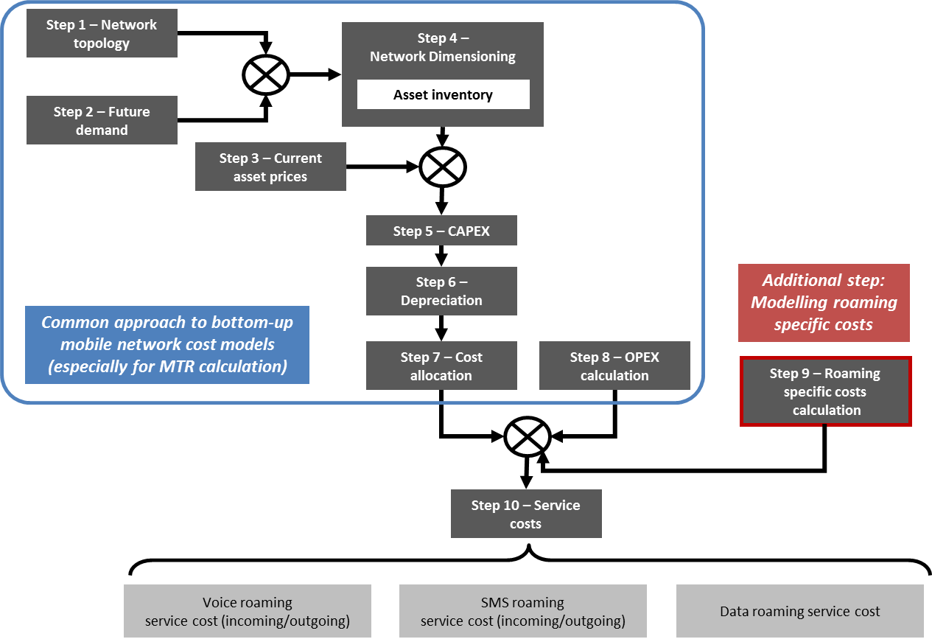
Source: TERA Consultants report.

The estimation of the network costs in the cost model consists of the 8 steps shown above. As described in more detail in TERA's report, the approach followed by TERA is consistent with the typical approach used by NRAs to estimate mobile termination costs in the EEA. In order to populate the model with relevant national data TERA relied on:
- Publicly available cost models used by NRAs to estimate mobile termination costs; and/or
- Information provided by NRAs in response to a questionnaire prepared by TERA; and/or
- Other publicly available information sources (e.g. Eurostat, CISCO studies, etc.)

In order to test the cost model, TERA sense-checked its results against those obtained by several NRAs using their respective cost models, as further described in the study's Final report.

As explained above, the costs of two services (voice and SMS termination) are estimated at pure LRIC and at zero, respectively. In order to ensure full recovery of costs (including joint and common costs), as required by the Regulation, this implies that the costs not recovered through these two services need to be re-allocated to other services. In this case, the TERA cost model re-allocates the joint and common costs from voice termination to voice origination and those of SMS termination to SMS origination. This is shown in Figure 16 below.
Figure 16: Re-allocation of costs not recovered through voice and SMS termination
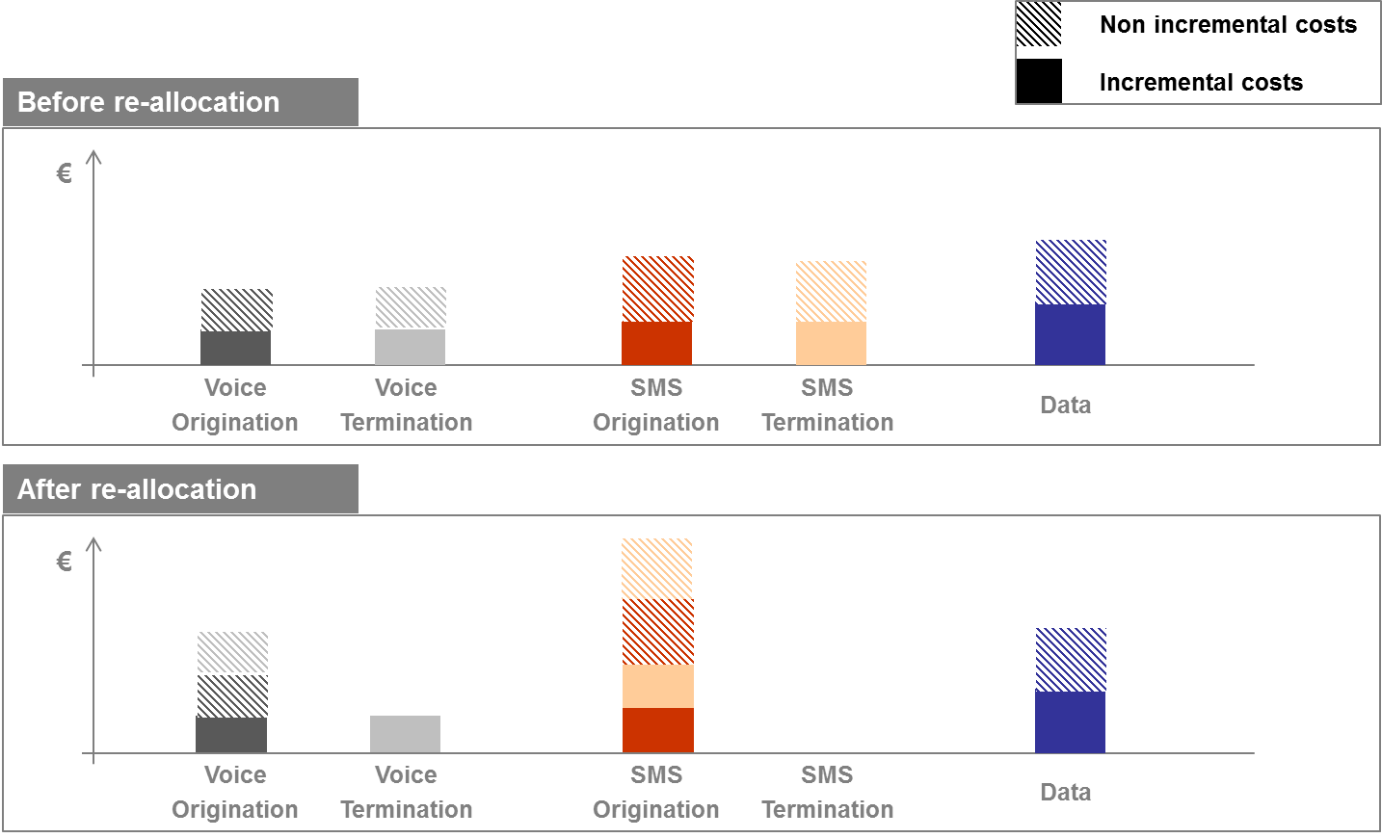
Source: TERA Consultants report.

In addition to this re-allocation of costs between services, the TERA cost model also includes a re-balancing of costs to take into account the mobile termination rates effective in every country. This works as follows. The TERA cost model calculates the total cost of the voice services, including the pure LRIC and common costs of both voice termination and origination. However, the model includes three different scenarios regarding termination rates:
- Voice termination rates are equal to mobile termination rates effective in each country on the second semester of 2015 (Scenario A in the model);
- Voice termination rates are capped at the highest pure LRIC rate effective in the EEA as of the second semester of 2015 (the Slovak termination rate at €1.23c/min). In other words, if the national termination rate is lower than that level, then the national rate applies but if it is higher, the Slovak termination rate applies (Scenario B in the model).
- Voice termination rates are considered to be equal to the pure LRIC for each country estimated by the cost model from TERA Consultants (Scenario C).

In practice, the impact of the above re-balancing is that if the termination rate considered is higher than the pure LRIC estimated by TERA, then the model considers that the termination rate contributes towards the joint and common costs (and potentially the costs of origination if the termination rate considered is higher than the LRIC+ cost of termination estimated by TERA). This is shown in Figure 17 below.
Figure 17: Example of re-balancing of costs with effective mobile termination rates
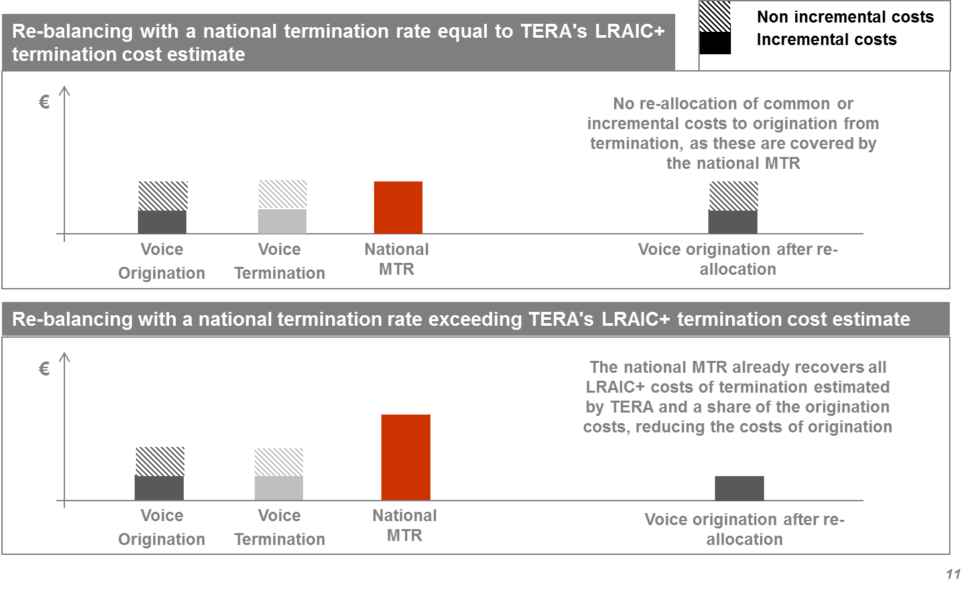

Figure 18 below shows TERA's estimates of the network costs in Scenario B (taking into account national MTRs when lower than the Slovak pure LRIC MTR or the latter if higher) for voice origination.
Figure 18: TERA's cost estimates for voice origination after re-balancing for national MTRs under Scenario B (€c/min)
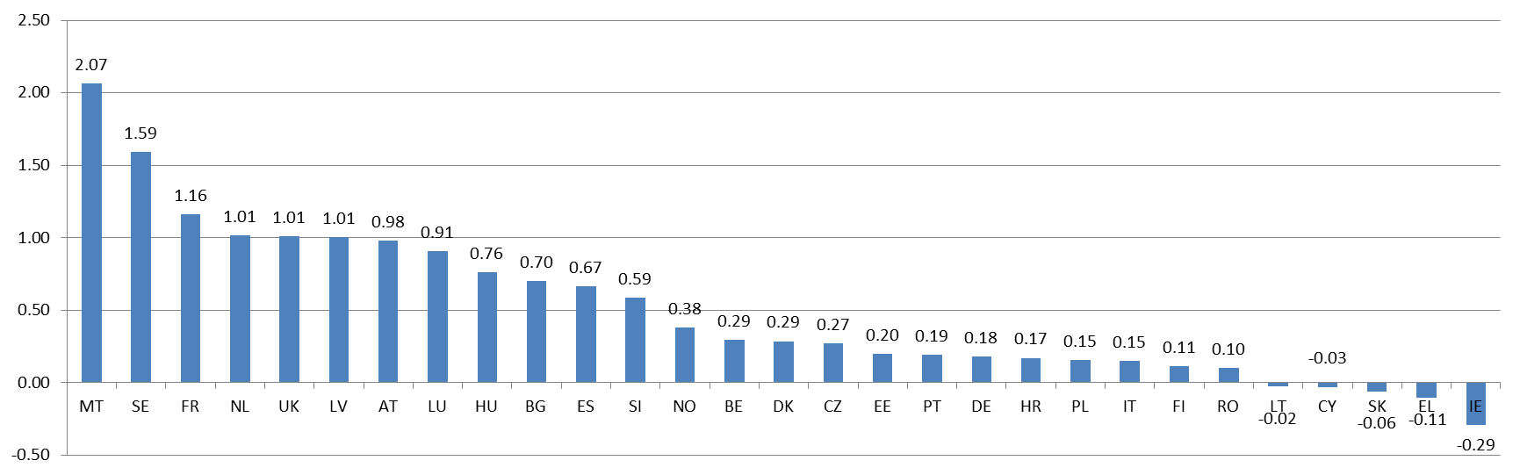

Figure 19 presents the costs estimated by TERA for data services.
Figure 19: TERA's cost estimates for data services (€c/MB)
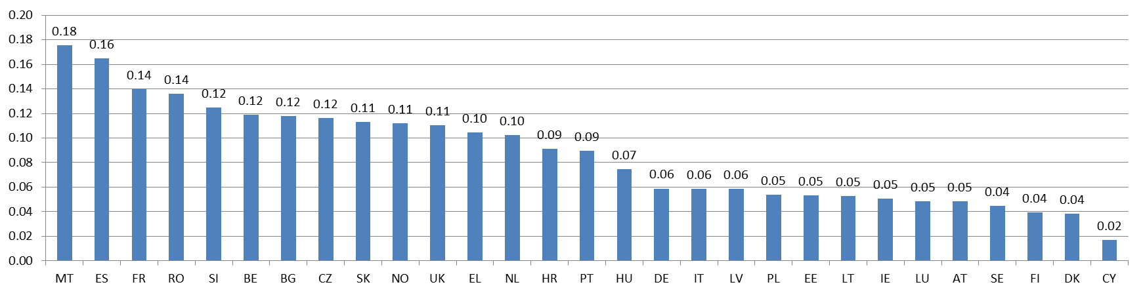

In addition, the unit cost estimates from TERA have been sense checked against the retail unit prices derived from a Commission study for each of the 29 countries considered. This section relied on the study's assessment of the prices for 5 mobile baskets in the 29 countries, namely:
Table 5: Allowances included in the baskets of the study considered to estimate retail prices
 | Handset use
 | Voice calls | SMS | Data
Basket 1 | 51 min | 100 | 100 MB
Basket 2 | 191 min | 140 | 500 MB
Basket 3 | 576 min | 225 | 1 GB
Basket 4 | 1809 min | 350 | 2 GB
Basket 5 | 191 min | 140 | 2 GB

The baskets used in the study are consistent with the OECD methodology for mobile telecommunications price baskets. Domestic retail prices have been derived by subtracting from the VAT-inclusive prices the VAT in every MS considered in the analysis. The VAT rates considered were as follows:
Table 6: Country VAT rates used to derive domestic retail prices excluding VAT
Country | VAT rate
AT | 20%
BE | 21%
BG | 20%
CY | 19%
CZ | 21%
DE | 19%
DK | 25%
EE | 20%
EL | 23%
ES | 21%
FI | 24%
FR | 20%
HR | 25%
HU | 27%
IE | 23%
IT | 22%
LT | 21%
LU | 17%
LV | 21%
MT | 18%
NL | 21%
PL | 23%
PT | 23%
RO | 24%
SE | 25%
SI | 22%
SK | 20%
UK | 20%
NO | 25%
Source: http://ec.europa.eu/taxation_customs/resources/documents/taxation/vat/how_vat_works/rates/vat_rates_en.pdf (page 16)]

In order to allocate basket prices to each service, we use the average wholesale roaming prices effective in the 28 MS plus Norway that were gathered during the autumn information request to derive relative prices between services (voice, SMS and data). The basket prices have been allocated to each service ensuring that the relative retail prices derived are the same as for average wholesale roaming prices in the 29 countries considered.

Table 7 below presents the retail prices for each of the 29 countries considered.
Table 7: Country retail prices using the relative prices of wholesale roaming prices
 | Voice (€c/min) | SMS (€c/SMS) | Data (€c/MB)
AT | 3.84 | 1.18 | 1.31
BE | 3.87 | 1.19 | 1.32
BG | 8.74 | 2.70 | 2.99
CY | 5.77 | 1.78 | 1.98
CZ | 7.43 | 2.29 | 2.54
DE | 4.41 | 1.36 | 1.51
DK | 3.09 | 0.95 | 1.06
EE | 3.83 | 1.18 | 1.31
EL | 6.21 | 1.92 | 2.13
ES | 5.86 | 1.81 | 2.01
FI | 3.91 | 1.21 | 1.34
FR | 3.75 | 1.16 | 1.29
HR | 5.24 | 1.62 | 1.79
HU | 8.61 | 2.66 | 2.95
IE | 4.69 | 1.45 | 1.61
IT | 4.04 | 1.25 | 1.38
LT | 1.77 | 0.55 | 0.61
LU | 4.80 | 1.48 | 1.64
LV | 4.33 | 1.34 | 1.48
MT | 8.54 | 2.64 | 2.93
NL | 5.60 | 1.73 | 1.92
PL | 3.72 | 1.15 | 1.27
PT | 7.16 | 2.21 | 2.45
RO | 3.88 | 1.20 | 1.33
SE | 3.80 | 1.17 | 1.30
SI | 4.69 | 1.45 | 1.61
SK | 5.40 | 1.67 | 1.85
UK | 2.91 | 0.90 | 1.00
NO | 3.80 | 1.17 | 1.30

In order to compare TERA's cost estimate for voice origination against retail unit prices, Figure 20 below compares TERA's cost estimates for voice origination after re-allocation of termination common costs but before the re-balancing against effective national mobile termination rates, as this is the TERA cost estimate that is more appropriate to compare against retail prices.
Figure 20: Comparison of TERA's voice origination costs against retail unit voice prices (€c/min)
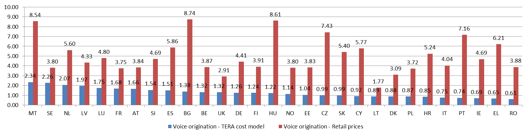

Figure 20 shows that the costs estimated by TERA Consultants for voice origination are well below estimated retail prices in all countries considered. It also shows that countries for which TERA Consultants have estimated relatively low voice costs (e.g. Lithuania, Poland and Romania) similarly have relatively low retail prices. There are however countries for which TERA Consultants have estimated relatively low costs in contrast to relatively higher retail prices. This is not necessarily an inconsistency of the costs estimated by TERA Consultants, given that retail prices are not solely determined by underlying costs but also other factors such as competitive conditions present in every country. No country was identified where very low domestic retail prices would directly put in question the plausibility of the underlying TERA cost estimates.

Figure 21: Comparison of TERA's data costs against retail unit data prices (€c/MB)
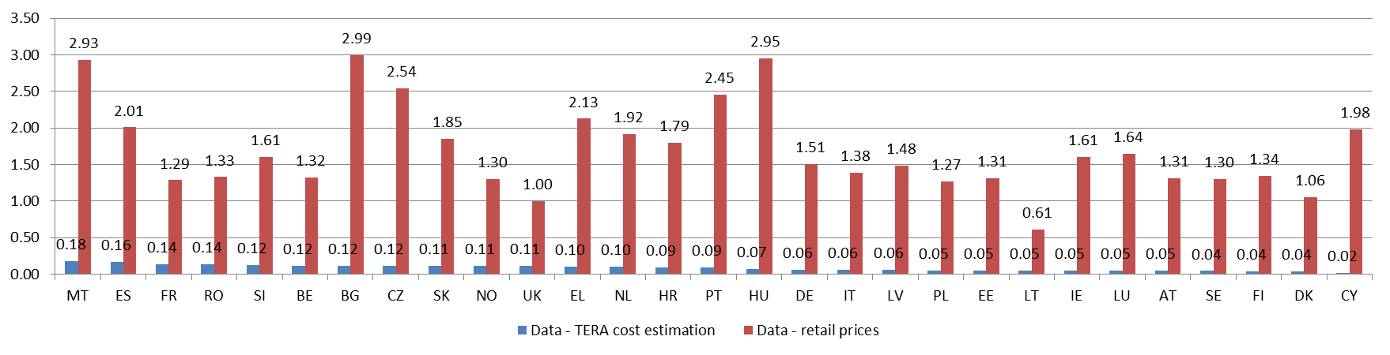

The comparison of TERA Consultants' cost estimates with the data retail prices estimated for each country (Figure 21) yields similar results to the comparison of voice services.

TERA Consultants conducted additional sensitivity checks on its estimates that are explained in detail in its Final report.

      - Roaming-specific costs
Roaming-specific costs are considered as mobile operators' costs that can be solely attributed to the provision of wholesale roaming services (as opposed to domestic mobile services). In other words, mobile network and non-network costs that are incremental to the provision of the wholesale roaming service.

In order to assess the magnitude of these costs, data from mobile operators on roaming-specific costs were included in the autumn information request. Following this request, 90 operators replied with data on roaming-specific costs. TERA Consultants analysed the information provided by operators and identified four separate categories of roaming-specific costs, namely:
- Roaming network related costs: operating network costs specific to roaming services such as roaming route testing/monitoring and route provisioning. No capital expenditures specific to roaming services were identified at the network level.
- Roaming Operation and Management (O&M) costs: costs relating to all business intelligence systems and software dedicated for roaming O&M, including: accounting, payment, fraud prevention, revenue assurance, roaming steering and quality assurance.
- Roaming data clearing and payment costs: costs relating to roaming clearing costs including both data clearing costs (DCH: Data Clearing House) incurred with the exchange of TAP/RAP files between the home and the visited operator, as well as the financial clearing of payments between operators.
- Roaming contract negotiation costs: costs relating to the administration and negotiation of wholesale roaming contracts, including external fees (consulting services) or internal expenses (e.g. settlement of roaming agreements, contract monitoring and regulatory expenses).

The approach followed by TERA Consultants to derive roaming-specific costs consists of two steps. First, for each of the cost categories of roaming-specific costs described above, using regression analysis they derive a relationship between the total cost provided by operators in response to the information request and its assumed underlying cost driver. In particular:
- For roaming network-related costs, TERA assumes that these costs are driven by the total roaming traffic (expressed in GB).
- For O&M and data clearing and payment costs, TERA assumes that these costs are driven by the number of TAP records generated;
- For contract negotiation costs, TERA assumes that the costs are fixed and independent of traffic or any other underlying driver.

Using regression analysis, TERA estimates a fixed and variable (i.e. depending on the value of the underlying cost driver) cost for each category of roaming-specific costs. This is shown in Table 8 below.
Table 8: Roaming-specific costs estimated by TERA
 | Network costs |  | O&M costs |  | Clearing costs | Negotiation costs
 | Capex | Opex | Capex | Opex | Opex | Opex
Fixed cost |  | €225K | €14K | €55K | €70K | €190K
Cost driver |  | Traffic (GB) | TAP | TAP | TAP | No
Variable cost |  | €2.1/GB | €10/100K TAP | €30/100K TAP | €40/100K TAP | No

Second, using the relationships obtained in the first step, TERA calculates roaming-specific costs for each country based on the size of the operators (i.e. the number of TAP records and traffic GB of the operators) in the country.

Figure 22 and Figure 23 below present the roaming-specific unit costs estimated by TERA for both voice and data services respectively.
Figure 22: Mark-ups on voice services for roaming-specific costs (€c/min)
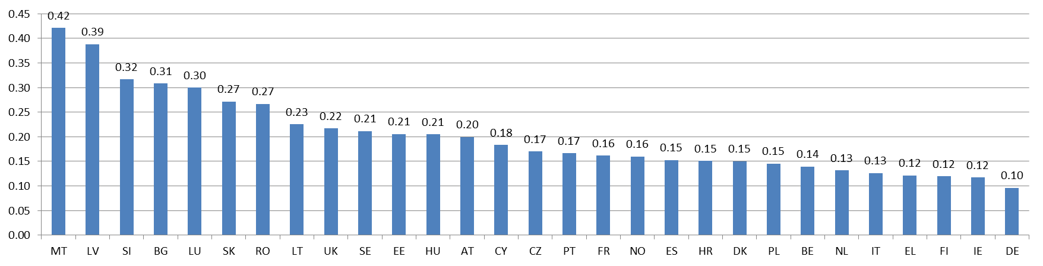

Figure 23: Mark-ups on data services for roaming-specific costs (€c/MB)
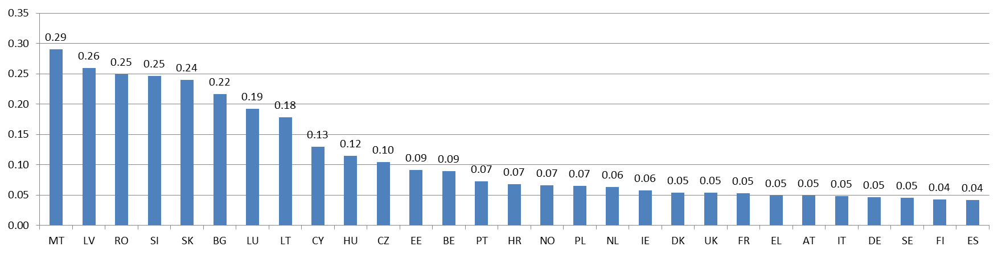

In general, TERA Consultants have estimated higher roaming-specific cost mark-ups for smaller size countries with relatively high wholesale roaming-in traffic. This is because a significant proportion of roaming-specific costs are fixed, thus, resulting in relatively higher unit costs for small countries with small mobile operators. Similarly, countries with proportionally higher wholesale roaming-in traffic (when compared to their size) are also likely to have a relatively higher unit cost for roaming-specific costs, as the variable part of these costs is mainly driven by the level of roaming-in traffic.

      - Impact of seasonality
As explained in section 5.4.1 above, half of the operators in the public consultation have argued that the seasonal character of roaming traffic and its geographic concentration in certain touristic areas implies that roaming traffic may drive network investment decisions in certain areas to accommodate the additional network capacity required by roaming subscribers over the short holiday period (typically the summer period running from June until August). These operators argue that a relatively higher share of network costs in these areas should be allocated to roaming traffic (rather than domestic traffic) in order to reflect the impact of roaming traffic on mobile operators' decisions to invest in additional capacity.

TERA Consultants investigated the impact of seasonal roaming traffic on mobile operators' underlying network costs. In a nutshell, the approach followed by TERA Consultants consists of:
- Identifying the month with the highest total traffic (roaming and domestic), as the month with highest total traffic will drive the mobile operator's investment decision (i.e. the maximum capacity that it needs to build to accommodate for the traffic on the network);
- Assessing the share of traffic corresponding to domestic and roaming subscribers in the month with the maximum total traffic; and
- Allocating total network costs to domestic and roaming traffic based on their relative share of traffic in the month with the maximum total traffic.

In order to estimate the impact of seasonality, TERA Consultants has used different sources of information:
- data from Eurostat on the number of nights spent by non-residents in EU countries;
- quarterly inbound traffic per country in 2014 obtained from BEREC;
- publicly available data on roaming from ANACOM (Portugal), ARCEP (France), MCA (Malta) and HAKOM (Croatia);
- national monthly domestic and roaming traffic from an operator active in several Southern Member States; and
- monthly domestic and roaming traffic disaggregated by geographical location in (a Southern European country obtained from (the NRA of that country).

Based on the evidence analysed, TERA concludes that seasonal roaming traffic:
- has a significant effect only in suburban and rural areas, excluding cities from the scope of the analysis. In cities, the peak of network traffic is typically in months other than the summer period, given that the traffic generated by seasonal roaming subscribers is balanced out by a reduction in the traffic of domestic subscribers, which move to touristic areas outside of the cities;
- only has a significant impact on voice traffic but not on data traffic. This is due to the fact that the structural increase observed in data traffic from domestic users is likely to have a more significant weight on operators' network-build decisions than the increase in data traffic from seasonal roaming subscribers during the holiday period. Thus, seasonal roaming data traffic during the summer period is unlikely to determine the decision to build additional capacity by mobile operators. Instead, this decision is likely to be driven by the growth in demand for data services from domestic users; and
- is only relevant in a sub-set of EU countries. Based on TERA Consultants' analysis, the impact of seasonality is only significant in 9 countries out of the sample of 29, namely: Croatia, Greece, Bulgaria, Spain, Malta, France, Italy, Slovenia and Cyprus.

Using the above information, TERA Consultants have modelled two different scenarios:
- Scenario 1: assumes that domestic traffic in touristic areas remains constant over the year (i.e. does not show seasonality); and
- Scenario 2: assumes that domestic traffic in touristic areas also increases over the summer period, in parallel to seasonal roaming traffic.

The second seasonality Scenario 2 appears more appropriate to assess the true impact of seasonality. This is because the first Seasonality 1 scenario assumes that domestic traffic in touristic areas over the holiday periods is similar to the domestic traffic in these areas over the rest of the year. In contrast, it should be considered that domestic traffic in these areas over the holiday period is likely to increase, as national mobile users typically share the same touristic areas as roaming subscribers over the same period. In other words, domestic traffic is likely to reflect some seasonality and geographic concentration, in the same way as roaming traffic. Thus, the Seasonality 1 scenario is likely to overestimate the proportion of network costs in touristic areas that should be allocated to roaming subscribers, whereas the Seasonality 2 scenario more accurately reflects that domestic traffic is also likely to increase in touristic areas over the holiday periods.

In addition, there are other factors that suggest that the impact of seasonality is likely to be relatively small. In particular, seasonal roaming traffic is typically concentrated in a small number of geographic locations. This implies that roaming traffic is only likely to affect mobile operators' investment decisions in a small proportion of their network locations, limiting any impact of roaming traffic on the mobile operators' total costs of building their national mobile network.

Figure 24 presents the impact of seasonality on voice origination costs estimated by TERA for each country under the Seasonality 2 scenario.

Figure 24: Mark-ups on voice services for seasonality (€c/min)

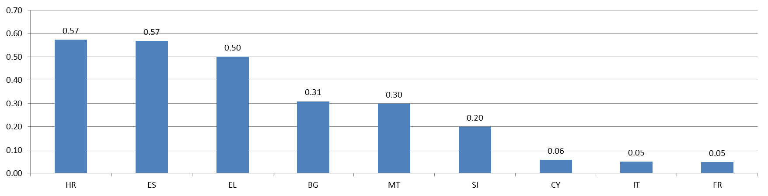

      - Total estimated wholesale roaming costs
The total costs for wholesale roaming services estimated by TERA are the sum of the three different components described above, namely, the:
- network costs;
- roaming-specific costs; and
- a re-allocation of network costs between roaming and domestic customers to take into account the impact of seasonality.

The figure below presents the total wholesale roaming costs estimated by TERA for voice and data services, respectively.
Figure 25: Total estimated wholesale roaming unit costs for voice origination (€c/min)
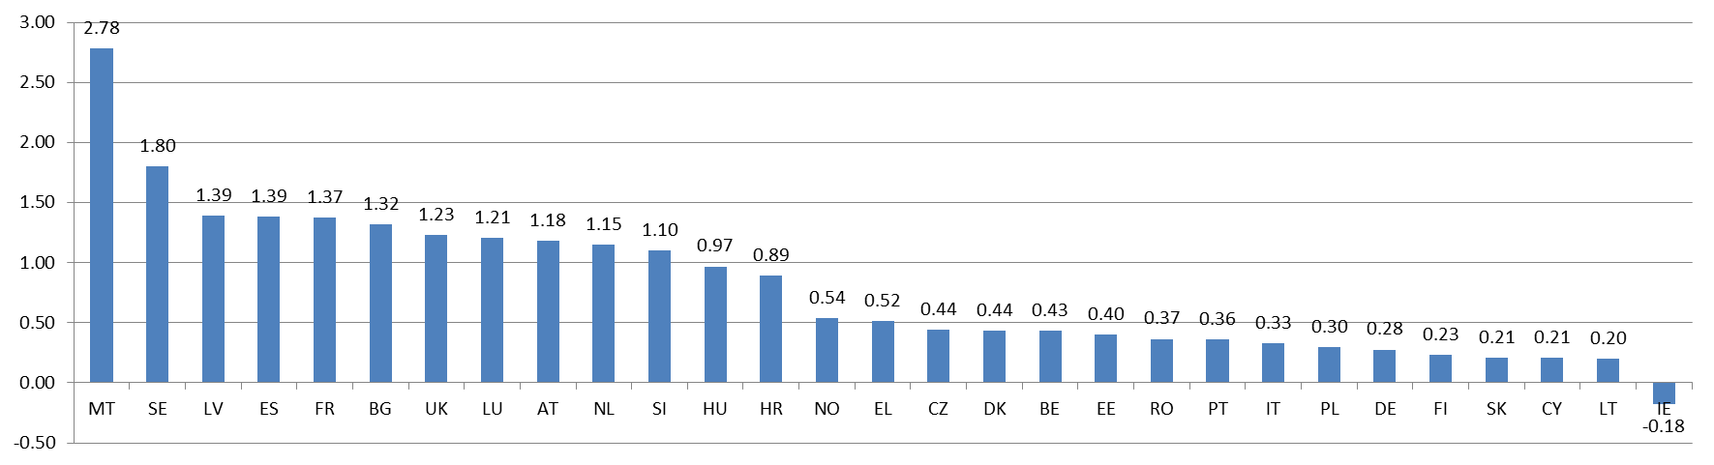

Figure 26: Total estimated wholesale roaming unit costs for data services (€c/MB)
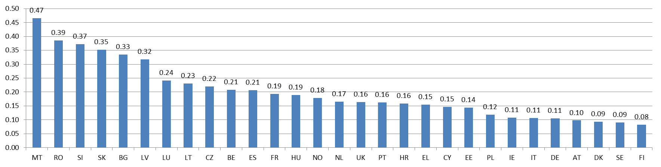

  - Termination rates
When a roaming customer originates a call on a visited network, this call is then terminated on the network of the customer receiving the call. Similarly to the situation with a domestic call, the originating network operator pays the terminating network operator for terminating the call. In this sense, the termination rate charged by the terminating network operator is part of the total cost of originating the call for the visited network operator, as the latter has to pay the terminating network operator for terminating the call.

Fixed and mobile termination rates are currently regulated in all countries of the EEA, with the exception of Finland for fixed termination rates. However, the rates applicable are different in every MS, as shown in Figure 27 and Figure 28, respectively.
Figure 27: Fixed termination rates applicable in MS (S2 2015) – BU-LRIC rates in blue (€c/min)
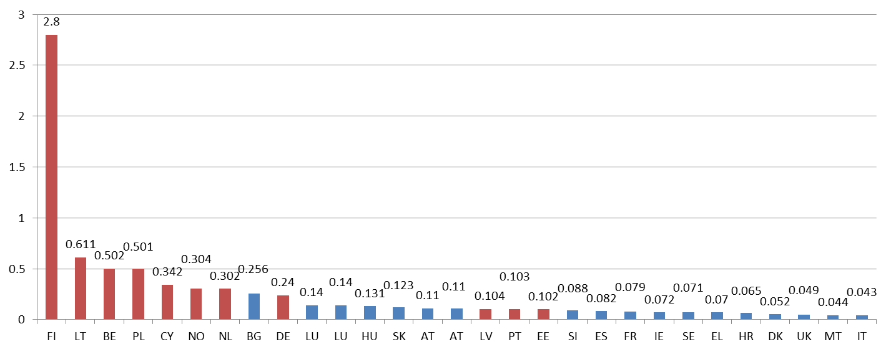
Source: BEREC Report on the implementation of the Termination Rate Recommendation, BoR (15) 209, December 2015.

Figure 28: Mobile termination rates applicable in MS (S2 2015) – BU-LRIC rates in blue (€c/min)
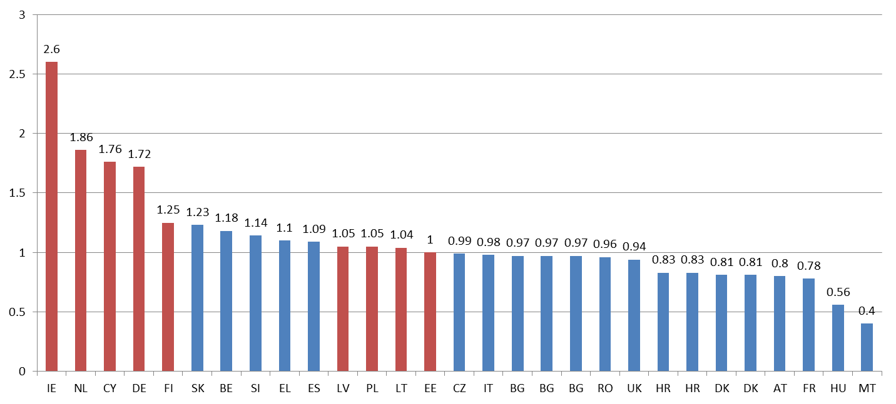
Source: BEREC Report on the implementation of the Termination Rate Recommendation, BoR (15) 209, December 2015.

For the purposes of assessing the cost that needs to be considered to compensate the visited network operator for paying the terminating network operator's termination rate, the following assumptions were made:
- 13% of calls are likely to be terminated on landlines and 87% on mobiles;
- only mobile and fixed termination rates that have been set by NRAs using a BU-LRIC approach were considered, consistent with the Commission's 2009 Termination Rates Recommendation (i.e. only the MTRs in blue in Figure 27 and Figure 28 were considered); and
- for the fixed and mobile termination rates considered, in the interests of prudence, an average of the five highest BU-LRIC fixed and mobile termination rates, respectively, currently in place in the EEA was used.

Table 9 presents the calculation of the termination rates that were considered for the purposes of assessing the total costs of originating a roaming call by a visited network operator, including a compensation for the termination rate paid to the terminating network operator. As shown in Table 9 the termination rate to be accordingly considered should be €1.02c/min.
Table 9: Termination rate to be considered within the cost of originating a mobile roaming call (€c/min)
Country | SK | BE | SI | EL | ES
Mobile termination rate | 1.23 | 1.18 | 1.14 | 1.1 | 1.09
Average mobile termination rate | 1.15
Country | BG | LU | RO | HU | SK
Fixed termination rate | 0.256 | 0.14 | 0.14 | 0.131 | 0.123
Average fixed termination rate | 0.16
Weighted average termination rate | 1.02
Note: In each case the five highest BU-LRIC fixed and mobile termination rates were considered, their averages and finally the weighted average assuming 13% mobile-to-fixed and 87% mobile-to-mobile calls.
Source: BEREC Report on the implementation of the Termination Rate Recommendation, BoR (15) 209, December 2015.

The above termination rate estimations are likely to be relatively conservative for the following reasons:
- the M/FTRs effective on the second semester of 2015 were considered, however, RLAH will only be implemented in June 2017. We expect that by that time both M/FTRs will be lower due to efficiency savings that are likely to reduce termination price caps in EU countries; and
- a significant share of calls will be terminated in countries with M/FTRs lower than the five highest considered in the analysis. Thus, the weighted average termination rate effectively paid by the visited network operator is likely to be lower than the one estimated above.

  - Transit costs
International transit costs are also relevant for voice and data services:
- Voice services: when originating a call on a visited network operator, the originating operator interconnects with an international transit carrier of its choice that then routes the call to the terminating network operator; and
- Data services: data traffic needs to be routed back to the home network for real-time billing and measures for customer protection (e.g. to prevent bill shock) and charging transparency.

In the case of data, several mobile network operators were consulted and there is currently very little use of Local Break-Out (LBO), a technical development that would avoid the need to route data traffic back to the home network, in the EEA. All operators consulted agreed that it is very unlikely that LBO will develop to any significant extent in the EEA by the time of implementation of RLAH in June 2017. In contrast, all roaming data traffic is routed to the home network using a IPX/GRX provider, and each network pays a charge that covers both sending and receiving data traffic. It is therefore appropriate to account for transit costs for both voice and data services.

In its report on International Mobile Roaming Regulation of December 2010, BEREC concluded that transit costs "represent an insignificant share of the total cost of roaming services" and therefore excluded transit costs from the quantitative analysis of wholesale roaming costs.

In order to estimate transit costs, data provided by operators in their response to the autumn information request were used. Based on this evidence, it is concluded that it is appropriate to consider the following transit costs:
- Voice services: a cost of €0.4c/min; and
- Data services: a cost of €0.2c/min.

  - Comparison of the voice cost estimates derived from TERA's study against an alternative approach based on national mobile termination rates
In light of the above, we present in Figure 29 and Figure 30 the cost estimates for wholesale roaming voice and data services, respectively, including an allowance for termination rates and transit costs (in the case of voice) and transit costs (in the case of data), as described in the previous sections.

Figure 29: Total estimated costs of wholesale roaming voice origination including the termination rate and transit costs (€c/min)

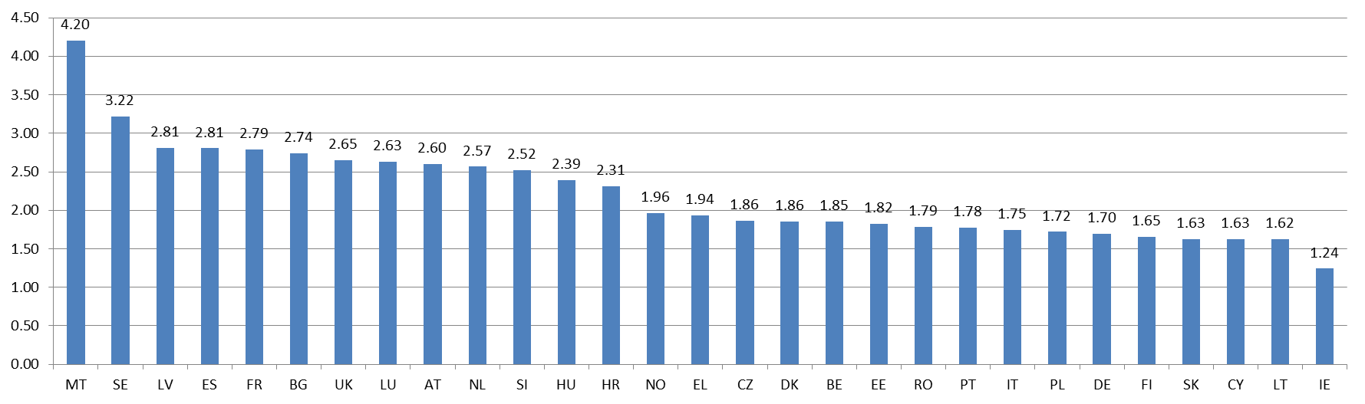

Figure 30: Total estimated costs of wholesale roaming data services including transit costs (€c/MB)
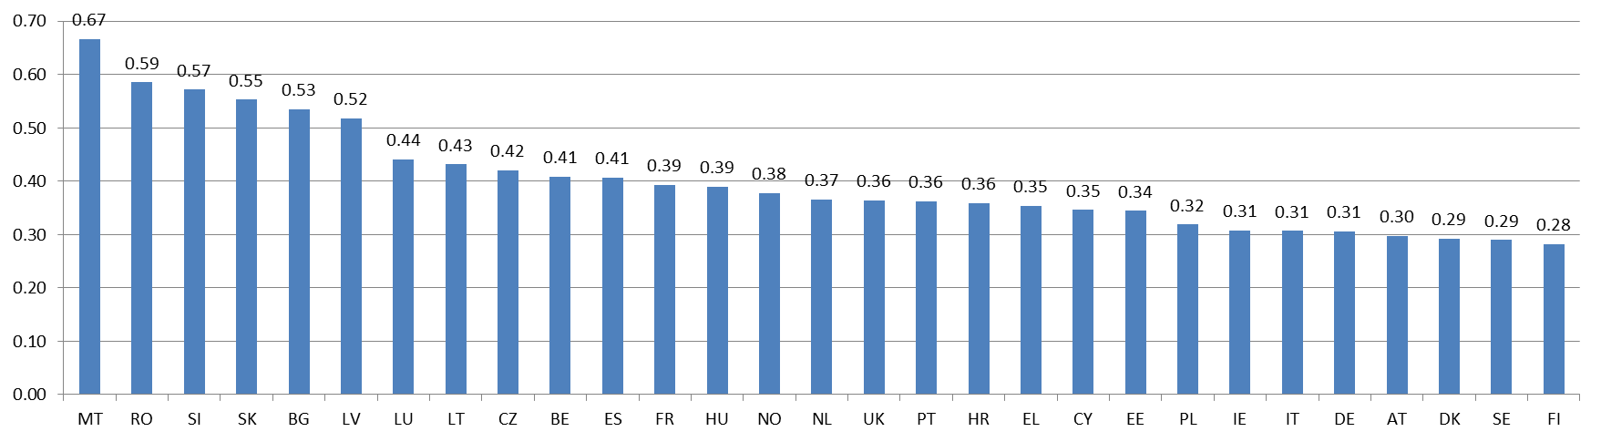

The cost estimates derived from TERA's study have been sense checked against an alternative approach to estimating wholesale roaming voice costs based on NRAs' estimated mobile termination costs. In particular, wholesale roaming voice costs under this alternative approach were estimated as follows:
- the cost of origination is assumed equal to the cost of termination. Also, in each country the cost of origination will be equal to the BU-LRIC cost estimated by the NRA (MS that do not estimate mobile termination costs based on a BU-LRIC approach were excluded from this analysis);
- the average joint and common costs estimated by TERA Consultants for voice services were added (equal to €0.55c/min);
- the roaming-specific costs estimated by TERA Consultants for each country were included;
- a mark-up to account for the seasonality impact estimated by TERA Consultants, where relevant, was included;
- a compensation was included for the termination rates that visited network operators are, on prudent assumptions, exposed to paying to terminating network operators for terminating calls on their network (€1.02c/min, as estimated above);
- transit costs equal to €0.4c/min, as described above, were added.

Figure 31 presents below a comparison of the wholesale roaming cost for voice services estimated using this alternative approach against the estimated wholesale roaming cost for voice services derived from the TERA study and the average wholesale roaming market price for unbalanced traffic.
Figure 31: Comparison between the TERA-based estimated cost for wholesale roaming voice, an alternative approach to estimating costs for wholesale roaming voice, average wholesale roaming market price for unbalanced traffic (€c/min)

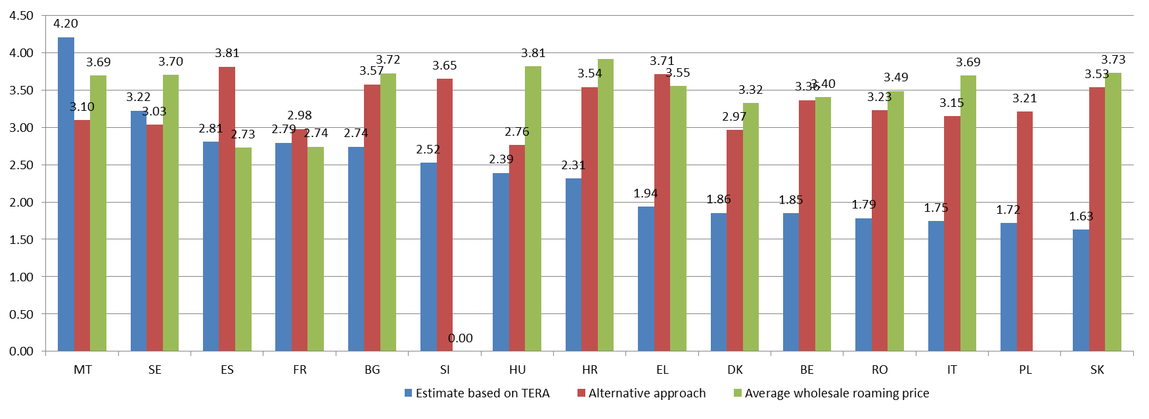

The comparison between the cost estimates for voice derived from TERA's study and the estimates using an alternative approach in Figure 31 above shows that:
- the TERA-derived cost estimates are always below the cost estimates using the alternative approach, with the only exception of Malta and Sweden. In the case of Malta, the TERA approach estimates a cost of €4.20c/min and the alternative approach shows a cost of €3.10c/min. In the case of Sweden, the TERA approach estimates a cost of €3.22c/min and the alternative approach shows a cost of €3.03c/min. In both cases, the lower cost estimate using the alternative approach is mainly due to the low termination rates effective in Malta and Sweden (€0.4c/min and €0.81c/min, respectively, in the second semester of 2015);
- the maximum cost estimate derived from TERA (€4.20c/min in Malta) is above, but broadly consistent with, the maximum cost estimate derived using the alternative approach (€3.81c/min in Spain);
- the cost estimates derived using the TERA cost model exceed the average market price for wholesale roaming voice services in several countries (namely: Malta, Spain and France). Similarly, the cost estimates derived using the alternative approach exceed the prices in several countries (namely: Spain, France and Greece). This supports the view that both the TERA cost model and the alternative approach provide conservative estimates of the costs of wholesale roaming voice services. Furthermore, it suggests that in the case of voice services, the effective wholesale roaming prices should be given due weight when assessing the costs of voice services.

  - Cost estimates for SMS services
As described above, TERA Consultants' cost estimates for SMS services do not appear robust enough to derive conclusions on actual SMS costs. For this reason, it is more appropriate to rely on other sources of information. Figure 32 below presents the average wholesale roaming prices for SMS services currently in place in EEA MS obtained in the autumn information request.

Figure 32: Current wholesale roaming prices for SMS in MS (€c/SMS)
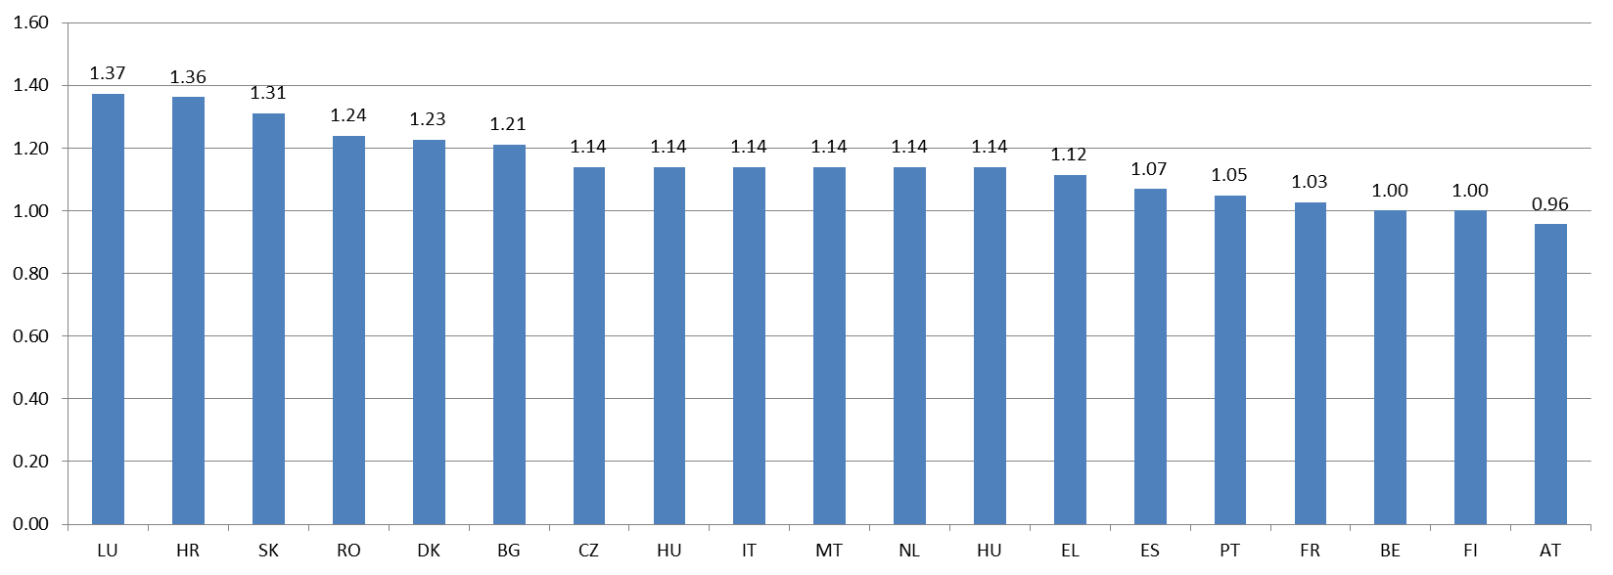

Based on the above evidence it is appropriate to assume a cost for wholesale roaming SMS services equal to €1c/SMS.

  - Conclusion on the costs of wholesale roaming services
This section assessed the costs of wholesale roaming services based on several sources of evidence, namely:
- the TERA Consultants' cost model;
- an alternative approach to estimate the costs of wholesale roaming voice services based on national mobile termination rates; and
- retail unit prices in MS from a Commission study on retail prices in the EEA.

Based on the evidence described in this section, Table 10 presents the cost estimates in each of the 28 MS plus Norway including:
- the total wholesale roaming costs estimated by TERA (including network costs, roaming-specific costs and the impact of seasonality on roaming costs), as discussed in section 5.4 above;
- an allocation for the termination rate that the visited network operator needs to pay the terminating network operator for terminating a call on its network, as discussed in section 5.5 above; and
- an allocation for the transit costs that the visited network operator needs to pay for routing a call to the terminating network operator or to send data traffic back to the home network, as discussed in section 5.6 above.

Table 10: Wholesale roaming services' cost estimates in each of the 29 countries considered in TERA Consultants' cost model
 | Voice (€c/min) | SMS (€c/SMS) | Data (€c/MB)
AT | 2.60 | 1.00 | 0.30
BE | 1.85 | 1.00 | 0.41
BG | 2.74 | 1.00 | 0.53
CY | 1.63 | 1.00 | 0.35
CZ | 1.86 | 1.00 | 0.42
DE | 1.70 | 1.00 | 0.31
DK | 1.86 | 1.00 | 0.29
EE | 1.82 | 1.00 | 0.34
EL | 1.94 | 1.00 | 0.35
ES | 2.81 | 1.00 | 0.41
FI | 1.65 | 1.00 | 0.28
FR | 2.79 | 1.00 | 0.39
HR | 2.31 | 1.00 | 0.36
HU | 2.39 | 1.00 | 0.39
IE | 1.24 | 1.00 | 0.31
IT | 1.75 | 1.00 | 0.31
LT | 1.62 | 1.00 | 0.43
LU | 2.63 | 1.00 | 0.44
LV | 2.81 | 1.00 | 0.52
MT | 4.20 | 1.00 | 0.67
NL | 2.57 | 1.00 | 0.37
PL | 1.72 | 1.00 | 0.32
PT | 1.78 | 1.00 | 0.36
RO | 1.79 | 1.00 | 0.59
SE | 3.22 | 1.00 | 0.29
SI | 2.52 | 1.00 | 0.57
SK | 1.63 | 1.00 | 0.55
UK | 2.65 | 1.00 | 0.36
NO | 1.96 | 1.00 | 0.38

Section 6 below presents evidence on current prices for wholesale roaming services and national wholesale prices for MVNOs. This evidence is broadly consistent with the costs estimated by TERA Consultants for wholesale roaming services presented in this section. In addition, evidence on wholesale roaming services' prices and MVNO rates supports the level of the wholesale price caps used in each of the options considered in the Impact Assessment.

- Degree of competition in wholesale roaming markets
In this section the Commission describes the functioning of wholesale roaming markets and assesses the degree of competition currently existing in these markets. The section is structured as follows:
- First the Commission's approach to analysing developments in wholesale roaming markets is described;
- Second, the market failures that have been traditionally associated with wholesale roaming markets are reviewed;
- Third, an overview of wholesale roaming agreements is provided;
- Fourth, the wholesale roaming markets in the EU is described;
- Finally, the degree of competition in wholesale roaming markets is assessed;
  - Description of the Commission's approach
    - Literature review and previous studies

Market failures that have been associated with wholesale roaming markets in the literature (section 6.2) have been confronted in the subsequent sections with the data and information provided by EEA operators during the autumn 2015 data gathering exercise described in section 6.1.2.

    - Questionnaire to operators and analysis of the data
The necessary data to analyse the functioning of, and level of competition in, the wholesale roaming markets in the EU were obtained via the questionnaire sent in September 2015 by the Commission and BEREC to M(V)NOs in all Member States.
For the purpose of assessing the degree of competition in wholesale roaming markets, operators were requested to provide data and information about: (i) current wholesale roaming agreement structures and tariffs, including the situation of light MVNOs; (ii) current and future wholesale competition situation, (iii) aggregated retail domestic and (intra-EU/extra-EU) roaming data consumption and revenue, (iv) wholesale roaming payments, revenues and volumes by Member States of destination and origin, (v) aggregated balanced-unbalanced traffic volumes and related average wholesale prices, (vi) expected wholesale roaming prices for the year 2016. In this questionnaire, operators were also asked to provide their views about the current functioning of the wholesale roaming market in the EU and about future wholesale roaming price regulation.
127 operators provided at least part of the quantitative data requested above. The CC-ME of the JRC extracted the original data and organized them in a unified database. Several inconsistencies in the way data were reported were corrected, in particular as regards the unit of measurement.
In order to analyse the representativeness of the sample of operators with respect to the whole market and the presence of potential response bias, NRAs were asked through BEREC to provide information on where the operators that provided data appeared in the distribution of national operators, when sorted according to size. This information was provided for all Member States that contributed data for the analysis; the Member States that did not provide data were: CY, DE, HU, IT, LU, SI, UK.
For Member States contributing some data, the fraction of operators providing data over the total was on average equal to 79%. When restricting attention to the largest 50% of operators, this fraction was equal to 93%. This means that the sample of 127 operators providing data slightly over-represents large operators. Due to the small absolute number of operators, this difference does not appear to be large.
In the remainder of this section, the results of the analysis are shown by operator and by country. For each variable of interest (e.g. inbound wholesale roaming volume as % of retail domestic consumption) the operators' graph represents the distribution of the operators' values in the sample of operators providing the necessary data as a cumulative fraction of the sample (expressed as %). This means that for each value of the variable of interest on the x-axis, the graph shows what % of the operators' sample is below that value. Operators are looked at on a per-country basis, which means per subsidiary for the multi-country groups. The countries' graphs show the aggregated value of the variable of interest over all operators operating in a given country that have provided the necessary data.
    - Public consultation
The first part of the 12-week public consultation was dedicated to gathering views on the functioning of, and level of competition in, the wholesale roaming markets in the EU, on the need to regulate them in view of the abolition of retail roaming surcharges by 15 June 2017, on possible options for doing so, and on the possible risks associated with permanent roaming and the ways to address them. The results of the consultation concerning the functioning of national wholesale roaming markets are analysed in sections 6.5.1 and 6.5.2.
  - Market failures in wholesale roaming markets
This section provides an overview of the market failures that have been traditionally associated with wholesale roaming markets, in particular:

- Natural oligopoly structure, which fosters low intensity of competition
- Imperfect wholesale roaming substitutes;
- Double marginalisation and coordination problem;
- Bilateral nature of wholesale roaming agreements:
- Exclusion of MVNOs from wholesale roaming market.
    - Natural oligopoly structure, which fosters low intensity of competition
An argument generally raised is that the roaming market presents many characteristics of a natural oligopolistic market. High infrastructural costs of mobile communications limit the entrance of players, and the situation creates low competitive pressure. There seems not to be indications that this has substantially changed, in one direction or another. In wholesale domestic roaming markets, there is generally more than one operator effectively competing for attracting visiting network, but the number does not rise to substantial competitive levels so that the overall structure of the market is affected. Moreover, the number of competitors is significantly reduced when it comes to those who offer full coverage, network quality, or traffic exchange deals (see section 6.2.4) which is seen by operators as key factors explaining their final roaming deals, generally tide to only one preferred network (see section 6.3). Moreover, according to investigations carried out by the Commission services, access measures applied at the domestic level do not significantly change this situation, as MVNOs do not resell, in the wholesale roaming market, their domestic wholesale access (a different situation is the role played by Global MVNOs, analysed below).
    - Imperfect wholesale roaming substitutes
Similarly to the situation at the retail level, where end users have limited alternatives to retail roaming services, operators have only imperfect substitutes at the wholesale level as well, a situation that a previous report ordered by the Commission already analysed . Developments in steering technology, which give control to operators over which visited mobile network their clients attached to, sparked an “internalisation” trend in the form of growing roaming alliances, hubs and other groupings. These changes, however, do not seem to have, in view of many operators, contributed much in perfecting the functioning of the wholesale market (see section 6.4), nor did it improve the incentives to pass-by potential savings to the consumers via retail discounts.

“Localization” (where roaming is offered to costumers at local terms) is another trend that does not seem to have had much impact at the wholesale level. Beside all the limits analysed in the retail dimension of these trend (see section 4.2.1), it does not seem that operators have so far designed localization strategies with a mass-market impact (for how eSims might or might not change this situation, see section 4.4). A special case in point are global MVNOs. Global MVNOs have access to networks in different countries on local terms and conditions based on domestic wholesale agreements or MVNO regulations. They typically use these agreements to interconnect their customers at local terms and conditions, thereby bypassing the IOT system. At the retail level, this enables local pricing for roaming services. However, global MVNOs typically target a niche market of mainly business customers and subscribers, who then need to pass on different numbers to business associates for each country they travel to. Given this level of inconvenience, it is unlikely that global MVNOs may develop into a fully effective roaming substitute for the mass market of residential users.
    - Double marginalisation and difficulties in coordination
The problem of double marginalisation has also been invoked as a possible market failure operating in the wholesale roaming market. Prices in the roaming market might be even above the monopoly price, it is argued, due to separate uncoordinated mark-ups applied by both retail suppliers and providers of wholesale roaming access. MNOs charge an oligopolistic price at wholesale, and at retail level, each MNO takes as given the wholesale price and adds a retail mark-up to the wholesale tariff. Ultimately, market agents prefer to charge oligopolistic mark-ups to a small volume of roaming transactions than expanding the market with lower prices.

It has therefore been argued that both social welfare and overall profits could improve if it was possible to coordinate an outcome with lower retail and wholesale prices that increase roaming demand and profits for both parties. However, there are difficulties in coordinating such an outcome due to uncertainties in future roaming demand and the sharing of risks from uncertain roaming demand following the reduction in prices at wholesale and retail level. This idea is supported by the evidence showing that RLAH-type of offers have been typically offered by MNOs active in several national markets, where this trans-national vertical integration would reduce the risks and costs of coordination

It is also the case that the difficulties in coordination between a wholesale and retail provider might have been somewhat mitigated with the improvement in steering technologies (see previous section), which have enabled MNOs to direct traffic generated by their customers to a visited network of their choice, making other market problems more prominent.
    - Bilateral nature of wholesale roaming agreements
Wholesale roaming agreements are generally driven by the amount of traffic that that the visiting operator is able to offer during bilateral negotiation. Operators typically agree to "balance" their respective traffic, and then the net sender of traffic gets an additional discount on the amount of traffic that exceeds the amount of traffic received from the roaming partner (see Section 6.3.4). It has been argued that this creates a situation where operators with low traffic are in practice unable to both, obtain a good price during the negotiations with visited networks, and effectively compete for visiting traffic, no matter their price offers. The fact that they cannot offer significant "traffic balancing" deals reduce their negotiation power, as operators are ultimately interested not so much on lowering costs, but on meeting overall revenue targets. This is in principal maximized by exchanging traffic, thus effectively hampering those who cannot deal in such terms. Section 6.3 of the report analyses current bilateral agreements.
    - Exclusion of MVNOs from wholesale roaming markets
The exclusion of full MVNOs from the wholesale inbound market is another problem often raised by these operators. This problem arises from the fact that bilateral negotiations for roaming services are most often based on Standard Terms for International Roaming Agreements (STIRA) (i.e. standard documents regularly amended giving a general framework to conclude agreements with foreign MNOs), which can currently only be used by GSMA members. In contrast, MVNOs cannot have the required GSMA membership. Although in theory, other types of contracts could be concluded, in practice these introduce higher uncertainty resulting in greater transaction costs for MVNOs. To improve this situation, the GSMA mentioned that they were preparing to allow MVNOs use standard commercial documents such as STIRA.

The exclusion of MVNOs implies that they typically buy roaming services from a domestic MNO, most of the time their host MNO. As there are no price caps on the wholesale resale market, and MNOs are at the same time suppliers for the MVNOs (at wholesale level) and competitors of these MVNOs (at retail level), MVNOs often encounter margin squeeze problems.
  - Overview of wholesale roaming agreements

BEREC has provided the following description of the wholesale roaming agreements that operators negotiate for roaming in the EEA, based on the information provided by EEA operators during the autumn 2015 data collection .
    - Standard Roaming Agreements and roaming discount agreements
Operators report that they sign two types of wholesale roaming agreements. The first type called International Roaming Agreements or Standard Roaming Agreements defines the operational and technical aspects of the roaming relationship. In addition, roaming discount agreements are annexes to the international roaming agreements and specify the commercial aspects of the agreement including the prices that have to be paid. While standard roaming agreements are ongoing (with the possibility to terminate them after a period of notice of six months), the discount agreements typically have a duration of 12 months (one calendar year). These bilateral roaming agreements are based on common principles developed by the GSM Association.

Operators regularly renegotiate discount agreements because of the unpredictable nature of the market with a high degree of regulatory uncertainty, unpredictable traffic volumes and frequent mergers and other changes of ownership. These uncertainties need to be balanced by the transaction cost of negotiating agreements. Some discount agreements are automatically renewed every year unless one party objects.
    - Bilateral and unilateral roaming agreements
Roaming agreements are usually negotiated bilaterally, so that each operator gets roaming access to the other operator’s network. Operators describe a number of advantages of bilateral agreements: they build partnerships, enlarge roaming coverage to the benefit of customers and not least secure inbound roaming traffic and revenue that can (partly) offset the outbound roaming cost. Sometimes, bilateral agreements are (initially) used unilaterally by one roaming partner. Unilateral agreements are signed when the requesting MNO has bad geographical coverage or network quality, or is a late entrant, or when a full MVNO requests access.

Typically, operators who are part of a group negotiate international roaming agreements individually but negotiate discount agreements as a group. By negotiating commercial terms for the whole group companies can get more attractive terms and prices because of higher volumes. However, in some cases these operators negotiate discount agreements individually when it is commercially relevant or for practical reasons. MNOs that are not part of a group negotiate individually.
    - Number of roaming agreements in each destination country
Generally, operators have agreements with more than one operator in each EU country, in order to address gaps in geographic coverage and get more inbound roaming revenue. Operators in big groups report that they have agreements with almost all operators. Nevertheless, operators typically have one preferred network in each country to which they try to steer their traffic.

Some smaller operators or operators from small countries only sign more than one agreement in countries where they have a lot of traffic (inbound or outbound) in order to prioritize resources.
    - Pricing models
Operators tend to apply a range of discount price models. The following are the most common types:
- Fixed rate model where there is a fixed (discounted) rate per unit per service or a discount as a percentage of the regulated cap.
- The balanced/unbalanced model is a typical pricing method in bilateral discount agreements. Each party exchanges traffic and the net sender of traffic gets an additional discount on the amount of traffic that exceeds the amount of traffic received from the roaming partner. This gives both parties an incentive to send more traffic to each other since additional outbound traffic will reduce the net sender’s average cost and the net receiver will increase its average revenue if it sends more traffic.
- When using traffic or volume commitments the roaming party commits to sending a certain amount of traffic for a discounted price. A version of this often used is tiered pricing where the price goes down if a certain volume threshold is reached. Sometimes prices go down from the first unit or just for the incremental volume above the threshold. Tiered pricing mean that higher outbound volumes result in lower per unit cost for the home operator.
- With a financial or revenue commitments or send-or-pay the visiting operator commits to paying at least a minimum amount in wholesale roaming charges across all services. This can be based on defined tariffs for each service or bundled volumes for each service. Additional discounts may apply if these thresholds are exceeded. These agreements secure a certain level of revenue for the visited network and lower prices for the net buyer if the included volumes are consumed. Typically, the higher the committed revenue the higher discounts can be achieved.
- For voice services sometimes a per destination pricing model is applied where prices vary depending on the destination of calls made in order to account for differences in interconnection cost.
These different pricing models are in many cases combined. For example a balanced/unbalanced agreement might include a minimum volume/revenue commitment. There can also be different price models for different services in the same discount agreement – e.g. one for voice and one for data services.
A number of elements specific to each individual negotiation determine the choice of pricing model and the level of discounts that can be negotiated. These elements include traffic volumes and the level of imbalances in inbound and outbound volumes. Other important elements are national market share, network quality and MTR cost. An operator with a high national market share and good network quality will, ceteris paribus, secure better discount agreements. Alliance networks are more likely to offer discounts.
Some operators report that a high amount of outbound traffic gives operators bargaining power that can result in higher discounts for the net buyer of roaming services than they have to give to the net receiving party. Other operators report that the net seller of roaming services has the advantage since it is usually the seller who has the geographical advantage e.g. the best network in a popular roaming country.
Some operators report that if they compete in the domestic market with an operator that is part of a pan-European group they are not able to negotiate reasonable roaming discounts with other members of this group in visited markets and thus have to rely on agreements with smaller operators in those countries.
Most group operators report that they apply internal transfer pricing that is based on an arm’s length principle. In these cases the internal rate is based on the market rates offered to external partners. One group reports that this market rate is calculated as the average rate charged to the main trading partners. One group apply bill and keep while another group uses zero pricing between subsidiaries.
    - Permanent roaming
A majority of MNOs responded that they have so far not implemented any measure to prevent a foreign operator from permanently roaming on their network. They claim that there has so far been no compelling reason to implement any such measure since under past and current wholesale roaming caps wholesale roaming providers have been able to recover their costs with a good margin. Some even highlight that they seek to increase the roaming traffic on their network by using mechanisms like volume commitments, revenue commitments in their wholesale roaming agreements.

About 20% of the responding MNOs have however some kind of mechanism in their wholesale roaming agreement which could be used to discourage permanent roaming. This is usually done by excluding permanent roaming from any price discount. The difference between discounted and non-discounted wholesale roaming prices therefore seems to be a crucial element for operators to control permanent roaming. In one case, the operator includes a maximum number of days per year per visiting SIM card in some of its wholesale roaming agreements: beyond that number of days, the roaming traffic generated on its network by a visiting SIM card is charged at the wholesale roaming cap level by the operator to the operator owning that visiting SIM card. In another example given by a respondent, individual roaming data consumption beyond 10 GB per month is subject to revised commercial negotiations, and if the parties do not agree on a less discounted price, the wholesale roaming cap is applied beyond the monthly 10 GB limit.

Some operators indicate that they might introduce mechanisms in the future to prevent unwanted permanent roaming if wholesale roaming caps are decreased below relevant costs.

A few operators also mention that they have mechanisms in their wholesale roaming agreement to prevent losses on terminating calls to destination with high MTRs. Countries with high MTRs might be excluded from special negotiated low wholesale rates or a consumption limit can be added for the total number of minutes to specific countries.
    - Machine-to-Machine communications (M2M)
SIM cards are introduced, possibly soldered, in the connected object at manufacture. The manufacturer of connected objects often sells them globally and cannot predict in which country a particular object will be sold and used ultimately. As a result, once sold, the connected object may well have to be permanently roaming on a network of the country where it is used. Permanent roaming may therefore be an important feature of many M2M applications. In addition, the traffic patterns many of them generate, with a lot of signalling and less data, are different from those of traditional communications generated by humans where data traffic largely dominates over signalling traffic. Permanent roaming and different traffic patterns might be two reasons why M2M communications could be subject to specific roaming agreements, distinct from those covering traditional person-to-person communications.

About 20% of the responding MNOs indicate that they have signed separate agreements for M2M communications. This shows that most operators do not, under the current regulatory regime, see the scope of such traffic as significant enough to enter into specific negotiations with their roaming partners. Many operators explicitly state that separate agreements for M2M are not necessary.

The majority of operators do not apply specific prices or conditions for M2M traffic. They seem to treat this traffic the same way as ordinary traffic when it comes to financial terms in the contracts. However, some operators also express concerns as they see some challenges in covering the production costs of traffic generated by some M2M communications because of the small amount of data they generate. In those cases, signalling traffic dominates the traffic, which is hard to recover from their roaming partners within today’s standard roaming prices structure. A few operators have special conditions and rates for M2M traffic, one operator says that M2M is typically excluded from discounts.

None of the respondents that engage into M2M agreements employ any exclusivity clause for the use of their network. One operator states that such clauses would harm the M2M services, since the offered quality could suffer if the applications could not select the best network at any given time.

Several respondents call for transparency regarding the type of traffic generated by visiting SIM cards (i.e. traditional traffic generated by a person or M2M communication). This is necessary to implement a specific M2M roaming contract if there is one. And those who do not have any specific roaming contract for M2M still want to monitor the extent and evolution of M2M traffic. Some respondents reveal that they intend to more and more closely monitor SIM cards that visit their network for longer periods.

Such monitoring is foreseen to become a necessity in the RLAH regime. National networks are dimensioned and built to host domestic SIM cards and if RLAH is introduced without proper safeguards, some see a risk that foreign SIM cards will be located on a permanent basis on their networks – creating problems of capacity management and possible network congestion.

A couple of MNOs refer to agreements that aim to reduce the risk of having many foreign M2M devices in their network on a permanent basis. These agreements allow a maximum percentage of traffic out of the total observed from that visiting operator to permanently roam. It is pointed out however, that for the visited network this percentage/limit is difficult to detect and control.

  - Description of the wholesale roaming market in the EU
    - Wholesale roaming traffic flows between Member States
As noted in BEREC's Report on the wholesale roaming market, observed patterns of voice roaming traffic between EEA countries reflect to some extent particular historical, linguistic, cultural and economic links between countries (see Table 14 in Annex 3 showing the detailed roaming voice traffic flows between countries).

There has also traditionally been a North-South divide in Europe between high-tourism Southern locations (e.g. Spain, Italy, Greece, Malta, Cyprus) and lower-tourism Northern locations (e.g. the UK, Germany, Netherlands). In this regard, roaming traffic flows are likely to be highly influenced by the patterns of tourism and travelling in the EU.

In order to assess the countries that are net senders and net receivers of roaming traffic, one can look at the ratio of inbound-to-outbound wholesale roaming traffic. A ratio greater than 1 (or 100%) implies that the country is a net receiver of roaming traffic whereas a ratio below 1 (or 100%) implies that the country is a net sender.

Table 11 below shows the inbound/outbound ratio for each country for each of the three services. Cyprus, Greece, Malta and Spain stand out as very pronounced net receivers in all three services. Bulgaria, Croatia, Hungary, Poland and Portugal have a particularly high data unbalance. This is likely to be due to low data consumption of customers from these countries when they roam abroad, and lower outbound travel patterns, in addition to a large inflow of tourists in some of these countries; Belgium and Luxembourg as well are marked net receivers in data, which might be related to the intensive data usage by business users coming to these countries all over the year.

In contrast, Ireland, the Netherlands, Norway, Romania, Slovakia and the UK are pronounced net senders in all three services. Other important net senders are Denmark, Finland and Poland, (voice and SMS), Czech republic and Slovenia (data and SMS), and Austria (data).

The other countries have a more balanced situation (France, Italy, Latvia, Lithuania, Sweden) or operators have not provided the necessary data (Estonia, Germany).
Table 11 - Inbound/Outbound ratio for roaming services: voice, data and SMS (in green values above 150%, in blue values below 75%)
 | Voice (Inbound/ outbound ratio) |  |  | Data (Inbound/ outbound ratio) |  |  | SMS (Inbound/ outbound ratio)
Country | 2013 | 2014 | 1H2015 | 2013 | 2014 | 1H2015 | 2013 | 2014 | 1H2015
Austria | 81% | 87% | 96% | 30% | 57% | 78% | 120% | 115% | 120%
Belgium | 114% | 131% | 168% | 161% | 170% | 247% | 102% | 107% | 127%
Bulgaria | 124% | 117% | 82% | 670% | 383% | 147% | 191% | 190% | 145%
Croatia | 144% | 155% | 122% | 3610% | 4238% | 1400% | 91% | 91% | 61%
Cyprus | 153% | 177% | 180% | 165% | 1053% | 1025% | 186% | 170% | 154%
Czech Republic | 107% | 90% | 86% | 52% | 77% | 121% | 48% | 49% | 50%
Denmark | 72% | 77% | 79% | 119% | 152% | 157% | 48% | 43% | 40%
Estonia
Finland | 72% | 77% | 72% | 96% | 84% | 78% | 55% | 55% | 51%
France | 144% | 141% | 149% | 219% | 125% | 113% | 102% | 80% | 70%
Germany
Greece | 289% | 323% | 240% | 559% | 709% | 497% | 733% | 890% | 658%
Hungary | 101% | 94% | 80% | 229% | 255% | 269% | 101% | 111% | 124%
Ireland | 37% | 45% | 55% | 27% | 39% | 40% | 41% | 42% | 48%
Italy | 98% | 95% | 116% | 110% | 100% | 128% | 125% | 152% | 186%
Latvia | 88% | 100% | 97% | 123% | 123% | 105% | 52% | 58% | 47%
Lithuania | 85% | 96% | 94% | 113% | 115% | 98% | 51% | 57% | 47%
Luxembourg | 104% | 120% | 145% | 153% | 176% | 247% | 131% | 137% | 151%
Malta | 330% | 305% | 343% | 800% | 760% | 722% | 274% | 277% | 314%
Netherlands | 45% | 51% | 58% | 23% | 34% | 49% | 62% | 70% | 77%
Poland | 63% | 61% | 65% | 108% | 219% | 503% | 42% | 38% | 38%
Portugal | 150% | 100% | 88% | 348% | 237% | 219% | 128% | 143% | 136%
Romania | 72% | 40% | 21% | 86% | 37% | 20% | 35% | 30% | 24%
Slovakia | 51% | 46% | 43% | 62% | 18% | 14% | 46% | 42% | 39%
Slovenia | 115% | 99% | 88% | 34% | 31% | 49% | 62% | 55% | 58%
Spain | 325% | 373% | 350% | 523% | 531% | 391% | 1445% | 1692% | 1913%
Sweden | 100% | 111% | 117% | 107% | 116% | 76% | 52% | 56% | 61%
UK | 75% | 76% | 90% | 58% | 55% | 70% | 63% | 63% | 74%
Iceland
Liechtenstein
Norway | 54% | 55% | 71% | 37% | 48% | 97% | 53% | 57% | 60%
Switzerland
Min | 37% | 40% | 21% | 23% | 18% | 14% | 35% | 30% | 24%
Mean | 100% | 101% | 100% | 270% | 311% | 218% | 139% | 152% | 152%
Median | 100% | 96% | 90% | 113% | 123% | 121% | 63% | 70% | 70%
Max | 330% | 373% | 350% | 3610% | 4238% | 1400% | 1445% | 1692% | 1913%
Source: BEREC report on the wholesale roaming market, BoR(16)33, February 2016
Data: operators' replies to the autumn 2015 data collection
    - Wholesale roaming traffic compared to retail domestic traffic
Figure 33 to Figure 36 show, per operator, the relative importance of wholesale roaming revenues and traffic compared to retail domestic revenues and traffic, based on operators' data from the autumn 2015 data collection.
Figure 33 – Intra-EEA wholesale roaming (inbound) revenue as % of retail domestic revenue all services (x-axis)
Data: operators' replies to the autumn 2015 data collection
JRC's calculations

Intra-EEA wholesale roaming revenues represent less than 2% of retail domestic revenues, all three services included, for all operators that provided this information in the autumn 2015 data collection. The size of wholesale roaming revenues compared to domestic retail revenues has decreased since 2013, reflecting the two reductions in wholesale roaming caps that took effect in July 2013 and July 2014 as well as ongoing commercial trends at wholesale level.

Figure 34 – Intra-EEA wholesale roaming (inbound) traffic as % of retail domestic traffic (x-axis) (outgoing voice)
Figure 35 – Intra-EEA wholesale roaming (inbound) traffic as % of retail domestic traffic (outgoing SMS)
Figure 36 – Intra-EEA wholesale roaming (inbound) traffic as % of retail domestic traffic (x-axis) (data)
Data: operators' replies to the autumn 2015 data collection
JRC's calculations

Intra-EEA wholesale roaming traffic represents less than 2% of retail domestic traffic for voice services and less than 5% for SMS services (with a few exceptions above 5% for SMS). This has been relatively stable since 2013. For data services however, wholesale roaming traffic represents less than 1% of retail domestic traffic only. As noted in the comparison of retail roaming consumption to total retail consumption in section 4.4, this reflects the larger propensity of roaming subscribers to refrain from using data services, relative to voice and SMS services, while roaming. One can also note that the size of wholesale roaming data traffic compared to retail domestic data traffic has been increasing since 2013. As noted in the comparison of wholesale roaming consumption to total retail domestic consumption in section 6.4.2, this reflects the more rapid increase in roaming data consumption than domestic data consumption, due inter alia to retail roaming cap reductions in 2013 and 2014.
Figure 37 – Intra-EEA wholesale roaming (inbound) revenues and traffic as % of retail domestic revenues and traffic (y-axis), 2014
Data: operators' replies to the autumn 2015 data collection
JRC's calculations

In all countries, intra-EEA wholesale roaming revenues and traffic represent less than 4% of retail domestic revenues and traffic, except for SMS services in some countries. Countries where intra-EEA wholesale roaming revenues are the highest compared to domestic retail revenues as Luxembourg (almost 4%), Croatia (3%), Spain and Malta (both slightly below 2%).
    - Wholesale roaming payments and revenues balance
Figure 38 shows the total (i.e. the three services included) intra-EEA wholesale roaming balance (i.e. revenues minus payments) expressed as a % of total retail domestic revenues, per operator, based on operators' data from the autumn 2015 data collection.
Figure 38 - Total intra-EEA wholesale roaming balance (revenues minus payments) as a % of total retail domestic revenues (x-axis), all services included
Data: operators' replies to the autumn 2015 data collection
JRC's calculations

About 60% of the operators providing the data have balanced intra-EEA wholesale roaming revenues and payments within the [-1%; +1%] range of total retail domestic revenues. About 20% of them have a negative intra-EEA wholesale roaming imbalance below -1% of total retail domestic revenues and about 20% a positive imbalance above +1%. The EEA wholesale roaming balance has stayed relatively stable since 2013.

Figure 39 shows the total intra-EEA wholesale roaming balance expressed as a % of total retail domestic revenues per country.
Figure 39 - Total intra-EEA wholesale roaming balance (revenues minus payments) as a % of total retail domestic revenues (y-axis), all services included, per country
Data: operators' replies to the autumn 2015 data collection
JRC's calculations

Operators in Croatia have the largest positive imbalance (i.e. wholesale roaming revenues exceeding wholesale roaming out-payments), which however decreased from slightly above 3% to slightly less than 3% of total retail domestic revenues. Other inbound roaming countries are Spain, Greece, Malta and Luxembourg, with a positive imbalance wholesale roaming representing about +1% of total retail domestic revenues in 2014. In contrast, operators in Slovenia, the Netherlands, Denmark, have the strongest negative imbalances (i.e. wholesale roaming payments exceeding wholesale roaming revenues), followed by Norway, Poland, Slovakia. The data therefore illustrate the North/South divide of outbound/inbound countries in Europe. They also show the modesty of the size of the wholesale roaming imbalance in either direction compared to total retail domestic revenues.
    - Wholesale roaming prices in the EU
Section 6.3 above described the process of negotiating wholesale access roaming prices and the contractual agreements typically observed between wholesale roaming operators in the EU. This section describes the wholesale roaming prices resulting from those negotiations, as well as the revenues derived from wholesale roaming services in different Member States.
In general, two MNOs in two different Member States will have a certain amount of roaming traffic (minutes, SMS, MB) that balance out ("balanced traffic") and a certain amount of roaming traffic that one MNO has to provide to the other in excess of the balanced part ("unbalanced traffic").

MNOs typically agree on different rates for balanced and unbalanced traffic. Figure 40 to Figure 42 below show the operators' average wholesale roaming prices for (i) balanced traffic and (ii) unbalanced traffic in inbound and outbound roaming situations.

The variability of the value among EEA countries is illustrated by using box plots which indicate the first and third quartile values (Q1 and Q3 respectively) as well as the median value.
Figure 40 - Average wholesale roaming prices for balanced and unbalanced traffic (inbound and outbound): voice services (2015)

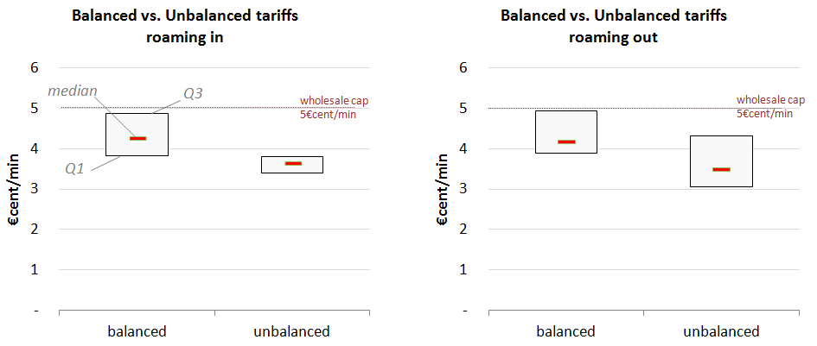
Source: BEREC Report on the wholesale roaming market, BoR(16)33, February 2016
Data: operators' replies to the autumn 2015 data collection

In the case of voice, the median wholesale roaming prices for balanced traffic (4.3 €c/min) are below the cap. The median wholesale roaming prices for unbalanced traffic (at 3.7 €c/min) are significantly lower than the cap with less variability compared to the balanced traffic average prices.

Roaming-in (inbound roaming) tariffs are comparable to the ones applied in roaming-out (outbound roaming) situation. The slight differences that appear are due to the incompleteness of the collected data, since not all the operators replied to the addressed questionnaire.

Figure 41 - Average wholesale roaming prices for balanced and unbalanced traffic (inbound and outbound): SMS services (2015)
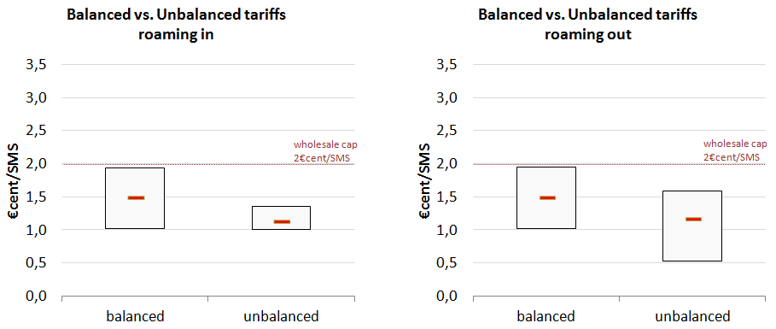
Source: BEREC Report on the wholesale roaming market, BoR(16)33, February 2016
Data: operators' replies to the autumn 2015 data collection

In the case of SMS, both average prices for balanced and unbalanced traffic are below the cap. The median of the average price for unbalanced traffic is slightly above half the cap (1 €c/SMS). Like in the case of voice, the variability of the average price across operators is smaller for unbalanced traffic.

Figure 42 - Average wholesale roaming prices for balanced and unbalanced traffic (inbound and outbound): data services (2015)
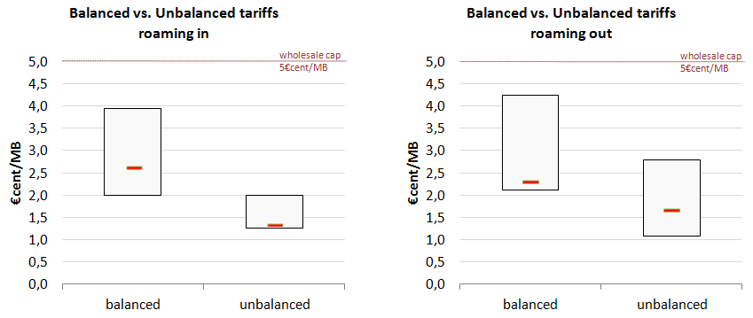
Source: BEREC Report on the wholesale roaming market, BoR(16)33, February 2016
Data: operators' replies to the autumn 2015 data collection

In the case of data services, the difference between the average prices and the cap is large: the median of these average prices is about half the cap (2.5 €cents/MB) for balanced traffic and about 1.3 €/MB for unbalanced traffic, i.e. less than one third of the cap. Like for voice and SMS, the variability of the average prices across operators is smaller for unbalanced traffic than for balanced traffic.

The general pattern observed for the three services is that for balanced traffic MNOs usually agree to mutually charge each other a higher price than for unbalanced traffic.

Since the number of minutes, (or SMS or MB) of balanced traffic is the same for both operators, and the price is the same for both operators, this price can be considered altogether irrelevant – the flow of payments in one direction (from operator A to operator B) is netted off by the flow of payments in the opposite direction (from operator B to operator A). Operators have therefore limited incentives to negotiate a lower price for that part of the traffic.

In contrast, the price for the unbalanced traffic matters as this part of the traffic is paid by only one MNO to the other. For this part of the traffic, the interests of the MNOs in the negotiation are therefore not aligned: the MNO that expects to sell more traffic (i.e. the net-receiver of roaming traffic) will tend to seek a high rate for excess traffic, whereas the MNO that expects to buy more minutes (i.e. the net sender of roaming traffic) will tend to seek a low rate.

It results from the above that price negotiation in wholesale roaming agreements is mostly about the unbalanced part of the traffic. The price for balanced traffic is by definition never paid, in the sense that it cannot lead to a payment deficit; only the rate for unbalanced traffic can lead to a payment deficit. For this reason, it can be considered that the lower, negotiated price for unbalanced traffic is the one that sets an effective lower bound on wholesale roaming prices.
  - Degree of competition in national wholesale roaming markets
It has traditionally been assumed that the incentives as regards wholesale roaming pricing are aligned with the specific position of the MNO as a net-receiver or net-sender of traffic. According to this view, mobile operators which are net-senders of traffic and net out-payers (e.g. in Northern location), therefore viewing wholesale roaming as a cost rather than a source of revenue, will have an incentive in setting and seeking low wholesale access prices. In contrast, net receivers, for whom wholesale roaming prices are a source of revenue, are likely to favour keeping wholesale rates higher, and might be reluctant to enter into alliances.
    - Operators' views of the functioning of the national wholesale roaming markets
The responses to the public consultation shows that mobile operators are split as regards their view of the functioning of national wholesale roaming markets currently: 50% of MNOs replied that they are well functioning for voice, SMS and data, and another 6% that they are well functioning for voice and SMS only. 75% of MNOs are able to negotiate prices well below the cap for voice, 62.5% for SMS and 97% for data. MVNOs claim they never get prices well below the caps.
Only 10% of MNOs and MVNOs combined do not steer traffic over one or more networks in the visited country. MVNOs in particular say they have no incentive to steer traffic since they get a unique price from visited networks. 61% of the operators which steer traffic steer all traffic, and 39% steer only a fraction. However, most of the latter specify that they steer a very large part of their traffic (typically 95%), claiming that there is always a residual traffic that cannot be steered (coverage, capacity).
There is a Sender/Receiver divide among MNOs (i.e. incumbent/operators with large footprint vs smaller operators, operators with large inbound vs large outbound roaming traffic) in the appreciation of the functioning of national wholesale roaming markets: operators sending out more roaming traffic and/or with smaller roaming volumes to offer find the wholesale roaming market not properly functioning (smaller operators, MVNOs, large outbound operators), while operators receiving more roaming traffic and/or with large roaming volumes to offer (incumbents/operators with large footprint, large inbound operators) find it properly functioning. All MVNOs find the market not properly functioning.
Operators that consider the national wholesale roaming markets as well-functioning 'function well' mainly argue that:
- Regulated wholesale caps serve as references from which operators commercially negotiate the prices;
- Actual negotiated prices are below regulated caps and have decreased continuously in between two successive cap changes;
- The visiting operator can choose between several operators in the visited country and steer traffic to its chosen partner(s) only;
- Continuous and expected growth of retail roaming volumes increases the competition among visited operators in a country in order to obtain those volumes (and the related revenues) on their own networks;
- Because they only have roaming-out wholesale volumes to buy and cannot offer roaming-in wholesale traffic in return, full MVNOs are in a good negotiation position, as visited operators compete with each other to offer their best prices to get this net traffic on their network and the corresponding additional revenue;
- There are already true RLAH offers on the market which shows that the wholesale roaming markets currently enable RLAH already.
Operators that consider the national wholesale roaming markets as not well-functioning mainly argue that:
- Prices obtained by some market players (MVNOs, smaller operators not part of a group) are at or close to cap level;
- Prices are much higher than the costs;
- Prices are much higher than domestic wholesale MVNO access prices, which are unregulated; this shows that MNOs do not compete for MVNO roaming traffic, while they do compete for MVNO domestic traffic;
- Prices are much higher than domestic retail prices;
- Even if there are several operators to choose from in each national market, the visiting operator is dependent on certain operators (coverage, capacity), which in practice limits the bargaining power of the visiting operator and hence competition on the visited market;
- There are structural differences in negotiation positions of different market players:
  - Operators in travel surplus countries attract inbound roamers anyway and do not need to decrease prices; they seek to maximise their inbound roaming revenues; in these countries, all network operators have a common interest in keeping wholesale rates at a high level;
  - Discount rates from the cap depend on roaming volumes, so that smaller operators and MVNOs, which send less traffic than bigger MNOs, benefit from no or very limited discount rates;
  - For coverage and quality of service reasons, the visiting operator may have to negotiate roaming agreements with several operators in a given visited countries, which reduces its roaming volume commitments to each visited network, and thereby reduces its ability to negotiate discount rates; in addition, for the same reasons of coverage and quality of service, there is always a residual part of the roaming traffic that the visiting operator cannot steer to the visited network(s) with which it has a wholesale roaming discounted rates;
  - Large groups with significant footprints in several countries can take advantage of the imbalance in European roaming; they have stronger negotiation power against smaller groups or individual operators;
- MVNOs are unilateral buyers, as they cannot host any inbound roaming, hence they do not have any traffic to trade;
- As shown by the much higher international non-EU wholesale roaming prices, the market needs caps to deliver lower prices, which implies that the market is not well-functioning by itself but is structurally not well-functioning.
It is interesting to note that although voice and SMS prices are closer to the cap than data prices are, voice and SMS markets are judged well-functioning by slightly more operators than data. This may be an indication that these operators are of the view that voice and SMS prices are approaching a (cost) floor. These operators are also of the view that, although data prices are usually well below the cap (a sign of competition dynamics), there is still large room for further decrease while remaining above costs, a sign of lack of competition on this market.
For most operators, the functioning of the market does not depend on the Member State. According to most operators what matters are the relative positions and bargaining powers of the two operators in roaming negotiations, more than the visited country itself. However, many operators also argue that the relative bargaining power of two operators heavily depends on geographical features that structurally make some countries large inbound countries while others are large outbound countries.
NRAs and governments express views similar to those of the operators of their countries. Large inbound roaming countries see national wholesale roaming markets as well-functioning, while large outbound roaming countries are of the opposite view.
As regards consumers and their associations, they are cautious in expressing views on wholesale roaming markets since they do not face these markets directly. More than half and up to 72% of consumers and up to 6 out of 7 consumers' associations do not express views about some of the wholesale review related questions of the consultation. When they do, their perspective is similar to that of smaller operators and MVNOs, as they tend to see national wholesale roaming markets as not well-functioning.
    - Operators' views about the ability of the current functioning of national wholesale roaming markets to enable RLAH in the EU
According to the responses to the public consultation, only 30% and slightly more than 25% of MNOs and MVNOs combined are of the view that the wholesale roaming market can deliver sustainable RLAH without regulation or under current regulation respectively.
In general, those operators that find the wholesale roaming market well-functioning (incumbents/operators with large footprint, operators with large inbound vs large outbound roaming traffic) also defend the view that current national wholesale roaming markets can deliver sustainable RLAH without regulation or with current regulation, and vice-versa. However, there are also operators that are of the view that under current regulation the wholesale roaming market is rather well-functioning, but not sufficiently to deliver RLAH or that the market would not be well-functioning anymore under RLAH. Hence, for those operators, the wholesale roaming market, although functioning relatively well now, would not deliver sustainable RLAH.
About half of MNOs and MVNOs combined are of the view that the lack of bargaining power of smaller operators (i.e. with a low market share and/or low amounts of roaming traffic negotiated and/or limited footprint) and too high wholesale caps are the main obstacles to RLAH.
The above analysis in sections 6.5.1 and 6.5.2 is fully consistent with the analysis made by BEREC of operators' replies to the autumn 2015 data collection in its Report on the wholesale roaming market.
    - MVNOs' views of the functioning of the national wholesale roaming markets
Light MVNOs buy roaming from their host MNO. Full MVNOs can buy wholesale roaming either by establishing direct roaming agreements with foreign operators or by contracting with a sponsor operator (not necessarily their host MNO) who already has roaming agreements. Because they are usually small operators, full MVNOs tend to favour a unique roaming sponsor to manage their traffic: indeed, besides the complexity of negotiating direct agreements, multiple roaming providers also means lower volumes per provider and therefore less bargaining power. In practice the tariff structures offered by roaming sponsors do not reflect the granularity of prices per visited operators. In particular, buyers have generally one unique tariff for the group of EU countries.

BEREC provides the following summary of MVNOs's views of the functioning of the national wholesale roaming markets expressed in the autumn 2015 data collection. This summary is confirmed by MVNOs' replies to the Commission's public consultation.

Full and light MVNOs report that they have access to the wholesale roaming market at the level of the current wholesale roaming caps. They therefore do not benefit from the lower wholesale roaming prices observed on the current wholesale roaming markets. In addition, MVNOs most often buy from the MNO providing them with roaming services the different services necessary to comply with the retail roaming obligations set in Roaming Regulation III (e.g. bill shock measure, welcome SMS). The prices for these services are not covered by the wholesale roaming caps. These services therefore have to be paid by the MVNO to the host MNO in addition to the capped wholesale roaming price. As a result, in practice MVNOs often pay higher wholesale roaming prices than the wholesale roaming caps. A minority of MNOs offer all services needed to comply with Roaming Regulation III at the level of current wholesale roaming caps.

MVNOs with a dual IMSI platform who are member of a group are usually in a more favourable situation as the group can bundle their individual volumes and therefore has buying power to enjoy the benefits of the lower wholesale roaming tariffs in the market.
    - Wholesale roaming prices vs wholesale and retail domestic prices and underlying costs
Domestic unit prices at retail and wholesale level are expected to be above the costs of providing the domestic wholesale service.
- Domestic retail prices
Deriving domestic retail prices per service implies some assumption about the allocation of the domestic bundle prices to the three services (voice, SMS, data) usually including in domestic bundles.
As shown in Table 7 in section 5, based on a recent Commission study on mobile broadband prices, retail domestic prices for voice vary considerably across countries, from less than 2 €c/min to more than 9 €c/min, depending on the allocation method considered.
Retail domestic prices for data in the least expensive domestic bundles are mostly between 1 €c/MB and 2 €c/MB. As to retail domestic data prices in the least expensive data-only domestic tariff plans of 5 GB and 10 GB for laptops and tablets, they are always below 1 €c/MB in all countries. However, the latter prices are likely to include certain assumptions about customers' actual use of the full data package, so effective aggregate unit prices may be higher.
Retail domestic prices for SMS in bundles are mostly between 0.8 €c/SMS and 2 €c/SMS. However, since more and more domestic bundles include unlimited SMS, the actual unit price of SMS entirely depends on the actual consumption of the subscriber.
- Domestic wholesale prices
According to information provided by MVNOs to the Commission, domestic wholesale prices for data are usually below 0.8 €c/MB on national wholesale markets and may be as low as0.1 €c/MB.
For voice, the domestic wholesale prices are usually below 1 €c/min for call origination. For a direct comparison to wholesale roaming caps, termination and transit costs need to be added to origination. Adding transit costs and an allocation for the termination rate that the visited network operator needs to pay the terminating network operator for terminating a call on its network, as discussed in sections 5.6 and 5.5 respectively, gives a total below 2.4 €c/minute.
As to SMS, 0.2-0.3 €c/SMS is commonly observed on national wholesale markets. The sample of prices provided to the Commission is however limited and relates to countries which are not at the higher end of the TERA Consultants' cost estimates.
- Estimated wholesale roaming costs
Wholesale roaming costs estimated in TERA Consultants' cost model for voice (including re-allocation of joint and common costs of incoming calls, roaming specific costs, seasonality, and transit costs) is at 4.2 €c/minute in Malta, 3.2 €c/minute in Sweden, and below 3 €c/minute in all other Member States and Norway (see Table 10 in section 5). Based on an alternative method using the national effective MTR as an estimate of origination costs, the highest cost estimates are below 4 €c/minute for all countries.

For data, wholesale roaming costs estimated in TERA Consultants' cost model (including roaming-specific costs) and including transit costs to be borne by the visited operator are below 0.67 €c/MB in all Member States and Norway.

- Wholesale roaming market prices
As shown in section 3.2, in the third quarter of 2015, according to BEREC's last Benchmark Report on roaming, the EEA average wholesale prices for intra-EEA roaming voice, SMS and data services were respectively:
- 3.6 €c/minute (minimum = 2.1 €c/minute in Portugal, maximum = 5 €c/minute in Malta),
- 1.2 €c/SMS (minimum = 0.8 €c/SMS in Portugal, maximum = 1.8 €c/SMS in Cyprus, Finland, Iceland, Latvia, Lithuania),
- 1.7 €c/MB (minimum = 1.0 €c/MB in Portugal, maximum = 4.4 €c/MB in Malta).

Section 6.4.4 shows that average prices for wholesale roaming unbalanced traffic range from:
- 2.7 to 3.9 €c/min for voice (median at 3.7 €c/min),
- from 1 to 1.4 €c/SMS (median at 1.1 €c/SMS),
- from 1 to 1.9 €c/MB for data (median at 1.3 €c/MB)

according to the data provided by operators in the autumn 2015 data collection. Standard deviations of these prices are relatively small for voice and SMS (0.32 and 0.12 respectively), larger for data (0.6).

Wholesale roaming prices for SMS and data are therefore above cost estimates as they can be inferred from the cost model and domestic wholesale prices. For voice, wholesale roaming prices are closer to the cost estimates.
    - Presence of pan-European mobile operators

Nine operators in the EEA provide mobile services in three or more EEA countries. Their respective footprints are shown in Table 12. As shown in section 6.5.6, these group operators have the possibility and the ability to steer roaming traffic on the networks of their affiliates in the countries where they are present, thereby internalising wholesale roaming costs and reducing their wholesale roaming out-payments to other operators. In addition, the group operators are usually able to negotiate better wholesale roaming prices with other operators, as they usually negotiate at the group level, thereby benefiting from higher volume commitments. The different affiliates of a group can then benefit from the wholesale roaming prices obtained by that group.

Table 12 - Presence of pan-European mobile operators
 | BE | BG | CZ | DK | DE | EE | IE | EL | ES | FR | HR | IT | LV | LT | LU | HU | MT | NL | AT | PL | PT | RO | SI | SK | FI | SE | UK | NO | LI | IS
Deutsche Telekom |  |  | x |  | x |  |  | x |  |  | x |  |  |  |  | x |  | x | x | x |  | x |  | x
Hutchison Europe |  |  |  | x |  |  | x |  |  |  |  | x |  |  |  |  |  |  | x |  |  |  |  |  |  | x | x
Orange | x |  |  |  |  |  |  |  | x | x |  |  |  |  | x |  |  |  |  | x |  | x |  | x |  |  | x
Tele2 |  |  |  |  | x | x |  |  |  |  | x |  | x | x |  |  |  | x | x |  |  |  |  |  |  | x
Telefonica |  |  |  |  | x |  |  |  | x |  |  |  |  |  |  |  |  |  |  |  |  |  |  |  |  |  | x
Telekom Austria Group |  | x |  |  |  |  |  |  |  |  | x |  |  |  |  |  |  |  | x |  |  |  | x
Telenor |  | x |  | x |  |  |  |  |  |  |  |  |  |  |  | x |  |  |  |  |  |  |  |  |  | x |  | x
TeliaSonera |  |  |  | x |  | x |  |  | x |  |  |  | x | x |  |  |  |  |  |  |  |  |  |  | x | x |  | x
Vodafone |  |  | x |  | x |  | x | x | x |  |  | x |  |  |  | x | x | x |  |  | x | x |  |  |  |  | x

Sources: Company annual reports 2014 (2015 for Vodafone) – 11 January 2016

    - Inside vs outside group roaming
      - Steering roaming traffic inside the group
Operators with a presence in different countries steer the roaming traffic of their roaming customers (outbound roaming traffic) on their own network (inside group traffic or on-net roaming traffic) (Figure 43 to Figure 45). For voice and SMS, when an operator owns a network in the destination country, the ratio between on-net and off-net roaming traffic in that destination country is respectively above 9 and 7 in 80% of the cases (i.e. below 9 and 7 in 20% of the cases). This means that when an operator owns a network in a destination country, in 80% of the cases it steers 9 times more of its outbound roaming voice traffic on its own network than on another network in that destination country. This on-net/off-net ratio can go above 100 for the top 20% of the cases as shown in Figure 43 and Figure 44. For data, the ratio is even higher: above 17 for 80% of the cases and goes beyond 100 for the top 40% of the cases.

For all three services, this ratio has markedly increased between 2013 and 2015, showing an increase in intra-group traffic steering over the last years. This is likely to reflect an increase in geographical coverage of the operators in destination countries where they are present and possibly some acquisitions. Such high on-net/off-net ratios show that only residual roaming traffic is hosted by a roaming partner when an operator owns a network in the destination country. The size of this residual off-net roaming traffic depends on the coverage of the operator's network in the destination country.
Figure 43 – Ratio inside group over outside group roaming volumes per operator and destination country (voice - outbound roaming traffic)
Data: operators' replies to the autumn 2015 data collection
JRC's calculations

Figure 44 - Ratio inside group over outside group roaming volumes per operator and destination country (SMS - outbound roaming traffic)
Data: operators' replies to the autumn 2015 data collection
JRC's calculations
Figure 45 - Ratio inside group over outside group roaming volumes per operator and destination country (data - outbound roaming traffic)

Data: operators' replies to the autumn 2015 data collection
JRC's calculations

      - Inside vs outside group wholesale roaming prices
Operators with a presence in different countries charge the wholesale roaming traffic of their roaming customers (outbound roaming traffic) at a lower price on their own network (inside group traffic or on-net roaming traffic) than the price they have to pay to other networks of the same destination (visited) country.

This is confirmed by the operators' data shown in Figure 46 to Figure 48. These figures show, for each service, the ratio between the effective wholesale roaming unit price (payments/revenues) inside the group and outside the group. A ratio below 1 indicates a smaller price inside the group than outside the group.

Figure 46 – Ratio between inside group and outside group wholesale roaming unit prices per operator and destination country (voice - outbound roaming traffic)
Data: operators' replies to the autumn 2015 data collection
JRC's calculations
Figure 47 - Ratio between inside group and outside group wholesale roaming unit prices per operator and destination country (SMS - outbound roaming traffic)
Data: operators' replies to the autumn 2015 data collection
JRC's calculations
Figure 48 Ratio between inside group and outside group wholesale roaming unit prices per operator and destination country (data - outbound roaming traffic)
Data: operators' replies to the autumn 2015 data collection
JRC's calculations

For voice and SMS, the ratio between inside group and outside group wholesale roaming prices homogeneously ranges from 0 to 1, with a median at 0.6 for voice in the first semester 2015 (0.5 for SMS), across operators and destination countries with on-net (inside group) traffic. In other words, in half of the operator-destination country pairs, wholesale roaming prices for voice are more than 1.7 (twice for SMS) cheaper inside group than outside group; and in the other half of the cases they are less than 1.7 (twice for SMS) cheaper. One can note than in 10% of the cases, the inside group price is higher than outside group (ratio above 1) bot for SMS and data.

For data the median is at 0.2. The inside group discount on data is therefore much larger than on voice and SMS: for data, in half of the cases, the inside group wholesale roaming price is more than 5 times cheaper than the outside group wholesale roaming price. For data there is no case where the price is higher inside group than outside group.

Finally, the ratio between inside and outside group prices has increased since 2013 for voice and data. This reflects decreasing outside group prices following the reductions in wholesale roaming caps in July 2013 and July 2014.
    - Competitive situation of operators with limited geographic scope
In the system of bilateral negotiations summarised above, operators with limited geographic scope (e.g. present in one country) structurally face a number of challenges as they tend to have:

- no possibility to internalise roaming costs while operators with a footprint in several countries may internalise those costs in their countries of operation (see section 6.5.6 above).
- higher unit costs of bilateral negotiations and contract management: operators with limited geographic scope tend to be smaller in size and thus do not benefit to the same extent from economies of scale because, as shown by the cost analysis in section 5, the costs of bilateral negotiations and contract management are overall approximately the same for larger and smaller operators
- less favourable discounted prices due to smaller volume commitments: smaller operators are not able to secure as beneficial discounts as larger operators because discounts are highly influenced by the amount of outbound traffic that can be committed. This is the object of the analysis below.

In addition, as they may also not be able to secure discount agreements with several operators in some visited countries (lack of resources, insufficient volume commitments to be split on several networks), smaller operators may more often have their roaming traffic hosted on networks with which no bilateral agreement have been passed and where the price cap is therefore automatically applied.

Due to the anonymity of the data collected in the autumn 2015, it is not possible to analyse any relationship between wholesale roaming prices and the actual geographical scope of operators. As a proxy, it was used the number of subscribers to account for the size of the operators, as several of the group operators have a large domestic customer base.

Figure 49 to Figure 51 show, for each service, the relationship between the size of the operator, expressed in number of subscribers, and the average wholesale roaming price for unbalanced traffic paid by that operator for outbound roaming traffic. It should be noted that operators are looked at on a per-country basis, which means per subsidiary for the multi-country groups.
Figure 49 – Average wholesale roaming price for unbalanced traffic vs operator size (voice - outbound traffic)
Figure 50 – Average wholesale roaming price for unbalanced traffic vs operator size (SMS - outbound traffic)
Figure 51 – Average wholesale roaming price for unbalanced traffic vs operator size (data - outbound traffic)
Data: operators' replies to the autumn 2015 data collection
JRC's calculations

The average wholesale roaming price paid for unbalanced outbound traffic tends to be lower for larger operators than for smaller operators. This negative correlation between average price and size is more marked for data. While some of the smaller operators may on average obtain comparable prices to larger operators, there is no large operator with high average prices. In addition, several of the smaller operators benefitting from average prices in the same price range as larger operators (e.g. below 0.025 €c/MB) are affiliates of larger groups which provided consolidated group average prices for their different affiliates, while the number of subscribers reported is that of the country affiliate itself. Smaller independent operators and MVNOs are mostly represented by the dots in the upper left part of the graphs above, which shows that the operators are subject to higher wholesale roaming prices for unbalanced traffic on average.

Figure 52 shows the average difference between the effective wholesale roaming unit price for data paid by the operator to an EEA country and the unit price received from the operator from that EEA country (outside group). This average difference between the effective unit price paid and received for data is represented against the size of the operator, expressed in terms of number of subscribers. For all larger operators, the difference is null, which indicates that larger operators effectively pay the same price to their partners for outbound roaming as they receive from them for inbound roaming. This is also the case for most of the smaller operators. However, some of the smaller operators do experience effective higher prices to be paid than received. For voice and SMS, the difference between prices paid and received is about zero for all operators (see Figure 53 and Figure 54 in Annex 2).
Figure 52 - Difference between effective unit prices (payments/volumes) paid and received (data - outside group traffic)
Data: operators' replies to the autumn 2015 data collection
JRC's calculations

Altogether, the data shown in the figures above indicate higher wholesale roaming prices paid by smaller independent MNOs than group MNOs.
  - Conclusions

In this section, different types of information have been used to assess the competitive dynamics under current regulation: a description of roaming traffic flows in the EU plus Norway, a description of wholesale roaming agreements between operators and the different pricing models used, the description and assessment of the functioning of wholesale roaming markets by operators, different sources of effective wholesale roaming prices compared to cost estimates and to domestic wholesale and retail prices.

The analysis shows that, due to a number of identified market failures (oligopolistic character of national wholesale markets, bilateral nature of roaming agreements, imperfect wholesale roaming substitutes, exclusion of MVNOs from wholesale roaming markets), wholesale roaming markets under current regulation continue to not function correctly despite some competitive dynamics.

The different sources of wholesale roaming prices that are available and have been considered show that:

- average wholesale roaming prices have remained below successive regulated caps for all three services over the last years. This is a sign of competition dynamics in the three markets. The gap between the cap and market prices is particularly high and continuously growing for data.
- wholesale prices for balanced roaming traffic are substantially larger than for unbalanced roaming traffic; only the prices for unbalanced roaming traffic are the real focus of bilateral roaming negotiations and subject to competition and one of the main negotiation drivers in bilateral roaming agreements is the amount of inbound and outbound traffic that can be balanced between each pair of operators.
- considerable difference between intra- and extra-group wholesale prices and the resulting advantage in providing RLAH services for group operators with footprint in several countries.

Overall, the comparisons of the sources of wholesale roaming prices with the costs estimates of the cost model summarized in section 5.9 and with domestic retail and wholesale prices analysed in section 6.5.4 lead to the same conclusion: wholesale roaming prices remain appreciably above costs. This is a sign that wholesale roaming markets under current regulation are not functioning well – wholesale roaming charges are not yet at a level that reflects underlying costs. The analysis shows that the gap between prices and estimated underlying costs is likely to be larger for data than for voice.

The report also shows that a number of market players, in particular smaller operators with less traffic volumes and MVNOs, do not generally benefit from lower wholesale roaming prices than the caps.
- RLAH in 2017

In the public consultation, 70% of mobile operators (including MVNOs) anticipate an effect of retail RLAH obligation on the functioning of the wholesale roaming market. However they have different and opposite views as to what this effect will be.

Operators note that RLAH will objectively modify two aspects of the bilateral roaming negotiations between two mobile operators. First it will increase wholesale roaming traffic due to increased retail roaming demand. Second it will limit one degree of freedom in the wholesale roaming negotiations, namely a certain capacity of the home (visiting) operator to influence, via its retail roaming offers, the volume of traffic it will send to the visited operator: since RLAH will (save in exceptional cases) be an obligation of the home operator, the latter will have fewer means to restrict or boost the retail roaming demand created by its customers on the visited operator's network. As explained in the remainder of this section, the overall impact on wholesale roaming prices of these two new features is ambivalent and may vary according to the relative situations of the two negotiating operators.
- RLAH will increase competition on the wholesale roaming markets
On the one hand, the RLAH-triggered increase in roaming traffic at the wholesale level is likely to reduce wholesale roaming unit costs due to economies of scale. Since in a given national market, a number of wholesale roaming providers are potentially in competition to obtain the increased inbound roaming traffic generated by RLAH from a given visiting operator, that competition may drive wholesale roaming prices downwards as unit costs decrease in the country.
- RLAH will decrease competition on the wholesale roaming markets
On the other hand, it is also claimed that even if there are several operators to choose from in each national market, the visiting operator is dependent on certain operators in the visited country (e.g. for coverage, capacity) and that there are relatively high switching costs for the provision of wholesale roaming services, which may limit competition on the visited market in practice. If the visiting operator is small and only brings, under RLAH, small volumes relative to those brought by larger operators, it might find even less competition in the provision of wholesale roaming services.

Some operators have also expressed concerns that the visited operator may attempt to recover part of the lost revenues on their retail roaming side (as home operators) through wholesale roaming prices. Therefore the willingness of visited operators to provide discounts may decline. This would imply that RLAH would exert some upward pressure on the wholesale roaming prices currently observed in the market.

In addition, the retail degree of freedom lost by the home operator implies that, for the visited operator, the RLAH inbound roaming traffic sent by the home operator will take place whatever the wholesale roaming price the visited operator imposes on the home operator. Under RLAH, the home operator may keep a certain capacity to influence the roaming traffic volumes it sends to the visited operator, but it will lose the bargaining power linked to the current possibility not to provide RLAH at all.
- RLAH will have no effect on competition on the wholesale roaming markets
Under the hypothesis that RLAH would have no effect on competition dynamics in wholesale roaming markets and current wholesale roaming prices obtained by the different market players could be maintained under RLAH, some stakeholders argue that RLAH would mechanically increase the impact of the wholesale roaming prices discrimination between market players (i.e. large groups vs smaller operators and MVNOs), as the negative impact of paying higher wholesale roaming prices will not be mitigated by retail roaming surcharges/margins and RLAH will increase roaming volumes.

Finally, as increased roaming volumes under RLAH would contribute to reduce unit costs of providing wholesale roaming services, under this hypothesis of unchanged wholesale roaming prices, the wholesale roaming margins of the wholesale roaming provider would increase.
- Conclusion
Altogether, it seems that RLAH may intensify both the competitive and anti-competitive dynamics that may be at work on the wholesale roaming market. Increased roaming volumes under RLAH may contribute to strengthen competition for those volumes between wholesale roaming providers in the visited market. At the same time, by increasing roaming volumes considerably and associating them to certain obligations for the home (visiting) operator, RLAH could exacerbate and aggravate the structural differences and imbalances in the relative negotiation positions of market players in bilateral roaming negotiations (North vs South, large operators with footprint vs smaller operators and MVNOs). RLAH could therefore strengthen further the negotiation position of net receivers of roaming traffic and weaken that of net senders, potentially allowing net receivers to reduce discount rates on the wholesale caps compared to the current situation.

From the above considerations, it is not possible to anticipate with certainty a unique and unidirectional effect of the retail RLAH obligation on competition on wholesale roaming markets. It is simply uncertain whether RLAH volumes by themselves will contribute to a general decrease of wholesale roaming prices of a magnitude that would reduce the cost of RLAH to an acceptable level, especially for countries where this cost is high in comparison to domestic revenues. Even if the evolution of new business models and of negotiation dynamics among operators with the establishment of RLAH is not excluded, the risk that the negotiation position of the net sender of roaming traffic, including the weaker market players on wholesale roaming markets, would in fact deteriorate due to the obligation to impose RLAH cannot be excluded in the absence of countervailing measures.

- Conclusions
This report provides an analysis of competition in retail and wholesale roaming markets in the EU, from which the following conclusions can be drawn.
With specific regard to the developments of retail roaming markets, the conclusions in Section 4.7 indicate that there have been some important developments recently, with domestic offers proposing more and more affordable roaming prices to the customers. However, most of the new, RLAH-like, retail roaming offers are not RLAH offers in the sense of the Roaming Regulation, i.e. covering the full of the EU for no additional surcharge at all (no add-on) within fair-use limits. In addition, some Member States have experienced much less of these developments than others. With the current levels of competition in wholesale roaming markets, therefore, the retail markets have not been capable of delivering full EU-wide RLAH.
Regarding the wholesale roaming market in the EU, the report looked at different types of information in order to assess the competitive dynamics under current regulation: a description of roaming traffic flows in the EU plus Norway, a description of wholesale roaming agreements between operators and the different pricing models used, the description and assessment of the functioning of wholesale roaming markets by operators, different sources of effective wholesale roaming prices compared to cost estimates and to domestic wholesale and retail prices.

The analysis shows that, due to a number of identified market failures (oligopolistic character of national wholesale markets, bilateral nature of roaming agreements, imperfect wholesale roaming substitutes, exclusion of MVNOs from wholesale roaming markets), wholesale roaming markets under current regulation continue to not function correctly despite some competitive dynamics.

Overall, the comparisons of the sources of wholesale roaming prices with the costs estimates of the cost model and with domestic retail and wholesale prices lead to the same conclusion: wholesale roaming prices remain appreciably above costs. This is a sign that wholesale roaming markets are not functioning well – wholesale roaming charges are not yet at a level that reflects underlying costs. The analysis shows that the gap between prices and estimated underlying costs is likely to be larger for data than for voice. The report also shows that a number of market players, in particular smaller operators with less traffic volumes and MVNOs, do not generally benefit from lower wholesale roaming prices than the caps.

In June 2017 Regulation 2120/2015 foresees the entry into force of the RLAH obligation, subject to outcome of the review of wholesale roaming markets, while in the meantime during the transition period the possibility to impose roaming surcharges on top of domestic retail price equal to the wholesale roaming cap (s.c. RLAH+) ensures full recovery of all wholesale costs incurred when providing roaming. The applicability of the full RLAH regime, therefore, depends on the outcomes of the wholesale roaming review and the adoption by co-legislators of measures proposed by the Commission and considered appropriate in view of the functioning of wholesale roaming market and the objective to enable RLAH across the Union. In the absence of adoption of these measures the current transition regime will continue to apply, entailing on the one hand that a) cost recovery for both the visited operator (since existing wholesale roaming caps would remain and they ensure cost recovery) as well as for the visiting operator (since the retail roaming surcharge will allow to recover any wholesale roaming costs, plus a potential margin in the event of real wholesale roaming prices below the cap level) is ensured but, on the other hand b) that the objective laid down in Regulation 2015/2120 (i.e. RLAH) will not be achieved.

If, on the contrary, any measure proposed by the Commission as a consequence of the analysis of the wholesale roaming market is adopted, and RLAH enters into force, section 7 concludes that the future retail RLAH obligation cannot be predicted per se to substantially increase competition on wholesale roaming markets and solve the observed market failures. The opposite situation cannot in fact be completely excluded. RLAH may lead to less competition at wholesale level, with in particular a weaker position of market players not benefiting from lower prices and of net senders of roaming traffic, compared to the current situation.

In conclusion, further regulation of the wholesale roaming market in the EU is necessary in order to enable RLAH in 2017. The accompanying impact assessment seeks to determine the best option for doing so.

BIBLIOGRAPHY

Alkatheeri, S. (2013). The Economics of Mobile International Roaming. Doctoral Dissertation. University of East Anglia School of Economics.

Ambjornsen, T., et al. (2011). Customer Ignorance, Price-cap Regulation, and Rent-seeking in Mobile Roaming. In Information Economics and Policy.
Buhler, B. (2009). Do International Roaming Alliances Harm Consumers? In Institutions and Markets Series (ed. Fausto Panunzi).
BEREC. (2010). International Mobile Roaming Regulation. (BoR(10)58).

BEREC. (2012). Analysis of Wholesale Roaming Costs. (BoR(12)14).

BEREC (2014). Analysis of the impacts of "Roam Like At Home. (BoR(14)209)

BEREC. (2015). The implementation of the Termination Rate Recommendation. (BoR (15) 209).

BEREC. (2015). Draft Report on Transparency and Comparability of International Roaming Tariffs. (BoR (15) 192).

BEREC. (2016). International roaming BEREC Benchmark Data Report April – September 2015. (BoR(16)28).
BEREC. (2016). BEREC Report on the wholesale roaming market. (BoR(16)33).

CMT. (2009). Report on the Analysis of the International Roaming Service in the Spanish Mobile Telephone Market. Comision del Mercado de las Telecomunicaciones.
Dominguez Lacasa & Javier. (2011). Competition for Partners: Strategic Games in Wholesale International Roaming. In 22nd European Regional Conference of the International Telecommunications Society.
Eurobarometer. (2007). Roaming. Special Eurobarometer no. 269.
Eurobarometer (2014), E-Communications Household Survey and Telecom Single Market Survey. Special Eurobarometer no. 414.
Europe Economics. (2008). Review of the Roaming Regulation, Study for the European Parliament's committee on Internal Market and Consumer Protection. (IP/A/IMCO/FWC/2006-186 C).
Europe Economics. (2008). Roaming Regulation. Brief for European Parliament.
European Commission. (2006). Impact Assessment of Policy Options in Relation to a Commission Proposal for a Regulation of the European Parliament and of the Council on Roaming on Public Mobile Networks Within the Community. (SEC(2006) 926).

European Commission. (2011). Commission Staff Working Paper – Impact Assessment of Policy Options in Relation to the Commission's Review of the Functioning of Regulation EC No 544/2009 of the European Parliament and of the Council of 18 June 2009 on Roaming on Public Mobile Telephone Networks within the Community. (SEC(2011) 871).
Falch, M. and Tadayoni, R. (2014). Regulation of International Roaming Data Services with the EU. In International Economics and Economic Policy.
GSMA. (2008). GSMA Briefing Paper On the Impact Assessment Accompanying the Proposal for a Regulation of the European Parliament and of the Council Amending Regulation (EC) No 717/2007 On Roaming on Public Mobile Phone Networks Within the Community.
Infante, J. and Vallejo, I. (2012). Regulation of International Roaming in the European Union – Lessons learned. In Telecommunications Policy.
Juniper Research. (2015). Mobile Roaming. Market Trends & Competitive Landscape.
Lupi, P. and Manenti, F. (2008). Traffic Management in Wholesale International Roaming: Towards a More Efficient Market?. In 2007 Annual Conference of the European Economic Association , Budapest.
Marcus, J.S. et al. (2013). Structural Solutions and the Evolution of International Mobile Roaming (IMR) in Europe: Where are We Headed?. Available at SSRN: http://ssrn.com/abstract=2342637.
OECD. (2012). Methodology for Constructing Wireless Broadband Price Baskets. (OECD Digital Economy Papers, No. 205).
Ofcom. (2014). Incidence of Unexpectedly High Bills 2014 Report.
Shortall, T. (2010). A Structural Solution to Roaming in Europe. In Robert Schuman Centre for Advanced Studies.
TERA Consultants. (2016). Assessment of the Cost of Providing Wholesale Roaming Services in the EU. (SMART 2015/006).
Van Dijk Management Consultants. (2016). Mobile Broadband Prices. (SMART 2014/049).
WIK-Consult. (2010). Study on the Options for addressing Competition Problems in the EU Roaming Market. (SMART 2010/018).
WIK-Consult. (2013). International Mobile Roaming Policy and Regulatory Actions: Theory and Practice. In ITU High-Level Workshop on Regulatory and Economic Aspects of Roaming Geneva, Switzerland; 24 September 2013.

ANNEX 1: Existing 'Roam-Like-At-Home' (RLAH) offers

Table 13 - RLAH offers per country (add-ons are excluded), September 2015
Country | Amount of operators that offer RLAH tariff plans | Total amount of tariff plans observed
 | 2 | 15
  Austria
Belgium | 3 | 12
Bulgaria | 1 | 16
Czech Republic | 1 | 1
France | 6 | 43
Germany | 2 | 10-15
Greece | 1 | 2
Hungary | 2 | ±5
Luxembourg | 4 | 58
Norway | 1 | 4
Poland | 3 | 16
Portugal | 1 | ±7
Romania | 1 | 9
Slovakia | 3 | 14
Slovenia | 2 | 3
Spain | 2 | 6
United Kingdom | 2 | ±7
Source: BEREC report on the wholesale roaming market, BoR(16)33, February 2016
Data: operators' replies to the autumn 2015 data collection

ANNEX 2: Wholesale roaming price paid and received

Average difference between the effective wholesale roaming unit price for voice and SMS paid by the operator to an EEA country and the unit price received from the operator from that EEA country (outside group prices)
Figure 53 - Difference between effective unit prices paid and received (voice - outside group traffic)
Figure 54 - Difference between effective unit prices paid and received (SMS - outside group traffic)
Data: operators' replies to the autumn 2015 data collection
JRC calculations

ANNEX 3: Roaming traffic flows between countries

Table 14 - Roaming voice traffic flow between countries in the second semester of 2014
Country of destination  Country of origin | Austria | Belgium | Bulgaria | Croatia | Cyprus | Czech R. | Denmark | Estonia | Finland | France | Germany | Greece | Hungary | Iceland | Ireland | Italy | Latvia | Liechtenstein | Lithuania | Luxembourg | Malta | Netherlands | Norway | Poland | Portugal | Romania | Slovakia | Slovenia | Spain | Sweden | UK
Austria | 0,0% | 0,9% | 0,7% | 4,9% | 0,1% | 3,0% | 0,5% | 0,1% | 0,3% | 3,0% | 36,9% | 2,0% | 6,4% | 0,0% | 0,5% | 18,5% | 0,1% | 0,7% | 0,1% | 0,1% | 0,2% | 2,0% | 0,4% | 2,3% | 0,5% | 1,9% | 2,3% | 2,3% | 4,1% | 1,1% | 3,9%
Belgium | 2,1% | 0,0% | 0,6% | 0,4% | 0,1% | 0,5% | 0,5% | 0,1% | 0,2% | 34,1% | 9,2% | 1,6% | 0,6% | 0,1% | 0,3% | 6,4% | 0,1% | 0,0% | 0,1% | 4,4% | 0,1% | 17,6% | 0,3% | 1,5% | 1,9% | 0,8% | 0,2% | 0,1% | 11,5% | 0,7% | 3,8%
Bulgaria | 6,1% | 4,2% | 0,0% | 1,2% | 0,6% | 2,0% | 1,2% | 0,1% | 0,3% | 9,8% | 19,6% | 16,1% | 2,9% | 0,1% | 0,2% | 9,2% | 0,1% | 0,0% | 0,1% | 0,3% | 0,4% | 2,9% | 0,5% | 1,3% | 0,4% | 5,4% | 0,6% | 0,8% | 5,8% | 1,0% | 6,9%
Croatia | 3,4% | 2,7% | 0,5% | 0,0% | 0,5% | 1,0% | 6,0% | 1,4% | 7,8% | 6,4% | 13,3% | 2,8% | 1,3% | 0,2% | 0,6% | 6,2% | 2,5% | 0,0% | 1,9% | 0,2% | 0,3% | 2,4% | 7,2% | 4,9% | 1,0% | 0,5% | 0,3% | 2,8% | 12,5% | 3,2% | 6,1%
Cyprus | 0,0% | 0,0% | 0,0% | 0,0% | 0,0% | 0,0% | 0,0% | 0,0% | 0,0% | 0,0% | 0,0% | 0,0% | 0,0% | 0,0% | 0,0% | 0,0% | 0,0% | 0,0% | 0,0% | 0,0% | 0,0% | 0,0% | 0,0% | 0,0% | 0,0% | 0,0% | 0,0% | 0,0% | 0,0% | 0,0% | 0,0%
Czech Rep. | 10,0% | 2,4% | 1,2% | 4,7% | 0,2% | 0,0% | 0,6% | 0,1% | 0,2% | 5,9% | 29,5% | 2,3% | 2,5% | 0,1% | 0,2% | 7,5% | 0,1% | 0,0% | 0,1% | 0,2% | 0,1% | 2,6% | 0,6% | 4,8% | 0,4% | 0,9% | 14,3% | 0,6% | 3,6% | 0,9% | 3,5%
Denmark | 2,7% | 1,3% | 0,3% | 0,4% | 0,2% | 0,7% | 0,0% | 0,2% | 1,3% | 6,0% | 18,0% | 1,5% | 0,5% | 0,5% | 0,6% | 4,7% | 0,3% | 0,0% | 0,3% | 0,1% | 0,2% | 2,7% | 9,2% | 2,1% | 0,8% | 0,4% | 0,1% | 0,1% | 7,9% | 30,0% | 7,1%
Estonia | 0,0% | 0,0% | 0,0% | 0,0% | 0,0% | 0,0% | 0,0% | 0,0% | 0,0% | 0,0% | 0,0% | 0,0% | 0,0% | 0,0% | 0,0% | 0,0% | 0,0% | 0,0% | 0,0% | 0,0% | 0,0% | 0,0% | 0,0% | 0,0% | 0,0% | 0,0% | 0,0% | 0,0% | 0,0% | 0,0% | 0,0%
Finland | 1,6% | 1,9% | 0,5% | 0,7% | 0,3% | 1,0% | 2,6% | 15,3% | 0,0% | 4,5% | 10,0% | 3,0% | 1,1% | 0,2% | 0,4% | 4,1% | 1,0% | 0,0% | 0,6% | 0,2% | 0,3% | 2,4% | 3,3% | 1,8% | 1,5% | 0,2% | 0,2% | 0,2% | 16,9% | 19,5% | 4,8%
France | 1,0% | 14,8% | 0,4% | 0,6% | 0,1% | 0,9% | 0,6% | 0,1% | 0,3% | 0,0% | 10,2% | 2,2% | 0,5% | 0,1% | 1,0% | 12,7% | 0,1% | 0,0% | 0,2% | 4,0% | 0,3% | 3,5% | 0,5% | 2,2% | 9,1% | 1,8% | 0,2% | 0,1% | 20,1% | 1,0% | 11,2%
Germany | 0,0% | 0,0% | 0,0% | 0,0% | 0,0% | 0,0% | 0,0% | 0,0% | 0,0% | 0,0% | 0,0% | 0,0% | 0,0% | 0,0% | 0,0% | 0,0% | 0,0% | 0,0% | 0,0% | 0,0% | 0,0% | 0,0% | 0,0% | 0,0% | 0,0% | 0,0% | 0,0% | 0,0% | 0,0% | 0,0% | 0,0%
Greece | 2,7% | 3,5% | 8,9% | 0,7% | 6,5% | 1,1% | 0,9% | 0,1% | 0,4% | 9,0% | 15,7% | 0,0% | 1,2% | 0,3% | 0,3% | 16,6% | 0,1% | 0,1% | 0,1% | 0,3% | 0,5% | 4,0% | 0,6% | 1,6% | 0,9% | 3,6% | 0,5% | 0,3% | 5,1% | 1,0% | 13,6%
Hungary | 22,2% | 2,6% | 0,5% | 2,7% | 0,2% | 3,0% | 0,6% | 0,0% | 0,2% | 5,7% | 28,4% | 1,8% | 0,0% | 0,3% | 0,0% | 7,7% | 0,1% | 0,0% | 0,1% | 0,2% | 0,2% | 2,9% | 0,5% | 1,8% | 0,2% | 4,4% | 3,5% | 1,7% | 2,8% | 1,1% | 4,8%
Iceland | 0,0% | 0,0% | 0,0% | 0,0% | 0,0% | 0,0% | 0,0% | 0,0% | 0,0% | 0,0% | 0,0% | 0,0% | 0,0% | 0,0% | 0,0% | 0,0% | 0,0% | 0,0% | 0,0% | 0,0% | 0,0% | 0,0% | 0,0% | 0,0% | 0,0% | 0,0% | 0,0% | 0,0% | 0,0% | 0,0% | 0,0%
Ireland | 0,7% | 1,2% | 0,3% | 0,2% | 0,1% | 0,6% | 0,5% | 0,1% | 0,2% | 5,4% | 4,2% | 0,5% | 0,5% | 0,0% | 0,0% | 3,0% | 0,3% | 0,0% | 0,5% | 0,1% | 0,3% | 1,7% | 0,3% | 2,1% | 3,3% | 0,3% | 0,3% | 0,0% | 19,6% | 0,6% | 53,1%
Italy | 4,7% | 3,1% | 0,8% | 2,6% | 0,1% | 1,4% | 0,7% | 0,1% | 0,3% | 22,4% | 14,9% | 4,4% | 1,4% | 0,1% | 0,9% | 0,0% | 0,1% | 0,0% | 0,2% | 0,4% | 1,4% | 2,7% | 0,5% | 2,2% | 1,3% | 4,6% | 0,4% | 1,6% | 13,9% | 0,8% | 12,0%
Latvia | 2,1% | 2,9% | 0,5% | 1,1% | 0,5% | 0,9% | 6,8% | 1,6% | 9,0% | 6,8% | 12,5% | 3,1% | 0,9% | 0,2% | 0,6% | 4,9% | 0,0% | 0,0% | 2,2% | 0,2% | 0,3% | 2,5% | 8,2% | 5,5% | 1,1% | 0,4% | 0,2% | 0,7% | 14,1% | 3,6% | 6,6%
Liechtenstein | 0,0% | 0,0% | 0,0% | 0,0% | 0,0% | 0,0% | 0,0% | 0,0% | 0,0% | 0,0% | 0,0% | 0,0% | 0,0% | 0,0% | 0,0% | 0,0% | 0,0% | 0,0% | 0,0% | 0,0% | 0,0% | 0,0% | 0,0% | 0,0% | 0,0% | 0,0% | 0,0% | 0,0% | 0,0% | 0,0% | 0,0%
Lithuania | 2,1% | 2,9% | 0,5% | 1,1% | 0,5% | 0,9% | 6,8% | 1,5% | 8,9% | 6,7% | 12,4% | 3,1% | 0,9% | 0,2% | 0,6% | 4,8% | 2,8% | 0,0% | 0,0% | 0,2% | 0,3% | 2,4% | 8,2% | 5,5% | 1,1% | 0,4% | 0,2% | 0,7% | 14,0% | 3,6% | 6,6%
Luxembourg | 2,0% | 3,8% | 0,3% | 0,4% | 0,1% | 0,6% | 0,5% | 0,1% | 0,3% | 35,0% | 10,4% | 1,6% | 0,6% | 0,1% | 0,4% | 6,6% | 0,1% | 0,0% | 0,1% | 0,0% | 0,1% | 16,0% | 0,4% | 1,3% | 2,5% | 0,5% | 0,2% | 0,1% | 11,3% | 0,7% | 4,0%
Malta | 2,1% | 2,7% | 0,8% | 0,6% | 1,0% | 0,8% | 0,6% | 0,1% | 0,3% | 6,3% | 9,4% | 2,0% | 1,0% | 1,2% | 0,3% | 33,4% | 0,3% | 0,0% | 0,2% | 0,3% | 0,0% | 2,9% | 0,6% | 0,9% | 0,8% | 0,9% | 0,3% | 0,4% | 5,8% | 2,0% | 22,2%
Netherlands | 3,2% | 18,2% | 0,5% | 0,6% | 0,1% | 0,7% | 1,9% | 0,2% | 1,3% | 11,7% | 24,9% | 1,6% | 0,8% | 0,2% | 0,7% | 6,3% | 0,4% | 0,0% | 0,4% | 0,5% | 0,1% | 0,0% | 1,8% | 2,5% | 1,5% | 0,9% | 0,2% | 0,2% | 8,7% | 1,9% | 8,3%
Norway | 1,0% | 0,9% | 0,7% | 1,3% | 0,6% | 0,5% | 10,2% | 0,5% | 1,9% | 4,5% | 5,7% | 3,4% | 0,6% | 0,4% | 0,7% | 3,3% | 0,6% | 0,0% | 0,7% | 0,0% | 0,2% | 2,7% | 0,0% | 3,1% | 1,0% | 0,3% | 0,1% | 0,1% | 20,7% | 25,9% | 8,4%
Poland | 3,7% | 4,4% | 0,7% | 1,6% | 0,1% | 3,1% | 1,7% | 0,2% | 0,5% | 8,0% | 37,5% | 1,8% | 1,3% | 0,1% | 0,6% | 6,2% | 0,3% | 0,0% | 0,8% | 0,2% | 0,1% | 6,0% | 3,5% | 0,0% | 0,5% | 0,6% | 2,0% | 0,3% | 3,5% | 3,2% | 7,4%
Portugal | 0,7% | 4,3% | 0,2% | 0,2% | 0,0% | 0,5% | 0,5% | 0,1% | 0,2% | 30,9% | 7,6% | 0,4% | 0,3% | 0,0% | 0,6% | 3,8% | 0,1% | 0,0% | 0,1% | 1,6% | 0,1% | 2,7% | 0,5% | 0,7% | 0,0% | 0,5% | 0,1% | 0,1% | 34,1% | 0,5% | 8,5%
Romania | 7,1% | 4,6% | 3,1% | 0,4% | 0,3% | 1,4% | 1,0% | 0,0% | 0,1% | 10,5% | 20,0% | 4,0% | 6,7% | 0,1% | 0,1% | 11,7% | 0,0% | 0,0% | 0,0% | 0,4% | 0,1% | 2,9% | 0,5% | 1,1% | 0,4% | 0,0% | 0,5% | 1,0% | 4,4% | 1,4% | 15,6%
Slovakia | 16,8% | 2,0% | 0,6% | 3,0% | 0,1% | 32,6% | 0,4% | 0,0% | 0,2% | 3,6% | 16,9% | 0,7% | 6,9% | 0,0% | 0,3% | 4,7% | 0,0% | 0,0% | 0,0% | 0,1% | 0,1% | 1,7% | 0,5% | 2,7% | 0,1% | 0,5% | 0,0% | 0,5% | 1,5% | 0,5% | 3,0%
Slovenia | 20,0% | 1,5% | 0,3% | 34,9% | 0,0% | 1,3% | 0,3% | 0,1% | 0,1% | 2,9% | 14,4% | 0,8% | 1,6% | 0,1% | 0,0% | 13,6% | 0,0% | 0,0% | 0,0% | 0,2% | 0,1% | 1,3% | 0,1% | 0,6% | 0,3% | 0,3% | 0,8% | 0,0% | 1,9% | 0,5% | 1,7%
Spain | 1,2% | 3,6% | 0,5% | 0,3% | 0,1% | 0,8% | 0,6% | 0,1% | 0,4% | 31,6% | 12,4% | 0,8% | 0,6% | 0,1% | 1,6% | 11,7% | 0,1% | 0,0% | 0,1% | 0,3% | 0,3% | 3,2% | 0,7% | 1,5% | 12,1% | 1,8% | 0,2% | 0,2% | 0,0% | 0,9% | 12,5%
Sweden | 2,0% | 2,1% | 0,4% | 0,9% | 0,6% | 0,9% | 15,9% | 1,0% | 6,8% | 6,1% | 9,9% | 2,6% | 0,8% | 0,3% | 0,5% | 4,7% | 1,5% | 0,0% | 1,2% | 0,2% | 0,3% | 2,3% | 13,3% | 3,8% | 1,1% | 0,3% | 0,2% | 0,4% | 13,8% | 0,0% | 6,4%
UK | 1,8% | 2,7% | 0,6% | 0,5% | 1,3% | 0,8% | 1,4% | 0,1% | 0,6% | 17,7% | 8,3% | 2,9% | 0,8% | 3,2% | 10,1% | 8,8% | 0,2% | 0,0% | 0,3% | 0,4% | 0,6% | 4,6% | 1,5% | 2,1% | 3,5% | 0,8% | 0,2% | 0,1% | 21,7% | 2,0% | 0,0%

Source: BEREC Report on wholesale roaming market, BoR(16)33, February 2016
Data: operators' replies to the autumn 2015 data collection

http://eur-lex.europa.eu/legal-content/EN/TXT/?uri=uriserv:OJ.L_.2015.310.01.0001.01.ENG&toc=OJ:L:2015:310:TOC
http://eur-lex.europa.eu/legal-content/EN/TXT/?uri=CELEX%3A32012R0531
We first look at retail developments, then assesses wholesale markets, according to the practice in wholesale access regulation. Falch, M. and Tadayoni, R. (2014). Regulation of international roaming data services with the EU. In International Economics and Economic Policy.
European Commission, Assessment of the cost of providing wholesale roaming services in the EEA, Final report, study conducted by TERA Consultants, to be published.
The Commission's request for input to BEREC of 28 July 2015 also covered the inputs needed for the implementing acts mandated to the Commission by the Regulation on the weighted average of maximum MTRs across the EU, fair use policy, and sustainability mechanism.
In addition, the questionnaire to operators included questions on fair use policies applied so far in unlimited domestic offers and roam-like-at-home-type of offers already marketed (usually for a fixed add-on price).
The Joint Research Centre (JRC) is the European Commission's in-house science service employing scientists to carry out research in order to provide independent, evidence-based scientific advice and support to EU policy. For further information, please visit the JRC's website at: https://ec.europa.eu/jrc/.
Study SMART 2015/006 "Assessment of the cost of providing wholesale roaming services in the EU", TERA Consultants.
European Commission, Assessment of the cost of providing wholesale roaming services in the EEA, Final report, study conducted by TERA Consultants, to be published.
In addition, the public consultation included two sets of questions on fair use policy and the sustainability mechanism foreseen in the Regulation, in view of implementing powers conferred to the Commission by the Regulation on these two topics. A short summary of the results of the public consultation is available here: https://ec.europa.eu/digital-single-market/en/news/summary-report-public-consultation-review-national-wholesale-roaming-markets-fair-use-policy
Six NRAs replied on their own behalf. BEREC did not reply to the public consultation directly but provided on 29 February 2016 its Report on the wholesale roaming market BoR(16)33.
In addition to the 92 replies to the online questionnaire, 3 respondents sent their replies by e-mail and 2 respondents sent separate position papers. .
Deutsche Telecom, Hutchinson Europe, Orange, Tele2, , Telefonica, Telekom Austria, Telenor, TeliaSonera, Vodafone
Only one affiliate of one of these nine group operators provided a contribution in addition to the group contribution. Therefore, 22 independent MNOs (operating in one or two Member States) have replied to the public consultation. Since the 9 group operators represent in total 64 operators in the 28 Member States plus Norway, the responses to the public consultation cover a total of 86 MNOs, plus 8 MVNOs, thus covering most of the telecom sector in the EU plus Norway (the total number of MNOs and MVNOs is on the order of 140; those having not responded are among the smaller operators).
BEREC Report on the wholesale roaming market, BoR(16)33, February 2016.
BEREC, International Roaming BEREC Benchmark Data Report, BoR(16)28, February 2016.
Infante, J. and Vallejo, I. (2012), Regulation of international roaming in the European Union – Lessons learned, In Telecommunications Policy.
European Regulators' Group (ERG) letter to the Directorate general of the Commission's DG information society, Fabio Colasanti, December 2005
Incoming calls have been subject to a decreasing price cap over time at retail level but have not been subject to any price cap at wholesale level.
Incoming SMS are not charged while roaming.
Consumers were informed that their consumption had reached 80% of the maximum threshold via an SMS. When consumption reached the maximum limit the data services were cut-off, unless customers gave explicit consent to exceed that limit.
International roaming BEREC Benchmark Data Report April – September 2015, BoR(16)28, February 2016
International roaming BEREC Benchmark Data Report April – September 2015, BoR(16)28, February 2016
For example, the average monthly outbound mobile voice minutes per person and the annual volumes of SMS messages in the UK increased by 10% and 5%, respectively, between 2008 and 2013 (see Statista here and here) and the number of outgoing call minutes on mobile networks and SMS sent in Germany increased by 29% and -19%, respectively, between 2008 and 2014 (see Statista here and here).
For example, average monthly data volume per mobile internet subscription in Germany increased by 970% between 2009 and 2014 (see Statista here) and total mobile data in the UK increased by 710% between March 2011 and June 2015 (see Statista here).
Falch, M. and Tadayoni, R. (2014). Regulation of international roaming data services with the EU. In International Economics and Economic Policy. WIK-Consult (2010), Study on the Options for addressing Competition Problems in the EU Roaming Market, SMART 2010/018, December, p. 8 and BEREC (2010), International Mobile Roaming Regulation BEREC Report, December 2010.
European Commission (2011), Commission Staff Working Paper – Impact Assessment of Policy Options in Relation to the Commission's Review of the Functioning of Regulation EC No 544/2009 of the European Parliament and of the Council of 18 June 2009 on Roaming on Public Mobile Telephone Networks within the Community, 6 July 2011, SEC(2011) 871, pp.58-65.
http://www2.deloitte.com/content/dam/Deloitte/de/Documents/technology-media-telecommunications/TMT-Roaming_safe.pdf , p.10
For a discussion on the possible impact of traffic off-load on roaming, see Marcus, J.S. et al. (2013) Structural solutions and the evolution of international mobile roaming (IMR) in Europe: Where are we headed?. WIK Available at SSRN: http://ssrn.com/abstract=2342637.
WIK-Consult (2010), Study on the Options for addressing Competition Problems in the EU Roaming Market, SMART 2010/018, December, p. 15.
WIK-Consult (2010), Study on the Options for addressing Competition Problems in the EU Roaming Market, SMART 2010/018, December, p. 8
Eurobarometer (2007), Roaming Summary, Special Eurobarometer no. 269, question QB9. 42% of respondents declared that they did not have a clear idea of the cost of communications when abroad, 14% stated they were not concerned with the question and 15% did not know.
For example, Ofcom's 2014 report on unexpectedly high bills cites roaming within the EU as one of the causes of unexpectedly high bills amongst those users experiencing bill shock. See Ofcom (2014), Incidence of unexpectedly high bills 2014 report, slide 14, available at here.
European Commission (2006), Impact Assessment of Policy Options in Relation to a Commission Proposal for a Regulation of the European Parliament and of the Council on Roaming on Public Mobile Networks Within the Community.
GSMA (2008), GSMA Briefing Paper On the Impact Assessment Accompanying the Proposal for a Regulation of the European Parliament and of the Council Amending Regulation (EC) No 717/2007 ON Roaming on Public Mobile Phone Networks Within the Community.
Europe Economics (2008), Review of the Roaming Regulation, Study for the European Parliament's committee on Internal Market and Consumer Protection, IMCO, IP/A/IMCO/FWC/2006-186 C.
CMT (2009), Report on the Analysis of the International Roaming Service in the Spanish Mobile Telephone Market.
European Commission (2011), Commission Staff Working Paper – Impact Assessment of Policy Options in Relation to the Commission's Review of the Functioning of Regulation EC No 544/2009 of the European Parliament and of the Council of 18 June 2009 on Roaming on Public Mobile Telephone Networks within the Community, 6 July 2011, SEC(2011) 871, p.16.
See, for example, WIK (2013), International Mobile Roaming Policy and Regulatory Actions: Theory and Practice, ITU High-Level Workshop on Regulatory and Economic Aspects of Roaming, slide 2; Europe Economics (2008), Roaming Regulation, Brief for European Parliament, 9 December, slide 5, available here.
European Commission (2011), Commission Staff Working Paper – Impact Assessment of Policy Options in Relation to the Commission's Review of the Functioning of Regulation EC No 544/2009 of the European Parliament and of the Council of 18 June 2009 on Roaming on Public Mobile Telephone Networks within the Community, 6 July 2011, SEC(2011) 871, p.16.
See the latest BEREC Transparency and Comparability Report, Chapter 4. While the number of roaming bundles, limited add-ons and RLAH-type offers is clearly on the rise, per-unit pricing generally applies even in these tariffs, once the bundle restrictions are reached. For data roaming tariffs, for example, a significant number of operators have a 1 day restriction. http://berec.europa.eu/eng/document_register/subject_matter/berec/reports/5578-draft-report-on-transparency-and-comparability-of-international-roaming-tariffs
Dominguez Lacasa, Javier (2011). Competition for Partners: Strategic Games in Wholesale International Roaming. In 22nd European Regional Conference of the International Telecommunications Society. Ambjornsen, T., et al. (2011). Customer ignorance, price-cap regulation, and rent-seeking in mobile roaming. In Information Economics and Policy.
Juniper Research estimates that, thanks to the RLAH policy, Europe will experience the greatest decline on "silent roamers" in the world, releasing also an important retail revenue opportunity for telecom operators, especially on data. In Western Europe, Juniper Research estimates that the lost revenue opportunity for operators will decrease from 723.9 billion dollars in 2016 to 261.3 billion dollars in 2017, once RLAH has been implemented. In North America, for example, the lost revenue opportunity will increase from 909 billion dollars to 1.022 billion dollars in the same period.
BEREC Report on the wholesale roaming market, BoR(16)33, February 2016, sections 2.1 and 2.2
Highest value among EU Member States: 23.80 € in Ireland
BEREC Report on the wholesale roaming market, BoR(16)33, February 2016, section 2.3.
According to Juniper Research's estimates, Western Europe will continue to be, despite the immediate effects on revenue of the RLAH regulation, the largest roaming market in the world, accounting for 14.011 billion dollars in 2020.
In terms of their potential openness, eSims are related to the so called "network-agnostic Sim cards", first regulated in the Netherlands in 2014. Companies (not costumers) are free to issue their own Sims, and then buy minutes, SMS and data in bulk from operators, what could have an impact on roaming as well. See: https://gigaom.com/2014/03/14/holland-says-yes-to-the-network-agnostic-sim-card/
Juniper Research (December 2015). Mobile Roaming. Market Trends & Competitive Landscape. p 12.
http://www.ft.com/intl/cms/s/0/fc78a3ea-294b-11e5-acfb-cbd2e1c81cca.html#axzz3yv6cE3pN
http://www.digiworldsummit.com/wp-content/uploads/2015/07/DWS15_Rob_van_den_Dam_1.pdf
http://www.mckinsey.com/industries/telecommunications/our-insights/e-sim-for-consumers-a-game-changer-in-mobile-telecommunications
http://rethink-wireless.com/2016/02/22/esim-extends-its-reach-to-wearables-cars-and-global-roaming/?utm_source=Rethink+Wireless+List&utm_campaign=f06999aa53-Rethink_Wireless_Monday_22_02&utm_medium=email&utm_term=0_80b97e02cb-f06999aa53-164266989
Other technologies considered have been: Local SIM cards, Over Wi-Fi, Over WiMax, Multi-IMSI, Call back.
http://www.businesswire.com/news/home/20150224006896/en/81-Operators-VoLTE-Key-Competing-OTTs-Expect
Orange announced in the MWC16 its plans to offer VoLTE and Wi-Fi calling services in Europe.
Juniper Research predicts a 783% growth on VoLTE connections until 2018. The same organization also estimates that data will take an increasing proportion of the global roaming revenues at least until 2020.
Juniper Research (December 2015). Mobile Roaming. Market Trends & Competitive Landscape. p 14.
European Commission, Assessment of the cost of providing wholesale roaming services in the EEA, Final report, study conducted by TERA Consultants, to be published
Study SMART 2015/006 "Assessment of the cost of providing wholesale roaming services in the EU", TERA Consultants
The 29 countries included in the TERA cost model are: Austria (AT), Belgium (BE), Bulgaria (BG), Cyprus (CY), Czech Republic (CZ), Germany (DE), Denmark (DK), Estonia (EE), Greece (EL), Spain (ES), Finland (FI), France (FR), Croatia (HR), Hungary (HU), Ireland (IE), Italy (IT), Lithuania (LT), Luxembourg (LU), Latvia (LV), Malta (MT), Netherlands (NL), Poland (PL), Portugal (PT), Romania (RO), Sweden (SE), Slovenia (SI), Slovakia (SK), United Kingdom (UK) and Norway (NO).
European Commission, Assessment of the cost of providing wholesale roaming services in the EEA, Final report, study conducted by TERA Consultants, to be published
BEREC (2010), International Mobile Roaming Regulation BEREC Report, BoR(10)58, December 2010.
BEREC (2012), BEREC Analysis of Wholesale Roaming Costs, BoR(12)14, February 2012
European Commission, Assessment of the cost of providing wholesale roaming services in the EEA, Final report, study conducted by TERA Consultants, to be published
In particular, as regards the assumption of (i) Single RAN; (ii) cost allocation (in Erlang vs Mbps); (iii) VoLTE; and (iv) volumes forecasts.
European Commission, Assessment of the cost of providing wholesale roaming services in the EEA, Final report, study conducted by TERA Consultants, to be published
Commission Recommendation of 7 May 2009 on the Regulatory Treatment of Fixed and Mobile Termination Rates in the EU, available here.
Regulation No 531/2012 of 13 June 2012 on roaming on public mobile communications networks within the Union, available here.
Also in previous cost estimation exercises related to roaming, one of the indicators was based on the cost-modelling exercise carried out by NRAs, see for instance BEREC Analysis of Wholesale Roaming Costs carried out in 2012, BoR(12)14, also based on the assumption of the efficient network operator.
European Commission, Assessment of the cost of providing wholesale roaming services in the EEA, Final report, study conducted by TERA Consultants, to be published
TERA relied on publicly available cost models from 9 countries, namely: Portugal, Spain, France, UK, Netherlands, Norway, Sweden, Czech Republic and Romania.
Eight countries with no publicly available cost model replied to TERA's questionnaire, namely: Belgium, Denmark, Estonia, Austria, Croatia, Bulgaria, Greece and Malta.
European Commission, Assessment of the cost of providing wholesale roaming services in the EEA, Final report, study conducted by TERA Consultants, to be published
The study Mobile Broadband prices was prepared for the European Commission by Van Dijk Management Consultants (prices from February 2015), March 2016: https://ec.europa.eu/digital-single-market/en/news/mobile-broadband-prices-february-2015
Namely OECD (2012), “Methodology for Constructing Wireless Broadband Price Baskets”, OECD Digital Economy Papers, No. 205, OECD Publishing. http://dx.doi.org/10.1787/5k92wd5kw0nw-en and OECD (2009), “Revision of the methodology for construction telecommunications price basket” (DSTI/ICCP/CISP(2009)14/FINAL).
European Commission, Assessment of the cost of providing wholesale roaming services in the EEA, Final report, study conducted by TERA Consultants, to be published
Transferred Account Procedures (TAP) records are a collection of procedures used by mobile operators to send billing records on roaming subscribers from the visited network operator to the home network operator of the roaming subscriber.
This assumption is based on data collected from NRAs and Eurostat by TERA Consultants in the context of the study SMART 2015/0008 – Assessment of the 2009 Termination Rates Recommendation and costing methodologies for estimating termination rates.
See also the evidence provided in International Roaming BEREC Benchmark Data Report April – September 2015 BoR(16)28, page 11, reporting only one operator offering LBO services submitting data to BEREC.
BEREC Report on International Mobile Roaming Regulation, BoR(10)58, December 2010, section 5 "Assessment of costs", p 137.
The alternative approach uses the country's effective MTR to estimate the cost of origination, the other components of the costs being derived from TERA's model (i.e. average common costs, average roaming-specific costs, country-specific seasonality) and from operators' data on transit costs.
The two other sections of the public consultation covered respectively fair use policy and the sustainability mechanism provided for in the Regulation.
Alkatheeri, S. (2013). The Economics of Mobile International Roaming. Doctoral Dissertation. University of East Anglia School of Economics. WIK-Consult (2010), Study on the Options for addressing Competition Problems in the EU Roaming Market, SMART 2010/018, December, p. 9. European Commission (2011), Commission Staff Working Paper – Impact Assessment of Policy Options in Relation to the Commission's Review of the Functioning of Regulation EC No 544/2009 of the European Parliament and of the Council of 18 June 2009 on Roaming on Public Mobile Telephone Networks within the Community, 6 July 2011, SEC(2011) 871. p. 15.
WIK-Consult (2010), Study on the Options for addressing Competition Problems in the EU Roaming Market, SMART 2010/018, December, p. 20-23.
Alkatheeri, S. (2013). The Economics of Mobile International Roaming. Doctoral Dissertation. University of East Anglia School of Economics. WIK-Consult (2010), Study on the Options for addressing Competition Problems in the EU Roaming Market, SMART 2010/018, December, p. 21.
In fact, they might have even further harmed competition: see Buhler, B. (2009) Do international roaming alliances harm consumers? In Institutions and Markets Series (ed. Fausto Panunzi).
WIK-Consult (2010), Study on the Options for addressing Competition Problems in the EU Roaming Market, SMART 2010/018, December, p. 21.
WIK-Consult (2010), Study on the Options for addressing Competition Problems in the EU Roaming Market, SMART 2010/018, December, p. 22-23.
Lupi, P. and Manenti, F. (2008). Traffic Management in Wholesale International Roaming: Towards a More Efficient Market?. Paper presented in the 2007 Annual Conference of the European Economic Association , Budapest. WIK-Consult (2010), Study on the Options for addressing Competition Problems in the EU Roaming Market, SMART 2010/018. P 39
European Commission (2011), Commission Staff Working Paper – Impact Assessment of Policy Options in Relation to the Commission's Review of the Functioning of Regulation EC No 544/2009 of the European Parliament and of the Council of 18 June 2009 on Roaming on Public Mobile Telephone Networks within the Community, 6 July 2011, SEC(2011) 871. p. 38. WIK-Consult (2010), Study on the Options for addressing Competition Problems in the EU Roaming Market, SMART 2010/018, December, p. 10.
Shortall, T. (2010). A Structural Solution to Roaming in Europe. Robert Schuman Centre for Advanced Studies.
European Commission (2011), Commission Staff Working Paper – Impact Assessment of Policy Options in Relation to the Commission's Review of the Functioning of Regulation EC No 544/2009 of the European Parliament and of the Council of 18 June 2009 on Roaming on Public Mobile Telephone Networks within the Community, 6 July 2011, SEC(2011) 871, p. 14-15.
European Commission (2011), Commission Staff Working Paper – Impact Assessment of Policy Options in Relation to the Commission's Review of the Functioning of Regulation EC No 544/2009 of the European Parliament and of the Council of 18 June 2009 on Roaming on Public Mobile Telephone Networks within the Community, 6 July 2011, SEC(2011) 871, p. 15.
BEREC (2016), BEREC Report on the wholesale roaming market, BoR(16)33, February 2016, section 3.1
WIK-Consult (2010), Study on the Options for addressing Competition Problems in the EU Roaming Market, SMART 2010/018, December, p. 7.
Alkatheeri, S. (2013). The Economics of Mobile International Roaming. Doctoral Dissertation. University of East Anglia School of Economics.
This is different from the case of mobile phones for which the SIM card is introduced only when the phone is sold to the end-user. Usually the smartphone is sold by the operator itself to the customer, together with its own SIM card.
BEREC's Report on the wholesale roaming market, BoR(16)33, 29 February 2016
There was no reduction of wholesale roaming cap for SMS in July 2014.
In certain cases however an MNO may not receive any in-coming roaming traffic. This is typically the case of late entrants that entered domestic markets after the existing MNOs had already reached wholesale access agreements with all MNOs abroad.
In other words, 'balanced traffic' between two operators A and B designates the part of roaming traffic generated by operator A's customers roaming on operator B's network that matches the roaming traffic generated by operator B's customers on operator A's network. 'Unbalanced traffic' designates the part of roaming traffic that one of the two operators sends to the other operator in excess of the balanced part.
There are few values (the last quartile of operators, not shown) above the wholesale roaming cap. This could be explained by the calculation perimeter considered by these operators in their response, taking into account the average of regulated (EU) and non-regulated (outside EU) tariffs.
In the case of roaming-out SMS, the higher variability observed for unbalanced traffic might be partly due to the lower response rate for this particular data.
WIK-Consult (2010), Study on the Options for addressing Competition Problems in the EU Roaming Market, SMART 2010/018, December, p. 36.
WIK-Consult (2010), Study on the Options for addressing Competition Problems in the EU Roaming Market, SMART 2010/018, December, p. 36.
WIK-Consult (2010), Study on the Options for addressing Competition Problems in the EU Roaming Market, SMART 2010/018, December, p. 38.
WIK-Consult (2010), Study on the Options for addressing Competition Problems in the EU Roaming Market, SMART 2010/018, December, p. 34.
BEREC report on the wholesale roaming market, BoR(16)33, February 2016, section 3.
This is because light MVNOs do not have their own Mobile Network Code which identifies a particular operator on another operator's network.
BEREC Report on the wholesale roaming market, BoR(16)33, February 2016, section 3.2.
European Commission, Mobile Broadband Prices (prices from February 2015), study conducted by van Dijk Management Consultants, March 2016: https://ec.europa.eu/digital-single-market/en/news/mobile-broadband-prices-february-2015
Ibid.
And using TERA's estimates of average common costs, average roaming-specific costs and country seasonality effect, as well as the same transit cost estimate as in the first method.
International roaming BEREC Benchmark Data Report April – September 2015, BoR(16)28, February 2016
Consistent with the finding of TERA Consultants, WIK-Consult (2010), Study on the Options for addressing Competition Problems in the EU Roaming Market, SMART 2010/018, December, p. 22, also found that bilateral negotiations and contract management costs are similar for larger and smaller operators.
Total wholesale roaming payments of the operator to country A / total wholesale roaming volumes sent by the operator to country A
Total wholesale roaming charges received by the operator from country A / total wholesale roaming volumes received by the operator from country A
i.e. (i) BEREC Benchmark report's average wholesale roaming prices in the EU and per EEA country per quarter, and their evolution compared to successive caps; (ii) Autumn 2015 data from operators on their individual average wholesale roaming prices collected for the purpose of this wholesale roaming review. These data distinguish between average prices for balanced and unbalanced roaming traffic; (iii) Autumn 2015 data on operators' effective wholesale roaming prices obtained by dividing wholesale roaming payments by wholesale roaming volumes. These data allow distinguishing in particular between intra- and extra-group prices.
The value is in green when the share of roaming voice traffic from the roamers is between 5% and 25%.The value is in red when the share is over 25%.

