Guided Capstone Project Report

Problem Statement
Big Mountain Resort is considering strategic improvements to increase its competitiveness and revenue in the ski resort industry. The goal of this project is to model the resort’s ticket pricing against competitors using available data and recommend adjustments based on various operational scenarios.

Data Wrangling
The original dataset was cleaned and preprocessed by addressing missing values and correcting column formats. Features like skiable terrain, snowfall, and facilities were reviewed for completeness. Missing numerical values were imputed using median and mean strategies based on modeling context.

Exploratory Data Analysis
Descriptive statistics and visualizations revealed patterns and outliers in key variables such as vertical drop, number of runs, and chair lifts. Correlation heatmaps and PCA were used to understand feature importance and reduce dimensionality. Big Mountain Resort was benchmarked against competitors.

Model Preprocessing with Feature Engineering
Data was standardized and features were selected using SelectKBest with f_regression as the scoring function. PCA was applied for variance analysis, and a baseline dummy model was used for initial benchmarking. Important features were identified through correlation and regression coefficients.

Algorithms and Evaluation
Two models were developed:
1. Linear Regression with feature selection.
2. Random Forest Regressor with hyperparameter tuning using GridSearchCV.
Evaluation metrics included R², MAE, and MSE. Random Forest outperformed Linear Regression and was selected as the final model.

Winning Model & Scenario Modeling
The Random Forest model was used to simulate various business scenarios including:
- Closing runs
- Adding snow-making equipment
- Extending the longest run
Predicted changes in ticket prices and revenue were calculated and visualized.

Pricing Recommendation
Model suggests Big Mountain can support a higher ticket price based on its offerings. With strategic improvements like vertical expansion and snow-making, price increases could be justified to cover added costs and boost revenue.

Conclusion
Big Mountain should consider increasing ticket prices moderately in line with facility upgrades. The Random Forest model provided robust predictions with consistent test scores, supporting these decisions.

Future Scope of Work
Additional data on operating costs, visitor feedback, and seasonal trends would improve the model. Future tools could include an interactive dashboard allowing business analysts to simulate changes and view model predictions directly.

Example
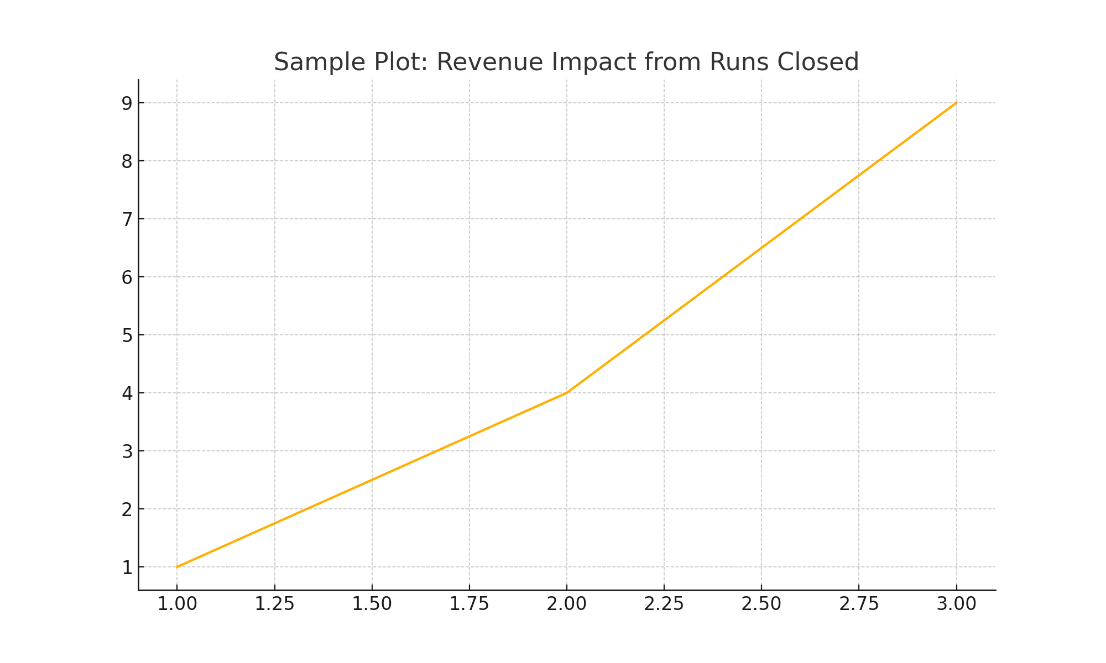
Figure: Sample revenue impact visualization used during scenario modeling.

