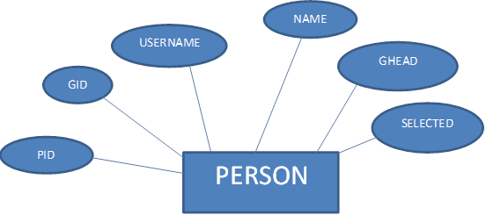

TRANSACTION DETAILS

TRANSACTION

PERFORM

USES

RATE

SELECTION

GROUP DETAILS

GROUP

IS IN

USES

SELECTS

CALCULATES

PERFORM

ACCOUNT DETAILS

BANK

HAS

USES

USER LOGIN DETAILS

USES