PROJECT REPORT ON

Collateral Pledging

Submitted in partial fulfilment of the requirements for
the award of the degree of

BACHELOR OF TECHNOLOGY
IN
COMPUTER SCIENCE AND ENGINEERING

OF
SASTRA UNIVERSITY

Submitted by

<name(Reg.No)> <name(Reg.No)>
(depending on group members you may add)


Under the Guidance of

Prof. <Guide name>

SASTRA UNIVERSITY, THANJAVUR

SCHOOL OF COMPUTING

SHANMUGHA

ARTS, SCIENCE, TECHNOLOGY & RESEARCH ACADEMY

(SASTRA UNIVERSITY)
(A University Established under section 3 of the UGC Act, 1956)

TIRUMALAISAMUDRAM

THANJAVUR – 613 401

April 2017
SCHOOL OF COMPUTING

SHANMUGHA

ARTS, SCIENCE, TECHNOLOGY & RESEARCH ACADEMY
(SASTRA UNIVERSITY)
(A University Established under section 3 of the UGC Act, 1956)

TIRUMALAISAMUDRAM, THANJAVUR – 613401

BONAFIDE CERTIFICATE

Certified that this project work entitled “<Title of the Project>” submitted to the Shanmugha Arts, Science, Technology & Research Academy (SASTRA University), Tirumalaisamudram-613401 by <name of the student(s) with Reg. No> in partial fulfilment of the requirements for the award of the degree of BACHELOR OF TECHNOLOGY IN COMPUTER SCIENCE AND ENGINEERING is the original and independent work carried out under my guidance, during the period December 2016 - April 2017.

INTERNAL GUIDE | ASSOCIATE DEAN
<Name of the guide in Capital Letter> | Dr. A. UMAMAKESWARI
SCHOOL OF COMPUTING | SCHOOL OF COMPUTING

Submitted for University Examination held on___________________

EXAMINER - I EXAMINER - II
SCHOOL OF COMPUTING

SHANMUGHA

ARTS, SCIENCE, TECHNOLOGY & RESEARCH ACADEMY
(SASTRA UNIVERSITY)
(A University Established under section 3 of the UGC Act, 1956)

TIRUMALAISAMUDRAM, THANJAVUR – 613401


DECLARATION

I/We submit this project work entitled “<Title of the project>” to the Shanmugha Arts, Science, Technology & Research Academy (SASTRA) University, Tirumalaisamudram–613 401, in partial fulfilment of the requirements for the award of the degree of BACHELOR OF TECHNOLOGY IN COMPUTER SCIENCE AND ENGINEERING and declare that it is our original and independent work carried out under the guidance of Prof. <Name of the guide>, School of Computing, SASTRA.

Date : | Name | : | Signature:
Place : | Reg. No:
 | Name | : | Signature:
 | Reg. No:

(You may add name & signature based on your team members)

ACKNOWLEDGEMENT

First and Foremost, we take pride in thanking the almighty to gave us strength for the successful completion of this project.

We have immense pleasure in expressing my heartfelt thanks to our Vice-Chancellor prof.R.Sethuraman for the benevolent advice and guidance during my tenure in the college.

We would like to express our gratitude to Dr.Balachandran, Registrar,SASTRA UNIVERSITY, for his benevolent guidance through-out my college life.

We wish to express our thanks to Dr.S.Vaidhyasubramanian, Dean of Planning and Development for his encouragement and providing us with all the needed amenities.

We would like to express our gratitude to Dr.P.Swaminathan, Dean , School of Computing,SASTRA UNIVERSITY, for his benevolent guidance through-out my college life.
We would like to express our gratitude to Dr.A.Umamakeshwari, Associate Dean , Computer Science and Engineering, School of Computing, SASTRA UNIVERSITY, for her benevolent guidance through-out my college life.
We wish to express our thanks to Prof. Kamakshi . S, Associate Professor Computer Science and Engineering, School of Computing, SASTRA UNIVERSITY for her encouragement and providing us with all the needed amenities.

we deeply thank our family and friends for supporting me in all the tasks that I have carried for the successful completion of this project.

TABLE OF FIGURES USED IN THIS PROJECT:

S.NO: | FIG.NO | NAME OF THE FIGURE: | PAGE NUMBER:
1 | FIG 4.1 | Block Diagram for LandMine Detection Robot controlled by Android
2 | FIG 4.2 | GPIO Pin Diagram for Raspberry pi controlled by Android
3 | FIG 4.3 | Block Diagram of L293D
4 | FIG 5.1 | Usecase Diagram for Robot controlled by Android application
5 | FIG 5.2(1) | Activity Diagram for LandMine Detection Robot
6 | FIG 5.2(2) | Activity Diagram for server driven model
7 | FIG 5.3 | Sequence Diagram for the sensor detection
8 | FIG 5.4 | Class Diagram for the developed autonomous robot
9 | FIG 5.5 | Collaboration Diagram for detecting landmine
10 | FIG 7.1 | Output Screen of Android Applicatin controlling Robot
11 | FIG 7.2 | Output Screen of Google Maps android application which retrieves path from source to destination

TABLE OF CONTENTS

S. No. | Title | Page No.
 | List of Tables  List of Figures  Acknowledgement  Abstract | Pages must be numbered in continuation from certificate page using Roman numerals for this section also.
1 | Introduction
2 | Problem Statement
3 | Literature Review / Literature
4 | Software, Hardware Requirement Specification
5 | Conceptual Model / Proposed Architecture
6 | Interaction Scenario
7 | Methodology and Approach
8 | Output/Results
9 | Conclusion
10 | References
11 | Appendix(If necessary)

TABLE OF CONTENTS

S. No. | Title | Page No.
ᵢ | Abstract
ᵢᵢ | Introduction
ᵢᵢᵢ | Problem Statement
ᵢᵥ | Literature Survey
ᵥ | Software, Hardware Requirement Specification
ᵥᵢ | Conceptual Model / Proposed Architecture
ᵥᵢᵢ | Interaction Scenario
ᵥᵢᵢᵢ | Methodology and Approach
ᵢᵪ | Output/Results
ᵪ | Conclusion
ᵪᵢ | References

1)ABSTRACT

The purpose of this project is to build a system that will allow clients to initiate their pledging process. Currently Clients are handling their own collateral funding and pledging process using various tools and platform. They use the one of the system to view securities that are available for pledging and releasing and use another tool to complete their pledging process by filling their shells (method used to classify the quality of securities).

The Client is now looking to be a fully disclosed client of Clearing house and will need to be able to perform their pledging process using the Clearing house systems. Client will be using the Front end screens to only see securities for pledging and releasing. Entitlements will be created and be available to client.

The data for pledging and releasing will be maintained for 10 years with the current open items. The Pledging Screen will be available 24/7. Action can only be taken on US business days 6 AM – 6 PM. During bank holidays, the screen will display the account holdings but no action can be taken from the screens.

2)INTRODUCTION

EXISTING SYSTEM:
DonorSnap provides you with tools to manage the pledge process from start to finish. A donation forecast report is available to help an organization try to estimate incoming receipts based upon initial pledge information. But the system is globally available and are not specific to the requirements of our client.

PROPOSED SYSTEM:
In the proposed system, we create a standalone pledger management for our clients. It is easy to create a Pledge within the system and then to apply subsequent donation receipts to the pledge. The system allows you to monitor the status of a specific pledge or to view all pledge activity as a whole on printed reports.

The main purpose is to create a Pledge Management page which is used by administrators and staff members to manage pledge records. From this page, you can view clients who have pledged to a specific fund, add and delete pledge records, view pledge details, and make adjustments to existing pledges. The organization administrator can see all funds and their associated pledges while staff members can see only those pledges associated with the funds they granted permission to access. Every clients will be having their own broker dealer and every dealer will have their own unique IBD(Broker Dealer ID). Using that IBD, clients can either pledge or release shares and securities.

3)PROBLEM STATEMENT

A Stock Pledge is nothing but a transfer of stocks against a debt. It is an agreement between the client and the bank. The debtor pledges the shares as an asset against the amount of money taken from a lender and promises to return the amount within specific period. The debtor pledges the stocks as a security against the debt. According to the law, after the payment of the obligation the bank in which stocks are ledged must return the stocks to the debtor and the agreement stands void.

In Early, it was very difficult to manage this pledge process for the individual clients. Many components are needed to check the status of the individual user’s pledge process. To view the pledge details, the client has to navigate to different modules which are tedious process. Since, many components are needed to check the status of the individual user’s pledge process, the convenience of the user and the response time is affected.

In order to overcome all the burden of the user, a single page is developed to fetch all the details from various components and displayed in the required format. User can specify their own requirements and can change the columns to be displayed. Every shares and securities associated with each banks for the particular broker id can be viewed with great ease. The pledging process can be scalable for existing and new client.

4)SOFTWARE/HARWARE REQUIREMENT SPECIFICATION

ESTABLISHING CONNECTION WITH BACKEND MAINFRAME SERVER FROM FRONT END USING PEELING AS MIDDLEWARE

4.1. HARDWARE REQUIREMENT SPECIFICATION:
4.1.1.Client Side:
The most common set of requirements defined by any operating system or software application is the physical computer resources, also known as hardware. A hardware requirement list is often accompanied by a Hardware Compatibility List (HCL), especially in case of operating systems. An HCL lists tested, compatible and sometimes incompatible hardware devices for a particular operating system or application.

Processor | Intel core 2 duo and advance
Speed | 2.0 GHz
Hard Disk Drive | 250 GB and above.
Operating System | Windows, linux
Memory | 2 GB RAM and above
System Type | 32,64 bit Operating System

4.1.2.Server Side:
Mainframe:
A Mainframe Computer is a high performance Multi User computer system which is the most scalable, available, reliable and secured machine in the world capable of performing some Million Instructions per second (up to 569,632 MIPS).

Characteristics:
1) Reliable single-thread performance
2) Maximum I/O connectivity
3) Maximum I/O bandwidth
4) Reliability, Availability & Serviceability (RAS)
5) Unbreakable Security & Scalability (USS)

Z13 Mainframe:
The z13 processor has faster I/O and the ability to address up to 10144 GiB of RAIM memory -- three times as much as its predecessor. It can house up to 168 processor units in a single system and run as many as 8,000 virtual servers.

At a maximum 5GHz, the z13's processor is slower in terms of clock speed than the chip in the z12, but IBM says it more than compensates for that with other improvements. The chip has eight cores compared with six for its predecessor, and it's manufactured on a newer, 22 nanometer process, which should mean smaller, faster transistors.

The z13 chip is IBM's first mainframe processor to incorporate simultaneous multi-threading, allowing it to execute two instructions in parallel on each clock cycle. SMT has long been offered on x86 chips and more recently with IBM's Power processors, but the company hasn't added SMT to its mainframe chips in the past because the zOS mainframe software isn't written to take advantage of it.

The z13 also gets support for SIMD (single instruction, multiple data), another parallel computing technology long supported by x86 chips, which should speed up the mainframe's analytics capabilities. Analytics also get a boost from DB2 BLU for Linux, an in-memory database technology now coming to the mainframe.

With the ability to have 10TB of memory with large memory frames/pages, the practice of bringing analytics to the data (rather than copying the data, via ETL, to the analytics) has more relevance than ever before. z13 is designed for cloud, mobile and advanced analytics capabilities, which is a function not only of speed but of design.

The z13 supports up to 8000 Linux images simultaneously for cloud computing. For the mobile economy the z13 does real-time encryption and can process 2.5 billion transactions per day. For the z13, IBM spent over 1 billion dollars and five years of development and with more than 500 new patents.

The following table shows the specifications of IBM z13 Mainframe:

Available | March 9,2015
Memory | Up to 10TB
Number Of Models | 5-NE1,NC9,N96,N63,N30
Channels | -PCIe Gen3 16GBps channel buses  -SIX CSSs, upto 85 LPARs  -4 Sub channels sets per CSS  -Flash Express
Operating Systems | z/OS, z/VM, z/VSE, z/TPF, Linux on z Systems

The above mentioned configuration of mainframe is of high level standards. Apart from that, the system can run under the following mainframes:
-Z/800
-Z/890
-Z9

4.2. SOFTWARE REQUIREMENTS SPECIFICATION:

1 ) npm and node js Installation

Node.js and npm are essential to modern web development with Angular and other platforms. Node powers client development and build tools. The npmpackage manager, itself a node application, installs JavaScript libraries.
Version:
node v4.x.x or higher
npm 3.x.x or higher

The versions of node and npm can be checked using following commands :
node -v
npm –v
Older versions produce errors.

After installing node and npm, the following steps are performed
- Create a project folder named quickstart.
- Clone the QuickStart seed into project folder.
- Install npm packages.
- Run npm start to launch the sample application.

git clone https://github.com/angular/quickstart.git quickstart
The above command is given in GIT bash console to clone the quickstart folder from the GitHub link. We can also download it separately and save it in a folder.
cd quickstart
Switch to the quickstart folder
npm install
Install all the packages necessary to run Angular JS 2 application
npm start
Once the command is executed, the npm server is started and https://localhost:3000 path is set by default.

Visual studio code editor
General structure

The following is the small snippet of code which is used to display the table in front end using Angular JS 2 technology:
app.component.js
angular.module('ngTableTutorial', ['ngTable'])
.controller('tableController', function ($scope, $filter, ngTableParams) {

$scope.records=/*data fetched from rest services*/;
$scope.usersTable = new ngTableParams({
page: 1,
count: 10
}, {
total: $scope.records.length,

getData: function ($defer, params)
{
$scope.data=params.sorting()? $filter('orderBy')($scope.records, params.orderBy()) : $scope.records;
$scope.data = $scope.data.slice((params.page() - 1) * params.count(), params.page() * params.count());
$defer.resolve($scope.data);
}
});
});

main.js
<div ng-controller="tableController">
<table ng-table="releaseTable" showfilter=”true” class="table table-striped">
<tr ng-repeat="row in data">
<td data-title="'CUSIP'" >
{{row.cusip}}
</td>
<td data-title="'SYMBOL'" >
{{row.symbol}}
</td>
<td data-title="'DESCRIPTION'" >
{{row.description}}
</td>
<td data-title="'RELEASE QUANTITY" >
{{row.release_quantity}}
</td>
<td data-title="'PLEDGE QUANTITY'">
{{row.pledge_quantity}}
</td>
<td data-title="'PLEDGE VALUE'" >
{{row.pledge_value}}
</td>
</td>
<td data-title="'PLEDGE BANK'" >
{{row.pledge_bank}}
</td>
</tr>
</table>
</div>

2)Interfacing Client FrontEnd and Server BackEnd Using Message Queuing
2)Interfacing and Client formation through Android Mobile Application
The PHP code which runs on Apache server controls the robot but it controls the bot based on the request rised by client(android).So, PHP backend is interfaced through android mobile application.
To develop Android mobile application ,first knowledge on android development environment like Android Studio and Eclipse is necessary. Eclipse is an Integrated Development Environment used to develop interface through which we send request to Apache server. Eclipse is an easy Ide through which application can be developed easily. Android development Tool and Android Standard Development Kit are to be installed on eclipse in order to run android libraries and functions in eclipse. In Android , XML is frontend which we see when we run the application and Java is the backend which processes all actions based on the inputs from xml.
In the application which is developed , there are four buttons start,stop,right,left, in xml which sends a unique request to Apache server running on PI. Onclicking each button a Java code module is executed, the following Java code is executed when we press back button and it establishes connection between Android and Apache server. Similarly, for each button a Java function is executed.
Java Code :

private void insertToDatabase1(String name, String add){

class SendPostReqAsyncTask extends AsyncTask<String, Void, String>
{
@Override
protected String doInBackground(String... params) {
String paramUsername = params[0];
String paramAddress = params[1];

try {
HttpClient httpClient = new DefaultHttpClient();
HttpPost httpPost = new HttpPost(
"http://192.168.81.103/index1.php?username=back");
HttpResponse response = httpClient.execute(httpPost);

HttpEntity entity = response.getEntity();

} catch (ClientProtocolException e) {

} catch (IOException e) {

}
return "success";
}

@Override
protected void onPostExecute(String result) {
super.onPostExecute(result);

Toast.makeText(getApplicationContext(), result, Toast.LENGTH_LONG).show();
TextView textViewResult = (TextView) findViewById(R.id.textViewResult);
textViewResult.setText("Back");
}
}
SendPostReqAsyncTask sendPostReqAsyncTask = new SendPostReqAsyncTask();
sendPostReqAsyncTask.execute(name, add);
}

In the above Java code module, insertToDatabase1 method is called on clicking back button.In this, there is SendPostReqAsyncTask class which extends AsyncTask class which is used to communicate with server. It uses HttpPost to post the request to server and receives HttpResponse and if it is successfully posted to a toast is prompted indicating that request is succeddfully posted.

3)Path retrieval between source and destination using Google Polyline concept

An android mobile application for path retrieval between source and destination developed based on Google Polyline concept. Android Studio IDE was utilized to develop this android mobile application. Android Studio is also an IDE like eclipse which is used to develop android applications easily.

Polylines were added in Google’s local maps which helps to retrieve path locally. To access Google maps and polylines in android mobile application following dependency is to be added in build.gradle file

compile 'com.google.android.gms:playservices:8.4.0'

After adding this dependency, Google maps can be accesed. Google play services must be installed in SDK manager to access Google’s services. User permissions are to be added in manifest file to access Internet and GPS location services in end-user phone. Following permissions are to be added in manifest file

<uses-permission android:name="com.karthik.mybot.permission.MAPS_RECEIVE" />
<uses-permission android:name="android.permission.ACCESS_NETWORK_STATE" />
<uses-permission android:name="android.permission.WRITE_EXTERNAL_STORAGE" />
<uses-permission android:name="com.google.android.providers.gsf.permission.READ_GSERVICES" />
<uses-permission android:name="android.permission.ACCESS_COARSE_LOCATION" />
<uses-permission android:name="android.permission.ACCESS_FINE_LOCATION" />

After adding above permissions to manifest file, user can access various services like GPS on phone. In front-end layout a GoogleMaps fragment is used on which we point source and destination. The path between the source and destination is acquired through Google Polyline from Java code for path retrieval.

Java Code

public List<List<HashMap<String,String>>> parse(JSONObject jObject){

List<List<HashMap<String, String>>> routes = new ArrayList<List<HashMap<String,String>>>() ;
JSONArray jRoutes = null;
JSONArray jLegs = null;
JSONArray jSteps = null;

try {

jRoutes = jObject.getJSONArray("routes");

for(int i=0;i<jRoutes.length();i++){
jLegs = ( (JSONObject)jRoutes.get(i)).getJSONArray("legs");
List path = new ArrayList<HashMap<String, String>>();

for(int j=0;j<jLegs.length();j++){
jSteps = ( (JSONObject)jLegs.get(j)).getJSONArray("steps");

for(int k=0;k<jSteps.length();k++){
String polyline = "";
polyline = (String)((JSONObject)((JSONObject)jSteps.get(k)).get("polyline")).get("points");
List<LatLng> list = decodePoly(polyline);

for(int l=0;l<list.size();l++){
HashMap<String, String> hm = new HashMap<String, String>();
hm.put("lat", Double.toString(((LatLng)list.get(l)).latitude) );
hm.put("lng", Double.toString(((LatLng)list.get(l)).longitude) );
path.add(hm);
}
}
routes.add(path);
}
}

} catch (JSONException e) {
e.printStackTrace();
}catch (Exception e){
}

return routes;
}

private List<LatLng> decodePoly(String encoded) {

List<LatLng> poly = new ArrayList<LatLng>();
int index = 0, len = encoded.length();
int lat = 0, lng = 0;

while (index < len) {
int b, shift = 0, result = 0;
do {
b = encoded.charAt(index++) - 63;
result |= (b & 0x1f) << shift;
shift += 5;
} while (b >= 0x20);
int dlat = ((result & 1) != 0 ? ~(result >> 1) : (result >> 1));
lat += dlat;

shift = 0;
result = 0;
do {
b = encoded.charAt(index++) - 63;
result |= (b & 0x1f) << shift;
shift += 5;
} while (b >= 0x20);
int dlng = ((result & 1) != 0 ? ~(result >> 1) : (result >> 1));
lng += dlng;
LatLng p = new LatLng((((double) lat / 1E5)),
(((double) lng / 1E5)));
poly.add(p);
}
return poly;
}

In the above Java Module there is a method Parse which is called from main activity and it returns a route object which is list of list of hashmaps. This Parse method indeed utilizes decode method to retrieve list of latitudes and longitudes .Decode method returns a poly object which is list of latitudes and longitudes. Using these two methods, path between source and destination is retrieved.

6) Conceptual Model / Proposed Architecture

BLOCK DIAGRAM:

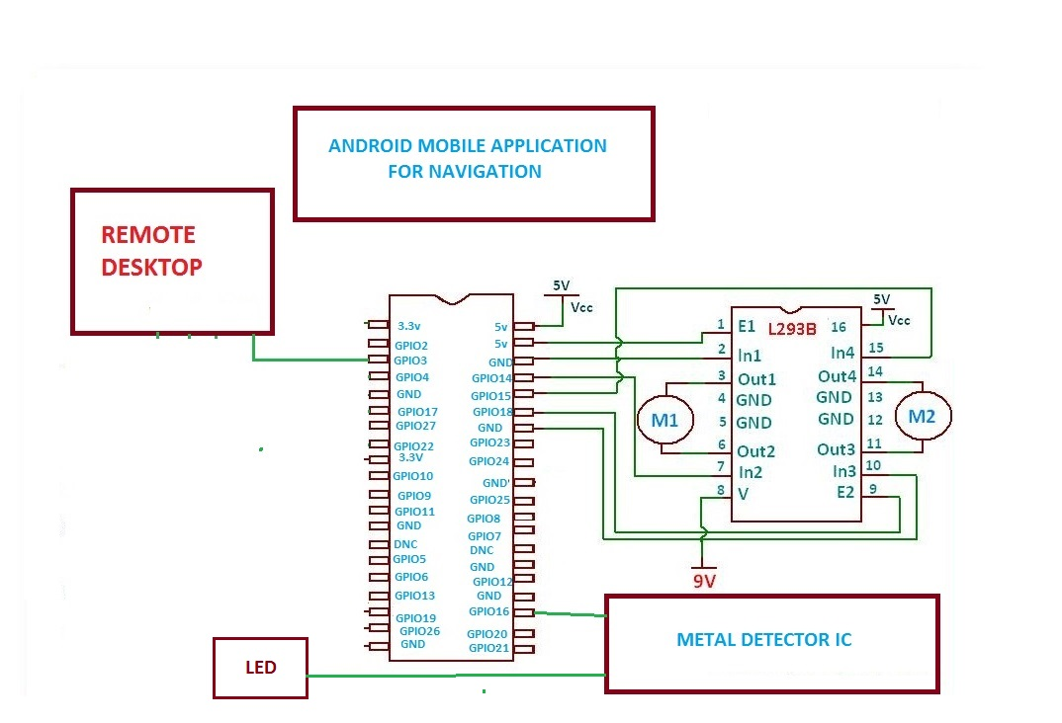
Fig 4.1: Block Diagram for LandMine Detection Robot controlled by Android

This figure represents the GPIO pins of the Raspberry pi, and the flow of the entire process that is going to taken part in our project.The pins will be given input from the mobile application then the GPIO pins wil respond accordingly and the motor drivers will be given the high signal, they will in turn move the motors and there by tyres.

GPIO PINS FOR RASPBERRY PIE:

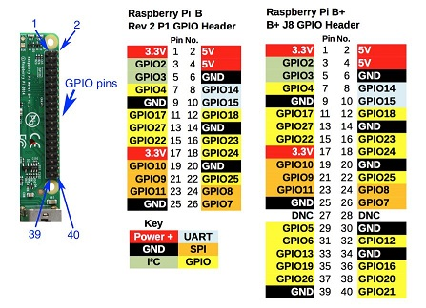
Fig 4.2:GPIO Pin Diagram for LandMine Detection Robot controlled by Android

This diagram shows the GPIO pins and the different pins that are embedded in the raspberry pi, mainly there are common and special keys, common keys are GPIO pins,ground and VCC of 5v and 3.3v. Special pins contains the power+,UART,GND,SPI,PC and also some kinds of GPIO.

FUCTIONAL BLOCK DIAGRAM OF L293D:

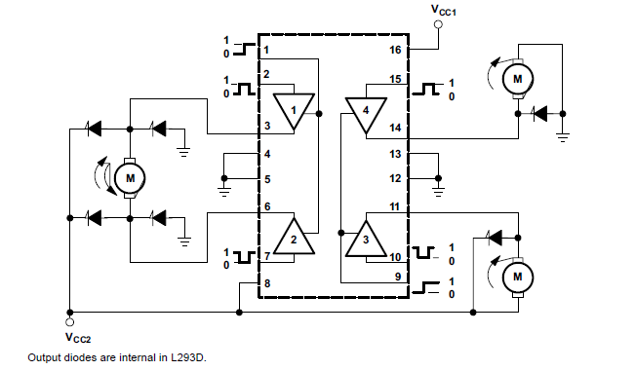

Fig 4.3: Block Diagram of L293D

The L293x have TTL-compatible readings and higher potential difference outputs for inductive load driving.

This is the functional diagram of the L293D block diagram that is used in this project.This figure shows us the different Gates that are used in the scratch of the integrated circuit of the L293D

7) Interaction Scenario:
USECASE DIAGRAM:

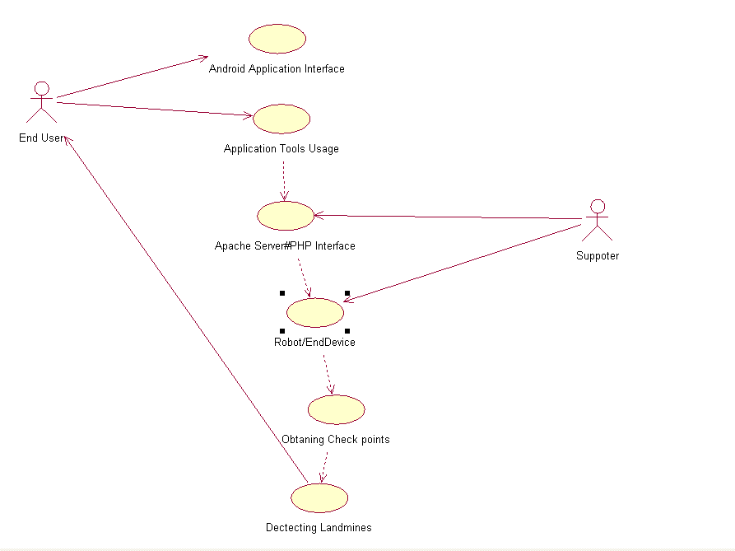
Fig 5.1: Usecase Diagram for LandMine Detection Robot controlled by Android

In this Usecase diagram, end-user is the actor who is interacting with the robot. This end-user interacts with the robot through android mobile application which acts as an interface to apache server php program.End-user gives input to the android application and this input is processed through php program in Apache Server. In Apache Server, as shown in Fig 5.1 several process flows occur and response is delivered to end-user.
After processing this data in PHP server,these inputs will be passed to raspberry pi processor, this in turn connects to L293D which drives the motor and moves along the path tracing all the check points from source to destination to detect landmines.
Usecase Diagram (Fig:5.1)Process flow:
1.End User to Application Interface
2.End User uses Application Tools
3.PHP server processes this inputs from Application Tool.
4.Processed Data to Raspberry pi.
5.Robot moves by Obtaining check points continuously.
6.Finally robot will detect landmines.
ACTIVITY DIAGRAM:

ACTIVITY DIAGRAM FOR APPLICATION TO APACHE SERVER

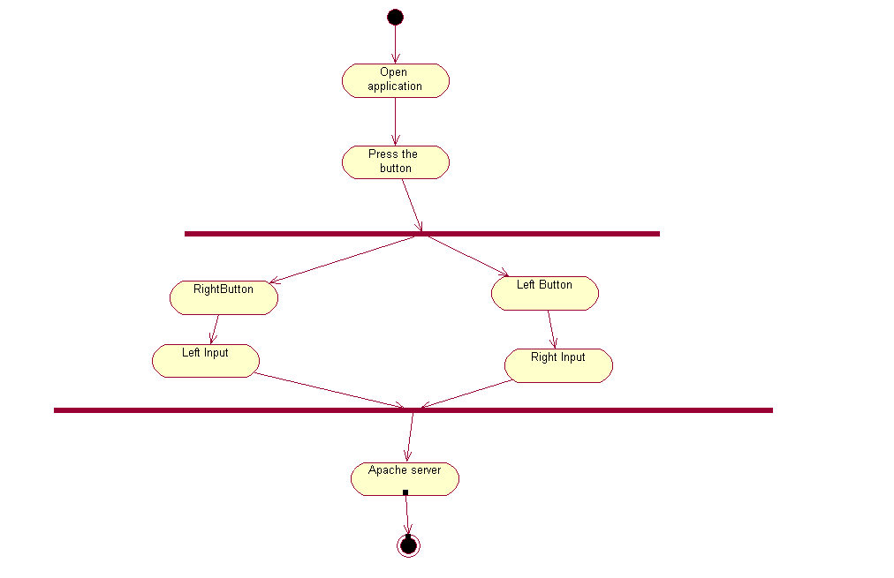
Fig 5.2(i): Activity Diagram for LandMine Detection Robot controlled by Android

In this Activity diagram, basic flow of process through which connection between android mobile application and server is explained. Android mobile application acts as an interface to apache server php program.End-user gives input to the android application and this input is processed through php program in Apache Server. In Apache Server, as shown in Fig 5.2(i) several process flows occur and response is delivered to end-user.
After processing this data in PHP server,these inputs will be passed to raspberry pi processor, this in turn connects to L293D which drives the motor and moves along the path tracing all the check points from source to destination to detect landmines.
Activity Diagram(Fig 5.2(i)) Process flow:
1.End-User to Application.
2.Pressing Particular Button.
3.If right button is pressed,robot moves in right direction.
4.If left button is pressed, robot moves in left direction.
5.If up button is pressed, robot moves in forward direction.
6.If down button is pressed, robot moves in downward direction.

ACTIVITY DIAGRAM FOR APACHE SERVER TO ROBOT ACTUATORS

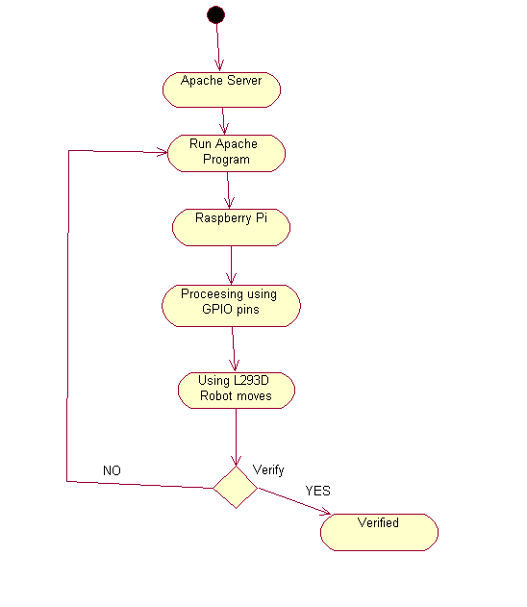
Fig 5.2(ii): Activity Diagram for LandMine Detection Robot controlled by Android
In this Activity diagram, basic flow of process through which connection between Apache Server and Robot is explained. The PHP program which runs on Apache Server receives request and process request .After processing the request, it sends a signal to motors through GPIO pins. Depending on the signal received from PHP program, bot is moved.
After processing this data in PHP server,these inputs will be passed to raspberry pi processor, this in turn connects to L293D which drives the motor and moves along the path tracing all the check points from source to destination to detect landmines
Activity Diagram(5.2) process flow:
1.End user to Apache Server.
2.Running program in Apache Server.
3.PHP Server data to Raspberry pi.
4.Raspberry pi includes GPIO pins.
5.Motor drives using L293D
SEQUENCE DIAGRAM:
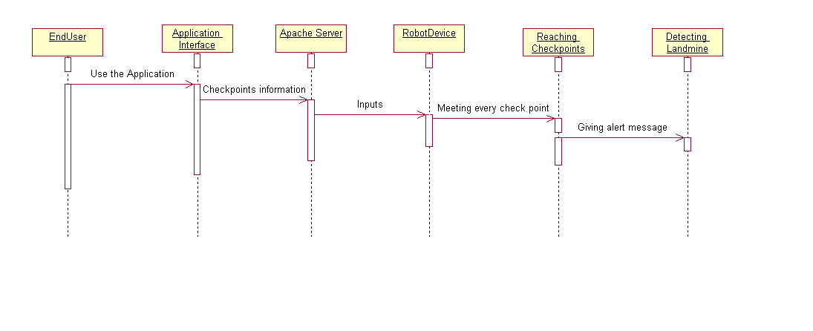
Fig 5.3:Sequence Diagram for LandMine Detection Robot controlled by Android
This sequence diagram explains process flow and interaction of processes in a sequence. It explains how input is taken at each stage and processed to next stage. It explains sequence of events through which entire process flow occurs. In the given diagram, process flow starts with end user interacting API and feeding input and this input is taken to server and processed in server. After the processing of input in server ,the signal is given to motors through GPIO pins .Then land mine detection event occurs. All these events occur in a sequence.
After processing this data in PHP server,these inputs will be passed to raspberry pi processor, this in turn connects to L293D which drives the motor and moves along the path tracing all the check points from source to destination to detect landmines
Sequence Diagram process flow:
1.End User to Application Interface
2.End User uses Application Tools
3.PHP server processes this inputs from Application Tool.
4.Processed Data to Raspberry pi.
5.Robot moves by Obtaining check points continuously.
6.Finally robot will detect landmines.

CLASS DIAGRAM:
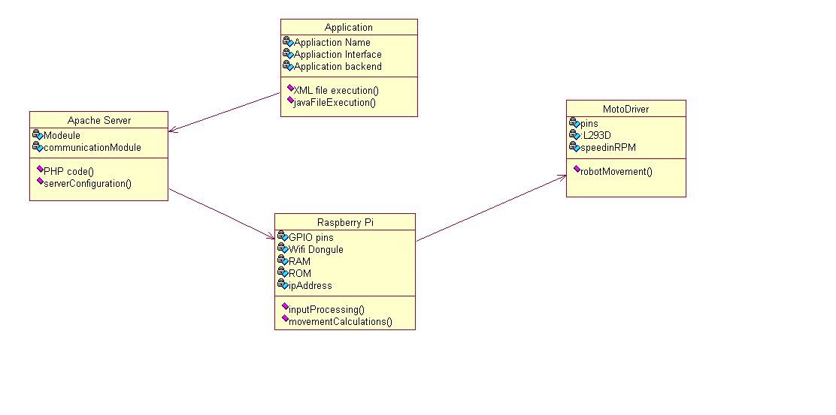
Fig 5.4: Class Diagram for LandMine Detection Robot controlled by Android
In the above class diagram, four classes Application, Apache Server, Raspberry Pi and Motor Driver are used. These four classes form main contents of project and help in achieving goals. Each class has several attributes which determines properties of class respectively. These classes interact with each other for successful functioning of bot.
Class Diagram Process Flow:
1.Application to Apache Server.
2.Class Diagrams contains Attributes and Functions.
EXAMPLE:
*Application contains attributes and functions as follows:
*Attributes:
*Application Name
*Application Interface
*Application Backend
*Functions:
*XML File Execution
*Java File Execution
3. In this way all the class Diagrams are linked :
Application to Apache.
Apache Server to Raspberry pi.
Raspberry pi to Motor Driver.

COLLABORATION DIAGRAM

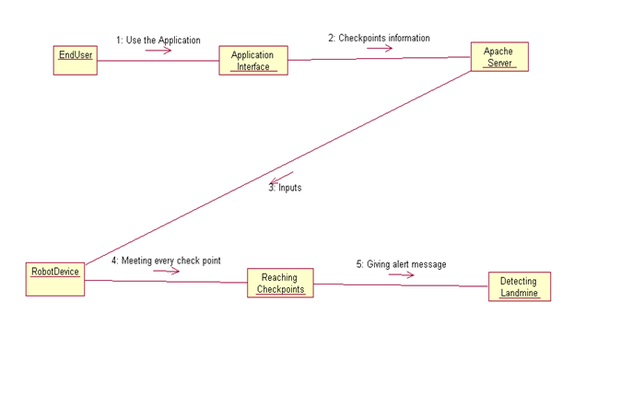
Fig 5.5: Collaboration Diagram for LandMine Detection Robot controlled by Android
This collaboration diagram describes how various objects are organized in the project. It also depicts communication between objects which send and receive messages. It describes dynamic behaviour of the system. In the above diagram, various objects like end-user, Apache sever interact with each other transferring system messages which help in successful functioning of the system.
In collaboration Diagram of this project explains about the way of process flow with Arrow marks having inputs to next object.
Process Flow:
1.End User will use the application interface.
2.Application Interface will give check point information.
3.Apache Server will give inputs to Robot Device.
4.Robot Device will meet all the check points in the path.
5.Finally Landmines will be detected by giving Alert message.

8) Methodology and Approach:
Module No. 1: Assembling Robot and Integrating with Remote Desktop
Assembled a robot which has raspberry pi Micro-Controller, operated through the remote desktop connection with a client server connection through the static IP of the raspberry pi. Raspberry pi consists external memory interface in which we load Raspbian operating system useful for accessing the files that are loaded into the Micro-controller. Input is given from the connected desktop to controller board, which sends the necessary signal to the actuators (motors) depending on the input received. Establishing remote desktop connection is done by setting up a local area network connection, both the raspberry pi and desktop are connected to the LAN. The raspbian operating system is loaded into the desktop for accessing, executing the functions of the robot.

Module No. 2: Integrating Mobile with the Robot for getting the GPS location and Controlling the Robot Movement along the required checkpoints
In this phase of project, we interface the robot with android application deployed in a Mobile. The android application use the Google’s polyline line concept for navigation.The application makes use of Google maps and determines a path between two places. Along the path obtained from it, more number of check points are created and the robot is made to trace through those check points for detecting the landmine.

Module No. 3: Integrating Metal Detector with the Robot and Sending SMS to the End-User upon detection of Landmines.
In this phase of project, we attach a landmine detection module (metal detector IC) to the robot. In the location where landmine gets detected an interrupt is generated and sent to raspberry pi controller which in-turn sends a signal to android application. Android application receives this signal from raspberry pi and sends corresponding location to end-user as a SMS.

In this, a client-server model is used between Robot and Android Mobile application. Apache Server which acts as a server and Android mobile application acts as a client which sends requests to the server which are processed on the server and based on the processing of request , a signal is generated and sent to motors of the robot through GPIO pins. Motors help in the rotation of the wheel based on the signal received.

Apache Server :
Apache Server is a leight-weight server which can respond to client requests very quickly. In this project , client is android mobile application which connects to this server and communicates information.

To develop Android mobile application, first knowledge on android development environment like Android Studio and Eclipse is necessary.
ANDROID STUDIO :
Android Studio is the official IDE for Android app Development, here we will do application for our project which controls the bot by giving inputs as check points along the source to destination path. Each project in Android Studio contains one or more modules with source code files and resource files. Different types of modules include:
1. Android app modules
2. Test modules
3. Library modules
4. App Engine modules
By using above tools, Successful functioning of robot is achieved and user can control the robot effectively.

9) Output/Results:

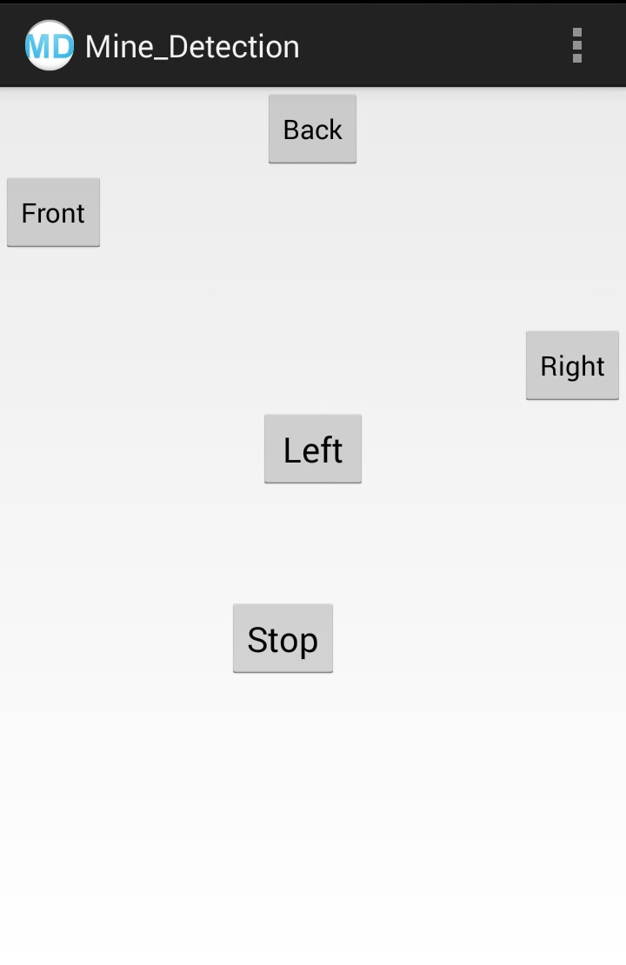
Fig 7.1 : Output Screen of Android Applicatin controlling Robot

In the above Fig 7.1 : output screen of android mobile application controlling robot is shown. It contains five buttons Front,Back,Right,Left and Stop respectively. It sends request to apache server based on the button clicked. Request is processed in Apache Server based on the command received.

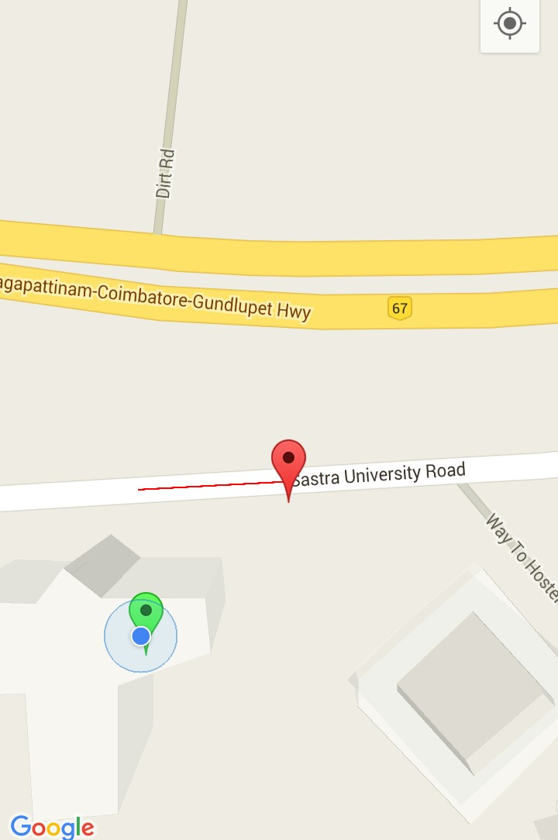
Fig 7.2 : Output Screen of Google Maps android application which retrieves path from source to destination
In the above output screen, path between source is destination is shown through red colour polyline. Green colour is source and red colour is destination.
10) Conclusion:

Thus, the main aim of building an android driven bot is to provide a completely autonomous robot for the detection of the land mines without any casualities is achieved.This robot can be used in the military applications where the risk for the human life will be more.These completely autonomous robots will provide a secure authentication since the LAN connected by the devices are completely in the private network.The developed project will be used in vast areas, not only in this land mind detection. This autonomous robot can be used for deep diving and also for the other applications.Our proposed system is the low cost product with in the 6000-7000 rupees of the components,where as in the existing system they are using the costly products which are not needed for the basic functions.

11) References:
REFERENCE:

Yuanliang Zhang, Dong Pyo Hong, “Navigation of mobile robot using Low-cost GPS” in International Journal of Precision Enginee… (2015),.

