Anupam Baral
Sunwal, Nepal | +977 9767606302
baralanupam111@gmail.com
https:// www.linkedin.com/in/ gomugomucode

Date: May 21, 2026

To,
The Hostmaster
Mercantile Communications Pvt. Ltd.
Durbar Marg, Kathmandu
Nepal

Subject: Request for Registration of anupambaral.info.np

Dear Sir/Madam,

I am writing to kindly request the registration of the domain anupambaral.info.np for my personal website. As required for .np domain registration, I have attached a copy of my citizenship for verification.

The domain name corresponds to my full legal name, making it suitable for personal use under the .com.np category. I intend to use this domain to host my personal website, which will help me present my professional profile, portfolio, and future projects. I understand the guidelines for .np domain registration and have ensured that all required information and documents are complete

I would sincerely appreciate your kind approval of my request. Thank you very much for your time and kind consideration.

Sincerely,
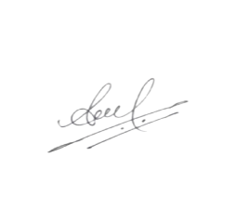
Anupam Baral

