image1603289567277.pngimage1603289567279.pngimage1603289567281.pngimage1603289567283.pngimage1603289567285.pngimage1603289567286.pngimage1603289567288.pngimage1603289567289.pngimage1603289567291.pngimage1603289567291.pngimage1603289567293.pngimage1603289567294.pngimage1603289567296.pngimage1603289567298.pngimage1603289567299.pngimage1603289567300.pngimage1603289567301.pngimage1603289567302.pngimage1603289567303.pngimage1603289567304.pngimage1603289567305.pngimage1603289567307.pngimage1603289567307.pngimage1603289567309.pngimage1603289567309.pngimage1603289567310.pngimage1603289567311.pngimage1603289567312.pngimage1603289567313.pngimage1603289567314.pngimage1603289567314.pngimage1603289567315.pngimage1603289567316.pngimage1603289567317.pngimage1603289567317.pngimage1603289567318.pngimage1603289567319.pngimage1603289567320.pngimage1603289567321.pngimage1603289567322.pngimage1603289567323.pngimage1603289567324.pngimage1603289567325.pngimage1603289567326.pngimage1603289567327.pngimage1603289567328.pngimage1603289567329.pngimage1603289567330.pngimage1603289567330.pngimage1603289567331.pngimage1603289567332.pngimage1603289567333.pngimage1603289567333.pngimage1603289567334.pngimage1603289567335.pngimage1603289567335.pngimage1603289567336.pngimage1603289567337.pngimage1603289567338.pngimage1603289567339.pngimage1603289567340.pngimage1603289567342.pngimage1603289567343.pngimage1603289567344.pngimage1603289567345.pngimage1603289567346.pngimage1603289567347.pngimage1603289567348.pngimage1603289567349.pngimage1603289567349.pngimage1603289567350.pngimage1603289567351.pngimage1603289567351.pngimage1603289567352.pngimage1603289567353.pngimage1603289567354.pngimage1603289567355.pngimage1603289567356.pngimage1603289567356.pngimage1603289567357.pngimage1603289567358.png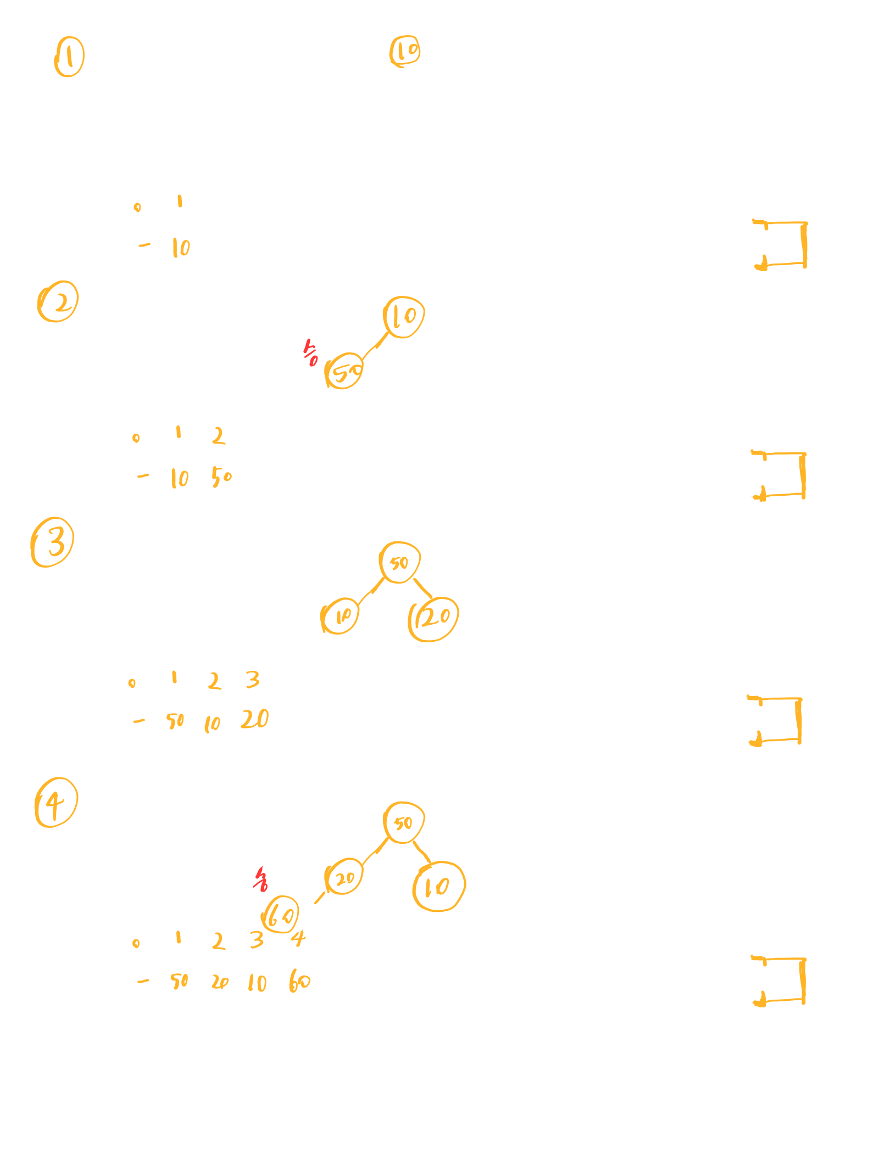

image1603289567695.pngimage1603289567697.pngimage1603289567698.pngimage1603289567699.pngimage1603289567700.pngimage1603289567701.pngimage1603289567702.pngimage1603289567702.pngimage1603289567703.pngimage1603289567704.pngimage1603289567705.pngimage1603289567706.pngimage1603289567706.pngimage1603289567707.pngimage1603289567708.pngimage1603289567709.pngimage1603289567710.pngimage1603289567710.pngimage1603289567711.pngimage1603289567712.pngimage1603289567713.pngimage1603289567714.pngimage1603289567716.pngimage1603289567718.pngimage1603289567718.pngimage1603289567720.pngimage1603289567721.pngimage1603289567722.pngimage1603289567722.pngimage1603289567723.pngimage1603289567724.pngimage1603289567724.pngimage1603289567725.pngimage1603289567726.pngimage1603289567726.pngimage1603289567727.pngimage1603289567728.pngimage1603289567729.pngimage1603289567730.pngimage1603289567731.pngimage1603289567732.pngimage1603289567732.pngimage1603289567734.pngimage1603289567735.pngimage1603289567736.pngimage1603289567737.pngimage1603289567738.pngimage1603289567739.pngimage1603289567740.pngimage1603289567741.pngimage1603289567742.pngimage1603289567743.pngimage1603289567744.pngimage1603289567745.pngimage1603289567746.pngimage1603289567747.pngimage1603289567748.pngimage1603289567749.pngimage1603289567749.pngimage1603289567750.pngimage1603289567751.pngimage1603289567752.pngimage1603289567753.png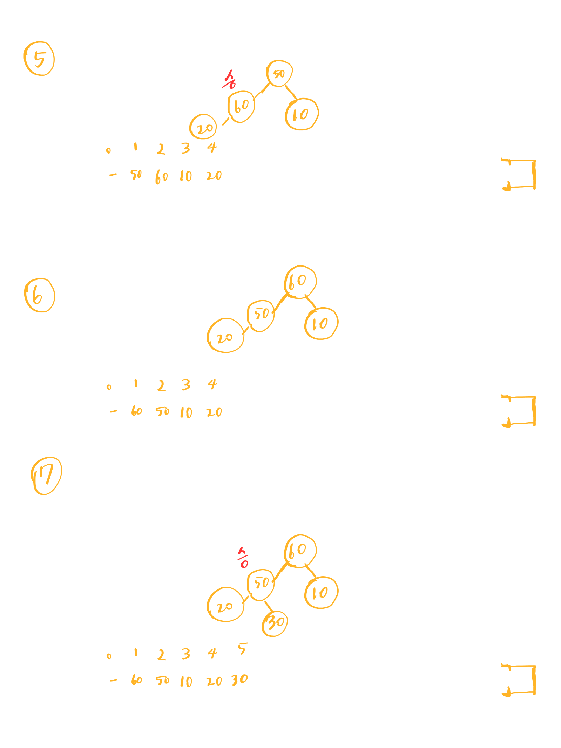

image1603289568052.pngimage1603289568053.pngimage1603289568055.pngimage1603289568055.pngimage1603289568057.pngimage1603289568057.pngimage1603289568058.pngimage1603289568059.pngimage1603289568059.pngimage1603289568060.pngimage1603289568061.pngimage1603289568061.pngimage1603289568062.pngimage1603289568063.pngimage1603289568063.pngimage1603289568064.pngimage1603289568065.pngimage1603289568066.pngimage1603289568066.pngimage1603289568067.pngimage1603289568068.pngimage1603289568069.pngimage1603289568070.pngimage1603289568071.pngimage1603289568072.pngimage1603289568073.pngimage1603289568074.pngimage1603289568074.pngimage1603289568075.pngimage1603289568076.pngimage1603289568076.pngimage1603289568077.pngimage1603289568078.pngimage1603289568078.pngimage1603289568079.pngimage1603289568080.pngimage1603289568081.pngimage1603289568081.pngimage1603289568082.pngimage1603289568083.pngimage1603289568083.pngimage1603289568084.png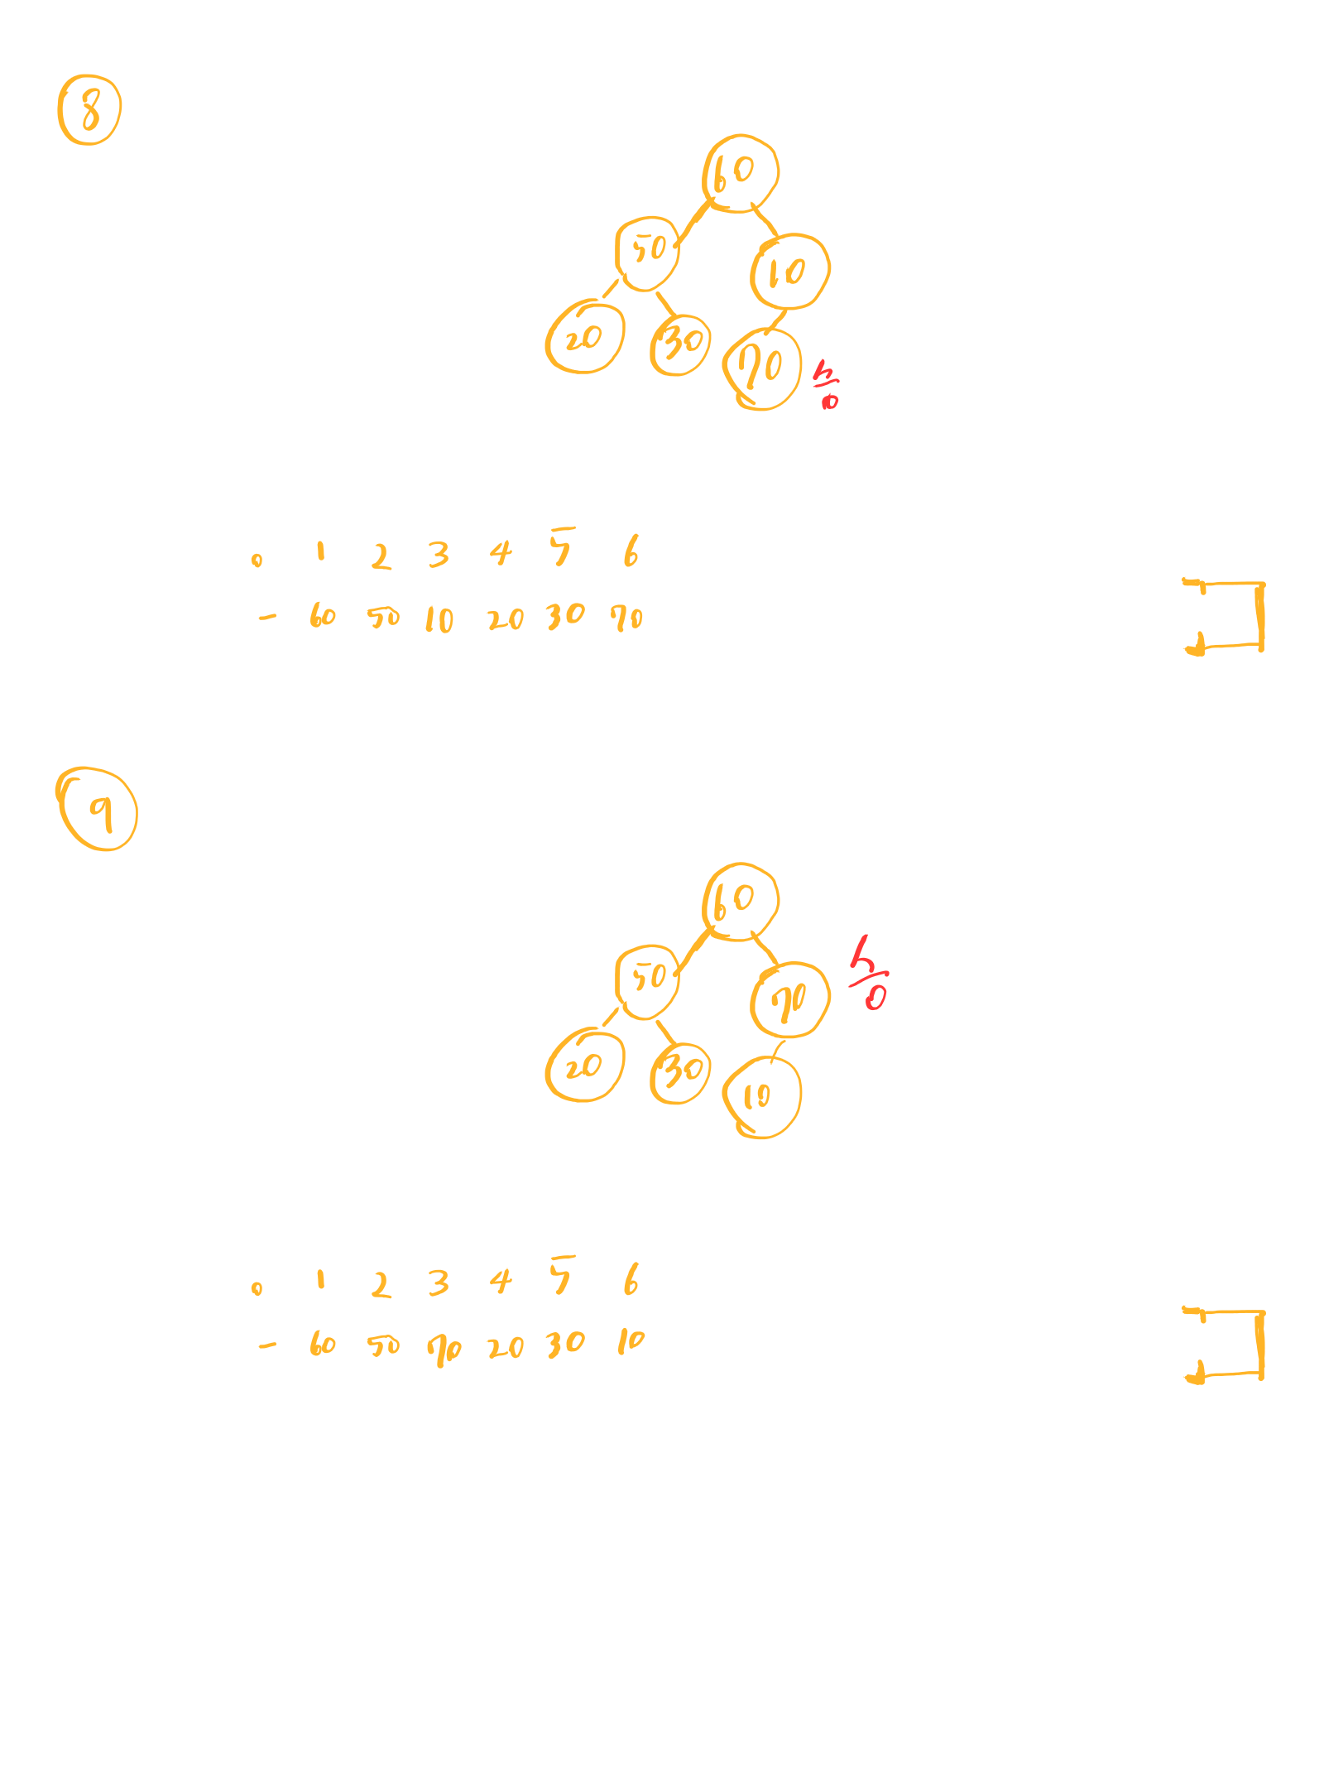

image1603289568371.pngimage1603289568372.pngimage1603289568374.pngimage1603289568374.pngimage1603289568376.pngimage1603289568377.pngimage1603289568377.pngimage1603289568378.pngimage1603289568378.pngimage1603289568379.pngimage1603289568380.pngimage1603289568381.pngimage1603289568381.pngimage1603289568382.pngimage1603289568383.pngimage1603289568383.pngimage1603289568384.pngimage1603289568385.pngimage1603289568385.pngimage1603289568386.pngimage1603289568387.pngimage1603289568388.pngimage1603289568389.pngimage1603289568390.pngimage1603289568391.pngimage1603289568392.pngimage1603289568393.pngimage1603289568394.pngimage1603289568394.pngimage1603289568395.pngimage1603289568396.pngimage1603289568396.pngimage1603289568397.pngimage1603289568398.pngimage1603289568398.pngimage1603289568399.pngimage1603289568400.pngimage1603289568400.pngimage1603289568401.pngimage1603289568402.pngimage1603289568402.pngimage1603289568403.png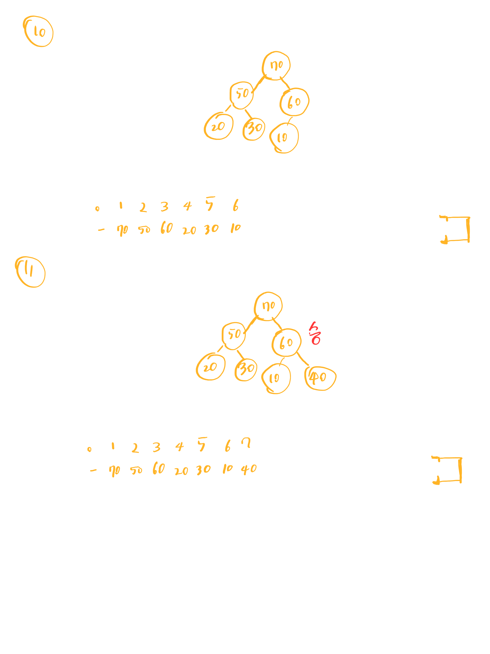

image1603289568723.pngimage1603289568724.pngimage1603289568725.pngimage1603289568726.pngimage1603289568727.pngimage1603289568728.pngimage1603289568729.pngimage1603289568729.pngimage1603289568730.pngimage1603289568730.pngimage1603289568731.pngimage1603289568732.pngimage1603289568732.pngimage1603289568733.pngimage1603289568734.pngimage1603289568734.pngimage1603289568735.pngimage1603289568736.pngimage1603289568736.pngimage1603289568737.pngimage1603289568737.pngimage1603289568739.pngimage1603289568740.pngimage1603289568741.pngimage1603289568742.pngimage1603289568743.pngimage1603289568744.pngimage1603289568744.pngimage1603289568745.pngimage1603289568745.pngimage1603289568746.pngimage1603289568747.pngimage1603289568747.pngimage1603289568748.pngimage1603289568749.pngimage1603289568749.pngimage1603289568750.pngimage1603289568751.pngimage1603289568751.pngimage1603289568752.pngimage1603289568753.pngimage1603289568753.png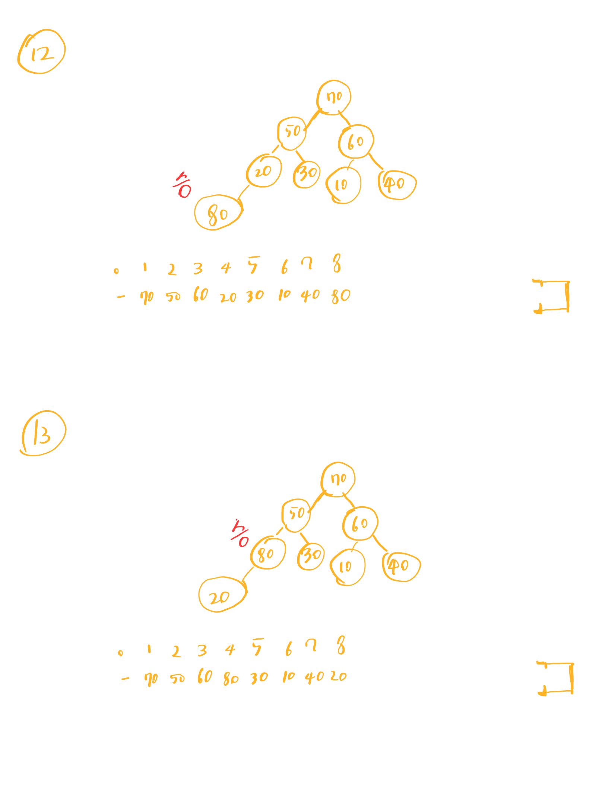

image1603289569080.pngimage1603289569081.pngimage1603289569082.pngimage1603289569083.pngimage1603289569084.pngimage1603289569085.pngimage1603289569085.pngimage1603289569086.pngimage1603289569087.pngimage1603289569087.pngimage1603289569088.pngimage1603289569088.pngimage1603289569089.pngimage1603289569090.pngimage1603289569090.pngimage1603289569091.pngimage1603289569092.pngimage1603289569092.pngimage1603289569093.pngimage1603289569093.pngimage1603289569094.pngimage1603289569095.pngimage1603289569096.pngimage1603289569098.pngimage1603289569098.pngimage1603289569100.pngimage1603289569100.pngimage1603289569101.pngimage1603289569101.pngimage1603289569102.pngimage1603289569103.pngimage1603289569103.pngimage1603289569104.pngimage1603289569105.pngimage1603289569105.pngimage1603289569106.pngimage1603289569107.pngimage1603289569107.pngimage1603289569108.pngimage1603289569109.pngimage1603289569109.pngimage1603289569110.png