image1603289583430.pngimage1603289583432.pngimage1603289583434.pngimage1603289583435.pngimage1603289583437.pngimage1603289583437.pngimage1603289583438.pngimage1603289583439.png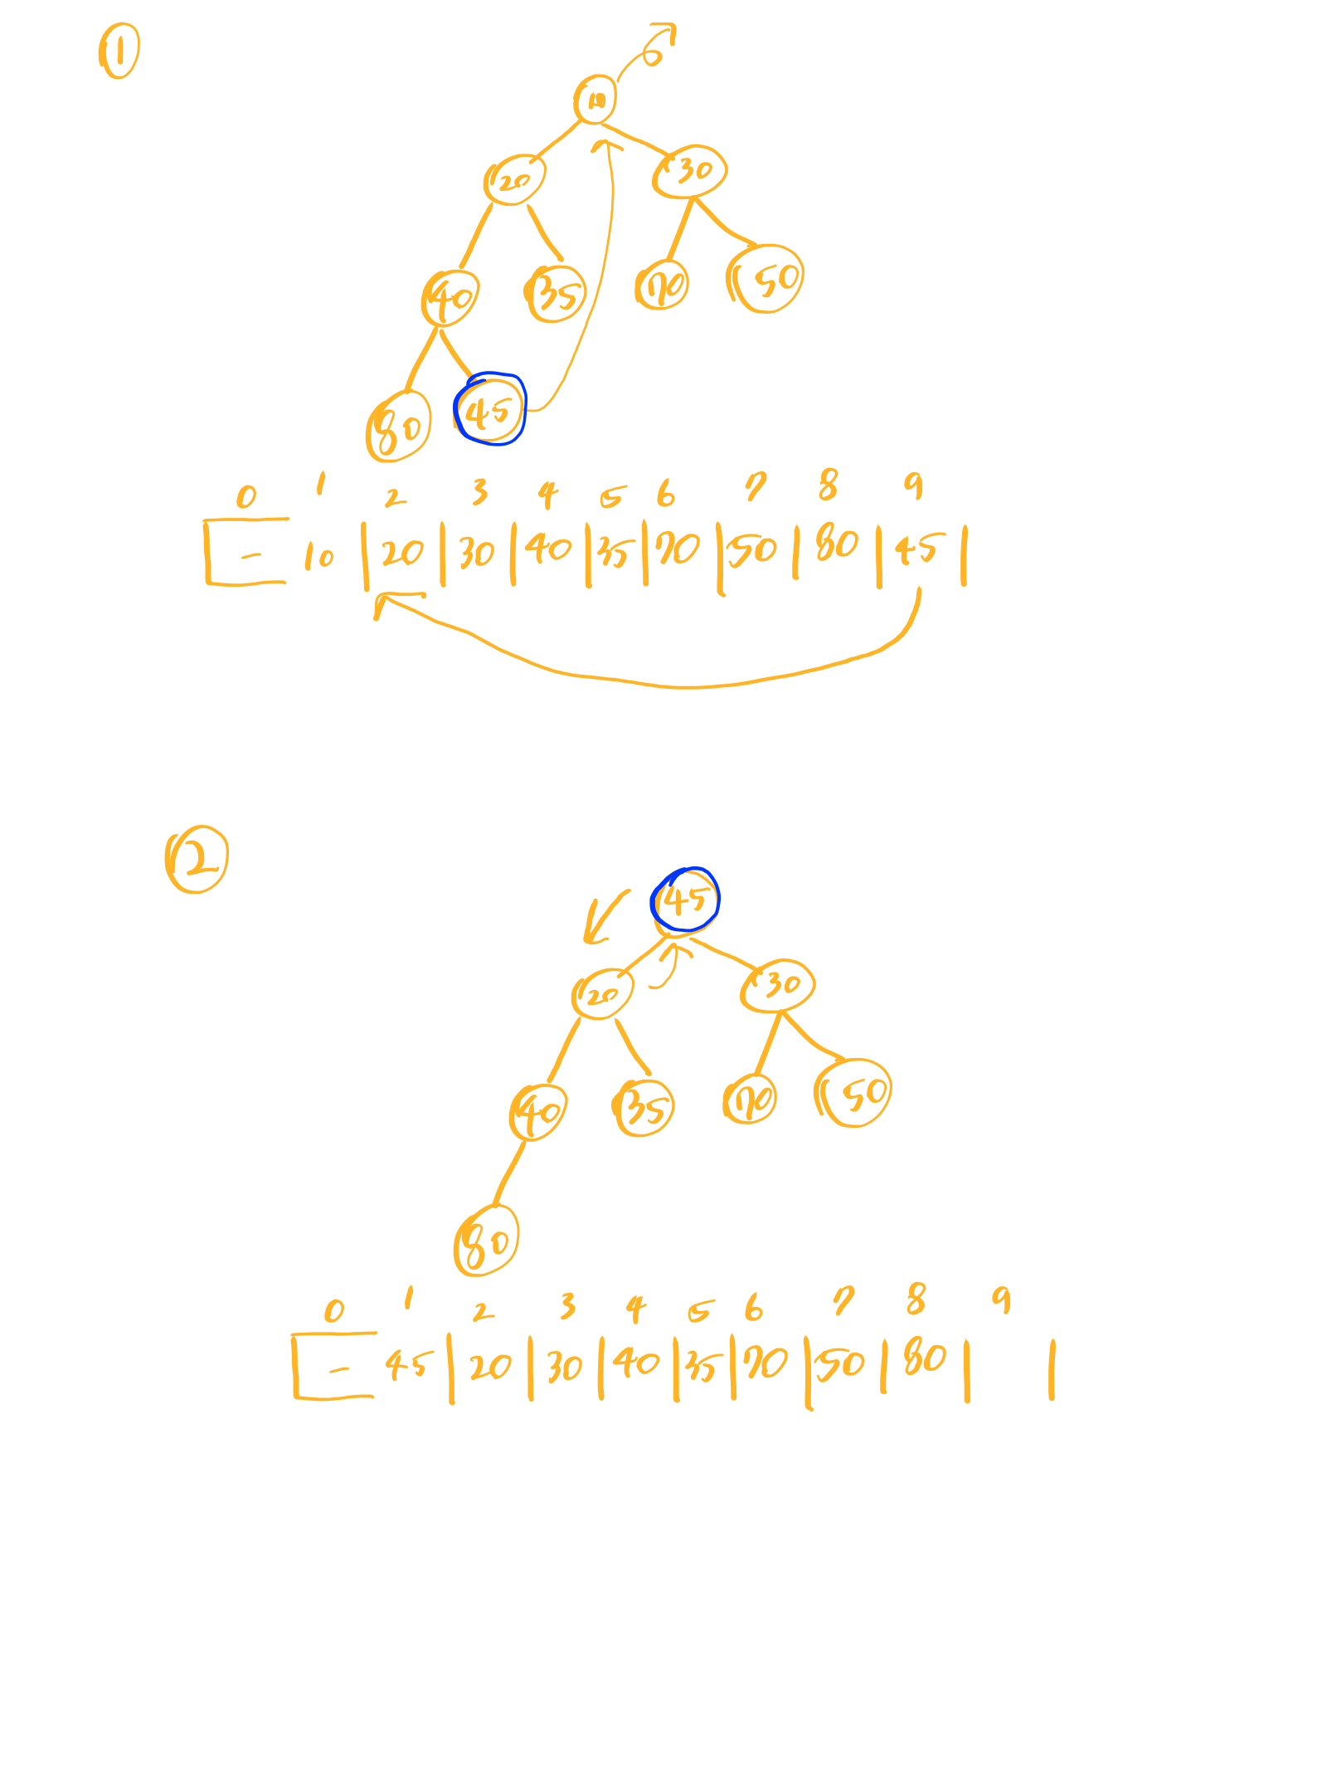

image1603289583766.pngimage1603289583767.pngimage1603289583768.pngimage1603289583769.pngimage1603289583770.pngimage1603289583771.pngimage1603289583772.pngimage1603289583773.png