Indoor Plant & Pet Advisor
Product Use Cases, AI Reference Architecture, MCP Integrations and Evaluation Strategy
Version 1.0 | Prepared September 2026
Purpose Define a measurable product and a production-oriented architecture that helps a person moving within the United States choose exactly one category—an indoor plant, a dog or a cat—and then make a responsible, evidence-backed purchase or adoption decision.

Audience: Product leadership, engineering, architecture, data/AI, security, quality engineering and operations teams.

1. Executive Summary
The application delivers personalized recommendations based on destination ZIP code, home environment, household, lifestyle, experience, budget and care capacity. It returns up to three qualified matches, explains the score, identifies nearby purchasing or adoption sources, and produces an actionable care plan.
Architecture decision Use a hierarchical Supervisor–Specialist LangGraph architecture with deterministic category routing, typed shared state, restricted MCP tools and an evaluator–optimizer gate. Only the Plant, Dog or Cat specialist selected by the user runs in a session.

- React provides the guided questionnaire and recommendation experience.
- FastAPI provides application APIs and acts as the MCP host/client.
- PostgreSQL is the authoritative system of record; Pinecone provides dense+sparse hybrid retrieval over curated knowledge.
- LangChain supplies model, retriever and tool integrations; LangGraph owns orchestration, state and checkpoints.
- Mem0 stores only consented long-term preferences, not authoritative or transactional records.
- You.com and domain-specific MCP servers add current web, place, climate and adoption data.
- LangSmith traces the graph and supports offline experiments, sampled online evaluation, dashboards and alerts.
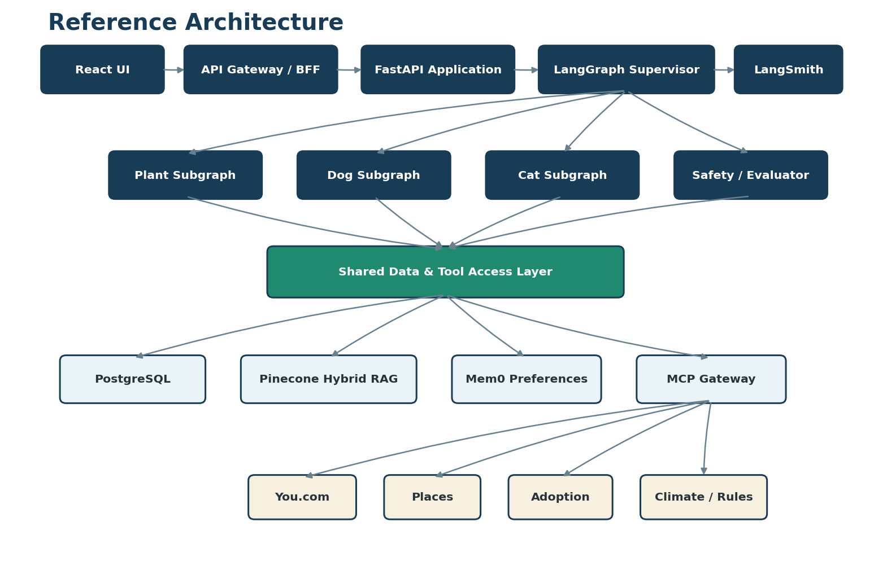
Figure 1. Recommended reference architecture

2. Product Definition and Scope

2.1 Product objective
Help a person moving to or recently arriving in a U.S. state choose an indoor plant, dog or cat that fits the new location and household, find a responsible source, and understand the ongoing effort and cost before committing.

2.2 Primary actor and stakeholders
Role | Need or responsibility
Prospective owner | Accurate, understandable and local recommendations.
Product owner | Measurable adoption, usefulness, safety and conversion outcomes.
Content curator / expert reviewer | Approve sources, safety facts and content versions.
Operations | Monitor availability, latency, cost and failures.
Security/privacy | Protect identity, location, preferences and API credentials.
Shelter, rescue or retailer | Provide current, correctly represented availability.

2.3 Scope
MVP includes | Not in initial MVP
All 50 states and Washington, D.C.; ZIP-based location | Direct purchasing, payment or shipping
One active category per session | Veterinary diagnosis or emergency guidance
Top-three personalized matches and explanations | Guaranteed temperament, health or plant survival
Nearby stores, shelters and rescues | Automated adoption approval
Care plans, costs, saved recommendation and feedback | Unconfirmed inventory represented as available
100+ plant, 50+ dog-profile and 30+ cat-profile records | Open-ended autonomous browsing without source controls

3. Business Rules
- A recommendation session contains exactly one category: PLANT, DOG or CAT.
- Changing category requires confirmation and either saves or clears current progress.
- The initial result contains no more than three primary recommendations.
- Every result includes a 0–100 score, at least three positive reasons and relevant concerns.
- A candidate below 60 cannot be labeled Best Match.
- Plant results disclose toxicity to children, cats and dogs.
- Pet results consider housing rules, household composition, time alone, activity, grooming and affordability.
- Shelters and rescues are prioritized for pet discovery. Source type is always labeled.
- Prices, inventory and adoption availability include a last-verified timestamp and confidence label.
- The LLM explains results but cannot override deterministic safety exclusions.
- Health and legal information is general guidance and must cite authoritative sources.
- The system records prompt, graph, source and model versions for auditability.
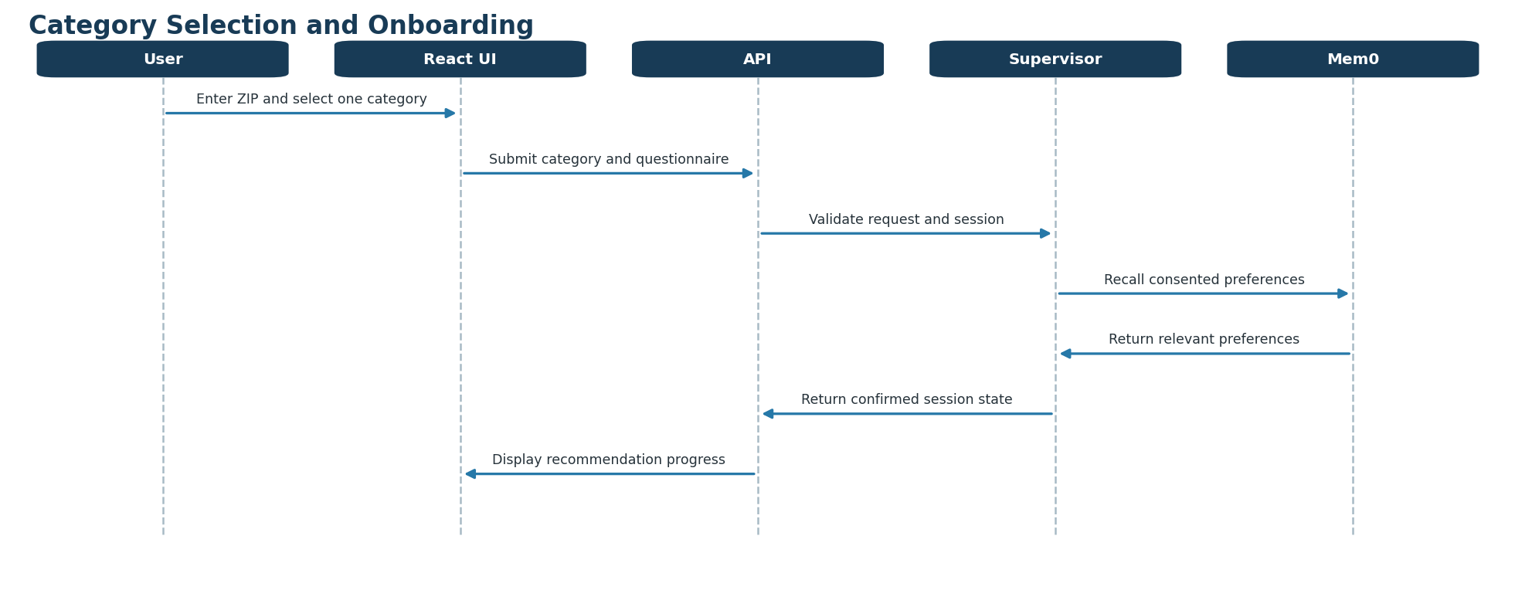
Figure 2. Category selection and onboarding sequence

4. Use-Case Model
ID | Use case | Primary outcome
UC-01 | Start recommendation session | Valid location, one category and complete questionnaire.
UC-02 | Recommend indoor plants | Top-three safe, suitable plants and placement/care guidance.
UC-03 | Recommend a dog profile | Top-three suitable profiles plus current adoption candidates.
UC-04 | Recommend a cat profile | Top-three suitable profiles plus current adoption candidates.
UC-05 | Find local source or service | Nearby sources with type, distance and verification state.
UC-06 | View detailed care guidance | Evidence-backed maintenance requirements and costs.
UC-07 | Save and manage care plan | Confirmed schedule persisted for the user.
UC-08 | Provide feedback | Feedback linked to recommendation and trace versions.
UC-09 | Refresh knowledge | Approved, evaluated content promoted to Pinecone.
UC-10 | Evaluate and monitor quality | Release and production quality measured continuously.

4.1 UC-01 — Start a recommendation session
Attribute | Definition
Trigger | User selects Find My Match.
Preconditions | Destination ZIP/state available; user accepts required terms.
Inputs | Location, exactly one category and category-specific questionnaire.
Postcondition | A valid typed session is ready for routing.
Failure handling | Show field-level validation; preserve non-sensitive progress.

- Enter destination ZIP code or select state.
- Select Indoor Plant, Dog or Cat.
- Display only the selected questionnaire.
- Validate required answers and normalize values.
- Load consented preferences from Mem0 and ask before applying conflicting values.
- Create a session and start the appropriate workflow.

4.2 UC-02 — Recommend an indoor plant
Inputs include window direction, measured or estimated light, humidity, room, available space, indoor temperature, care experience, watering availability, budget, children and existing pets.
Result field | Required content
Identity | Common and scientific name.
Fit | Score, matching reasons and challenges.
Placement | Room, window direction, distance and light level.
Care | Watering trigger/frequency, fertilizer, pruning, cleaning and repotting.
Safety | Child, dog and cat toxicity plus source.
Risk | Common pests, disease indicators and corrective actions.
Cost/source | Initial/monthly cost and up to three local or online sources.

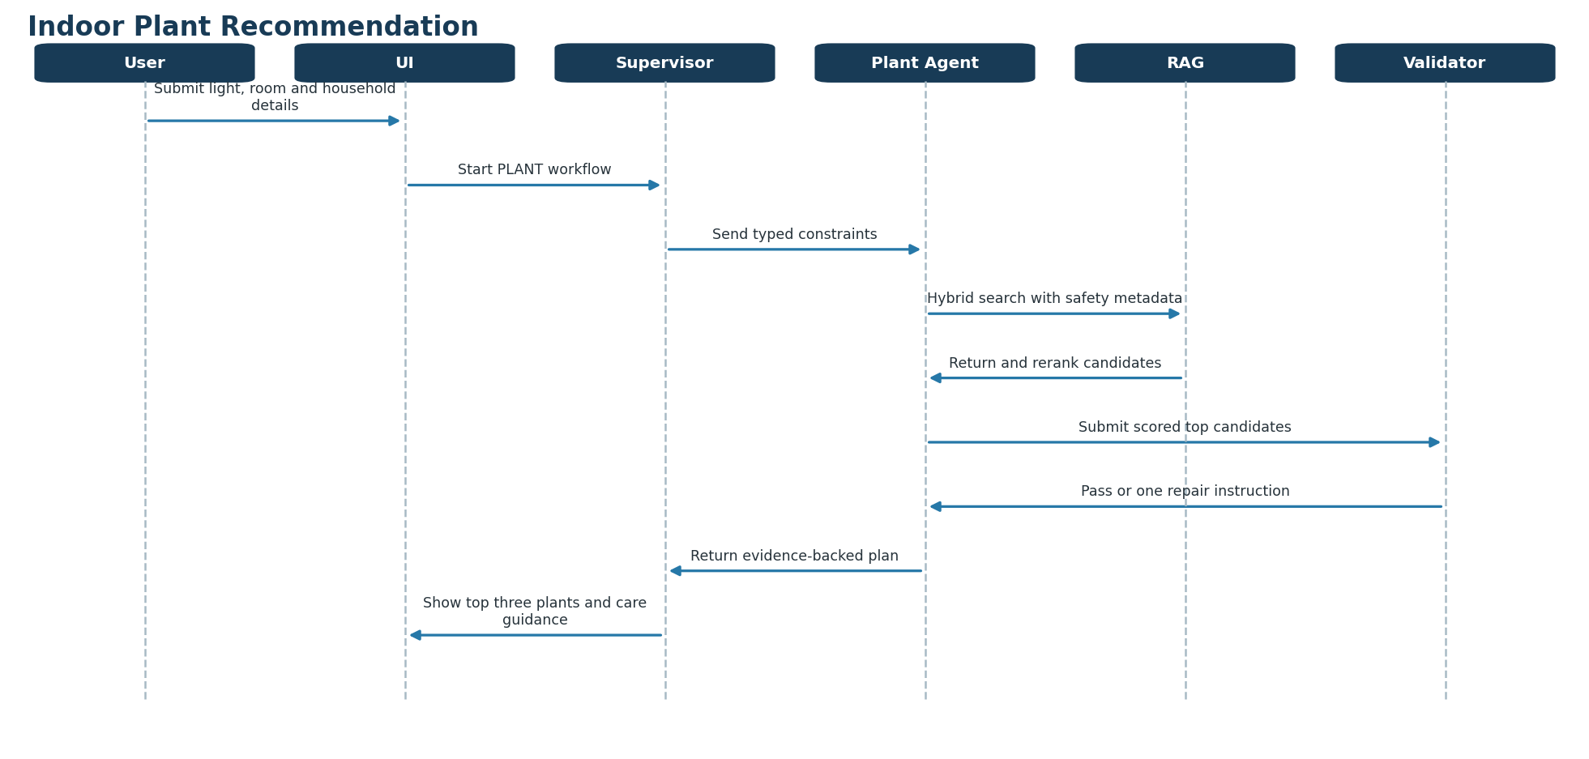
Figure 3. Indoor plant recommendation sequence

4.3 UC-03 — Recommend a dog profile and adoption matches
Inputs include housing type and size, yard, rental/HOA restrictions, children, existing pets, activity, hours alone, experience, allergies, size/age preferences, grooming tolerance and budget.
- Return a profile recommendation before individual animals.
- Include exercise, climate fit, training difficulty, grooming, feeding, preventive care, expected cost and common health considerations.
- Use shelter-provided individual behavior observations when available; do not guarantee temperament from breed alone.
- Display current adoption records separately with source organization and verification time.
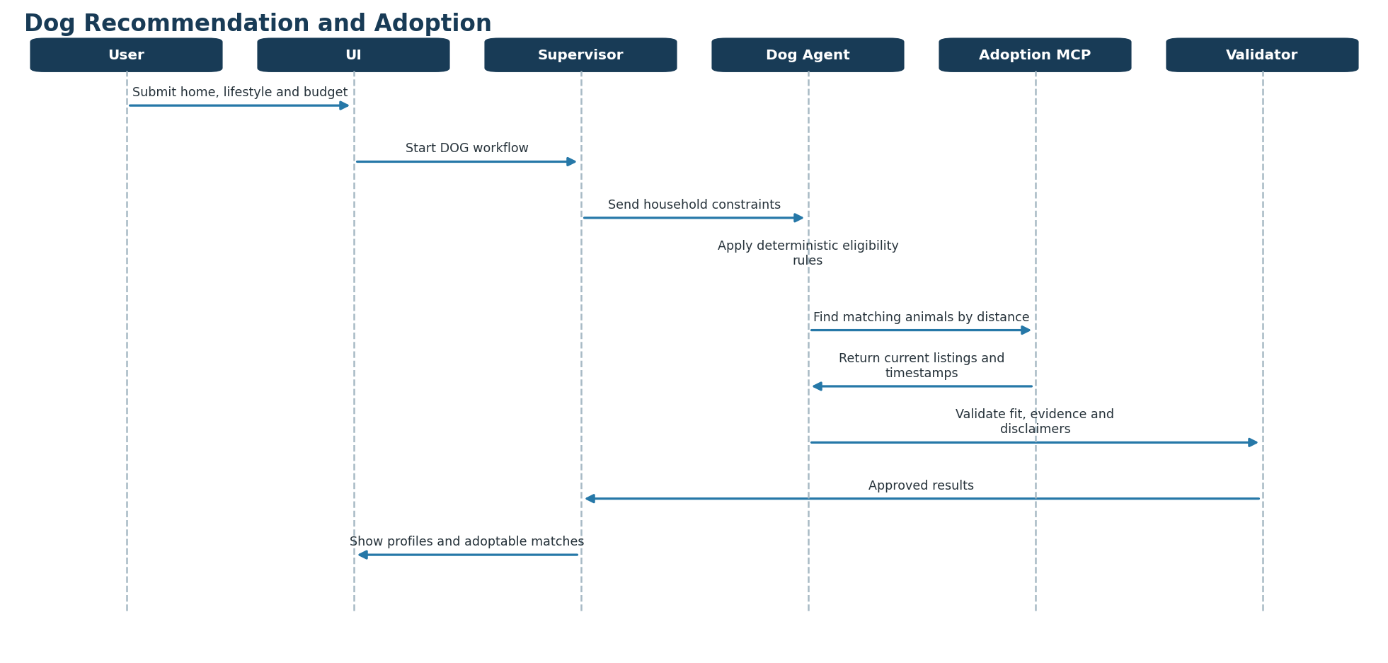
Figure 4. Dog recommendation and adoption sequence

4.4 UC-04 — Recommend a cat profile and adoption matches
Inputs include home and rental restrictions, children, existing pets, time alone, desired activity and affection, coat preference, grooming tolerance, allergies, experience and budget.
- Return age, temperament and energy profile recommendations.
- Include indoor suitability, social needs, feeding, litter, enrichment, brushing, nail care, preventive care and costs.
- Search current adoption records by location only after the profile passes constraints.
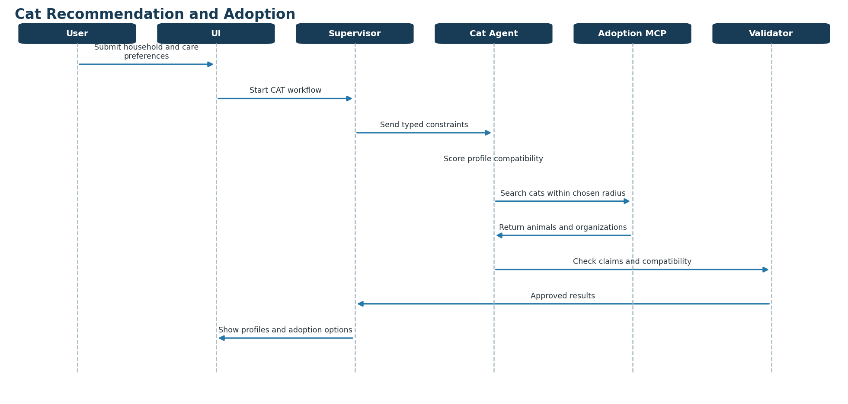
Figure 5. Cat recommendation and adoption sequence

4.5 UC-05 — Find a local purchase, adoption or service source
- Receive selected entity/profile and ZIP code.
- Use Places MCP for business identity, location and distance.
- Use Adoption MCP for current animals and shelter/rescue records.
- Use You.com Search/Contents for current pages and supporting evidence.
- Reconcile sources and label inventory as Confirmed, Recently observed or Unverified.
- Return up to three useful sources with type, contact, distance, URL and timestamp.
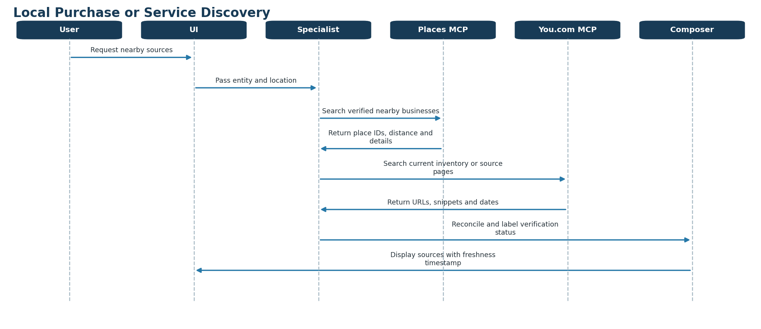
Figure 6. Local purchase or service discovery sequence

4.6 UC-06/07 — View and save a care plan
A care plan is generated from approved structured rules and evidence. The user previews the tasks and explicitly confirms before the application persists the plan or enables reminders.
Category | Plan examples
Plant | Check soil, water, rotate, clean leaves, fertilize, inspect pests, repot review.
Dog | Feed, exercise, training, brushing, nail care, preventive-care planning.
Cat | Feed, litter care, play/enrichment, brushing, nail care, preventive-care planning.

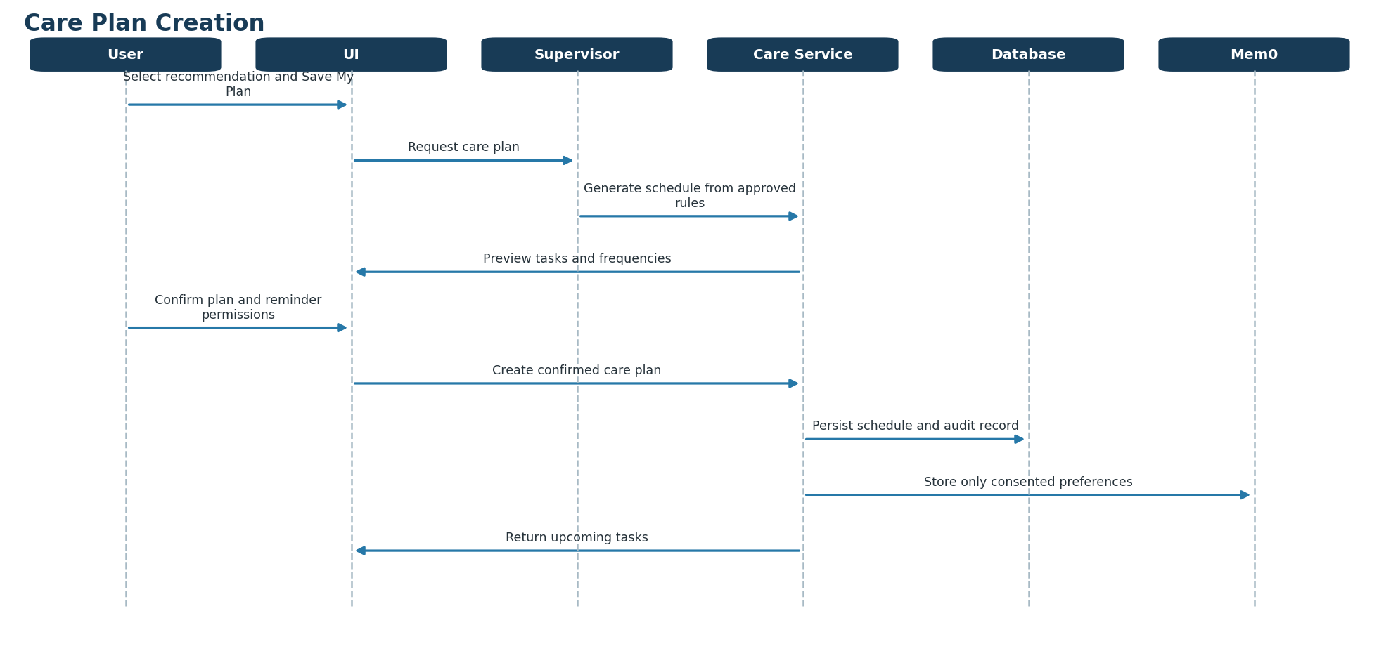
Figure 7. Care-plan creation sequence

5. Acceptance Criteria and Product Metrics
Criterion | Measurable target
Category integrity | 100% of submitted sessions contain exactly one valid category.
Question relevance | No questions from non-selected categories are shown.
Response time | Top-three results within 5 seconds for at least 95% of standard requests; deep research is asynchronous.
Explanation completeness | 100% include score, three reasons, concerns and estimated cost.
Local-source coverage | At least one qualified source within 50 miles or verified online option for 90% of supported ZIPs.
Safety completeness | 100% of plant results contain toxicity status; 100% of pet results pass household/housing constraints.
Save reliability | At least 99% successful save-and-retrieve rate.
Questionnaire completion | At least 70%.
Recommendation usefulness | At least 80% positive user rating.
Save conversion | At least 40% of completed sessions save a recommendation.
Source engagement | At least 25% open a seller, shelter or rescue source.
Application errors | Below 1% of recommendation requests.

6. Reference Architecture

6.1 Logical components
Layer | Technology | Responsibility
Experience | React | Guided questionnaire, category isolation, streaming results and saved plans.
Edge/API | Gateway + FastAPI | Authentication, rate limits, API contracts, application services and MCP host.
Orchestration | LangGraph | Typed state, routing, checkpoints, retries, interrupts and subgraphs.
AI integration | LangChain | Models, retrievers, prompts, parsers and tool adapters.
Retrieval | Pinecone | Dense+sparse hybrid retrieval and metadata filtering.
System of record | PostgreSQL | Profiles, catalogs, rules, sources, sessions, plans, feedback and audit.
Cache | Redis | Response/tool cache, throttling, locks and short-lived data.
Memory | Mem0 | Consented long-term preferences across sessions.
External tools | MCP servers | Web, maps, adoption, climate, catalog and care actions.
AI operations | LangSmith | Traces, datasets, experiments, evaluators, dashboards and alerts.

Shared-access clarification Plant, Dog and Cat subgraphs do not own separate datastores. Each selected specialist uses the shared data-and-tool access layer: PostgreSQL for authoritative facts and rules, Pinecone for approved narrative retrieval, Mem0 for consented preferences only, and MCP for current external information.

Specialist | PostgreSQL | Pinecone | Mem0 | MCP
Plant | Plant facts, toxicity and scoring | Placement and care guidance | Maintenance preferences | Nurseries, climate and inventory
Dog | Breed facts, eligibility and scoring | Care, grooming and training | Lifestyle preferences | Adoption, vets, groomers and rules
Cat | Breed facts, eligibility and scoring | Care, grooming and enrichment | Lifestyle preferences | Adoption, vets, groomers and rules

6.2 Multi-agent architecture pattern
Selected pattern Hierarchical Supervisor–Specialist with deterministic routing, specialist subgraphs, shared restricted tools, typed state and an evaluator–optimizer stage.

Component | Responsibility
Supervisor | Validates the request, loads state/memory, selects one subgraph, manages failure and composes the response.
Deterministic router | Routes PLANT, DOG or CAT from the session field; the LLM cannot change category.
Plant specialist | Plant compatibility, placement, maintenance and toxicity.
Dog specialist | Profile fit, care requirements and adoption search.
Cat specialist | Profile fit, care requirements and adoption search.
Evaluator | Checks constraints, sources, calculations, schema and safety.
Optimizer | Repairs only failed sections, with a maximum of two attempts.
Safe fallback | Returns qualified guidance or requests missing information when evidence is inadequate.

Avoid peer-to-peer swarms and running all specialists in parallel. Scoring, toxicity, ZIP validation, schema checks and database queries remain deterministic functions or controlled tools—not autonomous agents.

6.3 Typed graph state
The state contract includes request/session/user identifiers, category, intent, destination, questionnaire, recalled preferences, hard constraints, candidate IDs, retrieved evidence, live sources, ranked matches, validation issues and the final structured response. Each node reads only required fields and writes designated outputs.

7. Hybrid RAG Design

7.1 Retrieval model
- Apply exact eligibility and safety rules using PostgreSQL data.
- Construct a category-specific query and required metadata filters.
- Retrieve approximately 30–50 Pinecone chunks using dense semantic and sparse lexical signals.
- Merge/deduplicate and rerank approximately 15–20 passages.
- Provide approximately 5–8 strongest passages to the model.
- Generate an answer whose material claims map to evidence.
- Validate grounding, freshness, source tier and hard constraints.

7.2 Pinecone organization and metadata
Use one hybrid index with versioned category namespaces such as plant-knowledge-v1, dog-knowledge-v1 and cat-knowledge-v1. The one-category product rule makes category isolation natural.
Metadata field | Purpose
category / entity_id / entity_name | Category and canonical identity.
document_type / topics | Target retrieval to care, safety, placement, cost or regulation.
state_codes / climate_zones | Location filtering.
pet_safe / child_safe | Pre-retrieval safety exclusion.
source_name / source_url / trust_tier | Provenance and source quality.
published_date / reviewed_date | Freshness decisions.
content_version | Reproducibility and rollback.

7.3 Recommendation scoring
Scores are computed by deterministic code and explained by the LLM. Plant weighting begins with light 25%, humidity 15%, temperature 15%, maintenance 15%, budget 10%, experience 10% and space 10%. Pet weighting begins with home 20%, activity 20%, climate 15%, time alone 15%, grooming 10%, budget 10% and family 10%. These weights must be calibrated using expert review and user outcomes.
Hard exclusion example If a household contains a cat and an indoor plant is classified as toxic to cats by the approved safety record, exclude the plant before ranking. The model cannot reinstate it.

8. MCP and External Tool Architecture
The FastAPI application is the MCP host. It connects to remote or privately hosted MCP servers. Agents receive only the tools required for their selected category and intent.
MCP server | Representative tools | Use
You.com | search_current_web, fetch_contents, research_question | Current web discovery, page verification and selective deep research.
Places | search_nearby, get_place_details, calculate_distance | Plant stores, shelters, veterinarians and groomers.
Adoption | search_animals, get_animal, get_organization | Current adoptable cats/dogs and rescue data.
Climate | weather, alerts, climate profile, hardiness zone | Location-specific environmental context.
Catalog | profiles, toxicity, constraints, provenance | Approved internal knowledge and safety facts.
Regulations | state/city rules and licensing | Versioned rules supported by government sources.
Commerce | inventory, price and pickup | Confirmed retail availability where contracts permit.
Care Plan | preview, create, adjust, complete task | Confirmed user-facing care actions.

8.1 You.com API usage
Capability | Recommended use | Execution model
Search API | Stores, shelters, current pages, regulations and recent guidance. | Online with caching and domain restrictions.
Contents API | Extract an already selected trusted page for verification or ingestion. | Online selectively or ingestion job.
Research API | Multi-source comparisons and conflicting evidence. | Asynchronous/deep-comparison option; not every request.

The official remote endpoint is https://api.you.com/mcp. API credentials remain server-side. Web results are evidence, not automatically authoritative records.
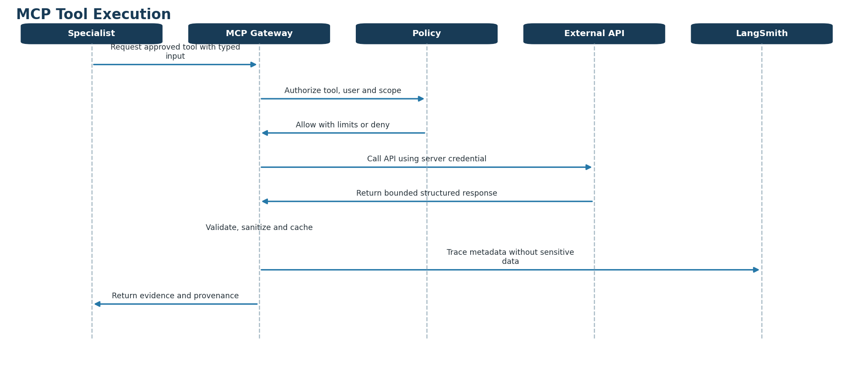
Figure 8. Controlled MCP tool-execution sequence

9. Data Architecture and Memory
Data class | Authoritative store | Examples
Transactional and identity | PostgreSQL | Accounts, sessions, saved plans, consent and audit.
Structured domain facts | PostgreSQL | Profiles, costs, toxicity, constraints and source records.
Unstructured knowledge | Pinecone + object storage | Approved care guides and source chunks.
Graph execution | LangGraph checkpointer | Conversation thread and resumable workflow state.
Durable preferences | Mem0 | Low-maintenance preference or grooming tolerance.
Short-lived results | Redis | Tool responses, retrieval cache and rate limits.
Observability | LangSmith + platform telemetry | AI traces/evals plus infrastructure logs and metrics.

Mem0 must not be the source of truth for address, authentication, consent, adoption, medical information or schedules. Users must be able to inspect and delete remembered preferences.

10. Knowledge Ingestion
- Collect only approved or reviewable sources.
- Extract, normalize, section and deduplicate content.
- Assign trust tier, provenance, applicability and freshness metadata.
- Require expert approval for toxicity and health-sensitive records.
- Generate dense and sparse representations.
- Upsert into a candidate versioned namespace.
- Run retrieval, safety and regression evaluations.
- Promote the namespace only after release gates pass; retain rollback capability.
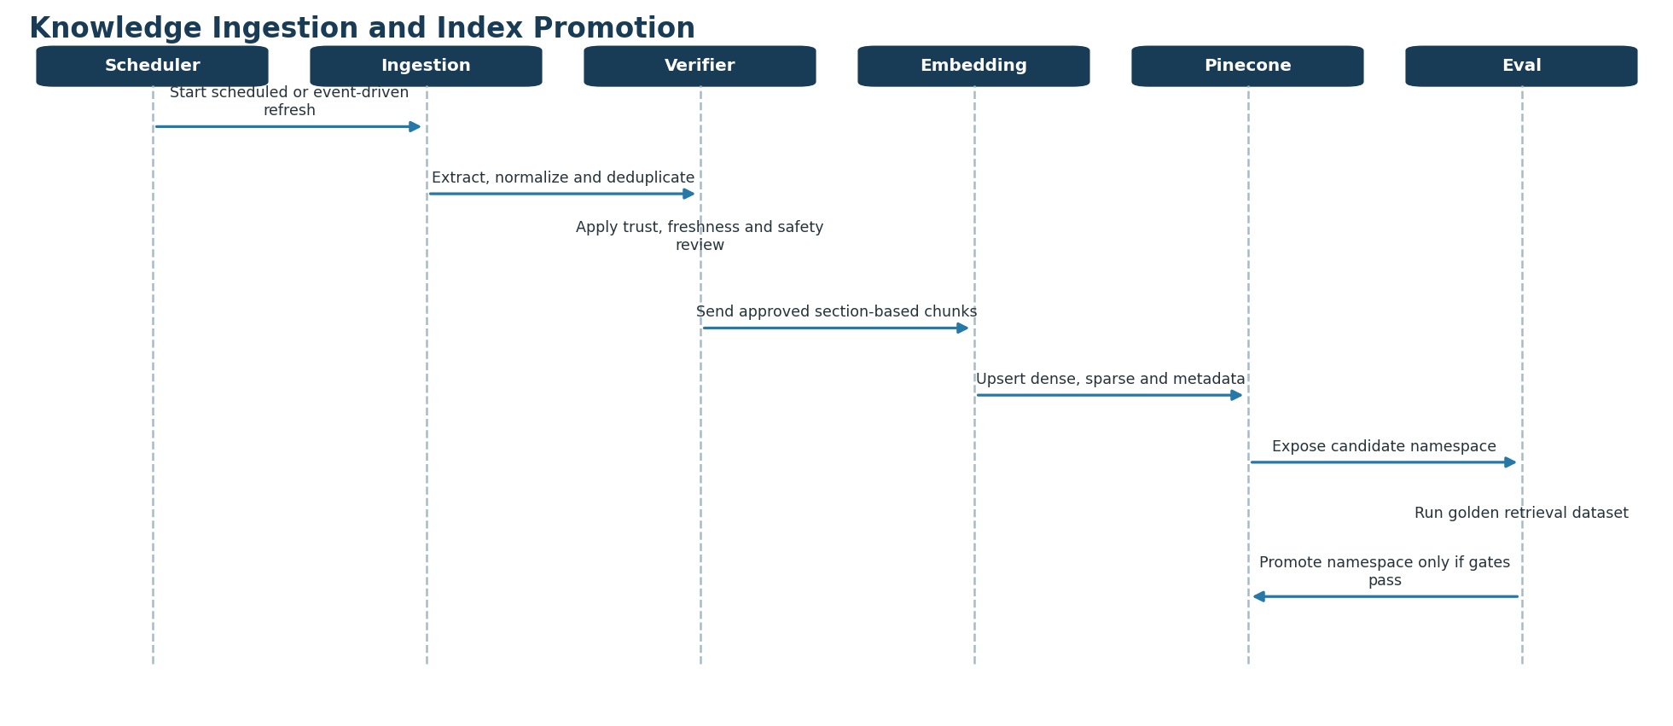
Figure 9. Knowledge ingestion and namespace-promotion sequence

11. Dataset Sources and Storage Instructions
Core storage rule PostgreSQL holds exact, filterable and authoritative facts. Pinecone holds approved narrative passages used to explain recommendations. Current availability, prices, business details, weather, recalls and changing regulations are retrieved live through MCP and are not bulk-embedded.

11.1 Recommended source catalog
Use case | Preferred sources | Primary treatment
Plant identity and distribution | USDA PLANTS downloads; GBIF species data | Normalize taxonomy and identifiers into PostgreSQL; embed only approved descriptive material.
Plant care | USDA NRCS Plant Guides; licensed university extension publications | Store normalized care ranges in PostgreSQL; chunk guidance by plant and care topic into Pinecone.
Climate and hardiness | USDA 2023 hardiness data; NOAA or PRISM climate normals | Store ZIP/coordinate-based values in PostgreSQL/PostGIS; do not embed numeric grids.
Plant toxicity | ASPCA toxic/non-toxic plant guidance, subject to permitted use | Store dog/cat safety status as hard constraints; embed reviewed explanatory and emergency-safety text.
Dog characteristics | Licensed AKC material or an internally curated, expert-reviewed breed catalog | Store scoring attributes in PostgreSQL; embed permitted breed-care explanations.
Cat characteristics | Licensed TICA material or an internally curated, expert-reviewed breed catalog | Store scoring attributes in PostgreSQL; embed permitted breed-care explanations.
Pet preventive care | AVMA resources and licensed AAHA/AAFP guidelines | Store approved schedules/rules in PostgreSQL; chunk educational guidance by species and life stage.
Adoptable animals | RescueGroups Adoptable Pet Data API | Retrieve live through Adoption MCP; short cache only, no permanent vector ingestion.
Local businesses | Google Places API | Retrieve live through Places MCP; retain only fields allowed by provider terms, such as place ID where permitted.
Current web evidence | You.com Search, Contents and Research APIs | Use at query time or as an ingestion-discovery step; never auto-promote unreviewed results.
Regulations and movement requirements | USDA APHIS plus official state/local government pages | Live lookup or controlled refresh; store versioned rule facts only after review.
Product safety | FDA animal/veterinary recalls | Live safety lookup and alert feed; do not rely on an old embedded recall chunk.

11.2 PostgreSQL: authoritative structured data
Insert information into PostgreSQL when the application must filter, compare, calculate, enforce a rule, join records or reproduce a recommendation exactly. These values must not depend on semantic similarity.
Domain | Tables and representative fields
Plants | plant, plant_alias, plant_care_fact and plant_toxicity: scientific/common name, taxonomy ID, light range, temperature range, watering interval, humidity, fertilizer cadence, difficulty and dog/cat safety.
Dogs and cats | breed_profile, species_rule and care_schedule: size, energy, grooming, trainability, apartment fit, heat/cold tolerance, life stage, estimated cost and evidence status.
Geography | location_profile, hardiness_zone and climate_normal: ZIP, state, coordinates, zone, temperature, humidity and precipitation summaries.
Provenance | source, source_version, ingestion_run and review_decision: owner, URL, license, checksum, effective date, reviewer, approval and refresh SLA.
Product data | user_profile, recommendation_session, recommendation_score, saved_plan, task, consent, feedback and audit_event.
Retrieval control | chunk_manifest and index_release: chunk ID, entity ID, document version, checksum, Pinecone namespace, embedding version and promotion status.

- Use typed columns or validated JSONB for category-specific extensions; do not place all facts in an ungoverned JSON blob.
- Use database constraints for categorical values and hard safety rules.
- Keep original source files in versioned object storage and reference them from source_version.
- Use PostgreSQL full-text search only for administrative discovery; user-facing semantic retrieval remains in Pinecone.

11.3 Pinecone: content that should be chunked
Insert approved prose into Pinecone when it answers a natural-language question, supplies rationale or provides contextual care instructions. A vector must complement the PostgreSQL entity, not replace it.
Chunk family | Examples of one answerable chunk
Plant care | Spider Plant - light and room placement; watering; fertilizer; pruning and repotting as separate chunks.
Plant safety | Spider Plant - cat/dog toxicity explanation; Lily - cat exposure warning and escalation guidance.
Dog guidance | Labrador Retriever - activity and living space; grooming; climate considerations; training and enrichment.
Cat guidance | Maine Coon - grooming; enrichment; household fit; climate and indoor comfort.
Life-stage care | Adult dog preventive care; senior cat home setup; kitten grooming introduction.
Decision explanation | Why a low-light, pet-safe plant fits an apartment; why a high-energy breed conflicts with limited exercise time.

Do not embed as the source of truth Exact toxicity flags, numeric thresholds, prices, inventory, adoption status, business hours, coordinates, user records, consent, schedules, weather forecasts, recalls or unreviewed web results.

11.4 Chunk construction standard
- Resolve the canonical entity in PostgreSQL and assign entity_id and source_version_id.
- Extract headings, paragraphs, tables and lists while preserving document structure.
- Remove navigation, advertisements, duplicated boilerplate and unrelated material.
- Split by semantic heading and answerable topic before applying a token limit.
- Target 300-600 tokens per chunk; use 50-80 tokens of overlap only when a sentence or procedure crosses a boundary.
- Prepend a short contextual label containing entity, species and topic; do not invent facts in the label.
- Attach complete metadata, calculate a checksum and write the chunk manifest to PostgreSQL.
- Create dense and sparse representations and upsert into a candidate Pinecone namespace.
- Run retrieval and safety evaluations; promote only when quality gates pass.
Required metadata | Example
Identity | chunk_id, entity_id, entity_type, canonical_name, species and topic.
Applicability | state or ALL, life_stage, household_type, pet_safety and climate tags.
Provenance | source_id, source_name, source_url, source_version_id, license and authority tier.
Freshness | published_at, effective_from, effective_to, reviewed_at and refresh_by.
Retrieval control | language, content_version, embedding_model, index_version, approval_status and checksum.

11.5 Storage decision matrix
Information | PostgreSQL | Pinecone | Live MCP
Scientific name, breed, aliases and IDs | Canonical | Optional context | No
Light, water, energy and grooming ratings | Scoring facts | Explanation | No
Toxicity and hard exclusions | Mandatory | Reviewed rationale | Safety refresh
Care instructions and educational guidance | Schedule facts | Primary | Freshness fallback
Climate normals and hardiness zone | Primary | No | Refresh/API
Available animals, inventory and price | Short cache | No | Primary
Store, shelter, vet and groomer details | Permitted IDs | No | Primary
Rules, recalls and current alerts | Reviewed version/cache | No active status | Primary
User profile, consent and saved plan | Primary | No | No
Long-term user preferences | Profile source of truth | No | Mem0 with consent

11.6 Data-routing procedure
- Structured and narrative forms may both be created from one approved source. For example, a watering range becomes a PostgreSQL fact while the supporting explanation becomes a Pinecone chunk.
- A failed license, provenance, freshness or expert-review check sends the item to quarantine rather than either production store.
- Live MCP responses may be cited in the current answer but cannot silently modify canonical records or the production index.
- Every Pinecone result must be traceable through chunk_manifest to the exact source version and reviewer decision in PostgreSQL.
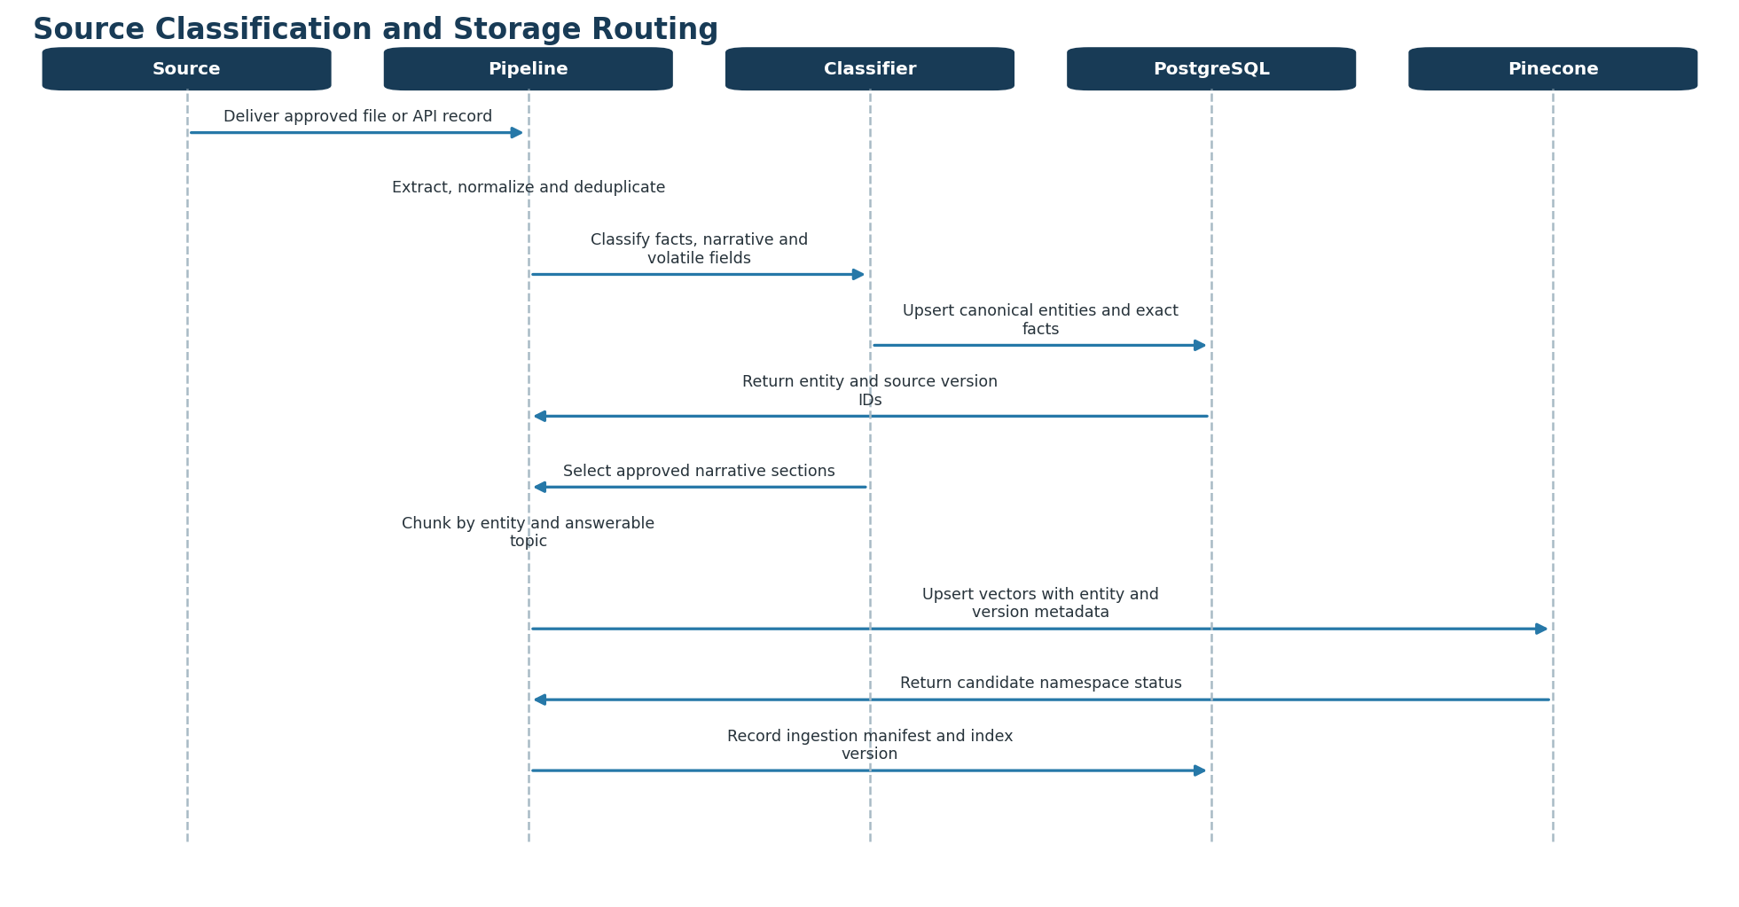
Figure 10. Source classification and PostgreSQL/Pinecone routing sequence

11.7 MVP ingestion scope and acceptance checks
- Begin with approximately 100 indoor plants, 50 dog breeds, 40 cat breeds, 50 state profiles and 200-400 approved care articles.
- Reject a production release if any hard-constraint record lacks a source, license decision, effective date or reviewer.
- Require 100% traceability from Pinecone chunk to source_version and 100% checksum agreement between the manifest and index.
- Require zero price, inventory, adoption-status or user-profile documents in the production Pinecone namespace.
- Refresh climate normals annually or when a source version changes; retrieve availability and safety alerts live.

12. Observability and Evaluation

12.1 LangSmith tracing
Trace validation, memory recall, rules, query construction, retrieval, reranking, specialist execution, MCP calls, safety evaluation, repair and response composition. Attach hashed user/session identifiers, category, state, graph/prompt/model version, retriever configuration, namespace, latency, token cost, cache state and feedback outcome.
- Redact names, exact addresses, emails and sensitive questionnaire values.
- Create alerts for quality, safety, cost, latency and tool failure regressions.
- Use platform observability separately for React, FastAPI, databases, cache, queue and networks.

12.2 Evaluation framework
Layer | Metrics | Initial gate
Routing | Correct category and intent | 100% category routing.
Retrieval | Recall@20, Precision@5, MRR, NDCG | Recall@20 ≥90%; Precision@5 ≥80%.
Generation | Faithfulness, citation correctness/completeness | Grounding and citations ≥95%.
Recommendation | Constraint compliance and suitability | Hard-constraint compliance 100%.
Structure | JSON/schema validity | ≥99%.
Performance | P50/P95 latency and cost | P95 ≤5 sec for standard requests.
Reliability | Error and retry rates | Request failures <1%.
Memory | Preference precision and deletion behavior | No unauthorized write; deletion 100%.

Use deterministic evaluators for exact requirements and LLM-as-judge for subjective clarity or relevance. Maintain category-specific golden datasets, edge cases and adversarial prompt-injection examples. Sample production traces rather than evaluating every request with an expensive judge.
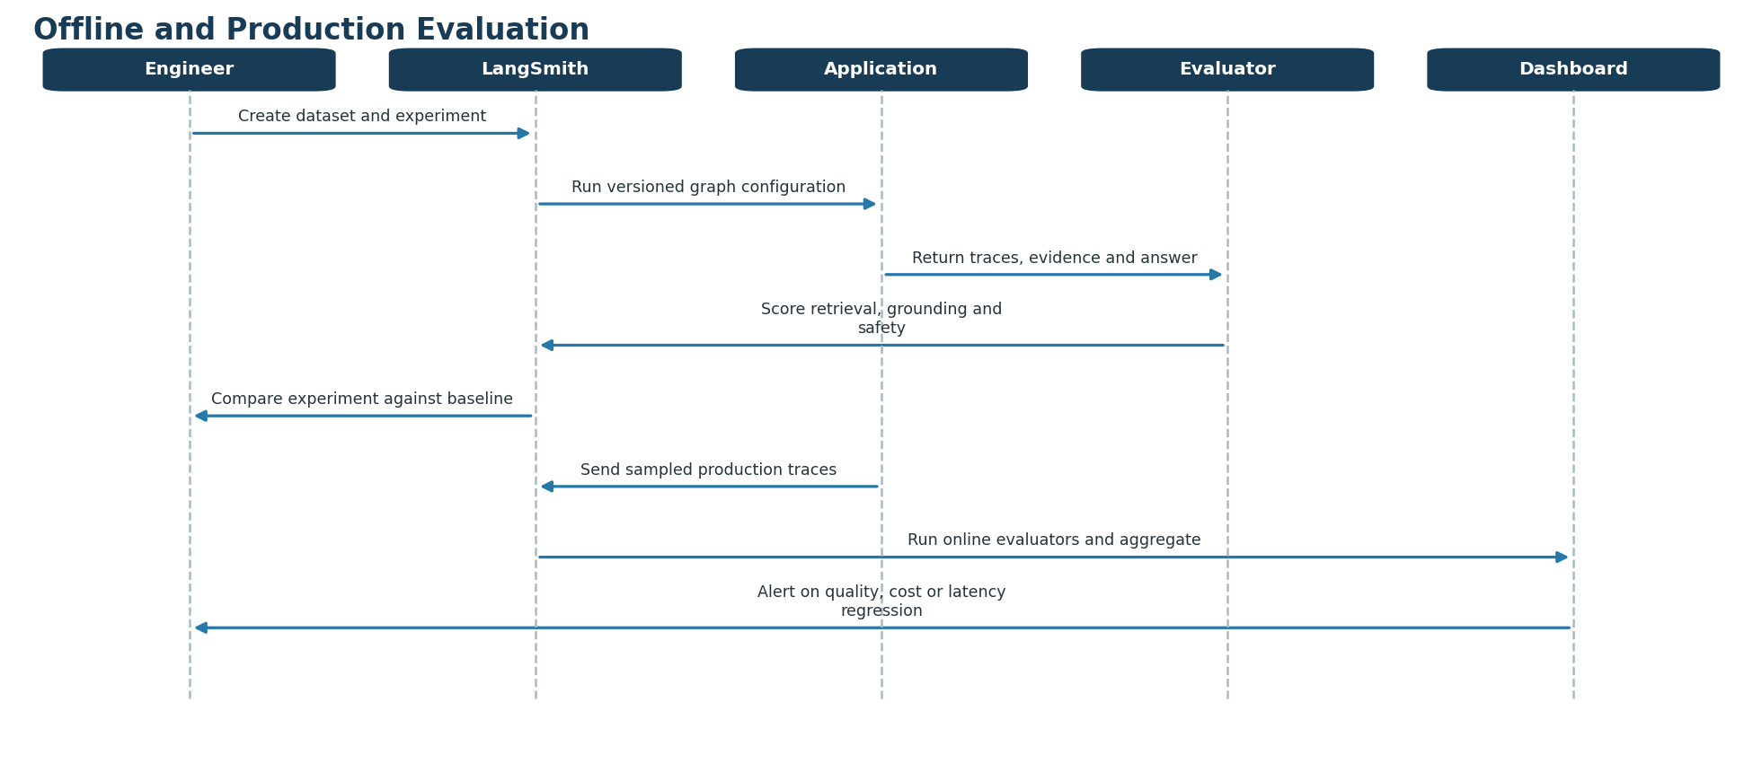
Figure 11. Offline and production evaluation sequence

13. Security, Privacy and Responsible AI
Control area | Required controls
Identity/access | OIDC/OAuth, least privilege, tool allowlists and user-level authorization.
MCP | OAuth 2.1 where applicable, server credentials, schemas, timeouts, size/rate limits and audit logs.
Data privacy | Consent, minimization, encryption, retention, export/delete and PII trace redaction.
Web safety | Approved domains/trust tiers, prompt-injection scanning, content sanitization and no arbitrary URLs.
LLM safety | Structured output, deterministic exclusions, evidence requirements and bounded repair loops.
Actions | Explicit confirmation before saving plans, enabling reminders or performing writes.
Commercial integrity | Suitability ranking separated from sponsored placement.
User communication | No guarantee of health, temperament, legality, availability or plant survival.

14. Nonfunctional Requirements
Quality attribute | Requirement
Availability | Target 99.9% monthly for core recommendation APIs.
Latency | P95 ≤5 seconds standard path; deep research asynchronous.
Scalability | Stateless API workers; horizontally scalable retrieval/tool calls.
Resilience | Timeouts, circuit breakers, retries with jitter, cached fallback and degraded-mode messaging.
Auditability | Reconstruct result from graph, prompt, model, index, source and rules versions.
Accessibility | WCAG 2.2 AA target for the React experience.
Maintainability | Versioned tool contracts, typed state, modular subgraphs and automated regression suites.
Freshness | Display verified-at time; category-specific refresh SLAs.
Cost | Budget and alert by model, MCP tool and completed recommendation.

15. Four-Engineer Codex Execution Strategy
Recommended separation Divide ownership by architectural capability rather than assigning one engineer to Plant, Dog or Cat. The category subgraphs share contracts, retrieval, data and tools; capability ownership minimizes duplication and merge conflicts while allowing all four engineers to work concurrently with Codex.

15.1 Component ownership
Owner | Primary mission | Owned components
Engineer 1 - Product experience | Deliver the end-user workflow independently against mocks. | React shell, category selection, questionnaires, streaming/progress, recommendation cards, comparisons, source display, care plans, feedback, accessibility, frontend telemetry and generated API client.
Engineer 2 - Recommendation intelligence | Deliver deterministic and agentic recommendation behavior behind stable interfaces. | FastAPI recommendation endpoints, LangGraph supervisor, Plant/Dog/Cat subgraphs, typed state, scoring, hard constraints, safety validator, evaluator-optimizer loop, prompts and structured outputs.
Engineer 3 - Knowledge and data | Deliver authoritative facts and high-quality retrieval behind repository contracts. | PostgreSQL schema/migrations, catalogs, source registry, ingestion, chunking, Pinecone namespaces, hybrid retrieval, reranking, index promotion, seed data and retrieval evaluations.
Engineer 4 - Integrations and operations | Deliver bounded external capabilities and the production control plane. | MCP gateway, You.com, Places, adoption, climate and regulation adapters, Redis policies, LangSmith tracing, secrets/configuration, CI/CD, deployment, health checks and operational dashboards.

Plant, Dog and Cat domain behavior remains with Engineer 2, while their facts, passages and live external data are supplied through interfaces owned by Engineers 3 and 4. Engineer 1 consumes only the published application API and never provider-specific models.

15.2 Monorepo ownership boundaries
Path | Owner | Purpose
apps/web; packages/ui; packages/api-client | Engineer 1 | React experience and generated client.
apps/api; agents/*; services/orchestration; services/scoring; services/safety | Engineer 2 | Recommendation APIs and graph behavior.
services/catalog; services/ingestion; services/retrieval; database/*; evals/retrieval | Engineer 3 | PostgreSQL, Pinecone and knowledge lifecycle.
services/mcp-gateway; integrations/*; packages/observability; infrastructure/* | Engineer 4 | External tools, observability and environments.
packages/contracts; packages/domain-models; packages/test-fixtures | All four, reviewed | Versioned shared boundary; changes require affected-consumer review.
docs/decisions; AGENTS.md | All four, reviewed | Architecture decisions and Codex operating instructions.

- Avoid a general shared-utils package. Create small purpose-specific packages with an owner and stable public surface.
- Use CODEOWNERS to enforce review for shared contracts, migrations, security policy and deployment changes.
- Give each engineer an isolated PostgreSQL schema, Pinecone namespace, Redis prefix and external-tool test credentials.

15.3 Contracts to freeze before parallel coding
- OpenAPI contract between React and FastAPI, including streaming events and error envelopes.
- Typed RecommendationContext and LangGraph state with explicit node read/write fields.
- Plant, dog, cat, recommendation, evidence, source and care-plan domain models.
- CatalogRepository and KnowledgeRetriever interfaces owned by the data boundary.
- Provider-neutral MCP tool schemas for adoption, places, current web, climate and regulations.
- Trace/evaluation event schema, correlation IDs and required redaction fields.
- Golden request/response fixtures for happy paths, missing data, exclusions and external failures.
Dependency inversion Engineers 1 and 2 build against mocks and fakes from the frozen contracts. Engineers 3 and 4 implement those interfaces. Integration replaces adapters without rewriting consumer logic.

15.4 Codex working model
Practice | Required implementation
Persistent instructions | Root AGENTS.md defines architecture rules, commands, safety constraints and global definition of done. Add narrower AGENTS.md files only where a component needs specialized guidance.
Task brief | Every Codex task names the owner directory, goal, acceptance criteria, allowed files, interfaces that must not change and verification commands.
Isolation | One engineer and one Codex session per short-lived branch/worktree. Do not have two sessions edit the same owned files concurrently.
Context | Provide the relevant contract, ADR, example fixture and failing test. Do not ask Codex to infer cross-service contracts from the entire repository.
Change size | Prefer one bounded capability per pull request. Separate generated migrations, contract changes and behavioral changes when review would otherwise be ambiguous.
Verification | Codex must run component tests, contract tests, lint/type checks and the relevant evaluation subset before proposing completion.
Review | Human owner reviews behavior, security, data handling and architectural boundaries; generated code is never merged solely because it compiles.
Traceability | Record prompt/task ID, branch, changed component, tests, eval results and contract version in the pull-request template.

15.5 Parallel delivery sequence
- Foundation: jointly approve contracts, fixtures, repository layout, AGENTS.md and CI gates.
- Parallel build: Engineer 1 builds UI against the mock server; Engineer 2 builds graphs against fake repositories/tools; Engineer 3 builds data and retrieval adapters; Engineer 4 builds MCP and operations adapters.
- Continuous contract integration: every pull request runs schema compatibility and consumer contract tests before component tests.
- Adapter integration: replace one fake at a time - API, catalog, retriever, MCP tools and tracing - behind feature flags.
- Vertical-slice validation: run Plant, Dog and Cat golden scenarios plus safety and degraded-mode cases.
- Release: promote database migrations, Pinecone namespace, tool configuration and application version as one recorded release manifest.
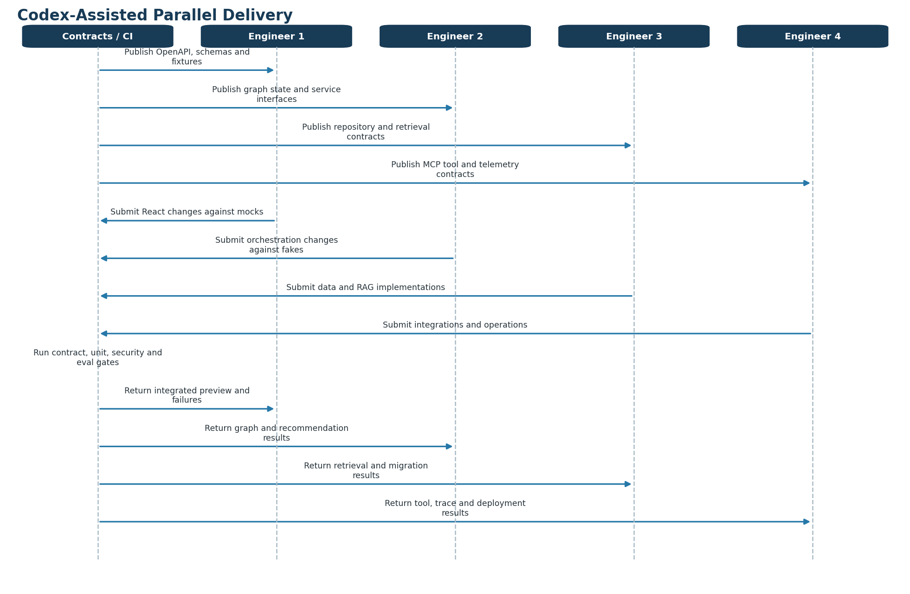
Figure 12. Codex-assisted four-engineer parallel-delivery sequence

15.6 Branch, review and integration policy
Control | Policy
Branch naming | feat/ui-*, feat/graph-*, feat/data-*, feat/mcp-* or fix/<component>-<issue>.
Contract changes | Require version update, compatibility notes, updated fixtures and review from every affected owner.
Merge frequency | Merge small green pull requests daily; use a continuously deployable main branch rather than long-running integration branches.
Feature flags | Merge incomplete categories and integrations disabled by default; enable only after contract and evaluation gates pass.
Database changes | Forward-compatible expand/migrate/contract sequence; no destructive migration in the same release as dependent code.
Pinecone changes | Write to a candidate versioned namespace; evaluate, promote by alias/configuration and retain rollback.
Provider changes | Keep vendor payloads inside adapters and update provider contract tests before rollout.
Conflict rule | The directory owner resolves semantic conflicts; shared-contract conflicts require the affected owners together.

15.7 Pull-request definition of done
- Change stays within declared ownership boundaries or includes required cross-owner approval.
- Public interfaces and generated clients are synchronized and backward compatible or explicitly versioned.
- Unit, integration, contract, type, lint and security checks pass.
- Relevant LangSmith/RAG/recommendation evaluation subset meets its existing baseline.
- No secrets, personal data, unlicensed source content or provider-specific payloads leak across boundaries.
- Operational telemetry, failure behavior and feature-flag state are defined.
- Documentation and golden fixtures are updated when observable behavior changes.
- Codex-generated code receives accountable human review before merge.

15.8 Coordination metrics
Metric | Initial target
Contract-breaking merges | Zero without an approved version transition.
Pull-request cycle time | Median under one business day for bounded changes.
Merge-conflict rework | Less than 5% of engineering capacity.
Independent work ratio | At least 80% of sprint tasks executable without another unfinished task.
Main-branch health | At least 95% of commits pass all required gates on first rerun.
Escaped integration defects | Fewer than 2 per release, with declining trend.
Evaluation regression | Zero unapproved safety or hard-constraint regression.
Codex review coverage | 100% of Codex-authored pull requests receive human review.

16. Delivery Roadmap
Phase | Capabilities | Exit criteria
1 — Foundation | React questionnaire, FastAPI, PostgreSQL catalog, deterministic rules, single graph and Pinecone retrieval. | Plant flow meets safety and retrieval gates.
2 — Category expansion | Dog/cat subgraphs, RescueGroups-style adoption integration, Places and climate tools. | All categories meet route, safety and latency gates.
3 — Personalization | Mem0 consent/controls, saved care plans and feedback loop. | Memory and plan reliability targets met.
4 — Freshness and operations | You.com MCP, ingestion approval, LangSmith online evals and alerts. | Quality/cost dashboards and rollback proven.
5 — Optimization | Weight calibration, model routing, caching, selective deep research and experiments. | Measured improvement without safety regression.

17. Key Risks and Mitigations
Risk | Mitigation
Unsafe or unsuitable recommendation | Pre-ranking exclusions, expert-approved facts and 100% constraint evaluation.
Stale availability | Timestamps, confidence labels, live adoption/inventory APIs and short caches.
Web prompt injection | Sanitize retrieved content, domain controls and prohibit web text from redefining system policy.
Agent cost/latency growth | One specialist only, deterministic routing, bounded tools and asynchronous research.
Over-personalization | Consent, inspect/delete memory and authoritative profile separation.
Vendor dependency | MCP adapters, fallback providers, cached safe content and versioned contracts.
Misleading breed assumptions | Profile-first recommendation and individual shelter observations.
Legal/medical reliance | Authoritative citations, clear disclaimers and local/veterinary verification prompts.

18. Architecture Decision Summary
Recommended target state A React and FastAPI application orchestrated by LangGraph using a Supervisor–Specialist pattern; deterministic rules and scoring; PostgreSQL as system of record; Pinecone hybrid RAG over approved content; Mem0 for consented preferences; MCP servers for current web, place, climate and adoption data; and LangSmith for full AI traceability and evaluation.

- Start as a modular monolith and separate services only when scale or ownership requires it.
- Treat tools as bounded capabilities, not additional agents.
- Require evidence and safety validation before every recommendation.
- Promote prompts, rules, models and knowledge indexes through measurable release gates.

Appendix A — Example API Contract
POST /v1/recommendations
Field | Type / example
category | PLANT | DOG | CAT
destination.zip_code | Five-digit U.S. ZIP code
questionnaire | Category-specific typed object
session_id | UUID
use_saved_preferences | Boolean with consent

The response contains request ID, category, up to three recommendations, scores, reasons, concerns, evidence references, local sources, care summary, cost estimates, verification timestamps and validation status.

Appendix B — Source and Technology References
- Model Context Protocol architecture and tools — https://modelcontextprotocol.io/docs/2026-07-28/learn/architecture
- MCP authorization and security — https://modelcontextprotocol.io/docs/2026-07-28/tutorials/security/authorization
- LangGraph workflows and agents — https://docs.langchain.com/oss/python/langgraph/workflows-agents
- LangGraph persistence — https://docs.langchain.com/oss/python/langgraph/persistence
- LangChain multi-agent guidance — https://docs.langchain.com/oss/python/langchain/multi-agent
- Pinecone hybrid search — https://docs.pinecone.io/guides/search/hybrid-search
- Pinecone metadata filters — https://docs.pinecone.io/guides/search/filter-by-metadata
- Pinecone reranking — https://docs.pinecone.io/guides/search/rerank-results
- LangSmith observability and dashboards — https://docs.langchain.com/langsmith/observability
- You.com Search and MCP — https://you.com/docs/guides/search
- You.com Research API — https://you.com/docs/guides/research
- Google Places Nearby Search — https://developers.google.com/maps/documentation/places/web-service/nearby-search
- RescueGroups adoptable-pet data API — https://test1-api.rescuegroups.org/v5/public/docs
- National Weather Service API — https://www.weather.gov/documentation/services-web-API
- USDA Plant Hardiness Zone Map — https://planthardiness.ars.usda.gov/home
- USDA PLANTS Database and downloads — https://plants.sc.egov.usda.gov/downloads
- USDA NRCS Plant Guides — https://www.nrcs.usda.gov/plant-materials/news/nrcs-plant-guides
- GBIF API reference — https://techdocs.gbif.org/en/openapi/
- NOAA U.S. Climate Normals — https://www.ncei.noaa.gov/products/land-based-station/us-climate-normals
- PRISM 30-year climate normals — https://prism.oregonstate.edu/normals/
- ASPCA toxic and non-toxic plants — https://www.aspca.org/pet-care/aspca-poison-control/toxic-and-non-toxic-plants
- AKC dog breed catalog — https://www.akc.org/dog-breeds/
- TICA cat breed catalog — https://tica.org/ticas-breeds/browse-all-breeds/
- AVMA pet-care resources — https://www.avma.org/resources-tools/pet-owners/petcare
- AAHA/AAFP feline life-stage guidelines — https://www.aaha.org/resources/2021-aaha-aafp-feline-life-stage-guidelines/
- USDA APHIS state-to-state pet travel — https://www.aphis.usda.gov/pet-travel/state-to-state
- FDA animal and veterinary recalls — https://www.fda.gov/animal-veterinary/safety-health/recalls-withdrawals
- Google Places storage and attribution policies — https://developers.google.com/maps/documentation/places/web-service/policies

