Master in Data Science and Advanced Analytics

NOVA Information Management School
Universidade Nova de Lisboa

Text Mining Project

Group 03

João Ramos, 20250413
Gonçalo Castro, 20250415
Sapana Dhami, 20250403

Spring Semester 2025-2026

1. Project Overview 1
2. Data Analysis 1
2.1. Data Description 1
2.2. Data Exploration 1
2.2.1. Data Visualization 1
2.3. Data Preprocessing 2
2.3.1. Class Imbalance 2
3. Evaluation Methodology 3
4. Model Development & Iterative Improvements 3
5. Results And Critical Analysis 3
6. Conclusion 3
7. Appendix 4
8. Annexes 5

Project Overview
The project addresses the problem of predicting market sentiment from tweets, which is a common task in natural language processing (NLP). The goal is to classify tweets into three categories: Bearish (0), Bullish (1), or Neutral (2).

Data Analysis

Data Description
The data for this project is divided in a file for training “train.csv”, and another file for testing “test.csv” where the training file presents the tweets (“text”) and the sentiment label (“label”) that can have the following values Bearish (0), Bullish (1), or Neutral (2). The test file has the same structure as the training one except for the fact that it doesn’t contain the “label” column, which we’re supposed to predict for each tweet present in this same file so that they can then be compared with the actual labels.

Data Exploration

Data Visualization
An initial inspection of the training dataset showed that there were no missing values nor duplicate tweets. However, we did find a significant class imbalance where 64.7% of the tweets were labeled as Neutral, 20.22% as Bullish and 15.1% as Bearish as can be seen in Figure 1.
Then we checked the typical tweet structure on our dataset by analyzing the length of the tweets based on the number of characters and words taking their class into consideration. Given the histogram generated, we can conclude that even though there is a much larger percentage of Neutral tweets, their word and character count seem to follow the same overall trends of quantity of tweets per character/word count of the other two smaller classes.
Following this, we examined the most frequent words within each sentiment class to better understand the language patterns associated with bullish, bearish, and neutral tweets. We first used word clouds as a quick way to explore the top 15 most common words in each sentiment class. This gave us an immediate visual sense of which terms stand out the most in bullish, bearish, and neutral tweets, since more frequent words appear larger and are easier to spot at a glance.
To complement this, we then looked at the same information using bar charts, which provide the exact frequencies and allow for a more precise comparison between classes. From these charts, we can see that “stock” is the most common word across all three categories (Bearish: ~135, Bullish: ~140, Neutral: ~145). This is expected, as “stock” is a general term that appears frequently regardless of sentiment and does not carry clear positive or negative meaning on its own.
Looking beyond this shared baseline, clearer differences start to appear. In the bearish class, words such as “misses,” “cut,” “coronavirus,” and “oil” are common, pointing to negative earnings results, downward revisions, and broader economic concerns. Terms like “china” and “economy” further suggest uncertainty driven by external factors.
In contrast, the bullish class includes more positive and performance-focused terms like “beats,” “target,” “raised,” “higher,” and “buy,” which are typically linked to strong earnings, upgrades, and growth expectations. Words such as “revenue,” “eps,” and “shares” also show that bullish tweets often highlight solid company performance.
The neutral class is more focused on factual or informational language, with words like “marketscreener,” “reports,” “earnings,” “dividend,” and time references such as “2019” and “2020.” This suggests that neutral tweets mainly report news or updates without expressing a clear opinion, which is in line with what we would expect.
Now, considering that our dataset consists of tweets, we also looked into the use of hashtags, mentions, and cashtags, since these are very common elements in this type of text and often carry useful context about topics or specific stocks being discussed.
We started by analyzing the top 15 most frequent hashtags and cashtags for each sentiment class, as shown in Figure 5. From the hashtag plots, we can see that some terms appear across all classes, such as “marketscreener,” “stock,” and “economy,” which suggests they are general-purpose tags not strongly tied to a specific sentiment. However, there are still some differences: bearish tweets include tags like “covid19” and “wti” pointing to negative macroeconomic events, while bullish tweets lean more toward terms like “trading,” “business,” and “sp500,” which are more related to market activity and growth. Neutral tweets, on the other hand, are more dominated by broad and informational tags like “markets,” “stock,” and “economy.”
Looking at cashtags (stock tickers), clearer distinctions emerge. While some popular tickers like “TSLA” and “SPY” appear across multiple classes, their frequency varies depending on sentiment. Bearish tweets tend to mention assets like “USO” (oil-related) and “NFLX,” which may reflect negative sentiment tied to specific sectors or events. Bullish tweets are more concentrated around major tech and growth stocks such as “TSLA,” “NVDA,” and “AAPL,” suggesting optimism around these companies. Neutral tweets again show a more mixed distribution, with a wider variety of tickers (e.g., “SPY,” “QQQ,” “IWM”), indicating a more general or reporting-focused discussion rather than strong opinions.
Finally, we checked the average character and word count alongside with the percentage of tweets that contain a URL or a stock ticker per class in order to determine wether any of these would be a good indicator of the class that those tweets were in. Out of the three, the neutral was the one who had the highest average of characters per tweet with 88 characters, even though all of the classes had the exact same average number of words at 12 words. Regarding the presence of URL’s neutral was also the class with the highest percentage with 49.8% whereas bearish and bulish came with 44.3% and 39.1%, respectively. Regarding the presence of a stock ticker the bullish class came first with 24.6% which represents almost double the percentage that both bearish and neutral classes got at around 13% as can be seen on Figure 6

Data Preprocessing

Class Imbalance

Evaluation Methodology

Model Development & Iterative Improvements

Results And Critical Analysis

Conclusion

Appendix

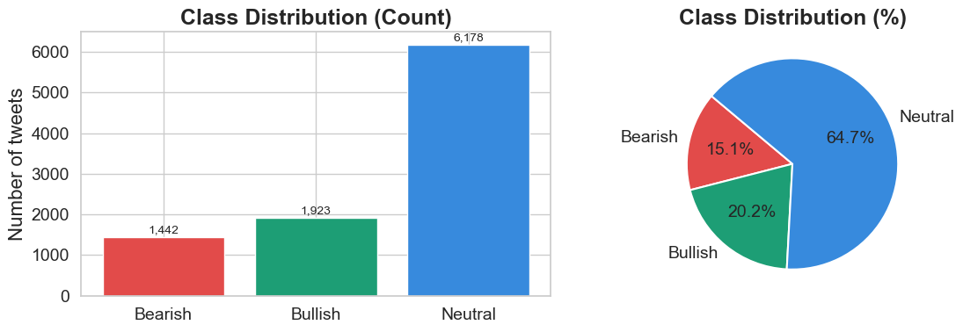

Figure 1: Class distribution of the training dataset
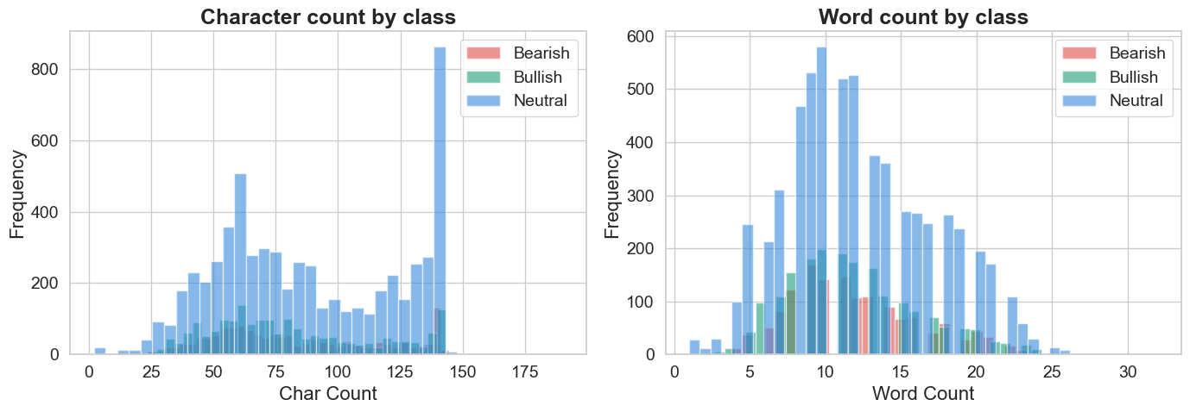

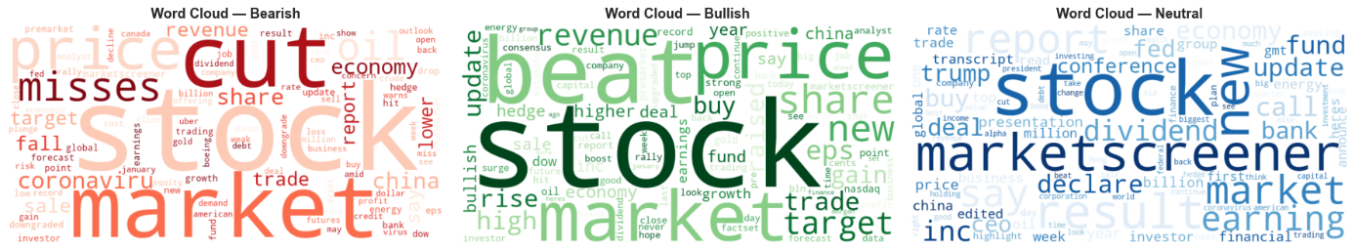
Figure 2: Distribution of each class tweets by character and word count

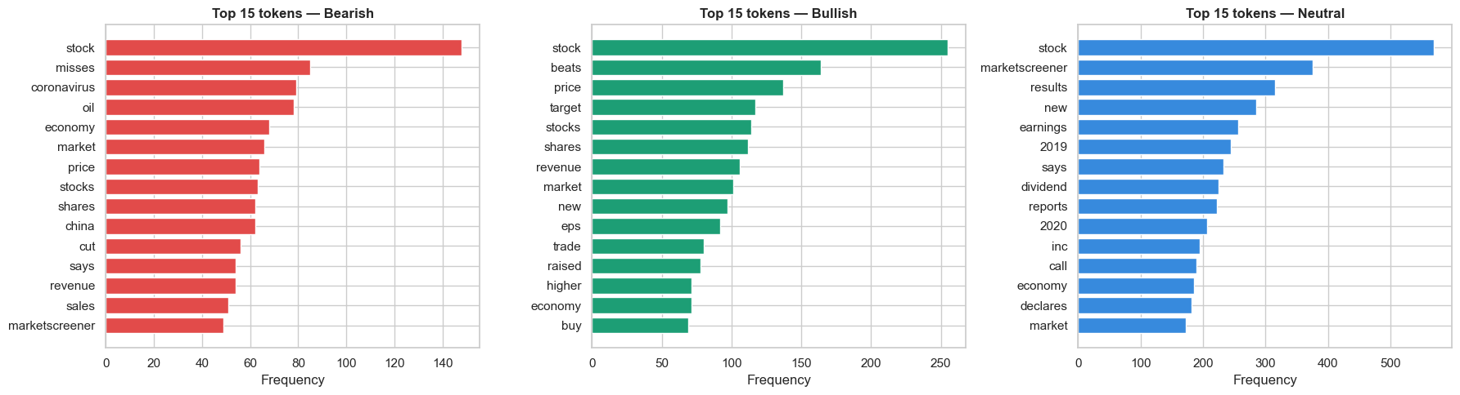
Figure 3: Top 15 most common words per class represented in the form of word clouds

Figure 4: Top 15 most common words per class
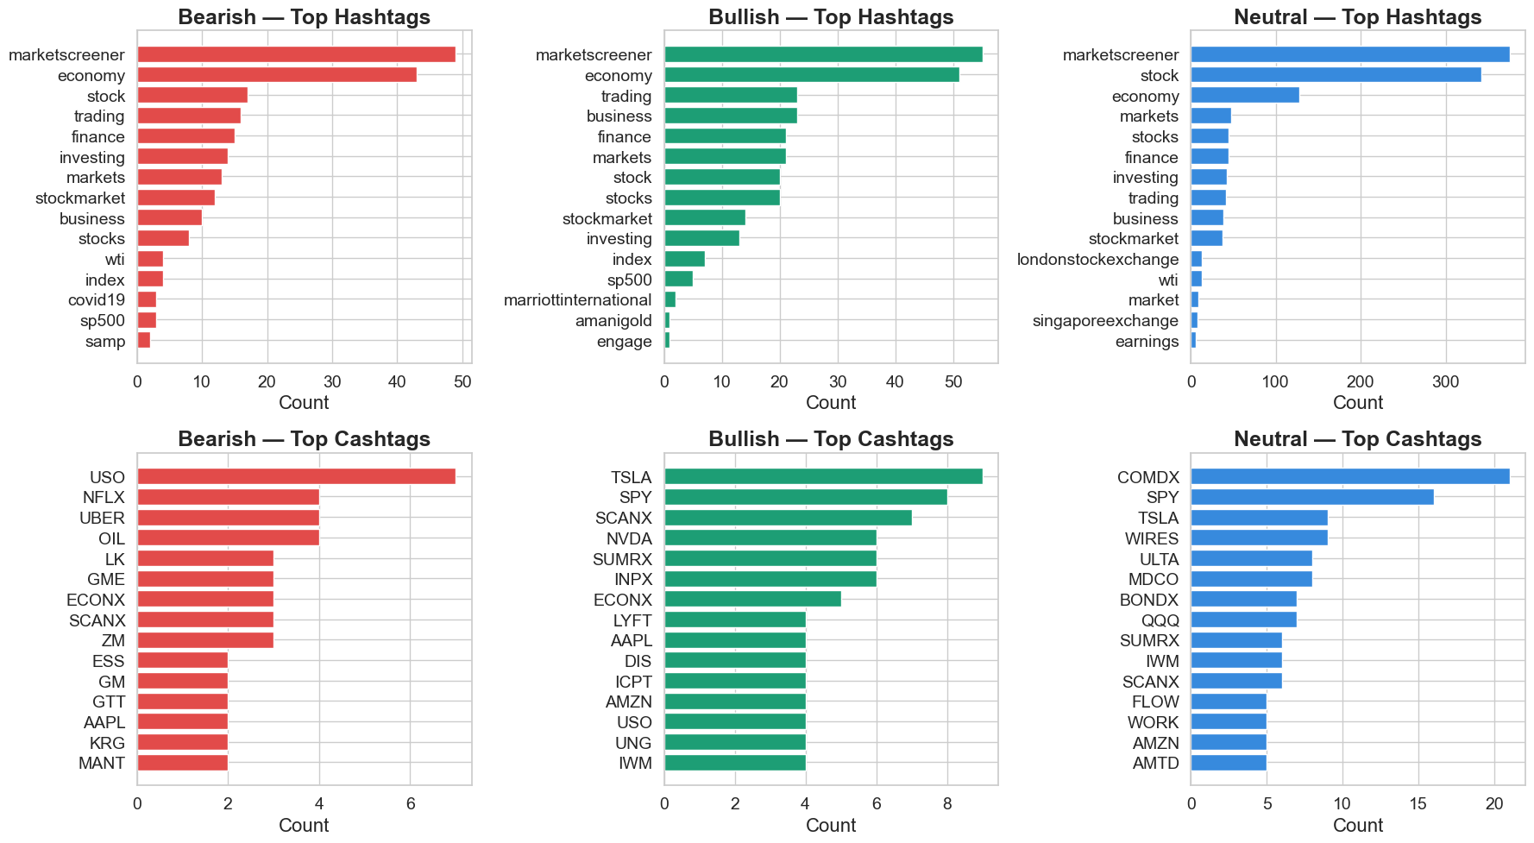
Figure 5: Top 15 most used hashtags and cashtags per class
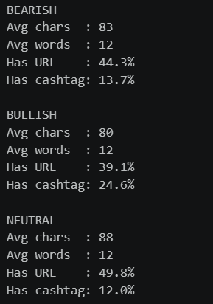

Figure 6: Class statistics regarding average number of characters, words and presence of URL and cashtag

Annexes

