# Information Visualization

# CHECKPOINT III: Visualization Sketch

G52

**1. Overview**

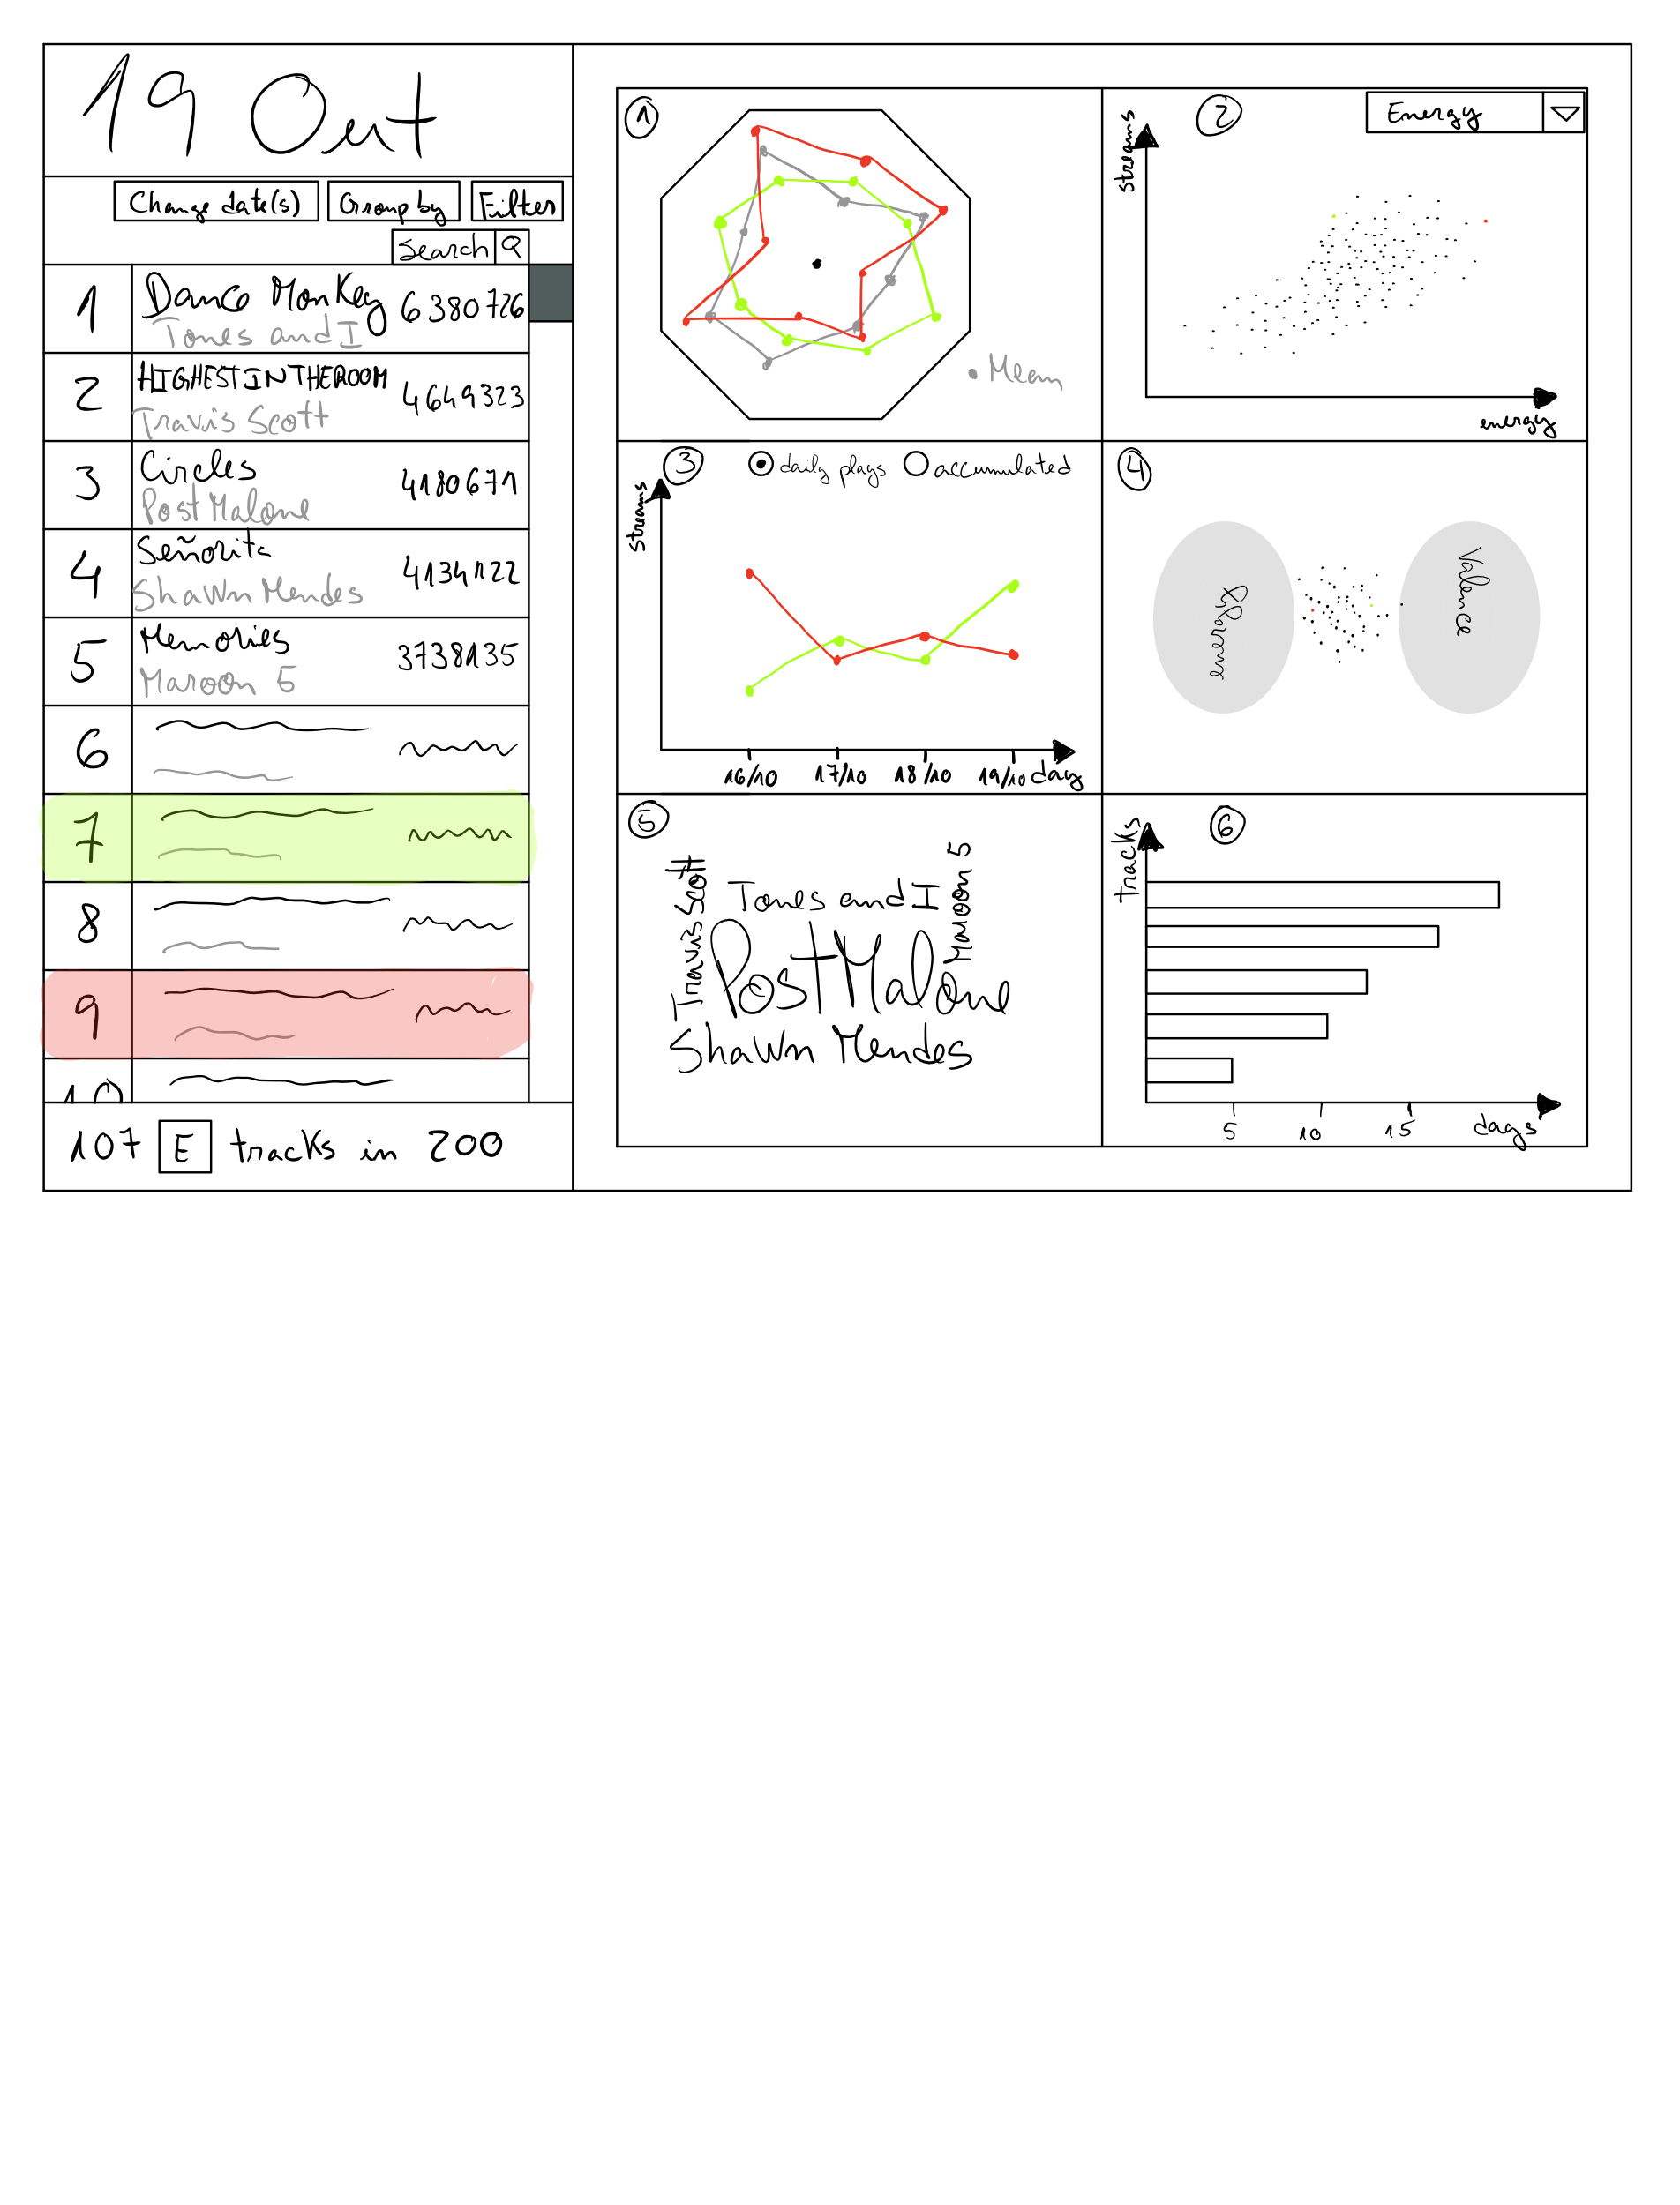

The visualization has a list with the tracks for a given day (or interval between two dates), ordered by the number of streams. The tracks shown can be filtered. All the idioms depend on the tracks that are being shown in the list. It is in this list that is selected the tracks for which the user wants to view the information. The selected tracks affect the idioms 1 through 4.

The idiom 1 is a spider chart with the purpose to compare the features values between tracks, this idiom always shows the mean value for each feature for all the tracks in the list.

The idiom 2 is a scatter plot with the purpose to see if there is a correlation between a selected feature and the number of streams.

The idiom 3 is a line chart that shows the daily streams or the accumulated daily streams for the selected tracks.

The idiom 4 is a multi-foci force layout, where each focus is a feature and the force it exerts over each track depends on the track’s value for that feature. The purpose is to show the distribution between multiple features.

The idiom 5 is a word cloud that shows which artists have more streams for the day or time period selected.

The idiom 6 is a bar chart that when a day is selected shows the *n* tracks that have been on the charts consecutively the longest, when a time period is selected it shows the tracks that spent more days consecutively for that time period.

**2. Visual Encoding**

Idiom 1:

Marks:

* Point – A track feature

Channels:

* Color – A selected track
* Position (distance to the center) – Feature value

Idiom 2:

Marks:

* Point – A track

Channels:

* Color – A selected track
* Position (vertical) – Number of streams
* Position (horizontal) – Feature value

Idiom 3:

Marks:

* Point – A track’s streams in a day or the accumulation

Channels:

* Color – A selected track
* Position (vertical) – Number of streams
* Position (horizontal) – Day

Idiom 4:

Marks:

* Point – A track

Channels:

* Color – A selected track
* Position – Distribution of various features

Idiom 5:

Marks:

* Word – An artist

Channels:

* Size – The artist’s accumulated streams

Idiom 6:

Marks:

* Bar – A track’s number of consecutive days on the charts

Channels:

* Length – Number of days

**3. Answering the questions**

**How does the features (energy, loudness, tempo, etc) of the track affect its popularity?**

After selecting in the liston the left the desired tracks to analyze. They will appear on the Star Chart (Idiom 1) and be highlighted on the Scatter Plot (Idiom 2), that way we can analyze with the average of all the tracks in the desired period. And we can also analyze specific traits of the tracks on the scatter plot, which will appear what we select with the rest of the tracks.

**Are music trends affected by the song duration?**

To understand if there is any correlation between the song duration and its popularity, we can choose the trait duration in the scatter plot (Idiom 2). And afterwards analyse the plot to see if indeed there is any correlation or not.

**Which artists have had a good 2019? Which tracks were most played during a period?**

To answer this question, we select in the list on the left, a range that spans all of 2019, and afterwards analyse the Word Cloud (Idiom 5) which will demonstrate with bigger letters the artists which were played the most. And also, by grouping the table on the left by artists we can analyse what were the streaming numbers for each artists track.

**What’s the evolution of the track’s streaming numbers during a period?**

After selecting the desired songs on the table on the left, they will appear on the line chart (Idiom 3) that demonstrates the tracks streaming numbers in the period in question. That way we can analyse its streaming numbers.

**Which tracks lasted longer on the top?**

After choosing the desired time span, the histogram (Idiom 6) will show the tracks that lasted longer on top, over consecutive days.

**Is there any correlation between the happiness / danceability of the most listened tracks with the time of year?**

