**Speed**

$$s=\frac{d}{∆t}=\frac{{|p}_{t_{2}}-p_{t_{1}}|}{t_{2}-t_{1}}$$

d – distance traveled

t – time elapsed

$p_{i}$– position at timestamp i

**Acceleration**

$$a=\frac{∆s}{∆t}=\frac{{|s}_{t_{2}}-s_{t_{1}}|}{t_{2}-t_{1}}$$

s – speed

t – time elapsed

**Turning Angle**

$$σ=arctan2(y, x)$$

arctan2 = “angle in the [Euclidean plane](https://en.wikipedia.org/wiki/Euclidean_plane), given in [radians](https://en.wikipedia.org/wiki/Radian), between the positive x axis and the [ray](https://en.wikipedia.org/wiki/Ray_(geometry)) to the point (x, y)”

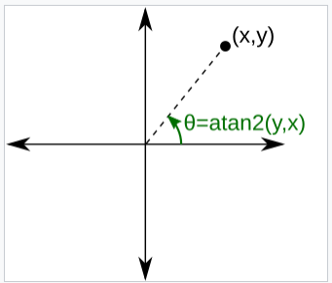

**Curvature**

$$k=\frac{{x'y}^{''}-y'x''}{{\left(x^{'2}+y^{'2}\right)}^{\frac{3}{2}}}$$

Intuition:

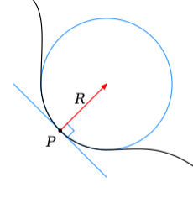

$$k=\frac{1}{R}$$

**Centered Distance**

$$cd=|p-c|$$

p – position

c – center of the trajectory

**Pass by**

* counter for each region

$$c_{i}=c_{i}+1 if p ⊆r_{i}$$

$c_{i}$– counter of region i

p – position

r – region

**Normalized Size of Bounding Box**

$$ns= \frac{w}{h}$$

w –width of the bounding box

h – height of the bounding box