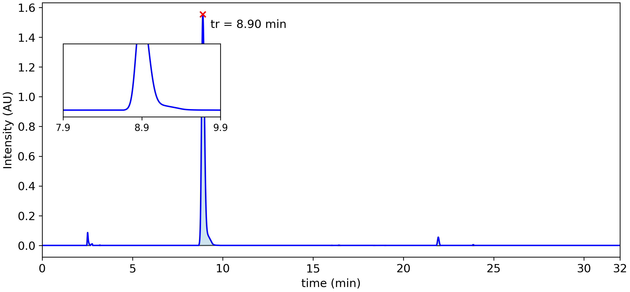

|  |  |  |  |  |  |  |
| --- | --- | --- | --- | --- | --- | --- |
| **Peak #** | **tstart (min)** | **tend (min)** | **rt (min)** | **Heightmax (AU)** | **Area (AU)** | **Area (%)** |
| 1 | 2.47 | 2.66 | 2.52 | 0.086 | 5.72x10-3 | 1.73 % |
| 2 | 3.16 | 3.23 | 3.19 | 0.003 | 9.38x10-5 | 0.03 % |
| 3 | 8.66 | 9.71 | 8.90 | 1.554 | 3.18x10-1 | 96.34 % |
| 4 | 15.98 | 16.10 | 16.04 | 0.001 | 5.05x10-5 | 0.01 % |
| 5 | 16.36 | 16.52 | 16.43 | 0.002 | 1.74x10-4 | 0.05 % |
| 6 | 18.35 | 18.42 | 18.38 | 0.000 | 1.05x10-5 | 0.00 % |
| 7 | 18.96 | 19.02 | 18.99 | 0.000 | 1.05x10-5 | 0.00 % |
| 8 | 21.82 | 22.06 | 21.93 | 0.055 | 5.64x10-3 | 1.71 % |
| 9 | 23.81 | 23.94 | 23.87 | 0.005 | 3.73x10-4 | 0.11 % |

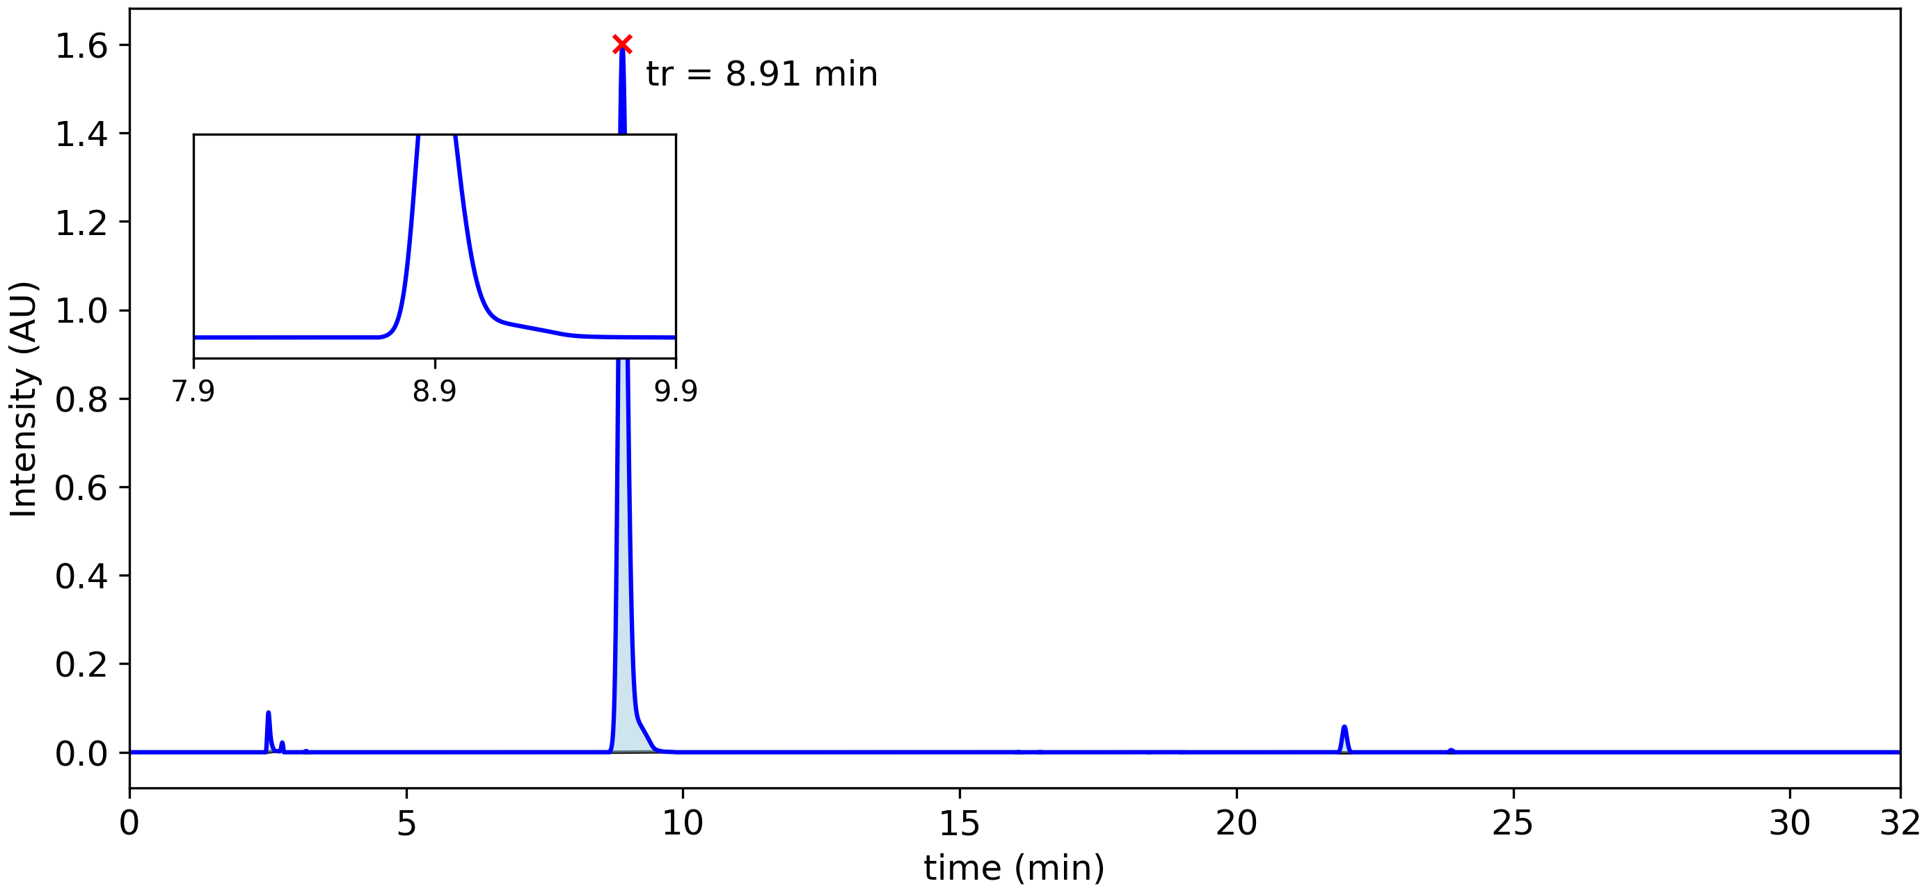

|  |  |  |  |  |  |  |
| --- | --- | --- | --- | --- | --- | --- |
| **Peak #** | **tstart (min)** | **tend (min)** | **rt (min)** | **Heightmax (AU)** | **Area (AU)** | **Area (%)** |
| 1 | 2.46 | 2.66 | 2.52 | 0.090 | 5.61x10-3 | 1.64 % |
| 2 | 3.16 | 3.23 | 3.19 | 0.003 | 1.05x10-4 | 0.03 % |
| 3 | 8.67 | 9.73 | 8.91 | 1.601 | 3.30x10-1 | 96.48 % |
| 4 | 16.01 | 16.12 | 16.06 | 0.001 | 4.06x10-5 | 0.01 % |
| 5 | 16.40 | 16.51 | 16.46 | 0.001 | 4.24x10-5 | 0.01 % |
| 6 | 18.40 | 18.43 | 18.41 | 0.000 | 3.70x10-7 | 0.00 % |
| 7 | 18.98 | 19.05 | 19.02 | 0.000 | 1.21x10-5 | 0.00 % |
| 8 | 21.84 | 22.08 | 21.95 | 0.058 | 5.88x10-3 | 1.72 % |
| 9 | 23.82 | 23.95 | 23.88 | 0.005 | 3.47x10-4 | 0.10 % |

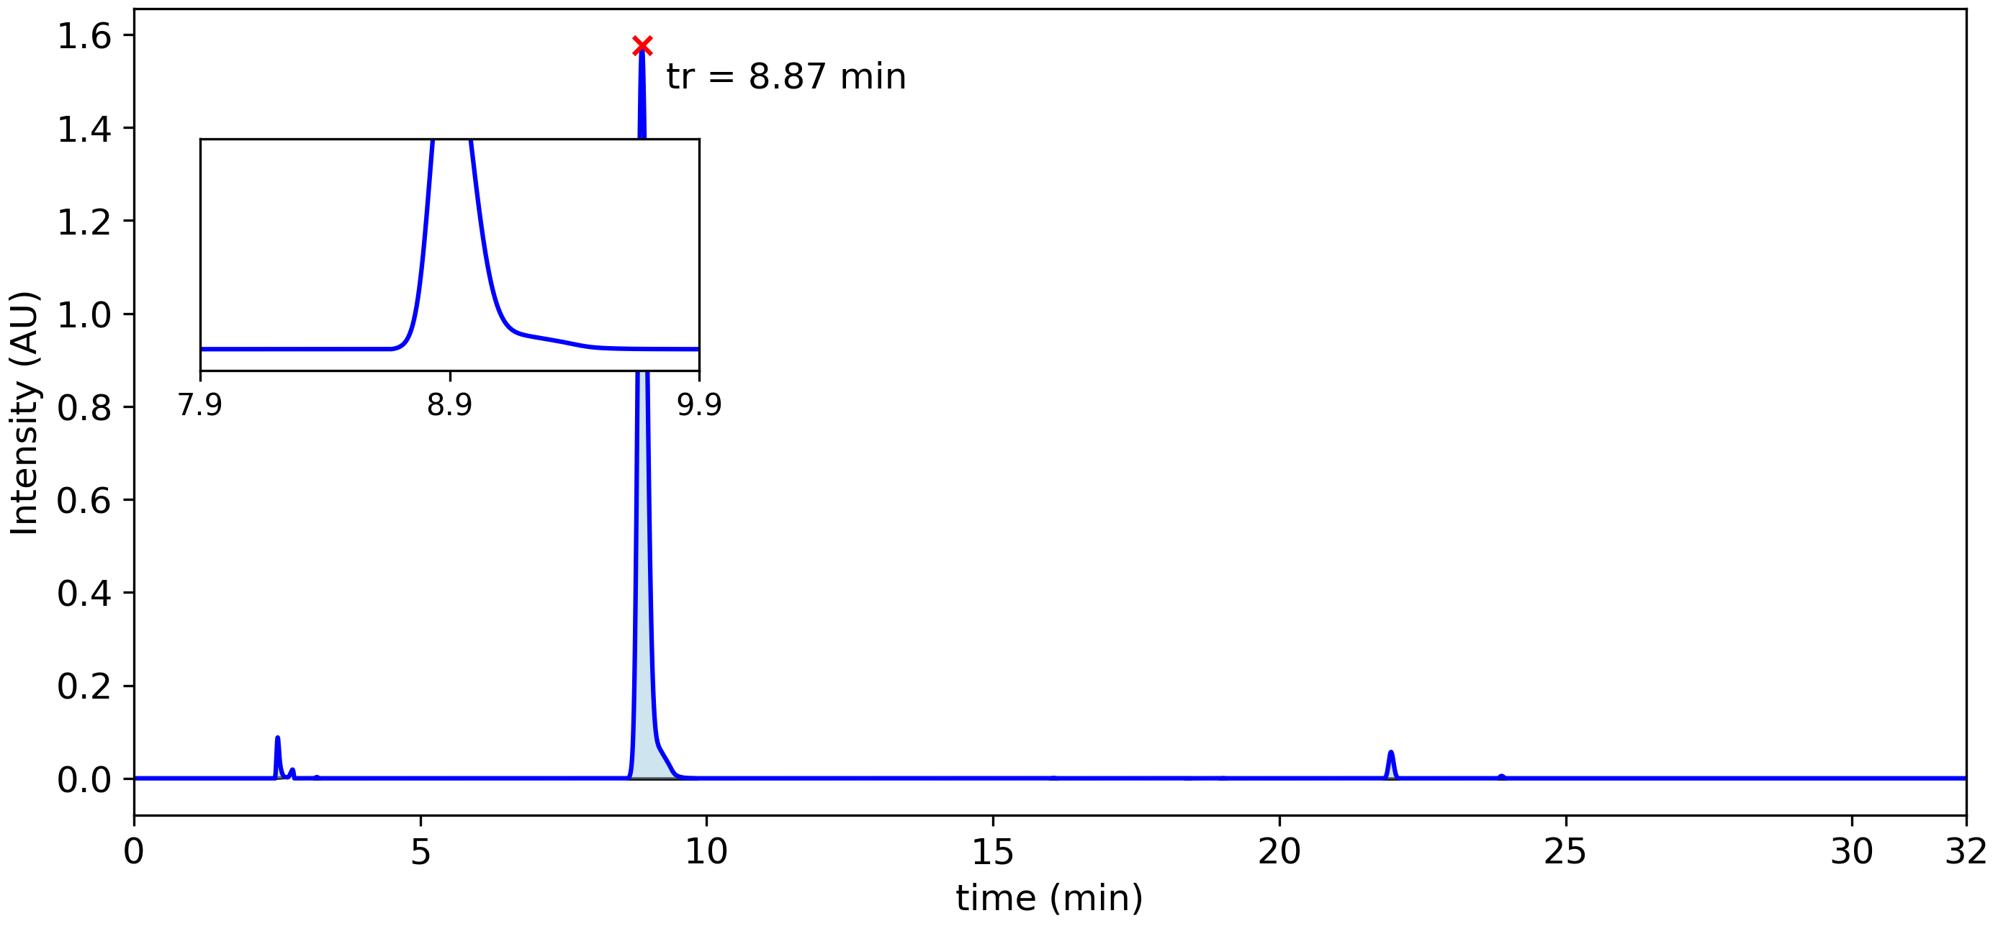

|  |  |  |  |  |  |  |
| --- | --- | --- | --- | --- | --- | --- |
| **Peak #** | **tstart (min)** | **tend (min)** | **rt (min)** | **Heightmax (AU)** | **Area (AU)** | **Area (%)** |
| 1 | 2.46 | 2.68 | 2.51 | 0.088 | 5.50x10-3 | 1.62 % |
| 2 | 3.16 | 3.23 | 3.20 | 0.003 | 9.95x10-5 | 0.03 % |
| 3 | 8.63 | 9.81 | 8.87 | 1.577 | 3.28x10-1 | 96.51 % |
| 4 | 16.00 | 16.12 | 16.06 | 0.001 | 5.11x10-5 | 0.01 % |
| 5 | 18.37 | 18.44 | 18.41 | 0.000 | 9.26x10-6 | 0.00 % |
| 6 | 18.96 | 19.06 | 19.01 | 0.000 | 2.77x10-5 | 0.01 % |
| 7 | 21.84 | 22.08 | 21.95 | 0.057 | 5.81x10-3 | 1.71 % |
| 8 | 23.82 | 23.95 | 23.88 | 0.005 | 3.61x10-4 | 0.11 % |

# Peak Summary

This table shows the peak with the largest percent area from each replicate.

|  |  |  |  |  |  |  |  |  |
| --- | --- | --- | --- | --- | --- | --- | --- | --- |
| File | index | t_start_min | t_end_min | rt_min | apex_intensity | area | pct_area | measure_value |
| f4724cccda014d8fadc1bd6ddcc1a4d7_kh26002.cdf | 3.0 | 8.6592 | 9.7125 | 8.8967 | 1.5544660091400146 | 0.318354 | 96.344 | 0.318354 |
| 027a5217ba2c46989076c0e8f57dcd08_kh26001.cdf | 3.0 | 8.6725 | 9.7333 | 8.9083 | 1.6011401414871216 | 0.329869 | 96.481 | 0.329869 |
| 68cf6d698b1b4968ad344d467442cbb3_kh26.cdf | 3.0 | 8.635 | 9.815 | 8.8733 | 1.5765708684921265 | 0.328011 | 96.513 | 0.328011 |

Mean of % Area: 96.45

Standard Deviation of % Area: 0.09