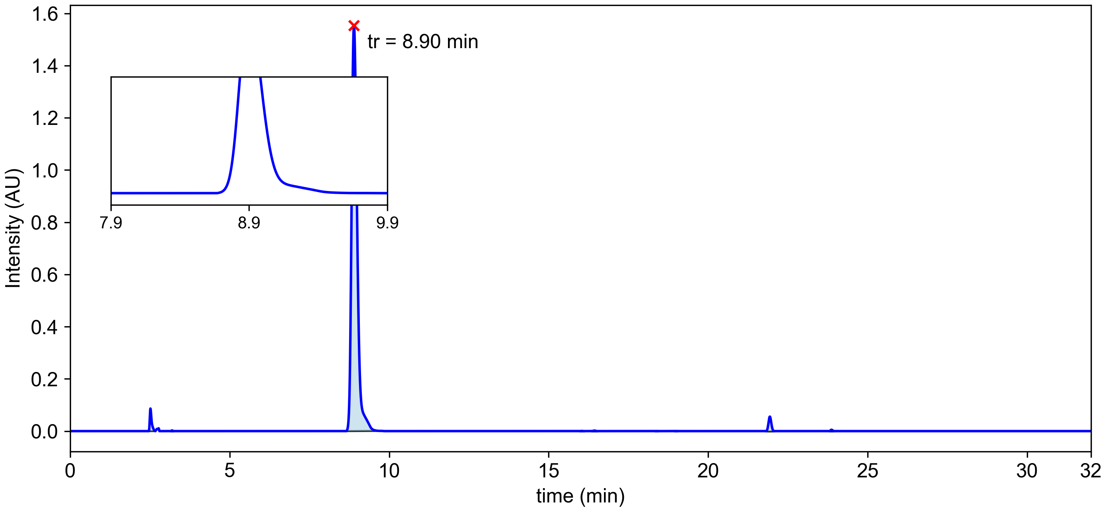

|  |  |  |  |  |  |  |
| --- | --- | --- | --- | --- | --- | --- |
| **Peak #** | **tstart (min)** | **tend (min)** | **rt (min)** | **Heightmax (AU)** | **Area (AU)** | **Area (%)** |
| 1 | 2.47 | 2.66 | 2.52 | 0.086 | 5.72x10-3 | 1.73 % |
| 2 | 3.16 | 3.23 | 3.19 | 0.003 | 9.38x10-5 | 0.03 % |
| 3 | 8.66 | 9.71 | 8.90 | 1.554 | 3.18x10-1 | 96.34 % |
| 4 | 15.98 | 16.10 | 16.04 | 0.001 | 5.05x10-5 | 0.01 % |
| 5 | 16.36 | 16.52 | 16.43 | 0.002 | 1.74x10-4 | 0.05 % |
| 6 | 18.35 | 18.42 | 18.38 | 0.000 | 1.05x10-5 | 0.00 % |
| 7 | 18.96 | 19.02 | 18.99 | 0.000 | 1.05x10-5 | 0.00 % |
| 8 | 21.82 | 22.06 | 21.93 | 0.055 | 5.64x10-3 | 1.71 % |
| 9 | 23.81 | 23.94 | 23.87 | 0.005 | 3.73x10-4 | 0.11 % |