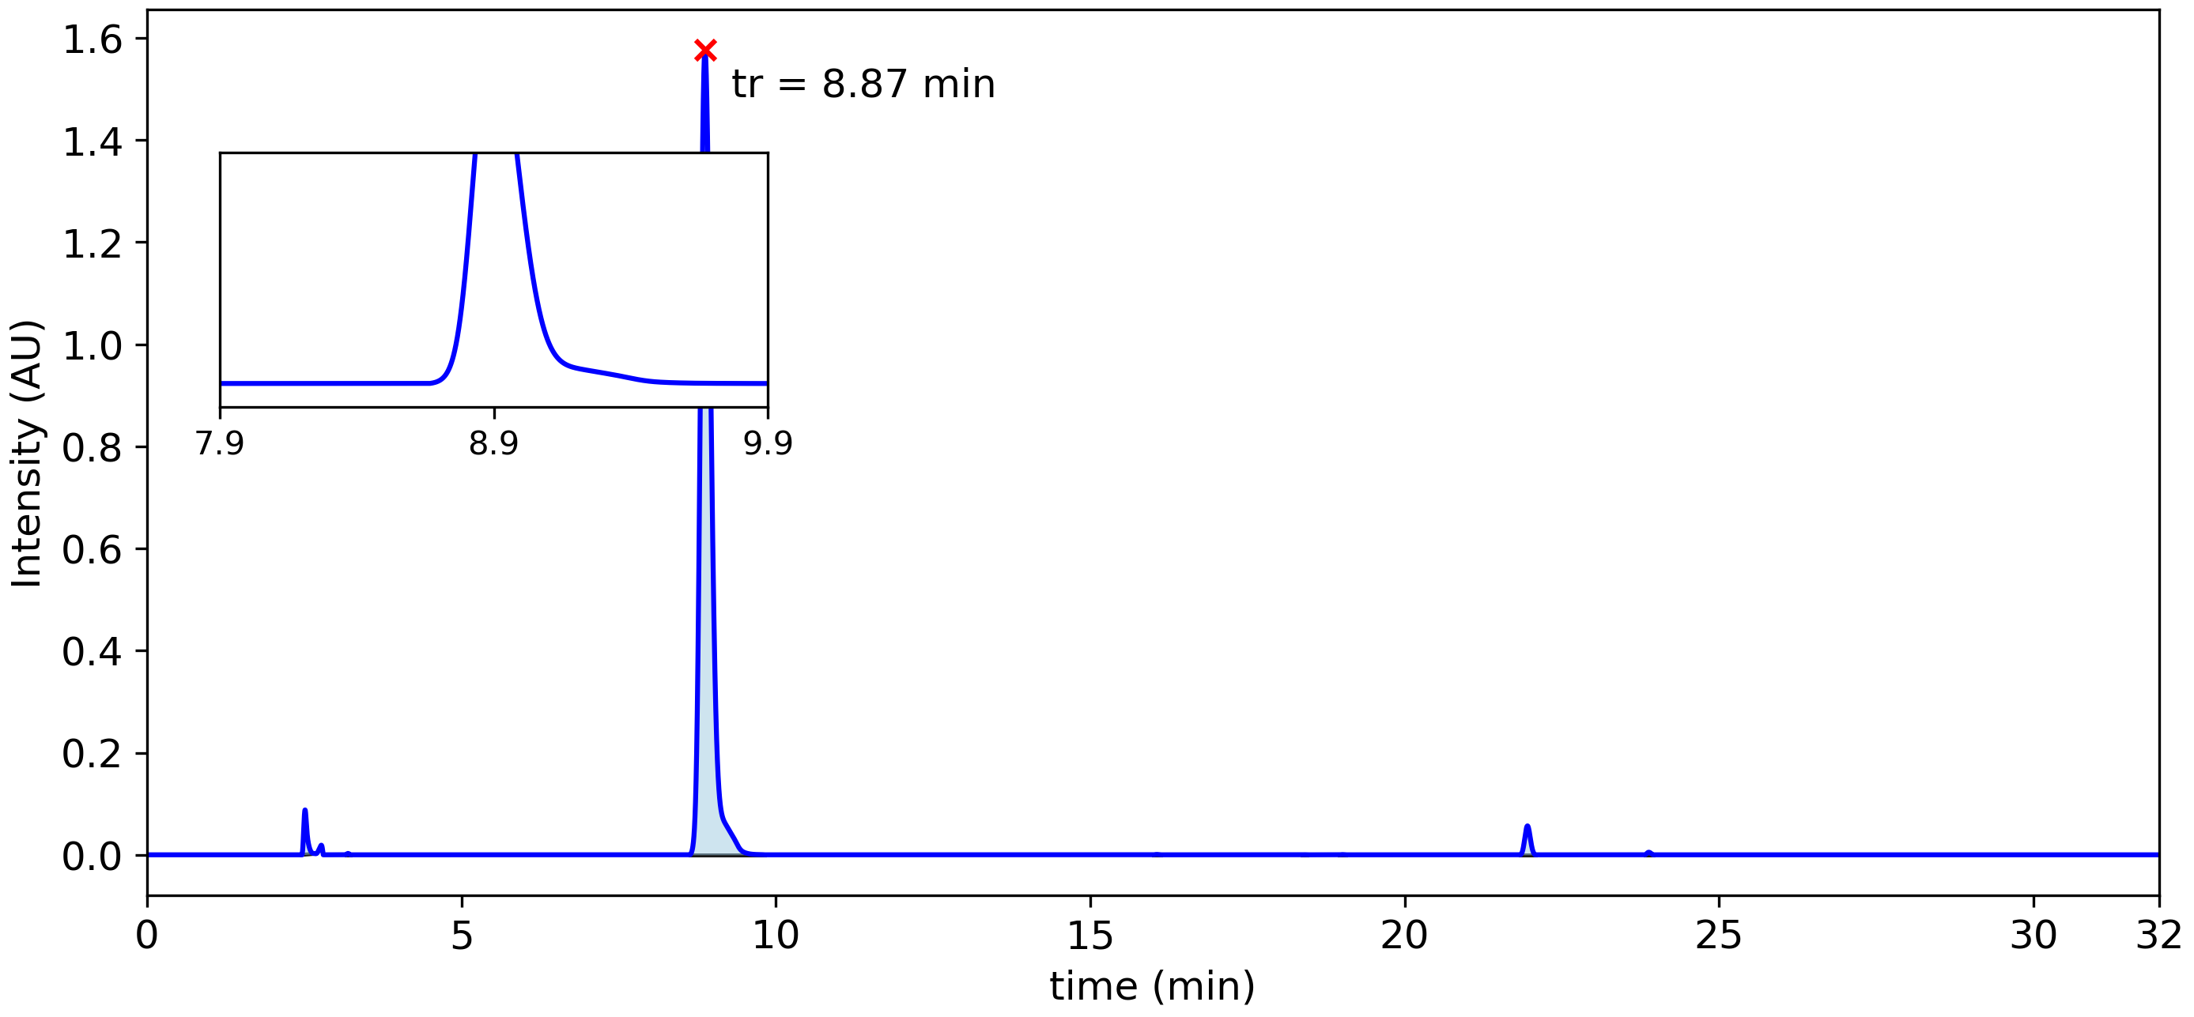

|  |  |  |  |  |  |  |
| --- | --- | --- | --- | --- | --- | --- |
| **Peak #** | **tstart (min)** | **tend (min)** | **rt (min)** | **Heightmax (AU)** | **Area (AU)** | **Area (%)** |
| 1 | 2.46 | 2.68 | 2.51 | 0.088 | 5.50x10-3 | 1.62 % |
| 2 | 3.16 | 3.23 | 3.20 | 0.003 | 9.95x10-5 | 0.03 % |
| 3 | 8.63 | 9.81 | 8.87 | 1.577 | 3.28x10-1 | 96.51 % |
| 4 | 16.00 | 16.12 | 16.06 | 0.001 | 5.11x10-5 | 0.01 % |
| 5 | 18.37 | 18.44 | 18.41 | 0.000 | 9.26x10-6 | 0.00 % |
| 6 | 18.96 | 19.06 | 19.01 | 0.000 | 2.77x10-5 | 0.01 % |
| 7 | 21.84 | 22.08 | 21.95 | 0.057 | 5.81x10-3 | 1.71 % |
| 8 | 23.82 | 23.95 | 23.88 | 0.005 | 3.61x10-4 | 0.11 % |