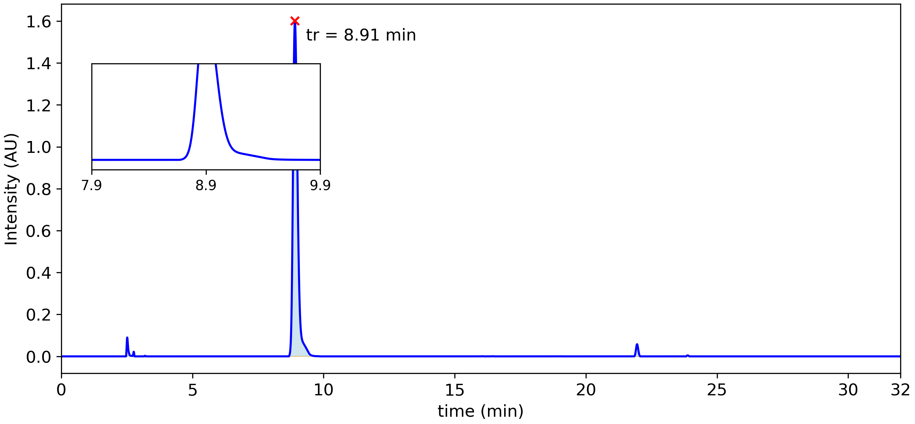

|  |  |  |  |  |  |  |
| --- | --- | --- | --- | --- | --- | --- |
| **Peak #** | **tstart (min)** | **tend (min)** | **rt (min)** | **Heightmax (AU)** | **Area (AU)** | **Area (%)** |
| 1 | 2.46 | 2.66 | 2.52 | 0.090 | 5.61x10-3 | 1.64 % |
| 2 | 3.16 | 3.23 | 3.19 | 0.003 | 1.05x10-4 | 0.03 % |
| 3 | 8.67 | 9.73 | 8.91 | 1.601 | 3.30x10-1 | 96.48 % |
| 4 | 16.01 | 16.12 | 16.06 | 0.001 | 4.06x10-5 | 0.01 % |
| 5 | 16.40 | 16.51 | 16.46 | 0.001 | 4.24x10-5 | 0.01 % |
| 6 | 18.40 | 18.43 | 18.41 | 0.000 | 3.70x10-7 | 0.00 % |
| 7 | 18.98 | 19.05 | 19.02 | 0.000 | 1.21x10-5 | 0.00 % |
| 8 | 21.84 | 22.08 | 21.95 | 0.058 | 5.88x10-3 | 1.72 % |
| 9 | 23.82 | 23.95 | 23.88 | 0.005 | 3.47x10-4 | 0.10 % |

# Peak Summary

This table shows the peak with the largest percent area from each replicate.

|  |  |  |  |  |  |  |  |  |
| --- | --- | --- | --- | --- | --- | --- | --- | --- |
| File | index | t_start_min | t_end_min | rt_min | apex_intensity | area | pct_area | measure_value |
| 2302eabd3d77461d80ff524cc6b31845_kh26001.cdf | 3.0 | 8.6725 | 9.7333 | 8.9083 | 1.6011401414871216 | 0.329869 | 96.481 | 0.329869 |

Mean of % Area: 96.48

Standard Deviation of % Area: nan