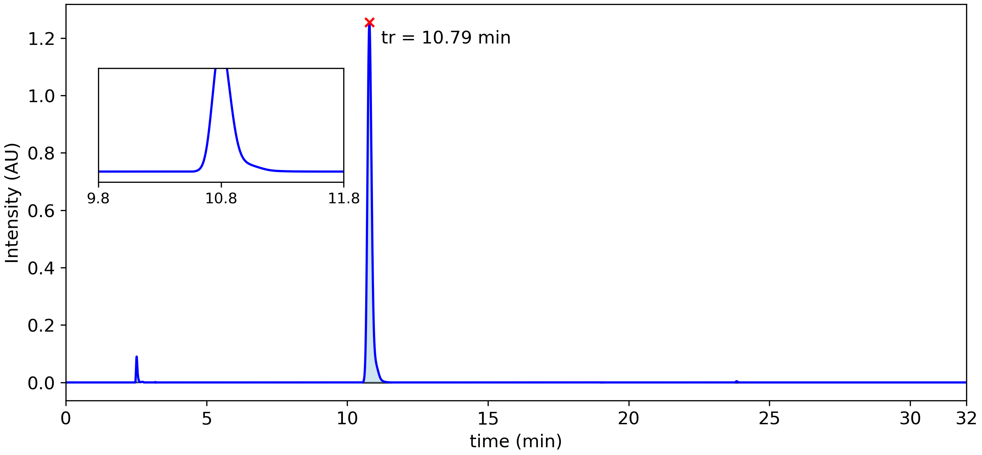

|  |  |  |  |  |  |  |
| --- | --- | --- | --- | --- | --- | --- |
| **Peak #** | **tstart (min)** | **tend (min)** | **rt (min)** | **Heightmax (AU)** | **Area (AU)** | **Area (%)** |
| 1 | 2.47 | 2.65 | 2.52 | 0.090 | 5.30x10-3 | 2.23 % |
| 2 | 3.15 | 3.21 | 3.18 | 0.001 | 4.18x10-5 | 0.02 % |
| 3 | 10.55 | 11.55 | 10.79 | 1.255 | 2.32x10-1 | 97.62 % |
| 4 | 18.99 | 19.08 | 19.03 | 0.000 | 1.58x10-5 | 0.01 % |
| 5 | 23.78 | 23.90 | 23.83 | 0.004 | 2.88x10-4 | 0.12 % |