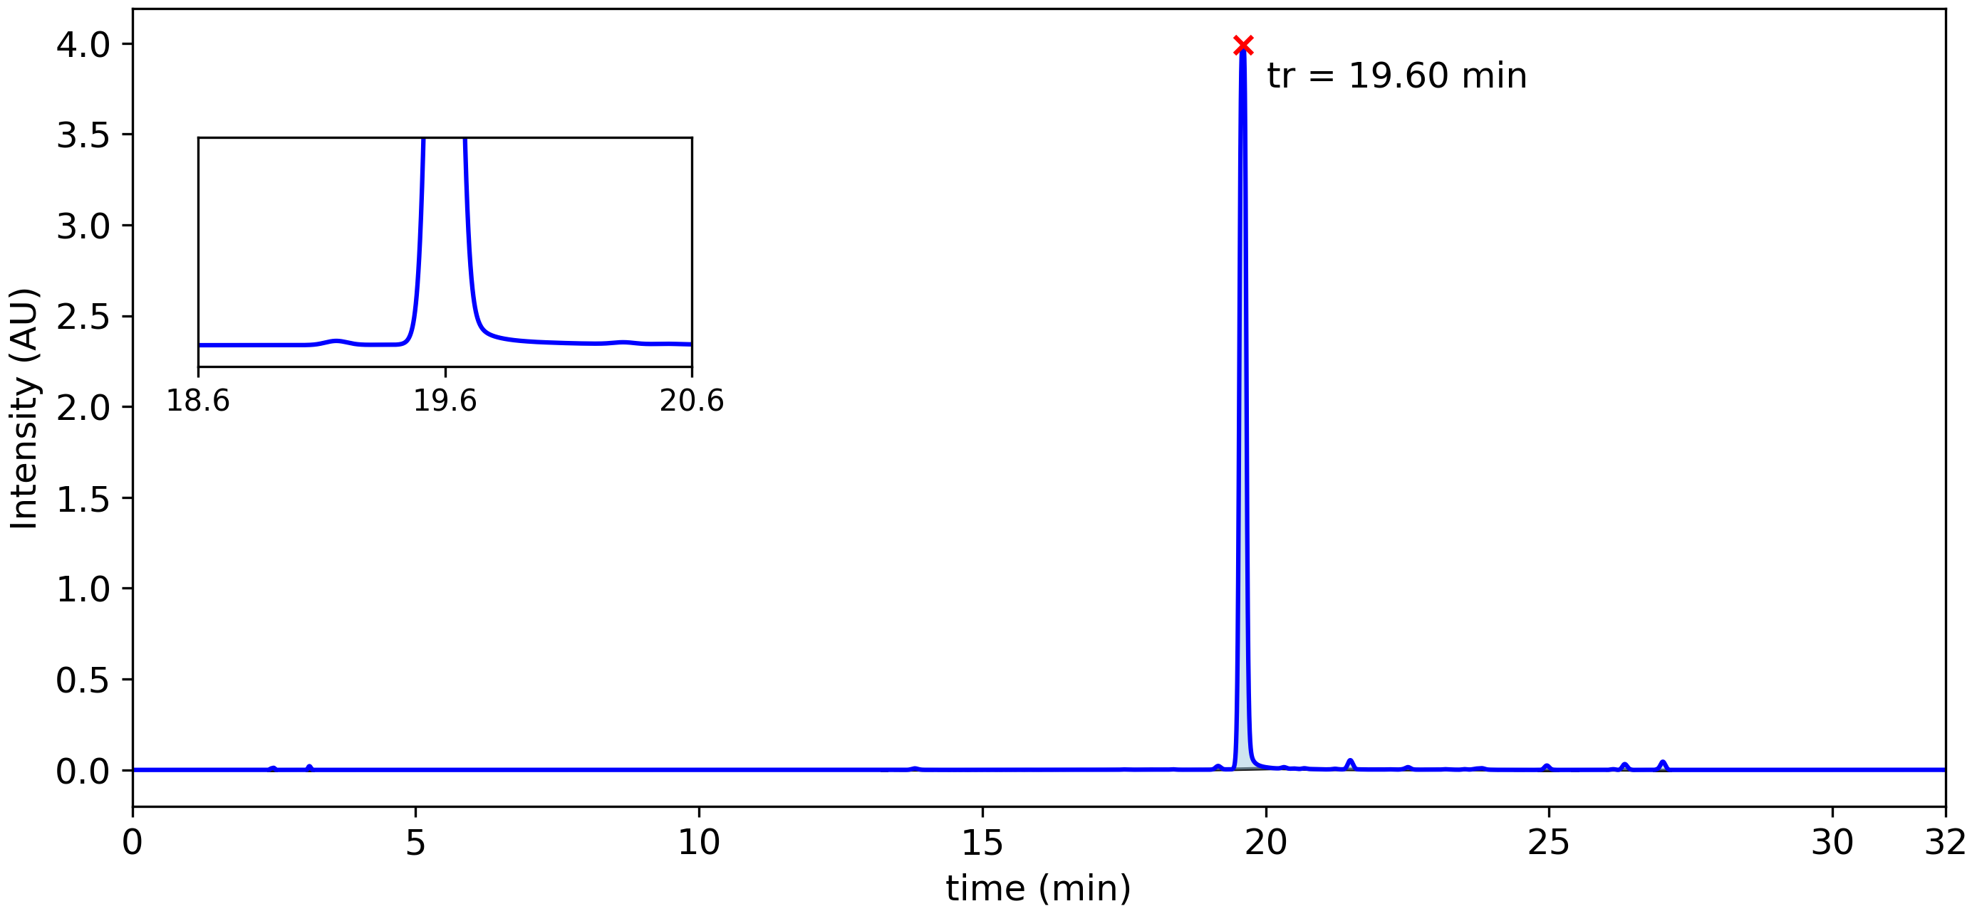

|  |  |  |  |  |  |  |
| --- | --- | --- | --- | --- | --- | --- |
| **Peak #** | **tstart (min)** | **tend (min)** | **rt (min)** | **Heightmax (AU)** | **Area (AU)** | **Area (%)** |
| 1 | 2.41 | 2.53 | 2.49 | 0.012 | 8.76x10-4 | 0.15 % |
| 2 | 3.08 | 3.18 | 3.13 | 0.021 | 1.13x10-3 | 0.19 % |
| 3 | 13.23 | 13.30 | 13.27 | 0.000 | 8.81x10-7 | 0.00 % |
| 4 | 13.47 | 13.57 | 13.52 | 0.000 | 3.45x10-6 | 0.00 % |
| 5 | 13.57 | 13.63 | 13.60 | 0.000 | 6.44x10-7 | 0.00 % |
| 6 | 13.63 | 14.11 | 13.81 | 0.008 | 1.16x10-3 | 0.20 % |
| 7 | 14.24 | 14.42 | 14.36 | 0.000 | 6.32x10-6 | 0.00 % |
| 8 | 14.42 | 14.51 | 14.47 | 0.000 | 2.38x10-6 | 0.00 % |
| 9 | 14.51 | 14.61 | 14.54 | 0.000 | 9.71x10-7 | 0.00 % |
| 10 | 14.61 | 14.72 | 14.67 | 0.000 | 2.79x10-6 | 0.00 % |
| 11 | 14.72 | 14.77 | 14.73 | 0.000 | 1.43x10-7 | 0.00 % |
| 12 | 14.77 | 14.89 | 14.84 | 0.000 | 3.68x10-6 | 0.00 % |
| 13 | 14.89 | 14.98 | 14.96 | 0.000 | 1.05x10-6 | 0.00 % |
| 14 | 14.98 | 15.10 | 15.01 | 0.000 | 1.33x10-6 | 0.00 % |
| 15 | 15.10 | 15.25 | 15.15 | 0.000 | 8.08x10-6 | 0.00 % |
| 16 | 15.25 | 15.32 | 15.29 | 0.000 | 9.96x10-7 | 0.00 % |
| 17 | 15.32 | 15.42 | 15.41 | 0.000 | 1.78x10-6 | 0.00 % |
| 18 | 15.43 | 15.50 | 15.48 | 0.001 | 1.03x10-6 | 0.00 % |
| 19 | 15.50 | 15.58 | 15.52 | 0.001 | 5.79x10-7 | 0.00 % |
| 20 | 15.58 | 15.72 | 15.68 | 0.001 | 2.10x10-6 | 0.00 % |
| 21 | 15.72 | 15.77 | 15.76 | 0.001 | 2.07x10-7 | 0.00 % |
| 22 | 15.77 | 15.90 | 15.83 | 0.001 | 5.44x10-6 | 0.00 % |
| 23 | 15.90 | 15.97 | 15.93 | 0.001 | 9.90x10-7 | 0.00 % |
| 24 | 15.97 | 16.02 | 15.99 | 0.001 | 2.54x10-7 | 0.00 % |
| 25 | 16.02 | 16.23 | 16.16 | 0.001 | 9.79x10-6 | 0.00 % |
| 26 | 16.23 | 16.31 | 16.28 | 0.001 | 1.85x10-6 | 0.00 % |
| 27 | 16.31 | 16.44 | 16.39 | 0.001 | 4.47x10-6 | 0.00 % |
| 28 | 16.44 | 16.55 | 16.55 | 0.001 | 1.16x10-6 | 0.00 % |
| 29 | 16.60 | 16.75 | 16.70 | 0.001 | 8.13x10-6 | 0.00 % |
| 30 | 16.75 | 16.86 | 16.78 | 0.001 | 1.88x10-6 | 0.00 % |
| 31 | 16.86 | 17.23 | 17.06 | 0.002 | 9.34x10-5 | 0.02 % |
| 32 | 17.23 | 17.30 | 17.27 | 0.001 | 1.31x10-6 | 0.00 % |
| 33 | 17.30 | 17.38 | 17.36 | 0.001 | 1.52x10-6 | 0.00 % |
| 34 | 17.38 | 17.61 | 17.49 | 0.002 | 1.30x10-4 | 0.02 % |
| 35 | 17.61 | 17.69 | 17.65 | 0.001 | 1.66x10-6 | 0.00 % |
| 36 | 17.69 | 17.98 | 17.94 | 0.002 | 1.07x10-5 | 0.00 % |
| 37 | 17.98 | 18.22 | 18.01 | 0.002 | 1.22x10-5 | 0.00 % |
| 38 | 18.22 | 18.60 | 18.36 | 0.003 | 2.30x10-4 | 0.04 % |
| 39 | 18.73 | 18.84 | 18.80 | 0.001 | 1.40x10-6 | 0.00 % |
| 40 | 18.84 | 18.91 | 18.85 | 0.001 | 3.96x10-7 | 0.00 % |
| 41 | 18.91 | 19.30 | 19.16 | 0.022 | 2.11x10-3 | 0.36 % |
| 42 | 19.38 | 20.21 | 19.60 | 3.991 | 5.59x10-1 | 95.19 % |
| 43 | 20.21 | 20.43 | 20.32 | 0.015 | 7.36x10-4 | 0.12 % |
| 44 | 20.43 | 20.59 | 20.50 | 0.008 | 1.22x10-4 | 0.02 % |
| 45 | 20.59 | 21.06 | 20.68 | 0.009 | 5.30x10-4 | 0.09 % |
| 46 | 21.06 | 21.34 | 21.22 | 0.006 | 3.44x10-4 | 0.06 % |
| 47 | 21.34 | 21.77 | 21.49 | 0.054 | 5.56x10-3 | 0.95 % |
| 48 | 21.86 | 22.00 | 21.91 | 0.002 | 1.30x10-5 | 0.00 % |
| 49 | 22.00 | 22.05 | 22.02 | 0.002 | 5.45x10-7 | 0.00 % |
| 50 | 22.05 | 22.30 | 22.18 | 0.003 | 1.42x10-4 | 0.02 % |
| 51 | 22.30 | 22.68 | 22.51 | 0.015 | 1.64x10-3 | 0.28 % |
| 52 | 22.82 | 23.03 | 22.95 | 0.002 | 3.98x10-5 | 0.01 % |
| 53 | 23.03 | 23.39 | 23.16 | 0.004 | 3.92x10-4 | 0.07 % |
| 54 | 23.39 | 23.59 | 23.51 | 0.004 | 2.12x10-4 | 0.04 % |
| 55 | 23.59 | 24.10 | 23.81 | 0.009 | 1.47x10-3 | 0.25 % |
| 56 | 24.41 | 24.54 | 24.48 | 0.000 | 1.48x10-5 | 0.00 % |
| 57 | 24.82 | 25.15 | 24.96 | 0.024 | 2.58x10-3 | 0.44 % |
| 58 | 25.41 | 25.50 | 25.46 | 0.000 | 1.62x10-5 | 0.00 % |
| 59 | 26.03 | 26.21 | 26.13 | 0.004 | 3.37x10-4 | 0.06 % |
| 60 | 26.21 | 26.49 | 26.33 | 0.032 | 3.33x10-3 | 0.57 % |
| 61 | 26.85 | 27.13 | 27.01 | 0.045 | 4.90x10-3 | 0.83 % |
| 62 | 31.96 | 32.00 | 32.00 | 0.001 | 1.19x10-17 | 0.00 % |