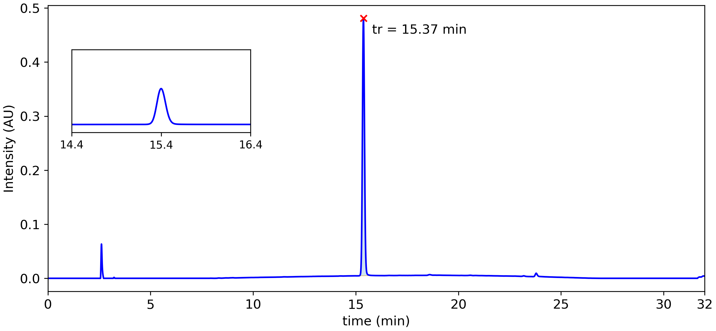

|  |  |  |  |  |  |  |
| --- | --- | --- | --- | --- | --- | --- |
| **Peak #** | **tstart (min)** | **tend (min)** | **rt (min)** | **Heightmax (AU)** | **Area (AU)** | **Area (%)** |
| 52 | 15.12 | 15.85 | 15.37 | 0.481 | 5.70x10-2 | 100.00 % |

# Peak Summary

This table shows the peak with the largest percent area from each replicate.

|  |  |  |  |  |  |  |  |  |
| --- | --- | --- | --- | --- | --- | --- | --- | --- |
| File | index | t_start_min | t_end_min | rt_min | apex_intensity | area | pct_area | measure_value |
| 123da1a4a150437fab52fe81f45b7349_ku104_1.cdf | 52.0 | 15.1208 | 15.8533 | 15.3717 | 0.4808749854564666 | 0.0569966 | 100.0 | 0.0569966 |

Mean of % Area: 100.00

Standard Deviation of % Area: nan