G093_User Manual

João Sousa 1222123
Diogo Silva 1241229
Gonçalo Pinto 1241232
Gonçalo Tavares 1241234

Índice
Introduction 3
Program Overview 4
System Requirements 5
Features 6
Main Menu 6
The Editor 6
1. Create Map 7
2. Create City 7
3. Create Scenario 7
4. Display Map 7
The Player 8
1. Build a Station 10
2. Upgrade a Station (Type) 10
3. Upgrade a Station (Building) 10
4. Buy a Locomotive 10
5. List my locomotives 11
6. Associate a locomotive to a route 11
7. Pause the game 11
Troubleshooting & Helpdesk 12
FAQ 13

Figure 1 - Main Menu 6
Figure 2 - The Editor Menu 7
Figure 3 - Map Display for the Editor 8
Figure 4 - Players' Menu 9
Figure 5 - Players' Options during the game 9
Figure 6 - A Depot in the Map 10
Figure 7 - List of Locomotives 11
Figure 8 - Main Menu while the Game is Paused 11

Introduction
In this User Manual, we’re going to go over some of the details of this project, such as detailed information on how to play, what are the requirements for running this project and the features of this project. We’re also going to include a troubleshooting tab, as well as a FAQ tab.

Program Overview
This program was designed to be a game about a railway management system. It includes the possibility to create cities, buy stations and upgrade such stations, giving them bonuses to enhance their use during the gameplay. We can also buy locomotives, which deliver cargo produced by industries to cities. These actions produce money, which makes the player’s budget increase. This project has a very innovative part to it, which defines the tech limitations simulating different timestamps on human history.

System Requirements
To run this program, the user needs to have a functional computer with Java 23 installed. There are no external requirements outside of GraphViz, SLF4J and Apache Commons, which are used to view graphs made in the folder railway_connectivity.

Features
The user can login into 2 roles: Player (who plays the game) and Editor (who prepares the game for the Player). The Editor is responsible to create the maps, place cities and their respective house blocks into the map, and create a scenario, which will be associated to one and only one map. Players can place different types of stations on a select map and scenario, as well as upgrade them. Positioned stations can be upgraded and connected by railway lines. After the cargo of a city/industry finishes the producing state, players can choose a locomotive and retrieve the cargo, to increase their budget and allow them to progress into the game.

Main Menu
The first menu the app presents is the general menu. Here, the user can login into an account (which can be an account from an Editor or from a Player), create a new account or even see the development team for this project.
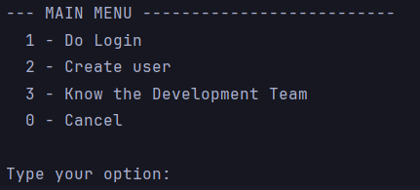
Figure 1 - Main Menu

After creating the account, the user can play. But beforehand, someone needs to create a map and scenario in which the player will play. That’s the job of the editor.

The Editor
When the editor logs into his account, he is presented with a menu that showcases what he can do.
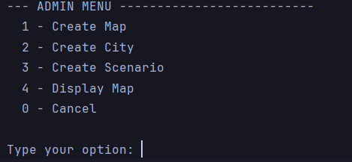
Figure 2 - The Editor Menu

Create Map
Create Map allows the Editor to define the width and height of a map. This data is important to the player, for him to understand the size of the map and being able to place his stations inside the map.

Create City
Create City allows the Editor to place a city inside a certain map. He can choose the City’s center coordinates, but he must respect the map size (can’t place it outside the map) or in the same position as another city. Cities are also made of House Blocks, which are responsible for producing cargo. House Blocks can be placed manually or automatically. Manually, the editor chooses the X and Y coordinates himself, however in Automatic, the program runs a normal distribution to determine their positions.

Create Scenario
Create Scenario allows the Editor to create a scenario for a specific map. Scenarios basically define the rules of the game, whether it being by specifying the types of locomotives the player can use, the start and finishing year of the simulation, and the historical restrictions (for example, if there is a school program happening, there will be an increase in production regarding cities). All these aspects matter, because each one of them impacts gameplay.

Display Map
Display Map allows the Editor to see a map, and all the cities and house blocks placed there.
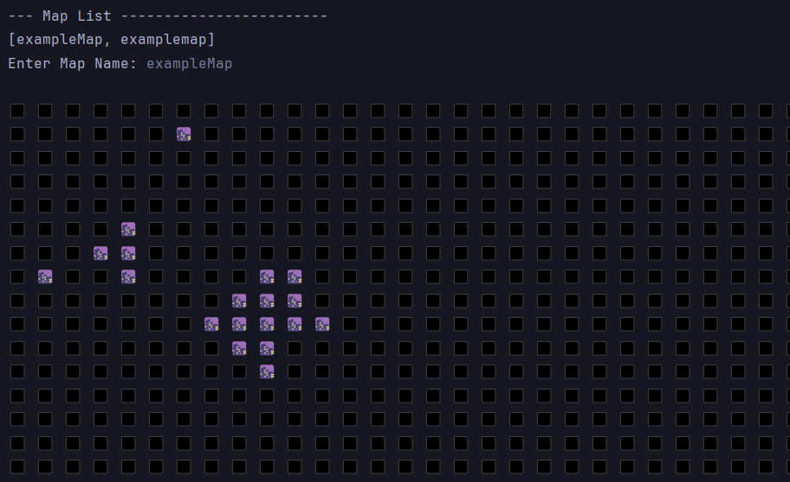
Figure 3 - Map Display for the Editor

The Player
The player, as soon as he logs in, is presented with the Players Menu. In this menu, he can play the game or log out if he wants to. If he chooses to play the game, he must choose the map, and the scenario of that map he wants to play in.
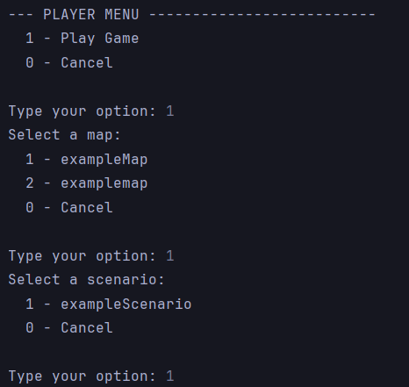
Figure 4 - Players' Menu
After he chooses what map and what scenario he wants to play in, the map is displayed for map, and alongside it, a long list of options.
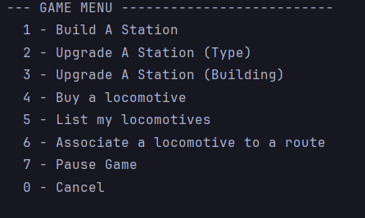
Figure 5 - Players' Options during the game
As soon as he starts the game, the time will start to count. The years will go by, and with it (if there are available stations) the cities will start to produce cargo. This is where the strategic part of the gameplay kicks in. If he stays on the menu, the years will go on. The current year determines what locomotives he can buy and what type of buildings he can use. When the simulator reaches the final year for that specific scenario, the game finishes, sending him back to the main menu. However, it is important to notice that when the player is interacting with the menu itself, the cargo will stop to be produced, and the years will pause.

Build a Station
The player can build three main types of station: depots, stations and terminals, each one having different prices and different capacities to storage cargo. Not only that, but each type of station also occupies a different area on the map, with Depots occupying a 3x3 area, stations a 4x4 area and terminals 5x5 area. The name of the station will be automatically generated, based on the nearest city and the type of station it is. After buying one, the map will update itself, showing the location of the newly bought station.
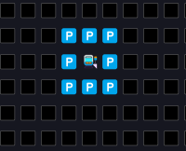
Figure 6 - A Depot in the Map

Upgrade a Station (Type)
If the player has a Depot, however he wants to have a Station at the same location, he can do it. Upgrade Station (Type) allows the player to choose one of the stations he owns on that map and change its type. Depots can transform into Stations and Terminals, and Stations can become Terminals, but Terminals are not allowed to be upgraded in this part.

Upgrade a Station (Building)
With this option, the player can choose one of the stations he owns on that map and upgrade it with a building. Buildings can grant a variety of bonuses to that station, allowing it to become more profitable.

Buy a Locomotive
The main objective of the game is to earn more and more money, but to do that, after placing stations and letting them fill themselves with cargo, it’s time to buy a Locomotive. In our project, players can pick from a variety of different locomotives, counting 65 in total. Every one of them has different top speeds, different types (steam, diesel or electric), different maintenance and fuel costs (the player must pay the maintenance and fuel yearly, otherwise the locomotive becomes unavailable, until the player has enough budget to be able to use it again).

List my locomotives
When the player starts to own a lot of locomotives, it can become hard to track the ones he owns and the ones he doesn’t. Using this option, the software will display all the locomotives that the player owns.
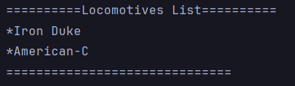
Figure 7 - List of Locomotives

Associate a locomotive to a route
This is where the player can increase his budget. When the player wants to, and there is cargo available to pick from at least 2 stations, the player can create a route. The route can be formed by only 2 stations, or by more. If there are more than 2 stations, the player can choose the starting and finish point of the route and decide whether there will be other stops in the middle. The player also needs to choose what type of carriages there will be on the train, and how many of them. The type of carriages decides what type of cargo it can carry. After the route is finished, the player will receive money according to the amount of cargo the player picked and delivered.

Pause the game
The years will go by, but the player can change that. By using this function, the game will stop counting years and produce cargo. It’s a practical functionality, since the player can stay away from the computer, but the years won’t go by, and right after he comes back, he can press the option to “Resume Game” and pick up from where he left.
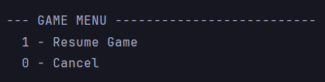
Figure 8 - Main Menu while the Game is Paused

Troubleshooting & Helpdesk
Currently, the only issue we’re facing is related to the folder railway_connectivity, which only works if present in the root of the Desktop.

FAQ
There are currently no FAQs. Any possible doubts will be investigated, and if necessary, we will update this section.

