DATA MINING

GROUP 9: GONCALO, SUSHANT

PHASE 2 – SETTING UP RASPBERRY PI

For this phase, we chose option 2 to setup the raspberry pi, where we setup a direct connection to VNC Viewer.

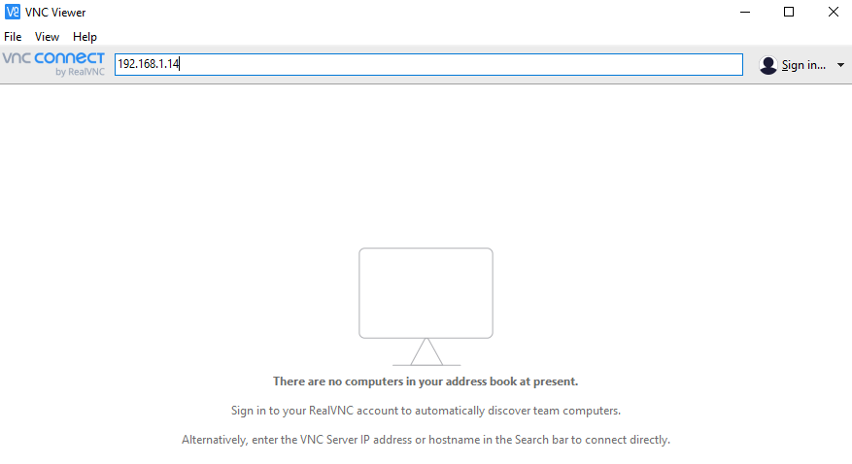

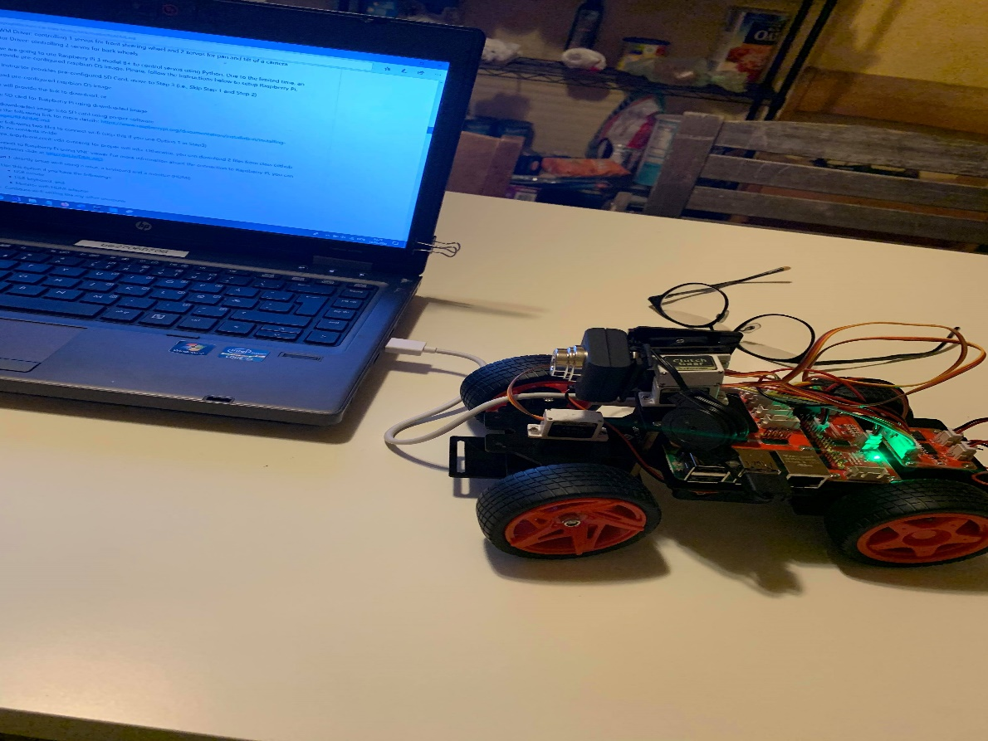

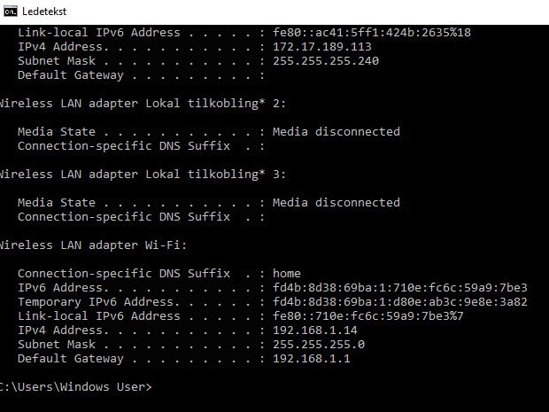

Ideas for improvement of PI-Car –

* The setup is a bit complicated for the raspberry pi, because it is not easy to find the IP address in our network.
* Using the option of the VNC Viewer it makes it possible after finding the IP address, but after trying option 1 with hotspot and option 3 with cloud, it was impossible as most of the instructions fail.
* The best way to improve would be to have a setup where we could work already with our own mouse and keyboard. A small user interface that displays raspberry pi environment, that is what I would do if this project would be longer and harder.
* Cables wise, it is also unclear which connections we have to make with Raspberry pi board to connect it to our computer, to the wi-fi and also to the power.