**Attendance Manager**

**General Overview:**

This is a mobile app designed for **managing classroom attendance**. The app supports two types of users:  
**Teachers** and **Admins**, each with their own unique interfaces and permissions.

**Login & Role Detection**

1. **User logs in** via a login form (Firebase Authentication).
2. After login, the app checks the user’s **role** (stored in Firestore):
   * If **Teacher** ➝ goes to **Teacher Home** screen.
   * If **Admin** ➝ goes to **Admin Panel**.

**Teacher Features:**

* **View Assigned Classes**
* **Edit Class Info** (like subject name)
* **Mark Attendance**
* **Save Attendance** to Firestore
* **Delete Class**

**Admin Features:**

* **Create New Classes**
  + Set subject, date/time, and assign students/teacher.
  + **Assign Teachers and Students** to classes.
* **Create Teacher Accounts**
  + Adds new teacher profiles to Firebase Auth + Firestore with role = "teacher".

**Data Model (Firestore):**

User {

uid: string,

fullName: string,

role: "admin" | "teacher"

}

Class {

subject: string,

teacherId: string,

students: [string],

dates: [string],

times: [string],

attendanceRecords: {

"2024-05-14": {

"studentName": "present" | "missing"

}

}

}

**App sketch:**

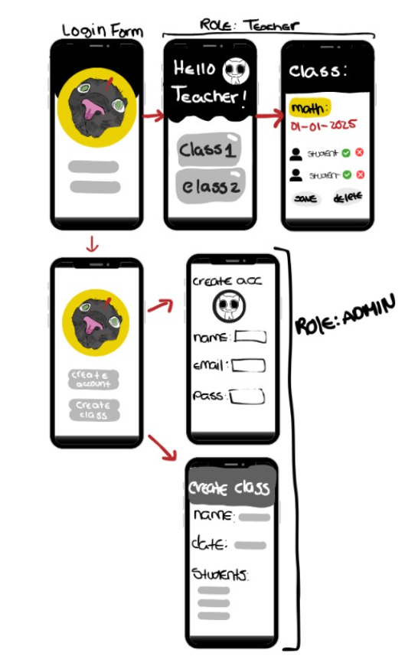

Group 07:  
  
Gonçalo Faustino: 20231721

Juliana Reis: 20231590

Madalena Duarte: 20231614

Sofia Saraiva: 20231620