Computer Graphics for Games 2018

Required:
Project Code + Report
(Online submission or DVD if size does not allow online submission)

Raft in the Ocean

A Raft with a flag floating in the ocean

<Your best project snapshot >

<Name>  <Number>  <Course>  <E-mail> | Gonçalo Marques  84719  MEIC-T  goncalo.alexandre.marques  @tecnico.ulisboa.pt | Joana Hrotkó  81423  MEIC-A  joana.hrotko@tecnico.ulisboa.pt
Abstract

Brief description (max. 200 words) of the main concepts described in the document. It should not be just an outline of the covered topics. It should give a clear idea of the solutions described and why they were chosen.

In this document, it is going to be about the different techniques used to achieve the raft in the ocean.
(cada um deve ter cerca de 60 palavras)
(falar da bandeira)
(falar da madeira)
For the water, it was used a Render to Texture technique with Frame Buffer Objects to achieve a fairly realistic reflection and refraction effect. In addition, it was used DuDv and Normal maps, to give the rippling effect of the water. The DuDv map samples the texture coordinates while the Normal map was to simulate the rippling normals for the specular highlights to be more realistic.

Feel free to format this report as you see fit, while respecting the page limits and the document structure. The way you present the information will be taken into account.

Concept (max 2 pages)

Describe your project concept, using visual references to what you aimed to achieve, citing inspirational material. List the main features of the concept. Use sketches and snapshots to illustrate your ideas. If the concept changed throughout the semester, describe this evolution.

Technical Challenges (max 1 page / student)

Describe the main issues and technical challenges that were tackled during project development. Each challenge should list the students that contributed to its resolution. Use visual references to clearly state what each challenge was aiming for.

1st Challenge [Student name, student name, etc.]

2nd Challenge [Student name, student name, etc.]

Cloth Simulation [Gonçalo Marques]
In order to simulate the behaviour of a flag, we implemented Nvidia’s most recent cloth simulation library, NvCloth, in the project.

Post-Processing filters [Gonçalo Marques]
We decided to implement post-processing filters that allow us to change the scene’s overall color and mood.

Water Reflection [Joana Hrotkó]
It was used a Render to Texture technique. This effect was achieved with the usage of a frame buffer object that processed the scene with the camera mirrored (upside down). This image was used to give the reflection effect. It was also used a clipping plane on the objects in order to only reflect what was on the surface of the water with a normal of (0, 1, 0).
  - Water Refraction [Joana Hrotkó]
Just as before, it was also used a Render to Texture technique. It was processed the scene bellow the water surface. As before it was used a clipping plane, but with a inverted normal (0, -1, 0).
  - Fresnel Effect [Joana Hrotkó]
To have a realistic water effect, it was simulated the Fresnel effect. Where the water refracts the most when the viewer is aligned with the eater surface and reflects the most when the viewer is 90º to the water’s normal. It was used the Schlick approach.
  - Water Distortion [Joana Hrotkó]
In order to give rippling effect, it was applied a distortion to the mesh, varying with time. For this it was used a DuDv map (a texture) and it was sampled in the water mesh. The DuDv map has red and green pixels that will represent the distortion in each point.
  - Light [Joana Hrotkó, Pedro]
For the water, it was applied specular highlights. The Normal Map was used to simulate the water normal to be irregular instead of being a flat surface (as it actually is), and this way, the specular highlights become more interesting.

Proposed Solutions (max 4 pages / student)

Tackling each challenge lead the team to explore different solutions before deciding which one to use for the final implementation. This section describes this process. Use diagrams and snapshots to explain the approaches explored, and detail the final chosen implementation so it could be reproduced.

Water Reflection

Explored approaches
3.1.1.2. The approach used in the section was Render to Texture. For the water, the scene was rendered in a total of 3 times: one to render the Reflection, then the refraction and finally render the scene. The first two, the rendered image was sent to a frame buffer object and that image in that buffer was sent to the water plane in addition to the refraction image and calculated the percentage of each with the Fresnel effect.
For the reflection the camera needed to be flipped in the y axis and moved to beneath the water the same distance as it was above the water, in order to get the reflection that would hit the water surface.
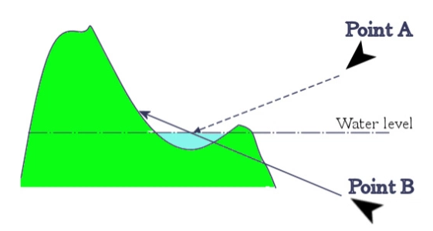
Since we wanted only the reflection from the everything above the water plane, it was used a clipping plane on all the objects of the scene to only reflect what was above the surface. For simplification, since the water is a horizontal plane, the normal clipping plane would be (0, 1, 0).

Final implementation
As for the implementation, there is a waterFBO that has both reflection and refraction frame buffer objects. In the drawScene() method the following code is written:
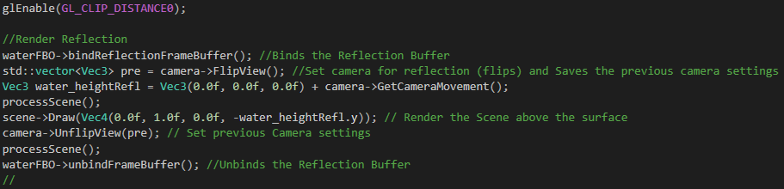
The glEnable(GL_CLIP_DISTANCE0) is necessary to activate the clipping planes.
In the fragment shader, the image received from the reflection buffer object

Water Refraction

Explored approaches
The approach used is similar to the previous approach. In this case the scene that would be bellow from the plane with a normal of (0, -1, 0) would be drawn to the water mesh.

Final implementation
For the Refraction is very similar as the Reflaction:
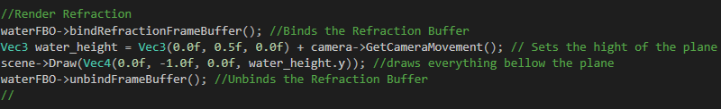

So we get:
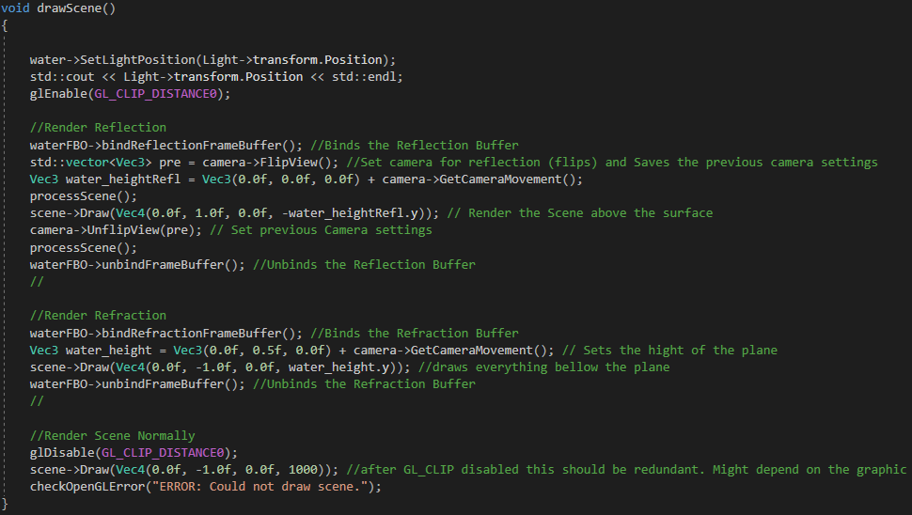

Fresnel Effect

Explored approaches
For the Fresnel effect it was explored two approaches:

      - The first one, it was simply to calculate the dot product between the view Vector and the normal vector. This approach does not consider the refraction index of the material, but it is computationally cheap.

      - The Second approach was calculating through the Schlick’s
approximation. This formula calculates the reflection coefficient R that can be approximates by:
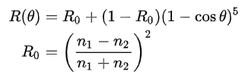
Where θ is the angle between the direction from which the incident light is coming and the normal od the surface between the two media, hence cosθ = N . V. n1 and n2 are the indices of refraction of the two media, in our case n1 = 1 (air/ vaccum) and n2 = 1.33 (water). R0 is the reflection coefficient for the light incoming parallel to the normal.

Final implementation
For the final implementation it was used the second approach (Schlick’s approximation) since it is has a more realistic look and considers the refraction index of the material. The Fresnel effect was applied at the Fragment Shader with the following code:
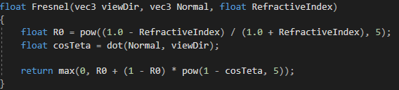
In order to avoid negative values, the minimum value returned in this function is 0.

Water Distortion

Explored approaches
It was used a DuDv map which is a texture of red, yellow and green pixels. This texture was used to shift the pixels before it was applied to the mesh.

Final implementation
The Distortion was implemented in the WaterFragmentShader.glsl. The first lines 3 lines we get the red and green coordinates.
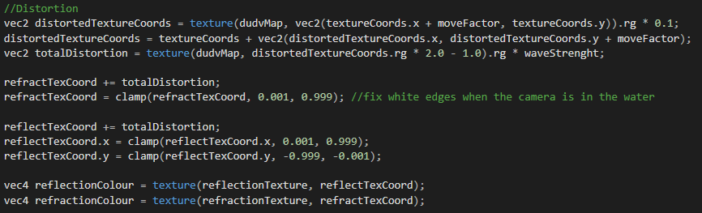

Light

Explored approaches

Final implementation

Post-Mortem (max 2 pages)

This section provides a critical review of the development process. Do not restrict yourself to technical issues. Discuss project management as well. Do not repeat information already provided in previous sections.

What went well?

Describe the decisions that revealed themselves to be as good or better than expected. Explain why these decisions were the right ones.

What did not go so well?

Describe the main difficulties encountered throughout the project, namely the options that looked promising but ended up not being so adequate. Be honest. Rarely everything goes according to plan. Explain why certain decisions turned out inadequate and how you overcame the situation.

Lessons learned

If you could go back to the start of the team project while taking all the knowledge you gathered throughout this semester, what would you do differently? What lesson did you learned? What advice would you give to others following a similar path?

References

List all documents and websites cited in the text. Additionally, if you based your solution on third party code, you should provide a clear link to it. As long as you understand what the code does and explain how it works (and are not infringing any copyright!), there will be no penalization.

Archives format

The archives of the project must abide by the following directory structure:
Archives that do not follow this structure will be penalized.

Stage 1: Project Code
(deadline: Friday, January 19th 16:30)

- /release
Contains all the files required to run the project. It should be possible to run the project from this directory. Include an install.txt file describing all the steps required to have the application running.

- /source
Contains all the source files of the project. Include only the minimum set of files required to build the project in MSVC. Include a build.txt file describing how to recreate the release directory from the source provided.

Stage 2: Project Report and Documentation
(deadline: Monday, January 22th 16:30)

- /media/docs
Contains a (1-page if possible) user manual in pdf format (user.pdf) describing how to interact with and set/change the parameters of your application.

- /media/report
Contains a copy of your report in both word (report.doc) and pdf format (report.pdf).

- /media/snapshots
Contains (at least) a dozen snapshots (png format) of your application running. Provide for a wide coverage of the developed functionality and use meaningful filenames.

- /media/videos
Contains two videos:
- One short video demonstrating the main features of your application.
(demo.mp4, max 2 min, format: 720p30 MP4 H.264 AAC stereo)
- One short video commentary in which the team discusses the development process.
(makingof.mp4, max 3 min, format: 720p30 MP4 H.264 AAC stereo)

- /media/fan (optional)
Contains multimedia content produced during development (e.g. sketches, pictures of your working space, etc.), everything your fan is entitled to!

