TECH OREON ANALYTICA
HIV Care and Treatment Services: CLM Feedback Analysis
Editable stakeholder report
Prepared by Tech Oreon Analytica

This report presents findings from patient and community feedback on HIV care and treatment services, with a focus on service experience, satisfaction, access barriers, and priorities for improvement.

Overview
The workbook contains 23,457 responses, dominated by CLM feedback and concentrated in Homa Bay, Kilifi, and Makueni. Overall experience is broadly positive, especially around staff attitude and reception, but a meaningful share of respondents still report access and service-delivery bottlenecks.
The analysis is presented in a CLM-style format so that the evidence can be used in stakeholder meetings, quality-improvement discussions, and routine review of what patients say about HIV services.

Key Indicators
Indicator | Value
Total responses | 23,457
Satisfied or very satisfied | 89.6%
Reported access challenges | 22.4%
Confidentiality respected | 89.0%
Rights awareness | 79.9%
Average sentiment score | 0.434

Background and Context
This analysis sits within the broader HIV response ecosystem in Kenya, where community networks, civil society, government, and global health partners all play a role in improving access, treatment continuity, and quality of care. In this setting, community-led monitoring evidence is useful because it shows how services are actually experienced by the people who use them.
Organizations active in this wider ecosystem include NEPHAK, county and national health teams, PEPFAR/USAID, the Global Fund, UNAIDS, WHO, and other implementing and community partners supporting HIV prevention, treatment, care, and community systems.

Plots and Findings

Satisfaction and Sentiment
The feedback is largely positive, but the comments help explain where operational gaps continue to affect the experience of care.
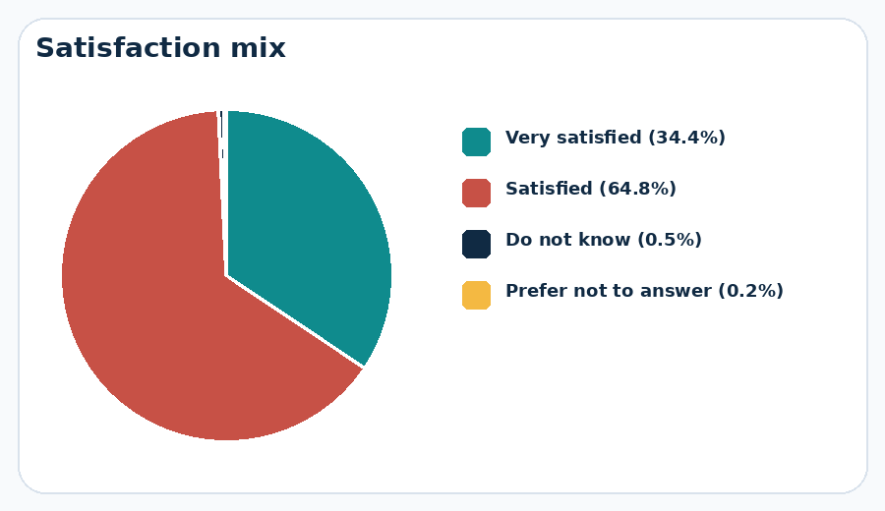
Satisfaction Mix
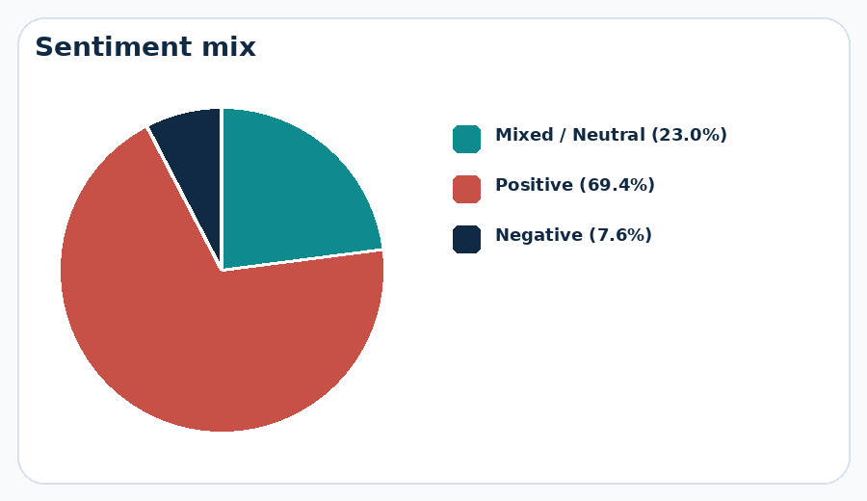
Sentiment Mix

Response Distribution
Most responses come from a few counties and are heavily concentrated in CLM feedback, which should be kept in mind when interpreting the profile of issues raised.
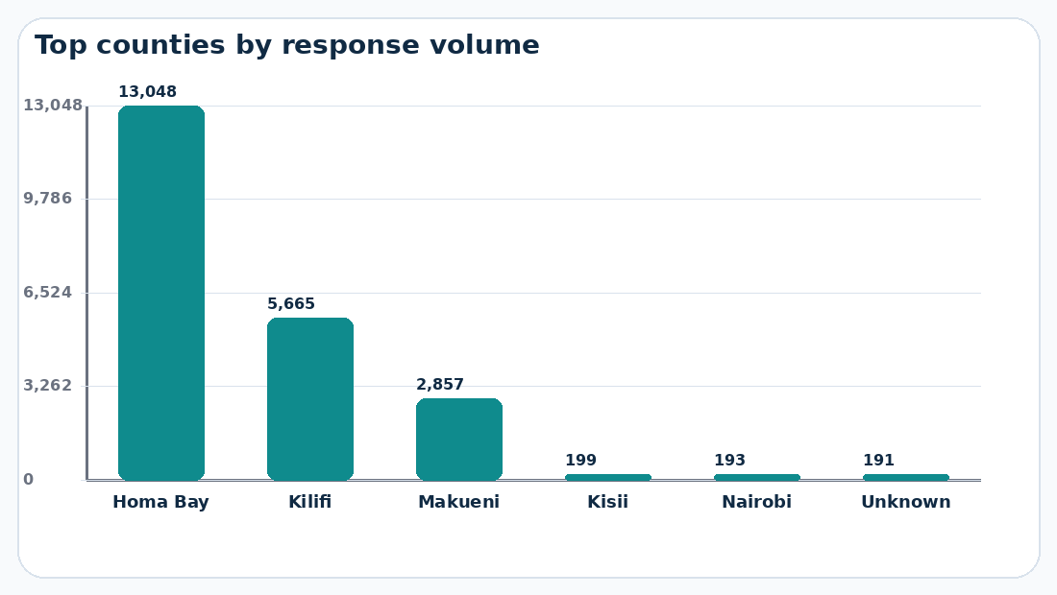
County Volume
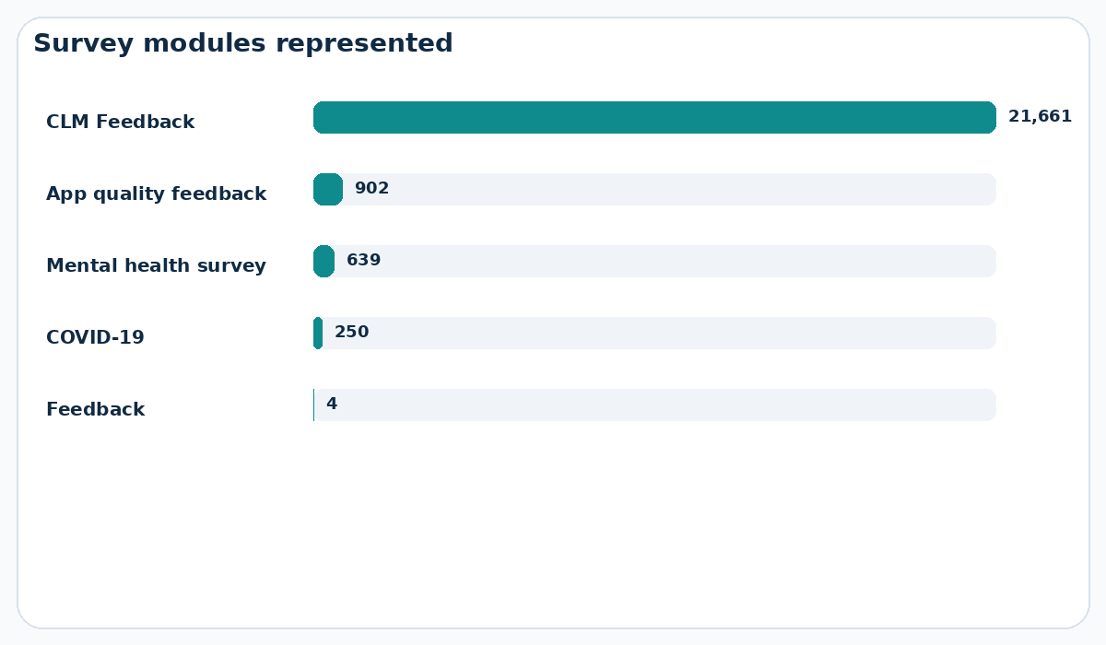
Survey Mix

Service Priorities
The most frequently discussed themes point to concrete service-delivery issues rather than abstract satisfaction alone.
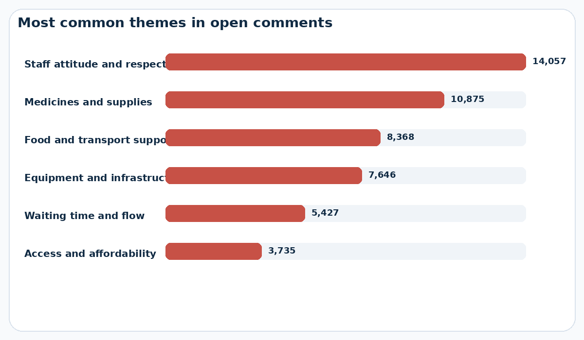
Theme Priority
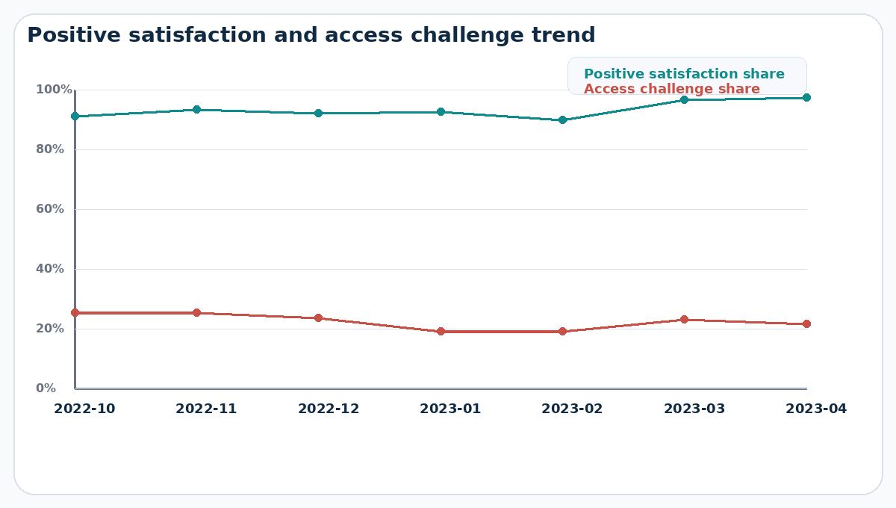
Service Trend

Client Language
The word clouds show the language respondents use most often when describing what worked well and what should improve.
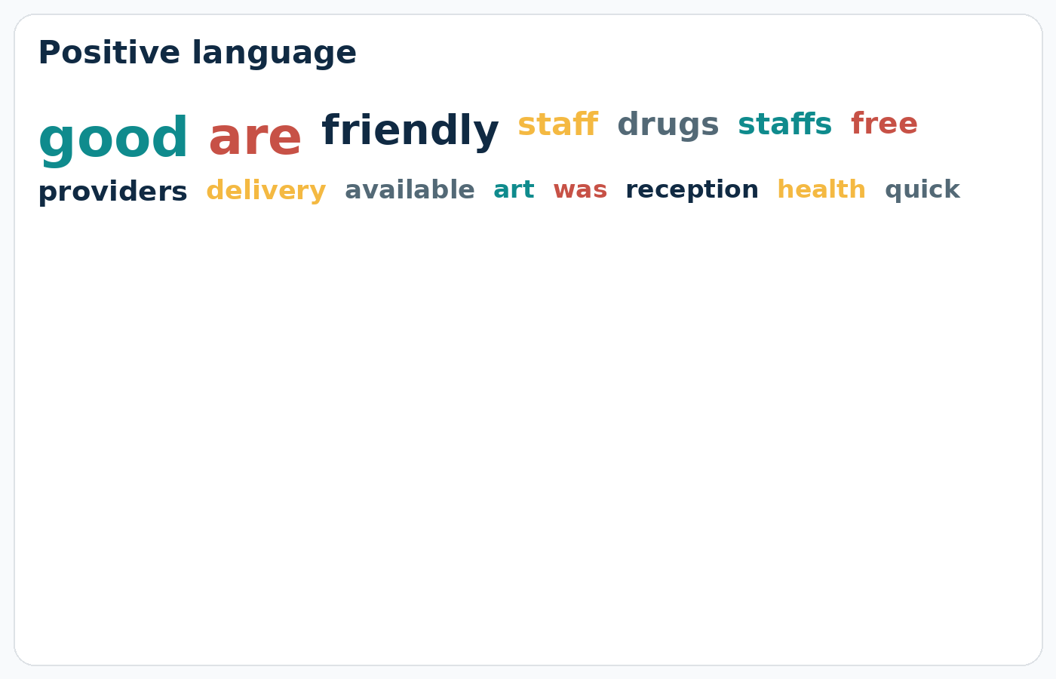
Positive Wordcloud
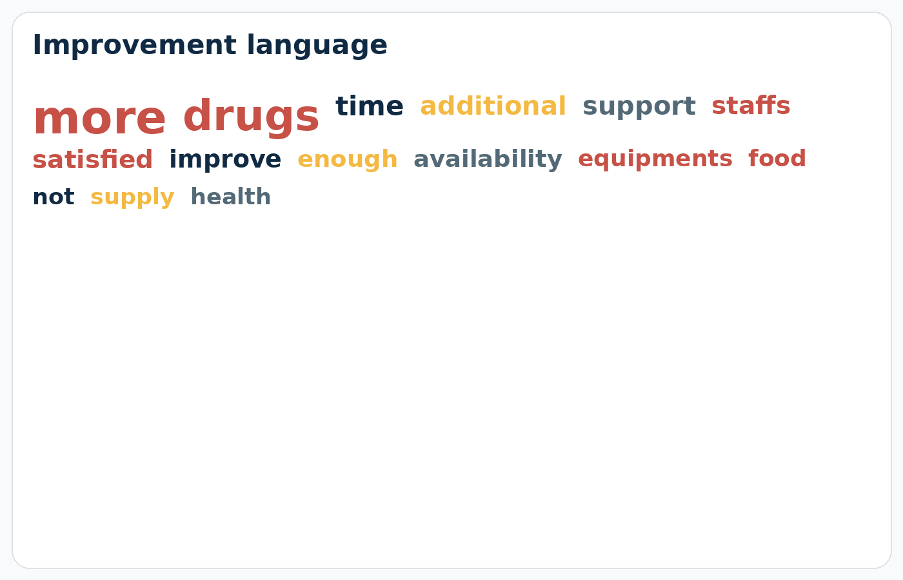
Improvement Wordcloud

Main Insights
- Staff friendliness, respectful reception, and supportive care are among the strongest positive themes in the feedback.
- The most common improvement requests relate to medicines and supplies, food and transport support, equipment and infrastructure, and waiting time.
- High satisfaction scores do not eliminate the need to act on practical barriers, because many respondents still describe specific service gaps that affect access and continuity of care.
- The open comments provide useful explanatory detail that can strengthen routine review meetings and help interpret service-quality indicators more clearly.

Selected Client Voice
Homa Bay | CLM Feedback: "The good services and friendly staffs at this facility it so amazing"
Homa Bay | CLM Feedback: "Good health care system"
Homa Bay | CLM Feedback: "Lack of enough medicine and equipment that lead to referrals"
Kilifi | CLM Feedback: "Long queing"

Recommendations
- Protect the positive service culture reflected in comments on friendly staff, respectful treatment, and supportive care.
- Prioritize action on medicines and supplies, food and transport support, equipment, and waiting time because these are the most consistent operational concerns in the feedback.
- Use both structured indicators and open comments in review meetings so that service-quality trends are interpreted alongside direct patient voice.
- Refresh these charts regularly as new feedback is collected so the report can support ongoing quality improvement rather than one-off presentation use.

