Screenshot:

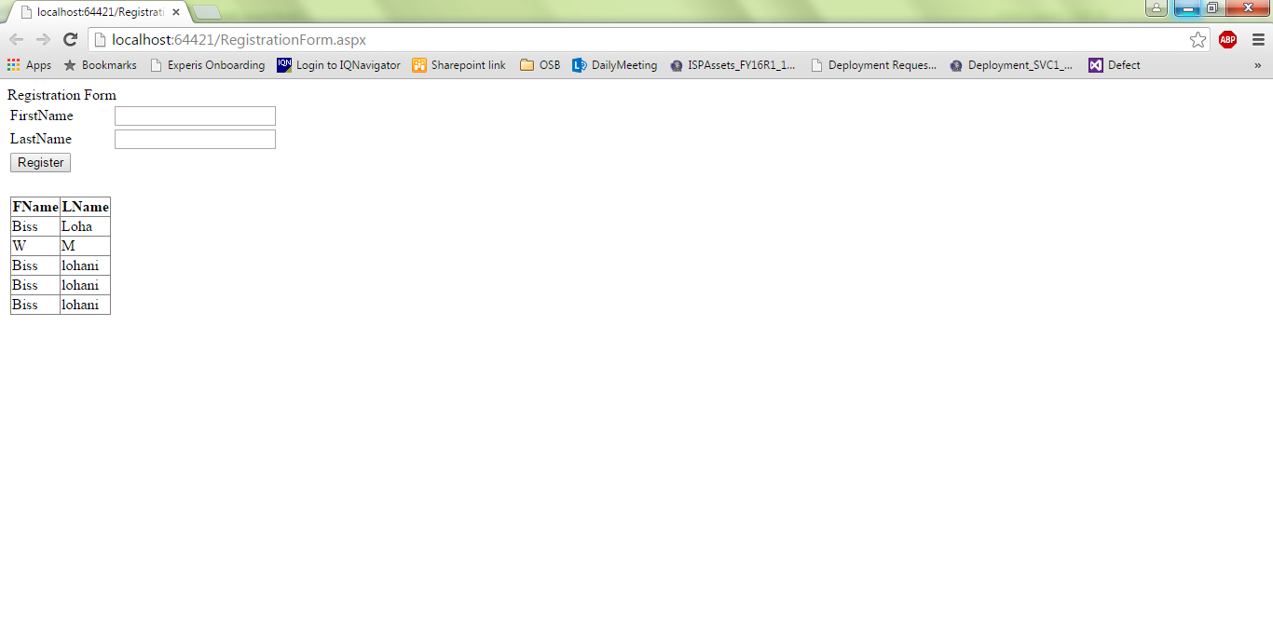

Code:

Imports System.Data.OleDb

Partial Class RegistrationForm

Inherits System.Web.UI.Page

Protected Sub Button1_Click(sender As Object, e As EventArgs) Handles Button1.Click

Dim conn As New OleDbConnection("Provider=Microsoft.ACE.OLEDB.12.0;Data Source=" & Server.MapPath("Student.accdb"))

Try

Dim cmd As New OleDbCommand("insert into Registration(Fname, Lname) values(@p1, @p2)", conn)

cmd.Parameters.AddWithValue("p1", TextBox1.Text)

cmd.Parameters.AddWithValue("p2", TextBox2.Text)

conn.Open()

cmd.ExecuteNonQuery()

conn.Close()

Button1.Text = "Successfully Registered!"

TextBox1.Text = ""

TextBox2.Text = ""

GridView1.DataBind()

Catch ex As Exception

conn.Close()

MsgBox("Error During Registration")

End Try

End Sub

End Class