## ASSIGNMENT-1: LANDING PAGE

NAME:GONDI NAVYA SRI

EMAIL ID: [gondinavyasri@gmail.com](mailto:gondinavyasri@gmail.com)

PHONE: 7032916578

ROLL NUMBER: 20NN1A1281

COLLEGE: VIGNAN’S NIRULA INSTITUTE OF TECHNOLOGY AND SCIENCE FOR WOMEN

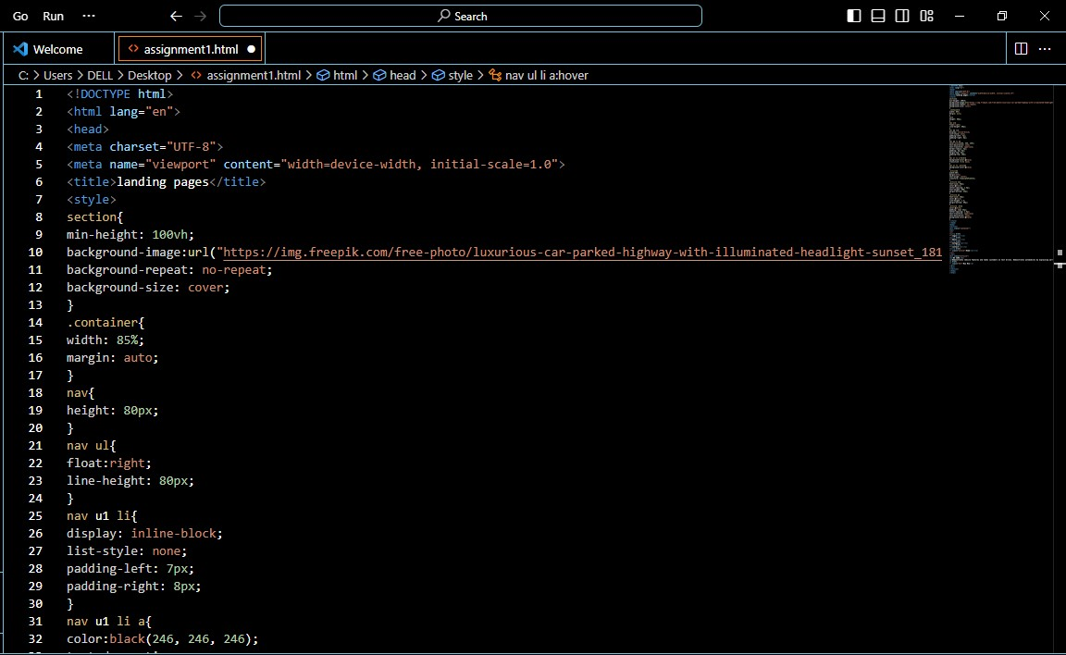

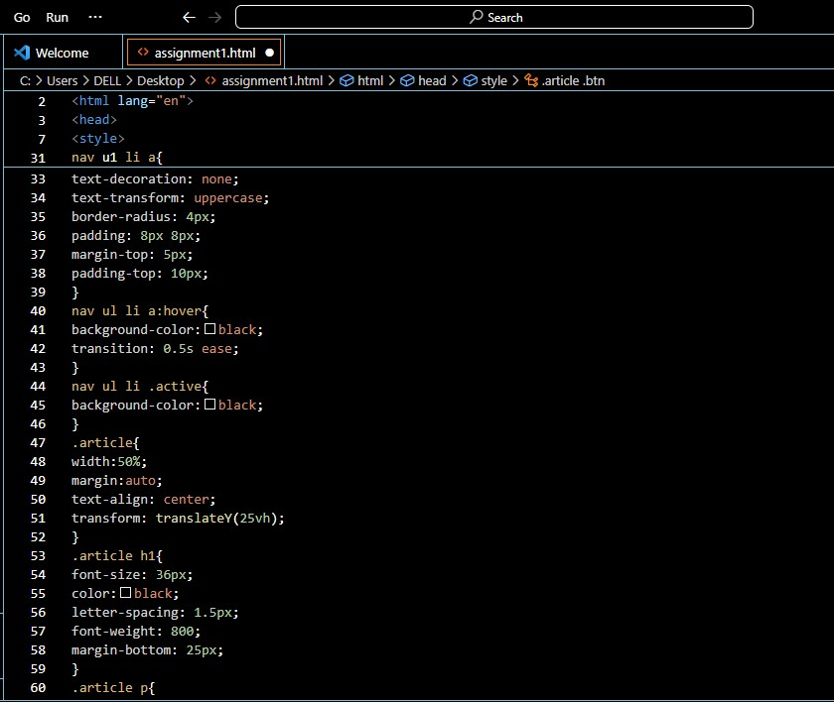

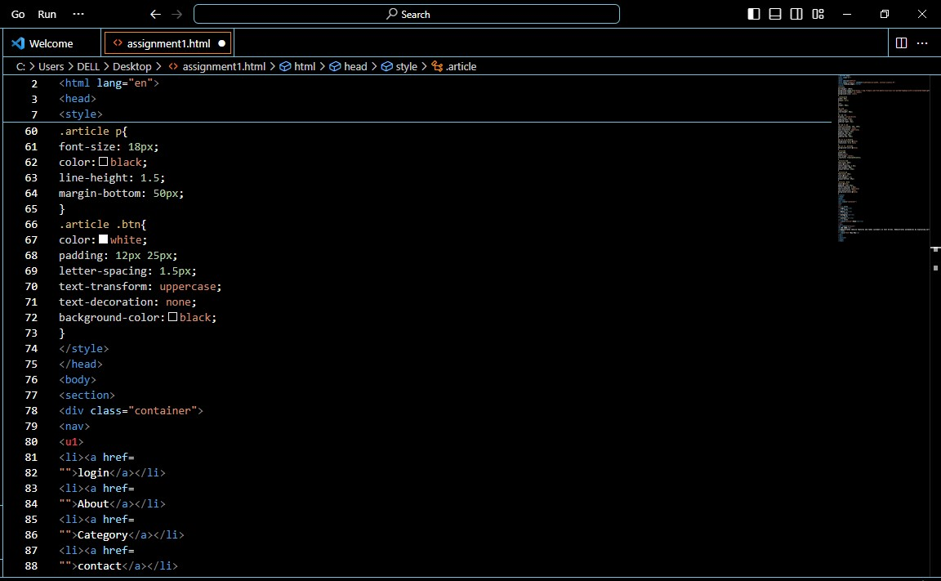

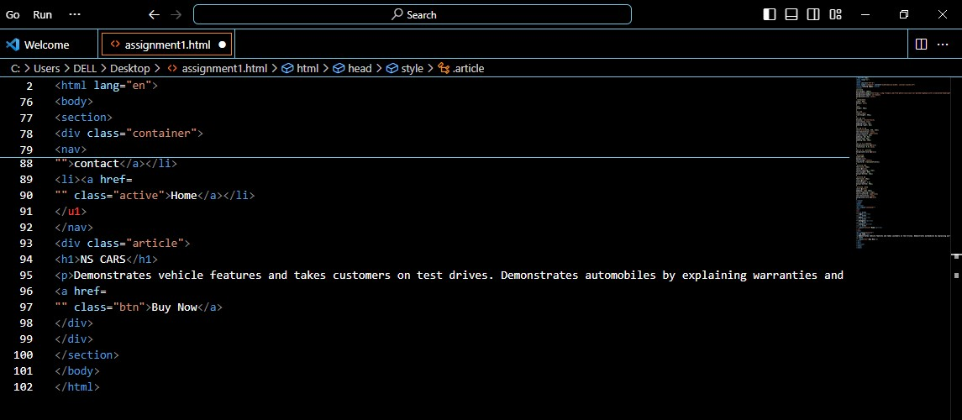

OUTPUT:

