**Ethereum Wallet**

Install & Setup Tutorial

Wenyan Qin

2017-05

# Ethereum Wallet – Installation

The **Ethereum Wallet**is a gateway to decentralized applications on the Ethereum blockchain. It allows you to hold and secure ether and other crypto-assets built on Ethereum, as well as write, deploy and use smart contracts. [Download the latest Ethereum Wallet from the official website.](https://github.com/ethereum/mist/releases) (https://github.com/ethereum/mist/releases)

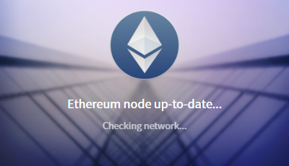

After download the latest Wallet Installer, click to start the installation …

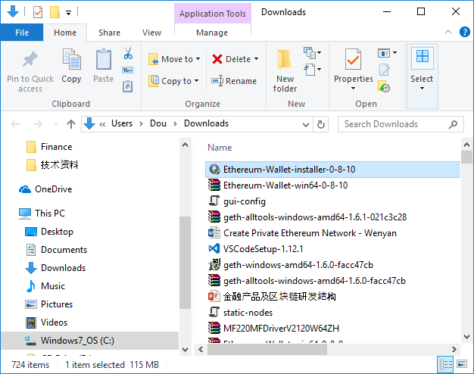

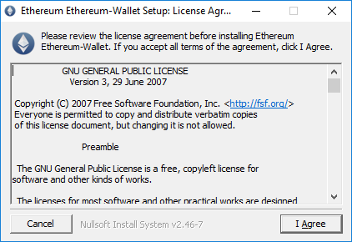

Accept Default Wallet location unless you want to have your customized destination

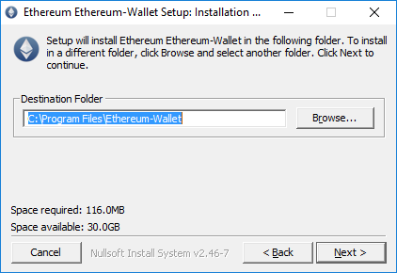

Accept Default Wallet location unless you want to have your customized destination of Ethereum blockchain data, like account keys, ether data etc.

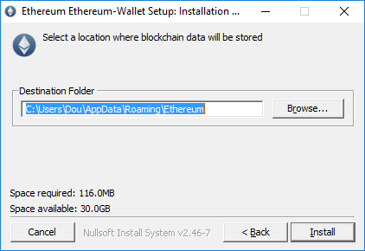

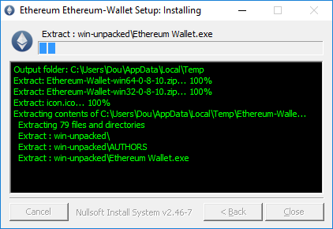

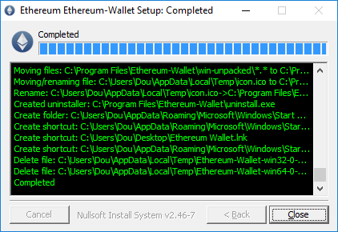

There will be a “Ethereum Wallet” icon created on the desktop, double click to start setup Ethereum wallet.

# Ethereum Toolset Installation

Download the Ethereum toolset in the same location and unzip to a $PATH location, such as: C:\Program Files\Geth

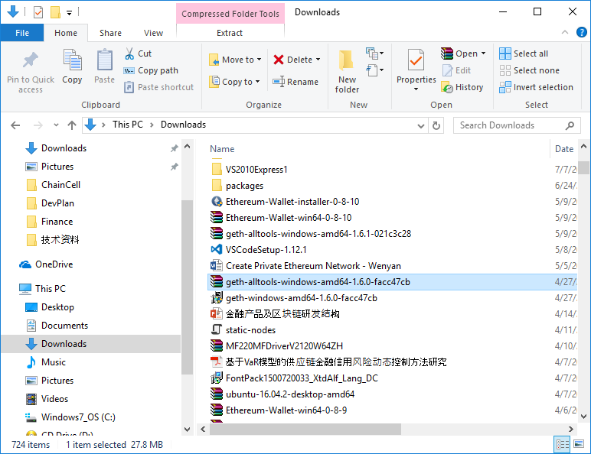

C:\Program Files\Geth>ls -lart

total 95710

-rw-r--r-- 1 Dou Administrators 32397 May 4 11:50 COPYING

-rwxr-xr-x 1 Dou Administrators 6789948 May 4 11:51 abigen.exe

-rwxr-xr-x 1 Dou Administrators 13339284 May 4 11:51 bootnode.exe

-rwxr-xr-x 1 Dou Administrators 13021071 May 4 11:51 evm.exe

-rwxr-xr-x 1 Dou Administrators 2830336 May 4 11:51 rlpdump.exe

-rwxr-xr-x 1 Dou Administrators 10046669 May 4 11:51 puppeth.exe

-rwxr-xr-x 1 Dou Administrators 20923699 May 4 11:51 **geth.exe**

-rwxr-xr-x 1 Dou Administrators 14038601 May 4 11:51 wnode.exe

-rwxr-xr-x 1 Dou Administrators 16948817 May 4 11:51 swarm.exe

dr-xr-xr-x 72 Dou Administrators 28672 May 9 14:38 ..

drwxr-xr-x 2 Dou Administrators 4096 May 9 15:11 .

C:\Users\<user>\AppData\Roaming\Ethereum>where geth

**C:\Program Files\Geth\geth.exe**

# Ethereum Wallet Setup



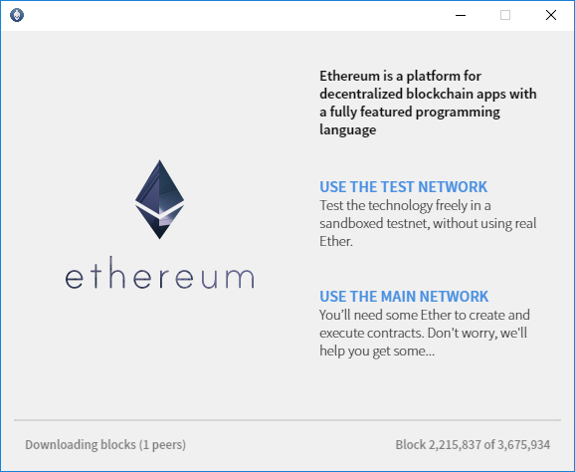

* USE THE TEST NETWORK for a sandbox testnet, not the real ether.
* USE THE MAIN NETWORK will be for user to use the real ether again Ethereum main network.
* We start with TEST NET first so click on “USE THE TEST NETWORK” and continue.

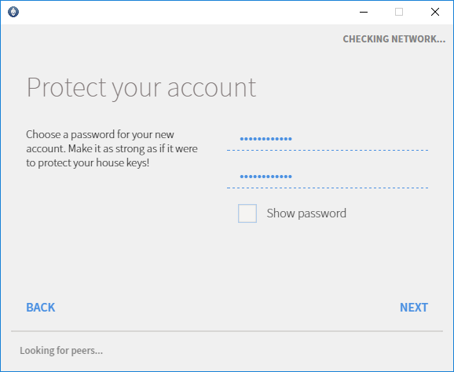

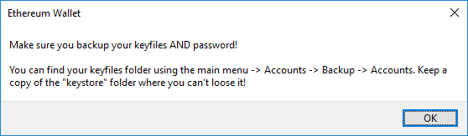

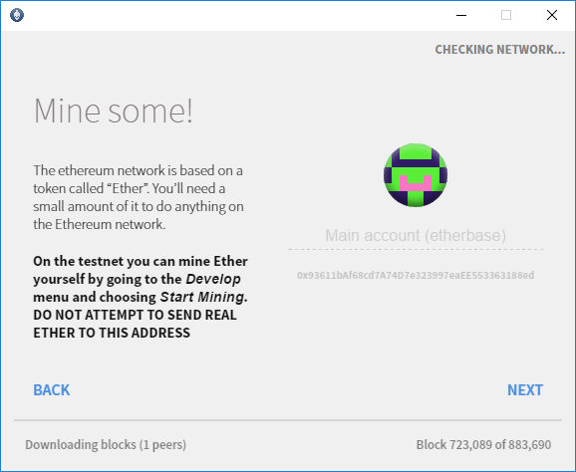

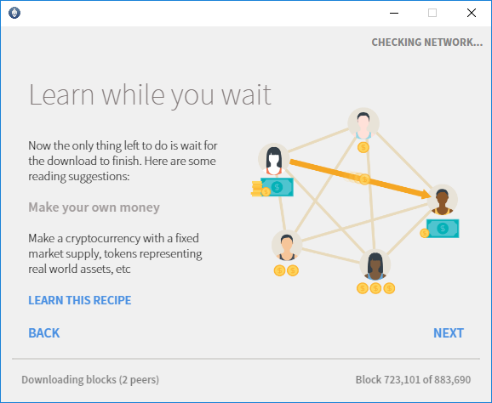

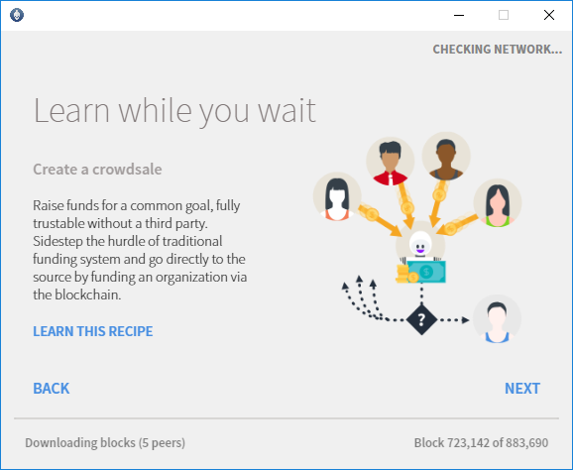

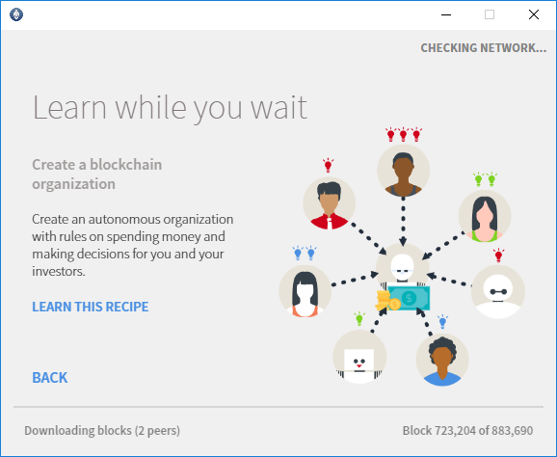

There will be a long time process of syncing the blockchain data online.

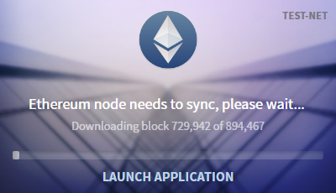

We have two options, one to continue let the wallet sync all the TESTNET data, there are about 30G data for TESTNET and 50G data for MAIN NET Ethereum. Option two is the go through a fast sync process we provide in next section.

We close the Ethereum Wallet for going through a fast sync.

# Fast Sync of Ethereum blockchain data

By Default, Ethereum data are stored on following location as:

C:\Users\<user>\AppData\Roaming\Ethereum

Or you pick your own customized location, make sure you have ethereum toolset installed and “geth” utilities are available. Run following command to do the fast blockchain data sync:

geth --datadir <path to Ethereum data> --fast --testnet --cache=1024

and from another terminal windows, run following to bring back the wallet again:

C:\Program Files\Ethereum-Wallet>"Ethereum Wallet.exe" ipc:\\.\pipe\geth.ipc

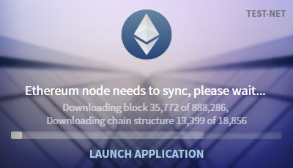

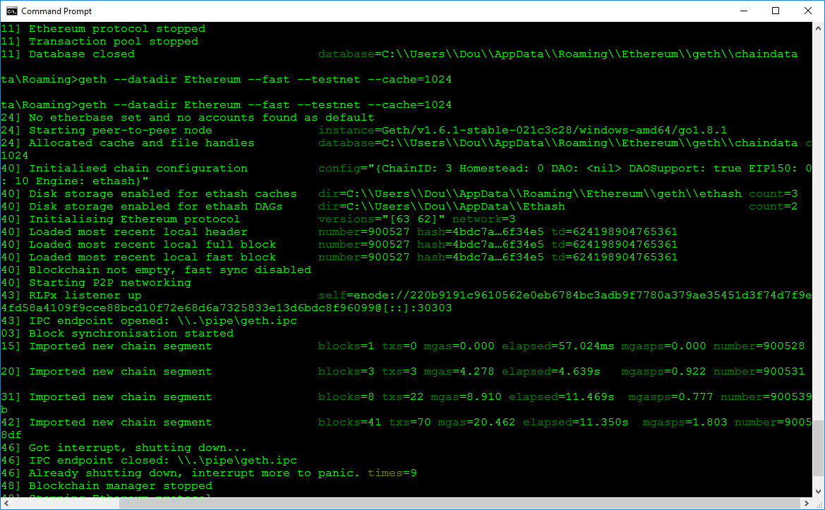

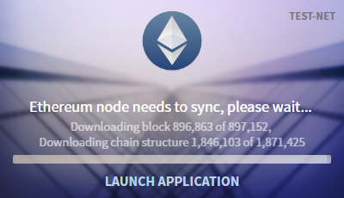

After data sync, we have Ethereum Wallet ready for TESTNET

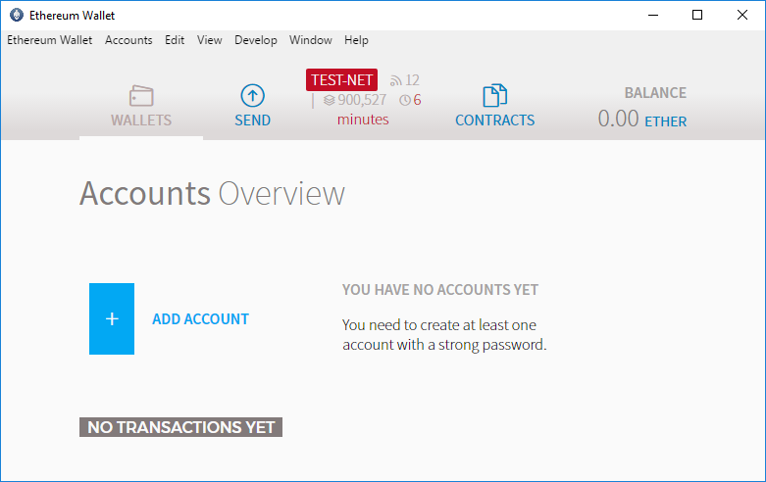

# Using Ethereum

Due to directly connecting to the public TESTNET, so the transaction data might not always synced everything bring up the wallet once again. So there will be a quick sync happen before you can get into the wallet full GUI.

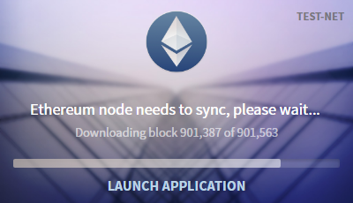

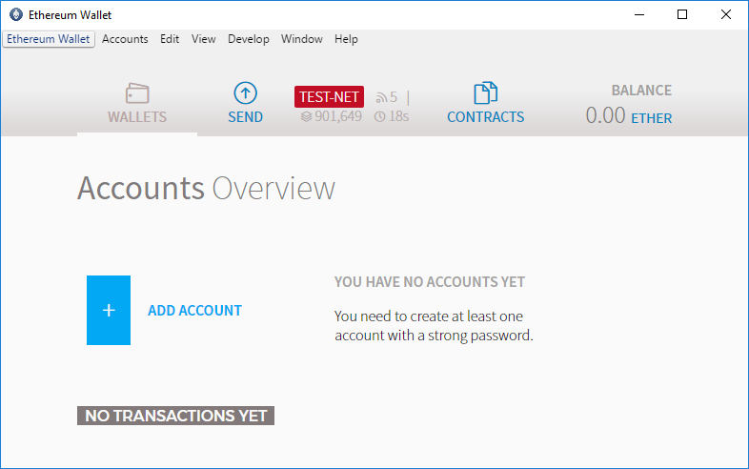

Adding Account as following, Click “ADD ACCOUNT” link and enter password.

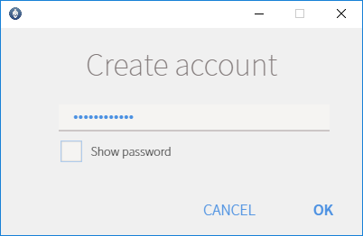



New Account added as shown:

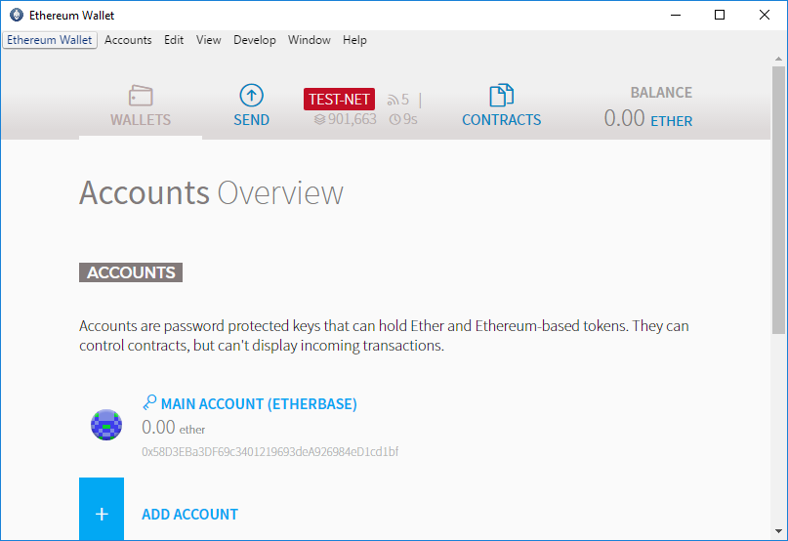

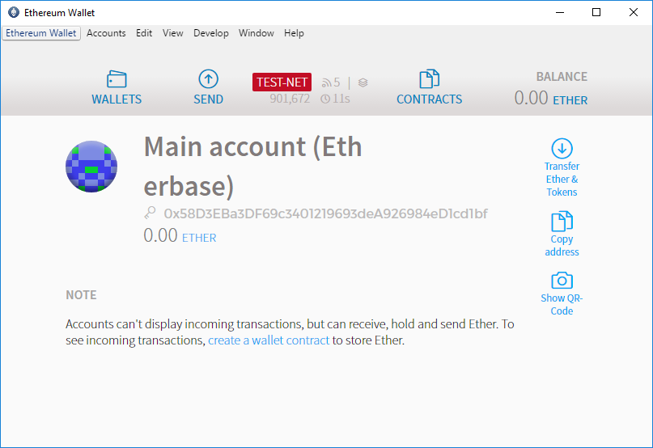

To request some testnet ethers, goto: <http://faucet.ropsten.be:3001/>

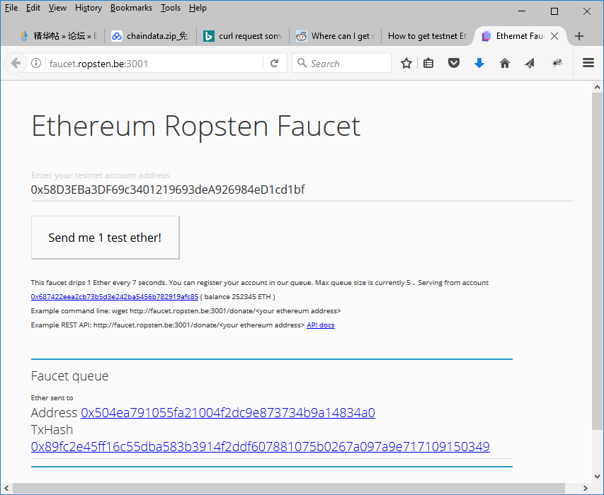

Enter the testnet account address and

# Uninstall the Ethereum Wallet

Once you don’t need it, uninstallation process is strain forward and simple as shown:

* For Windows, goto: Control Panel\Programs\Programs and Features

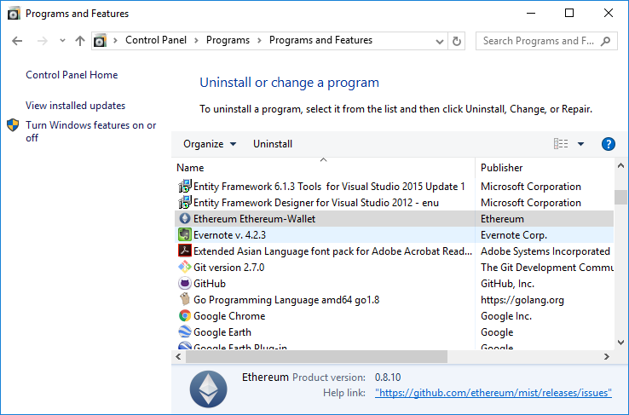

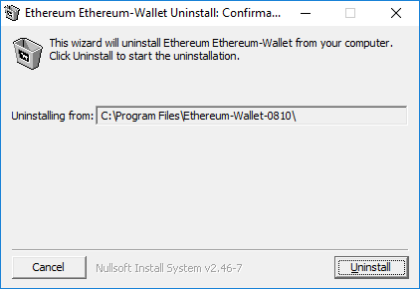

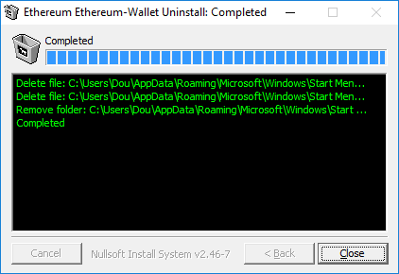

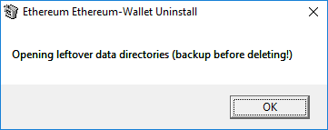

# Mist Installation

Mist is one of the most popular Ethereum Wallets. It’s almost identical with Ethereum Wallet described above, with some customized features, easier for Smart Contract developments.

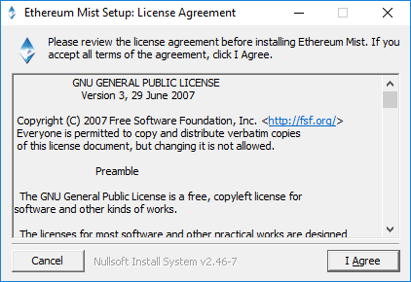

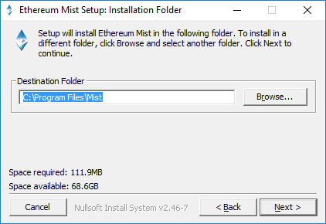

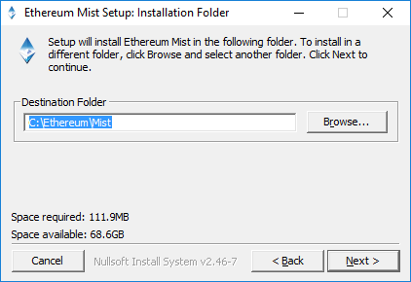

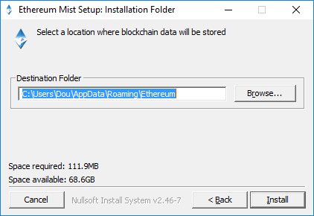

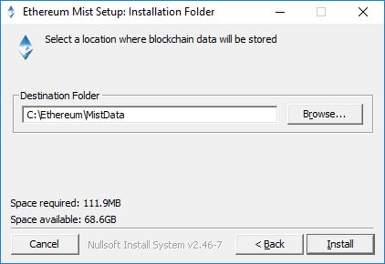

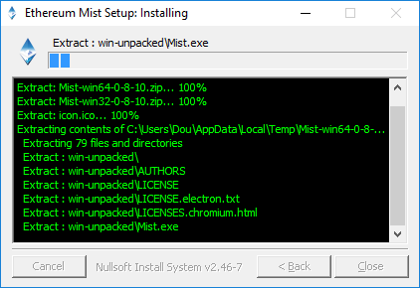

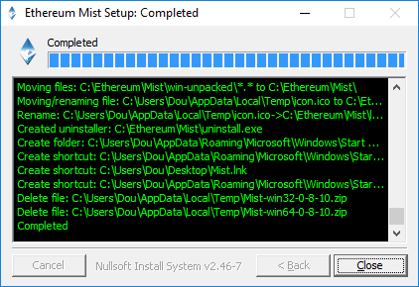

Double click Mist.exe or shortcut icon after installation.

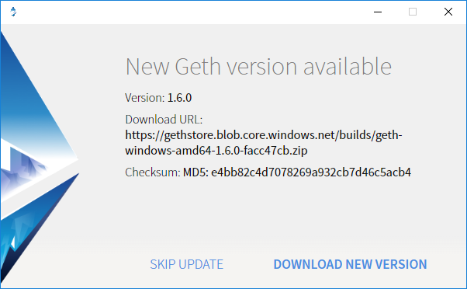

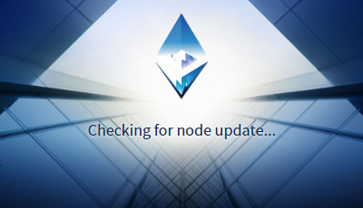

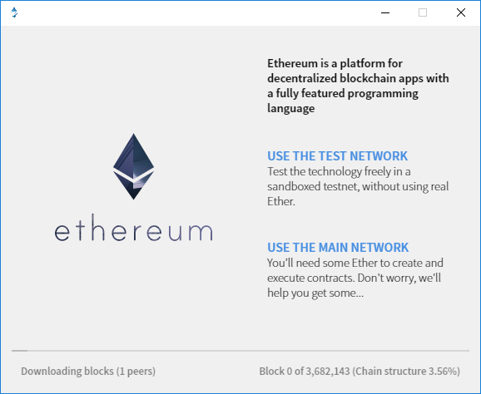

We select “USE THE MAIN NETWORK”

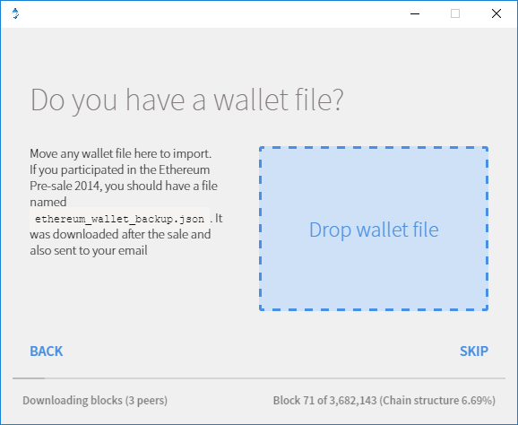

Click “SKIP” continue.

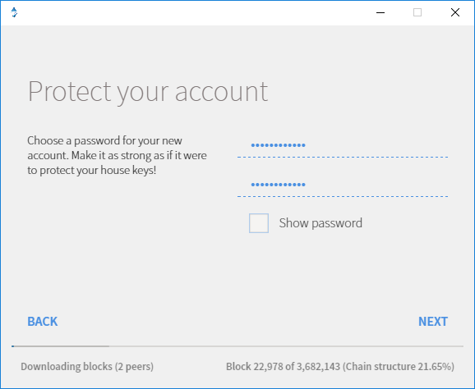

Privide password and click “NEXT”

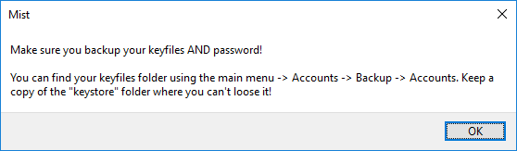

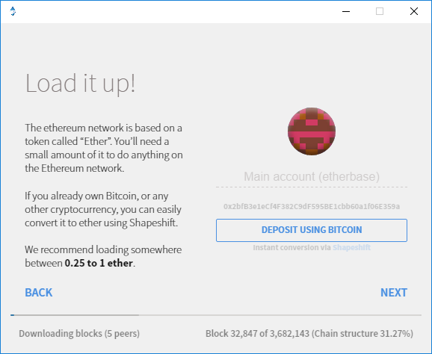

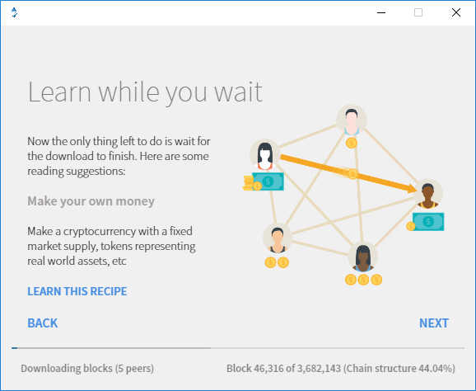

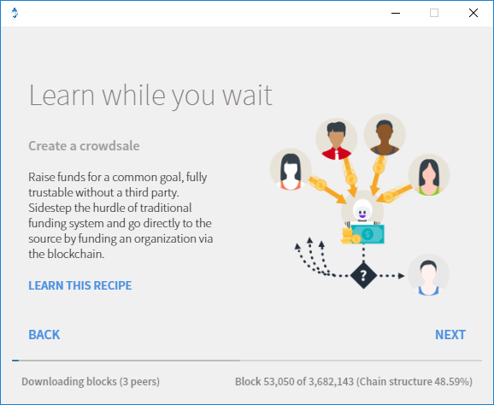

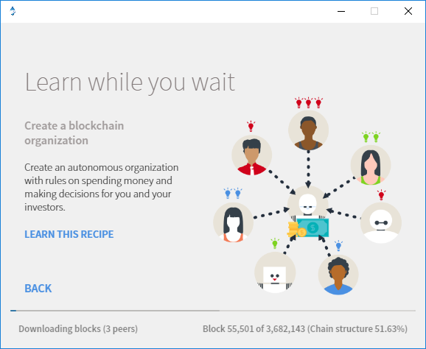

The Mist will do that Ethereum MAIN NET blockchain data sync as shown above.

Close the slow sync Mist and re-run, Mist will continue the data sync as shown below.

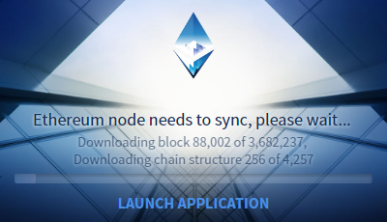

After the MAIN NET Blockchain data synced, we should be able to have a ethereum wallet, which has full function features and is able to manage real ethers with real support currencies.

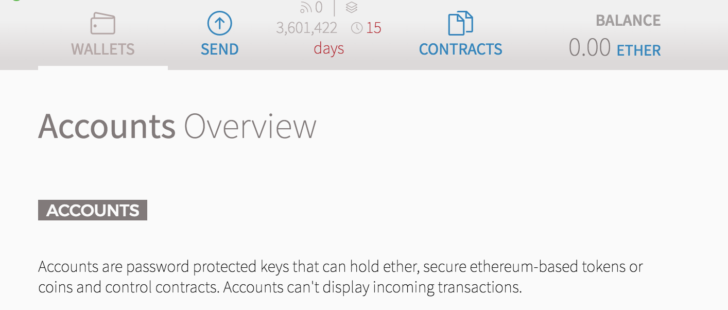

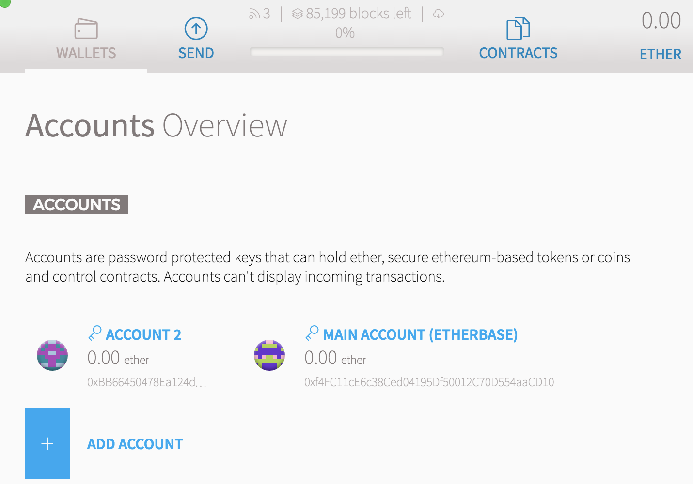

**Tips**: in order to avoid long period of time for Blockchain data sync, you can download the trust exist Blockchain data and unzip it into chaindata folder like C:\Users\<User>\AppData\Roaming\Ethereum\geth

# Ready to get started?

We hope you enjoy Ethereum!

# Learn More

Keep going. There are lots more new features and ways to use/work in Ethereum and development. Check out <https://ethereum.org> and <https://github.com/ethereum> page online to dive right in.